**Name : Sagar Sharma(17BLC1068) – QA PROFILE**

**Solution 1**



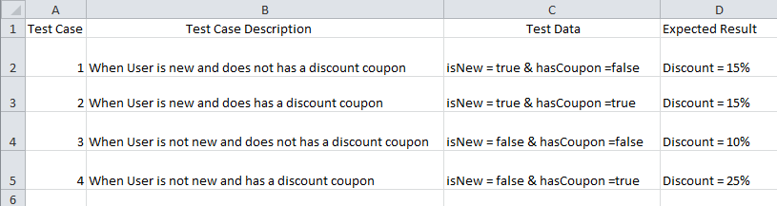

Description of Variables :-

isNew : Boolean to store whether customer is new or not.

hasCoupon : Boolean to store whether customer has coupon.

**Solution 2**

1. **Understanding/Synopsis: -**

* As per the given paragraph, we have deciphered that Jenny has made a wrong choice by migrating from the former location to the new location. Ronnie has taken over the place and it has benefitted him in enhancing his business. Post migrating to the new location Jenny realised that she has definitely erred in shifting to its new location.

1. **Approach –Point of View**

* First of all, Jenny made a mistake in choosing the wrong location as she didn’t identify the right spot based on her business requirements
* Jenny could have done the recce of the new location before finalizing based on the below factors
  + Rent and the commercials of the new location
  + Not focusing on Marketing agenda and propagations
  + Not providing value addition to the new customers via providing offers/discounts
  + Co-workers and the staff availability & conveyance at the same price
  + Amenities at the new locations
  + Whether the new location is commercial or residential
  + No of existing beauty parlours around the new location
  + Is the target audience/customers are residing near to the new location?
  + Not upgrading the services based on the customer requirements
* Jenny should have checked the customer base around the new location and feasibility of her existing customers travelling to a new location
* Ronni was benefited because of his due diligence in finalizing the location which indirectly helped him in expanding his business

1. **Mitigation Approach: -**

* Jenny could have followed the below approaches to mitigate the downfall,

• Right selection of location

• Focusing on marketing agenda and propagation

• Provide value-added services to the customer

• Delegation with the existing co-workers for a location shift

• Recce of the new location

• Customer availability based on the location

• Improvising the services based on customer demands

1. **Conclusion: -**

* Someone rightly said, “**Life is a matter of choices, and every choice you make makes you**”. It is always important to do thorough analysis with the proven strategies and seek insider advice to start anything new. Life gives us enormous chances and we have to be very precise in choosing the opportunity, sometimes we make mistakes by opting inappropriate choices which indirectly incur the losses to ourselves.

**Solution 3**

Here are some basic this we would do to check the quality of the mouse

* Brand value of the product
* Product reviews
* Price factor
* Compatibility with the OS
* Coverage area
* Batteries backup
* Demand in the market

Then we will plug the USB port into a computer and see, does it get detected right away, does it automatically setup the driver, does it move around well and does it click well.

**Basic Test Cases need to be Done on Initial Level [For All Types of Users]**

* Verify that left-click and right-click buttons are working fine
* Check if the double click is working fine
* Verify the time duration between two left clicks, in order to consider it as a double click.
* Verify the speed of the mouse pointer
* Check the pressure required for clicking the mouse buttons
* Verify the acceleration of the mouse pointer
* Verify that clicking the button and dragging the mouse operation is working fine (drag and drop functionality)
* Check the dimension of the mouse, if it’s suitable to grip and work
* Verify that the mouse works in all the allowed surfaces
* In the case of wireless mouse, check the range up to which the mouse remains operational.
* check the battery requirement of the mouse Bad or failing [batteries](https://www.computerhope.com/jargon/b/battery.htm) can also cause low signal strength with wireless mice

**Physical Material Testing:**

* Sweat-Resistant Coating to further elevate the experience
* Should be symmetrical and suitable for Both Right Hand and Left Hand.
* Mouse must have Comfortable Ergonomic Design feels light
* Sweat-Resistant Coating to further elevate the experience for IT Employees.
* Convenient Controls