**INDEX**

|  |  |  |
| --- | --- | --- |
| **Sr. No** | **Title** | **Page no** |
| 1 | **CHAPTER 1 : INTRODUCTION** |  |
|  | 1.1 Company Profile |  |
|  | 1.2 Introduction |  |
|  | 1.3 Existing System and Need for System |  |
|  | 1.4 Limitations of existing system |  |
| 2 | **CHAPTER 2 : PROPOSED SYSTEM** |  |
|  | 2.1 Problem statement |  |
|  | 2.2 product position statement |  |
|  | 2.3 product overview |  |
|  | 2.4 summary of capabilities |  |
|  | 2.5 assumptions and dependencies |  |
|  | 2.6 objective of proposed system |  |
|  | 2.7 Functional requirements |  |
|  | 2.8 Nonfunctional requirements |  |
|  | 2.9 Stakeholder summary |  |
|  | 2.10 Users summary |  |
|  | 2.11 Scope of the system |  |
|  | 2.12 Operating environment |  |
|  | 2.13 Operating environment |  |
| 3 | **CHAPTER3 : REQUIREMENT DETERMINATION AND ANALYSIS** |  |
|  | 3.1 Fact finding methods |  |
|  | 3.2 feasibility study |  |
| 4 | **CHAPTER 4 : SYSTEM ANALYSIS & DESIGN** |  |
|  | 4.1 Use case diagram |  |
|  | 4.2 Sequence diagram |  |
|  | 4.3 Activity diagram |  |
|  | 4.4Class diagram |  |
|  | 4.5 Object diagram |  |
|  | 4.6 Module hierarchy diagram |  |

**CHAPTER 1: INTRODUCTION**

**1.2 Introduction**

**Recruitment Process System**

This project is aimed at developing a web-based and central Recruitment Process System for the University or college. Some features of this system will be creating vacancies, storing Applicants data, Interview process initiation, Scheduling Interviews, Storing Interview results for the applicant and finally Hiring of the applicant. Reports may be required to be generated for the use of Company.

Presently In any college we don’t have a website for Recruitments. Student has to manually submit his details to placement officer. Placement officer has to submit student details to company manually. Present system is not providing many options to old Jobseeker of college. There is no concept of student desired search for job options. There no chance of providing latest coursed updated by student.

This system has computerized the operations done in a Recruitment Process System. It maintains various files by doing additions & modifications to them. It has a selection process where persons are selected according to the client requirements. This is done making use of personal details, personal qualification, client details and client requirements. In this Project student can directly submit his resume to Placement officer and student can directly communicate with company official by using this system. By this college can provide more jobs for old student and final year student.

**Pay Roll System**

The purpose of employee management system is to automate the existing manual system by the help of computerized equipment and full-fledged web application, fulfilling their requirement so that their valuable data/ information can be stored for long period with easy accessing and manipulation of the same. The required software and hardware are easily available and easy to work with.

Employee management system as described above, can lead to error free, secure, reliable, fast management system. It can assist to the user to concentrate on their other activates rather to concentrate on the record keeping. Thus it will happen organizing in better utilization of resources.

The organization can maintain computerized records without redundant entries. That means that one need not distracted by information that is not relevant while being able to reach the information. This Application uses ASP.net as front-end and My-SQL as the back-end.

.

**1.3 Existing System and Need for System**

**Existing System**

**Recruitment System**

There are many existing systems for client side. So all the work are handling online but some limitations are found as Costs Can Spiral Depending on the online platform you use, you may have to pay a subscription fee or other costs to post your vacancy. It Can Be Difficult to Measure Effectiveness. For some roles, companies perceive that online job postings particularly on social media can give off the wrong image of their company. It Attracts Bad Candidates. There’s a Lot of Competition If you are receiving large volumes of applications that need to be pruned, there are technical issues with the platform you are working with, or the job ad itself constantly needs to be changed, then the process can start to become difficult to manage. It Attracts Fraudulent Applicants

**Pay Roll System**

There are many existing pay roll systems for client side but all are run on private basis not use third party system. We can give facility to employee or company to all process from hiring to payroll system work on one portal. Not need to carry extra system in company. Some system work offline or some work on online central basis.

**Need for System**

**Recruitment System:**

We are Develop the recruitment System. To overcome problems of cost and time consuming process and unwanted posts, ads distract to student. Removing problems from existing systems and create fast process to hire employee. An online recruitment system is a service that automates a company's recruiting needs by getting volumes of employment applications over the internet.

**Payroll System:**

Now a day payroll system work on private basis or offline so we need to make this online or all employee manage on one place from hiring to managing profile. And is helps to pay taxes easily. These systems allow easy management of employees' salaries, wages, taxes and other deductions. Companies need to be extra careful while calculating taxes, EPF and SOCSO to prevent any mistakes.

**1.4 Limitations of existing system**

**Recruitment System limitations:**

There are many existing systems for client side. So all the work are handling online but some limitations are found as following:

* Costs Can Spiral
  + Depending on the online platform you use, you may have to pay a subscription fee or other costs to post your vacancy.
* It Can Be Difficult to Measure Effectiveness
  + Not all online recruitment services offer an in-depth analysis of your posting; therefore, it can be hard to figure out what is and isn’t working and how to optimize your ad.
* It’s Informal
  + For some roles, companies perceive that online job postings – particularly on social media – can give off the wrong image of their company.
* It Attracts Bad Candidates
  + As previously mentioned, it’s very easy for people to apply for jobs online; this can potentially be a negative point as well, though. Posting a position online usually results in hundreds of applicants, many of whom will not be suitable for, or serious about, the role, thus diluting the quality of your talent pool.
* There’s a Lot of Competition
  + The main downside to following trends is that everybody else is doing the same thing. As a result, your post can quickly become buried under a mountain of other job offers, forcing you to either pay more for extra exposure or risk not being seen.
* There Could Be Lost Labor Hours
  + If you are receiving large volumes of applications that need to be pruned, there are technical issues with the platform you are working with, or the job ad itself constantly needs to be changed, then the process can start to become difficult to manage.
* It Attracts Fraudulent Applicants
  + Some applications might be fake, in order to get information about the company or hiring officer (a common espionage tactic), while spammers might use the information posted online to promote a service or product to your company.

**Payroll System Limitations:**

### **Payroll Software Can Be Expensive**

### You must purchase and maintain your software, which can be costly.

### You May Need to Hire Staff to Process Your Payroll

### When you purchase payroll software, you may need to hire and train someone to take on the responsibilities of using it. An added employee comes with the additional cost of salary and benefits.

### You Must Constantly Backup Your Payroll Data

### You must have a system in place to constantly archive this data. You or an employee must set aside the time each day to perform this backup.

* Access to Payroll Software May Be Limited
  + In most cases, when you buy payroll software, it’s loaded on to one computer. This means the software can only be accessed using that one machine.
* Your Payroll Software May Lead to Withholding Errors
  + According to the Internal Revenue Service, some payroll software systems can’t tell the difference between additional voluntary withholding amounts and regular withholding amounts when it calculates catch-up withholding for a current tax year.
* You or your payroll employee must compute payroll taxes and make sure all forms are completed accurately and payments are made on time.

**CHAPTER 2 : PROPOSED SYSTEM**

**2.1 Problem statement/s**

RecruitmentProcessSystem

This project is aimed at developing a web-based and central Recruitment Process System for the University or college. Some features of this system will be creating vacancies, storing Applicants data, Interview process initiation, Scheduling Interviews, Storing Interview results for the applicant and finally Hiring of the applicant. Reports may be required to be generated for the use of Company.

Presently In any college we don’t have a website for Recruitments. Student has to manually submit his details to placement officer. Placement officer has to submit student details to company manually. Present system is not providing many options to old Jobseeker of college. There is no concept of student desired search for job options. There no chance of providing latest coursed updated by student..

Pay Roll System

The purpose of employee management system is to automate the existing manual system by the help of computerized equipment and full-fledged web application, fulfilling their requirement so that their valuable data/ information can be stored for long period with easy accessing and manipulation of the same. The required software and hardware are easily available and easy to work with.

Employee management system as described above, can lead to error free, secure, reliable, fast management system. It can assist to the user to concentrate on their other activates rather to concentrate on the record keeping. Thus it will happen organizing in better utilization of resources.

The organization can maintain computerized records without redundant entries. That means that one need not distracted by information that is not relevant while being able to reach the information. This Application uses ASP.net as front-end and My-SQL as the back-end.

## 2.2 Product position statement

**2.3 Product overview**

**2.4 Summary of Capabilities:**

**2.6 Objectives of proposed system**

**2.7 Functional requirements**

This section provides requirement overview of the system. Various functional modules that can be implemented by the system will be –

MODULES-1

* Resolve issues manual staffing processes.
* Make easy process to hire employees with sort time.
* Search every types of job you need.
* Fast hiring process minimizes paper work.
* Online paper work and arrange or schedule interview when criteria will be match.

MODULES-2

* It excludes the use of paper and human efforts.
* The system is helpful as it generates a systematic overall report of every employee.
* The system introduce a manageable and systematic approach of maintain attendance record.
* It saves user time cost and organization resources.
* Employee manage all own report, employee can download their salary slip.
* Employee manages leave.
* It deals with monitoring the information and transaction of attendance.
* Integration of all records of registration.

**2.8 Nonfunctional requirements**

**Performance Requirements:**

The performance will be fully based on the Internet connection. The user may not worry their local system. The local system will be only used as a terminal.

**Safety Requirements:**

There are the possibilities of data loss due to the interruption of connection in Internet. So the user must ensure about his uninterrupted Internet connection.

**Security Requirements:**

No users are allowed to enter and view the details without proper authentication (password Protection).

**2.9. STAKEHOLDER SUMMARY**

**Recruitment System:**

**1. Login Module**

* User name
* Password

**2. Student Registration Module**

* First Name
* Last Name
* Email ID
* Role
* Country
* State
* Postal Code
* Username
* Education
* Qualifications
* Documents
* ID Proof
* Resume

**3. Admin Module**

* Login an Account
* All Type of Access like to create new user and user profile
* To give the permission of users for accessing functionality
* Add, Edit, Delete, and View all data.

**4. Consultancy Module**

* Check Jobseeker Resume and give proper advice for job opportunity.
* Manage the Campaign, Case, Account, Contact, and Opportunity ...Etc.
* Manage the Reports and Company data.
* Manage all automated actions such as send emails to student.
* Scheduled meeting with student.

**5. Company Module**

* Post Requirement’s on site and publishes advertisements.
* Provide Information about post to Consultancy.
* Schedule interview date with Jobseeker.
* Inform before 1 week of herring process.

**Payroll System:**

**1. Employees, Admin and Company Login Module**

* User name
* Password

**2. Registration Module**

* Employee ID
* First Name
* Last Name
* Email ID

**3. Admin Module**

* Login an Account
* All Type of Access like to manage new employee and pay or attendance sheet.
* To give the permission of employee for accessing functionality
* Add, Edit, Delete, and View all data.

**5. Company Module**

* Provide Employee information to Admin.
* Provide Attendance sheet of other list taxes , allowances, like payroll polies.

**2.10 Users summary**

The users expect the system to have the following capabilities:

A system to be able to:-

* Validating records i.e. checking for an already stores the records in same name and emails, checking the inputs is valid or not according to data type from the system.
* Allowing the user to add, remove or edit different records in each module like Registration.
* Provide a suitable graphical user interface of only what is necessary for a particular operation without related confusions.
* Provide a separate Page Layout and separate functionalities according to user roles and responsibility.

**2.11 Scope of the system**

This System is totally web based and creating in asp.net language on windows platform.

This software that stores student, Employee, company contact information like names, addresses, and phone numbers, as well as keeps track of all activity like website visits, phone calls, email, and more.

It is very helpful to any type of business to grow the business rapidly. The business like small scale business or large scale business. It used in any types of business.

Using this Web application you can store the student or employee data on one place and you want to access it anytime and anywhere through Internet. This data is totally secure because you don’t know where is the data is stored.

* 1. **Operating environment**

**SYSTEM SPECIFICATION**

* **Operating system**- Windows 7 up to window 10
* **IDE**- visual studio 2010
* **Front end**- ASP.net
* **Backend**- MySQL.
* **Hardware**- Intel Pentium processor, RAM-2GB

**CHAPTER 3 : REQUIREMENT DETERMINATION AND ANALYSIS**

**3.1 Fact finding methods**

**Definition**:

**“The specific methods, techniques analyst used for collecting data about requirements are called as fact finding/gathering techniques.”**

Fact finding is the formal process of collect information about system and requirements. It is also called information gathering or data collection. It has to be gathered in an organized way so that no system details are left out, right problems are identified, repetitive work is avoided and wrong or incomplete details are not collected. Information gathering is very important while developing any application.

To understand the drawbacks in the existing system study was conducted by using following fact finding techniques.

Fact finding techniques are:

**1. Interview**

* **Structured Interview**
* **Unstructured Interview**

**2. Questionnaires**

* **Open ended questionnaire**
* **Close ended questionnaire**

**3. Observation**

* **Record Review**

**3.1.1. Interview:**

* **Definition:**

**“Interview technique is used to collect information from individuals or from groups.”**

The interview is best method for producing qualitative information, opinions, policies, suggestions, subjective description of activities and problems etc. Interview helpful for gathering information from individuals who do not communicate effectively in writing or who may not have time complete questioning.

We have taken interview of Manager Mrs. [Sudhanshu Jain](https://www.linkedin.com/in/sudhanshu-jain-%E2%98%81-56ab7a12/) of the Premium learning institute.

* **Interview can be of two types:**

**1. Structured Interview:**

Structured interviews are used standardized question in either open response or close response format. It requires deep study and preparation.

**2. Unstructured Interview:**

Unstructured interviews allows respondent to answer in their own words. Whereas a structure interview uses the set of prescribe answers. In this type of interview question are connected with last question so it does not required deep study and preparation.

**3.1.2. Questionnaires:**

* **Definition**:

**“A questionnaire is a research instrument consisting of a series of question for the purpose of gathering information from respondent.”**

Questionnaire may be used as a supplement to interviews. Questionnaires are useful for:

1. Gathering numerical data.

2. Getting relatively simple opinion from a large number of people.

3. Obtaining collective opinion.

4. Standardized question format can produce more reliable data than other fact finding techniques.

**There are two types of questionnaires:**

1. **Open ended questionnaire:**

Use open ended questionnaire to learn about feeling, opinion and general experience or to explore a process or problem.

1. **Close ended questionnaire :**

Close ended questionnaire controls the frame of reference by presenting respondent with specific responses from which to select. This format is appropriate for collecting factual information.

**3.1.3. Observation:**

* **Definition:**

**“Observation methods is most useful when the analyst need to be actually observe how documents are handle, how process are carried out and whether specified steps are actually followed or not.”**

Observation provides close view of the working of the real system. System analyst observes people, objects, documents and occurrences of events. Observation allows analyst to get information, which they cannot obtained any other fact finding technique.

1. **Record Review :**

In record reviews system analyst examines information that has been recorded about the system and about the users. The record review can take place at the beginning of the system study or in the later in the study for comparing actual operations with what the records indicate. Many records and reports can provide valuable information about organization and operation. Records may include written policy manuals, rules and regulations, standard operating procedures used in the organization and form and documents. We are maintain the records of customer detail, supplier detail, purchase details, sale details, item details, stock details and service details muster.

**3.2 Feasibility study**

A feasibility study is an evaluation of a proposal designed to determine the difficulty in carrying out a designed task. Generally, a feasibility study proceeds. Technical development and project implementation. In other words, a feasibility study is an evaluation or analysis of the potential impact of a proposed project.

**Economic feasibility:**

Economic analysis is the most frequently used method for evaluating the effectiveness of a new system. More commonly known as cost/benefit analysis, the procedure is to determine the benefits and savings that are expected from user system and compare them with costs. If benefits outweigh costs, then the decision is made to design and implement the system. An entrepreneur must accurately weigh the cost versus benefits before taking an action.

**Cost Based Study:**

It is important to identify cost and benefit factors, which can be categorized as follows: 1. Development costs and 2.Operating costs. This web application needs lessamount of cost in both development and operating state.

**Time Based Study:**

This is an analysis of the time required to achieve a return on investments. This Web application takes less time to execute and to use.

**Operational feasibility:**

is a measure of how well a proposed system solves the problems, and takes advantage of the opportunities identified during scope definition and how it satisfies the requirements identified in the requirements analysis phase of system development. The proposed system solves all the problems in the existing system in the basis of time, cost, risk, Etc.

**Technology and system feasibility:**

The assessment is based on an outline design of system requirements in terms of Input, Processes, Output, Fields, Program, and Procedures. This can be quantified in terms of volumes of data, trends, frequency of updating. Etc. in order to estimate whether the new systems will perform adequately or not. Technological feasibility is carried out to determine whether the company has the capability, in terms of software, hardware, personnel and expertise, to handle the completion of the project. The usage of this web application over cloud environment simply needs a uninterrupted Internet connection of 512kbps of speed.

**CHAPTER 4: SYSTEM ANALYSIS & DESIGN**

**Use case diagram-**

Recruitment Process system

Company

Admin

Jobseeker

**Use case diagram-**

Payroll system

Employee

Admin

**Sequence Diagram for Login process:**

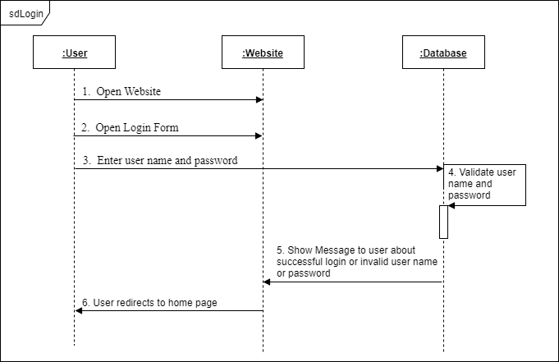

**Sequence Diagram for recruitment process:**

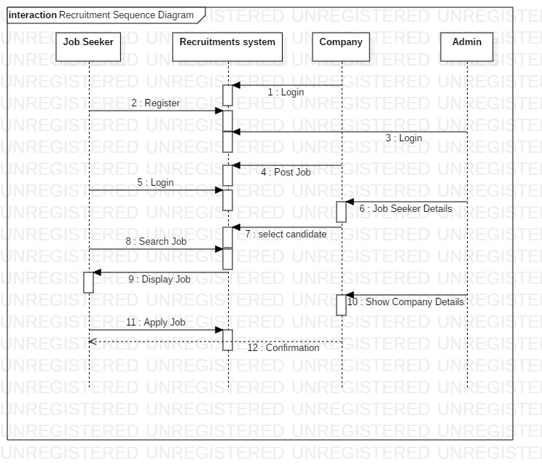

**Sequence Diagram for Employee management process:**

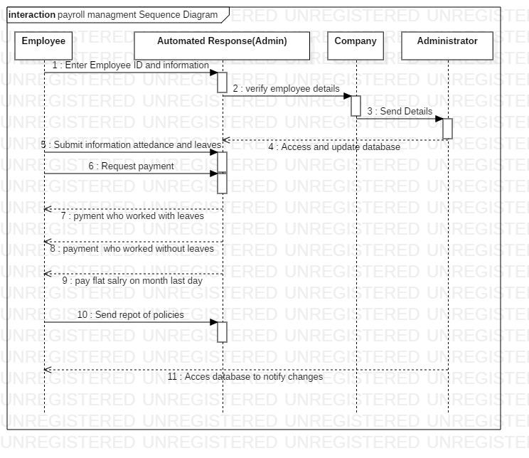

**Payroll:**

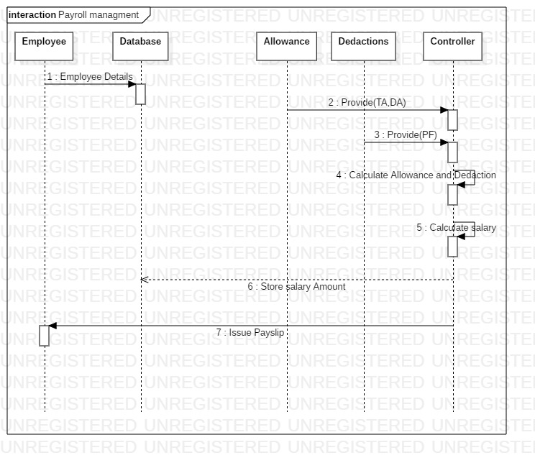

Activity Diagram:

**Login to the Recruitment management system**

Check user level and permissions

**CHECK PERMISSION**

**CHECK PERMISSION**

**CHECK PERMISSION**

**CHECK PERMISSION**

**CHECK PERMISSION**

**MANAGE AGENCY**

**MANAGE EMPLOYEE**

**MANAGE JOB**

**MANAGE CAMPUS**

**MANAGE PLACEMENT**

**LOG OUT FROM THE SYSTEM**

**START**

**START**

**END**

Activity Diagram:

Login to the Payroll management system

Check user level and permissions

**CHECK PERMISSION**

**CHECK PERMISSION**

**CHECK PERMISSION**

**CHECK PERMISSION**

**CHECK PERMISSION**

**MANAGE PAYROLL**

**MANAGE EMPLOYEE**

**MANAGE SALARY**

**MANAGE APPRISAL**

**MANAGE WORKING POINT**

**LOG OUT FROM THE SYSTEM**

**START**

**START**

**END**