Assignment 4

Dart Assignment 1 :

Data Types

1. Tye this code and write the explanation in your own words.

void main () {

Int sh1 = 19;

Int sh2 = 11;

Int sh3 = sh3 + sh2;

print(sh3);

}

Explanation:

1. Tye this code and write the explanation in your own words.

void main () {

Int sh1 = 19;

double sh2 = 11;

var sh3 = sh3 + sh2;

print(sh3);

}

Explanation:

1. Tye this code and write the explanation in your own words.

void main () {

Int sh1 = 19;

double sh2 = 11;

Int sh3 = sh3 + sh2;

print(sh3);

}

Explanation:

1. Tye this code and write the explanation in your own words.

void main () {

String str;

Int x = 10;

Double x=20;

Str=”${x+y}”;

print(str);

}

Explanation:

1. Tye this code and write the explanation in your own words.

void main () {

bool valueFirst = 1;

bool valueSecond = 0;

print(valueFirst);

print(valueSecond);

}

Explanation:

Input-Output:

1]

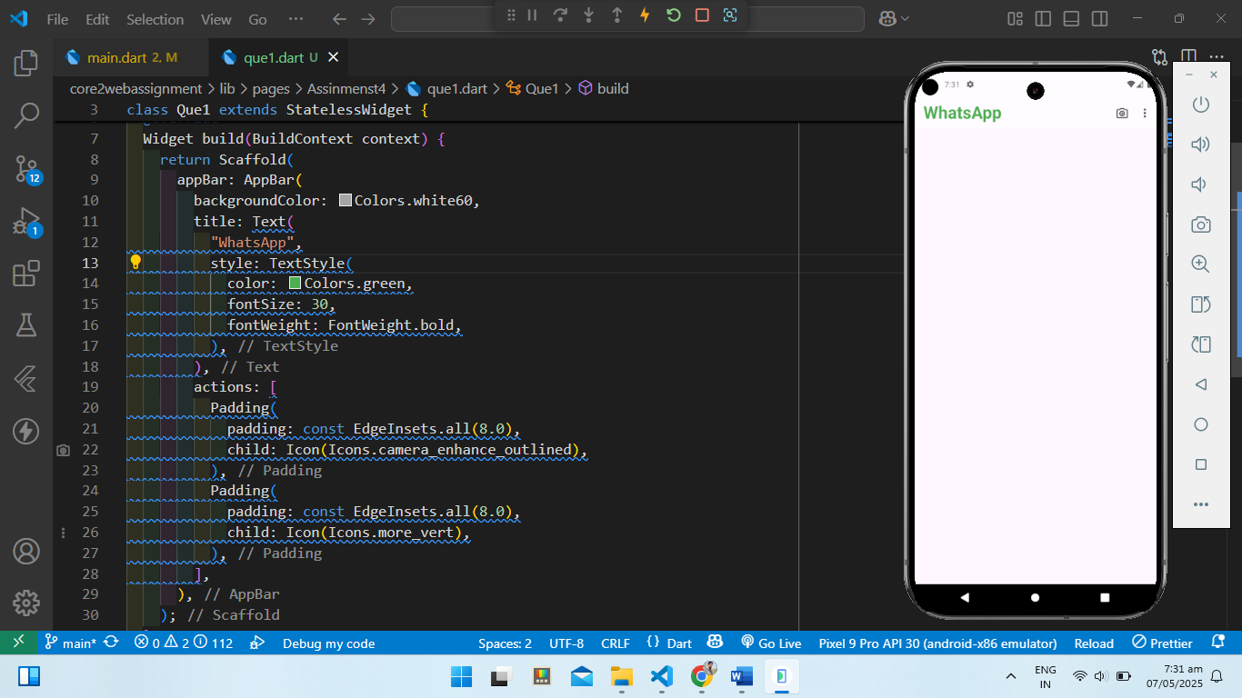

2]

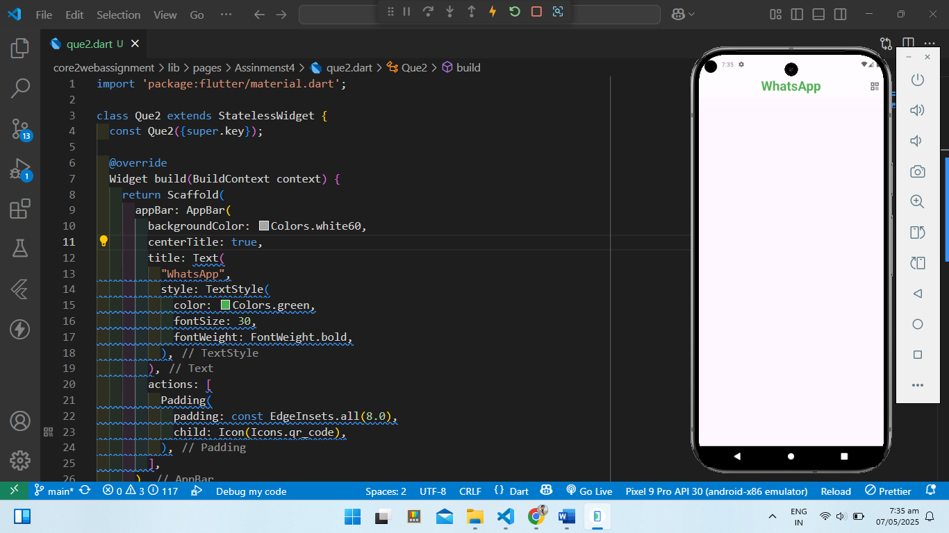

3]

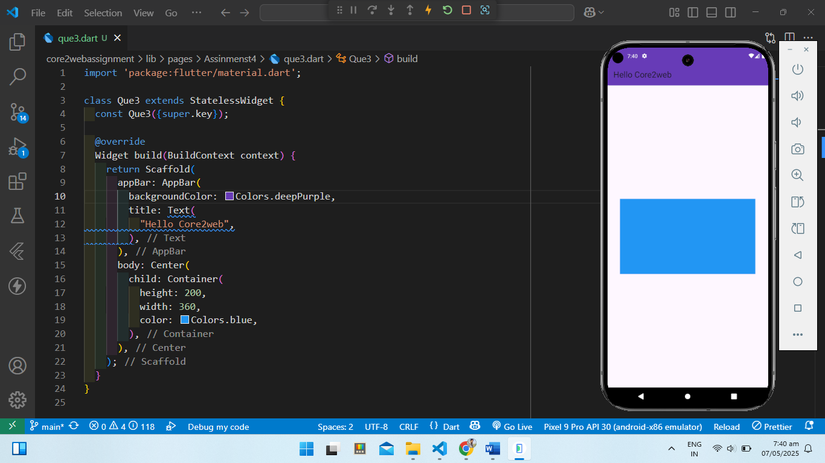

4]

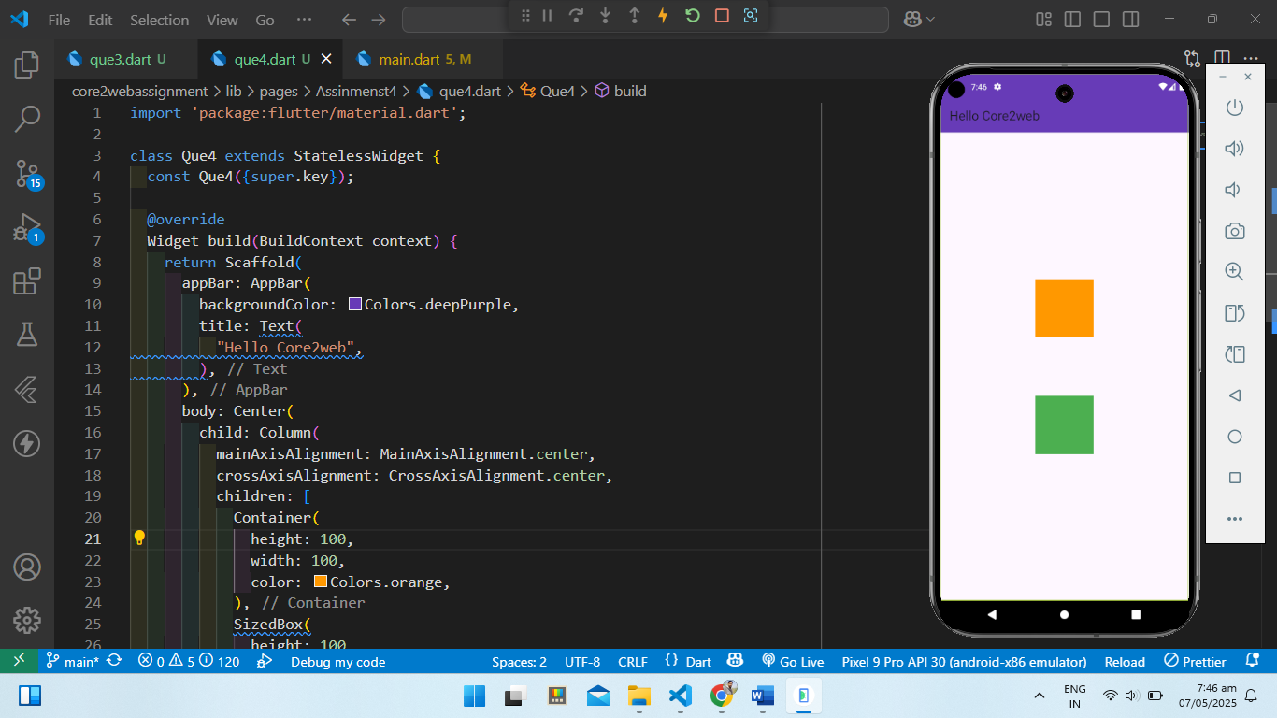

5]

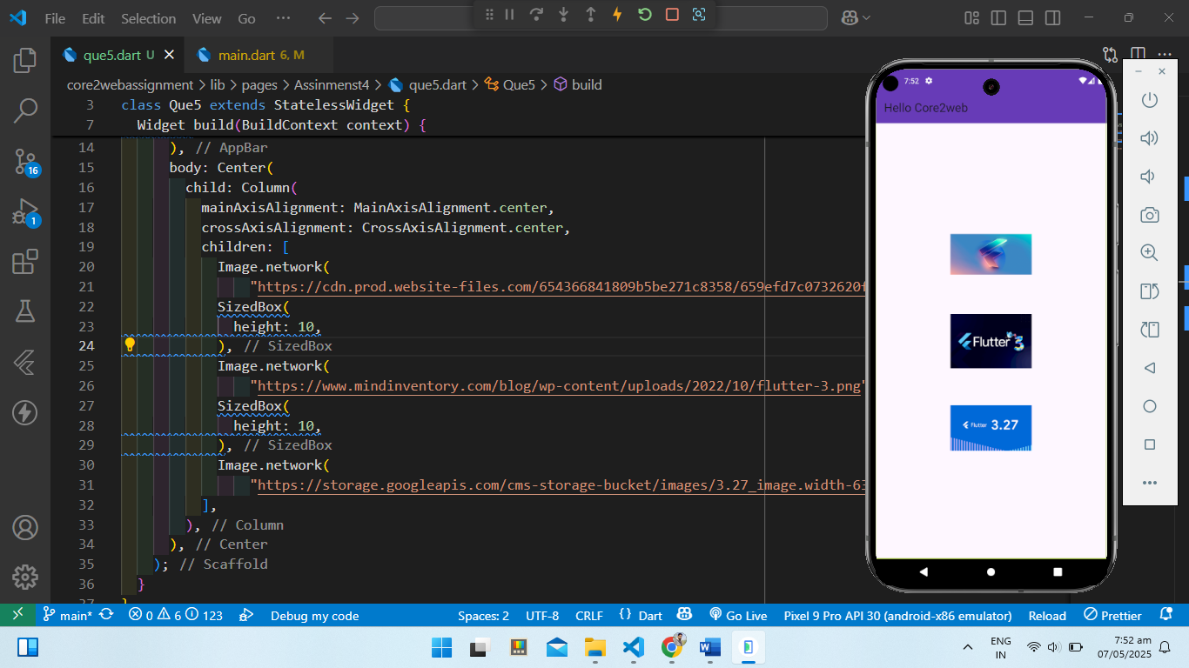

6]

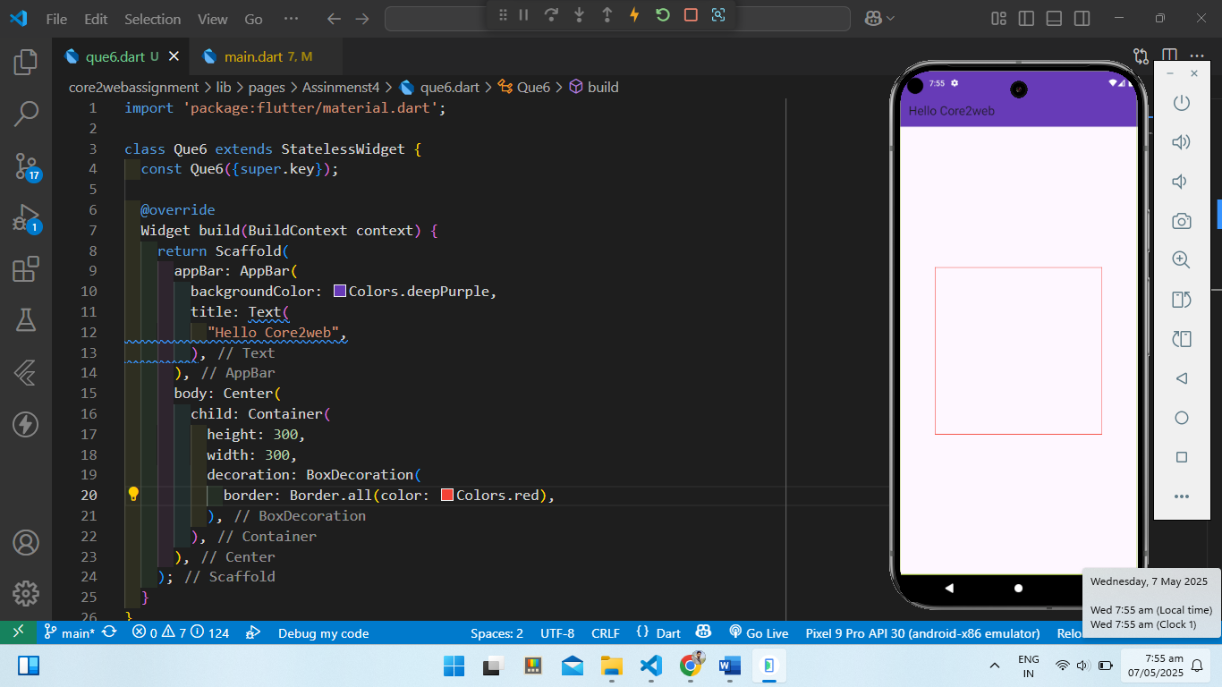

7]

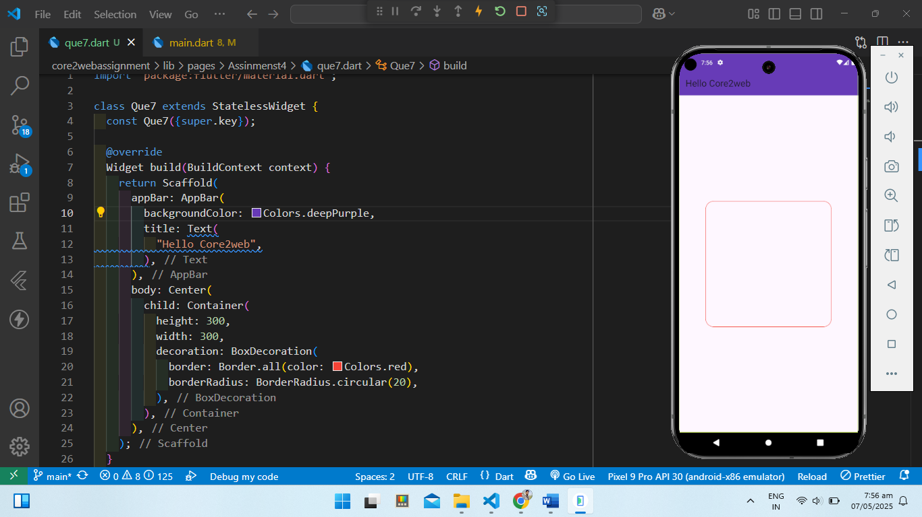

8]

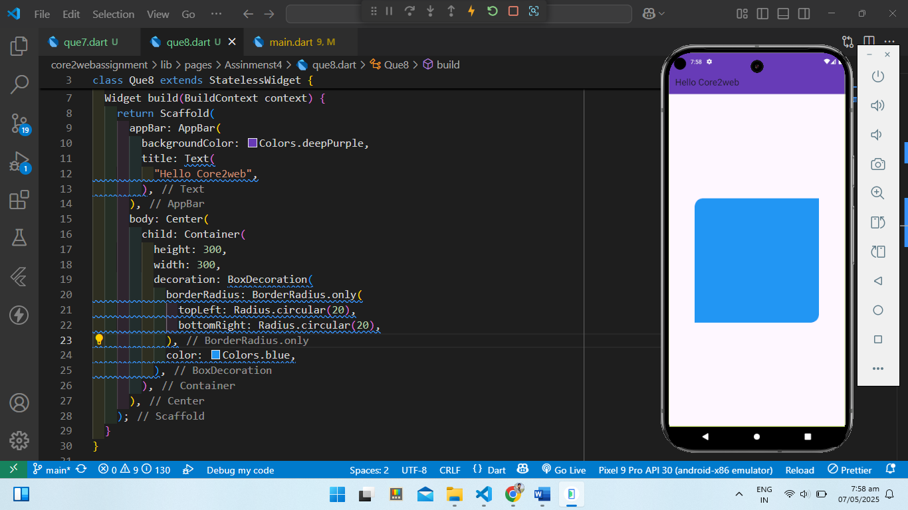

9]

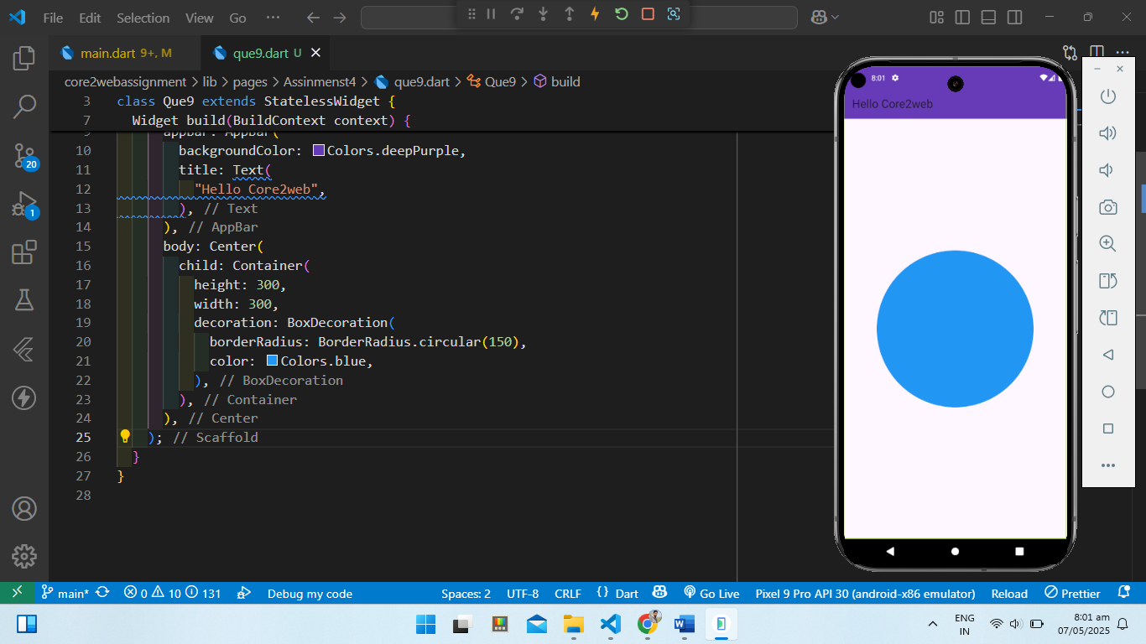

10]

