1) Introduction

The National thermal power corporation Auraiya Gas Power Plant is one of the important gas-based power stations operated by NTPC Limited, India’s largest power utility. Located at Dibiyapur in Auraiya district, Uttar Pradesh, the plant plays a key role in meeting the power demands of the northern region. Commissioned between 1988 and 1990, it operates on natural gas supplied mainly through the HBJ pipeline and uses water from the Auraiya–Etawah canal system.
The station has an installed capacity of around 652 MW, consisting of four Gas Turbine (GT) units and two Steam Turbine (ST) units working in a combined-cycle configuration. In this system, exhaust heat from gas turbines is utilized to generate steam for the steam turbines, significantly increasing overall efficiency and reducing environmental impact compared to conventional coal-based plants.
NTPC Auraiya is also known for its operational reliability, cleaner fuel usage, and contribution to grid stability. In recent years, NTPC has undertaken modernization and sustainability initiatives at the plant, including renewable energy additions and the exploration of hydrogen-based clean-fuel technologies.

2) Overview of NTPC Auraiya
Location:
The NTPC Auraiya Gas Power Plant is located at Dibiyapur, in the Auraiya district of Uttar Pradesh, India. The plant receives natural gas through the GAIL HBJ (Hazira–Bijaipur–Jagdishpur) pipeline, and water for cooling is sourced from the Auraiya–Etawah Canal. Its strategic location ensures smooth access to fuel supply and water resources required for operation.

Capacity:
The power plant has an installed capacity of about 652 MW. This capacity is achieved through a combination of four 110 MW gas turbines and two 106 MW steam turbines. All units were commissioned between 1989 and 1990, making it one of NTPC’s earlier gas-based stations.

Base of power generation:
Power generation at NTPC Auraiya is based on Combined Cycle Gas Turbine (CCGT) technology. In this system, natural gas is used as the primary fuel to run the gas turbines, which generate electricity. The hot exhaust gases from the gas turbines are then used in Waste Heat Recovery Boilers to produce steam. This steam drives the steam turbines, generating additional power without any extra fuel consumption. Naphtha is used as a backup fuel. This combined-cycle process increases efficiency and reduces emissions, making the plant cleaner and more efficient than coal-based power plants. Despite its age, the NTPC Auraiya plant remains an important source of electricity for several northern Indian states and continues to support India’s shift toward cleaner energy.

3) Section of power plant

Gas turbine plant:
The Gas Turbine Plant is the heart of the NTPC Auraiya power station and serves as the primary stage of electricity generation. It operates by burning natural gas, which is supplied through the GAIL HBJ pipeline at high pressure. When this natural gas is injected into the combustion chamber and ignited, it produces an extremely high-temperature and high-velocity gas stream. This expanding gas rotates the turbine blades connected to a shaft. The mechanical energy of this rotating shaft is converted into electrical energy by the generator. Gas turbines at Auraiya are specifically designed for high efficiency and rapid startup, making them suitable for meeting sudden electricity demand. Each of the four gas turbines at the plant has a capacity of 110 MW. One of the key advantages of this system is its cleaner combustion compared to coal-fired boilers, leading to significantly lower emissions of carbon dioxide, sulfur oxides, and particulate matter
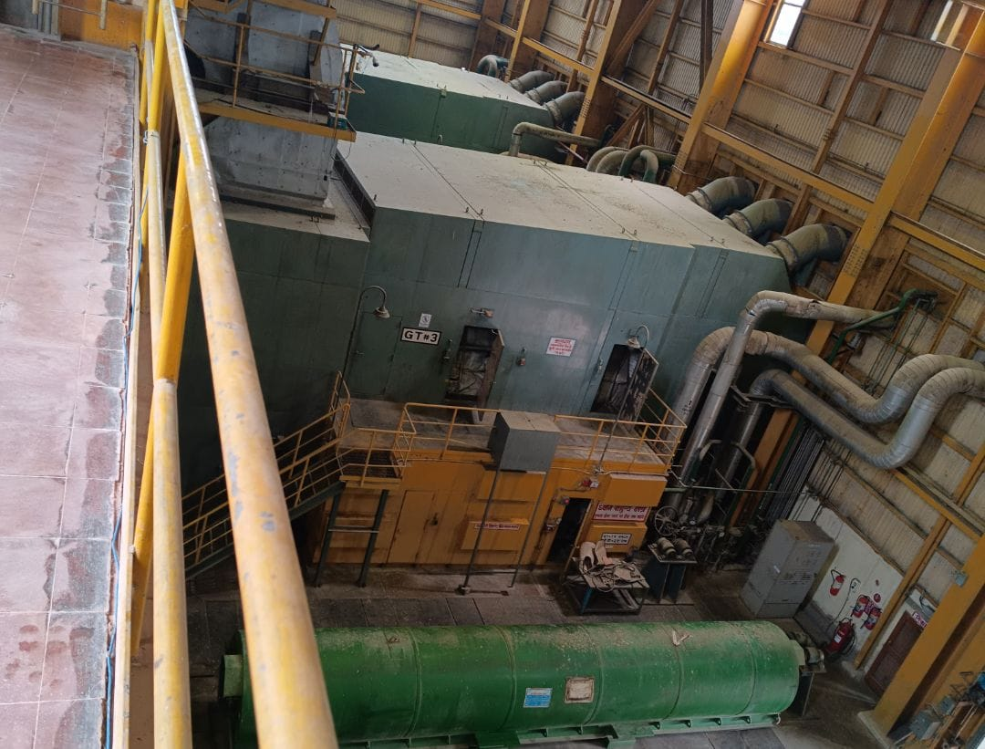.

(fig. Gas turbine)
Steam turbine plant:
The Steam Turbine Plant at NTPC Auraiya is the secondary power generation stage and plays a central role in enhancing the overall efficiency of the combined-cycle system. After the gas turbines complete their primary task of generating electricity, they release extremely hot exhaust gases. Instead of wasting this heat, the plant uses it to generate steam in the Waste Heat Recovery Boilers. The steam produced is then directed to the steam turbines, which are designed to extract maximum thermal energy from high-pressure steam. As the steam expands through the turbine blades, it spins the turbine shaft, which is connected to an electrical generator. This process produces additional power without any extra fuel consumption, making the system much more efficient than a simple cycle gas turbine. The two steam turbines in the plant each have a capacity of 106 MW. These steam turbines are equipped with advanced control systems that monitor temperature, pressure, vibration, and load conditions to ensure stable and safe operations.

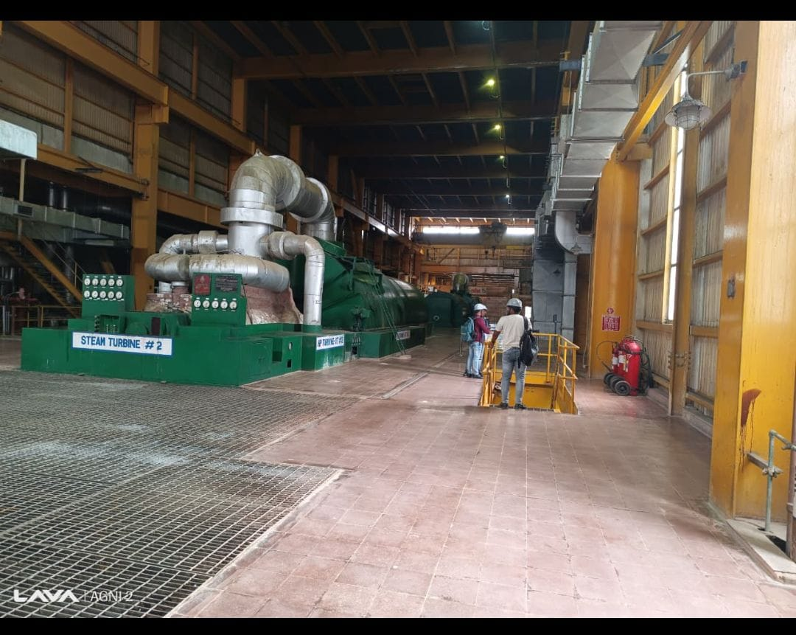
(fig. Steam turbine)
Waste heat recovery boiler:
The Waste Heat Recovery Boilers are one of the most important components of the NTPC Auraiya Gas Power Plant because they enable the use of a combined-cycle process, which greatly increases overall energy efficiency. When the gas turbines operate, they release exhaust gases with temperatures often exceeding 500°C. Instead of releasing this heat into the atmosphere, the WHRB captures this thermal energy and uses it to generate steam without burning any additional fuel. This makes the WHRB an environmentally friendly and economically efficient system. Inside the WHRB, the hot gases flow through specially designed heat exchanger tubes, where water is converted into steam. This steam is then supplied to the steam turbines to generate additional power. The design of the WHRB is complex, involving economizers, evaporators, superheaters, and reheaters, all arranged to ensure maximum heat absorption.

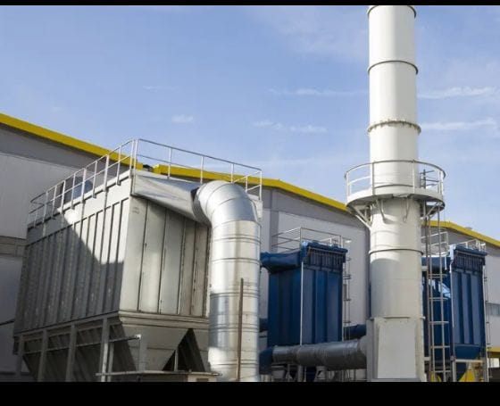
(fig. Waste heat recovery boiler)

4) Fire protection and safety system

The fire protection and safety system at NTPC Auraiya Gas Power Plant is designed to provide complete protection against fire hazards, equipment failures, and emergency situations that may occur in a combined-cycle gas power station. Since the plant handles large quantities of natural gas, high-pressure steam, lubricating oils, and electrical equipment, a multilayered fire protection system is essential. The plant uses an integrated fire safety network that includes automatic detection, rapid suppression, and continuous monitoring. In areas such as the gas turbine hall, steam turbine building, fuel gas pressure-reducing stations, cable tunnels, control rooms, transformers and switchyard, highly sensitive smoke and heat detectors are installed. These detectors instantly send signals to the central fire alarm panel in the main control room. For extinguishing fires, different types of systems are used depending on the nature of the equipment. Gas turbine enclosures are protected by CO₂ flooding systems that rapidly displace oxygen and stop combustion without damaging machinery. Transformers and oil-handling areas use high-velocity water spray systems to control oil fires. The control rooms and electronic equipment are protected by clean agent systems such as FM-200, which extinguish fire without harming sensitive electronics.

5) De-materialized water plant
The DM Water Plant at NTPC Auraiya Gas Power Plant plays an essential role in ensuring the reliability and efficiency of the combined-cycle operation. Since the plant uses high-pressure boilers and heat recovery steam generators (HRSGs) to produce steam, extremely pure water is required to prevent scaling, corrosion, and deposits inside tubes and turbine blades. Ordinary water contains dissolved salts, minerals, silica, and organic impurities which can cause severe damage when used in steam systems, so the DM plant removes almost all ionic impurities and produces water with conductivity close to zero. The process typically begins with raw water pre-treatment, where suspended particles, mud, and organic matter are removed through filtration and clarification. This pre-treated water then passes through ion-exchange units consisting of cation exchangers, anion exchangers, and mixed-bed polishers. In the cation exchanger, positively charged ions such as calcium, magnesium, sodium, and iron are replaced by hydrogen ions. The water then enters the anion exchanger where chloride, sulfate, nitrate, and silica ions are replaced by hydroxyl ions. These hydrogen and hydroxyl ions combine to form pure water. Mixed-bed polishers further improve purity to the level required by high-pressure boilers. Regeneration of resin beds is done using acids and alkalis to restore their capacity.

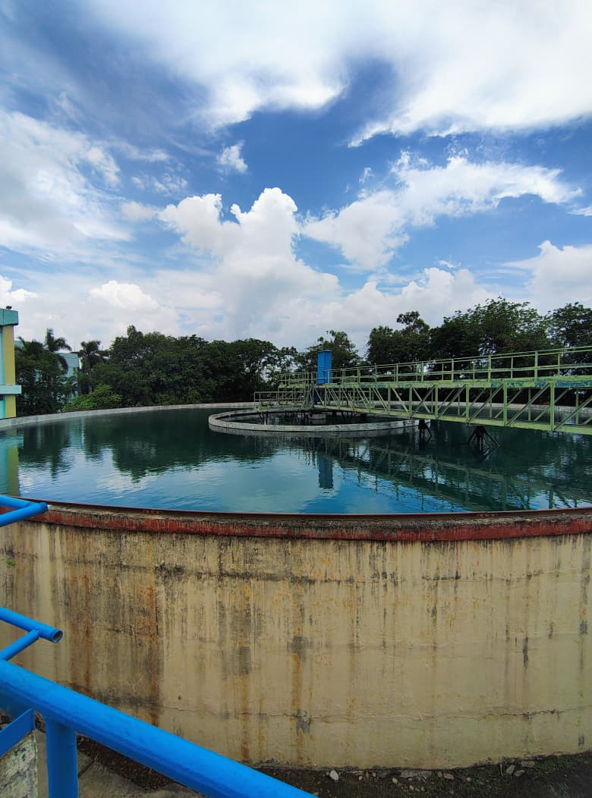

(fig. Clariflocculator
6) Cooling Tower

The NTPC Auraiya Gas Power Plant, located at Dibiyapur in Auraiya district of Uttar Pradesh, is a combined-cycle gas power station with an installed capacity of 652 MW. In this plant, the cooling tower plays a crucial role in maintaining the efficiency of the steam cycle. Since Auraiya operates on a combined-cycle configuration—where both gas turbines and steam turbines produce power—the cooling tower becomes an essential component for heat rejection and water recirculation.
After the gas turbines generate electricity, their hot exhaust gases are sent to the Heat Recovery Steam Generator (HRSG), which produces steam. This steam drives the steam turbine to generate additional power. Once steam has expanded in the steam turbine, it must be condensed back into water to complete the closed-loop cycle. The condenser, located after the steam turbine, uses cooling water to convert the exhaust steam into water. During this process, the cooling water absorbs a large amount of heat and becomes hot. This hot water cannot be reused directly; it must be cooled before returning to the condenser. This is where the cooling tower at NTPC Auraiya comes into action.
The cooling tower at Auraiya is typically an induced-draft or natural-draft cooling structure designed to reject heat by evaporative cooling. Hot water from the condenser is sprayed over PVC fills or splash bars inside the tower. As air is drawn upward by fans (or via natural draft), it evaporates a small fraction of the water, resulting in significant cooling. The cooled water at the bottom of the tower is collected in a basin and pumped back to the condenser, completing the cycle.

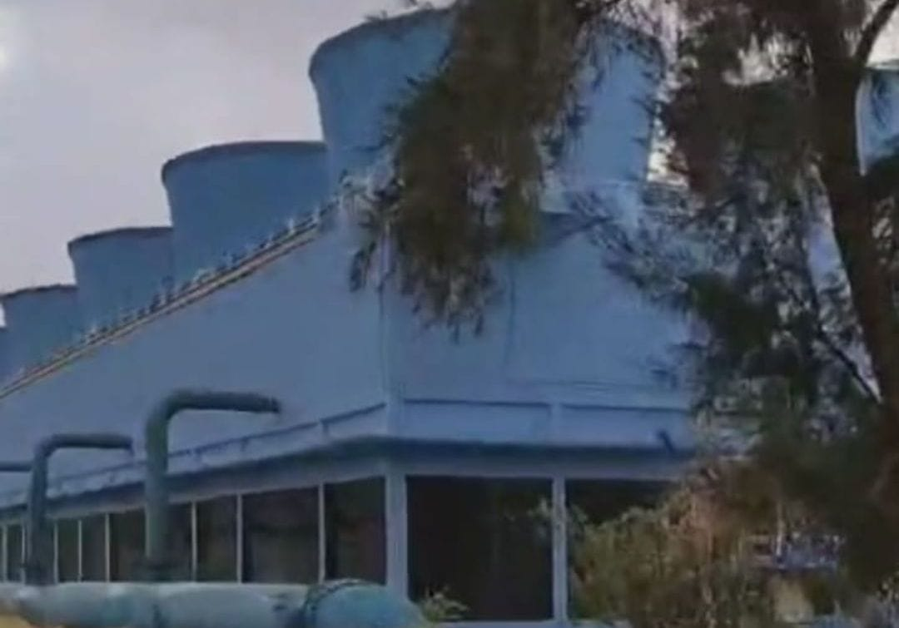

(fig. Cooling tower)

7) Circulating pump house

The circulating pump house in NTPC Auraiya Gas Power Plant is one of the most important facilities responsible for ensuring continuous water circulation between the cooling tower and the condenser. Its primary function is to supply large quantities of cooled water from the cooling tower basin to the surface condenser, where it absorbs heat from the exhaust steam coming out of the steam turbine. The pump house is usually constructed as a robust RCC structure designed to support heavy-duty pumps, electrical systems, valves, suction pipes, and discharge pipelines. Inside the pump house, multiple vertical or horizontal centrifugal pumps are installed, each capable of handling thousands of cubic meters of water per hour. These pumps operate with high efficiency to maintain a steady flow and prevent any interruption in condensation, which is crucial for stable turbine performance. The pump house is also equipped with strainers and trash racks at the suction side to stop debris, vegetation, or foreign particles from entering the pump and damaging the impeller. Sophisticated control panels, variable frequency drives (VFDs), and motor protection relays ensure safe and reliable operation. Regular monitoring of parameters such as discharge pressure, flow rate, bearing temperature, and vibration levels helps maintain performance and avoid unplanned outages. The entire circulating water circuit depends on the pump house to maintain the cooling cycle, as insufficient flow causes condenser backpressure to rise, reducing plant efficiency and affecting power generation. Proper ventilation, drainage, and firefighting arrangements are also part of the pump house design to ensure safety for equipment and personnel. Overall, the circulating pump house serves as the heart of the cooling water system, maintaining consistent thermal balance and supporting the continuous, efficient operation of NTPC Auraiya’s combined-cycle power generation process.

8) Naphtha tanks
The naphtha tanks at NTPC Auraiya Gas Power Plant serve as critical components of the plant’s fuel storage and supply system. While the primary fuel for the plant is natural gas, naphtha acts as a backup fuel, ensuring uninterrupted operation in case of disruption or shortage of natural gas supply. These tanks are specially designed to store large volumes of liquid hydrocarbon safely under controlled conditions. Constructed using high-strength carbon steel or alloy steel, the tanks are equipped with floating or fixed roofs, anti-vapor systems, and internal heating coils to maintain naphtha at optimal temperature and prevent vaporization. Safety is a primary concern because naphtha is highly flammable. Therefore, the tanks are installed with flame arrestors, pressure-relief valves, level indicators, and emergency shutdown systems to prevent accidents. The storage area is designed with adequate bund walls to contain any potential spillage and prevent environmental contamination. The tanks are connected to a fuel pumping system that supplies naphtha to the gas turbines via carefully controlled pipelines, which include automatic control valves, filtration systems, and monitoring sensors to maintain precise fuel flow and quality. Regular inspection and maintenance of tanks, valves, and pipelines are performed to avoid leakage, corrosion, or other mechanical failures.
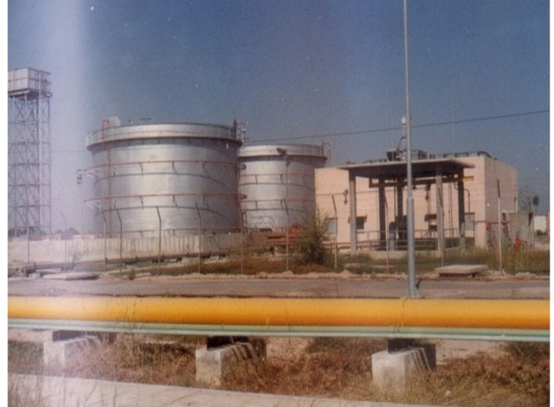
(Fig. Naphtha tanks)

9) Comparison between gas power plant and coal power plant

1. Fuel
- Gas Plant: Uses natural gas or naphtha; clean-burning.
- Coal Plant: Uses solid coal; high ash and sulfur content.

2. Plant Efficiency
- Gas Plant: Higher efficiency (50–60% in combined cycle).
- Coal Plant: Lower efficiency (32–38%).

3. Start-Up Time
- Gas Plant: Very fast startup; reaches full load in minutes.
- Coal Plant: Slow startup; takes hours due to boiler heating.

4. Space Requirement
- Gas Plant: Requires less land; no coal yard or ash pond.
- Coal Plant: Large land required for coal storage and ash disposal.

5. Pollution
- Gas Plant: Very low CO₂, NOₓ, SO₂, particulate emissions; no ash.
- Coal Plant: High emissions; needs ESP, FGD, ash handling systems.

6. Water Requirement
- Gas Plant: Low water consumption.
- Coal Plant: Very high water usage for boilers and cooling systems.

7. Fuel Handling
- Gas Plant: Simple pipeline supply; no manual handling.
- Coal Plant: Coal handling system needed (conveyors, crushers, mills).

8. Maintenance
- Gas Plant: Low maintenance; clean operation.
- Coal Plant: High maintenance due to ash, erosion, and mechanical systems.

9. Startup Reliability
- Gas Plant: Ideal for peak load and grid balancing.
- Coal Plant: Best for base load; slow response time.

10. Environmental Impact
- Gas Plant: Environmentally friendly with minimal waste.
- Coal Plant: Generates large quantities of ash and high greenhouse gas emissions.

10) Conclusion

The NTPC Auraiya Gas Power Plant represents a modern and efficient approach to power generation, combining advanced gas turbine technology with a highly effective combined-cycle operation. Its use of natural gas as the primary fuel ensures cleaner combustion, reduced emissions, and minimal environmental impact compared to conventional coal-based power plants. The plant incorporates well-designed systems such as the HRSG, cooling tower, DM water plant, circulating pump house, naphtha storage, and sophisticated fire protection networks, all of which contribute to reliable and continuous power generation. The comparison between gas- and coal-based plants clearly shows that gas plants offer higher efficiency, faster start-up, lower maintenance, and significantly lower pollution. Overall, NTPC Auraiya serves as an excellent example of sustainable and efficient power generation, supporting national energy requirements while balancing performance, safety, and environmental responsibility.

