- Hardware Components & System Assembly

SECTION A — CONCEPT APPLICATION

A1. Selecting Compatible Motherboard, CPU, RAM and Storage
Question: Explain the process of selecting a compatible motherboard, CPU, RAM, and storage device for a new office workstation, and justify how you would confirm they will work together?
Answer:
When selecting components for a new office workstation, I would check the compatibility of every component before purchasing them.
- Motherboard: I would first select a motherboard with the required features, ports, RAM slots, storage connectors and expansion slots.
- CPU: I would make sure the CPU uses the same socket supported by the motherboard. I would also check that the motherboard chipset and BIOS support the selected CPU.
- RAM: I would check the RAM type supported by the motherboard, such as DDR4 or DDR5. I would also check the maximum RAM capacity and supported speed.
- Storage: I would select an SSD or NVMe drive and confirm that the motherboard has the correct SATA or M.2 connector.
- Compatibility check: I would check the motherboard manufacturer's specifications and CPU/RAM compatibility list before assembling the computer.
This ensures that all components can communicate correctly and that the computer can boot and operate normally.

A2. HDD vs SSD vs NVMe

Question: Explain the differences between HDD, SSD, and NVMe storage, and recommend the most suitable option for office/productivity work?
Answer
- HDD:
A Hard Disk Drive stores data on rotating magnetic disks. It provides large storage capacity at a low price, but it is slower and contains moving parts.
- SSD:
A Solid-State Drive uses flash memory and has no moving parts. It is faster, quieter and more reliable than an HDD. SATA SSDs normally connect using a SATA interface.
- NVMe SSD:
An NVMe SSD also uses flash memory but normally connects through an M.2 slot using PCIe. It provides much faster data transfer speeds than a SATA SSD or HDD.
Recommendation
For office and productivity applications, I would recommend an SSD.
It provides:
- Faster Windows startup
- Faster application loading
- Better responsiveness
- Lower power consumption
- Less noise
- Better resistance to physical shock
An NVMe SSD can provide even higher performance, but a normal SATA SSD is also sufficient for many office computers.

A3. GPU and Cooling System

Question: Explain the role of the GPU and the cooling system in maintaining performance and stability under this kind of sustained load?
Answer
- The GPU (Graphics Processing Unit) processes graphical information such as images, videos, 3D models and design applications.
- A dedicated GPU can improve the performance of graphics-intensive software because it has its own processing cores and video memory.
- When the GPU and CPU operate for several hours, they produce heat. The cooling system removes this heat using:
- CPU cooler
- GPU fans
- Case fans
- Heat sinks
- Thermal paste
Good cooling keeps the components at safe temperatures.
If cooling is poor, the CPU or GPU may become too hot and reduce its performance through thermal throttling. Extreme overheating may cause system crashes or shutdowns.
Therefore, both the GPU and cooling system are important for maintaining good performance and system stability.

A4. Hardware Compatibility

Question: Explain why hardware compatibility matters when assembling a computer, and identify potential issues that could arise from incompatible components?
Answer
Hardware compatibility is important because all computer components must work together correctly.
Before assembling a PC, I would check:
- CPU socket compatibility
- Motherboard chipset support
- RAM generation such as DDR4/DDR5
- RAM speed and capacity
- GPU PCIe compatibility
- Storage interface
- PSU wattage and connectors
- Case size and motherboard form factor
Incompatible components may cause problems such as:
- PC not starting
- Failure to pass POST
- CPU not being detected
- RAM not being recognized
- Storage not appearing
- GPU not displaying output
- System instability
- Incorrect or missing power connections
Checking specifications before installation prevents these problems.

A5. Selecting and Connecting a PSU

Question: Explain how you would choose an appropriately rated PSU for this build and describe the safety and connection checks you would carry out before powering it on?
Answer
I would first calculate the approximate power requirement of the CPU, GPU, motherboard, storage devices and other components.
I would select a PSU that provides enough wattage with some additional capacity for stability and future upgrades.
For example, if the system requires approximately 400 W, I may select a good-quality 550 W or 650 W PSU, depending on the hardware.
Before powering on the computer, I would check:
- PSU is switched off while connecting components.
- 24-pin motherboard power cable is connected correctly.
- CPU 4-pin/8-pin power cable is connected.
- GPU PCIe power connector is connected if required.
- SATA power cables are connected to SATA storage devices.
- All connectors are fully inserted.
- No loose screws are inside the case.
- Cables are not blocking cooling fans.
- PSU voltage/settings are correct where applicable.
- Components are properly seated.
After completing these checks, I would connect the system to power and perform the first boot.

A6. POST Check

Question: Explain the checks you would perform to confirm the system passes POST successfully, and what you would do if it did not?
Answer
POST stands for Power-On Self-Test.
When the PC starts, I would check that:
- Fans start spinning.
- Power LEDs turn on.
- A display appears on the monitor.
- Manufacturer/BIOS logo appears.
- BIOS can be opened.
- CPU is detected.
- Correct RAM capacity is detected.
- Storage devices are detected.
- No POST error message appears.
- No unusual motherboard beep codes or diagnostic LEDs appear.
If POST fails
I would:
- Turn off and unplug the PC.
- Check motherboard and CPU power connections.
- Reseat the RAM.
- Check the GPU and monitor connection.
- Check CPU installation.
- Disconnect unnecessary devices.
- Check diagnostic LEDs or beep codes.
- Clear CMOS if appropriate.
- Try booting with minimum hardware.
- Replace/test suspected components if necessary.

Section B — Practical Coding Tasks

B1. Component Identification & Functions

Question: You need to identify the motherboard, CPU, RAM, GPU, storage and cooling system and record their make/model or key specification where visible.

Answer
Component | Function | Model/Specification
- Motherboard | Connects and allows communication between all computer components. | ASUS ROG Strix X870E-E Gaming WiFi
- CPU | Processes instructions and performs calculations for the computer. | AMD Ryzen 9 9950X
- RAM | Temporarily stores data currently being used by the CPU. | 64 GB DDR5-6000
- GPU | Processes graphics, images and video output. | NVDIA GeForce RTX 5080 16 GB GDDR7
- Storage | Permanently stores Windows, programs and user files. | Samsung 990 PRO 2 TB NVMe M.2 SSD
- Cooling System | Removes heat from the CPU and other components to prevent overheating. | 360 mm AIO Liquid Cooler

B2. Motherboard Ports & Socket Identification

Question: Motherboard: ASUS ROG Strix X870E-E Gaming WiFi

Answer
SATA Port | Connects SATA HDDs and SSDs.
- 24-pin ATX Connector | Supplies main power to the motherboard.
- CPU Power Connector | Supplies power to the CPU.
- USB Headers | Connect front-panel USB ports.
- PCIe x16 Slot | Used to install the graphics card.
- M.2 Slot | Used to install NVMe SSDs.
- Fan Headers | Connect CPU and case cooling fans.

CPU Socket: AM5
Compatible CPU Family: AMD Ryzen processors supported by the X870E/AM5 platform, including Ryzen 9000 series.
The selected motherboard has DDR5 support, PCIe 5.0 connectivity and multiple M.2 slots.
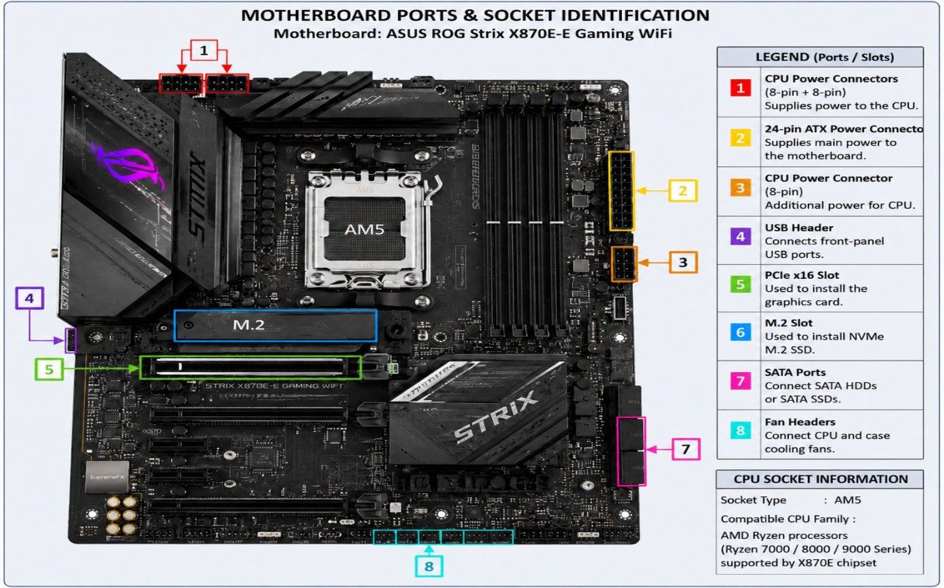

B3. RAM & Storage Installation

Simulation Used: High-end desktop workstation
RAM: 64 GB DDR5-6000
Storage: Samsung 990 PRO 2 TB NVMe M.2 SSD
Connection Type: NVMe/M.2
Procedure
- I simulated shutting down the PC and disconnecting the power supply.
- I followed ESD precautions before handling the components.
- I simulated removing one RAM module by opening the DIMM locking clips.
- I aligned the RAM notch correctly and reinstalled the module firmly.
- I simulated removing the Samsung 990 PRO NVMe SSD from the M.2 slot.
- I reinstalled the NVMe SSD correctly and secured it.
- I simulated powering on the computer and checking BIOS/UEFI.
- BIOS confirmed 64 GB RAM and the 2 TB NVMe SSD were detected.

B4. Full Desktop PC Assembly

Simulated System Configuration:
- ASUS ROG Strix X870E-E Gaming WiFi motherboard
- AMD Ryzen 9 9950X CPU
- 64 GB DDR5-6000 RAM
- NVIDIA GeForce RTX 5080 16 GB GPU
- Samsung 990 PRO 2 TB NVMe SSD
- 360 mm AIO Liquid Cooler
- 1000 W 80+ Gold PSU
Assembly Procedure
- I followed ESD and safety precautions.
- I installed the AMD Ryzen 9 9950X CPU into the AM5 socket.
- I installed the 360 mm AIO CPU cooler.
- I installed 64 GB DDR5 RAM into the motherboard.
- I installed the Samsung 990 PRO NVMe SSD into an M.2 slot.
- I installed the motherboard into the PC case.
- I installed the RTX 5080 into the PCIe x16 slot.
- I installed the 1000 W PSU.
- I connected the motherboard, CPU, GPU and required power cables.
- I checked that all components and cables were properly connected.
- I simulated powering on the computer.
- The system successfully passed POST and BIOS detected the CPU, RAM and storage.
POST Result: Successful

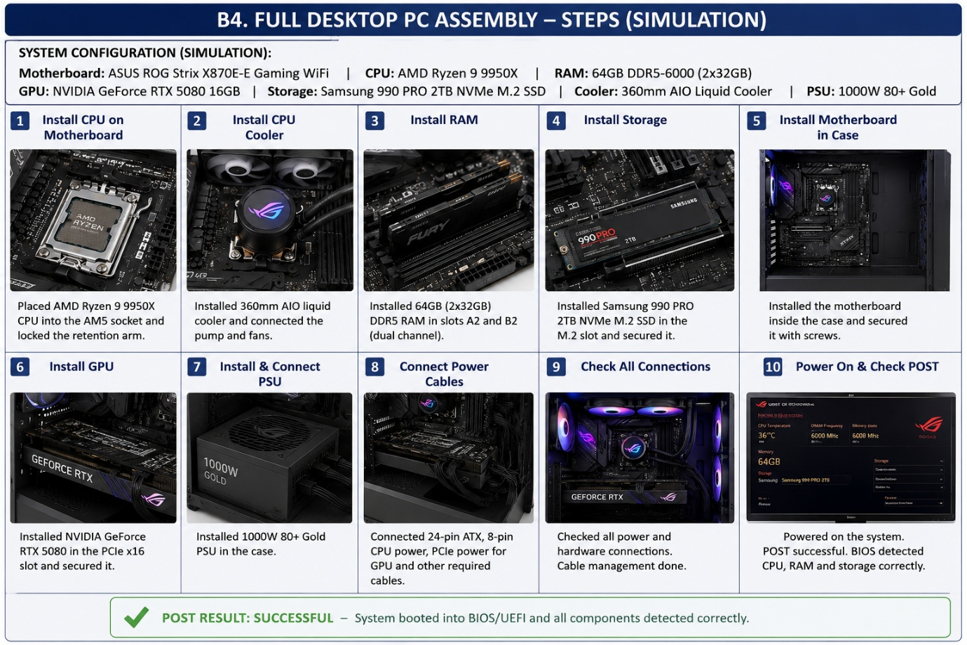

Section C — Mini Capstone Project

Mini Project: Workstation Deployment & Boot-Failure Diagnosis

C1. Three Hardware Components to Check First
If a newly assembled PC fails to boot, I would check these three components first:
1. PSU
I would check that the PSU is switched on and the 24-pin motherboard power cable and CPU power cable are connected properly. Without correct power, the PC may not start.
2. RAM
I would check that the RAM is installed in the correct slot and is fully seated. Loose or incorrectly installed RAM can cause no display or POST failure.
3. Motherboard
I would check that the CPU is installed correctly, the CPU socket is compatible with the motherboard, and the CPU power cable is connected properly. An installation or compatibility problem can prevent the system from booting.

C2. Motherboard–CPU Compatibility

Simulated System:
- Motherboard: ASUS ROG Strix X870E-E Gaming WiFi
- CPU: AMD Ryzen 9 9950X
- CPU Socket: AM5
Motherboard and CPU compatibility is important because the CPU must match the motherboard socket and supported chipset.
In this simulated system, the AMD Ryzen 9 9950X uses the AM5 socket, and the ASUS ROG Strix X870E-E motherboard also uses the AM5 socket.
I would also check the motherboard CPU support list and BIOS support before installation.
If the CPU is not compatible with the motherboard, the PC may fail to boot or fail POST.

C3. Verify RAM and Storage Installation

RAM: 64 GB DDR5-6000
Storage: Samsung 990 PRO 2 TB NVMe M.2 SSD
To verify the RAM and storage are installed correctly, I would:
- Check that the RAM is fully inserted in the DIMM slot and the locking clips are closed.
- Check that the NVMe SSD is properly inserted into the M.2 slot and secured.
- Power on the system and enter BIOS/UEFI.
- Confirm that BIOS shows the correct 64 GB RAM.
- Confirm that the 2 TB NVMe SSD is detected.
- Check that there are no POST errors related to memory or storage.
If either component is not detected, I would power off the PC and reseat that component.

C4. Hardware Installation Checklist

- Check that the motherboard, CPU, RAM, and other components are compatible before installation.
- Follow ESD precautions and disconnect the power before handling components.
- Install the CPU, RAM, storage, and GPU correctly and make sure they are properly seated.
- Connect the 24-pin motherboard power, CPU power, GPU power, and storage cables correctly.
- Power on the PC and check that it passes POST and that the components are detected in BIOS/UEFI.

C5. Why SSD Should Be Used Instead of HDD

For the ABC Solutions computer lab, I would use SSDs instead of HDDs because SSDs are faster and more suitable for modern office workstations.
- SSDs provide faster system startup.
- Applications open faster.
- File access is quicker.
- SSDs have no moving parts, so they are quieter and more reliable.
- They use less power than HDDs.
- They improve the overall speed and responsiveness of office computers.
Therefore, SSDs are a better choice for the ABC Solutions lab because employees can work faster and the systems will feel more responsive.

Section D — AI-Augmented Learning

D1. Exact Prompt Given to AI

Create a simple step-by-step troubleshooting checklist for a junior technician to diagnose a desktop PC that fails to boot immediately after assembly. Put the steps in the correct priority order. Include checks for the motherboard, RAM, storage, and PSU. Apply the checklist to the ABC Solutions scenario and explain which step could identify the reported problem.

D2. AI’s Original Troubleshooting Checklist

1. Check the PSU: Make sure the PSU switch is ON and the power cable is connected properly.
2. Check motherboard power: Check the 24-pin motherboard power cable and CPU power cable.
3. Check RAM: Remove and reinstall the RAM and make sure it is fully seated.
4. Check the motherboard: Look for loose connections, damage, or diagnostic LEDs.
5. Check storage: Make sure the NVMe SSD or SATA drive is connected and installed correctly.
6. Check the GPU/display: Make sure the GPU and monitor cable are connected properly.
7. Check POST/BIOS: Power on the PC and check for POST errors or beep codes.
8. Check BIOS/UEFI: Confirm that the RAM and storage devices are detected.
XYZ Solutions Scenario:
For XYZ Solutions, the RAM, PSU, motherboard, and storage checks could identify systems that fail to boot because of loose connections or incorrectly installed hardware.

D3. Corrected Troubleshooting Checklist

1. Follow safety and ESD precautions: Switch off the PSU, disconnect the power cable, and discharge static electricity before touching internal components.
2. Check the PSU: Make sure the PSU switch and power cable are connected correctly.
3. Check motherboard power: Check the 24-pin motherboard power cable and CPU power cable.
4. Check RAM: Remove and reinstall the RAM and make sure it is fully seated.
5. Check the motherboard: Look for loose connections, damage, or diagnostic LEDs.
6. Check storage: Make sure the NVMe SSD or SATA drive is installed correctly.
7. Check GPU/display: Make sure the GPU and monitor cable are connected properly.
8. Power on and check POST: Look for POST errors, beep codes, or diagnostic LEDs.
9. Check BIOS/UEFI: Confirm that the RAM and storage devices are detected correctly.
Correction Made:
I added the safety and ESD precaution as the first step before touching any internal hardware.

D4. 3-4 Line Note

I added safety and ESD precautions as the first step because they were missing from the original AI checklist. The power should be disconnected before touching internal components. This reduces the risk of electric shock and prevents static electricity from damaging hardware. The corrected version is safer and follows a better troubleshooting order.

