- TCP/IP Suite Theory

Q1. Open Wireshark, capture network traffic while you refresh the Flipkart homepage, and identify one packet each belonging to the Application, Transport, Internet, and Network Access layers by examining their headers?

Answer

- Identifying TCP/IP Layers in Wireshark
I captured network traffic in Wireshark while refreshing the Flipkart homepage. I selected a TLSv1.3 packet and examined its headers.
TCP/IP Layer | Protocol/Header | Purpose
- Application Layer | TLSv1.3 | Encrypts and protects web application data.
- Transport Layer | TCP | Provides reliable communication using ports, sequence numbers, and acknowledgements.
- Internet Layer | IPv4 | Provides IP addressing and routes packets between networks.
- Network Access Layer | Ethernet II | Handles local network communication using MAC addresses.

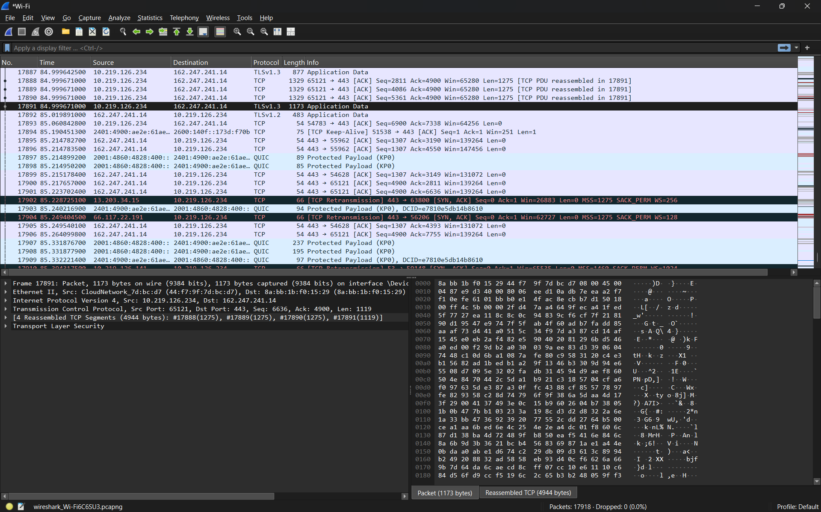
- Result:
The selected packet showed headers from all four TCP/IP layers: TLSv1.3, TCP, IPv4, and Ethernet II.

Q2. Create a table comparing the OSI and TCP/IP models, listing all layers side-by-side, and for each layer, give a real-world example from any app you use (e.g., WhatsApp message, Zomato order)?

Answer

- Comparison of OSI and TCP/IP Models

OSI Model Layer | TCP/IP Equivalent | Real-World Example
- Layer 7 – Application | Application | WhatsApp – Sending and receiving messages
- Layer 6 – Presentation | Application | Instagram – Images and videos are formatted, compressed, and encrypted
- Layer 5 – Session | Application | Zoom/WhatsApp Call – Maintains an active communication session
- Layer 4 – Transport | Transport | Spotify / WhatsApp – TCP or UDP carries data between devices
- Layer 3 – Network | Internet | Zomato – IP addresses help route data between the app and server
- Layer 2 – Data Link | Network Access | Wi-Fi connection – Frames and MAC addresses are used on the local network
- Layer 1 – Physical | Network Access | Wi-Fi radio signals / Ethernet cable – Carries the actual bits between devices

- Explanation:
The OSI model has 7 layers, while the TCP/IP model has 4 layers. The TCP/IP Application layer combines the OSI Application, Presentation, and Session layers, while the Network Access layer combines the OSI Data Link and Physical layers.

Q3. Given a screenshot of a TCP segment header (provided by your trainer), label the fields that belong to the Transport layer and explain what each field does in 1-2 lines.<br><br><em><strong>Hint:</strong> Look for fields like Source Port, Destination Port, Sequence Number, etc.</em>?

Answer

- TCP Segment Header Fields
In a TCP segment header, the following fields mainly belong to the Transport Layer:

TCP Header Field | Function
- Source Port | Identifies the application or service sending the data.
- Destination Port | Identifies the application or service that should receive the data.
- Sequence Number | Shows the order of data bytes so packets can be reassembled correctly.
- Acknowledgment Number | Confirms which data has been received successfully.
- Header Length | Specifies the size of the TCP header.
- Flags | Controls the TCP connection. Examples include SYN, ACK, FIN, and RST.
- Window Size | Tells the sender how much data the receiver can accept at one time.
- Checksum | Checks whether the TCP segment was damaged during transmission.
- Urgent Pointer | Indicates urgent data when the URG flag is used.
- Options | Contains additional TCP settings such as maximum segment size.

- Explanation:

These fields are part of the Transport Layer because TCP is responsible for reliable end-to-end communication between applications. Source and destination ports identify the applications, while sequence and acknowledgment numbers help ensure that data arrives correctly and in the proper order.

Q4. Draw a diagram showing how a message sent from your device to Instagram's server passes through each TCP/IP layer, and annotate what happens at each step using simple app-related terms (e.g., 'message split into packets', 'IP address added', etc.)?

Answer

- Message Flow Through the TCP/IP Model

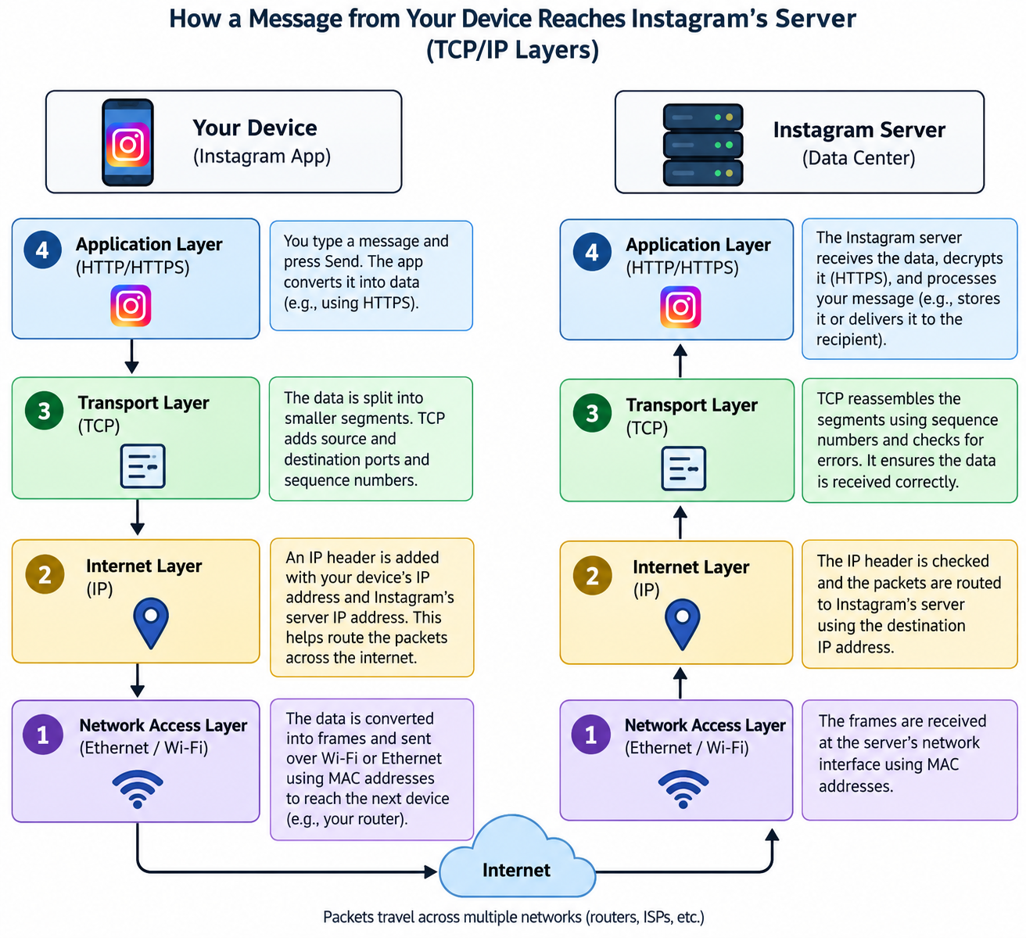
- Explanation:
The diagram shows how a message sent from my device to Instagram’s server passes through all four TCP/IP layers. At the Application layer, the message is created in the Instagram app. At the Transport layer, the data is divided into smaller segments. At the Internet layer, IP addresses are added so the data can be routed across networks. At the Network Access layer, the data is converted into frames and sent through Wi-Fi or Ethernet. At the server side, the process happens in reverse so Instagram can receive and process the message.

Q5. Pick any one packet you captured in Wireshark and write which TCP/IP layer it belongs to, how you identified it, and what real-world action in an app (like sending a WhatsApp message or booking a ticket on BookMyShow) it represents?

Answer

- Analysis of One Captured Wireshark Packet
I selected a TLSv1.3 packet from my Wireshark capture.
- Protocol: TLSv1.3
- TCP/IP Layer: Application Layer
- How I identified it: The Protocol column in Wireshark showed TLSv1.3, and the packet details displayed Transport Layer Security.
- Real-world action: This packet represents encrypted web traffic generated while I refreshed and loaded the Flipkart homepage in my browser.


- Result:
The TLSv1.3 packet belongs to the Application layer because it protects application data exchanged between the browser and the website using encryption.

