CREATE A MAVEN PROJECT

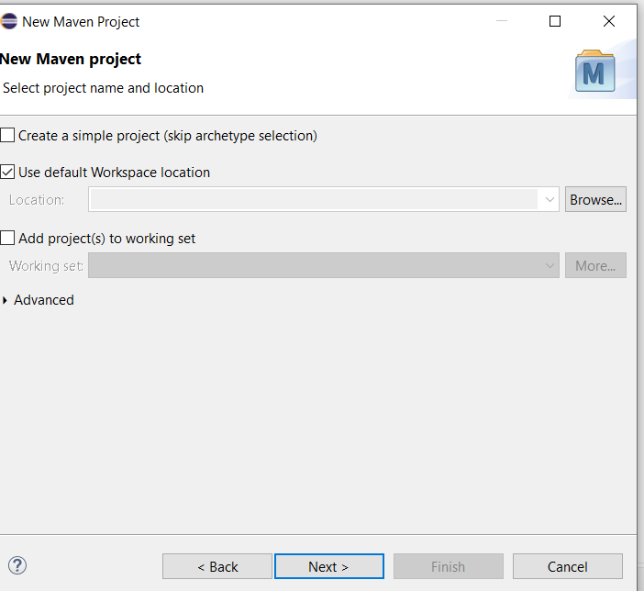

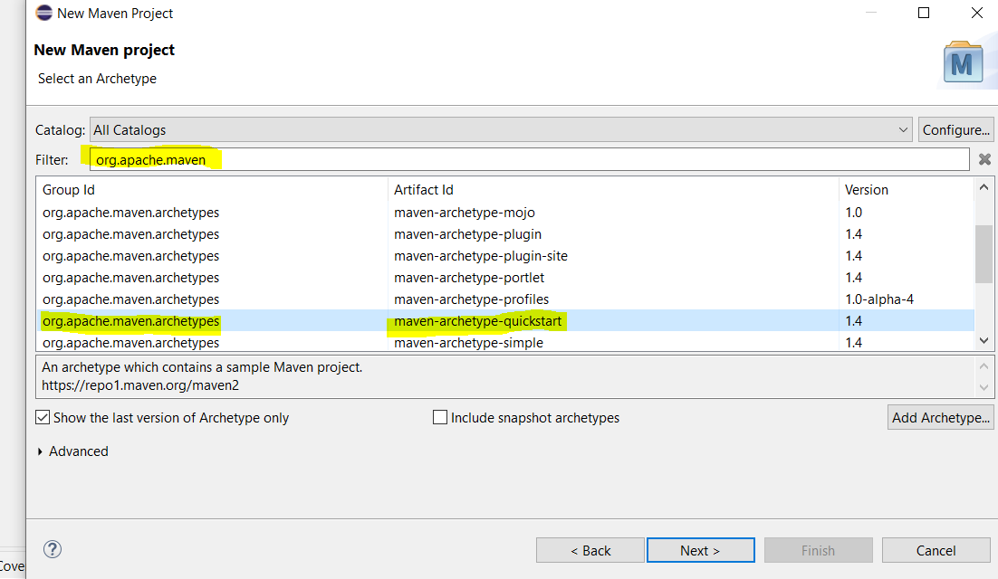

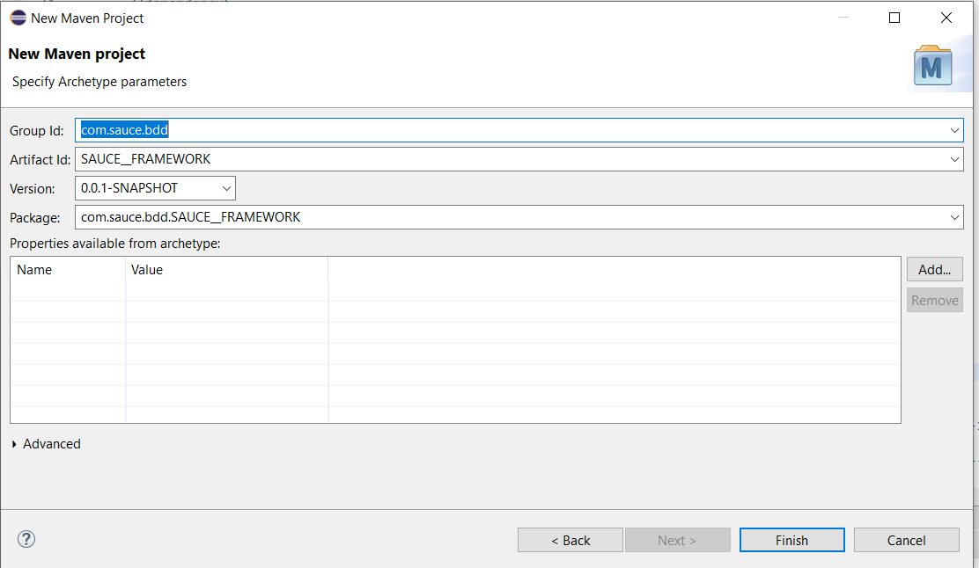

BELOW PROJECT IS CREATED AND DISPLAYED IN PROJECT EXPLORER

Delete app class under main java and main test

**Note:** Create Artifact id – SAUCEFRAMEWORK OR BDD_FRAMEWORK ( PROJECT NAME)

CREATE PACKAGES

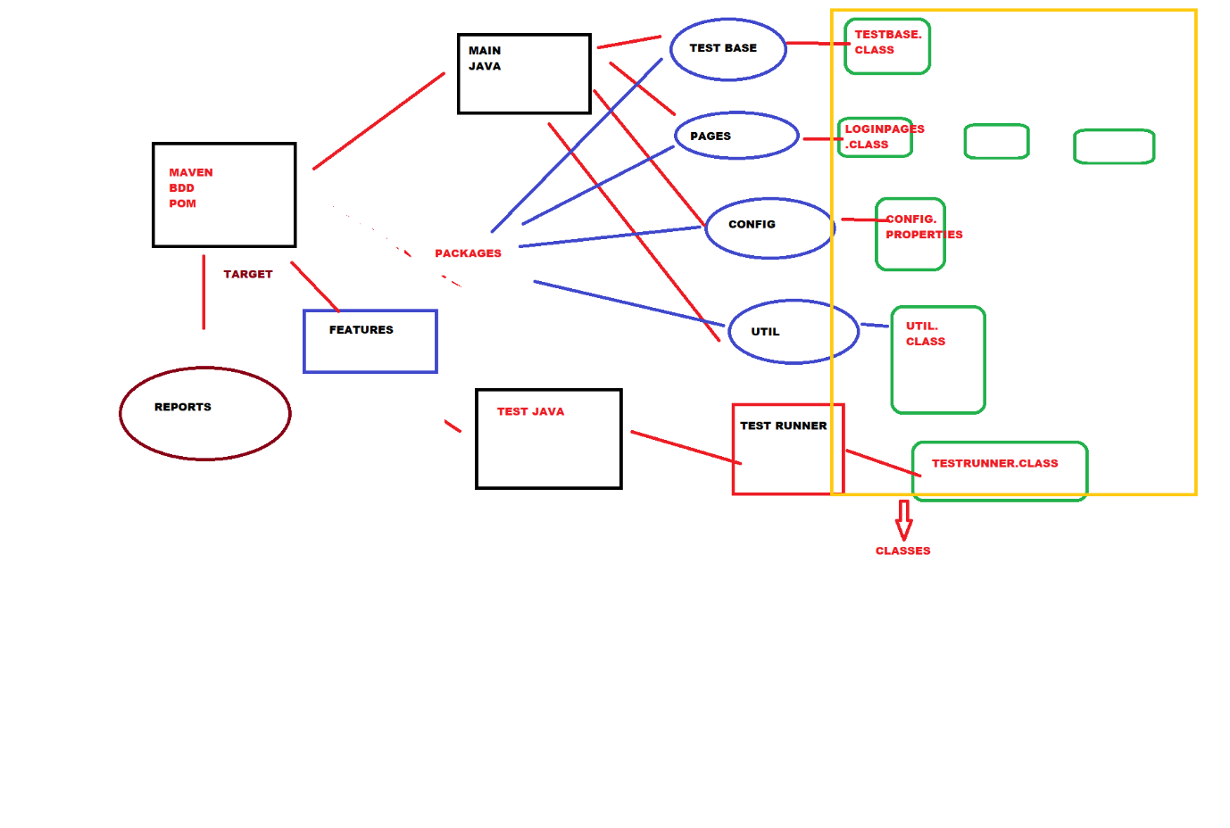

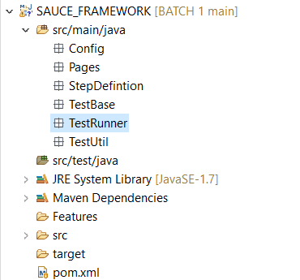

CLASSES

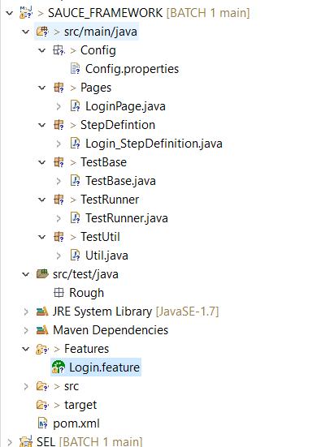

Dependency

<dependencies>

<dependency>

<groupId>info.cukes</groupId>

<artifactId>cucumber-java</artifactId>

<version>1.2.5</version>

</dependency>

<dependency>

<groupId>info.cukes</groupId>

<artifactId>cucumber-junit</artifactId>

<version>1.2.5</version>

</dependency>

<dependency>

<groupId>junit</groupId>

<artifactId>junit</artifactId>

<version>4.12</version>

</dependency>

<dependency>

<groupId>org.seleniumhq.selenium</groupId>

<artifactId>selenium-java</artifactId>

<version>3.141.0</version>

</dependency>

</dependencies>

Login page

public class Login_Page {

public WebDriver ldriver;

public Login_Page(WebDriver cdriver) {

ldriver=cdriver;

PageFactory.initElements(cdriver, this);

}

@FindBy(id="user-name")

WebElement uname;

@FindBy(id="password")

WebElement pwd;

@FindBy(id="login-button")

WebElement submit;

public void enter_username(String username) {

uname.sendKeys(username);

}

public void enter_password(String password) {

pwd.sendKeys(password);

}

public void click_submit() {

submit.click();

}