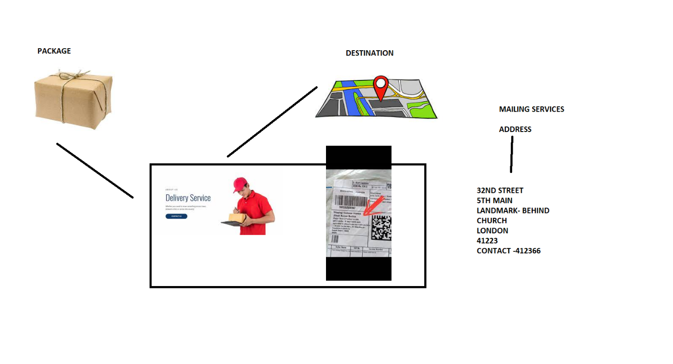

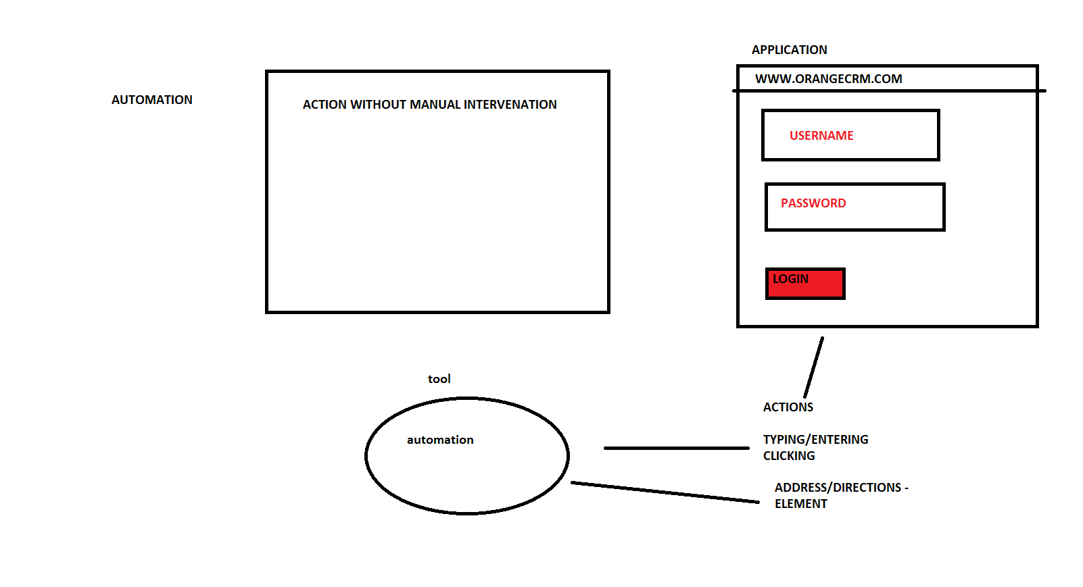

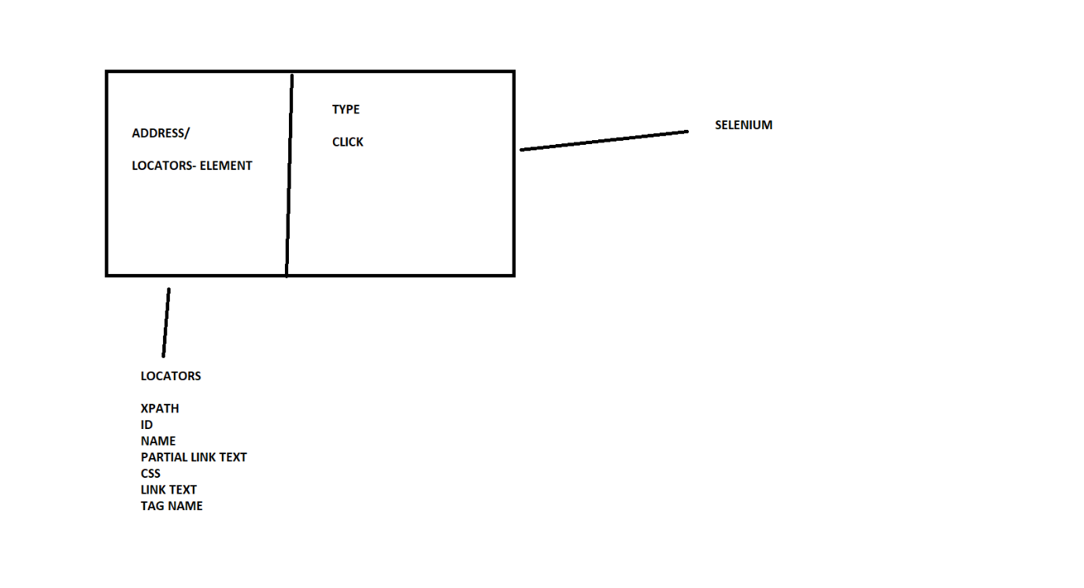

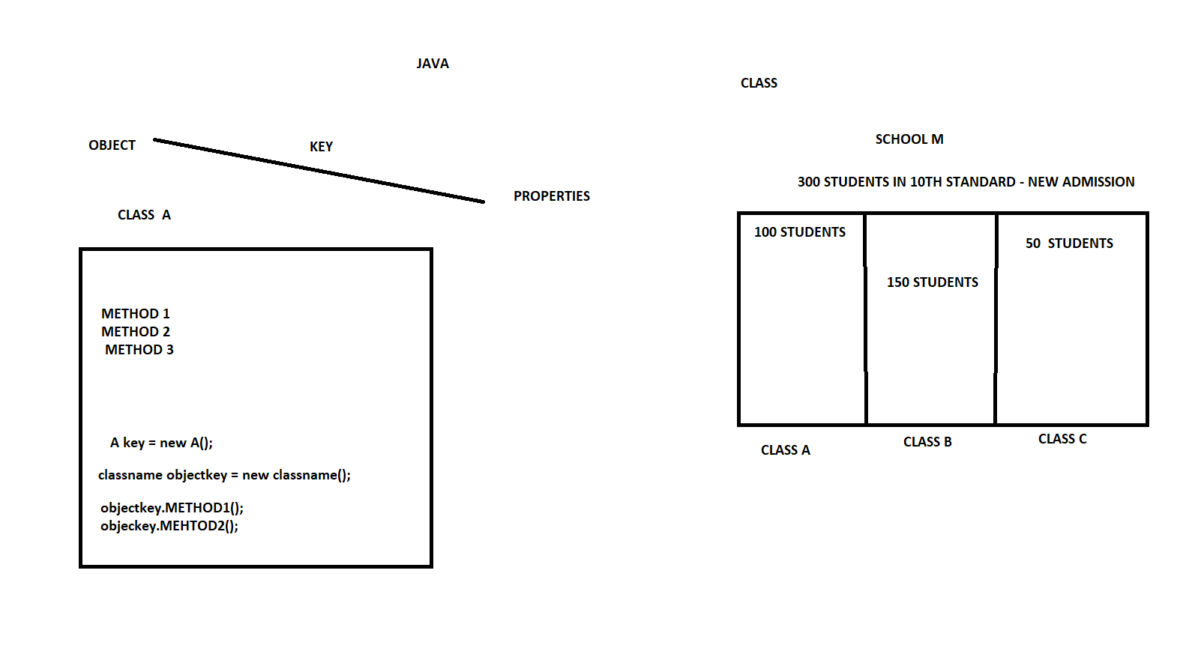

ECLIPSE DOWNLOADS - <https://www.eclipse.org/downloads/>

Create new project

File – New – Java – Project

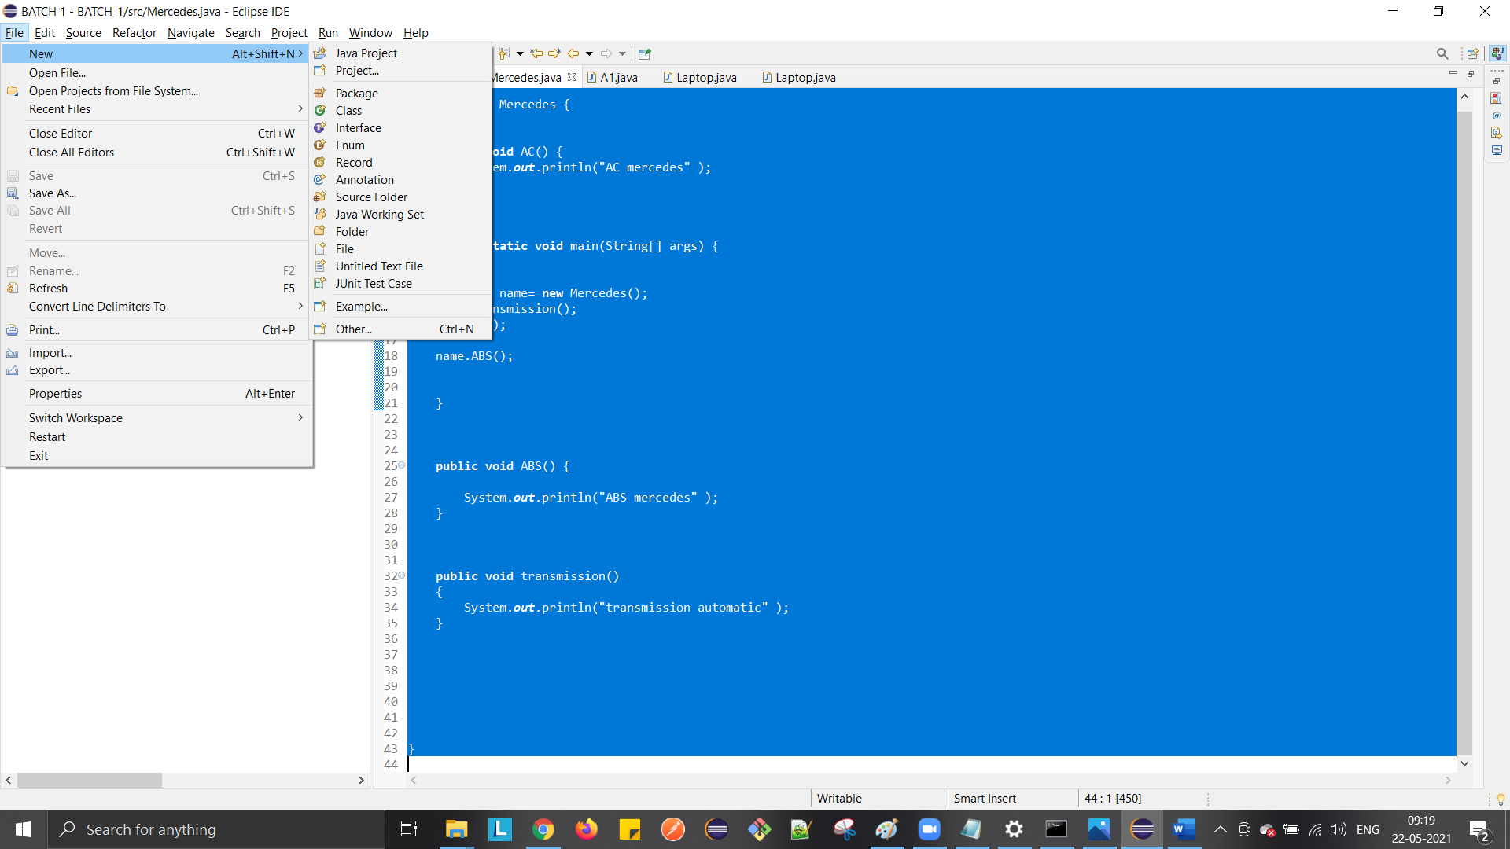

Create new class – Right click on project – new class

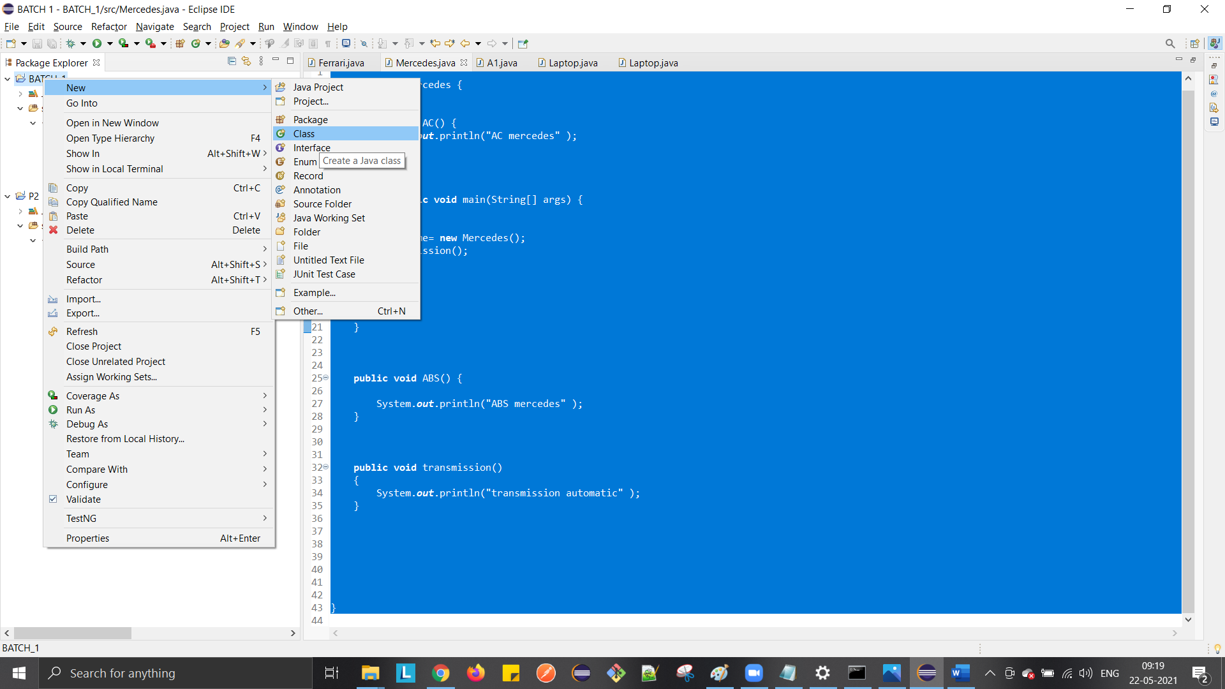

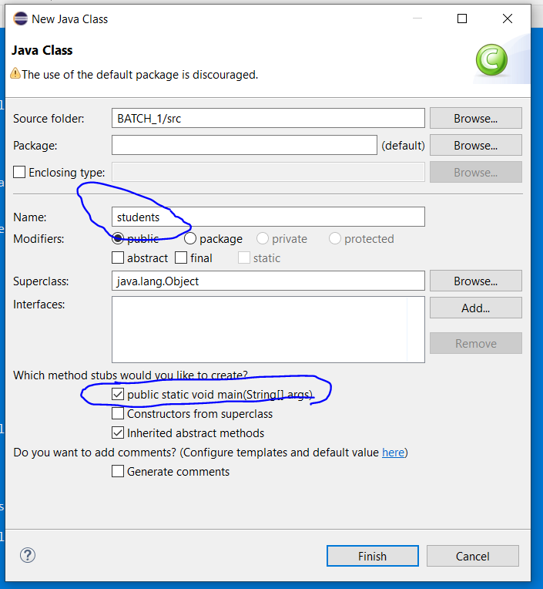

Note: check public static void main(String[] args)

To see output

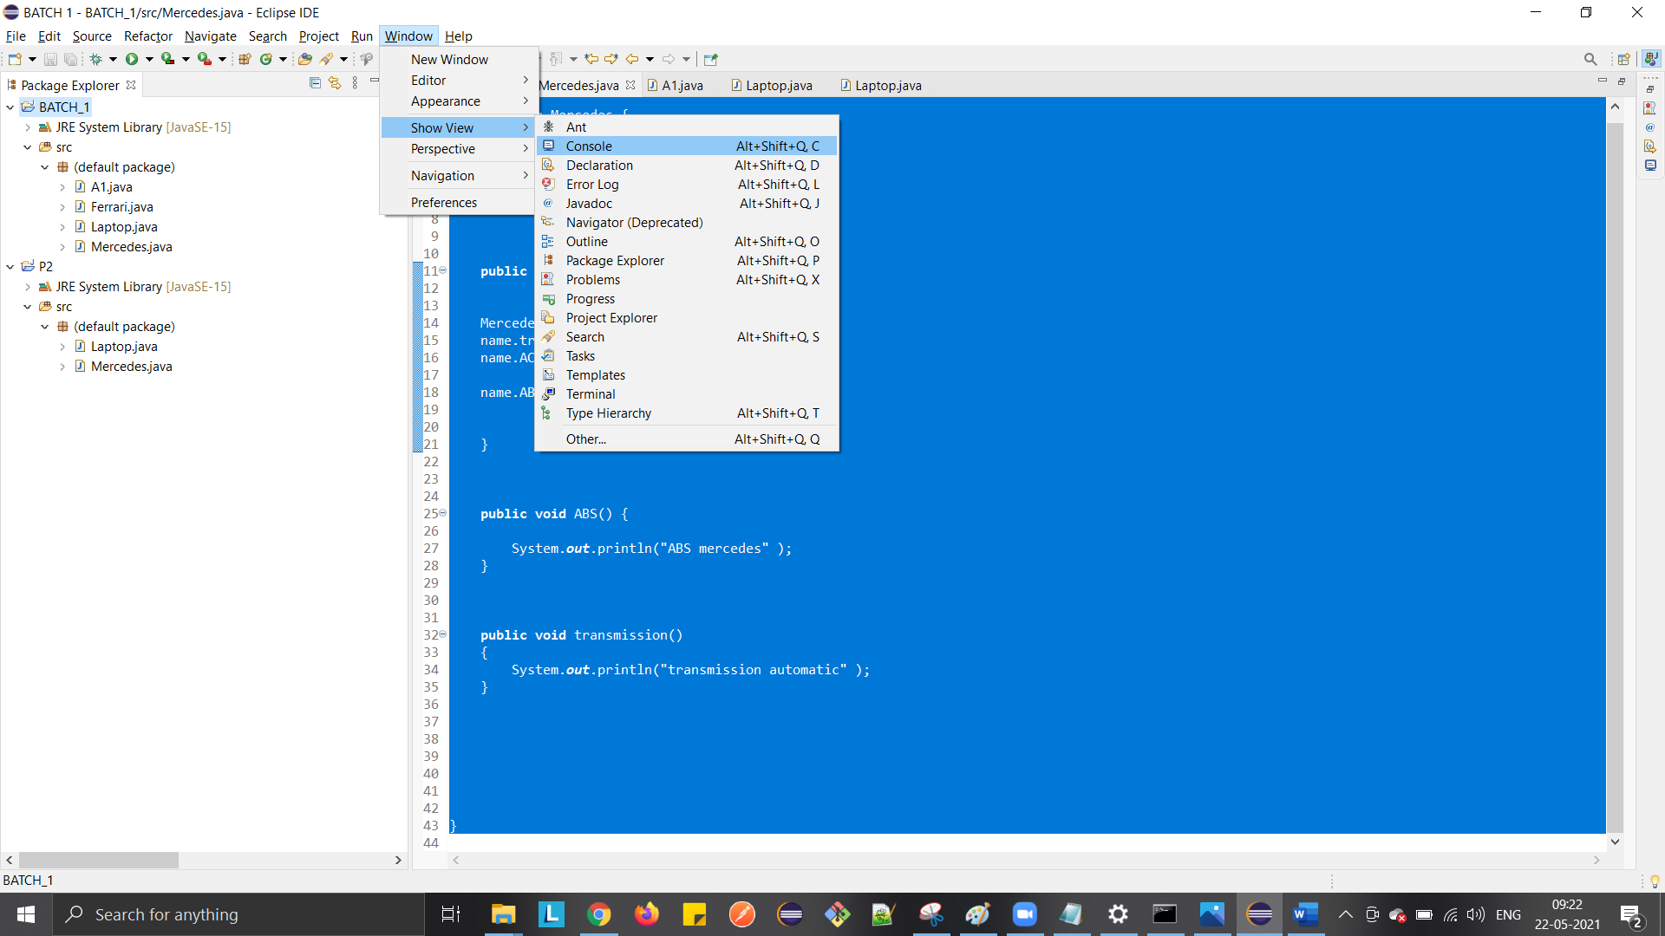

PROGRAMS

**public** **class** A1 {

**public** **static** **void** main(String[] args) {

System.***out***.println("hello world");

System.***out***.print("selenium");

System.***out***.println("automation tool");

System.***out***.print("java");

System.***out***.println(" welcome ");

}

}

**public** **class** Ferrari {

**public** **void** AC() {

System.***out***.println("AC ferrari" );

}

**public** **static** **void** main(String args[]) {

Ferrari name= **new** Ferrari();

name.AC();

}

}

**public** **class** Laptop {

**public** **void** memory() {

System.***out***.println(" memory is 4gb");

}

**public** **static** **void** main(String[] args) {

Laptop peter= **new** Laptop();

peter.memory();

}

}

**public** **class** Mercedes {

**public** **void** AC() {

System.***out***.println("AC mercedes" );

}

**public** **static** **void** main(String[] args) {

Mercedes name= **new** Mercedes();

name.transmission();

name.AC();

name.ABS();

}

**public** **void** ABS() {

System.***out***.println("ABS mercedes" );

}

**public** **void** transmission()

{

System.***out***.println("transmission automatic" );

}

}