Code download- https://github.com/sagarsomaiah98/BATCH1.git

ECLIPSE-> HELP🡪INSTALL NEW SOFTWARE

ADD TESTNG – <https://testng.org/testng-eclipse-update-site> and wait, Check TestNG and click next

<https://testng.org/testng-eclipse-update-site>

Click next and wait for software to get installed

If below prompt appears click install anyway

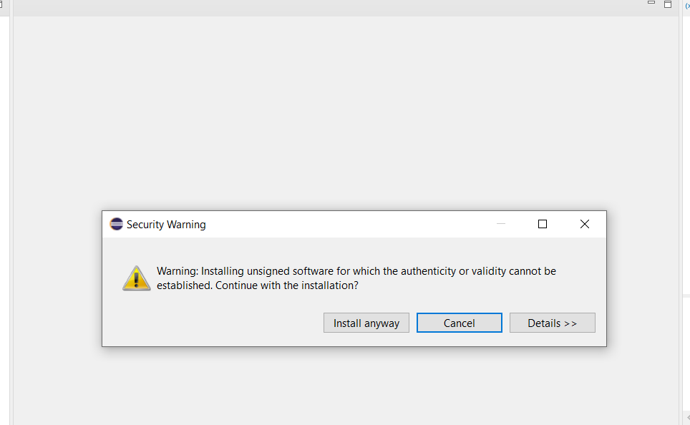

Restart prompt will appear , click restart

