Movie Recommendation System and Sentimental Analysis

Monica Pattjoshi Ramanan Parthasarathy Sagar Vishwakarma
Department of Computer Science Department of Computer Science Department of Computer Science
State University of New York State University of New York State University of New York
Buffalo, USA Buffalo, USA Buffalo, USA
mpattjos@buffalo.edu ramananp@buffalo.edu sagarvis@buffalo.edu

Abstract—the paper describes a content based movie recommendation system based on K-means clustering of various movie features. Several large movie datasets were collated to get various features. The collated dataset is clustered using K-means algorithm. This ensures that similar movies end up in a distinct cluster. The choice of initial cluster centers were derived based on the statistics of the given data. Different combinations for a director was derived by permuting the director with various genres and other features to get the initial cluster centers. User then inputs a movie for which he wants a recommendation for a list of similar movies. The user could even enter the features himself to get movies with similar features. If the user input is a movie, we derive the features through the API provided by Rotten Tomatoes. We then find the closeness of the user movie with each of the cluster centers. Top 5 movies from the matching cluster is returned to the user as a recommendation. We also perform sentimental analysis on the reviews of the movie and classify the movie into one of the five categories (very bad, bad, neutral, good, very good) using a SVM model.
Keywords—K-means Clustering, Rotten Tomatos API, SVM

Introduction
People today in the world are facing a problem of having too much choices. Be it the right song or even the right investment option, the problem of recommendation is of great importance. Good Research is going in this area employing techniques of Machine Learning to generate a model which gives the best result. The problem of Movie Recommendation has a lot of significance today as there a lot of movies that are made year after year in different languages and countries and people are always wanting to know which type of movie they would like be it in a different language.
We introduce a simple but effective approach to solve this problem using K-means. The important thing in our model is how we make clusters depending upon different features which contribute to two movie being similar. We make use of the existing API’s available to predict a movie score based on the different features and use this score to associate with the nearest cluster.
A Sentimental analysis based on the reviews of the movie is also performed using an SVM model. We initially train a model using Rotten Tomatoes API to classify about 10000 reviews and using that model classify the movie based on the reviews by calculating the average score.

Background and related work
Over the past years, a number of techniques have been deployed to solve the problem of movie recommendation system. K-means clustering itself have been chosen as the best clustering algorithm by many people.
Some methods have also used taking a lot of inputs from the user and optimizing the result. One such system was designed by Jung, Harris, Webster and Herlocker (2004). Although giving good results, the systems suffers from the drawback that users nowadays tend to get the result using minimum effort and this system requiring a lot of inputs is not popular owing to the above problem.
Another method, called MOVIEGEN, uses a combination of machine learning and clustering so as to produce good results but again it suffers from the same drawback as the previous as it asks the user a lot questions where they might get impatient.
Stanford has released library to perform sentimental analysis on a text which uses neural networks. Rotten Tomatoes API also find the sentiment of a text. This could be useful to obtain an initial training data to classify a reviews.

Theory
K-means

K-means technique is one of the most popular technique to perform clustering. It is based on the following algorithm:

- Cluster all the points based on initial sets of points chosen
- Now, calculate the new points based on all the points in new cluster as the average
- Again repeat step 1 and run this until convergence is achieved

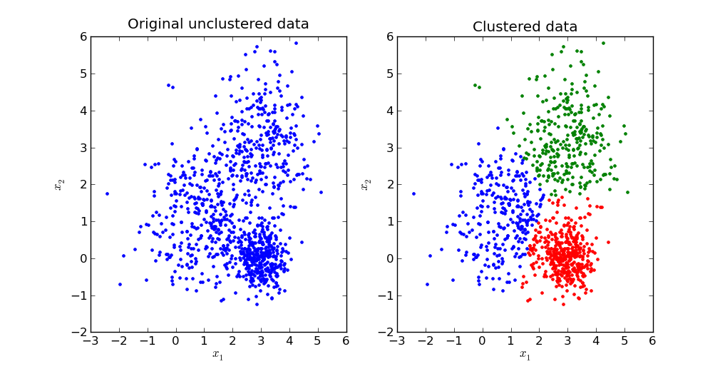

SVM

Support vector machine constructs a hyperplane or set of hyperplanes in a high- or infinite-dimensional space, which can be used for classification, regression, or other tasks. Intuitively, a good separation is achieved by the hyperplane that has the largest distance to the nearest training data point of any class (so-called functional margin), since in general the larger the margin the lower the generalization error of the classifier.

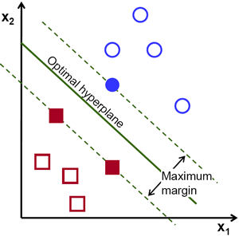

In the above picture you can see that there exists multiple lines that offer a solution to the problem. Is any of them better than the others? We can intuitively define a criterion to estimate the worth of the lines:

A line is bad if it passes too close to the points because it will be noise sensitive and it will not generalize correctly. Therefore, our goal should be to find the line passing as far as possible from all points.

Then, the operation of the SVM algorithm is based on finding the hyperplane that gives the largest minimum distance to the training examples. Twice, this distance receives the important name of margin within SVM’s theory. Therefore, the optimal separating hyperplane maximizes the margin of the training data.

methodology

Movie Recommendation
Data is initially accumulated from two datasets:-
- http://grouplens.org/datasets/movielens/
- https://raw.githubusercontent.com/daverb/Movie-Analysis/master/movies_data.csv

The First link gives features like length of the movie, rating, genre and year of making. The second dataset gives features such as actors and directors. Both the datasets are merged under the movie name column using Microsoft SSIS.

Some data preprocessing was required due to the following:

- Datasets are comma delimited.
- Year of movie was sometimes 1988 and sometimes just 88
- Movie names were blank sometimes. Eliminated such rows from consideration.
- Two such input data files each having different features are merged using Microsoft SSIS. The data anomalies were handled in the tool itself by setting appropriate rules.

Algorithm

- Choice of Initial cluster centers
We use the statistics of the datasets to derive the initial cluster centers.
E.g., for a particular director ‘A’, we identify the various genres that he has made a movie in. Then we make different combinations for the director with various genres. We extend this way of combinations to other features as well.

Below are some graphs which indicate the dataset statistics.
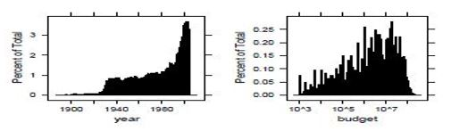

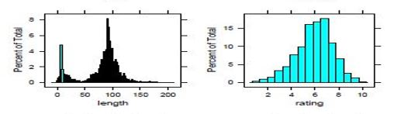

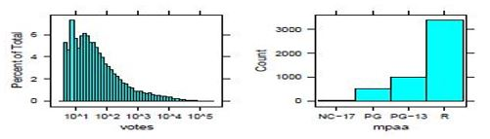
- Merge various datasets containing different sets of features into one large dataset
- The value of K is chosen after carefully analyzing the data in terms of how many total directors are there. We found out there are a total of around 1000 directors so K was chosen to be 1000
- Apply K-means clustering on this dataset where K=1000. We get a 1000 clusters where movies in each cluster are similar to each other.
- Take the input from the user for which he wants movies recommended.
- Given a user input as a movie name, we extract the features for the movie through rotten tomatoes API
- We find the cluster center to which the given movie is closest.
- We then find the top 5 movies in the nearest cluster and recommend those movies to the user.
- We also extract 30 movie reviews for a given movie from rotten tomatoes and perform sentiment analysis on it.

Sentimental Analysis
Some 10000 Review were obtained and classified on a scale from 1-5 using the Rotten Tomatoes API.

Now, a word Dictionary was performed corresponding to a rating between 1-5 which was calculated as the sum of all the scores of the review where the word occurs divided by the total number of reviews. A model is trained which consisted of the following features:-

- Total score of all the words which were present in the word dictionary. This would be give a pretty fair ideal of where the sentiment of tweet falls into which category.
- Total number of question marks (?) occurring in the review. A question mark in the review would most likely suggest the movie being given a negative review
- Total number of Exclamations (!) occurring in the review. This would give us an idea of the degree of the positivity in a review.
- Length of the review.
- Total number of stop words
- Total score of the emoticons present in the review. A standard emoticons score list was obtained from the interb which suggested its sentiment eg. ☺ was given 5 and ☹ was given 1.
- Negative and positive slangs list were obtained from the internet corresponding to scores eg. LOL 5

All of these features were trained with the target value obtained using the Rotten Tomatoes API using an SVM model using a nonlinear classification model. Radial basis function was chosen and the optimum values of C and gamma were deducted.

libSVM was choosen as the library to perform SVM computations in Java.

Now, to classify the review, all of the following features are first calculated and then the model was applied classifying into one of the five category. The categories were labelled as Very Negative, Negative, Neutral, Positive and very positive. Likewise for all the first 30 reviews, the average score was calculated and finally the movie was classified

Observation

Movie Recommendation Systems
For a user input movie: “Top Gun”. The list of suggested movies are: “Pearl Harbor”, “The guardian”, “Stealth”, “Iron Eagle”, “Fly Boys”.
The user input is “Top Gun” which is a movie based on aviation and flight technologies. The list of suggested movies also fall in the same category.

Sentimental Analysis

The best performance for the training model was achieved at gamma=0.001 and cost =1

The best accuracy achieved was 70.4 %

conclusion
K-means clustering proves to be very effective clustering algorithm to solve the above problem. Although not being a state of the art algorithm, the simplicity and the speed of the results proves to be very effective to the user. The dataset
chosen suffers from non-existence of some genre like horror movies so the system is not able to perform efficiently if a horror movie is given by the user as input. Also, It fails to accommodate references based on user similarities. The algorithm is purely content based and does not include collaborative methods.

Sentimental Analysis using SVM proves to be a pretty good approach as compared to the existing supreme model develop by Stanford based on accuracy. Several corner cases are handled which improves the accuracy but more corner cases needs to be handles which are handled in the NLP model of Stanford.

Future scope

- User queries could have been given as an option to improve results. The user can have the choice to enter more specific details or just recommend based on the movie name.
- Different final clusters will come based on different values of K so the program should run for different values to compare the result achieved.
- New Words which are not present in the word dictionary built from training data are not calculated and are left unused. There values could have been calculated and added to the dictionary.
- The SVM model doesn’t take into account the different meaning of sentences which can occur grammatically

References

- http://nlp.stanford.edu/
- http://www.cs.ucsb.edu/~nanli/projects/CS265-MovieGEN.pdf
- http://developer.rottentomatoes.com/docs
- http://cs229.stanford.edu/proj2008/GuptaJainSong-MovieRecommendationsUsingSocialNetworks.pdf
- http://pakacademicsearch.com/pdf-files/com/229/191-198%20Vol.%203,%20Issue%202,%20Jun%202013.pdf

