>>>>>nichay docker ka bhi content hai>>>
✅ VS Code me SSH terminal kaise open karein (GREEN prompt ke saath) ya command line interface:
Ye command chalao 👇total 3 step hai
Step1:
dir $HOME
Aur phir:
dir $HOME\Downloads
yeh command chalany k baad jo bhi humnay key pair bnaya current ec2-instance ka agar mil jata hai
then.
Step2:VS Code me ye dono command ek baar chalyoh:
1.)keypairnameofcurreninstance
command:
icacls C:\Users\sagar\Downloads\keypairname /inheritance:r
icacls C:\Users\sagar\Downloads\keypairname /grant:r sagar:R
👉 Is command ka matlab:
ec2.pem file par sirf user sagar ko read permission di gayi hai aur baaki sab users ki inherited permissions hata di gayi hain, taaki file secure rahe. 🔐

humay ec2 insatnce public ip m dikkat aari thi bcz ec2 m yeh real public ip nahi hoti due to which browser/ssh open nahi hota so we use elastic ip.
elastic ip is permanent public ip srever k restart/stop honay per bhi change nhi hoti Jenkins production and vs m ssh k liye must hai
Elastic IP: 54.157.68.118 this is our elastic ip for ex
Ab hum aws m k ec2 m search karengay elastic ip then usay current instance k saath allocate karenagay elastic ip search karkay allocate karoh then associate karenagy current instance jo running hai select karengay
✅ Elastic IP associate with EC2
AWS Console → Elastic IP → Associate with instance
Result:
Public IPv4 address: 54.157.68.118
👉 Ab ye real public IP hai.
👉 Ye step vscode Windows poweshell me SSH ke liye important hota hai.tabhi ssh connect hogaa
✅ Step 3: Ab SSH connect karo (FINAL COMMAND)
ssh -i C:\Users\sagar\Downloads\ec2.pem ubuntu@elastic-ip of current instance
Example:
ssh -i C:\Users\sagar\Downloads\ec2.pem ubuntu@54.157.68.118
then our ssh open << agar ssh stuck hojata hai ya apnay connection tut jaye toh ec2 instance ko phele stop kardoh 2 min baad start kardoh ab status m dekho 10 min ruko jab green color may 3/3 check pass ajay phir yeh tino step chalyoh tab ssh hojeyga >>
Aur agar command line interface ssh say exit karna hai toh 2 baar exit type kardoh like:
Exit , exit
Agar hum pta karna chathay hai public ip toh use :
*curl ifconfig.me*
agar dubara connection time out aye toh yeh hua
❌ Kya problem thi?
1️⃣ EC2 “Instance Reachability Check” fail ho gaya tha
Iska matlab:
- EC2 ka operating system hang / freeze ho gaya tha
- Network services (SSH, ping) response nahi de rahi thi
Isliye tumhe:
- ❌ SSH → connection timed out
- ❌ Ping → request timed out
Mil raha tha.

2️⃣ Iska key / Elastic IP / command se koi lena-dena nahi tha
- .pem file ✔️
- Elastic IP ✔️
- SSH command ✔️
Problem instance ke andar thi.

✅ Kaise thik hua?
🔄 Tumne Stop → Start kiya
Isse kya hua:
- EC2 ka OS fresh boot hua
- Network stack reset ho gaya
- SSH service dobara properly start ho gayi
Result:
- ✅ 3/3 status checks passed
- Instance healthy ho gaya
- Vaapis ping

54.157.68.118 kiya toh eror ara tha but kio baat nhu phir bhi ssh vaali commands chalyoh ssh chal jeyega
ssh -i C:\Users\sagar\Downloads\ec2.pem ubuntu@54.157.68.118 ssh opsen

>>>>>>>>>
Nichay jayoh docker ki journey start kartay hai >>>>>>>>>>>>>>>>>>>>>>>>>>>>>>>>>>>>>>>>>>>>>>>>>>>>>>>>>>>>>>>>>>>>.>>>>>>>>>>>>>>>>>>>>>>>>>>>>>>>>>>>>>>>>>>>>>>>>>>>>>>>>>>>>>>>>>>>>>>>>>>>>>>>>>>>>>>>>>>>>>>>>>>>>>>>>>>>>>>>>>>>>>>>>>>>>>>>>>>>>>>>>>>>>>>>>>>>>>>>>>>>>>>>>>>>>>>>>>>>>>>>>>>>>>>>>>>>>>>>>>>>>>>>>>>>>>>>>>>>>>>>>>>>>>>>>>>>>>>>>>>>>>>>>>>>>>>>>>>>>>>>>>>>>>>>>>>>>>>>>>>>>>>>>>>>>>>>>>>>>>>>>>>>>>>

MODULE-7 DOCKER
Day-1 docker
8feb 2026
Today we learn :
What is Docker?
Docker vs Virtual Machine
Image vs Container
Docker architecture
Practice
docker --version
docker info docker run hello-world

>>Docker kya hota hai:
Docker ek containerization platform hai jo applications ko containers ke andar run karne deta hai.
Simple samjho
Normally jab hum app run karte hain to:
- Alag-alag systems me dependencies different hoti hain
- Isliye app kabhi chalti hai, kabhi error deti hai
Then Docker us app ki sari libraries + dependencies ko ek container me pack kar deta hai, jisse:
- Har machine me same tarike se run hota hai
- “Works on my machine” problem khatam
Example:
Agar hum Java app Docker me run kray toh :
- Laptop may
- Server may
- Cloud (AWS) may.
Har jagah exact same result milega.

- Image → App ka package/template
- Container → Running application

Docker Image kya hoti hai?
Docker Image ek read-only template / package hoti hai jisme:
- Application
- Libraries
- Dependencies
- Runtime environment
sab kuch already included hota hai Is image se hi container run kiya jata hai.
Example:
docker run nginx
Yahan:
- nginx = Docker image
- Run hone ke baad = container
Real-life example:
Socho:
- Cake recipe = image
- Bana hua cake = container

Docker Container kya hota hai?
Docker Container ek running instance of Docker Image hota hai, jisme application actually run karti hai.
Simple samjho
- Docker Image → application ka package/template
- Docker Container → us image se chalti hui application

Example
docker run nginx
- nginx = image
- jo ye docker yeh hamara container hai toh nginx ko is docker container m dalega then yeh docker container nginx image ko run Karega .
Container ki khas baatein
- Lightweight hota hai
- Fast start hota hai
- Har system me same environment deta hai
- Easily start, stop, delete kiya ja sakta hai

Docker vs virtual machine:
Docker virtual machine
(1)Host os (1) har vm apna
Share karta hai full os run karta hai
2) lightweight 2) heavy.
3) start within seconds 3) take min.
4) faster 4) slow.
5) kam cpu/ram use 5) Jayda karta
Karta hai hai.
6) used in microservices, 6) used in
Ci/cd , devops . diff os testing .

Simple example
- Docker → ek hi OS par multiple lightweight apps run
- VM → har app ke liye alag complete operating system

Docker Architecture
Docker architecture mainly 3 core components se milkar bani hoti hai:
- Docker Client
- Docker Host (Docker Daemon)
- Docker Registry
1️⃣ Docker Client:
- User yahan se commands deta hai:like
- docker run nginx
- docker build
- docker pull
- Client commands ko Docker Daemon ko bhejta hai.
Example:
Terminal me jo docker commands likhte hai → wahi Docker Client hai.
2️⃣ Docker Host (Docker Daemon):
- Docker Daemon background service hoti hai (dockerd)
- Yeh:
  - Images manage karti hai
  - Containers run karti hai
  - Networks aur volumes manage karti hai
👉 Matlab: actual kaam daemon karta hai

3️⃣ Docker Registry;
- Yahan Docker Images store hoti hain
- Default registry: Docker Hub
Example:
docker pull nginx
- Docker daemon registry (DockerHub) se image download karta hai

🔁 Complete architecture Working Flow:
User (Docker Client)
↓
Docker Daemon (Host)
↓
Docker Registry (DockerHub)
↓
Image download → Container run

<<<<<<<now we how toinstall docker>>>>>

Phele ssh (secure shell ) ka set up then docker install karengay
Now we install docker; avoide stars
First security group m http 80 port rule add karoh then.
* sudo apt update *
* sudo apt install docker.io -y *
* docker –version *
expected output :Docker version 28.2.2, build 28.2.2-0ubuntu1~24.04.1

* sudo systemctl start docker *
* sudo systemctl enable docker *
then verify : docker –version
* sudo docker info *
Iska matlab: Docker engine (daemon) ki complete system information dekhne ke liye use hota hai.

* sudo docker run hello-world *
Iska matlab : hello world run kardega
* sudo docker run -d -p 80:80 nginx *
Iska matlab: yeh docker ko port 80 per start k liye allow karega
* sudo docker ps *
Iska matlab : system may currently running conatiners ki list deta hai
<<<<<ab browser m elastic-ip:80 ko dekho nichay>>
Like this 54.157.68.118:80 browser m daaloh .
<elastic-ip:80>
><<<<<<<<<<<we will see like this >>>>>>>>>>>
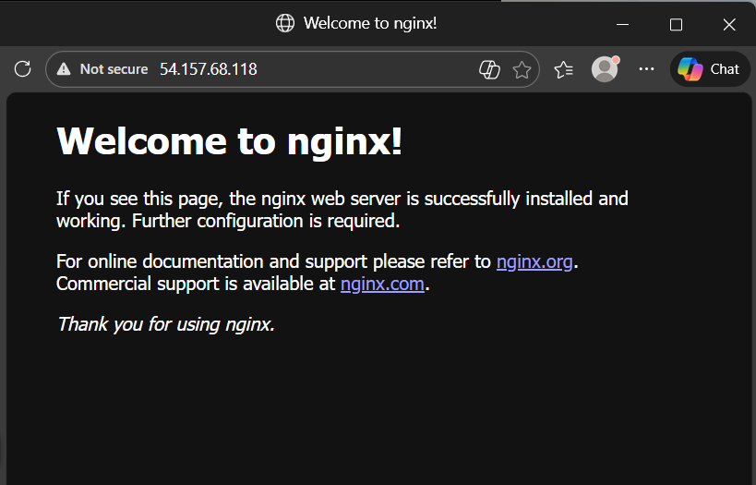

Docker Workflow (Build → Push → Pull → Run)
In commands ko run karnay say phele say docke install karna sikho then yeh commands chalyoh.
Yeh real-world Docker flow hai jo companies CI/CD pipelines me use karti hain.
Step-by-Step Workflow
1️⃣ Build (Image create karna):
Docker build chalny k liye phele humay docker file bnani hogi .
We create docker file using command:
<<< nano Dockerfile >> (doker bda d use karta hai)
editor khulega usmay yeh paste kardoh
FROM nginx
COPY . /usr/share/nginx/html
Meaning:
- FROM nginx → base image nginx use karo
- COPY . /usr/share/nginx/html → current folder ki files nginx web folder me copy karo
Save:
CTRL + X → Y → Enter
sudo docker build -t myapp .
(yeh puri command hai . k baad bhi )
<<<<<<<,iska ouput >>>>>>
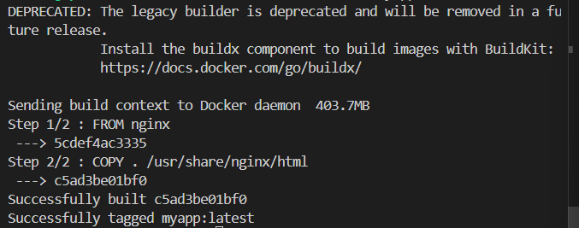

agar hum sudo use nahi karna chathay toh use :
User ko docker group me add karne se docker daemon access milta hai aur sudo ki zarurat nahi padti.
<< sudo usermod -aG docker ubuntu >>
then ssh reconnect karoh
then check karoh docker ps
step-1:dir $HOME\Downloads
step-2: icacls C:\Users\sagar\Downloads\keypairname /inheritance:r
icacls C:\Users\sagar\Downloads\keypairname /grant:r sagar:R
step-3: ssh -i C:\Users\sagar\Downloads\ec2.pem ubuntu@54.157.68.118
now create image of our docker file :
Developer apne project ke Dockerfile se image banata hai.
docker build -t myapp . (yeh dot bhi lagyoh)
👉 Result: myapp naam ki Docker image ban gayi.
Imay humnay sudo hta diya .
2️⃣ Push (Image registry me upload):
Image ko DockerHub / private registry me upload kiya jata hai.
In this we use :
* docker login -u sagar44827 *
Iskay baad enter press karoh >>>>> terminal :login succeed ayega .
* docker tag myapp sagar44827/myapp:latest *

Then use:
* docker push sagar44827/myapp *
Docker-username
Docker push tabhi hota hai jab login correct ho and image ka tag exact same username/repository formt me ho .
3️⃣ Pull (Server image download karta hai)
Production server image download karta hai:
Hamari image ka name hai: myapp
Hmara docker user name hai : sagar44827
docker pull sagar44827/myap
(dockerusename)
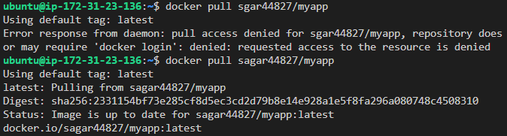
4️⃣ Run (Container start hota hai):
Image se container run hota hai
docker run -d -p 8080:8081 username/myapp
phele toh isko 8080 per nahi chalyengay bcz 8080 per hmara jenkins chalra hai. hum port 8081 per chalyengau phele security group m 8081 port ko add karengay. Then we use
* docker run -d -p 8081:80 sagar44827/myapp *
then verify : docker ps
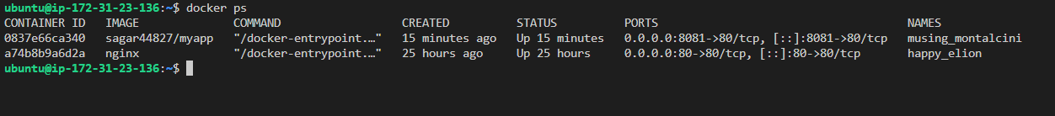
elastic-ip:8081 browser m daaloh .
like 54.157.68.118:8081
expected output nginx ka welcome page khulega .
👉 Application live ho jati hai. like this

<<<<<<<like this >>>>>>>>>>>>>
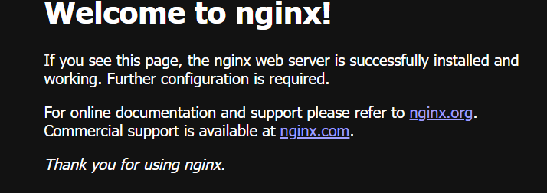

>>Ngnix ky hota hai?
Ans: Jab browser me hum website open kartay ho, to Nginx server us website ki files (HTML, CSS, images) browser ko bhejta hai. Ngnix ko “ Engine-X bhi bola jata hai .
Main uses:
- Web server (website host karna)
- Reverse proxy
- Load balancer
- Static file serving (fast performance)
Example:
humne jo Docker me run kiya:
docker run -d -p 80:80 nginx
Iska matlab:
Nginx web server start ho gaya aur ab humhari EC2 machine ek live website server ban gayi.

<<<<<,now we do day -2 of docker>>>>>>>>>>>>>>>>>>>>>>>>>>>>>>>>>>>>>>>>>>>>>>>>>>>>>>>>>>>>>>>>
Day-2
Docker Container Lifecycle
>>Docker container life cycle ky hoti hai?
Ans : Docker Container Lifecycle ka matlab hai container ke creation se lekar delete hone tak ke saare stages(process)
Main stages:
- Create / Run – container start hota hai (docker run)
- Running – container actively kaam kar raha hota hai
- Paused (optional) – container temporarily pause hota hai
- Stopped – container band ho jata hai (docker stop)
- Restarted – container dubara start hota hai (docker start)
- Removed – container permanently delete hota hai (docker rm)

<<<<ab docker lifecycle commands dekhengay >>>>>
1️⃣ Create / Run (container start):
docker run -d nginx
Output: a7c3f6d2b6f5c3e8d2e4f0c1c9b4c2a1...
Yeh container id hoti hai.
2️⃣ Running (running containers check)
Command
docker ps <<is command say hmay container id mailjaygi) + aur docker related info bhi .>>
Output
Our container id : 678ce220738d
3️⃣ Pause (temporarily stop processing)
Command
docker pause 678ce220738d
Resume:
docker unpause 678ce220738d
4️⃣ Stop (container band)
Command
docker stop 678ce220738d
Output
678ce220738d
5️⃣ Restart / Start again
Command
docker start 678ce220738d
Output
678ce220738d
Restart directly:
docker restart 678ce220738d
6️⃣ Remove (permanent delete)
Command
docker rm 678ce220738d
Output
678ce220738d
Short exam memory line
Run → Pause → Stop → Start → Remove = Docker container lifecycle

>>Port mapping ky hoti hai?
Ans: Port mapping ka matlab hota hai host machine ke port ko container ke port se connect karna, taaki bahar (browser/internet) se container ki service access ho sake.
Port mapping = Host port → Container port ka connection.
Example:
docker run -d -p 8080:80 nginx
Meaning:
- 8080 = Host (EC2 / system) port
- 80 = Container ke andar nginx ka port
Matlab : broswser>host:8080 >container:80>ngnix
Isliye jab tum browser me open karte ho:
http://PUBLIC-IP:8080 toh request container ke port 80 tak pahunchti hi aur website open hoti hai.

Day 3 – Docker Images & Layers
Learn
Docker images & layers
Image size importance
Caching concept
Practice
docker images
docker history nginx
docker rmi nginx

<< docker layer ky hoti hai:
Ans: Docker Layers Docker image ke chhote-chhote read-only parts hote hain jo ek-dusre ke upar stack hokar complete image banate hain.
Har command (jaise RUN, COPY, ADD) ek naya layer create karti hai.
Simple samajh lo
- Jab Docker image build hoti hai, to har step ek separate layer banata hai.
- Ye layers reuse (cache) ho sakti hain, isliye image build fast hota hai.
- Container run hone par ek top writable layer add hota hai jahan changes save hote hain.
Example
Agar Dockerfile me ye steps hain:
FROM ubuntu
RUN apt update
RUN apt install nginx
COPY index.html /var/www/html
Toh layers banegi :
- Base ubuntu layer
- apt update layer
- nginx install layer
- index.html copy layer
Har step = 1 layer
Layers ke fayde
- Fast build – same layer dobara build nahi hota (cache use hota hai)
- Small storage – shared layers multiple images me reuse ho sakte hain
- Easy rollback – layer change karke image modify kar sakte hain
Chaloh hum apni docker layer bnatay hai:
1️⃣ Image pull karo
docker pull nginx
Meaning: Docker Hub se nginx image download karo.
2️⃣ Image list check karo
docker images
Output me nginx image dikhegi.
3️⃣ Image ki layers dekho
docker history nginx
output m ek list aajyegi jismay hmay show hogay hmari image ky create kab ki gayi created by and size like this
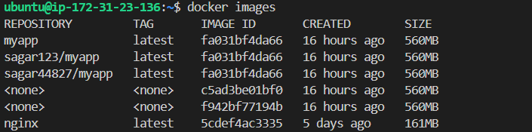

Har row = ek layer
Columns ka meaning
- REPOSITORY → image ka naam
- TAG → version (usually latest)
- IMAGE ID → unique ID
- CREATED → image kab bani
- SIZE → image ka size
Yeh none vaali file kisi kaam ki nahi hai jinhay hum dangling image boltay hai.

humaray output ka explanation
myapp latest fa031bf4da66 16 hours ago 560MB
sagar123/myapp latest fa031bf4da66 16 hours ago 560MB
sagar44827/myapp latest fa031bf4da66 16 hours ago 560MB
Meaning:
- Ye teen alag names (tags) hain lekin same image ID (fa031bf4da66) hai.
- Matlab ek hi Docker image ko alag-alag naam se tag kiya gaya hai (shayad Docker Hub push ke liye).

<none> <none> c5ad3be01bf0
<none> <none> f942bf77194b
Meaning:
Ye dangling images hain.
Ye build ke purane intermediate layers hain jinka koi naam/tag nahi hai.
Inko delete kiya ja sakta hai:
Use: * docker image prone *
Yeh command chalane par system unused intermediate layers (dangling images) remove karta hai aur storage optimize karta hai.
Iska output ayege phele warning aygi then y press kardoh then unused images ko delete kardega .
Verify karnay k liye use : * docker images *
Output m none vaali file delete hojaygi:
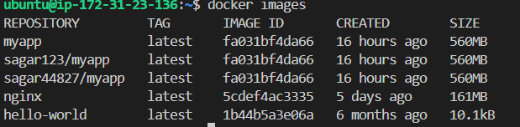

Ek yeh * docker image prune -a * command bhi hoti hai jo → sab unused images delete (dangerous ho sakta hai) but yeh dangorus ho sakti hai so use only
docker image prune .
>> docker image size ky hotai hai?
Ans:
Docker image size ka matlab hai ki ek Docker image disk me kitni storage space (MB/GB) leti hai.
Ye size image ke sabhi layers (base OS, installed software, files, libraries) ka total hota hai.
Example:
nginx image → 161MB
myapp image → 560MB
Matlab nginx image 161MB storage leti hai, jabki myapp 560MB leti hai.

IMAGE SIZE IMPOTANCE :
1 fast download (pull speed) .
2 fast deployment.
3 storage saving
4 network bandwidth saving.
5 secuirty advantage.

Bandwidth matlab: data transfer ki speed
Ex: agar bandwidth 100 mbps hai toh that means ek second m 100 mb data transfer hoga

>> caching ky hoti hai ?
Caching ka matlab hota hai frequently use hone wale data ko temporary storage me store karna taaki next time wo data jaldi access ho sake aur system fast chale.
Simple example :
- Jab tum website open karte ho, browser uske images aur files ko cache me store kar leta hai.
- Next time website open karne par files dobara internet se download nahi hoti — cache se load hoti hain, isliye site fast open hoti hai.

>>>docker caching ky hoti hai ?
Ans : Docker build process me har step ek layer banata hai.
Agar Dockerfile me koi step change nahi hua, to Docker us layer ko cache se reuse karta hai, dobara build nahi karta → build fast ho jata hai.
Advantages
- Performance fast hoti hai
- Time save hota hai
- Network bandwidth kam use hoti hai
- Syste m load kam hota hai
Phele hum type
docker images say oupt nikalengay then
First time build:
docker build -t myapp .
Result:
Sabhi steps execute honge, har step ki layer create hogi.
Second time build (file change nahi ki)
docker build -t myapp .
Result:
Docker dekhega ki steps same hain → sab layers cache se reuse ho jayengi → build bahut fast ho jayega.
Output me dikhega:
Using cache
Using cache
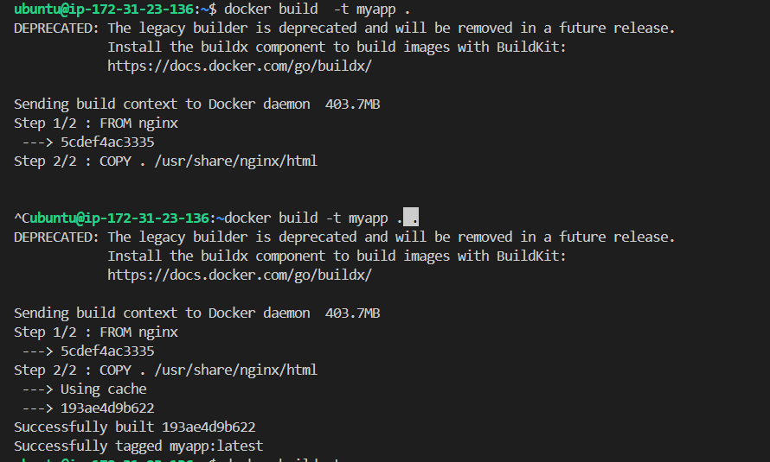
Jab humnay dusri baar docker build -t myapp . command chalayi toh humay iskay output step 2/2 k nichy cache dikh gya .
>> agar humaay nginx images ka record ka dekhna hai toh use: docker history nginx
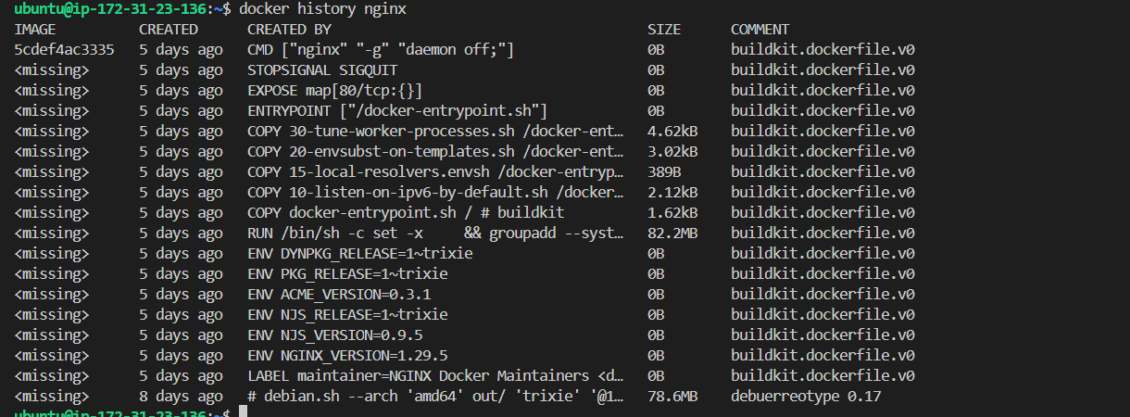

>> agar humay kisi bhi docker image ka record nikalna hai toh use ; docker history <image-name>
Example : docker history nginx , docker history myapp.
>>docker image ko delete karni k liye we use
docker rmi nginx
Local machine me stored nginx image remove ho jayegi aur disk space free ho jayega.
Possible situations:
1️⃣ Agar koi container nginx image use nahi kar raha
Image successfully delete ho jayegi:
Untagged: nginx:latest
Deleted: sha256:....
2️⃣ Agar koi running/stopped container nginx image use kar raha ho
Error aayega:
Error: conflict: unable to remove repository reference
Is case me pehle container delete karo:
docker rm <container-id>
docker rmi nginx

Force remove (agar zarurat ho)
docker rmi -f nginx
Ye forcefully image remove karega.

Docker rm vs rmi vs prune — Difference
Command | Kya delete karta hai | Example
docker rm | Containers delete karta hai | docker rm container1
docker rmi | Images delete karta hai | docker rmi nginx
docker image prune | Unused dangling images delete karta hai | docker image  prune
docker system prune | Unused containers, networks, images (dangling) sab clean karta hai
Simple samajh
- rm → container remove
- rmi → image remove
- prune → unused cheezein automatically clean

Example flow
- Container delete:
- docker rm mycontainer
- Image delete:
- docker rmi nginx
- Unused images clean:
docker image prune
day-4 create your own docker image

Learn
Dockerfile instructions
CMD vs ENTRYPOINT
Best practices
Practice
FROM openjdk:17
COPY app.jar app.jar
CMD ["java","-jar","app.jar"]
docker build -t myapp .
docker run -p 8080:8081 myapp
81 humnay dala hai bca 8080 per Jenkins chalra hai already .

>> docker-file instructions ky hoti hai?
Dockerfile instructions wo commands hoti hain jo Docker ko batati hain ki image kaise build karni hai — kaunsi base image use hogi, kaunsi files copy hongi, kaunsa software install hoga, aur container start hone par kya run hoga.
Common docker-file-instructions:
FROM : Base image define karta hai.
RUN: build k time commands ko run karta hai
COPY: local files image ke andar copy karta hai.
ADD: copy jaisi hai extra feature k saath like
automatic extract , remote url(uniform resource locator) se file download
CMD : Container start hone par default command run karta hai
ENTRYPOINT: fixed executable command set karta hai.
WORKDIR: container ka working directory set karta hai.
ENV: environment variable set karta hai
Agar humay vs doker-file-instuction ka oupt chaiy toh type
Docker build -t myapp .
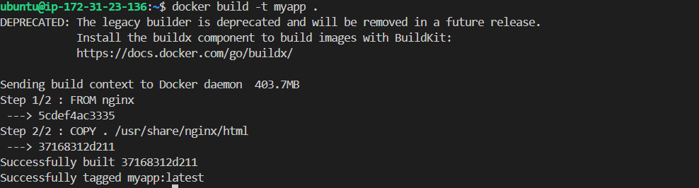

2️⃣ Agar layers detail me dekhni ho
docker history myapp
Isse har instruction ki layer aur size dikh jayegi.
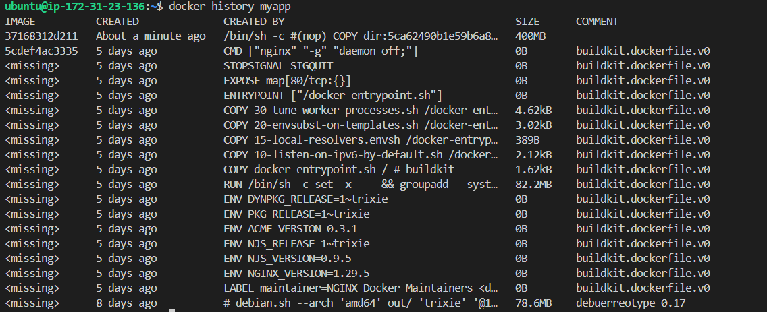

>>agar humay yeh check karna hai ki hmari kitni file hai toh
Ssh terminl * ls * tyepr kardoh output ayega
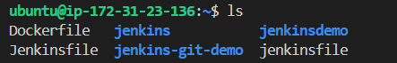

>>>Agar humay dekhna hi ki hum abhi kis folder may hai toh type pwd output ayegaa : /home/ubuntu
>>> Kisi bhi file ka folder (location/path) pata lagane ke liye
File search karke full path pata karp:
* find / -name "filename" 2>/dev/null *
Example:
find / -name "Dockerfile" 2>/dev/null
Output:
/home/ubuntu/Dockerfile
Yahan folder name hai:
/home/ubuntu >>>>>>>

>>Agar humay kisi bhi file ki exact location ya uska folder ya directory dekhni ho toh type
* find $(pwd) -name “file-name” *
output ayega like ; /home/ubuntu/jenkinsfile
agar humay current folder say ek level upper jana hai toh use
<<<* cd .. * >>uska use folder m ek level upper k liye
agar humay folder m jana hai toh use:
>>>* cd folder-name * >> hmay folder m jana toh >>>>

>>>CMD Ky hota hai?
CMD Dockerfile ki instruction hoti hai jo container start hone par run hone wali default command define karti hai.

Phele dockerfile open karo type in ssh terminal
nano Dockerfile
editor open hoga usmay yeh paste usmay fromubuntu k nichay yeh likh doh :
CMD [“echo” , “hello bro , I am Docker CMD. I run automatically when you type this command . ” ]
3️⃣ Save karo:
- Ctrl + O → Enter
- Ctrl + X → exit
Then image build karoh use: docker build -t mycmd .
Then container run karoh use;
* Docker run mycmd *
Then output will be:

>>CMD Override kya hota hai?
CMD override ka matlab hota hai ki Dockerfile me jo CMD (default command) set ki gayi hai, usko docker run command ke waqt replace (badal) kar dena.
Dockerfile
FROM ubuntu
CMD ["echo","Hello CMD"]
Normal run
docker run mycmd
Output:
Hello CMD
CMD override:
docker run mycmd ls ( yeh command hai )
Output:
ls (LS hai yeh ) command run hogi aur files list dikhengi, kyunki ls ne CMD ko replace kar diya.like this
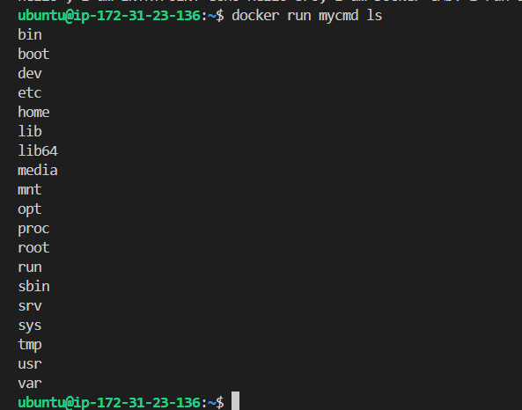
>>ENTRYPOINT KY HOTA HAI?
Ans ; ENTRYPOINT Dockerfile ki instruction hoti hai jo container start hone par fixed main command set karti hai — yani container hamesha wahi command run karega.
First nano Dockerfile then editor may yeh likh doh
FROM ubuntu
Iskay nichay likho
ENTRYPOINT ["echo","Hello, I am ENTRYPOINT"]
Commands
docker build -t myentry .
docker run myentry
Container run hote hi ENTRYPOINT me likhi command automatically execute ho gayi.
Expexted output:
Hello, I am ENTRYPOINT
Hmara output aya
Hello, I am ENTRYPOINT toh agya but iskay saath cmd vaali bhi command print hogayi bcz voh
(default) automatically run
Hoti hai agar humay yeh cmd vaaali hatni toh editor say cmd portion hta doh from ubuntu k nichay say.

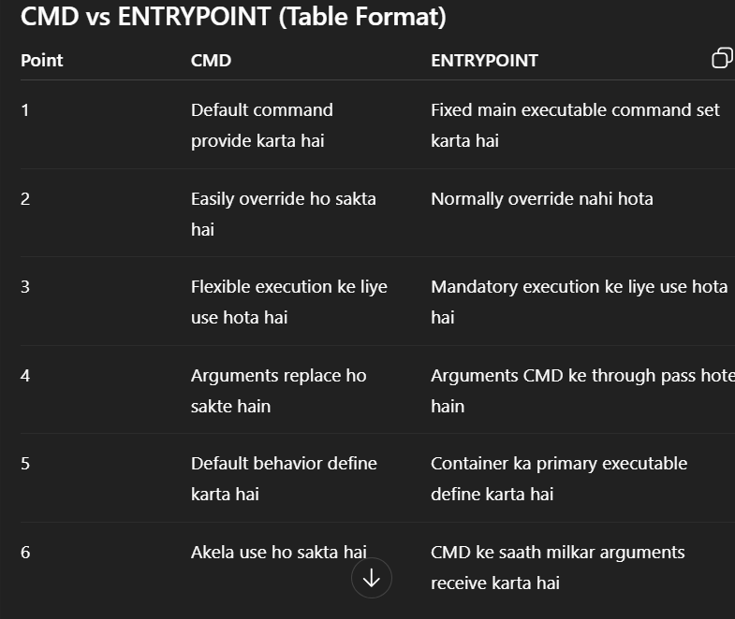
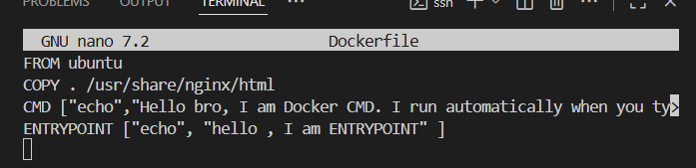
COPY . /usr/share/nginx/html line remove karne ki zarurat tab padti hai jab hum echo ka use karry ho agar echo ka use nahi karray toh remove mat karoh copy vaali line ko

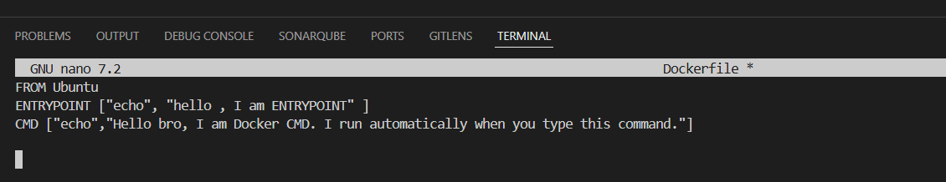
Yeh hai proper format ENTRYPOINT uper and cmd niahcy ayega

>> 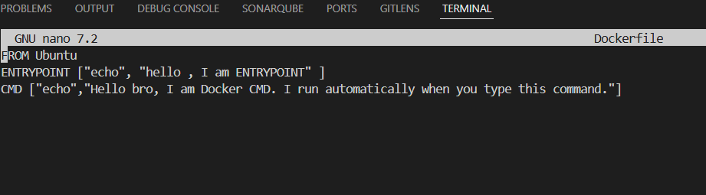
Yeh mera current editor hai ab humay yeh
FROM openjdk:17
COPY app.jar app.jar
CMD ["java","-jar","app.jar"]
Yeh chalana toh jo phele say editor m likha hai uso hta doh

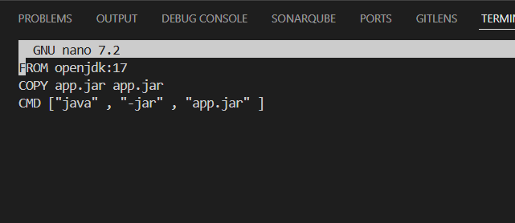
Yeh old version hai updated likhengay like this
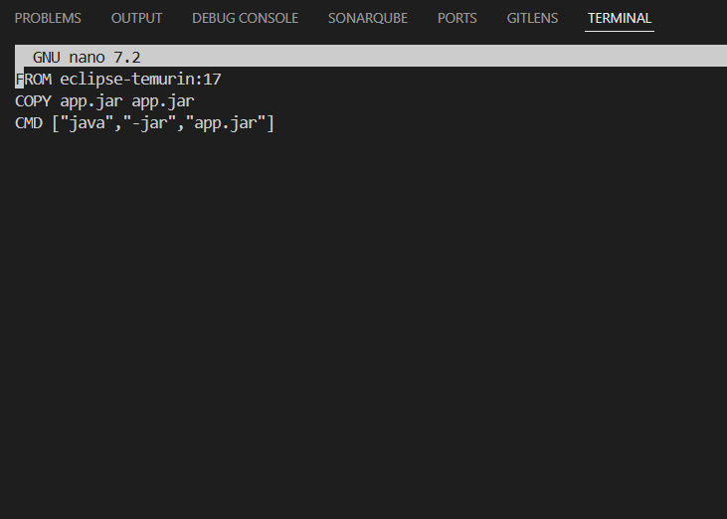
Yeh updated hai but jab isko build kiya using:
docker build -t myapp .
error aya
no main manifest attribute
Reason:
Jar file executable nahi thi, kyunki usme Main-Class (entry point) define nahi tha.
Java ko pata hi nahi chal raha tha ki program start kis class se karna hai.
Kaise thik hui:
Tumne ye steps kiye:
- Project me Main class (main() method) create ki
- pom.xml me maven-jar-plugin add kiya aur Main-Class specify ki
- mvn clean package run karke jar dubara build ki
- Jar ko Docker image me copy karke container run kiya
Ab jar ke manifest file me entry add ho gayi:
Main-Class: com.example.jenkinsdemo.MainApplication
Isliye java -jar app.jar successfully run ho gaya aur output aaya:
My Docker Java App Started

<<<< now we practically implemented >>>>>>>>>>>
Kaisay thik hua practically

Step-1: Main class create ki
* cd /home/ubuntu/jenkins-git-demo/src/main/java/com/example/jenkinsdemo *
* nano MainApplication.java *
Code: yeh code likhdoh
[
package com.example.jenkinsdemo;

public class MainApplication {
public static void main(String[] args) {
System.out.println("My Docker Java App Started");
}
}
](avoide bracktes[] yeh valay only )
Meaning:
Program ka entry point (main()) create kiya jisse Java program start hoga.
Step-2: pom.xml me plugin add kiya
* nano /home/ubuntu/jenkins-git-demo/pom.xml *
Add: yeh jo nichay code hai editor may project say just uper paste kardoh

[

<build>
<plugins>
<plugin>
<groupId>org.apache.maven.plugins</groupId>
<artifactId>maven-jar-plugin</artifactId>
<version>3.2.0</version>
<configuration>
<archive>
<manifest>
<mainClass>com.example.jenkinsdemo.MainApplication</mainClass>
</manifest>
</archive>
</configuration>
</plugin>
</plugins>
</build>
]Meaning: [] yeh valay bracket hta dena terminal may
Jar build hote waqt Main-Class manifest me automatically add ho jayegi, isliye jar executable banegi.
Step-3: Jar dubara build ki
cd /home/ubuntu/jenkins-git-demo
mvn clean package
Output (important lines):
Building jar: /home/ubuntu/jenkins-git-demo/target/jenkinsdemo-1.0-SNAPSHOT.jar
BUILD SUCCESS
Explanation:
Ab executable jar create ho gayi.
Step-4: Jar Docker folder me copy ki
cp target/*.jar /home/ubuntu/app.jar
Meaning:
Docker build context me jar available kara di.
Step-5: Docker image build ki
* cd /home/ubuntu *
* docker build -t myapp . *
Output:
Successfully built ...
Successfully tagged myapp:latest
Explanation:
Docker image successfully create ho gayi.
Step-6: Container run ki
* docker run myapp *
Output: MY Docker java App Started .
Explain: container start hotay hi java -jar app.jar run hua aur main() method execute ho gya.
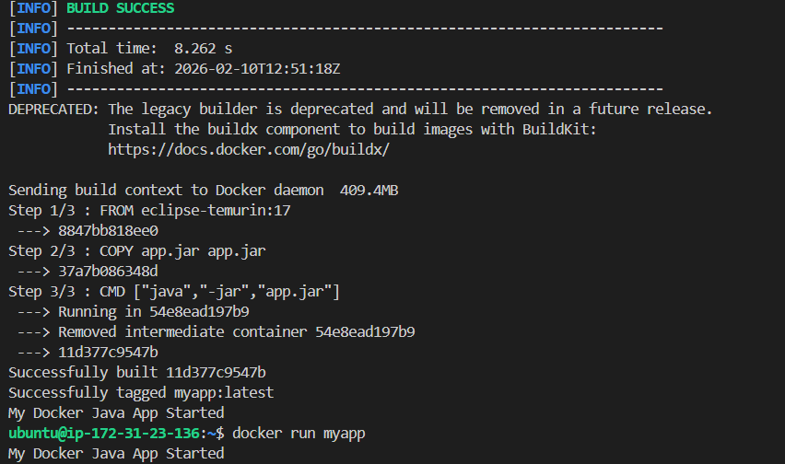
Yeh bus ek simple aap browser m nahi dikhega

Day-5 docker volume & data persistence

>>docker volume ky hoti hai?
Ans: Docker Volume ek persistent (=permanent) storage location hoti hai jahan container ka data store hota hai aur container delete hone ke baad bhi data safe rehta hai.
Simple example
Agar container ke andar koi file create hoti hai aur container delete ho jaye, to normally data delete ho jata hai.
Lekin agar data Docker volume me store ho, to container delete hone ke baad bhi data available rehta hai.
Example commands:
Volume create
docker volume create mydata
1️⃣ Volume create
docker volume create mydockervolume
(kuch bhi naam daal doh
Meaning: mydata naam ka Docker volume create karo.
Output:
Mydockervolume naam ki volume create ho gayi
2️⃣ Volume list dekhna:
docker volume ls
Meaning: System me available sab volumes ki list dikhao.
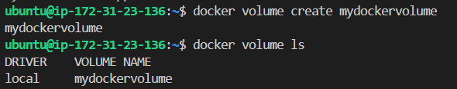

3️⃣ Volume details dekhna:
docker volume inspect mydockervolume
Meaning: Volume ka storage location aur configuration details dekho.
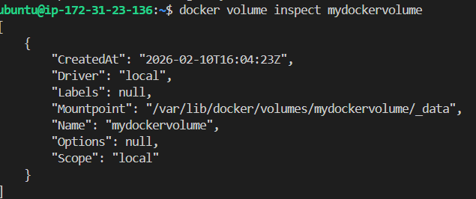
>> "Name": "mydockervolume"
→ Ye humhari volume ka naam hai.
>>> "Driver": "local"
→ Volume local system storage me store ho raha hai.
>>> Mountpoint": "/var/lib/docker/volumes/mydockervolume/_data"
→ Ye actual path hai jahan Docker system me volume ka data physically save hoga.

>>"Scope": "local"
→ Ye volume sirf is machine ke liye available hai.

4️⃣ Volume ke saath container run
docker run -d -v mydata:/data ubuntu
Meaning:
- mydata → Docker volume
- /data → container ke andar folder
Is folder ka data volume me persist rahega.

5️⃣ Volume delete:
docker volume rm mydockervolume
Meaning: mydata volume remove karo (agar use me na ho).
Output:
mydockervolume
6️⃣ Unused volumes clean
docker volume prune
Meaning: System ke sab unused volumes delete karo.
Output:
Deleted Volumes: mydockervolume
>> bind mount ky hota hai?
Ans: Bind mount Docker ka ek method hai jisme host machine ka koi specific folder directly container ke kisi folder se connect (mount) kar diya jata hai.
Matlab:
- Host ke folder me jo file create / change hogi
- Wo container ke andar bhi turant reflect hogi (aur vice versa)
Command:
docker run -v /home/ubuntu/data:/app/data ubuntu
Meaning:
- /home/ubuntu/data → host machine ka folder
- /app/data → container ke andar ka folder
Dono folders ab directly connected ho gaye.
Hum practically bind mount test karkay dkehengay

Step-by-step demo
1️⃣ Host machine par folder banao;
mkdir ~/bindtest
echo "Hello from host" > ~/bindtest/file.txt

2️⃣ Container run karo bind mount ke saath:
docker run -it -v ~/bindtest:/data ubuntu bash
Ab tum container ke andar aa jayenagy. Then usi may
Yeh commands daalo
cd /data
ls
cat file.txt
Expected output:
Hello from host
Matlab host ka file container me visible hai — bind mount kaam kar raha hai.
4️⃣ Container ke andar file change karo:
echo "Changed inside container" >> file.txt
exit
5️⃣ Host par check karo
cat ~/bindtest/file.txt
Meaning
- cat → file ka content terminal me dikhata hai
- ~ → current user ka home directory (e.g., /home/ubuntu)
~/bindtest/file.txt → home directory ke andar bindtest folder ki file.txt file
Matlab:
Home directory ke bindtest folder me jo file.txt file hai, uska content screen par dikhao
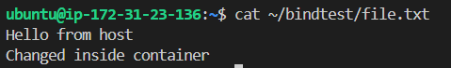
Matlab container me change host me reflect ho gaya — bind mount successfully kaam kar raha hai.

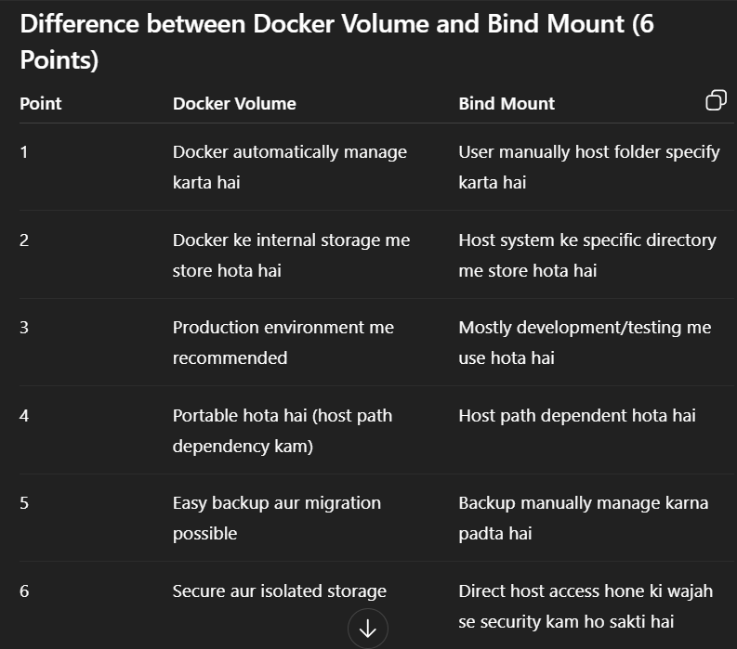
Day-6 docker networking

>>> docker networking ky hoti hai?
Ans; Docker Networking ek mechanism hai jo containers ko aapas me (container-to-container) aur host system / internet se connect karne ki facility deta hai.
Matlab:
- Containers ek dusre se communicate kar sakte hain
- Containers external network (internet) se connect ho sakte hain
- Services (web apps, databases) ek hi internal network me chal sakti hain

Simple example
Agar do containers same Docker network me hain:
- app1 → web server
- db1 → database
To app1 directly db1 se connect kar sakta hai sirf container name se.

Docker networking 4 main types
1) Bridge network → default internal container communication
2) Host network → container directly host network use karta hai
3) Overlay network → multiple Docker hosts ke containers connect karta hai
4) None network → networking disable.

>>bridge network ky hotai hai?
Ans:
Bridge network ek default network type hota hai jo Docker me use hota hai.
Iska kaam hota hai multiple containers ko aapas me connect karna, taaki wo ek hi host machine par rehkar ek-dusre se communicate kar saken.
Bridge network ek virtual private network hota hai jo Docker host ke andar banta hai aur containers ko internal IP address deta hai.
Matlab:
Container A ↔ Container B
Dono ek hi network ke through baat kar sakte hain.
>>Bridge network have 2 types :
  - default bridge network
  - use defined bridge network
🔹 Default Bridge Network ?
Jab aap simple command chalate ho:
docker run -d ubuntu
Toh container automatically default bridge network me attach ho jata hai.
Check karne ke liye:
docker network ls
Output me aapko bridge network dikhega.
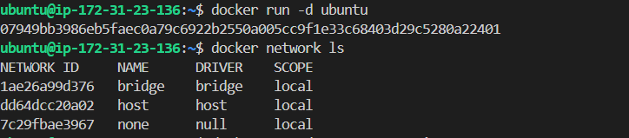
(2) User-Defined Bridge Network ky hota hau?
Better practice yeh hoti hai ki khud ka network banao:
docker network create mynetwork
Phir container run karo:
docker run -d --network mynetwork --name c1 ubuntu
docker run -d --network mynetwork --name c2 ubuntu
Ab:👉 c1 directly c2 ko name se ping kar sakta hai.
Yeh feature default bridge me nahi hota.
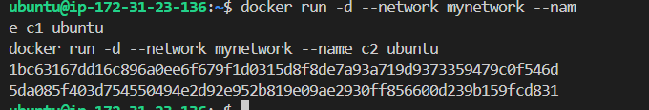
🔹 Bridge Network kaise kaam karta hai?
- Docker ek virtual interface banata hai (Linux me usually docker0)
- Har container ko ek internal IP milta hai
(jaise 172.17.0.x)
- Containers same bridge network me ho toh directly communicate kar sakte hain
- Host se access karne ke liye port mapping karni padti hai
Example: docker run -d -p 8080:80 ubutnu
Matlab:
Host ka port 8080 → Container ka port 80
🔹 Bridge Network ke Advantages
✔ Containers isolated rehte hain
✔ Easy communication
✔ Secure internal networking
✔ Custom networks bana sakte ho

>>host network ky hoti hai?
Host network ek aisa network mode hai jisme container directly host machine ka network use karta hai, alag se virtual bridge create nahi hota.
Yeh feature Docker me available hota hai.

Host network me container ka apna alag IP address nahi hota.
Woh host machine ka IP address aur ports hi use karta hai.
Matlab:
Container → Direct Host Network
🔹 Host Network kaise use karein?
Command:
docker run -d --network host ubuntu
Isme:
✔ -p (port mapping) ki zarurat nahi
✔ Container directly host ke port 80 par run karega
Agar host ka port 80 busy hai, container start nahi hoga.
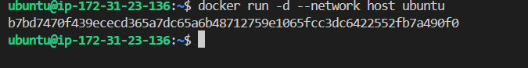

<<<<<hum dekhnegay ki host network kab use karty hai >>>>>>>>>>>>>>>>>>>>>>>>>>>>>>>>>>>>>>>>
Kab use karte hain?
✅ Jab high performance chahiye
✅ Jab network overhead kam karna ho
✅ Monitoring tools me
✅ Real-time applications me

🔹 Disadvantages
❌ Security kam hoti hai
❌ Port conflict ka risk
❌ Container isolation kam
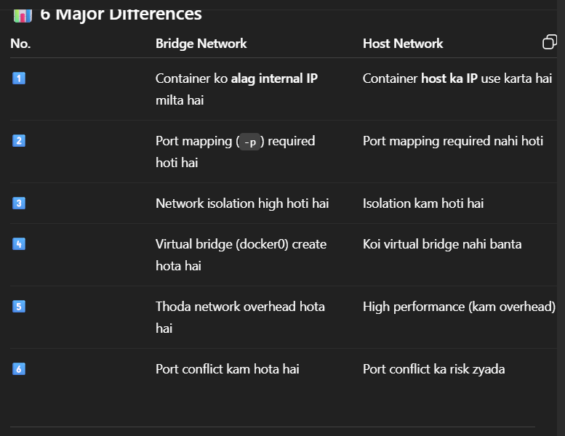

3) Overlay network ky hotay hai?
Ans: Overlay network ek advanced network type hai jo multiple Docker hosts (alag-alag machines) par chalne wale containers ko aapas me connect karta hai.
Yeh feature mainly Docker ke Swarm mode me use hota hai.

Overlay network ek virtual network hota hai jo:
✔ Different servers par chalne wale containers ko
✔ Ek hi private network jaisa connect karta hai
Ex:
Server 1 ka container ↔ Server 2 ka container
Dono ek hi network me communicate kar sakte hain.

🔹 Kab use hota hai?
✅ Jab multiple machines par containers run ho rahe ho
✅ Microservices architecture me
✅ Cluster environment me
✅ High scalability system me

🔹 Kaise kaam karta hai overlay network?
1️⃣ Pehle Swarm initialize karte hain:
docker swarm init
2️⃣ Overlay network create karte hain:
docker network create -d overlay myoverlay
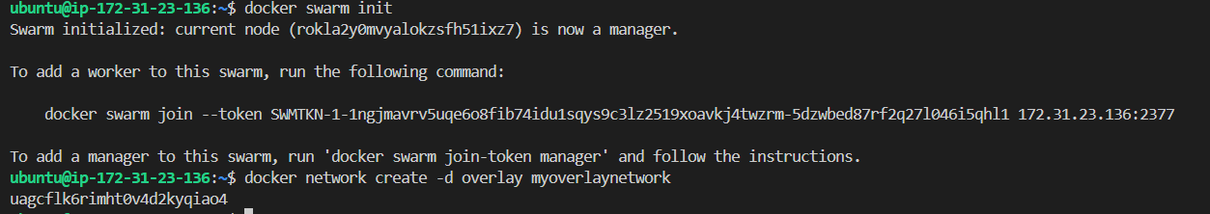
3️⃣ Containers/services ko is network me attach kar dete hain.
Ab alag-alag hosts ke containers bhi ek dusre se baat kar sakte hain.
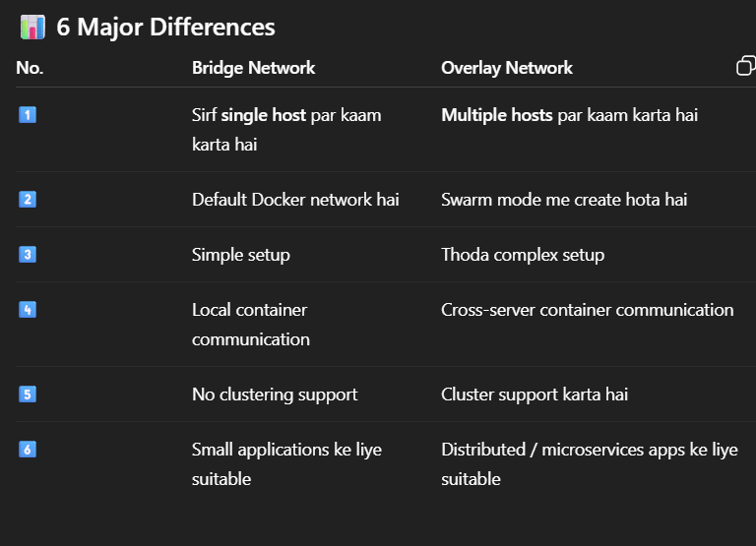

>>>none-network ky hota hai?
None network ek special network mode hai jisme container ko koi bhi network connectivity nahi di jati.
Yeh option Docker me available hota hai.
🔹 Simple Definition
None network me:
✔ Container ka koi external network connection nahi hota
✔ Na internet access
✔ Na dusre containers se communication
Matlab:
Container → Completely isolated (network ke hisaab se)
🔹 Kaise use karte hain?
docker run -d --network none ubuntu
Is command me container:
❌ Kisi network se connect nahi hoga
❌ IP address assign nahi hoga (sirf loopback milega)

🔹 Important Points
1️⃣ Sirf loopback interface (127.0.0.1) hoti hai
2️⃣ Bahar ke network se connect nahi kar sakta
3️⃣ High security isolation
4️⃣ Testing aur secure environment me useful

🔹 Kab use karte hain?
✅ Jab network ki zarurat nahi ho
✅ Security testing me
✅ Sensitive processing me
✅ Offline background jobs me

>>>service discovery ky hotay ?
Ans: Service Discovery ek mechanism hai jisme ek service (ya container) dusri service ko uske naam se automatically find aur connect kar sakti hai — bina IP address manually use kiye.
Yeh feature Docker me user-defined networks aur Swarm mode me available hota hai.
🔹 Simple Words me
Service Discovery = “Naam se service ko dhundhna aur connect karna”
Matlab agar ek container ka naam app1 hai, toh dusra container usse directly:
ping app1
ya
http://app1:80
se access kar sakta hai.

🔹 Important Points
✔ IP address yaad rakhne ki zarurat nahi
✔ Container restart hone par bhi naam same rehta hai
✔ Microservices architecture me useful
✔ Automation aur scaling me helpful
>>if we want all docker information then use
docker ps -a
🔹 Example
docker network create mynet
docker run -d --name app1 --network mynet ubuntu
docker run -it --network mynet busybox ping app1
Yaha busy box container, app1 ko naam se access kar raha hai.
Yahi service discovery hai.
But we gain error
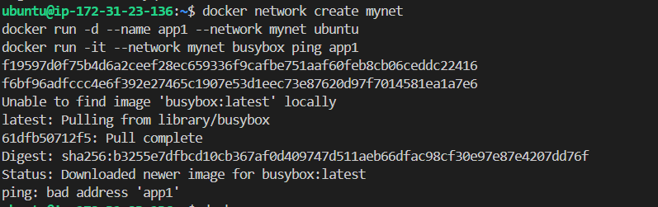

humne run kiya tha:
docker run -d --name app1 --network mynet ubuntu
Phir jab:
docker ps
chalaya — koi container running nahi tha ❌
Aur jab ping kiya:
docker run -it --network mynet busybox ping app1
Error aaya:
ping: bad address 'app1'

🔎 Problem Kya Thi?
1️⃣ Ubuntu container turant exit ho gaya
Ubuntu image default me koi service run nahi karti.
Docker container tab tak chalta hai jab tak koi main process run ho.
Ubuntu start hua → koi process nahi → container exit ho gaya.

2️⃣ Service Discovery fail ho gayi
Kyuki app1 container running hi nahi tha,
Docker ka internal DNS uska IP resolve nahi kar paaya.
Isliye:
ping: bad address 'app1'
🟢 Phir Kaise Thik Hua?
Step 1: Purana container remove kiya
docker rm app1
Kyuki name already reserved tha.
Step 2: Ubuntu ki jagah nginx use kiya
docker run -d --name app1 --network mynet nginx
Ab kya hua?
✔ Nginx ek web server hai
✔ Ye continuously background me run karta hai
✔ Container “Up” state me raha
Step 3: Ping Test
docker run -it --network mynet busybox ping app1
Output:
PING app1 (172.20.0.2)
64 bytes from 172.20.0.2 ...
✔ Naam resolve ho gaya
✔ Internal IP mil gaya
✔ Communication successful
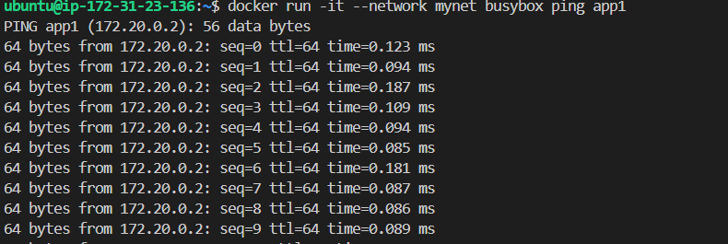
Day-7 (docker compose)

>>docker compose ky hota hai?
Ans: Docker Compose ek tool hai jisme hum ek file (docker-compose.yml) me multiple containers define karte hain, aur phir ek hi command se sab containers start ho jate hain.
🔹 Kyun Zaroori Hai?
Socho tumhari application me:
- Web server (nginx)
- Backend (node/java)
- Database (mysql)
Agar normal Docker use karo to 3 alag commands chalani padengi.
Compose me sab ek hi file me manage ho jata hai.
Docker compose up -d
Then docker compose version
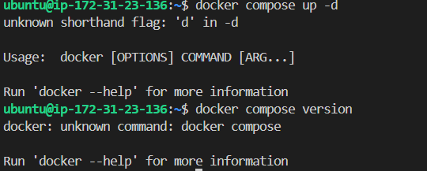

That means docker compose not installed
Now hum docker ko installed karengay
🔴 1️⃣ Pehli Problem Kya Thi?
Jab tumne run kiya:
docker compose up -d
Error aaya:
docker: unknown command: docker compose
🔎 Reason
👉 System me Docker Compose install nahi tha
👉 Sirf docker.io install tha
👉 Compose plugin missing tha

🔵 2️⃣ Phir Kya Kiya?
Tumne try kiya:
sudo apt install docker-compose-plugin
Error aaya:
Unable to locate package docker-compose-plugin
🔎 Reason
👉 System official Docker repository use nahi kar raha tha
👉 Isliye plugin package available nahi tha
🟢 3️⃣ Temporary Solution
Tumne install kiya:
sudo apt install docker-compose -y
Check kiya:
docker-compose version
Output:
docker-compose version 1.29.2
👉 Ye Docker Compose v1 (old version) tha
👉 Hyphen wali command use hoti thi:
docker-compose up -d

🔥 4️⃣ Proper Latest Installation (v2)
Phir humne:
✔ Purana docker remove kiya
✔ Official Docker repository add ki
✔ Install kiya:
sudo apt install docker-ce docker-ce-cli containerd.io docker-buildx-plugin docker-compose-plugin -y
Check kiya:
docker compose version
👉 Ab latest Docker Compose v2 install ho gaya

🔴 5️⃣ Next Problem – Docker Daemon Running Nahi Tha
Error aaya:
Cannot connect to the Docker daemon
🔎 Reason
👉 Docker service start nahi thi
✅ Fix
sudo systemctl start docker

🔴 6️⃣ Next Problem – Port Conflict
Error aaya:
failed to bind host port 8080: address already in use
🔎 Reason
👉 Port 8080 already Java application use kar rahi thi
Check kiya:
sudo lsof -i :8080
Java process mil gaya.

✅ Fix
YAML file me port change kiya:
8081:80
Phir:
sudo docker compose down
sudo docker compose up -d

🟢 Final Result
ubuntu-web-1 nginx Up 0.0.0.0:8081->80/tcp
✔ Container running
✔ Port conflict solved
✔ Compose working
✔ Multi-container setup ready
🔵 ✅ FINAL CORRECT COMMANDS (Docker Compose v2 Setup)

🧹 1️⃣ Purana Docker Remove (agar docker.io install ho)
sudo apt remove docker.io docker-compose -y
sudo apt autoremove -y

📦 2️⃣ Official Docker Repository Add karo
sudo apt update
sudo apt install ca-certificates curl gnupg -y
sudo install -m 0755 -d /etc/apt/keyrings
curl -fsSL https://download.docker.com/linux/ubuntu/gpg | sudo tee /etc/apt/keyrings/docker.asc > /dev/null
sudo chmod a+r /etc/apt/keyrings/docker.asc
echo \
"deb [arch=$(dpkg --print-architecture) signed-by=/etc/apt/keyrings/docker.asc] https://download.docker.com/linux/ubuntu \
$(. /etc/os-release && echo $VERSION_CODENAME) stable" | \
sudo tee /etc/apt/sources.list.d/docker.list > /dev/null

🔄 3️⃣ Update System
sudo apt update

🚀 4️⃣ Latest Docker + Compose Install
sudo apt install docker-ce docker-ce-cli containerd.io docker-buildx-plugin docker-compose-plugin -y

✅ 5️⃣ Verify Installation
docker --version
docker compose version

▶ 6️⃣ Docker Service Start karo
sudo systemctl start docker
sudo systemctl enable docker

🔐 7️⃣ (Optional – sudo hataane ke liye)
sudo usermod -aG docker $USER
newgrp docker

📄 8️⃣ docker-compose.yml File Banao
nano docker-compose.yml
Paste karo:
services:
web:
image: nginx
ports:
- "8081:80"
Save & exit.

🛑 9️⃣ Old Containers Stop (Clean Start)
docker compose down

▶ 🔟 Multi-Container Run
docker compose up -d

📊 1️⃣1️⃣ Check Status
docker compose ps
Expected:
0.0.0.0:8081->80/tcp
Up 1️⃣2️⃣ Port Conflict Check (Agar Zarurat Ho)
sudo lsof -i :8080

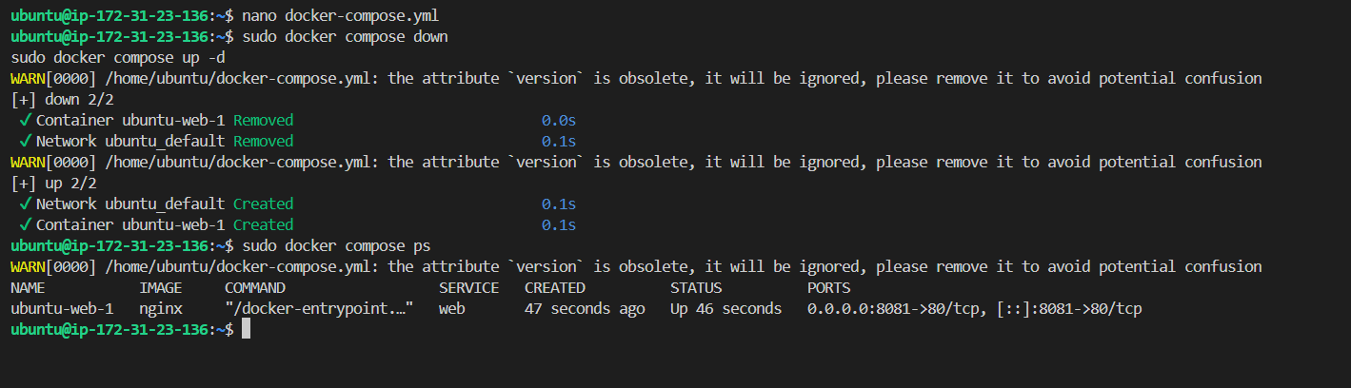
Then brower m elasti-ip:8081 yeh hoga
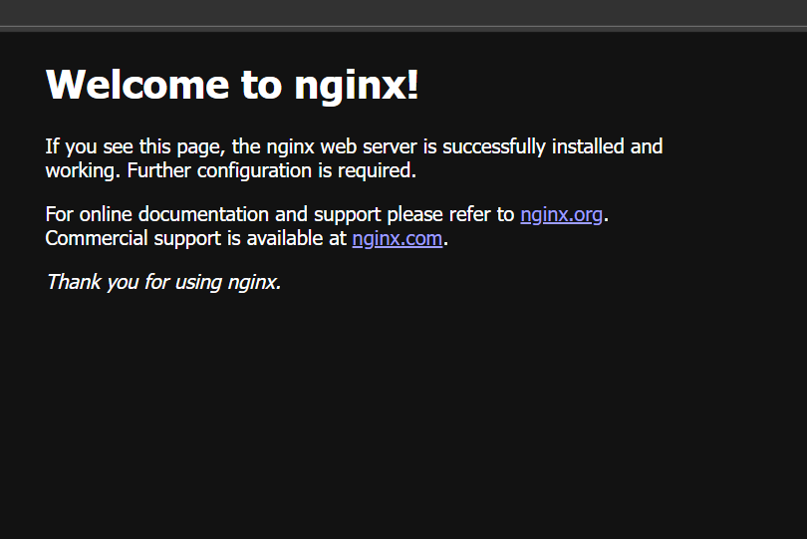
🎯 Final Result
✔ Docker installed
✔ Docker Compose v2 installed
✔ Docker daemon running
✔ Port conflict solved
✔ Nginx running on 8081

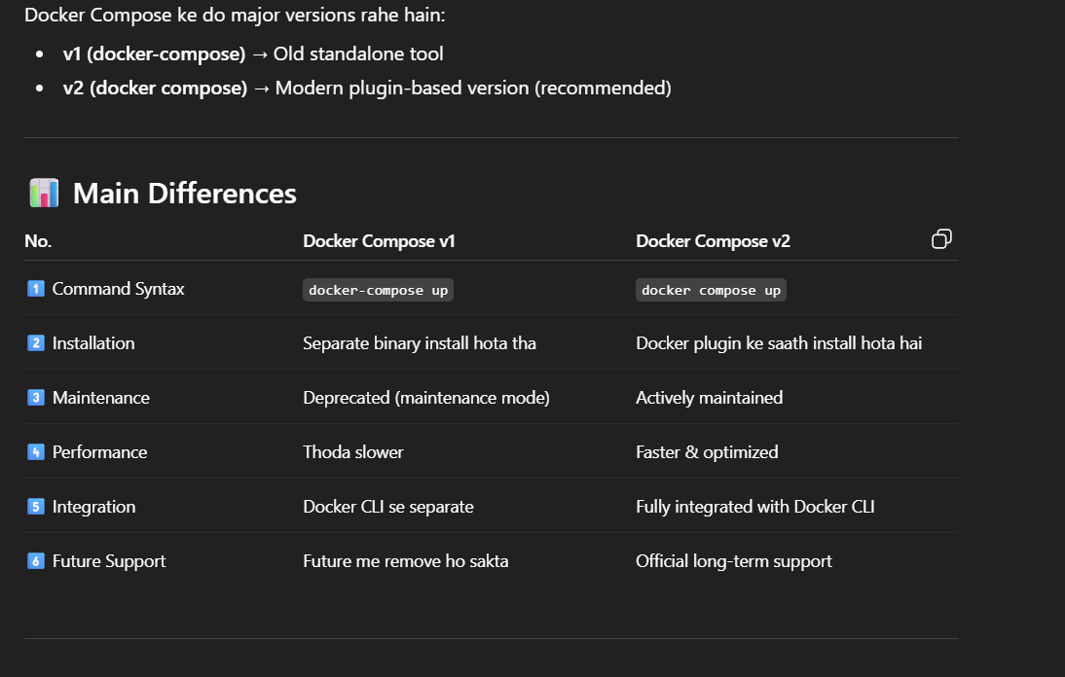

Day-8 docker+Jenkins integration
Firstly humi sikhengay ssh key step without password it is permanent solution

Perfect Sagar 🔥
Ab hum SSH key setup karte hain — permanent solution ✅
Iske baad kabhi 403, token, password issue nahi aayega.
🔐 STEP 1: Check karo SSH key already hai ya nahi
ls -la ~/.ssh
Agar id_rsa ya id_ed25519 dikhe → key already hai
Agar empty hai → new generate karenge
🔑 STEP 2: SSH Key Generate karo
ssh-keygen -t ed25519 -C "sagarvashist19-boop"
Press Enter (3 baar)
Password blank rakh sakte ho
Expected files create honge:
~/.ssh/id_ed25519
~/.ssh/id_ed25519.pub
📋 STEP 3: Public Key Copy karo
cat ~/.ssh/id_ed25519.pub
Jo long key output aaye — usko pura copy karo

🌐 STEP 4: GitHub me Add karo
1️⃣ GitHub → Profile → Settings
2️⃣ SSH and GPG keys
3️⃣ New SSH key
4️⃣ Title: EC2 Server
5️⃣ Key box me paste karo
6️⃣ Save
🔎 STEP 5: SSH Connection Test karo
ssh -T git@github.com
Agar first time hai to likhega:
Are you sure you want to continue connecting?
Type:
n
Phir output aayega:
Hi sagarvashist19-boop! You've successfully authenticated.
🔥 Matlab SSH working.
🔎 Test karoh:
ssh -T git@github.com
First time aaye to:
yes
Phir output aayega:
Hi sagarvashist19-boop! You've successfully authenticated.
🔥 Matlab SSH working.
Step6 :Remote URL Change karo
git remote remove origin
git remote add origin git@github.com:sagarvashist19-boop/jenkins-git-demo-2.git
step7 : Push karo
git push -u origin main
Ab bina password push ho jayega.
🔵 Docker + Jenkins Integration (Step by Step – Commands + Output + Meaning);
Yeh pura practical flow hai jo tum EC2 / Ubuntu server par kar sakte ho.
Step 1 – Jenkins Install
sudo apt update
👉 System packages update karta hai
Output (short):
Reading package lists... Done
Step2: sudo apt install openjdk-17-jdk -y
👉 Jenkins ko run karne ke liye Java install karta hai
Output:
Setting up openjdk-17-jdk...
Agar already Jenkins download hau toh use
Systemctl status Jenkins
Expected output: active running
Agar nahi download toh karoh
sudo apt install jenkins -y
👉 Jenkins install karta hai
Output:
Created symlink /etc/systemd/system/multi-user.target.wants/jenkins.service

sudo systemctl start jenkins
👉 Jenkins service start karta hai
sudo systemctl status jenkins
Output:
Active: active (running)
👉 Matlab Jenkins successfully run ho raha hai ✅

🐳 Step 2 – Docker Install
Agar already docker install hai toh use
Docker –version
Agar nahi download toh karoh
>>>> sudo apt install docker.io -y >>>>
👉 Docker install karta hai
Output:Setting up docker.io...

Step3: sudo systemctl start docker
👉 Docker service start karta hai
Step4: sudo docker --version
Output:
Docker version 24.x.x
👉 Matlab Docker install ho gaya ✅
🔐 Step 5 – Jenkins ko Docker Permission Dena
sudo usermod -aG docker ubuntu
>>kaisay pta kray ki hmara user mod ky hai:
STEP 1:Check karo Docker group exist karta hai ya nahi
getent group docker
Expected output:
docker:x:999:ubuntu
👉 Last me jo naam likha hai (jaise ubuntu)
Woh already docker group me added user hai.
Then Check karo Jenkins kis user ke under run ho raha hai
Run karo:
STEP2: ps -ef | grep jenkins
Ya more accurate:
systemctl show jenkins | grep User
Example output:
User=ubuntu
👉 Matlab Jenkins ubuntu user ke under run ho raha hai and Jenkins user ko docker group may add karta hai(permission deta hai)
STEP3: Jenkins ko restart karenagy nichay jayoh ab
sudo systemctl restart jenkins
👉 Permission apply karne ke liye Jenkins restart
Step 4 – Test Jenkins Docker Access
METHOD1 : method 2 sahi rahega
Jenkins Dashboard →
Manage Jenkins → Script Console
Run:
println "Test" issay better hai nichay yeh karoh
METHOD 2; YEH KAROH
Ya terminal me test karo:(best hai yeh)
sudo su - jenkins
docker ps
Output:
CONTAINER ID IMAGE COMMAND STATUS
👉 Matlab Jenkins Docker use kar sakta hai ✅
Step 5 – Sample Project Create:
mkdir docker-demo
cd docker-demo
then Dockerfile banao
nano Dockerfile

Paste:
FROM nginx
COPY . /usr/share/nginx/html
Matlab: nginx base image lo aur current folder ka data copy karo
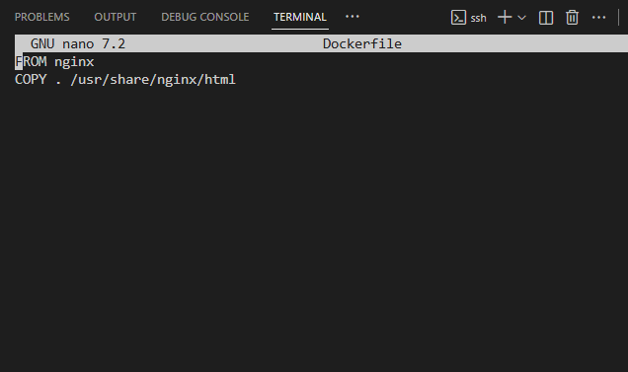

Ctrl o>then ctrl x then type
Step6: docker ps
Kuch bhi nhi ayay ismay now we type ;
Step-7 : docker ps -a
yeh saari information day dega container related
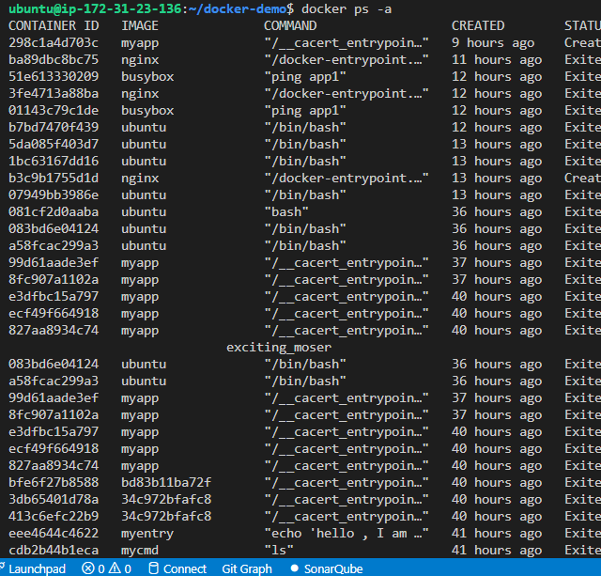

Yeh sab phele ki container and image ki information hai isay remove karengay
Type :
docker container prune -f
docker image prune -f
yeh commands purani docker container and docker images ko deltet kar dega
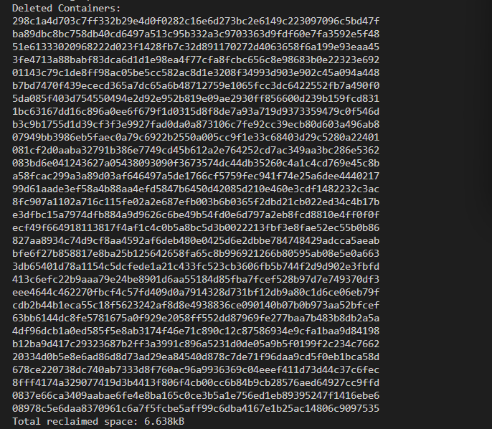

Ismay docker container unused info or exited delete done

Ismay docker image unused or exited info delete done
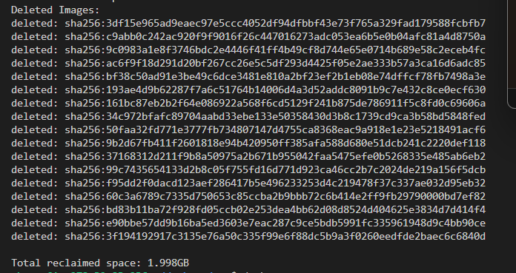
Now type:
docker ps
Abhi kuch nhi aya inmay colums so we build container.
Then we type ;
docker build -t my app .
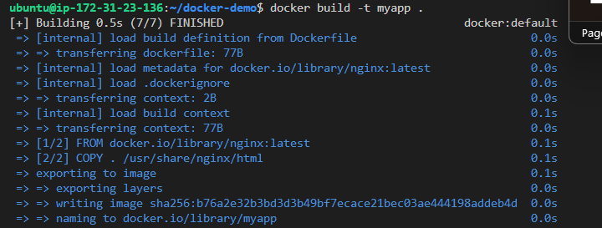
Now we check ki docker 8081 per chalra ya nhi
docker run -d -p 8081:80 --name myapp-container myapp
Yeh hamri container id hai
Now we type: docker ps
Ab dekho in coloums ki aagayi information
Perfect 🔥🔥
Screenshot se clear hai 👇
Up 8 seconds
0.0.0.0:8081->80/tcp
myapp-container
Iska matlab ✅
✔ Container successfully run ho gaya
✔ 8081 port correctly map ho gaya
✔ Nginx container andar 80 port pe chal raha hai
✔ System stable hai

🎯 Final Confirmation
Ab browser me open karo:
http://<EC2-IP>:8081
Nginx welcome page aana chahiye.
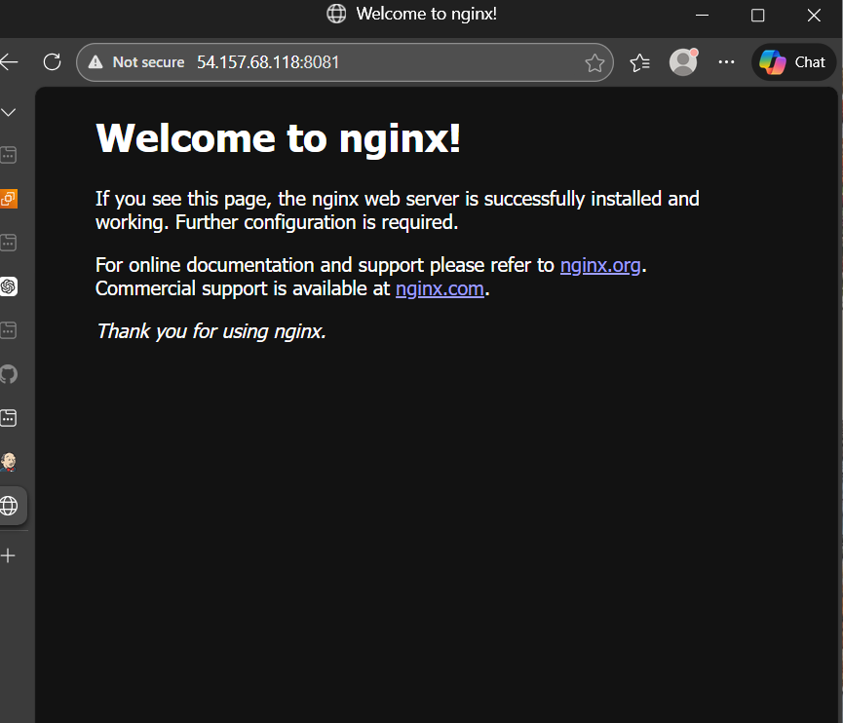
🔍 Agar Future Me Dubara Run Karna Ho
Sirf yeh command chalegi:
docker rm -f myapp-container
docker run -d -p 8081:80 --name myapp-container myapp
>>>first create freestyle job of docker:
Then Jenkins per ek freestyle docker pipeline banyoh
Create item : docker-jenkins-freestyle-pipeline then click on freestyle > then click on bulid step > select execute shell> then box docker version likhddoh then save output build success hoga .

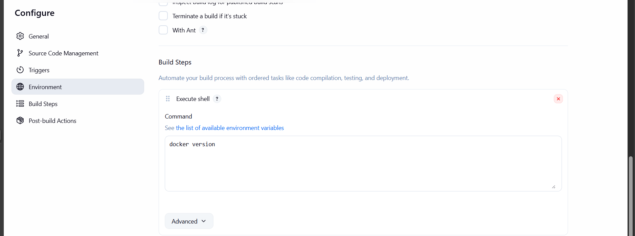

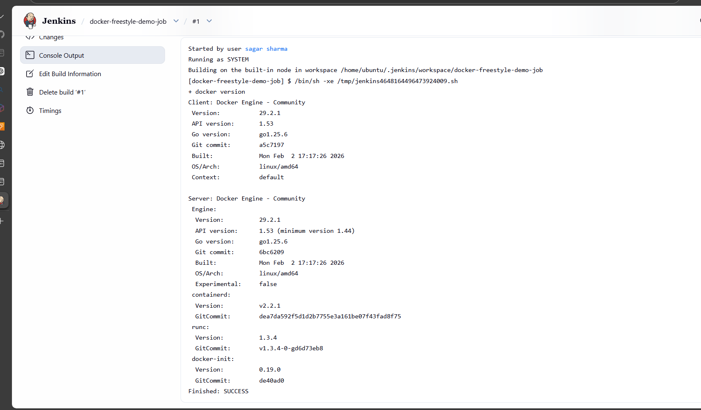

>>> nowe ab docker integrate karengay Jenkins say through pipeline script with SCM.
First github per jayoh Jenkins-git-demo-2 vaali repo may
Jenkins file add karoh
Dekho ss m likha hai add file ab add file per click kardoh usmay Jenkinsfile(capital J only) >> add karoh

Then usmay yeh code paste kardoh
[avoid brakets
pipeline {
agent any

stages {

stage('Test') {
steps {
sh 'whoami'
sh 'docker --version'
}
}

stage('Build Image') {
steps {
sh 'docker build -t myapp .'
}
}

stage('Run Container') {
steps {
sh """
docker rm -f myapp-container || true
docker run -d -p 8081:80 --name myapp-container myapp
"""
}
}

}
}

] avoid brakets

Is code ka matlab dekhengay
🔹 pipeline {
👉 Yeh Jenkins ko batata hai ki yeh Declarative Pipeline hai.
Yahin se poori pipeline start hoti hai.
🔹 agent any
👉 Jenkins bolega:
"Jo bhi available machine/agent ho, uspe yeh pipeline run kar do."
Matlab specific server define nahi kiya — kisi bhi available node par run ho sakti hai.
🔹 stages {
👉 Pipeline ke andar multiple stages (steps ke groups) hote hain.
Har stage ek logical part hota hai (Test, Build, Deploy etc.)
🟢 Stage 1
🔹 stage('Test') {
👉 Is stage ka naam Test hai.
Console output me yeh naam dikhega.
🔹 steps {
👉 Is stage ke andar jo commands chalengi woh yahan likhte hain.
🔹 sh 'whoami'
👉 Linux command run karega.
Yeh batata hai Jenkins kis user se command chala raha hai.
Example output: Jenkins ya ubuntu say
🔹 sh 'docker --version'
👉 Docker installed hai ya nahi check karta hai.
Version print karega.
Example:
Docker version 29.2.1
🟢 Stage 2
🔹 stage('Build Image') {
👉 Yeh stage Docker image banane ke liye hai.
🔹 sh 'docker build -t myapp .'
👉 Iska matlab:
- docker build → image build karo
- -t myapp → image ka naam do myapp
- . → current folder se Dockerfile use karo
Result:
Successfully built ...
Successfully tagged myapp
🟢 Stage 3
🔹 stage('Run Container') {
👉 Yeh stage container run karega.
🔹 sh """
👉 Multi-line shell command start ho rahi hai.

🔹 docker rm -f myapp-container || true
👉 Pehle agar purana container exist karta hai to delete karo.
- rm -f → force remove
- || true → agar container exist nahi karta to error ignore karo
Matlab build fail nahi hoga.

🔹 docker run -d -p 8081:80 --name myapp-container myapp
👉 Iska matlab:
- docker run → container start karo
- -d → background me run karo
- -p 8081:80 → server ka port 8081 container ke port 80 se map karo
- --name myapp-container → container ka naam
- myapp → kaunsi image use karni hai

now then usi repo yani Jenkins-git-demo-2 may: Dockerfile may
FROM nginx:latest
COPY . /usr/share/nginx/html
Yeh paste kardoh then save commit .
Then Jenkins open karoh
>>New item; docker-jenkins-integerate-test then click pipeline then pipeline-script from scm select karoh
Then SCM: git
Repo m url daalo doh jenkins-git-demo-2 vaali ka bcz usi may hmari Jenkinsfile and Dockerfile hai
Repo url:
https://github.com/sagarvashist19-boop/jenkins-git-demo-2.git
credential : none
branch speicifier: */main
Script path: Jenkinsfile(capital J)
Then save > then build now

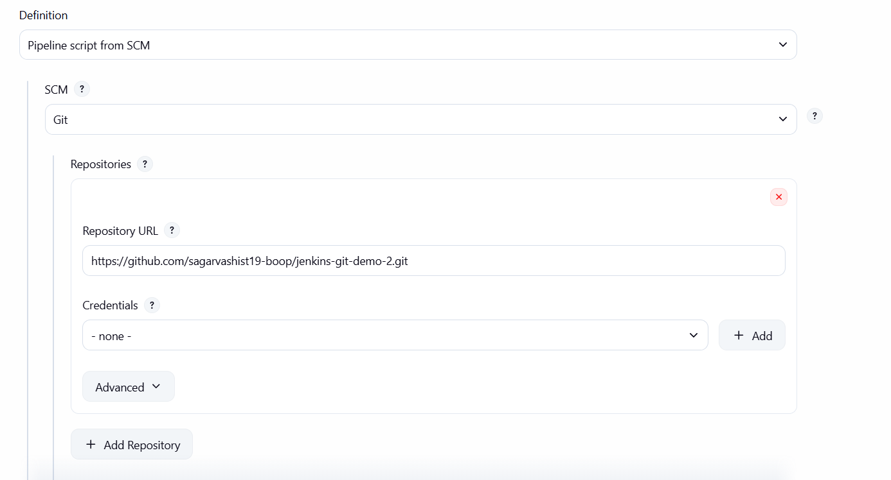

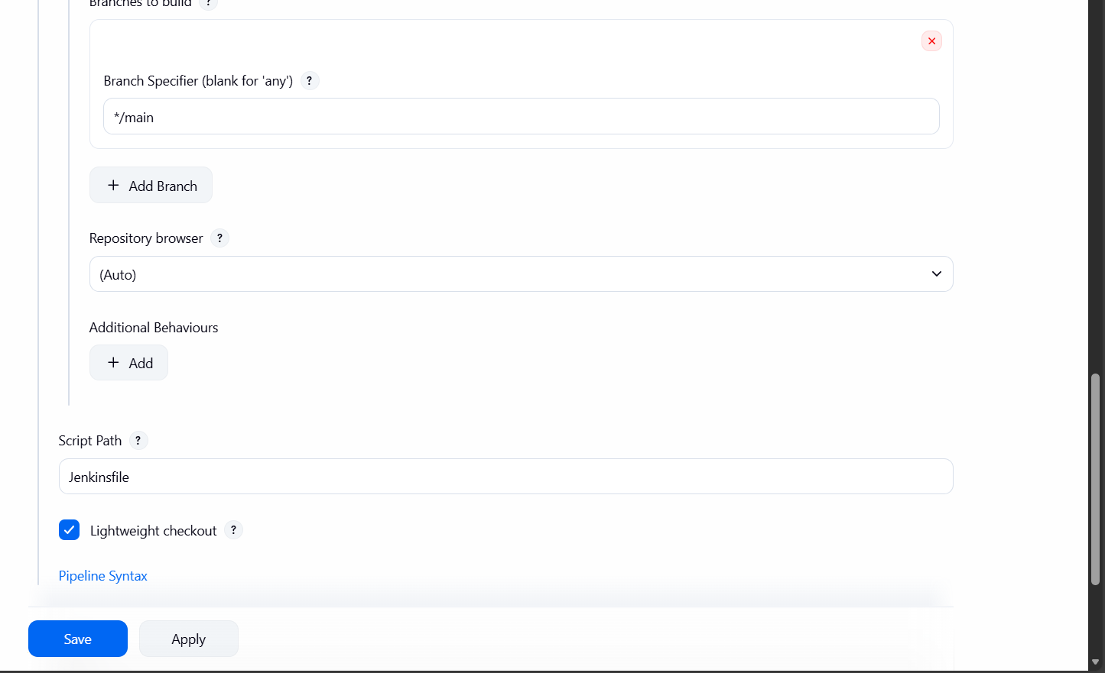

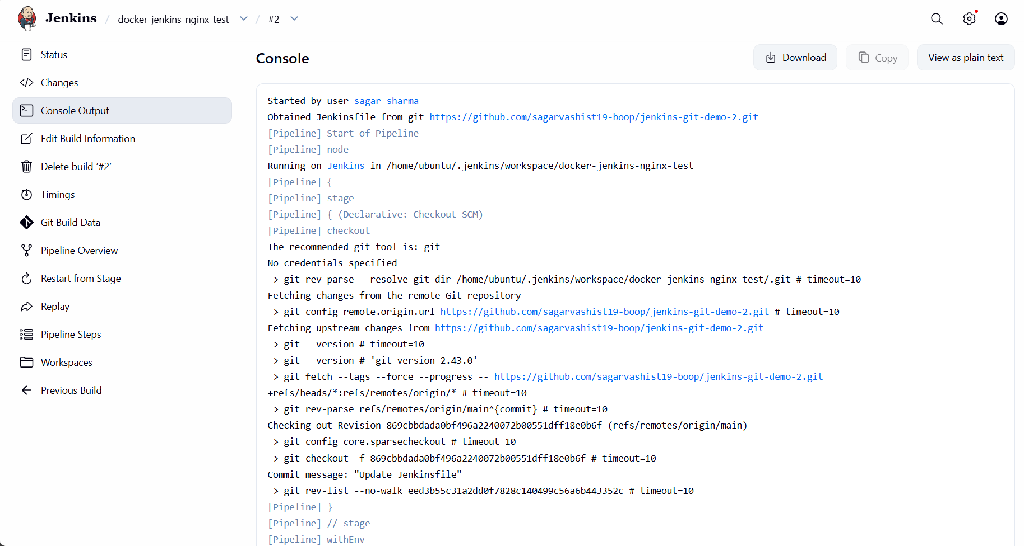

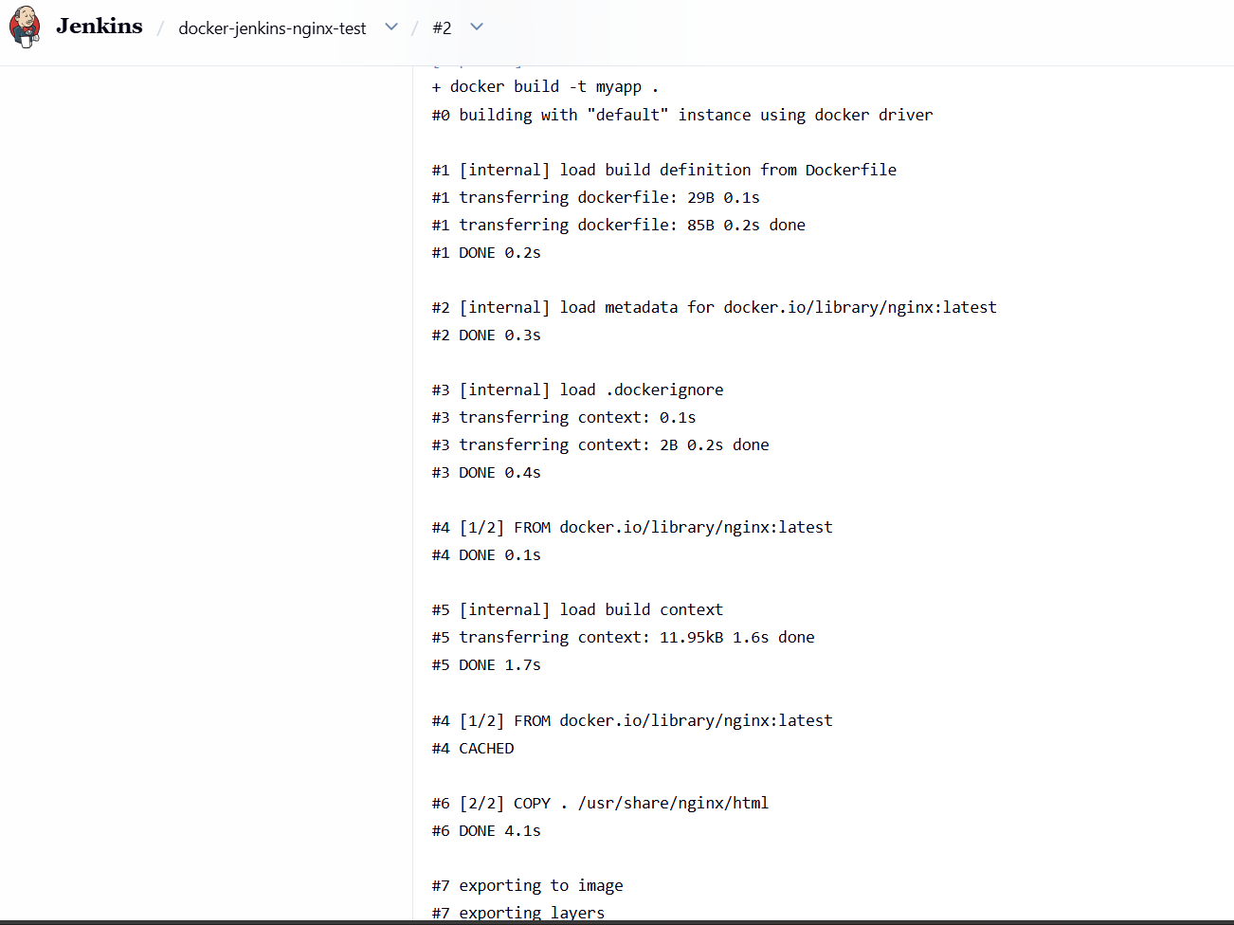

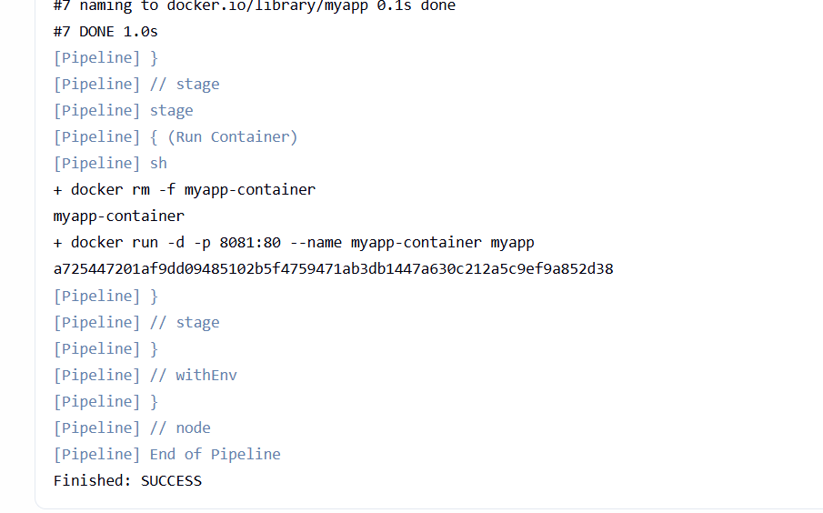

Pehle wala (Maven wala Dockerfile) kyun nahi chal raha tha?
🎯 Real Reason
Tumhara pehla Dockerfile yeh kar raha tha:
RUN mvn clean package -DskipTests
Matlab:
👉 Docker image build ke andar Maven project compile ho raha tha
👉 JAR file ban rahi thi
👉 Dependencies download ho rahi thi

🔥 Problem Kya Hui?
1️⃣ First time Maven build heavy hota hai
- Maven internet se dependencies download karta hai
- 2–4 minute lag sakte hain
- Kabhi kabhi 5 minute bhi

2️⃣ Jenkins Build Interrupt Ho Gaya
Console me yeh line thi:
Sending interrupt signal to process
After 20s process did not stop
Finished: ABORTED

Matlab:
👉 Jenkins restart hua
ya
👉 Tumne build stop kar diya
ya
👉 System resource issue tha
Isliye build complete hone se pehle abort ho gaya.

🧠 Important Difference
🟢 Simple nginx Dockerfile
FROM nginx
COPY .
✔ 15–20 sec me build
✔ No Maven
✔ No internet dependency
🔴 Maven Dockerfile
RUN mvn clean package
❌ Heavy process
❌ Time consuming
❌ Internet required

Pehla wala nahi chal raha tha kyunki:
👉 Maven build time le raha tha
👉 Build abort ho gaya
Docker + Jenkins integration me koi problem nahi t
🏗 Multi-Stage Build Kya Hota Hai?
Ek stage me build karte hain (Maven + dependencies)
Dusri stage me sirf final JAR copy karte hain (lightweight image)

Yeh bohotnheavy hota hai toh avoid karoh .

Day-9(docker registery and security )

>>docker hub ky hota hai?
Ans: DockerHub ek cloud-based Docker image registry hai jahan:
- 📦 Docker images store hoti hain
- 🌍 Images duniya bhar me share ki ja sakti hain
- 🚀 Images ko kisi bhi server pe pull karke run kiya ja sakta hai
Simple words me:
DockerHub = Docker images ka GitHub
📦 Example se samjho
Jaise GitHub pe tum code push karte ho:
git push origin main
Waise DockerHub pe tum image push karte ho:
docker push username/myapp

🏗 DockerHub ka kaam kya hai?
1️⃣ Image Store karna
Tum local image ko cloud me upload kar sakte ho.
2️⃣ Image Share karna
Team members ya production server image pull kar sakte hain.
3️⃣ Official Images provide karna
Jaise:
- nginx
- mysql
- redis
- ubuntu
- node
Tumne bhi use kiya tha:
docker pull nginx
Ye nginx DockerHub se hi aata hai.

🔄 Real Flow
- Developer → Image build karta hai
- DockerHub → Image store karta hai
- Server / Cloud → Image pull karke container run karta hai

🌍 Example
Tumne kiya tha:
docker push sagar44827/myapp:latest
Iska matlab:
- Image cloud me store ho gayi
- Ab kisi bhi machine pe run ho sakti hai:
docker pull sagar44827/myapp
docker run sagar44827/myapp

>>> Docker Registry kya hoti hai?
Ans: Docker Registry ek storage system hota hai jahan Docker images store aur manage ki jaati hain.
Simple words me:
Docker Registry = Docker images ka store / warehouse
🏗 Samajhne ke liye example;
Jaise:
- 📂 GitHub → Code store karta hai
- 📦 Docker Registry → Docker images store karti hai

🔄 Docker Registry ka kaam :
1️⃣ Image store karna
2️⃣ Image version manage karna (tags jaise latest, v1, v2)
3️⃣ Image ko network par share karna
4️⃣ Production server ko image provide karna

🌍 Types of Docker Registry
2 type hai 1) public registry 2) private registry
1️⃣ Public Registry:
Sab log access kar sakte
Example:
- DockerHub (sabse popular)
docker pull nginx
Ye nginx public registry se aata hai.
2️⃣ Private Registry:
Sirf authorized users access kar sakte
Companies apni internal registry use karti hain:
- DockerHub Private Repo
- AWS ECR
- GitHub Container Registry
- Self-hosted registry

>>Image tag ky hotay hai?
Ans:
Image Tagging ka matlab hai Docker image ko version ya name label dena taaki usko identify aur manage kar sakein.
Simple words me:
Tag = Image ka version naam
📦 Example se samjho:
Agar tum image build karte ho:
docker build -t myapp .
Yeh actually hota hai:
myapp:latest
👉 Yahan:
- myapp = image name
- latest = tag

🎯 Tag ka structure:
imagename:tag
Example:
nginx:latest
nginx:1.25
myapp:v1
myapp:prod
myapp:dev

🔥 Tag kyun important hai?
Without tag:
- Har build latest ko replace karega
- Old version ka record nahi milega
With tag:
- Multiple versions store kar sakte ho
- Rollback kar sakte ho
- Dev, Test, Prod alag versions bana sakte ho

🛠 Practical Example
1️⃣ Build image
docker build -t myapp:v1 .
2️⃣ Naya version
docker build -t myapp:v2 .
3️⃣ Images check
docker images
Output:
myapp v1 123abc
myapp v2 456def

🔄 Tag rename karna:
Agar humhare paas image hai:
myapp:latest
Use DockerHub ke liye tag karna:
docker tag myapp:latest sagar44827/myapp:v1
Yahan:
- Local image = myapp:latest
- New tag = sagar44827/myapp:v1

🧠 Real DevOps Use
Production me:
myapp:v1.0.0
myapp:v1.0.1
myapp:v2.0.0
Isse:
- Stable releases maintain hoti hain
- Bugs aaye to previous version par rollback possible hota hai
>>container security ky hota hai:
Ans:Container Security ka matlab hai Docker containers ko unauthorized access, attacks, aur vulnerabilities se protect karna.
Simple words me:
Container Security = Container ko secure rakhna taaki koi hacker ya malware usko misuse na kar sake.
🧠 Container insecure kyun ho sakta hai?
Container ke andar:
- OS libraries hoti hain
- Application code hota hai
- Open ports hote hain
- Internet access hota hai
Agar properly secure nahi kiya → attack ho sakta hai.

🔥 Container Security ke Main Areas:
1️⃣ Image Security
Image me vulnerabilities ho sakti hain.
Example:
FROM ubuntu:latest
Old version hua → security risk.
✔ Secure practice:
- Minimal base image use karo (alpine)
- Regularly update karo
- Image scan karo
2️⃣ Root User Avoid Karna:
Default container root user se run hota hai.
⚠ Risk:
Agar hack hua → full system access mil sakta hai.
✔ Secure practice:
Dockerfile me:
RUN adduser -D appuser
USER appuser
Ab container root se nahi chalega.

3️⃣ Unnecessary Ports Avoid:
Agar unnecessary ports open kar diye:
docker run -p 0.0.0.0:80:80
Risk badhta hai.
✔ Sirf required ports expose karo.
4️⃣ Secrets Hardcode Mat Karo:
Galat practice:
ENV DB_PASSWORD=123456
✔ Secure practice:
Environment variables ya secret manager use karo.
5️⃣ Image Signing & Scanning:
Tools:
- Docker Scout
- Trivy
- Clair
Image scan karte hain vulnerabilities ke liye.

🛡 Example Secure Dockerfile:
FROM eclipse-temurin:17-jdk-alpine
RUN adduser -D appuser
USER appuser
WORKDIR /app
COPY app.jar .
EXPOSE 8080
ENTRYPOINT ["java","-jar","app.jar"]

✔ Lightweight image
✔ Non-root user
✔ Minimal attack surface

🏆 Real DevOps Practice
Container Security includes:
✔ Secure base images
✔ Non-root user
✔ Image scanning
✔ Secrets management
✔ Network restrictions
✔ Regular updates

🔧 Basic Working
Step 1 – Image build
docker build -t myapp .
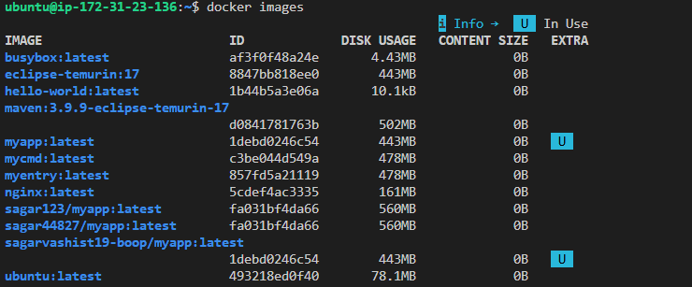
Step 2 – Tag image
docker tag myapp sagar44827/myapp
Step 3 – Push to registry
docker push sagar44827/myapp
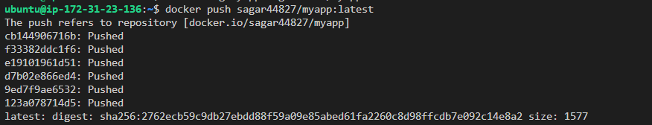
Step 4 – Kisi aur machine pe pull
docker pull sagar44827/myapp
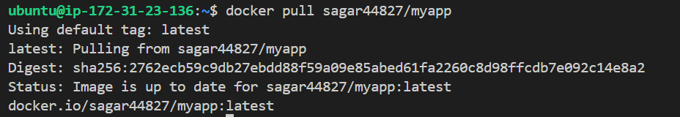
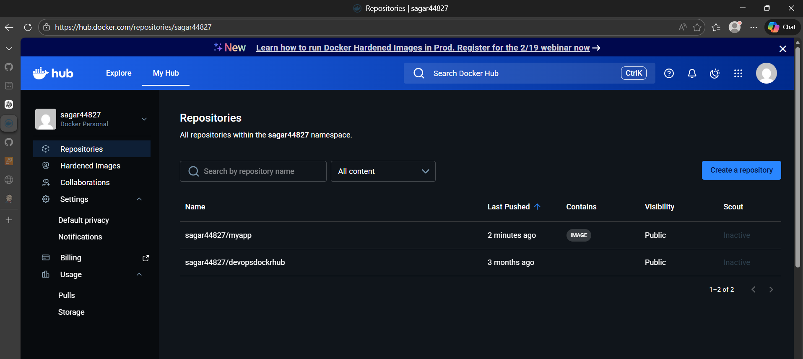

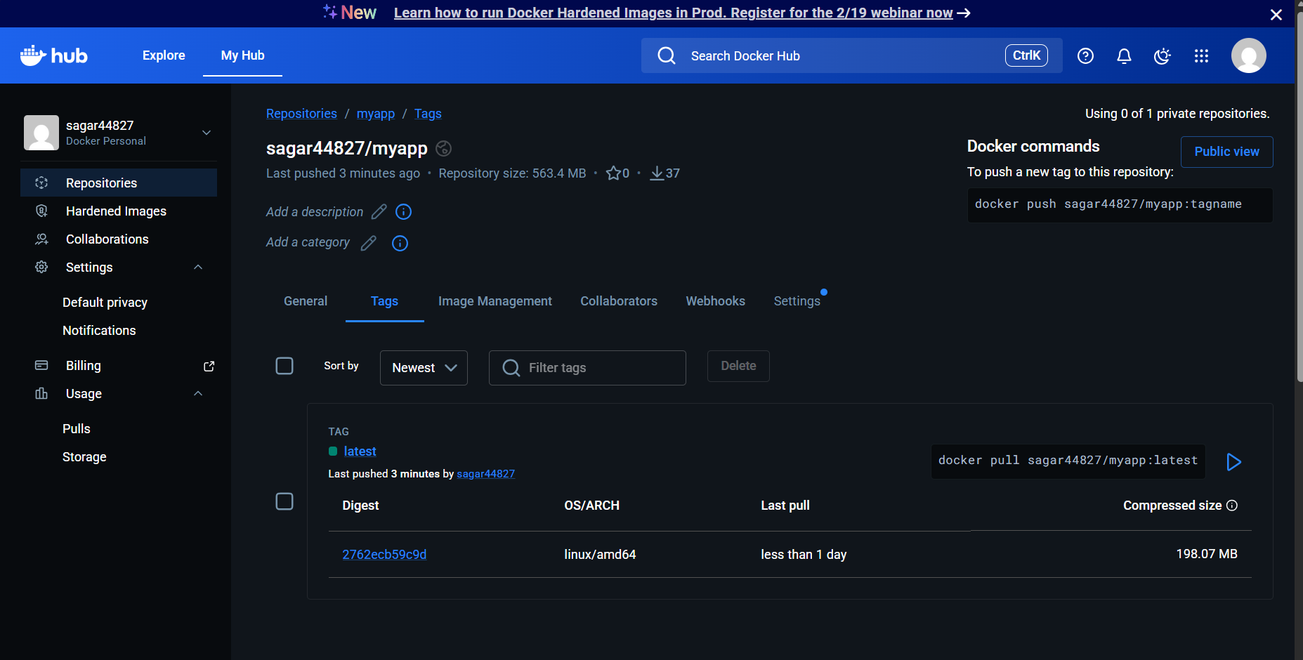

📦 Visual Flow
Developer → Build Image
⬇
Docker Registry → Store Image
⬇
Server → Pull Image → Run Container

Day -10 advanced docker+real ci/cd project
Aaj hum banayenge production-style CI/CD project:
GitHub → Jenkins → Build → Docker Image → Push → Deploy on EC2
Saath me seekhenge:
- ✅ Multi-stage build
- ✅ Image optimization
- ✅ Cleanup strategies
- STEP 1 – Project Folder Me Jao
Sabse pehle apne project ke folder me jao jahan pom.xml file hai.

🔹 Command:
cd ~/jenkins-git-demo-2

Matlab:
- cd = change directory
Ye tumhe project ke main folder me le jaata hai.

🔍 Confirm Karo pom.xml Hai

🔹 Command:
ls

Expected Output:
pom.xml
src
Dockerfile

🚀 STEP 2 – Project Build Karo:

🔹 Command:
mvn clean package

Is Command Ka Matlab:
Part | Meaning
Mvn | Maven tool run karna
Clean | Purani build (target folder) delete karta hai
package | Project ko compile karke JAR banata hai

🖥 Expected Output (Successful Build)
Console me bohot logs aayenge, last me important line hogi:
[INFO] BUILD SUCCESS
Aur ye line bhi dikhegi:
Building jar: target/jenkins-git-demo-2-0.0.1-SNAPSHOT.jar

📂 STEP 3 – Jar File Check Karo

🔹 Command:
ls target

Expected Output:
jenkins-git-demo-2-0.0.1-SNAPSHOT.jar
👉 Matlab JAR successfully generate ho gayi ✅

- 🔎 STEP 4 – Jar Run Karke Test Karo

🔹 Command:
java -jar target/*.jar

Expected Output (Spring Boot Web App Ho To):
Tomcat started on port(s): 8080
Started Application in 5.123 seconds
- 👉 Agar ye message aaya → app running hai 🎉
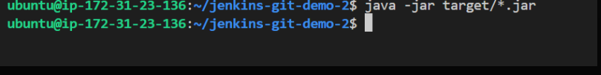
Kio output nahi aya bcz yeh application web app nahi hai only console app hai
Check karnay k liye type : docker logs myapp-container >output may humay My Docker Java App Started dikhega

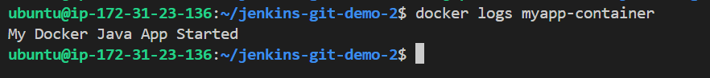
🎯 Important Concept:
Type | Behaviour
Console App | Run → Print → Exit
Web App | Run → Server start → Background me chalta rahe

>>>>>>go step 5>>>>>>>>>>

🐳 STEP 5– Multi-Stage Dockerfile Banana:
Project root me file banao:
nano Dockerfile
Paste this 👇
FROM maven:3.9.6-eclipse-temurin-17 AS build
WORKDIR /app
COPY . .
RUN mvn clean package -DskipTests

FROM eclipse-temurin:17-jre-alpine
WORKDIR /app
COPY --from=build /app/target/*.jar app.jar
EXPOSE 8080
CMD ["java","-jar","app.jar"]

🧠 Line-by-Line Meaning
🔹 FROM maven:3.9... AS build
Build stage — Maven + Java use karte hain.
🔹 mvn dependency:go-offline
Dependencies pehle download kar leta hai (faster rebuild).
🔹 COPY --from=build
Sirf final JAR copy hoti hai.
Maven image copy nahi hoti → lightweight image.
Step6:– Docker Image Build
docker build -t sagar44827/springapp:v1 .
📌 Matlab
Image create kar rahe ho Dockerfile se.
🖥 Output
Successfully built 8a7c9e...
Successfully tagged sagar44827/springapp:v1

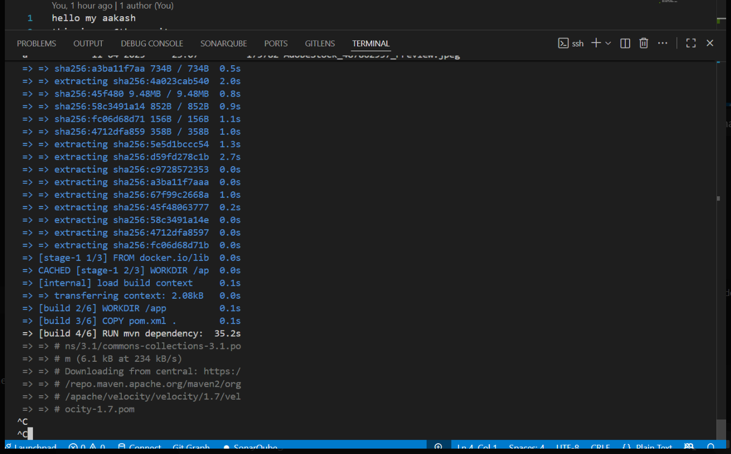

Iska matlab hai error nahi yeh dependencies ko download karra hai thoda time leta hai normal hai yeh bohot slow tha humnay nano Dockfile may change kiya tha usmay humnay mvn clean package -DskipTests line add kardi thi then uskay baad
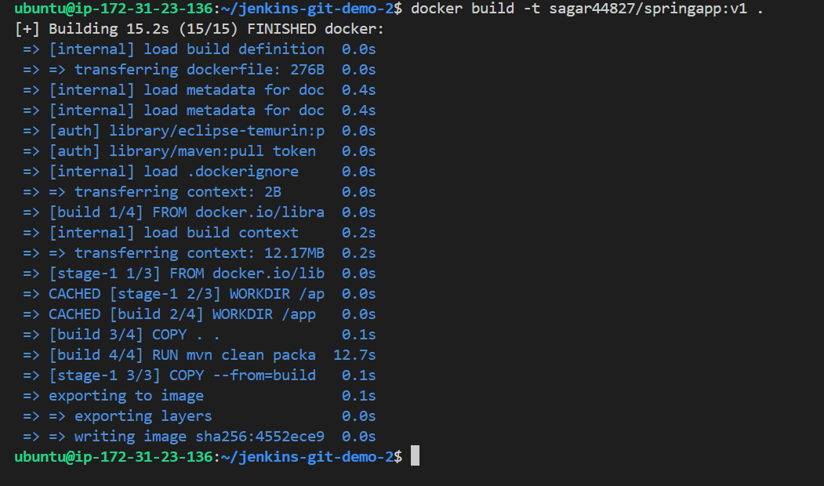
That means buld successful hua
🧹 STEP 7 – Cleanup Strategy
Old containers remove:
docker rm -f spring-container || true
Old unused images clean:
docker image prune -f (yeh use karoh )
📌 Matlab
Unused images delete karta hai.
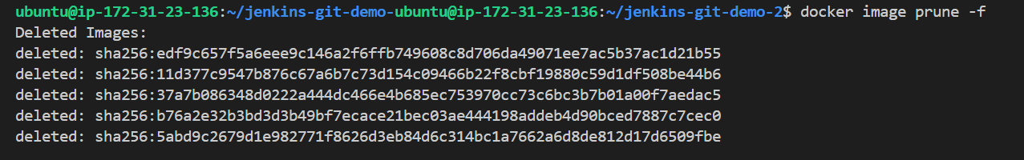
🚀 STEP 8– Run Container
docker run -d -p 8081:8080 --name spring-container sagar44827/springapp:v1
📌 Matlab
- -d → background me
- 8081:8080 → host port → container port
Then check : docker ps
Kio output nahi aya
Now we do
Type: nano pom.xml
Editor khulega yeh paste kardoh
[avoid this bracktet
Yha say start hai
<project xmlns="http://maven.apache.org/POM/4.0.0"
xmlns:xsi="http://www.w3.org/2001/XMLSchema-instance"
xsi:schemaLocation="http://maven.apache.org/POM/4.0.0
http://maven.apache.org/xsd/maven-4.0.0.xsd">

<modelVersion>4.0.0</modelVersion>

<parent>
<groupId>org.springframework.boot</groupId>
<artifactId>spring-boot-starter-parent</artifactId>
<version>3.2.5</version>
</parent>

<groupId>com.example</groupId>
<artifactId>springapp</artifactId>
<version>0.0.1-SNAPSHOT</version>

<properties>
<java.version>17</java.version>
</properties>

<dependencies>
<dependency>
<groupId>org.springframework.boot</groupId>
<artifactId>spring-boot-starter-web</artifactId>
</dependency>
</dependencies>

<build>
<plugins>
<plugin>
<groupId>org.springframework.boot</groupId>
<artifactId>spring-boot-maven-plugin</artifactId>
</plugin>
</plugins>
</build>

</project>

] avoid this bracket then ctrl o > enter then ctrl x> enter
humnay jar phele hi set up Karli thi toh
now type; mvn clean package -DskipTests
ab jaldi output milega
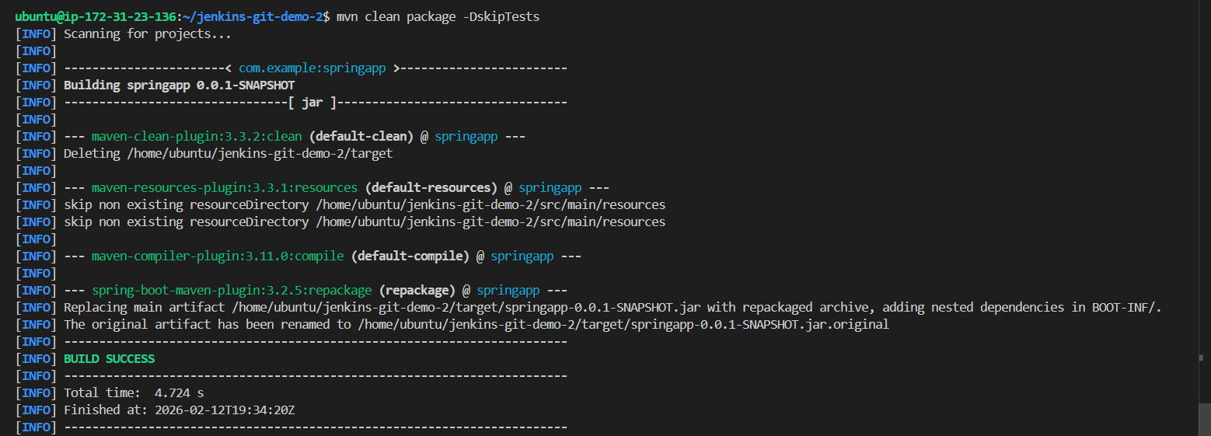

then type; docker build -t springapp .
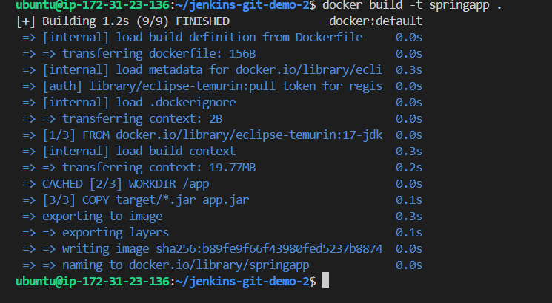
Hmara finish hua build jaldi output aya .
Now type; docker ps -a
Hmay ismay spring -container dikhjayega
Then type; docker logs spring-container
Yeh hmay hello world print karkay dega
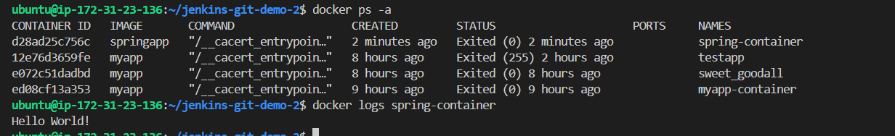

Yeh hmari only console app hai hum isay ab web app baneyngay

🧭 STEP 1 – Sahi Location Par Jao
Pehle check karo structure:
ls src/main/java
Agar com folder dikhe → next step.
Ab andar jao type :
cd src/main/java/com/example
STEP 2 – Check karo HelloController bana hai ya nahi
ls src/main/java/com/example
Agar HelloController.java nahi dikhe to banao:
nano src/main/java/com/example/HelloController.java
Paste this:
package com.example;
import org.springframework.web.bind.annotation.GetMapping;
import org.springframework.web.bind.annotation.RestController;
@RestController
public class HelloController {
@GetMapping("/")
public String hello() {
return "Hello brother from Spring Boot running inside Docker!";
}
}
Save karo.

STEP 3 – Clean Build Again
mvn clean package -DskipTests
Expected:
BUILD SUCCESS
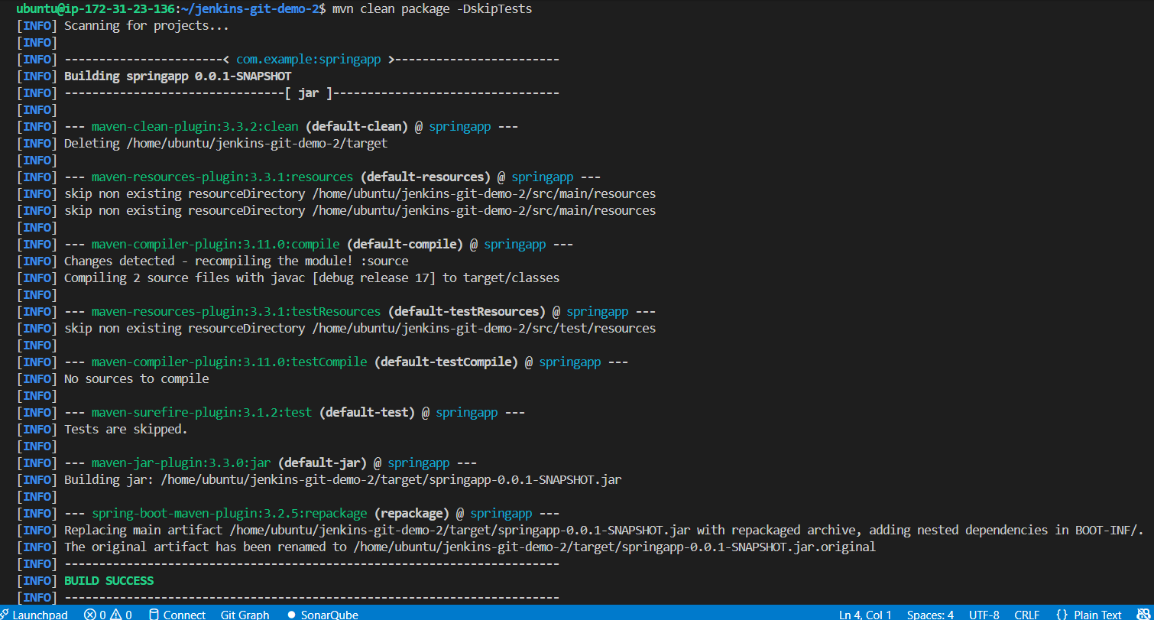

STEP 4 – Docker Rebuild (Important)
Because code change hua hai:
docker build -t springapp .
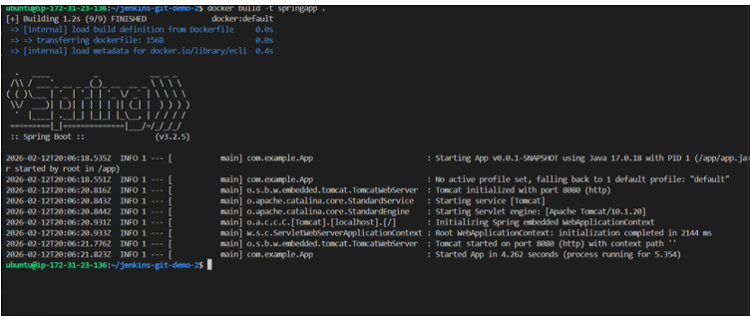
STEP 5 – Old Container Remove
docker rm -f spring-container || true
STEP 6 – Run Container
docker run -d -p 8081:8080 --name spring-
🛠 STEP 7 – Check Logs
docker logs spring-container
Ab tumhe yeh dekhna chahiye:
Tomcat started on port 8080
Started App in X seconds
🌍 STEP 8 – Browser me check karo
Open karo:
http://<EC2-IP>:8081
Expected output:
Hello from Spring Boot running inside Docker!
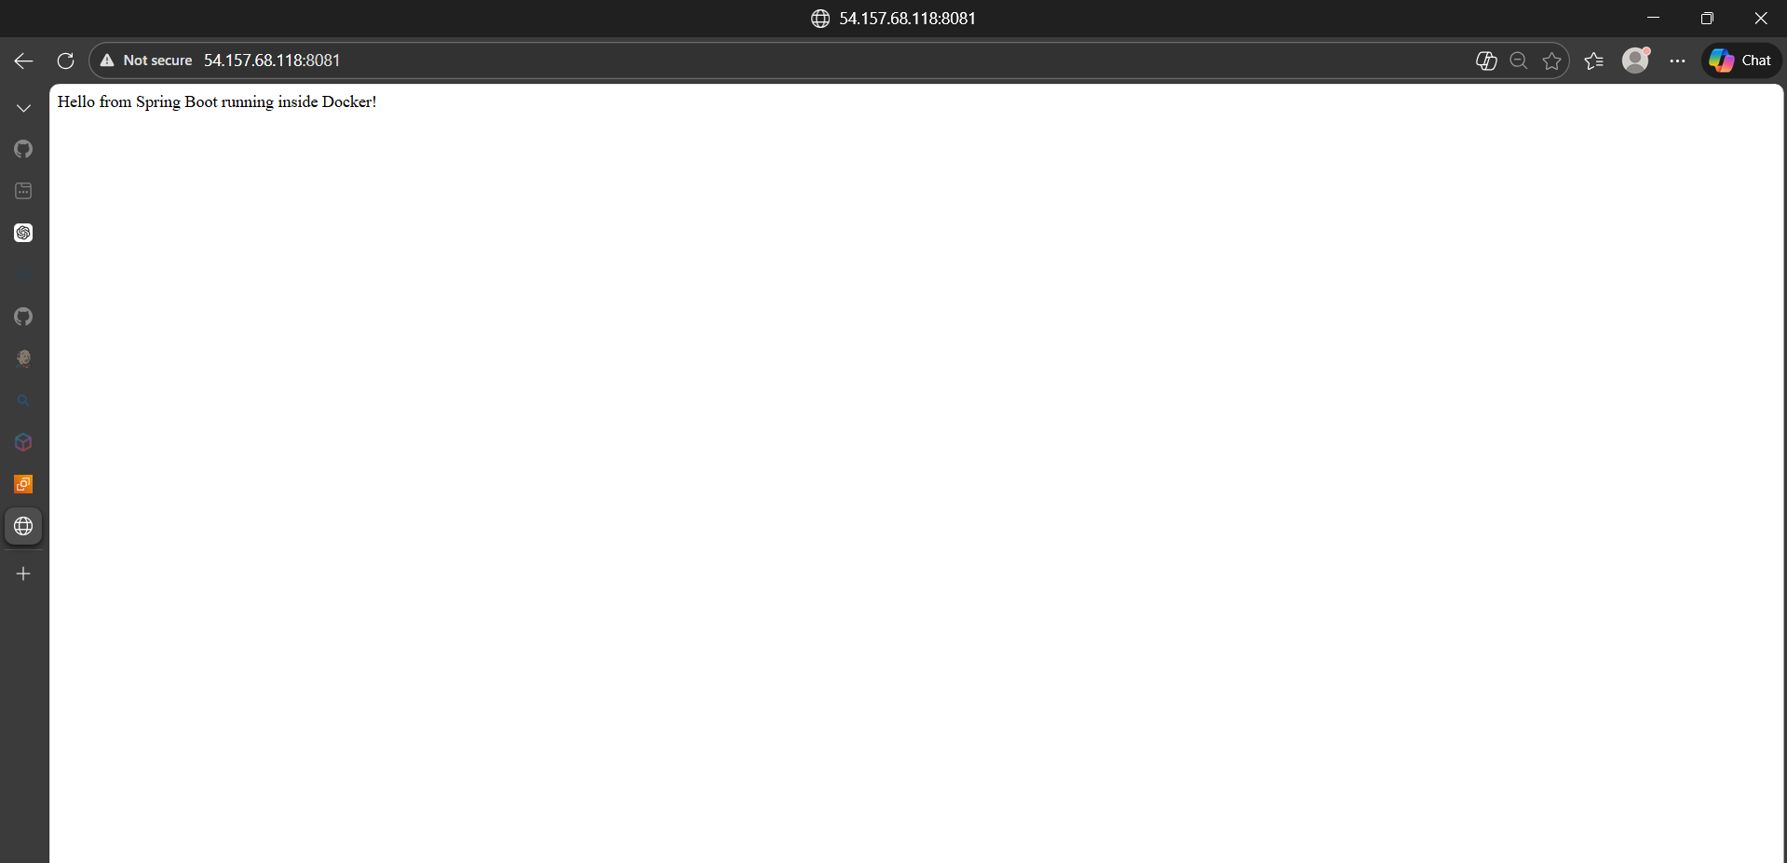

Now our final web app is ready congraltutations.
🧠 Tumne Kya Achieve Kiya?
Tumne successfully:
Spring Boot + Docker + EC2 deploy kar diya 🚀
Ye bilkul real DevOps workflow ka part hai.

