SmartSite Guard Architecture
This document describes the local SmartSite Guard implementation, including the dashboard, simulator, fog processor, and cloud lambda/IoT integration components.

System Overview
The system includes the following components:
- Simulator: generates sensor data and publishes raw events to AWS IoT Core.
- AWS IoT Core: routes raw messages on a raw topic and enables fog processor subscriptions.
- Fog Processor: subscribes to raw IoT messages, classifies and filters events, stores processed data in DynamoDB, and republishes processed events.
- DynamoDB: stores processed sensor events for dashboard visualization and historical queries.
- Dashboard: retrieves filtered events from DynamoDB and presents them through charts, summaries, and alerts.
- Cloud Lambda: optional API/lambda function for direct ingestion or event querying as a cloud endpoint.

Architecture Diagram
The following diagram illustrates the data flow from local sensor simulation through IoT ingestion to fog processing and dashboard storage.
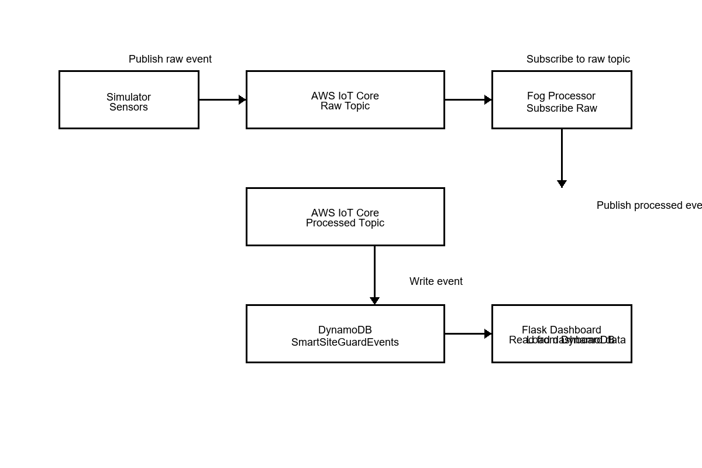

Data Flow
- Sensor Generation
The simulator generates events for temperature, gas, noise, vibration, and proximity sensors at regular intervals.
- Raw Event Publishing
The simulator publishes raw sensor events to AWS IoT Core on the configured raw topic.
- Fog Processing
The fog processor subscribes to the raw topic, validates and classifies events, and filters them based on severity.
- Event Storage
Processed events are normalized and stored in DynamoDB for persistent querying by the dashboard.
- Dashboard Visualization
The Flask dashboard reads events from DynamoDB and displays charts, summaries, and recent alerts.
- Optional Cloud Lambda
The cloud lambda can ingest HTTP or event-based payloads and store them in DynamoDB, enabling cloud-based integrations.

Sensor Selection Justification
Temperature: Detects overheating or abnormal thermal patterns that may indicate equipment failure or fire risk.
Gas: Monitors air quality and detects hazardous gas buildup, supporting early warning for leaks or toxic conditions.
Noise: Measures sound levels to detect intrusions, machinery anomalies, or environment disruptions.
Vibration: Captures mechanical health and structural integrity issues by sensing excessive vibration or instability.
Proximity: Supports presence detection or object movement in the monitored zone, useful for access control and safety.

Local Test Results
The local runtime validation confirmed that all Python modules compile successfully and required imports are available for dashboard, fog, simulator, and cloud lambda components.
These checks ensure the project can run locally, assuming AWS credentials and IoT configuration values are provided in the .env file.

