SmartSite Guard - Complete Architecture and Project Documentation
SmartSite Guard is a fog-edge safety monitoring solution for construction sites. It uses AWS IoT Core for raw event ingestion, a local fog processor for hazard classification, Amazon DynamoDB for storage, and a Flask dashboard for visualization.

1. System Overview
The system simulates live on-site sensor readings, processes them in a fog layer, stores results in the cloud, and displays the data in a dashboard.
The main goals are:
- Provide a simple fog-edge event pipeline that works with AWS IoT Core.
- Store processed safety events in DynamoDB.
- Display time-filtered charts, alerts, and logs in a dashboard.
- Keep deployment learner-lab friendly and avoid unnecessary cloud resources.

2. Architecture Diagram
The diagram below shows the main project flow from simulator to dashboard:
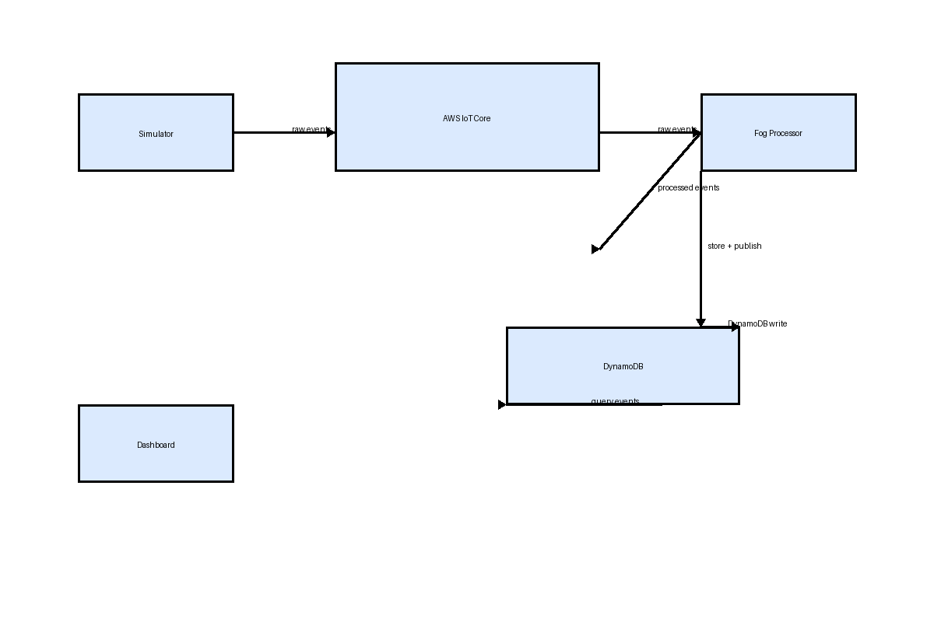
Legend:
• Simulator publishes raw sensor data to AWS IoT Core.
• Fog processor subscribes to raw topic, classifies events, stores processed data in DynamoDB, and publishes processed messages.
• Dashboard reads processed data from DynamoDB and renders metrics, charts, alerts, and logs.

3. Components and Files

Simulator
- File: simulator/publisher.py
- Generates random sensor events for temperature, gas, noise, vibration, and proximity.
- Discovers the AWS IoT endpoint using boto3 if IOT_ENDPOINT is not explicitly configured.
- Connects over MQTT via AWS IoT WebSockets using the default AWS credential chain.
- Publishes raw messages to topic smartsite/raw every configured interval.

Fog Processor
- File: fog/processor.py
- Subscribes to smartsite/raw and receives raw sensor JSON payloads.
- Classifies events using rules.classify_event and adds severity, message, and fog_processed_at metadata.
- Normalizes numeric values so DynamoDB can store them safely.
- Stores each processed event in the DynamoDB table defined by DYNAMODB_TABLE.
- Publishes processed events to smartsite/processed and logs every receive/store step.

Dashboard
- File: dashboard/app.py and dashboard/templates/index.html
- Loads processed events from DynamoDB and supports time filters and severity/sensor filters.
- Delivers a unified dashboard view with four sensor charts, summary cards, alerts, and logs.
- Supports quick ranges (5m, 10m, 60m) and custom start/end ranges using datetime-local controls.
- Refreshes the entire dashboard every 10 seconds so charts and logs remain synchronized.

Cloud Deployment
- File: cloud/template.yaml and cloud/deploy.ps1
- Deploys only the DynamoDB table to keep the Learner Lab deployment simple.
- Avoids creating IAM roles or IoT Rules in the stack for environment compatibility.
- Uses a stack-specific table name to prevent collisions with other lab resources.

4. Detailed Runtime Flow
- The simulator starts and resolves AWS credentials from the default chain (environment, profile, or instance role).
- It discovers the AWS IoT endpoint using iot.describe_endpoint if no endpoint is configured explicitly.
- The simulator connects to AWS IoT Core using websocket signing and publishes raw JSON payloads to smartsite/raw.
- The fog processor also resolves credentials and subscribes to the same IoT topic.
- Each raw event is logged in the fog processor before classification.
- The fog processor applies domain rules to determine severity and message.
- Processed events are normalized and written to DynamoDB.
- Processed events are also published to smartsite/processed for optional downstream routing.
- The dashboard queries DynamoDB for filtered events and renders the result.
- Custom dashboard time ranges are converted to ISO timestamps and sent as start_time/end_time query parameters.

5. Event Schema
Each raw event payload contains:
- event_id: unique UUID for the raw event.
- site_id: identifier for the construction site.
- zone_id: area or zone inside the site.
- sensor_id: sensor device identifier.
- sensor_type: temperature, gas, noise, vibration, or proximity.
- value: measured value from the sensor.
- unit: measurement unit for the value.
- timestamp: UTC ISO timestamp from the simulator.
Each processed event adds:
- severity: computed severity level such as CRITICAL, HIGH, MEDIUM, or LOW.
- message: classification summary based on sensor thresholds.
- fog_processed_at: UTC ISO timestamp when the fog processor handled the event.

6. AWS Cloud and Deployment Details
This project minimizes learner lab complexity by deploying only the DynamoDB resource in CloudFormation. All IoT connectivity is handled by the simulator and fog processor at runtime.
A typical deployment includes:
- DynamoDB table for storing processed events.
- AWS IoT Core endpoint for MQTT ingestion and subscription.
- IAM policy or IAM principal with IoT connect/publish/subscribe permissions for device clients.
- Optional IoT rule if you want to route processed topic events directly to DynamoDB or Lambda in the future.

7. Configuration and Environment Variables
- AWS_DEFAULT_REGION: AWS region for all AWS SDK operations, typically us-east-1.
- DYNAMODB_TABLE: The DynamoDB table name used by the dashboard and fog processor.
- IOT_ENDPOINT: Optional AWS IoT endpoint address. If unset, the app discovers it automatically.
- IOT_TOPIC_RAW: IoT topic for raw sensor ingestion.
- IOT_TOPIC_PROCESSED: IoT topic used by the fog processor for processed events.
- SITE_ID: Optional simulator site identifier.
- ZONE_ID: Optional simulator zone identifier.
- PUBLISH_INTERVAL_SECONDS: Simulator event publish interval in seconds.

8. Cleanup and Project Scope
The following cleanup has been applied to keep the project scope focused:
- • Removed unrelated test files such as test_aws.py.
- • Kept only the core fog-edge pipeline, the dashboard, the simulator, and the cloud deployment files.
The project now provides a clear, simplified learner-friendly architecture without unnecessary files.

9. Troubleshooting and Validation
Common startup checks:
- Verify AWS credentials with the default boto3 credential chain.
- Ensure the IoT endpoint can be discovered or set IOT_ENDPOINT explicitly.
- Check that the DynamoDB table exists and the dashboard is using the correct table name.
- Validate that the simulator and fog processor can connect to AWS IoT Core and publish/subscribe over WebSockets.

