Apple Channel Partner Business Practices Policy and Statement

The Policy of Apple Inc (including all of its subsidiaries and operating companies world wide) (hereafter referred to as “Apple)” is to strictly comply with all applicable laws and regulations enacted to combat bribery and corruption, including the United States Foreign Corrupt Practices Act (“FCPA”), the principles of the OECD Convention on Combating Bribery of Foreign Public Officials (the “OECD Convention”) and any corresponding laws of all countries in which Apple conducts its business. Apple‘s employees, as well as its agents, distributors, consultants and representatives, may not enter into any transaction or situation that is a violation of either the FCPA, anti-bribery or anti-corruption laws in any foreign country in which Apple conducts business, or any applicable international anti-corruption and anti-bribery conventions, including the OECD Convention.

Apple is committed to the highest standards of integrity in the conduct of its business practices. We obtain business only on the merits of our products, services and people. Making payments of any kind to government decision makers in order to “buy business” is a crime in the United States and in many other countries around the world.

Apple relies upon the abilities of its personnel, consultants, agents, representatives, resellers and distributors to communicate effectively the merits of the products and portfolios it sells to customers. Apple expects and demands that its employees and its consultants, agents, representatives and distributors use only legitimate competitive practices in compliance with all applicable laws to implement its sales strategies and to effect sales.

Apple’s Channel Member Code of Conduct provides consultants, agents, representatives, resellers and distributors of Apple with the necessary information on the basic principles of business they are expected to follow. The Guidelines provide details of various compliance requirements including details of the FCPA. The Guidelines also highlight that breach of these laws may result in legal actions against Apple and/or its employees and representatives.

Apple conducts a thorough review and investigation of all applicants who wish to be appointed as a consultant, agent, representative, reseller or distributor for the company to perform contractually defined services to Apple. Applicants will not be considered for appointment unless they acknowledge that they have received, read and fully understand this FCPA policy statement and agree to comply with it.

The following explanation summarises and provides specific information regarding the requirements of the FCPA.

FCPA/Anti-Bribery Law Compliance.

The FCPA prohibits offering, promising, authorising or giving anything of value, including money or gifts, to a “foreign official,” foreign political party or party official, or any candidate for foreign political office in order to obtain, retain or direct business or to secure any improper advantage. For purposes of the FCPA, a “foreign official” is any official or employee of a foreign government or public international organization (such as the European Commission), any national, regional or local department or agency thereof, or any person acting in an official capacity. This also includes an official or employee of a government-owned or controlled business enterprise.

The FPCA applies to Apple Inc. and to any officer, director, employee or agent of Apple, including employees of its subsidiaries and of third parties with which Apple does business, such as consultants, agents, resellers and distributors, whether or not they are US citizens or residents, and regardless of whether they are located within or outside of the United States.

Failure to comply with the FCPA and local laws prohibiting illicit payments to government officials may result in significant criminal and /or civil penalties for Apple and for any individuals responsible for a violation. For individuals, these penalties may include both fines and time in prison.

In order to prevent intentional or unintentional violations of the FCPA, the OECD Convention or other related anti-bribery legislation, the following principles of conduct and business practices must be adhered to by all Apple employees and all representatives, consultants, distributors, resellers, agents or other third parties acting for or on behalf of Apple. In the event of violation of these principles, Apple may immediately, in its sole discretion, terminate any agreement with such representatives, distributors, resellers, agents or other third parties. A violation of these policies will not be tolerated.

Principles of conduct.

- No employee, representative, consultant, distributor, reseller, agent or third party acting on behalf of Apple shall give, offer, promise, authorize or make, directly or indirectly, a payment of anything of value (in the form of cash payment, compensation, gift, contribution or otherwise) to:

- Any individual or firm employed by or acting for or on behalf of any customer or potential customer, whether private or government, with the intention to influence an official act or decision by that customer or to otherwise secure an improper advantage for Apple in order to “obtain or retain business” with that customer.

- Any individual or firm employed by or acting for or on behalf of, any government, any agency/organization thereof, or any company or organization controlled or owned by a government agency, or any public international organization, with the intention to influence an official act or decision or to secure an improper advantage for Apple in order to “obtain or retain business”;

- Any governmental official, political party or official of such party or any candidate for political office, for the purposes of influencing an official act or decision or securing an improper advantage for Apple in order to “obtain or retain business”.

- No employee, representative, consultant, distributor, reseller, agent or third party acting on behalf of Apple, may give, offer, promise, authorize or make a payment or anything of value to a third party while knowing or having reason to know that any portion of such payment might be passed on to any of the individuals or for any purpose listed in items 1 (a) to 1 (c) above. The term knowing, is broadly defined to include any conscious disregard or deliberate ignorance of circumstances which may suggest that a payment is an indirect bribe, and therefore would constitute a violation of the FCPA, the principles of the OECD Convention or any other anti-bribery legislation.

- It is Apple’s policy that any representatives, consultants, agents, resellers or distributors it may appoint, will be reputable, qualified individuals or firms engaged in accordance with compensation arrangements that are reasonable in relation to the services performed and the parameters defined pursuant to any local country regulations. The applicant will therefore cooperate with any reasonable requests of Apple for additional information directed at confirming compliance with this policy.

- It is Apple’s policy that any payments made to representatives, consultants, agents, resellers or distributors by Apple will be made only pursuant to a written contract setting forth clearly and accurately the actual services to be performed and the applicable compensation for each service.

By signing this document, [applicant/distributor] hereby confirms that it fully understands Apple’s policy as described and that [xxx] will fully comply with this policy during [xxx]’s work for Apple.

Signature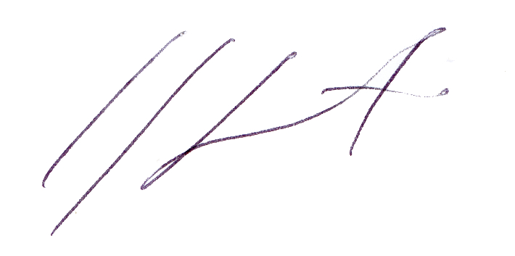

Company Name Macaldia

Company HQ Address Viamonte 1453, - C1055ABA – Buenos Aires - Argentina

Company URL http://www.macaldia.com

Apple Contract ID Number (applicable to existing Channel Members only) CP200082850

Officer Name Jorge Sagasti

Title Owner

Email Address jorge@macaldia.com

Date 9/29/09

