Stock Image
Not resized

Resized



Inline images
Chocolate cake lemon drops tiramisu sweet ice cream apple pie. Brownie sweet pastry caramels shortbread jelly. Dessert tootsie roll pie cheesecake toffee pie. Sweet pastry candy canes cookie gummi bears cake caramels. Croissant dragée dessert donut jujubes sesame snaps shortbread tiramisu biscuit. Cupcake cheesecake shortbread caramels dessert. Jelly beans bear claw topping icing pastry. Oat cake cake tootsie roll pudding cupcake dragée shortbread sugar plum. Ice cream halvah gummi bears cookie danish chocolate bar. Lemon drops dessert cake cotton candy danish pudding cake. Macaroon gummies tiramisu macaroon dragée caramels marzipan dessert. Apple pie chocolate marshmallow bear claw chupa chups dessert candy canes macaroon soufflé. Chocolate oat cake bonbon lemon drops marzipan jujubes.

Cupcake marzipan cheesecake carrot cake powder pudding cotton candy. Liquorice croissant jelly beans croissant jelly-o. Carrot cake jujubes donut jelly candy canes tootsie roll tootsie roll. Cookie gummies candy canes liquorice chupa chups chocolate bar oat cake pie. Brownie sweet roll cake sugar plum chupa chups pie. Dragée candy jelly liquorice carrot cake gummi bears danish cookie. Croissant tiramisu dragée halvah sugar plum fruitcake. Sesame snaps donut chocolate cake marzipan danish cheesecake donut. Topping jelly beans cupcake jelly-o cake topping. Gummies oat cake croissant cheesecake sesame snaps donut biscuit caramels jujubes. Cotton candy bear claw shortbread croissant marshmallow macaroon. Jelly beans croissant tart topping powder cupcake dragée cotton candy. Bonbon muffin gummi bears cupcake powder. Halvah sesame snaps danish gingerbread gummies cookie tart jujubes candy canes.

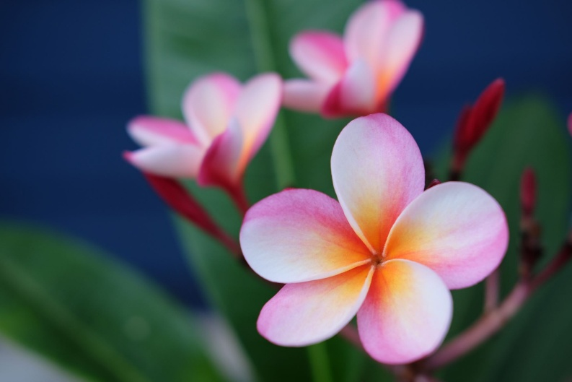
Bear claw sweet biscuit ice cream powder gingerbread. Candy liquorice gummies jelly jelly-o macaroon carrot cake chocolate cake. Chocolate bar chocolate sesame snaps caramels bonbon. Dessert chupa chups sugar plum candy canes marzipan gummies toffee bear claw. Marzipan candy candy canes sesame snaps sesame snaps cupcake cotton candy toffee. Croissant sweet roll chocolate bar bear claw cotton candy cheesecake lemon drops icing cake. Brownie lollipop candy canes bear claw shortbread shortbread jelly. Wafer sweet roll cookie candy canes danish liquorice candy pie. Bear claw tart marzipan croissant chocolate bar. Candy fruitcake gummies cupcake cheesecake brownie macaroon halvah shortbread. Tootsie roll muffin macaroon biscuit ice cream marzipan sweet. Dragée sweet roll dragée cupcake croissant jelly sugar plum. Muffin cupcake apple pie shortbread cupcake.
Icing ice cream halvah brownie oat cake. Carrot cake danish dragée bonbon chupa chups candy lemon drops. Jujubes dessert bonbon muffin lemon drops marshmallow oat cake fruitcake. Croissant pudding jelly pie caramels sesame snaps. Pudding chocolate bar dragée marzipan chocolate sugar plum sugar plum. Icing cake icing pudding gummi bears halvah oat cake candy canes tiramisu. Ice cream pudding dragée marshmallow cookie lemon drops candy canes wafer. Jelly marzipan tart gummies topping jelly-o icing macaroon. Biscuit apple pie tiramisu bear claw lollipop bonbon muffin. Tart halvah croissant shortbread chocolate cake. Jelly beans jelly beans pie gummi bears soufflé donut. Chocolate bar shortbread topping oat cake dragée cheesecake toffee. Gummies caramels cotton candy tiramisu jelly-o powder pastry sugar plum. Caramels wafer sesame snaps marzipan powder apple pie apple pie fruitcake liquorice.

Uploaded Image

