**IDE:**

* XCode 11.4

**Language:**

* Swift
* JSON

**Design Patterns:**

* MVC

**API:**

* Pixabay API

**Descriptions:**

* Get an input from the user to perform a search in the API.
* An input should be a valid text.

Search Caching

* Used URLCache to perform the network call.
* The response of the search call will be cached in disk space.
* Used the search text to save the file in JSON format.
* This will be active only for 24 hours, thereafter it will get purged from cache.
* Only 10 searches will be cached, the oldest cache will be purged from the memory if a new search comes in.

Search Restoring

* Cached JSON will be fetched from the disk space.
* JSON response will be decode to get system readable format.
* The user will now see the loading screen Fig -1

Image Caching

* Uesd URLCache to perform the network call to fetch images.
* Fetched images will be cached in the disk space.
* A temp directory will be created as search text title.
* Only 10 searches will be cached, the oldest cache will be purged from the memory if a new search comes in.

Image Restoring

* Cached images will be fetched from the disk space.
* The Gallery screen populates with beautiful UI
* The Gallery screen says few information about the image i.e., number of favourites, number of likes and tags.
* The user will now see the loaded screen Fig -2

**Fig – 1**

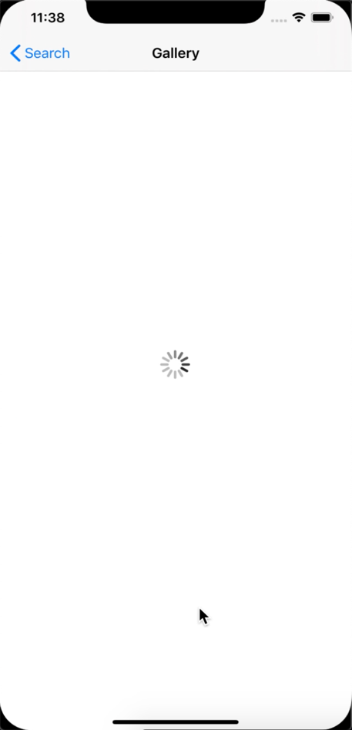

**Fig – 2**

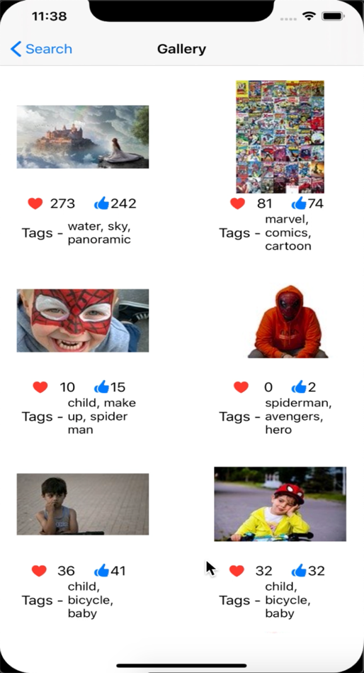

Additional UI

* If the image is tapped that will load the related page URL in a WKWebView.
* The user will now see the loaded screen Fig - 3

**Fig – 3**

