**What is Terraform?**

**Terraform** is a popular cloud orchestration tool in the world of automation, which is used to deploy your infrastructure through the **IAC** (**Infrastructure as code**) approach.

**Terraform** is built by **Hashicorp** and released under **Mozilla Public License**. It supports public, private as well as hybrid cloud, as of now Terraform supports 145 providers, which includes popular providers like AWS, Azure cloud, GCP, Oracle cloud, and many others.

**Terraform** architecture is very simple. All you need is to download the terraform binary to your local/server machine which is going to act as your base machine. We have to mention the provider to work within our syntax file. Terraform will download the plugin for that particular provider automatically and will authenticate with provider API to execute the plan.

**What is Infrastructure as Code?**

The process of provisioning and managing resources like Virtual Machine, Storage, Network, Database, etc.. through machine-readable definition files, rather than interactive tools or hardware configurations.

**Features**

* Open-source.
* Automate and manage your infrastructure
* Declarative syntax.
* Pluggable Modules.
* Immutable infrastructure.
* Simple client-only architecture.

**Installing Terraform in Linux Distributions**

The **Terraform** primary distribution packages come in .zip format, which includes single executable files that you can uncompress any location on your Linux system.

However, for simpler integration with configuration management tools, terraform also offers package repositories for **Debian**-based and **RHEL**-based systems, which enables you to install **Terraform** using your default package management tools called [APT](https://www.tecmint.com/apt-advanced-package-command-examples-in-ubuntu/) and [Yum](https://www.tecmint.com/20-linux-yum-yellowdog-updater-modified-commands-for-package-mangement/).

sudo yum install -y yum-utils shadow-utils  
sudo yum-config-manager --add-repo <https://rpm.releases.hashicorp.com/AmazonLinux/hashicorp.repo>  
sudo yum -y install terraform

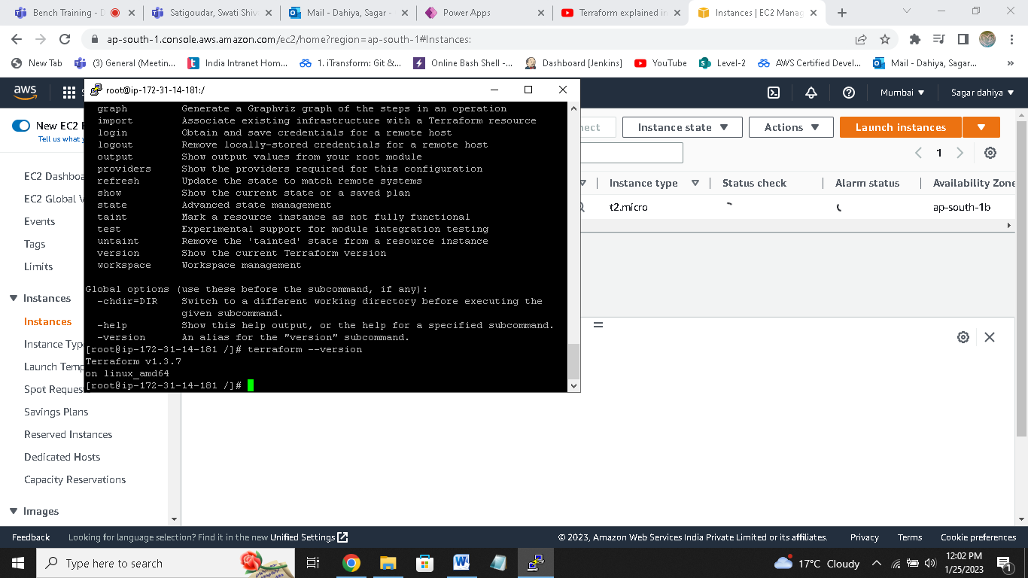

For provisioning infrastructure : devops ( terraform)

Deploying applications : Developers

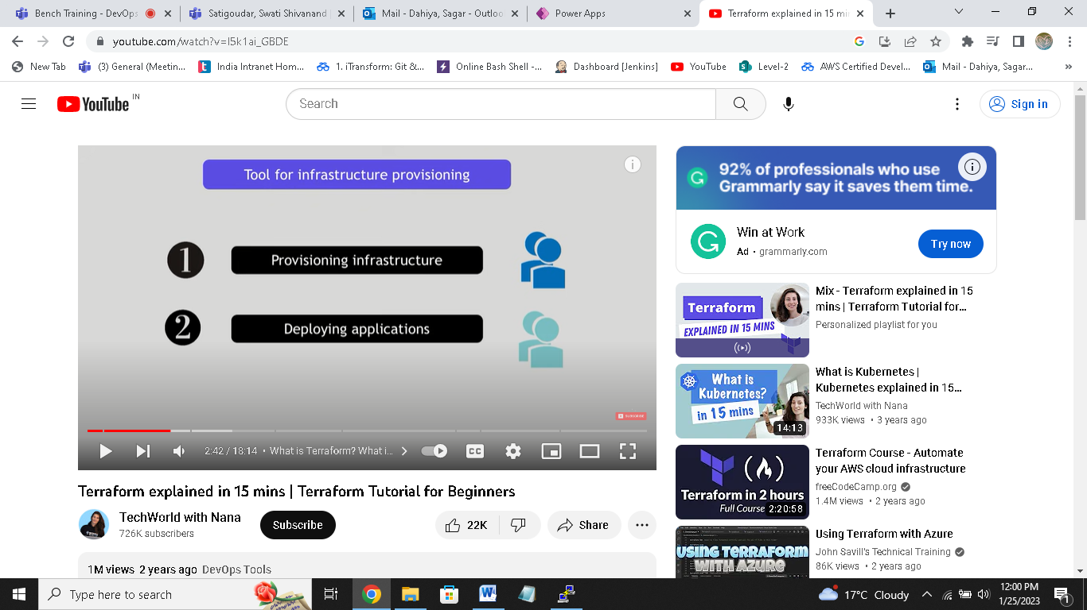

Difference btw Ansible and Teraform

Terraform : for provisioning infrastructure

Ansible : for configure that infrastructure

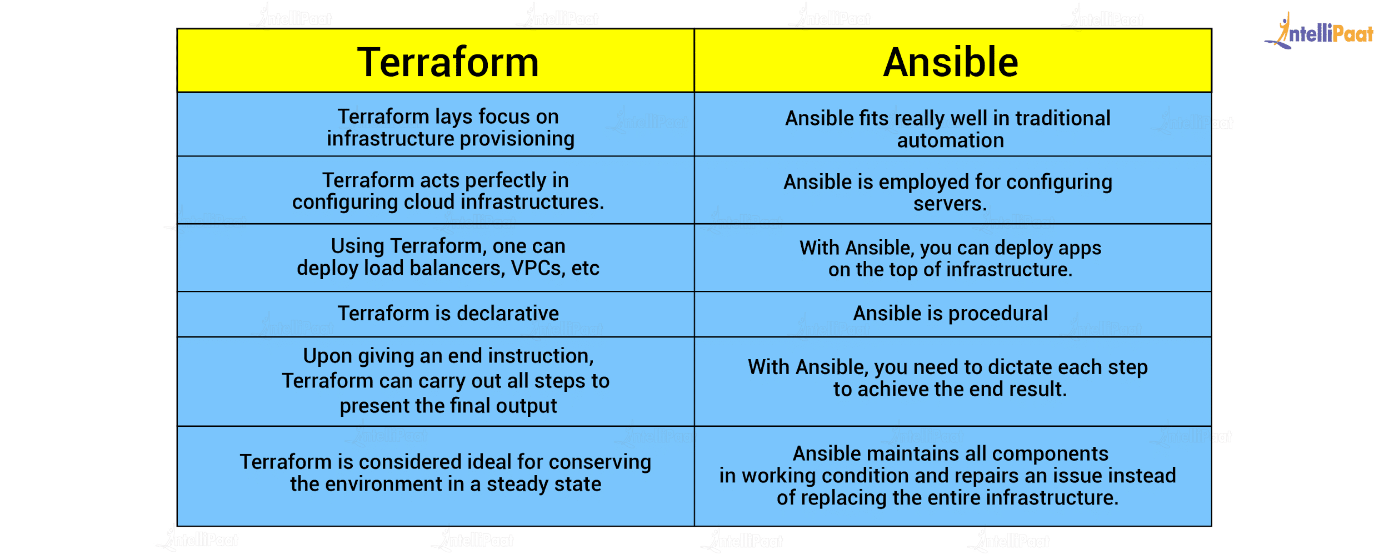

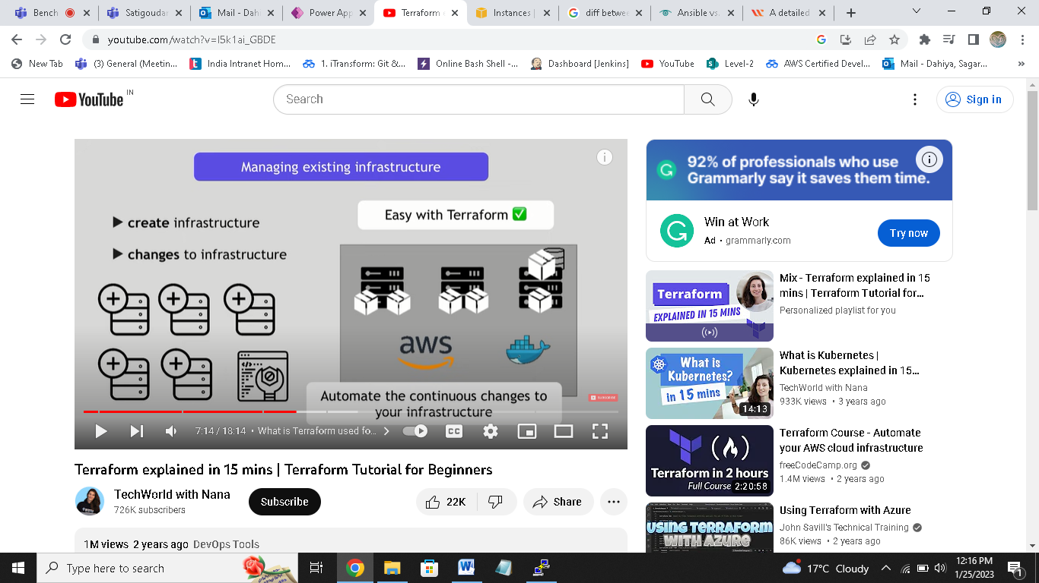

Terraform architecture

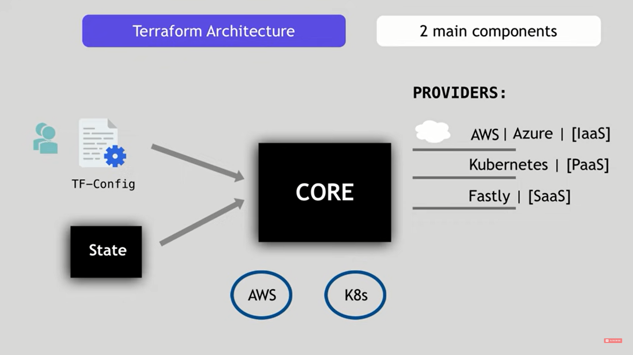

How terraform works

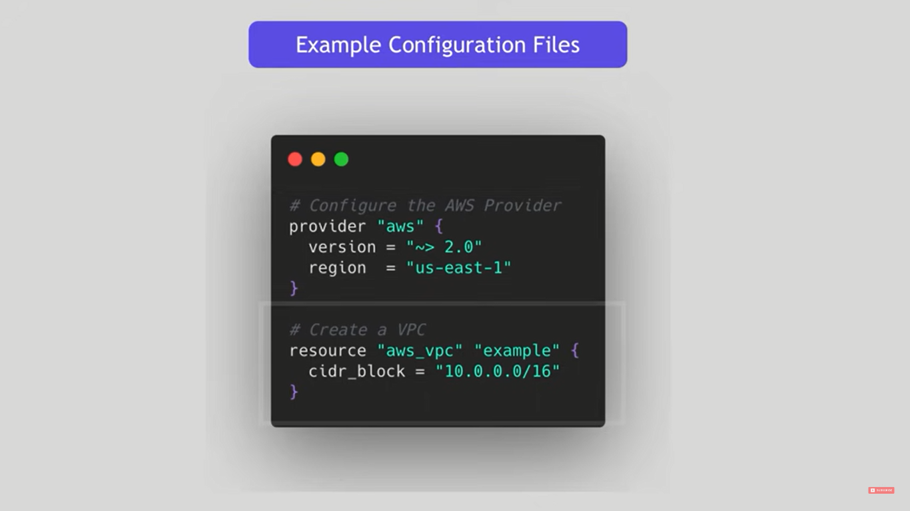

Declarative vs imperative

Declarative

You defined end state in your configuration file

Imperative

Defined exact steps how

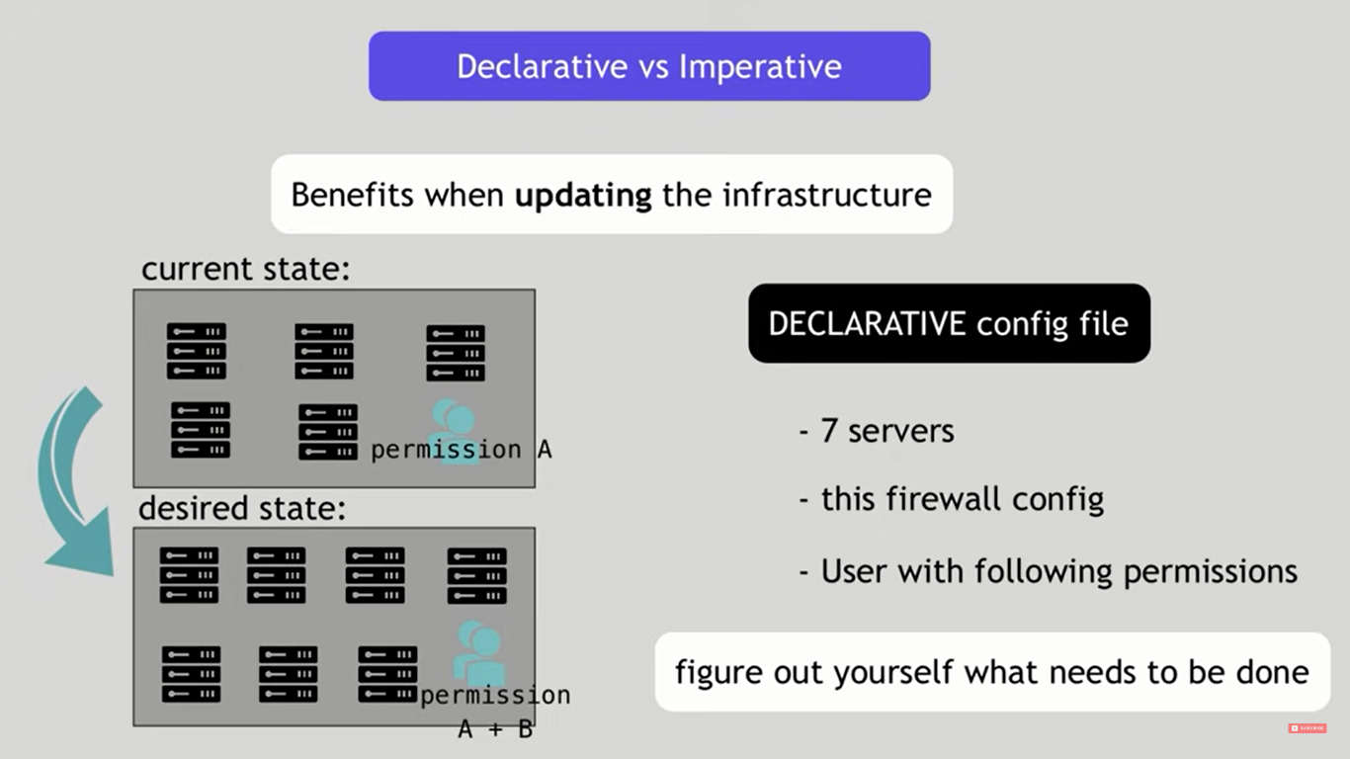

Terraform commands

Refresh : query infrastructure about current state

Plan : create execution plan

Apply :makes changes acc to plan

