UVIRA — DocParser
Intelligent SAP Document Processing Platform
Project Status & Overview Report
Prepared by: Sage Technologies | Date: 20 July 2026

1. Executive Summary
UVIRA DocParser is an intelligent document processing platform built to automate the capture, extraction, validation, and posting of business documents directly into SAP. The system uses OCR-driven data extraction to read vendor invoices, sales orders, goods receipts, freight invoices, and payment advices, then routes the extracted data through SAP transaction codes (MIRO, FB60, VA01, MIGO, F-26/F-28) — eliminating manual data entry for finance and operations teams.
The product is positioned as "Intelligence with Purpose" and markets itself around three headline capabilities: 45+ data fields extracted per document, 99.9% OCR accuracy, and automation across 5 core SAP financial processes.

Key Capabilities
- Automated invoice capture — vendor, PO, GSTIN, and line items lifted directly off the document image/PDF.
- High-accuracy OCR extraction across 45+ structured fields per document.
- Direct SAP integration — pre-built connectors post straight into MIRO, MIGO, FB60, and F-26.
- Coverage of 5 core SAP processes end to end: invoicing, goods receipt, payments, and sales orders.
- Role-based access — admins, managers, and operators each see only what they need.
- Complete audit trail — every login, upload, and posting is logged with user and timestamp.
- Multi-tenant Super Admin control panel for managing companies, billing, and activity across clients.

2. Architecture & Technology Stack
DocParser is a pnpm-based monorepo with a clearly separated frontend and backend, supported by a document-processing worker layer.

Frontend — apps/web
- React 18 + TypeScript, built with Vite 5
- TailwindCSS for styling; Zustand for state management
- TanStack React Query v5 for data fetching/caching; Axios for HTTP
- Socket.IO client for real-time updates; React Dropzone for uploads

Backend — apps/api
- Python, FastAPI + Uvicorn
- SQLAlchemy 2.0 (async) with Alembic migrations, backed by PostgreSQL
- JWT-based authentication (python-jose, passlib/bcrypt)
- Document handling: Pillow, pdf2image, PyMuPDF; async S3 storage via aioboto3
- Celery + Redis for background task processing (OCR, SAP posting workers)
- structlog + Sentry for observability; tenacity/pybreaker for resilience

Document Processing Workflow
Each document moves through a defined status pipeline: Uploaded → Extracting → Extracted → Validating → Validated → Posting → Posted / Failed. Dedicated Celery workers handle each stage per SAP transaction type: ocr_worker, sap_worker, fb60_worker, migo_worker, so_worker (sales order), and f26_worker.

3. Feature Modules

User-Facing Application
- Login — branded member login with product marketing panel.
- Dashboard — processing overview: total processed, posted-to-SAP rate, pending review, total value.
- Upload & Process — 5-step guided wizard (Upload → Extracting → Review → Validation → Complete) supporting Vendor Invoice, Sales Order, Payment Advice, Goods Receipt, and Freight Invoice.
- Documents — searchable/filterable list of all processed documents with SAP validation actions.
- Reports — analytics on volume, T-code distribution, processing status, and SAP posting history.
- Team & Settings — user/team management and account configuration.

Super Admin Control Panel
- Overview / Companies — cross-tenant view of companies, documents, pages scanned, active users, and monthly revenue.
- Billing & Revenue — per-company monthly billing records and totals.
- Activity Monitor — live, auto-refreshing feed of document activity across all companies.

4. Project Statistics
Snapshot as of 20 July 2026, based on current repository state and live application data.

Development Stats
Metric | Value
Total commits | 11
Development span | 16 Jun 2026 – 20 Jul 2026 (~5 weeks)
Frontend source files (apps/web/src) | 65
Backend source files (apps/api/src) | 197
SAP transactions integrated | MIRO, MIGO, FB60, VA01, F-26/F-28
Document types supported | 5 (Vendor Invoice, Sales Order, Payment Advice, Goods Receipt, Freight Invoice)

Live Application Data (Demo Tenant)
Metric | Value
Documents processed (all time) | 21
Posted to SAP | 7 (33% success rate)
Failed | 5 (24% failure rate)
Total value processed | ₹17,77,670.00
Companies onboarded | 2 (SSDN Technologies Pvt. Ltd., Reliance Industries)
Active users | 6
T-code split | MIRO 91% · VA01 10%

Recent Development Milestones
Date | Milestone
16 Jun 2026 | MIRO transaction flow completed
22 Jun 2026 | MIRO + MIGO working together
23 Jun 2026 | FB60 issue fixed
24 Jun 2026 | OCR extraction working
03 Jul 2026 | VA01 (Sales Order) working
08 Jul 2026 | Stable checkpoint before F-26 work
13 Jul 2026 | Database migrated to PostgreSQL; F-26 in progress
14 Jul 2026 | Admin panel and user panel completed
17 Jul 2026 | Login page finalized

5. Application Screenshots
The following screens were captured directly from the running application.
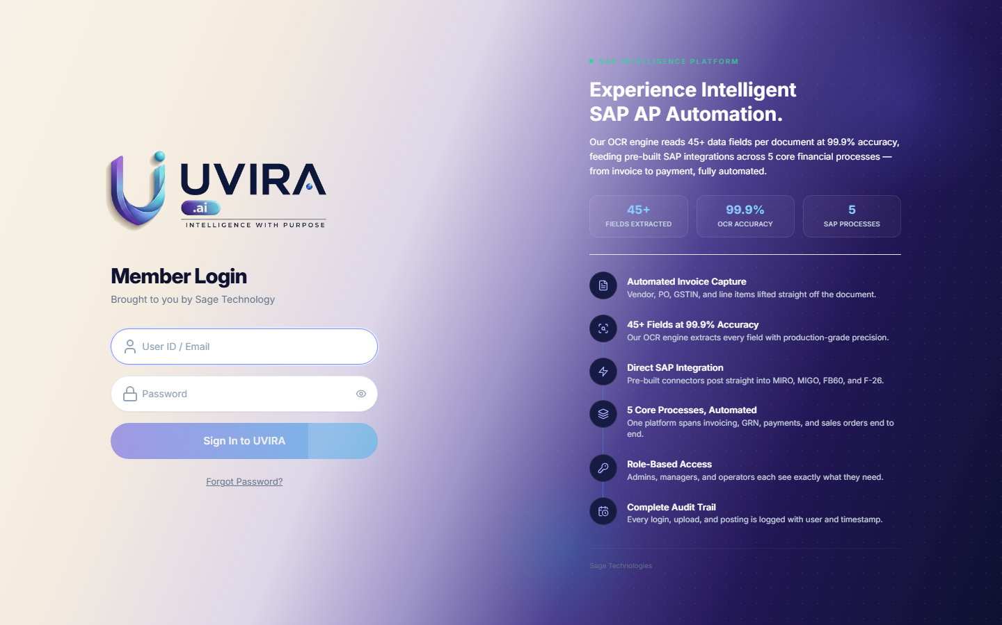
Figure 1 — Member Login screen with product marketing panel
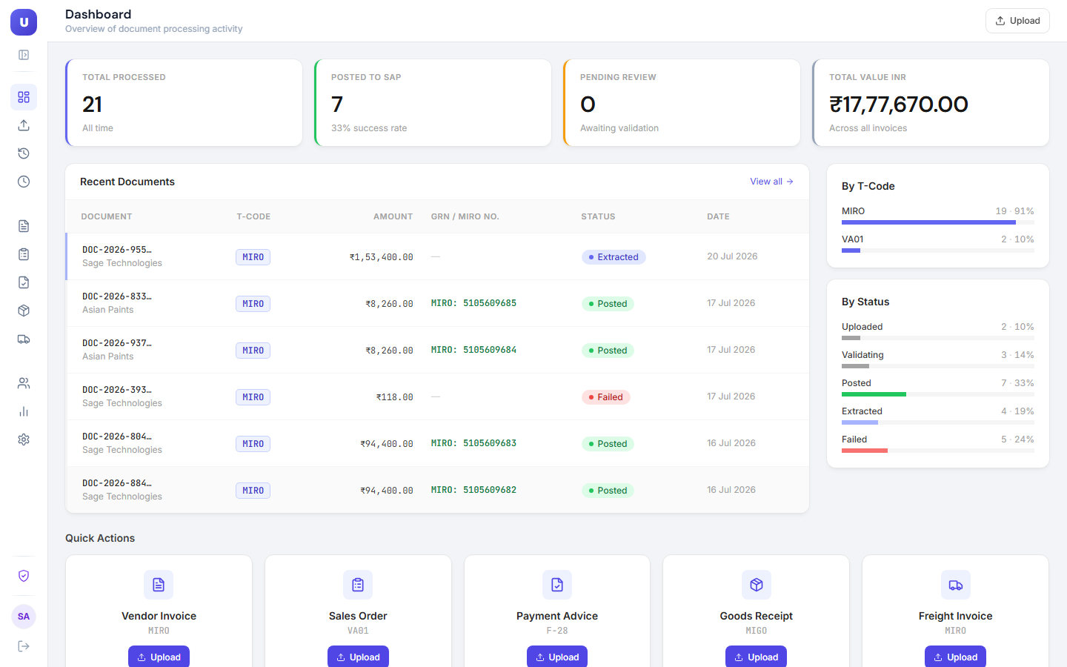
Figure 2 — User Dashboard: processing overview, recent documents, T-code and status breakdown
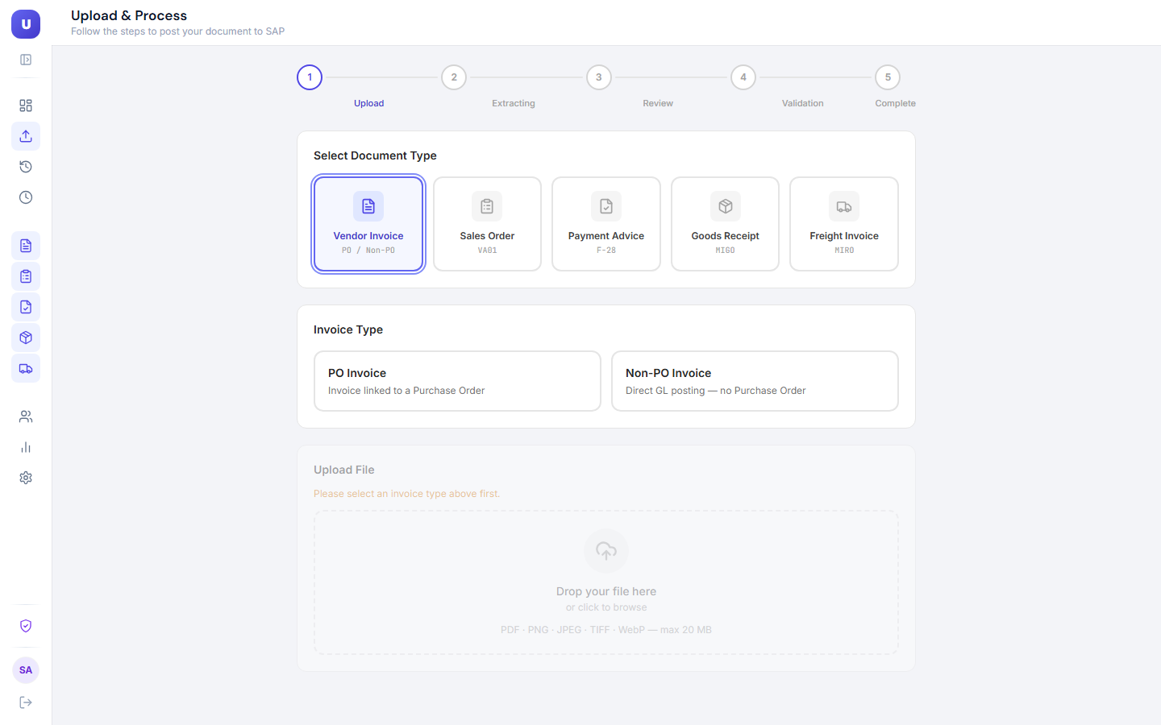
Figure 3 — Upload & Process wizard: document type selection
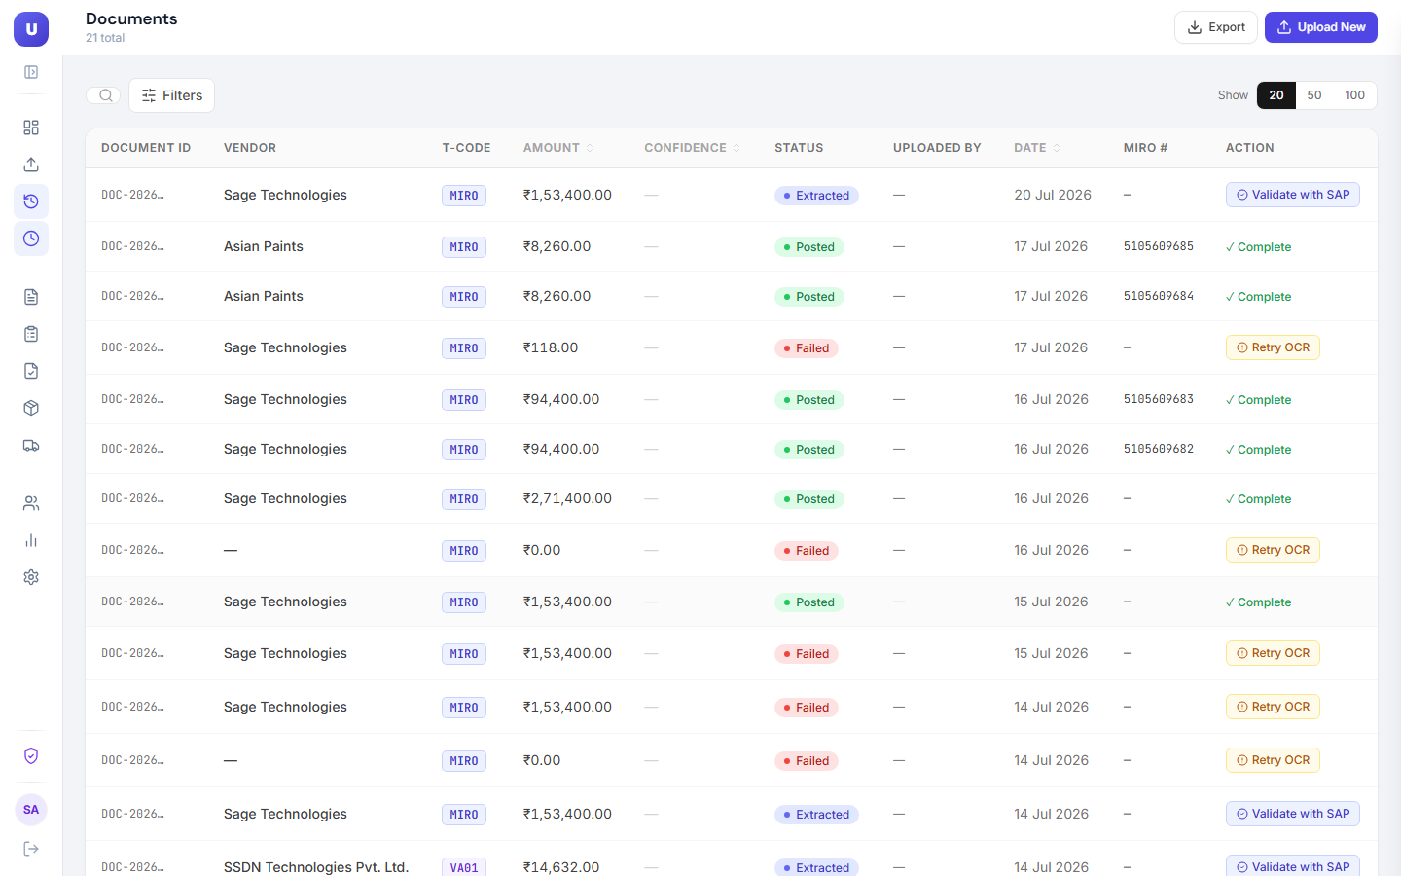
Figure 4 — Documents list with SAP validation actions
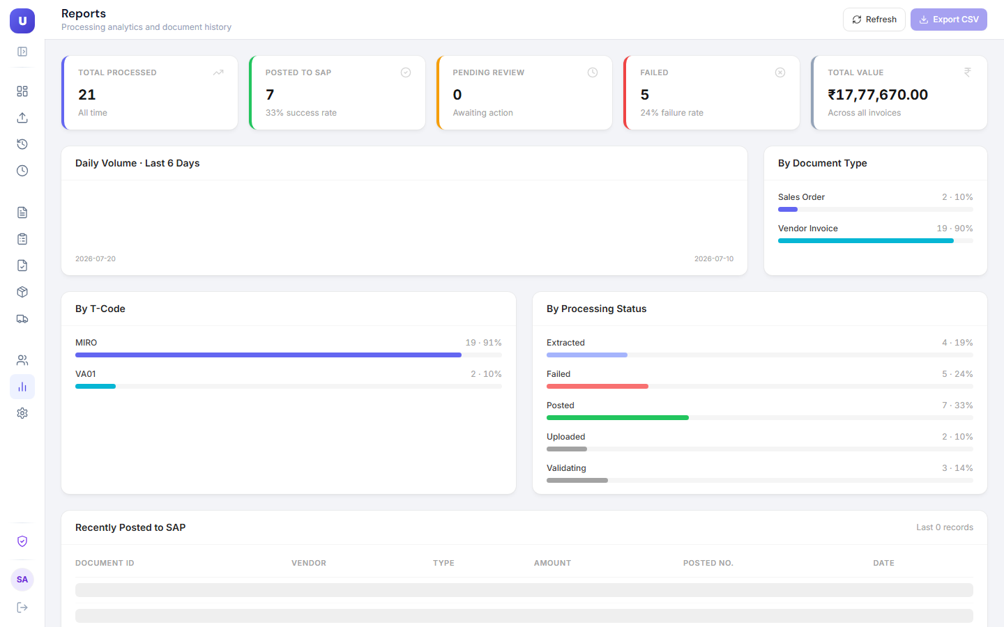
Figure 5 — Reports & Analytics: volume, T-code, and status distribution

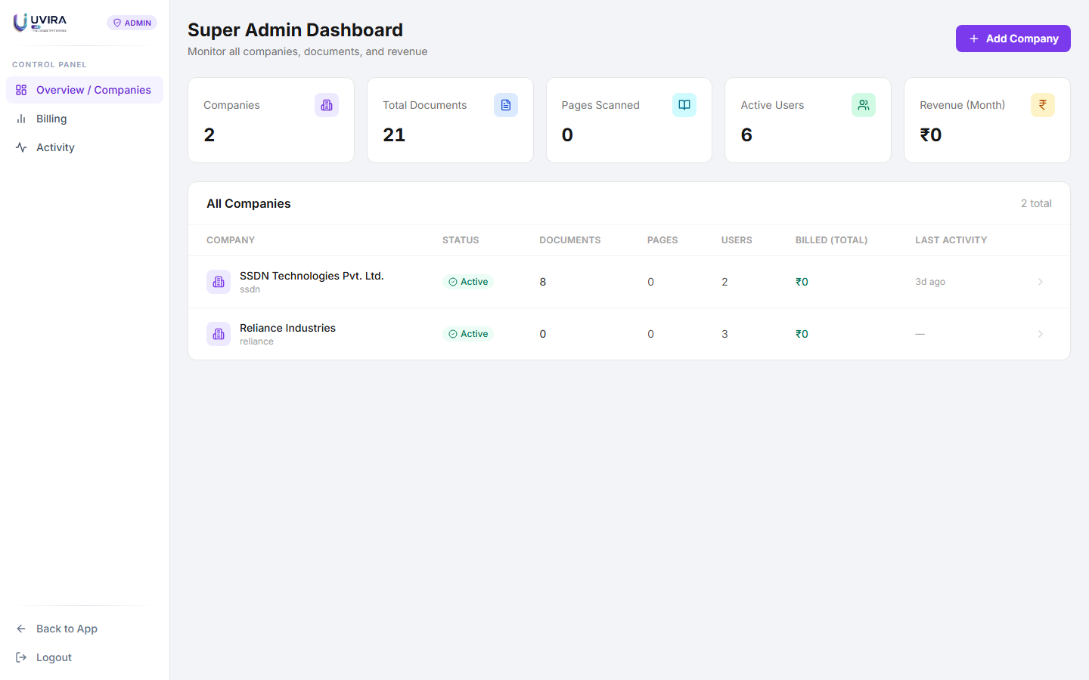
Figure 6 — Super Admin Dashboard: company overview
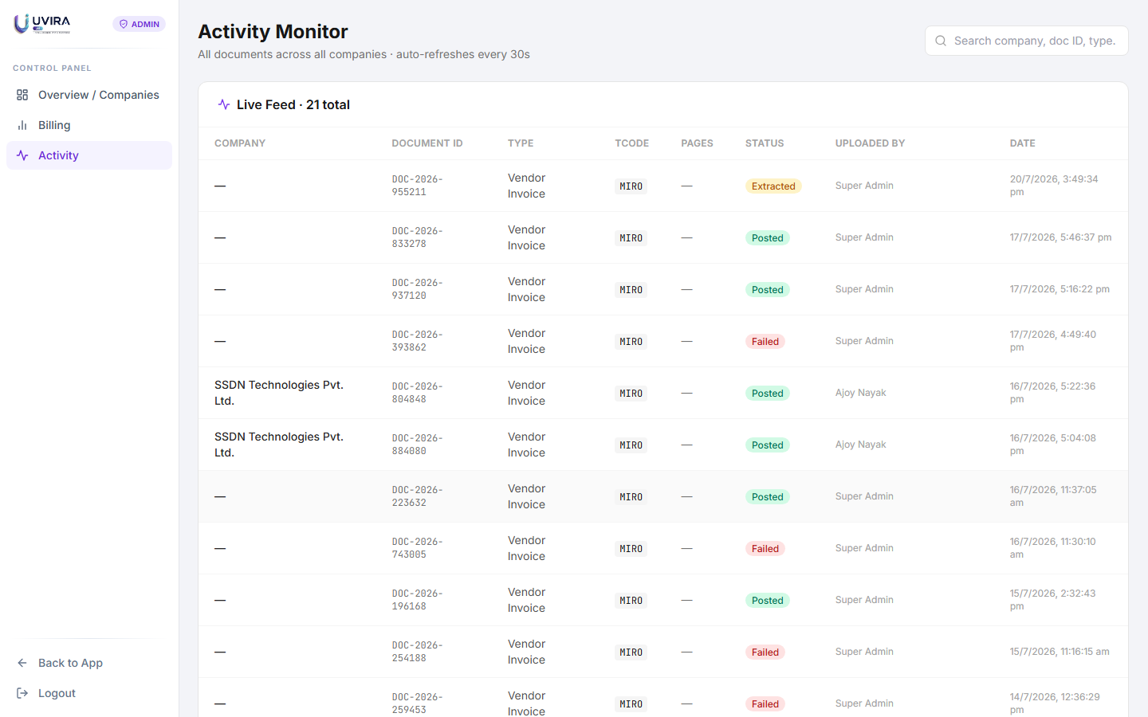
Figure 7 — Admin Activity Monitor: live cross-tenant document feed
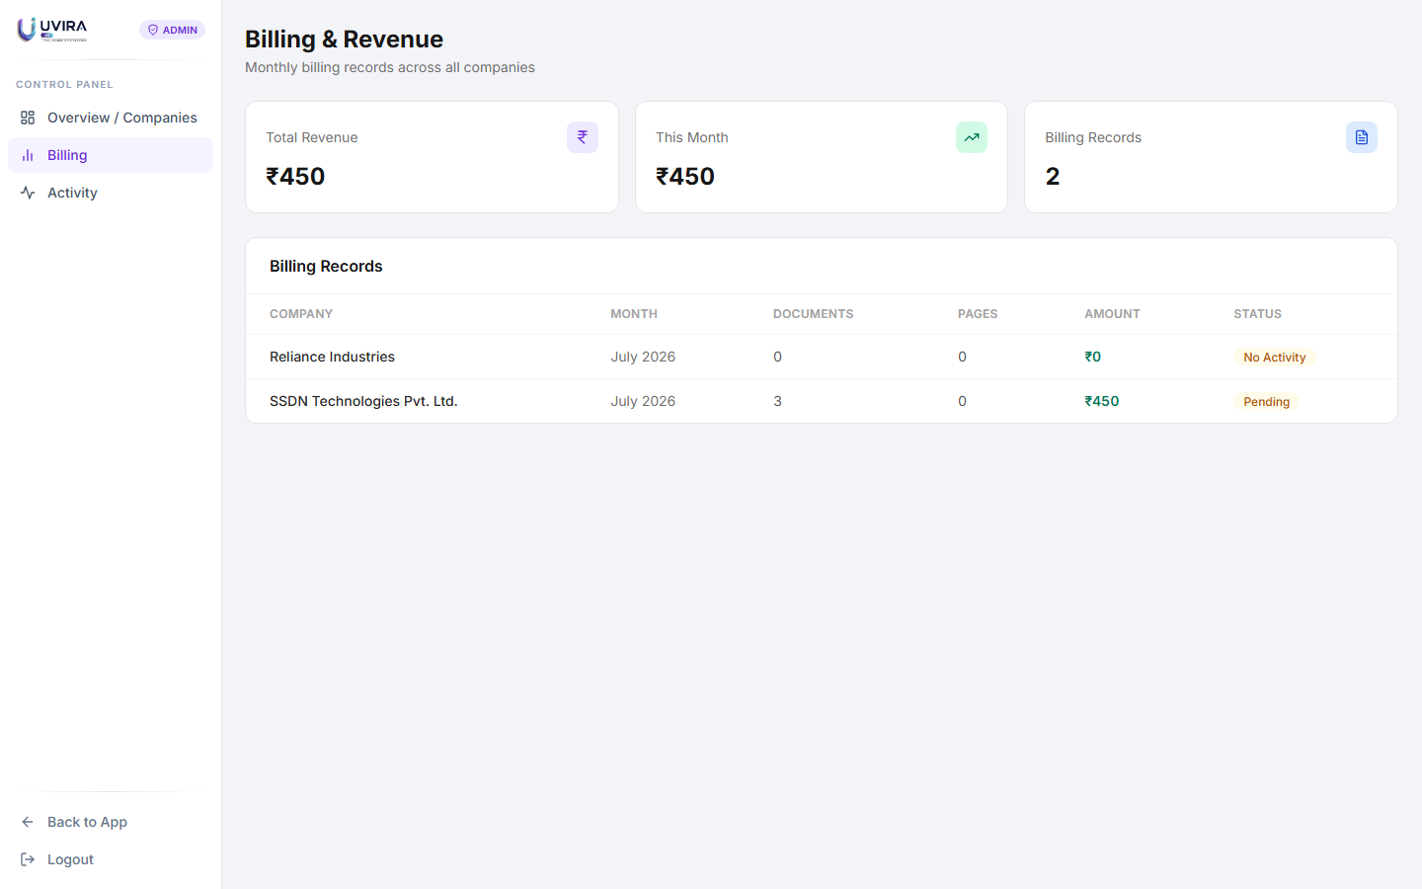
Figure 8 — Admin Billing & Revenue view

6. Summary
In roughly five weeks of active development, the DocParser/UVIRA platform has progressed from initial SAP transaction integration (MIRO/MIGO) through OCR extraction, additional transaction types (FB60, VA01, F-26), a PostgreSQL-backed data layer, and a full user + admin application experience with authentication. The application is functional end-to-end: documents can be uploaded, OCR-extracted, validated, and posted into SAP, with real-time reporting and multi-tenant administration already in place.

