# HEADING 1 WHALE

## Heading 2 Whale

### Heading 3 Whale

#### Heading 4 Whale

#### **~~Whale with highlight, italics, bold, underline, and strikethrough~~**

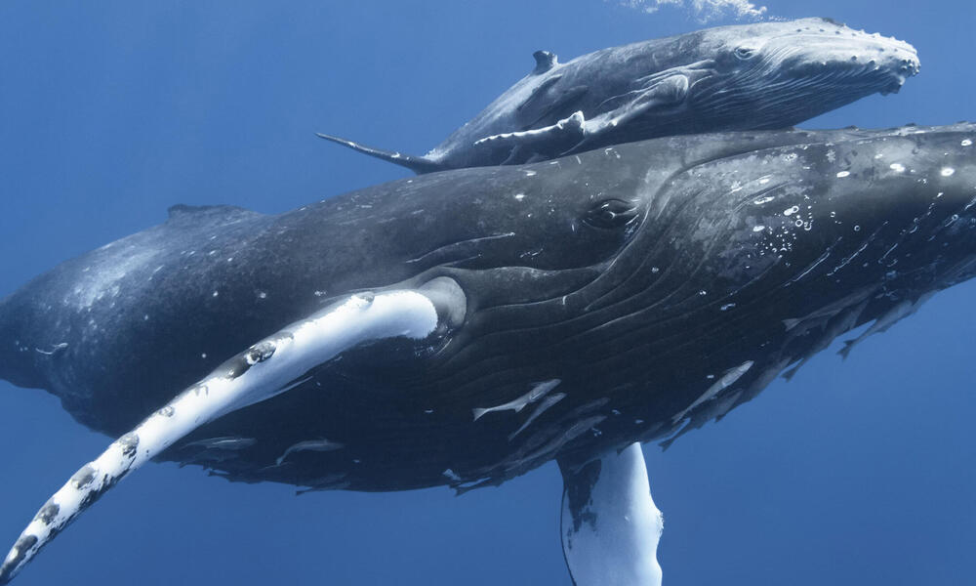

|  |  |  |
| --- | --- | --- |
| Whale in a table |  |  |
|  | Table whale |  |
|  |  | whale whalewhale |

Right-aligned whale

Center-aligned whale

Whale in a text box

1. Whale #1
2. Whale #2
3. Whale #3
   1. Whale #3a

**WHALE**