Table of Contents
Project Documentation 1
Objective 1
Application Architecture 1
Successful Features 2
Fonctionnalités non réussies 2
Roadmap 2
Week 1=June 7 - June 13 2
june 7 2
june 9 2
june 10 3
june 11 3
june 13 3
Week 2 =june 14 - june 20 3
june 14 3
june 16 3
18 juin 3
19 juin 3
Next Steps 3
Screenshots 4
Challenges Encountered 16

Project Documentation

Objective
The objective of this project was to create a calorie counting and meal planning application using React Native and Expo. This application allows users to set their health goals, choose foods from a food database to track their calorie intake, and plan their meals accordingly.

Application Architecture
The application is structured around several main files and folders:
- App.js =This is the entry point of the application. This file initializes the application’s navigator and defines the routes to the different screens.
- assets =This folder contains the static resources used in the application, such as images and icons.
- MealContext.js =CThis file defines the application’s context for managing the meal state. It provides functions for adding and removing foods from the meal plan, and for calculating the total calories.
- screens =This folder contains the application’s screen components. Each file corresponds to a different screen in the application:
  - FoodScreen.js =This screen allows users to search for foods in a database and display their nutritional information.
  - HealthScreen.js =This screen allows users to set their health goals and calculates the recommended daily calorie intake based on these goals.
  - MealScreen.js =This screen allows users to plan their meals for the week and display a summary of planned meals as well as the total calories.
  - MealItem.js =This component is used to display an individual meal item in the meal planning screen.
- node_modules =This folder contains all the project dependencies installed via npm.
- package.json and package-lock.json =These files contain the project’s metadata and the list of project dependencies.

Successful Features
All required features have been successfully implemented. Users can set their health goals, search for foods in a database, see their nutritional information, plan their meals, and see a summary of their meals and the total calories.

Fonctionnalités non réussies
All required features have been implemented.

Roadmap

Week 1=June 7 - June 13

june 7
- Creation of the GitHub repository and initialization of the React Native project with Expo.

june 9
- Start of the development of the “Health goals” module with the setup of the form for user information input.

june 10
- Start of the development of the “Food Database” module with the creation of the search interface.

june 11
- Finalization of the “Food Database” module with the addition of the food selection feature for meal planning.

june 13
- Addition of data persistence with AsyncStorage.

Week 2 =june 14 - june 20

june 14
- Start of the development of the “Meal Planning” module.

june 16
- Finalisation du module “Meal Planning” avec l’ajout de la fonctionnalité d’ajout et de suppression des aliments dans le plan de repas.

18 juin
- Finalization of the CSS style for the “Health goals” page.

19 juin
- Writing of the README.md file.

Next Steps
Although the project is finished for now, there are always improvements and additional features that we could add in the future:
- Improvement of the user interface with animations and transitions.
- Addition of a weight tracking feature to allow users to track their progress.
- Integration with other nutrition APIs to get more detailed information about foods.
- Addition of a reminders feature to help users stick to their meal plan.

Screenshots
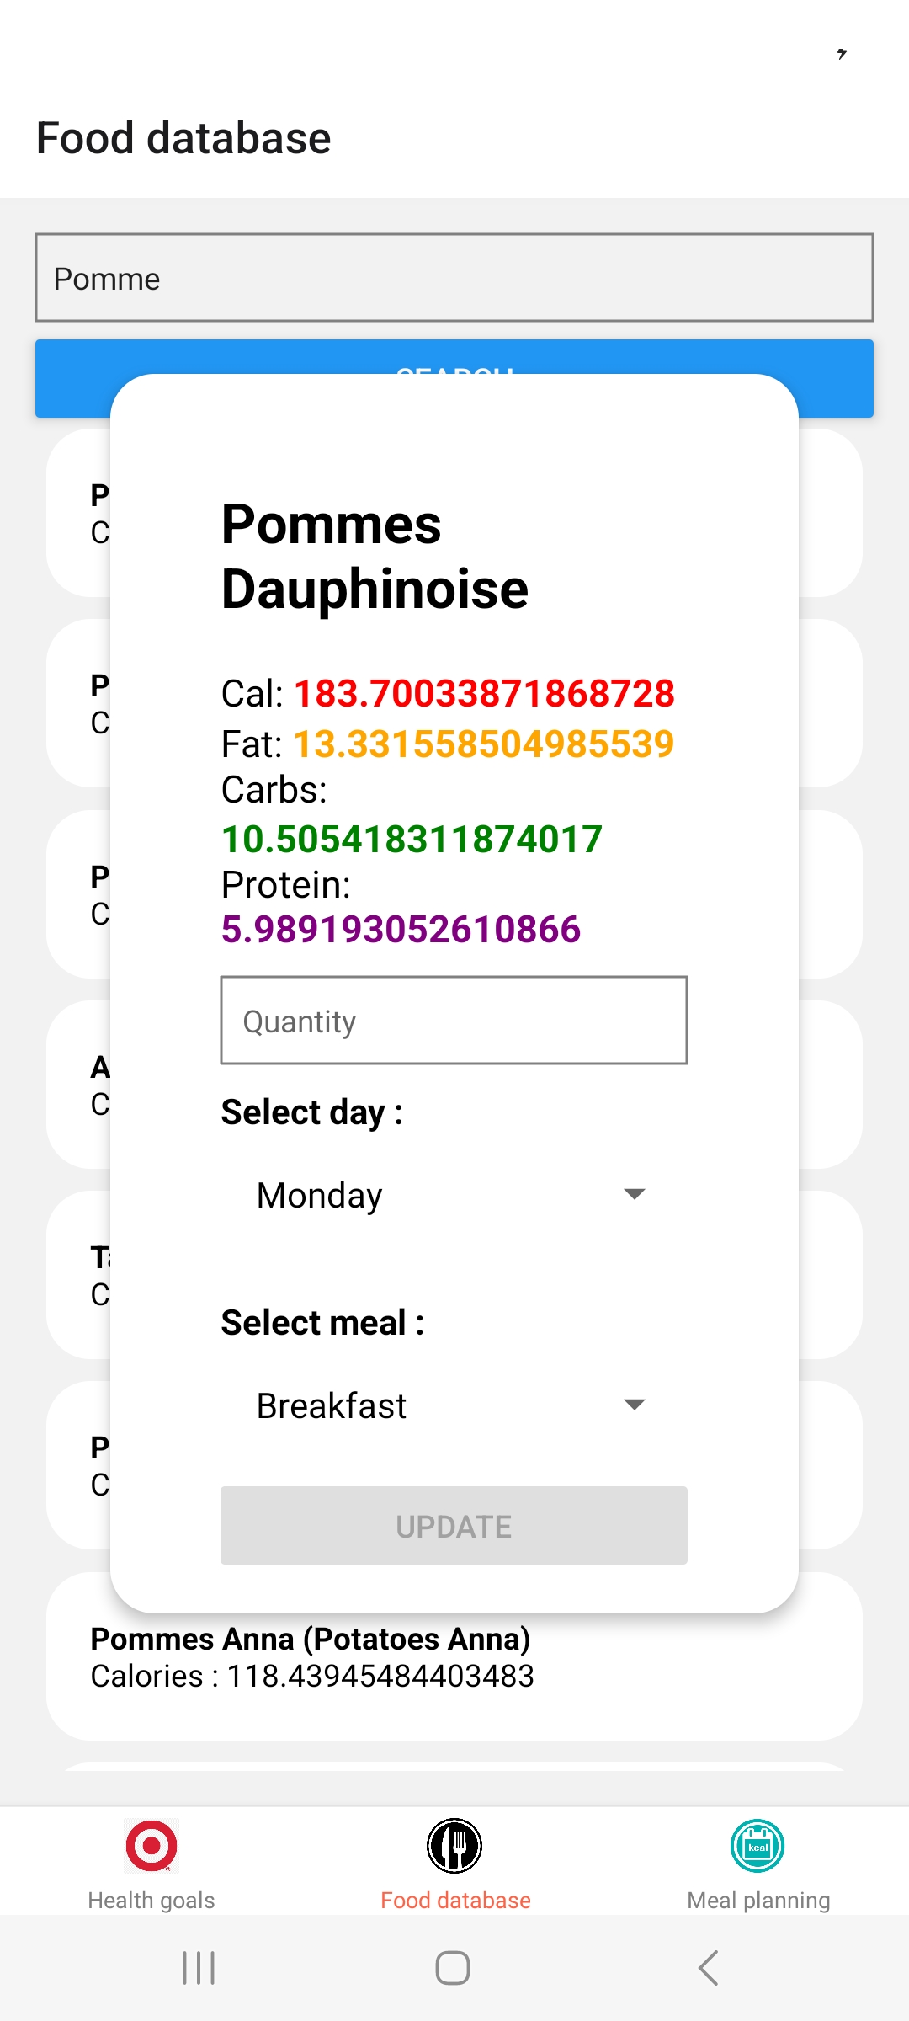
Description: This screenshot shows the interface for adding food items to the meal plan.
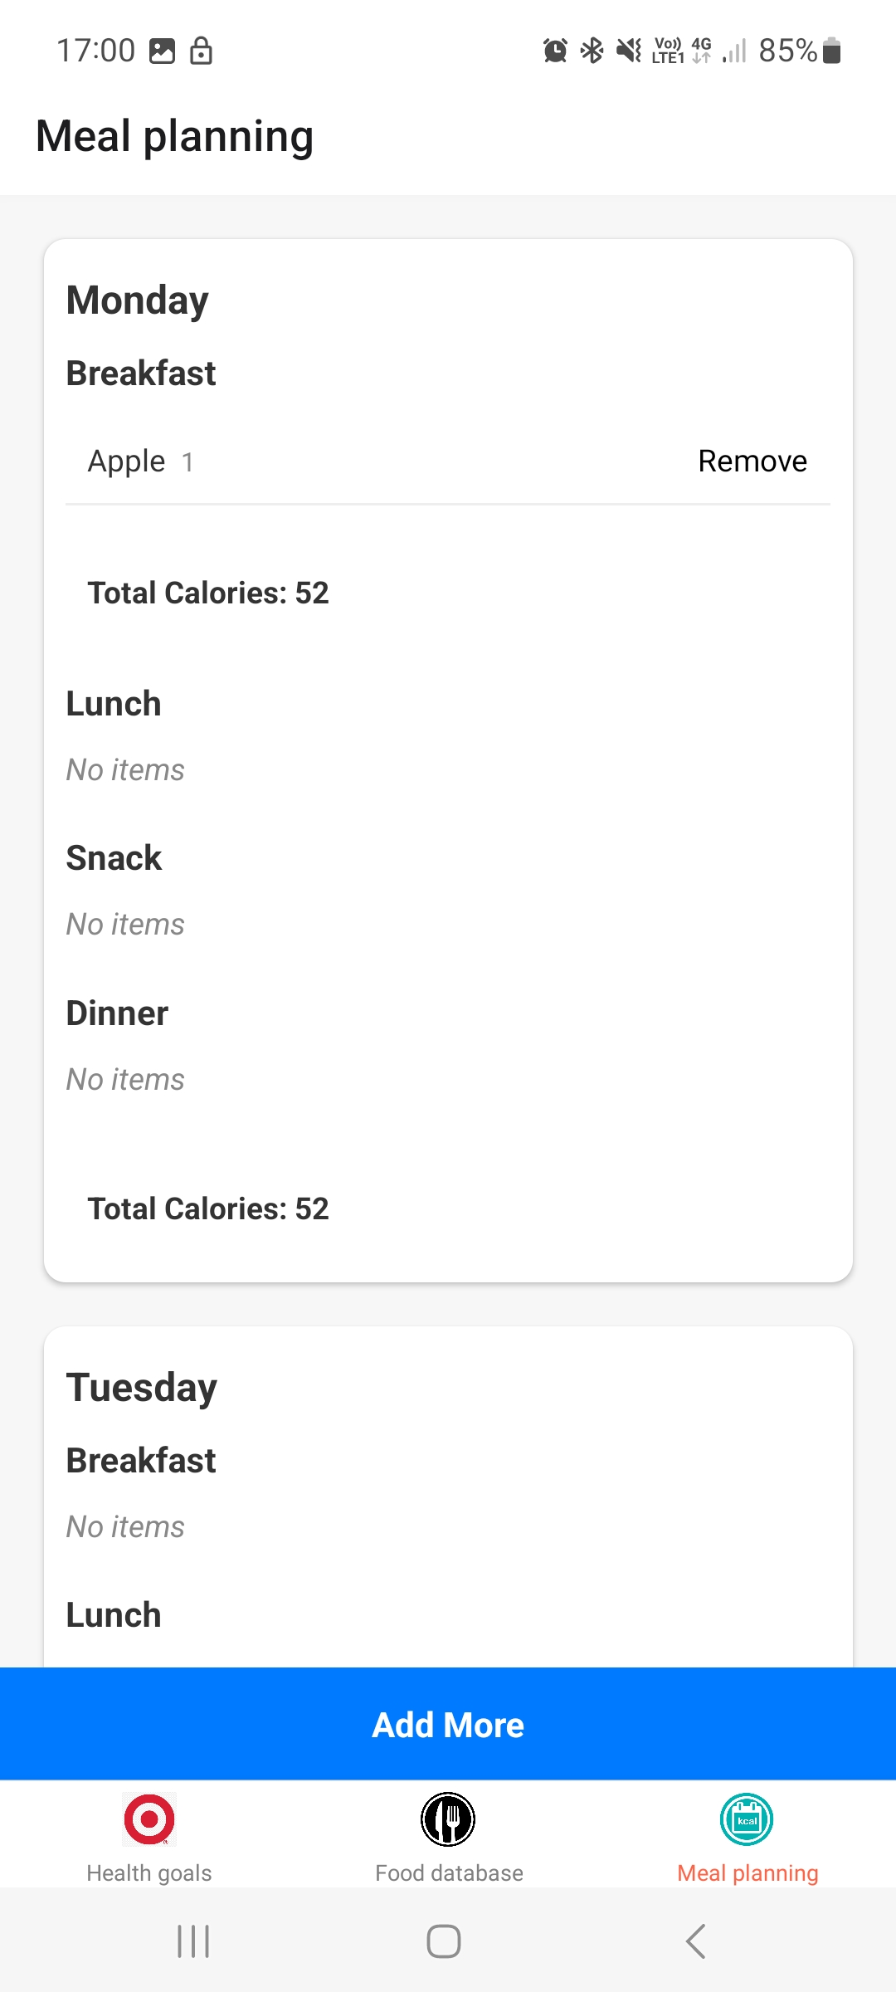
Description: This screenshot shows the process of adding an apple to the meal plan.
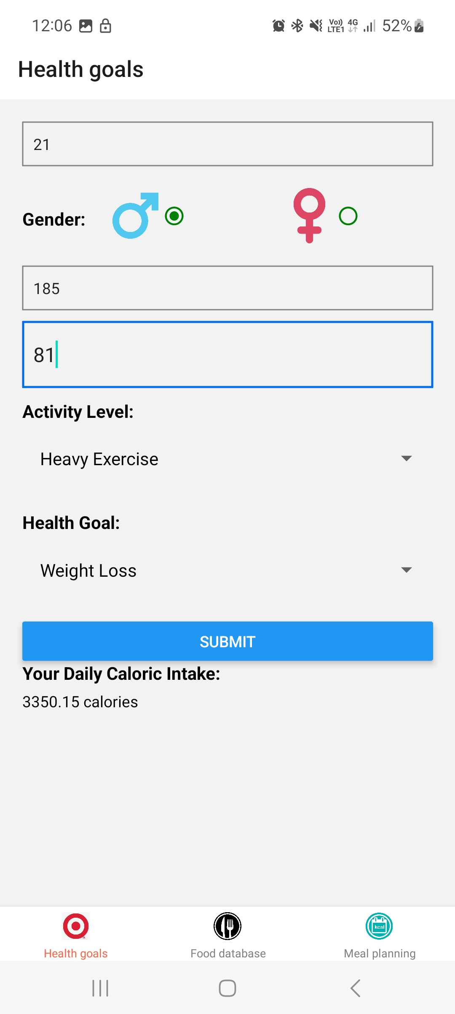
Description: This screenshot shows the OK button that users can click to confirm their actions.
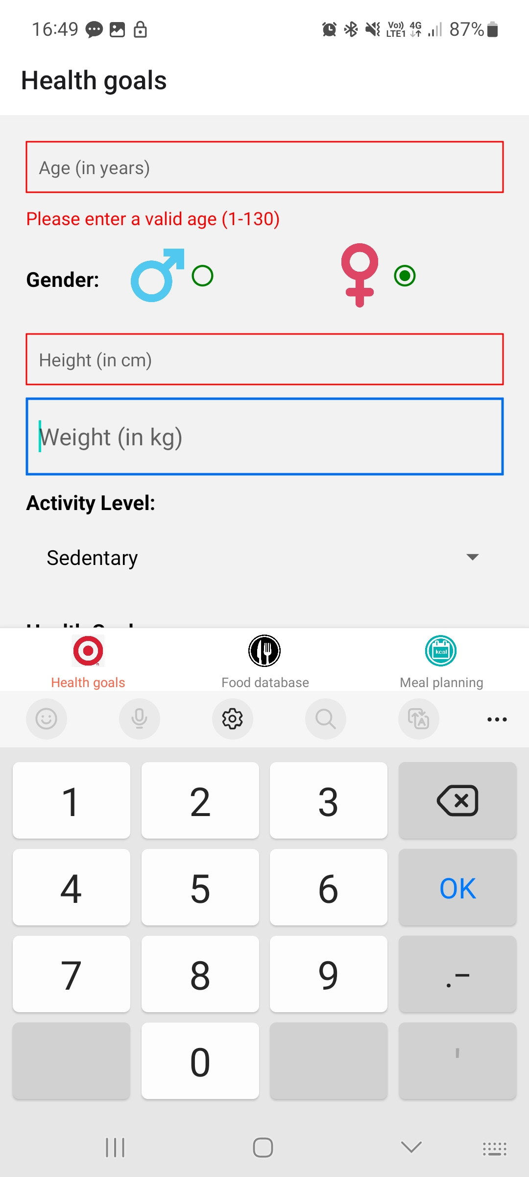
Description: This screenshot shows a form in focus, ready for user input.
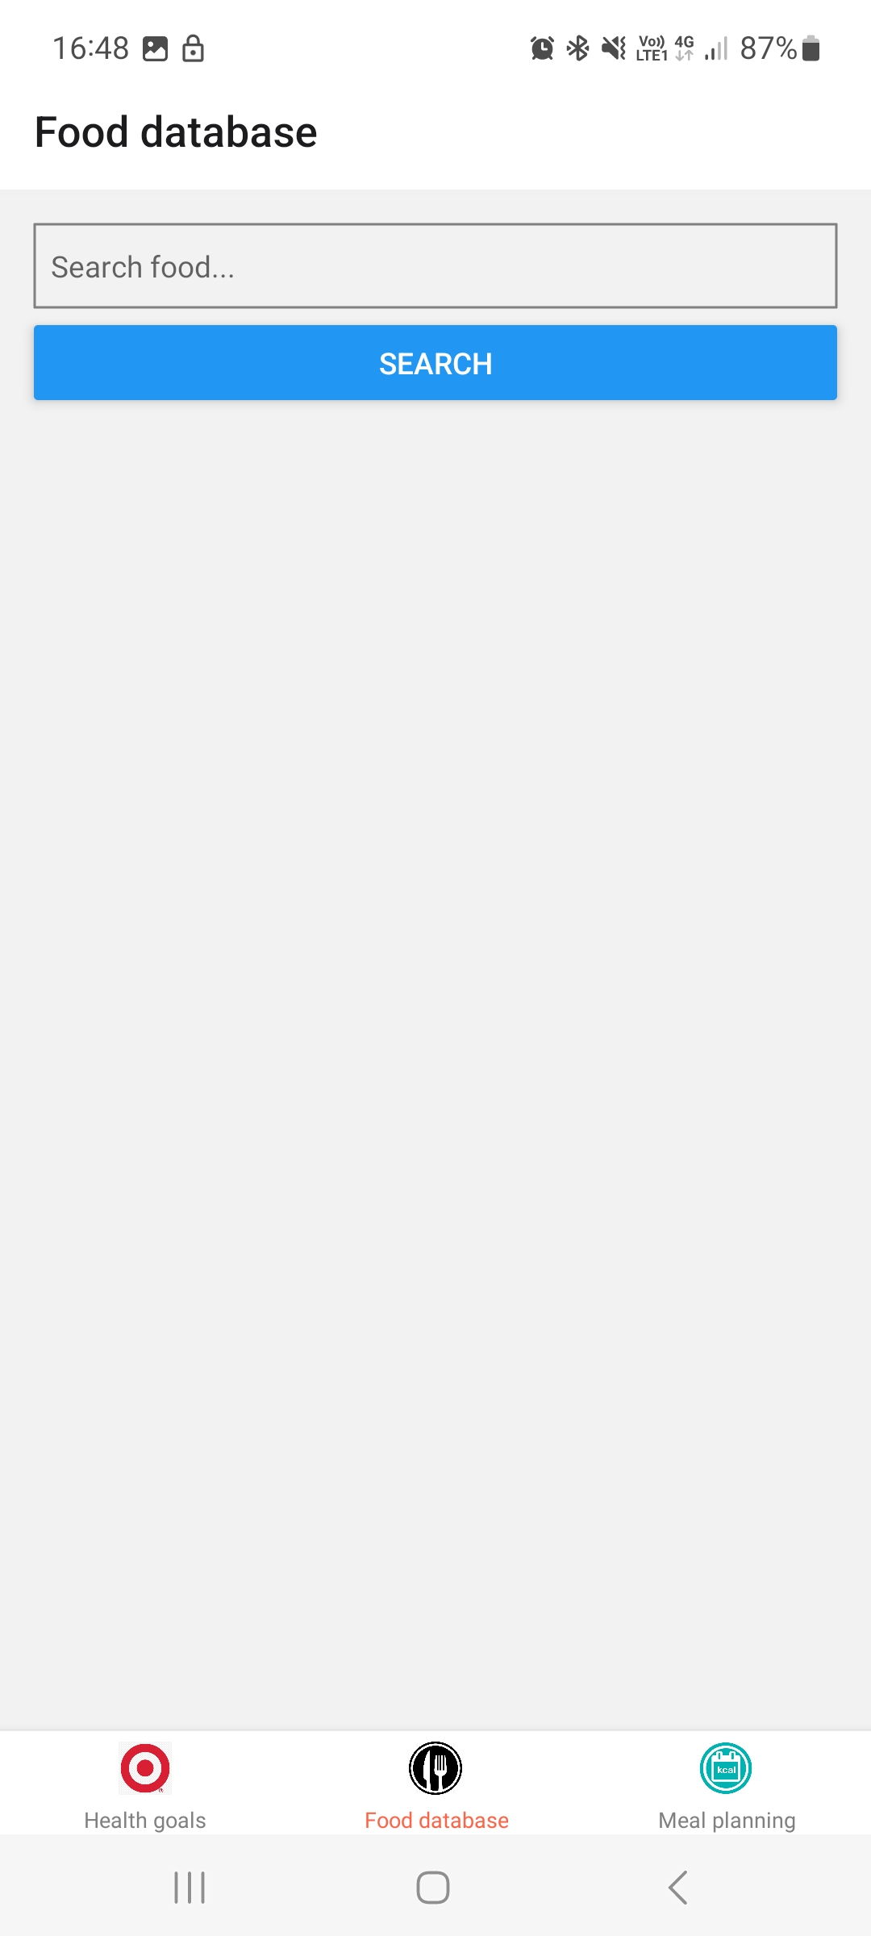
Description: This screenshot shows the food database where users can search for food items.
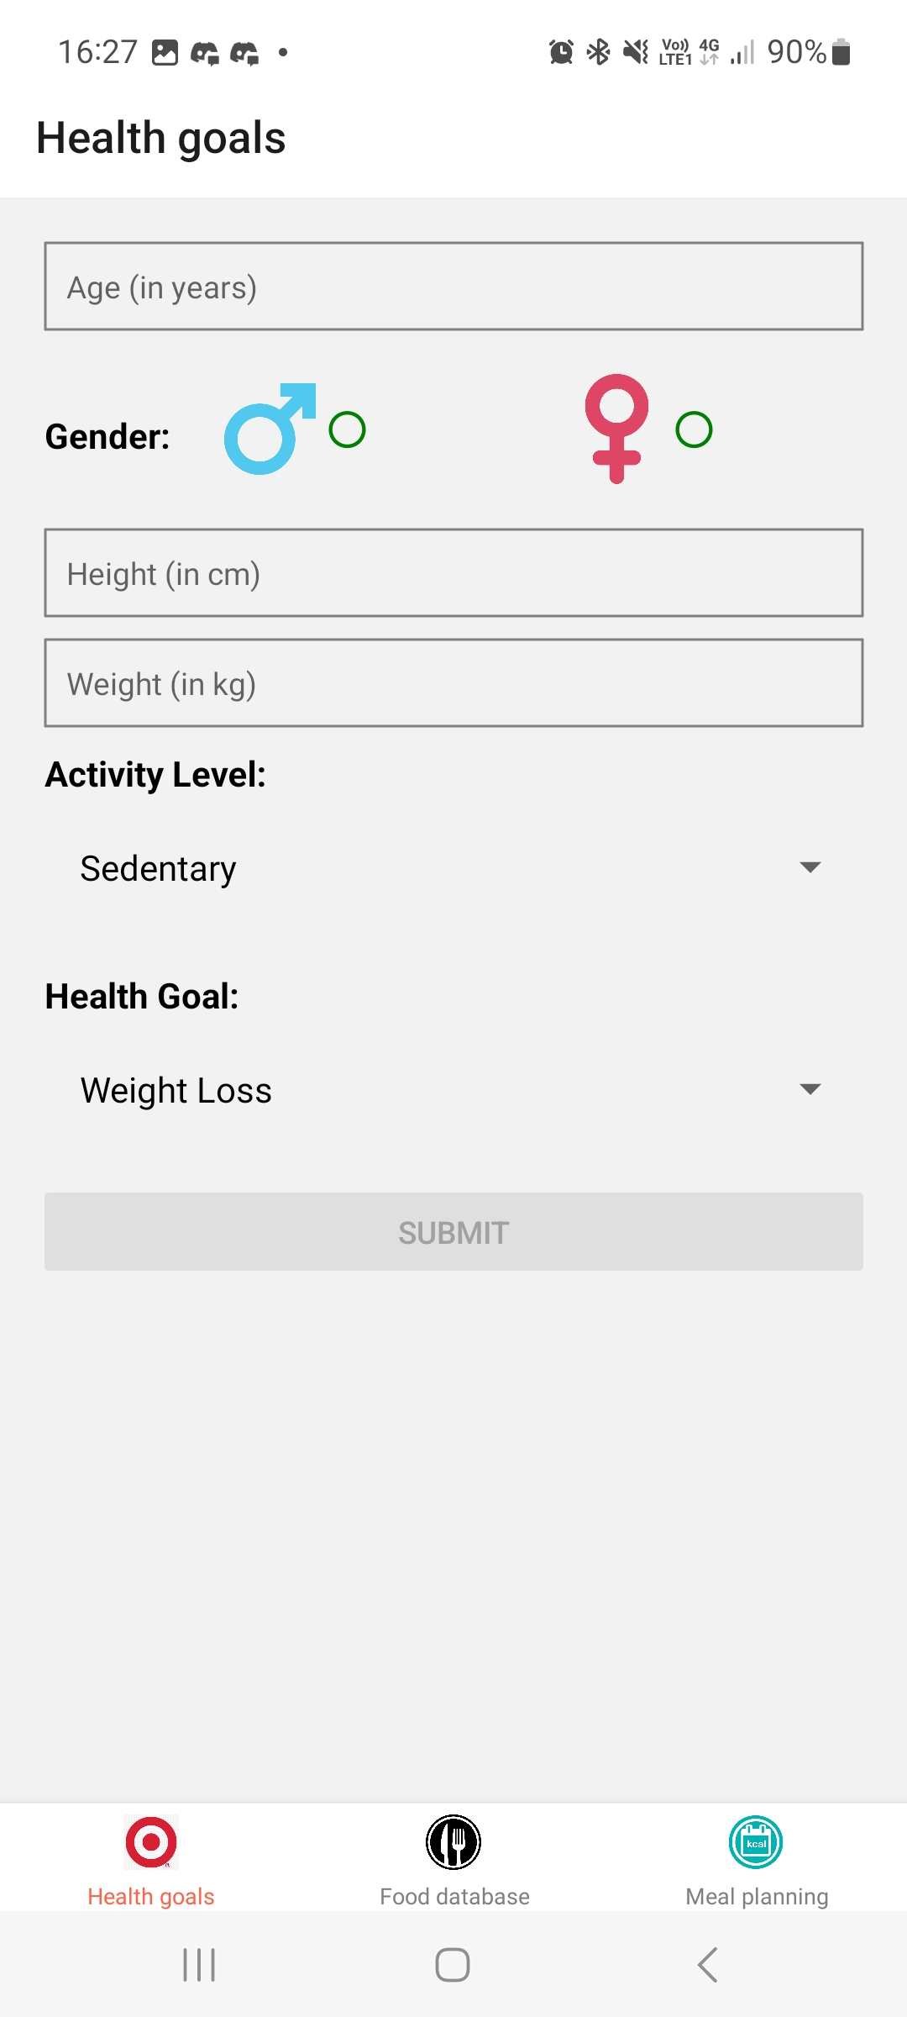
Description: This screenshot shows an empty form, indicating that the user has not yet entered any information.
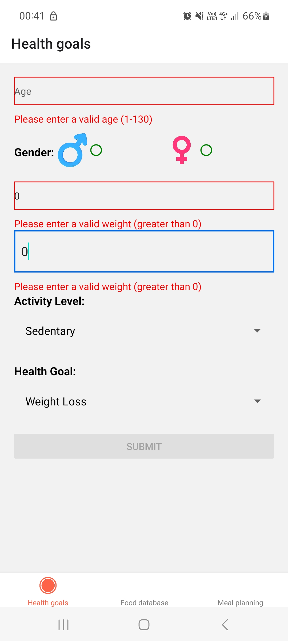
Description: This screenshot shows a form error, indicating that the user has entered invalid information.
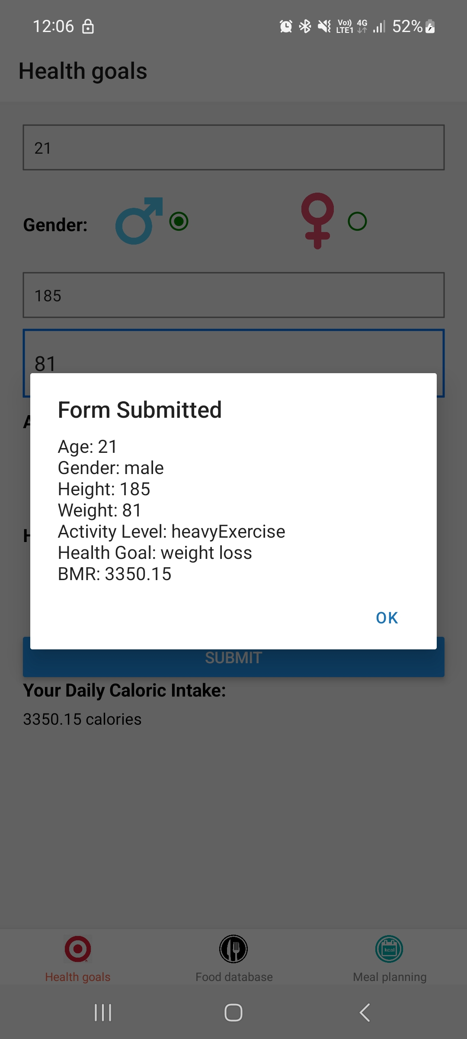
Description: This screenshot shows a form that has been successfully submitted.
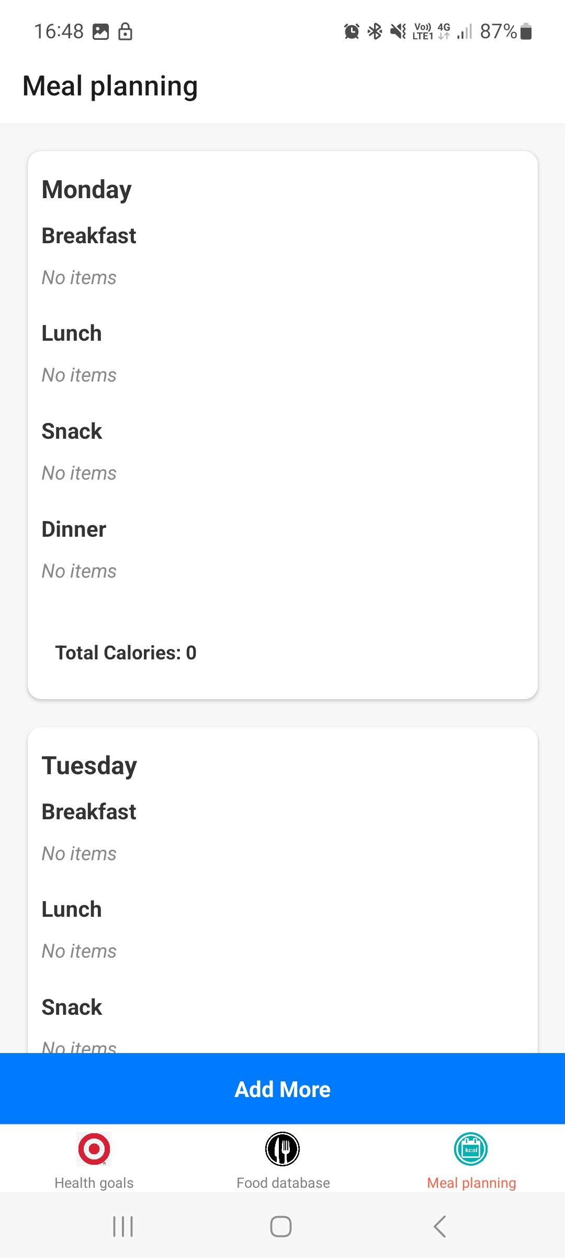
Description: This screenshot shows the meal planning interface where users can plan their meals for the week.
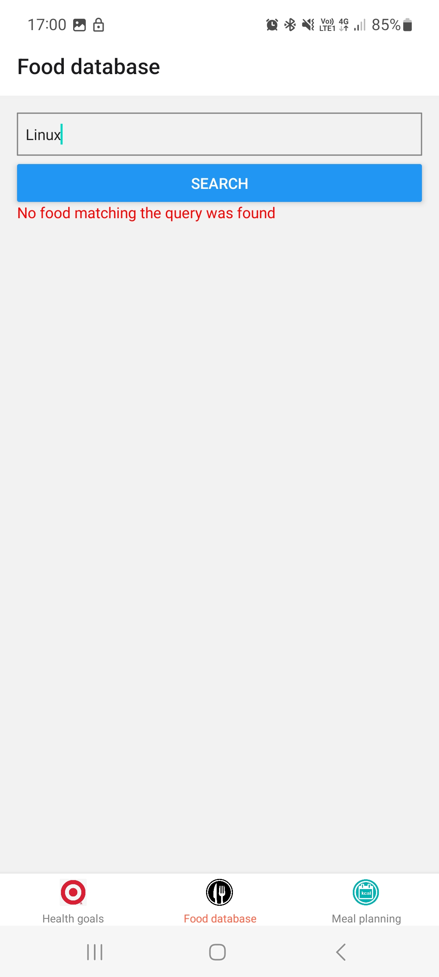
Description: This screenshot shows a “Not Found” message, indicating that the requested item could not be found in the database.
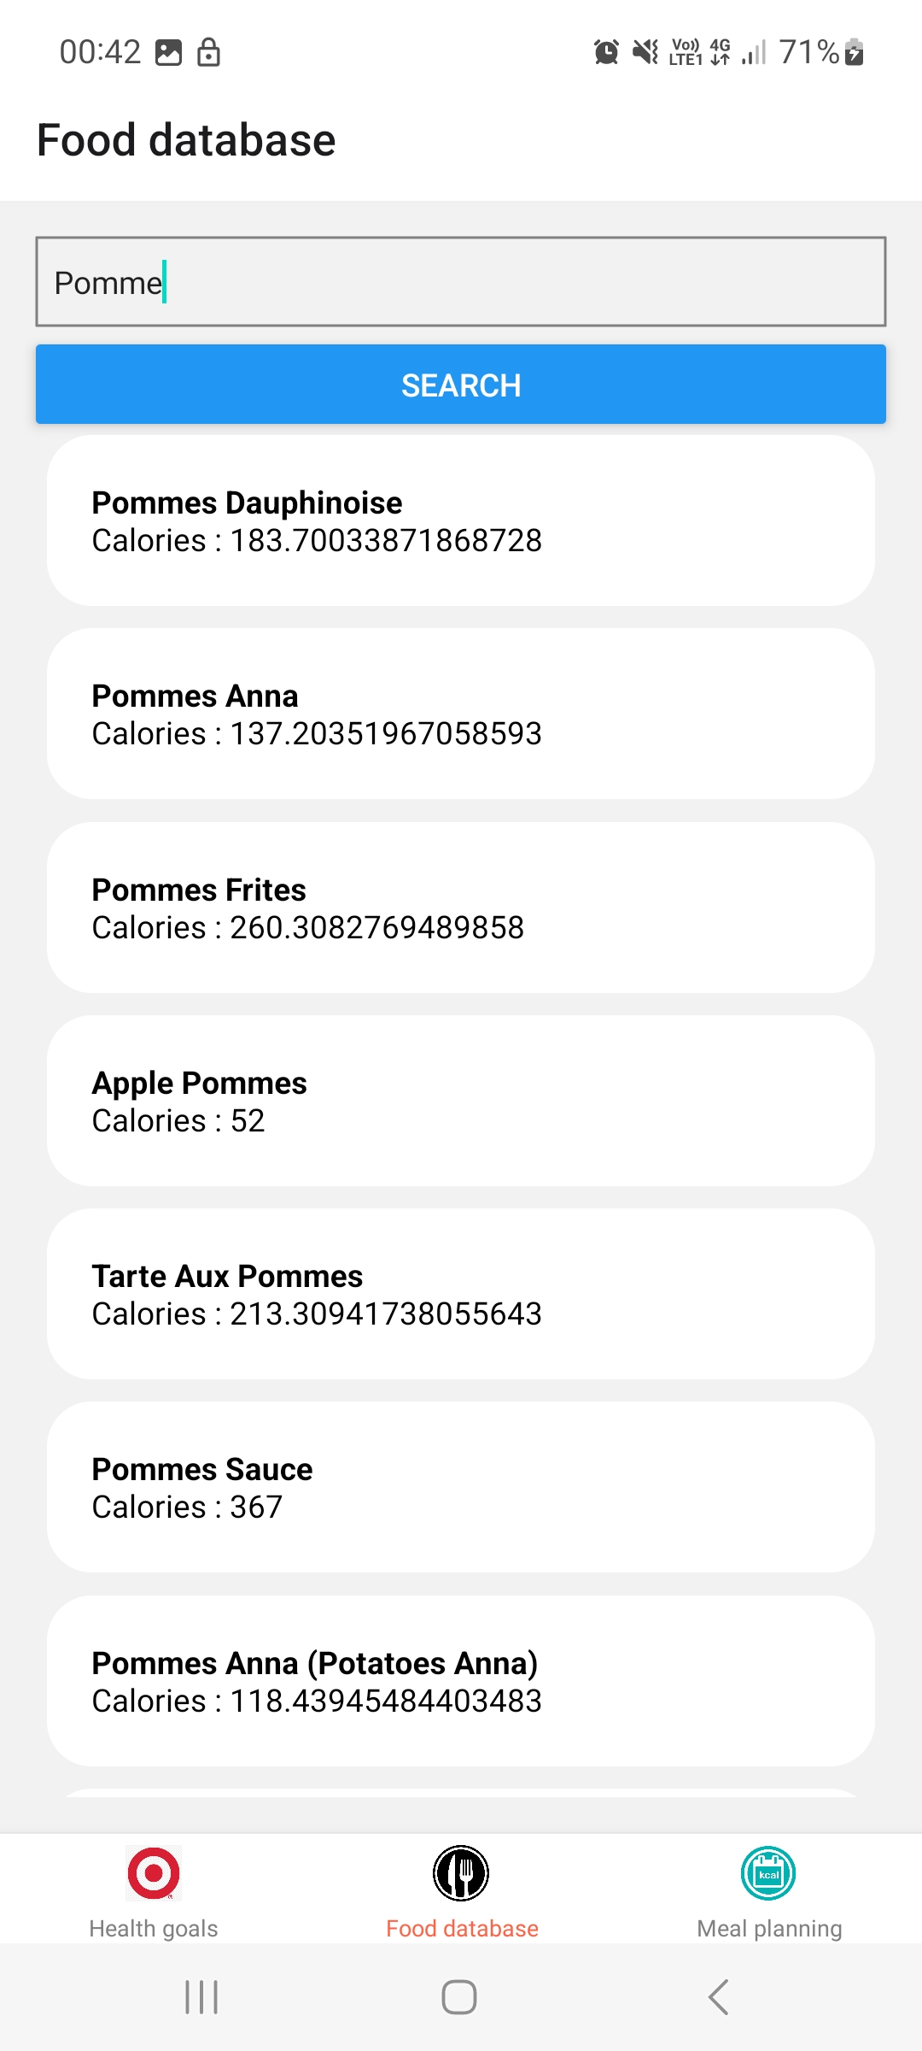
Description: This screenshot shows the result of a user’s actions, such as the total calories of a meal plan.
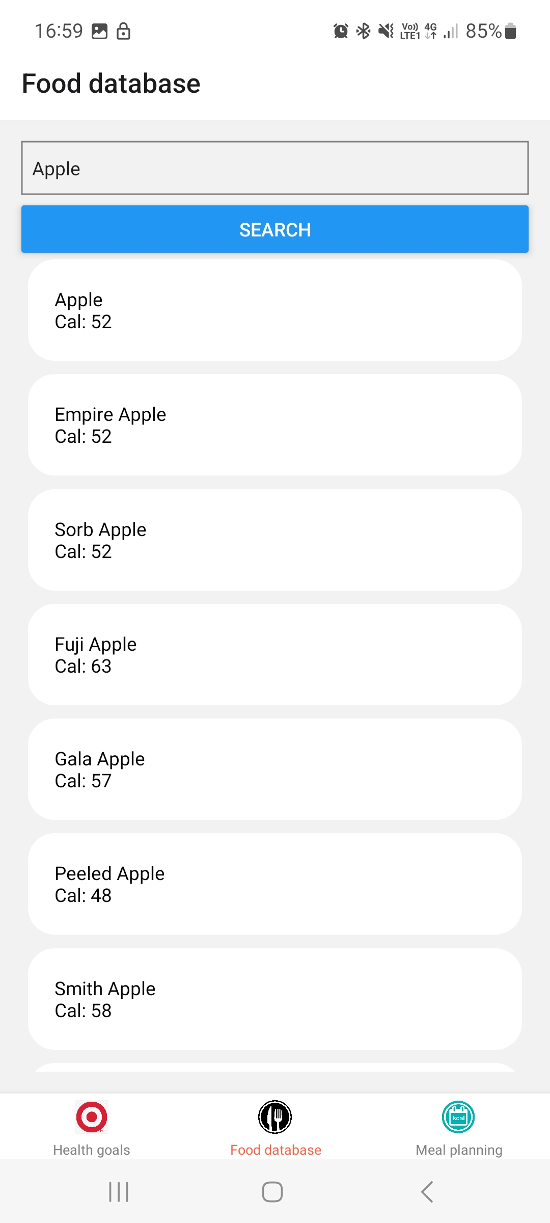
Description: This screenshot shows the result of a search for “apple” in the food database.

Challenges Encountered
During the development of the application we encountered some difficulties. These included understanding what was technically required of us, managing state in React Native, integrating with the nutrition API, and creating an intuitive and responsive user interface.
Finally, it was quite frustrating to have such an interesting subject but little time to devote to it because of the multiple simultaneous projects.

