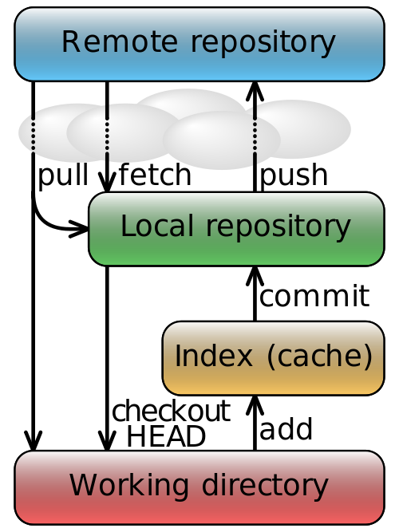

Official Git help: <http://git-scm.com/doc>

Official Github help: <https://help.github.com/>  
Official Github videos: <http://training.github.com/resources/videos/>

Entire Pro Git book: http://git-scm.com/book  
Online Git tutorial: <http://www.codeschool.com/courses/try-git>  (requires github login)   
Edutainment! <http://wheningit.tumblr.com/>  
Commit message best practices: <http://tbaggery.com/2008/04/19/a-note-about-git-commit-messages.html>  
Visual explanation of branches: <http://pcottle.github.com/learnGitBranching/>  
Good tool for big projects: gerrit.com  
All about distributed version controls: <http://en.wikipedia.org/wiki/Distributed_revision_control>  
Subversion (SVN) vs Git: <http://stackoverflow.com/questions/161541/svn-vs-git>  
Forking a repo instructions: https://help.github.com/articles/fork-a-repo

I wish I had some awesome document information to share.