Title: Boldness and Behavioral Diversity in Urban Coyotes Promote Increased Innovative Problem Solving
Authors: Sage Raymond¹*, Sarah Benson-Amram², Colleen Cassady St. Clair¹
Affiliations:
¹University of Alberta, Edmonton, Canada.
²Univeristy of British Columbia, Vancouver, Canada.
*Corresponding author. Email: rraymon1@ualberta.ca

Abstract: As landscapes are rapidly transformed by human modification, climate change, and other disturbances, understanding how wildlife adapt to novel ecosystems is increasingly important. The Cognitive Buffer Hypothesis posits that high intelligence buffers individuals against environmental challenges via adoption of novel behavioural responses. We tested this hypothesis in wild coyotes (Canis latrans) across an urban-to-wild gradient using puzzle-solving assays. Coyotes in more urbanized areas exhibited greater behavioural diversity and problem solving, indicating greater innovation. They were more exploratory and persistent, and less fearful, suggesting greater boldness. These results were consistent even when considering intrinsic and environmental factors. Our results suggest that behavioural traits can play an underappreciated role in shaping wildlife responses to increasing environmental novelty.

Main Text:
The Earth’s landscapes are rapidly changing courtesy of ongoing and accelerating habitat loss, climate change, and human modification, resulting in novel ecosystems (1–4). Such changes challenge wildlife by presenting them with novel environments that differ from the landscapes in which species evolved, and, sometimes, from the landscape in which an individual matured (5, 6). Arguably, the most extreme and novel ecosystems that contemporary wildlife face are cities (6), which present a suite of challenges, including the presence of people and their infrastructure, unavailability of natural food items, and altered patterns of habitat and disease (7–9). Despite the rapidity with which urbanization occurs (10), and the failure of many species to persist in cities, some species cope remarkably well (11, 12). Many studies investigate how species respond to environmental pressures presented by rapid anthropogenic change, but few consider cognitive mechanisms that underlie successful adaptive responses (13).
The Cognitive Buffer Hypothesis (CBH) suggests that intelligence evolved to buffer individuals against environmental challenges through novel behavioural responses (14). Specifically, the CBH predicts that species with larger brains will have greater domain-general cognition, exhibit more innovation and behavioural flexibility, and have a higher probability of surviving in novel and complex environments, including cities (Figure 1). The CBH similarly predicts that within a species, individuals in more urban environments will exhibit higher rates of innovation than individuals in natural environments.
Empirical evidence for the CBH is lacking, especially from wild environments (15). While some studies have used behavioral innovations or invasion success to test the CBH (16–19), these methods don't allow for detailed insights into how individual animals use cognition in human-modified environments. Despite evidence of high rates of innovation in some successful urban species (11–15); but see (16), there is less empirical data demonstrating a difference in innovation between individuals within a species across an urban-rural gradient ((20, 21), but see (22–24)). Such evidence is especially lacking for medium and large carnivores (15, 25).
Innovation can be assessed empirically by testing problem-solving abilities (19, 26). Animals are presented with a novel problem, often in the form of a puzzle box, and innovative animals are defined as those that successfully solve the problem (23, 27). Solving puzzles typically requires persistence (28) and behavioural diversity, where animals exhibiting a higher range of exploratory behaviors directed at the novel task are more successful at solving the problem (27). Puzzles require interaction with a novel human object, invoking boldness (29, 30), which has been observed in urban environments in many taxa (30–38), and which increases innovative problem-solving success (7, 16, 60). Boldness and innovation can bring animals into conflict with people (39). Such human-wildlife conflict is one of the greatest threats to survival for species living in human-dominated landscapes (40). Carnivores are often killed following human-wildlife conflict (41), decreasing ecosystem function, resilience, and health (42). However, cognitive studies are lacking for medium and large urban-adapted carnivores, for whom behavioural responses to novelty may play a critical role in shaping outcomes of human–wildlife coexistence (11, 25, 39).
We explicitly tested the CBH by experimentally assessing innovation and boldness in wild-living coyotes (Canis latrans) at varying levels of urbanization. Coyotes are a ubiquitous and successful urban-adapted mesocarnivore that is increasingly prevalent and prone to conflict with people in cities across North America (43–45). We deployed two sets of puzzles, with varying levels of anthropogenic cues to wild-living coyotes in urban and natural areas. We then extracted behavioural metrics for persistence, exploration, boldness, and behavioural diversity. We related these behaviours and frequency of solutions to urbanization and a suite of environmental and intrinsic characteristics. We completed these analyses at two scales of urban development by comparing behaviours (46) between an urban environment and a nearby protected, natural area and (11) along a continuous gradient of urbanization within the city (Figure 1). As per the CBH, we predicted that coyotes at more urban sites could exhibit higher innovation, demonstrated by greater behavioural diversity and more frequent solutions to puzzles than coyotes living at less urban sites. Additionally, if urban coyotes encounter more anthropogenic resources that reward boldness in urban areas, we predicted greater exploration of puzzles, greater persistence while attempting to solve puzzles, and less fearfulness compared to wild conspecifics.
Results
Between January and April in 2024 and 2025, we recorded a total of 1761 events of coyotes at puzzle assays, most of which occurred in the city (n = 1499, 85.1%; Movies 1-5). In 1156 events, the animal was oriented to the puzzle so the event was retained for subsequent behavioural analysis. Coyotes explored puzzles (e.g., smelling, investigating) in 486 events (42.0%), 458 of which occurred in the city (94.2%), and explorations lasted for 0.25 to 248.03 seconds. Coyotes contacted puzzles in 231 events (20.0%), 220 of which occurred in the city (95.2%). Persistence, measured as contact time, ranged from 0.07 to 144.57 seconds. Among events in which contact occurred, the number of behaviours exhibited ranged from 1 to 5 (x = 2.06, SD = 1.19). Coyotes exhibited fearfulness by fleeing with an escape gait 146 times (12.6% of events; 33.1% of events in wild). In total, coyotes solved puzzles in 48 events (4.2%), all of which occurred in the city. We could identify individual animals based on unique scars, coat colouration, and patterns of mange in 1092 events (94.5%). Sex was apparent in 1028 events (88.9%), and animals were visibly diseased in 376 events (32.5%). Most events occurred in darkness (n = 793, 68.6%). Events with a single focal animal were most common (n = 922, 79.8%), but group size ranged between 1 and 4. Mean daily temperature was -4.7°C (SD = 8.5) and ranged between -26.8°C and 9.9°C. Events involved wooden puzzles (n = 592; 51.2%) and plastic puzzles (n = 564; 48.8%) at similar rates
Urbanization increased innovation and boldness (Fig. 2). Relative to events occurring at wild sites, events in the city were characterised by four times greater odds of both exploration and physical contact, a 9.4% longer exploration duration, and contact persisted for 25% longer (table S1). City coyotes used 7.6% more behaviours and were 82% less likely to demonstrate an escape gait indicative of fearfulness. All 48 solutions in the study occurred in the city. Models containing the behavioural metrics of exploration, persistence, fearfulness, and solutions, but not behavioural diversity, improved model performance relative to a null model. R² values revealed that, for all models, much of the explanatory power could be attributed to urbanization rather than site ID.
Similar patterns occurred within the city along a continuous urbanization gradient; for a 10% increase in urbanization, odds of exploration and contact increased by 11.7% and 3.1% respectively, and exploration and persistence increased by 1% and 4% respectively. A 10% increase in urbanization increased behavioural diversity by 4%. Unlike the categorical comparison between city and wild sites, odds of an escape gait indicative of fearfulness increased by 6% per 10% increase in urbanization. Finally, a 10% increase in urbanization was associated with 25% greater odds of a solution. Among these, only models for behavioural diversity and solutions improved model performance relative to a null model. Model explanatory power was low for exploration, persistence, and behavioural diversity. For fearfulness and solutions, much of the explanatory power could be attributed to site ID (table S1). We observed the same pattern at the site scale (table S2; figure S1).
Intrinsic variables of sex and health and environmental event attributes of group size, temperature, puzzle type, daylight, year, and event sequence frequently failed to explain variation in outcome variables related to problem solving, though some patterns emerged (table S3-S4; figure S2). Odds of exploration increased when the puzzle was wooden (51%) and when the focal animal was male (9.4%), but predictors of duration had confidence intervals that considerably overlapped 0. Contact occurred more frequently when animals were diseased (99%), during the second year of study (68%), at wood puzzles (95%), and during the day (32%); persistence was 25% longer during the day. For behavioural diversity, no predictors improved model performance sufficiently for retention. Odds of an escape gait indicating fearfulness decreased by 22% for each additional animal in the group. Odds of a solution increased by 12% when the focal coyote was female, though confidence intervals extensively overlapped zero. For these models of intrinsic and environmental variables, only the persistence model improved performance relative to a null model. For fearfulness and solution models, site ID explained much of the variation (table S4).
When we included both urbanization metrics and the top predictors related to intrinsic and environmental event characteristics in a set of candidate models, urbanization occurred in the top model for all outcome variables (table S5-S6; Fig. 3). The inclusion of interaction terms and dispersion formulas failed to improve model performance for any variable. When we included individual ID as a second random effect in all models, we attained results that were categorically the same, but with weaker statistical power and some convergence problems given added model complexity and lower sample size (Tables S7 – S9).
Discussion
Accelerating landscape change creates novel and complex ecosystems to which some wildlife species successfully adapt while others do not (47, 48). Species can show rapid evolutionary change to novel ecosystems (49) or can adjust via changes in behaviour (39). Cognitive abilities, including innovative problem solving, facilitate these behavioural changes, which enable animals to navigate the challenges of environments like cities, including human presence (9), vehicle traffic (50), and limited refugia (51), while taking advantage of opportunities like anthropogenic food (52, 53) and reduced predation (45). We tested the Cognitive Buffer Hypothesis by determining innovation and boldness in coyotes both between a city and a nearby protected, natural area and along an urbanization gradient within a city. As predicted, innovative problem solving was higher at more urbanized sites, while behavioural diversity increased with increasing urbanization within the city, though it was similar between the urban and natural settings. Boldness was also greater among urban animals. Our results support the idea that behavioural adjustments are central to the success of some urban-adapting wildlife.
The influence of urbanization on innovation was indicated by greater behavioural diversity at urbanized sites within the city and higher frequency of problem solving across all sites, including the finding that all 48 puzzle solutions occurred at city sites. Despite evidence that behavioural diversity improves innovative problem solving (19, 26, 27, 54, 55) presumably facilitating adaptation to urban environments (6, 12), the role of urbanization in shaping innovation remains unclear, with previous studies showing mixed results. Urban mice demonstrate greater innovation (23), but rural spotted hyaenas were more innovative than urban conspecifics (22). Studies of red foxes (32) and sparrows (24) showed no influence of urbanization on innovation. Even among urban-adapted mesocarnivores, innovation is variable; urban raccoons are notably innovative (55, 56), whereas urban and rural red foxes are similarly innovative (32), and opossums are less innovative than raccoons (57). Innovation in wild-living coyotes had not been assessed prior to this study, in part because studies with captive coyotes documented limited problem-solving, apparently due to strong neophobia (28, 58–61).
That urbanization better predicted increased behavioural diversity among city sites (rather than strictly between city and wild sites) underscores the importance of heterogeneity within urban environments and their complex impacts on animal behaviour (62). Combined with the predictive power of Site ID in within-city models of innovative problem solving, this result suggests that behavioural diversity and problem-solving may be geographically stable, with some variation coming from sources other than those that we tested. For example, local social or ‘cultural’ context sometimes influence responses to novel problems or situations (63) and are likely to apply to coyotes which have stable home ranges (64), and exhibit learning via vertical transmission (65) and within generations (28). Both kinds of learning could contribute to creating local hotspots of conflict that persist over time and among generations (39).
Boldness was greater at more urban sites. This relationship has been documented in various taxa, including coyotes (30), red foxes (32), birds (33, 34), small mammals (31, 35), and reptiles (36–38). One apparent exception to our observed pattern was an increase in use of escape gaits at the highest levels of urbanization. Some of these videos appeared to contain play behaviour, which we coded as escape gaits in accordance with out a priori categorizations. Alternately, boldness may be most adaptive in moderately urbanized areas, such as suburbs (44). The effect of urbanization on boldness was strongest between urban and natural sites compared to sites within the city. This pattern may result from our choice of urbanization metric (i.e., percent anthropogenic cover), which is structural and may not have captured the most ecologically relevant predictors of boldness (66). For example, access to anthropogenic food (67) presumably increases boldness towards anthropogenic objects, but such factors are highly localized and difficult to measure consistently (68). Because increased boldness is a frequent correlate of problem solving (27, 29, 69, 70), and both boldness and resulting habituation to novel stimuli can persist across animal lives (71) and generations (65, 72), this personality trait appears crucial to adaptation to urban environments, though it also contributes to human-wildlife conflict (39).
Environmental and intrinsic event characteristics had some limited influence on behavioural outcomes, but effect sizes were small and frequently insignificant. Wooden puzzles were more likely to be explored and contacted, perhaps because they lacked strong anthropogenic cues and were perceived as less threatening by neophobic animals (59–61). Diseased individuals were more likely to contact puzzles, which could reflect increased risk-taking in physiologically stressed individuals (73), or the known relationship among disease, anthropogenic food consumption, and boldness in coyotes (74). Odds of contact also increased during daylight hours, perhaps because bolder individuals are more diurnal (50). Contact rates increased in the second year of the study, perhaps due to learned familiarity with puzzles. Fearfulness was less likely with increasing group size, which could reveal increased comfort from greater vigilance (75). Though many studies have not found an effect of sex on problem solving (27), males were somewhat more likely to explore puzzles, consistent with literature suggesting greater boldness in males (76), but females were marginally more likely to solve puzzles.
Urban wildlife is an increasing component of the novel and complex ecosystems that humans are creating (6). Our study demonstrated with multiple behavioural metrics that innovation and boldness were greater in coyotes occupying more urbanized sites, at two scales of urbanization. Though some adaptation to cities may be genetic or epigenetic (37), much of this variation can likely be attributed to the behavioural flexibility for which coyotes are renowned (45, 50, 53), and which supports exploration and adaptation to novel resources in cities (6, 12, 39). These behavioural traits may be enhanced by access to anthropogenic food, favouring further increases in expensive brain tissues (77, 78), increased cognitive buffer (14) and greater adaptation to changing environments. Such a positive feedback loop may contribute to the increasing prevalence of coyotes in urban areas throughout North America (45) and their recent expansion into South America (79). In a world that is changing rapidly courtesy of expanding urbanization and climate change, evidence of rapid adaptation to novel challenges underscores the capacity of some species to flexibly navigate, persist, and thrive within human-altered landscapes.

References and Notes
1. M. L. McKinney, Urbanization, biodiversity, and conservation. BioScience 52, 883–890 (2002).
2. B. Abrahms, N. Carter, T. Clark-Wolf, K. Gaynor, E. Johansson, A. McInturff, A. Nisi, K. Rafiq, L. West, Climate change as a global amplifier of human-wildlife conflict. Nature Climate Change 13, 224–234 (2023).
3. J. C. Rocha, G. D. Peterson, R. Biggs, Regime shifts in the Anthropocene: drivers, risks, and resilience. PloS One 10, e0134639 (2015).
4. C. Rosenzweig, D. Karoly, M. Vicarelli, P. Neofotis, Q. Wu, G. Casassa, A. Menzel, T. L. Root, N. Estrella, B. Seguin, Attributing physical and biological impacts to anthropogenic climate change. Nature 453, 353–357 (2008).
5. V. Mazza, V. Šlipogor, Behavioral flexibility and novel environments: integrating current perspectives for future directions. Current Zoology 70, 304–309 (2024).
6. D. Sol, O. Lapiedra, C. González-Lagos, Behavioural adjustments for a life in the city. Animal Behaviour 85, 1101–1112 (2013).
7. C. A. Bradley, S. Altizer, Urbanization and the ecology of wildlife diseases. Trends in Ecology and Evolution. 22, 95–102 (2007).
8. D. J. Becker, R. J. Hall, K. M. Forbes, R. K. Plowright, S. Altizer, Anthropogenic resource subsidies and host-parasite dynamics in wildlife. Philosophical Transactions of the Royal Society B-Biological Sciences 373, 20170086 (2018).
9. K. M. Gaynor, C. E. Hojnowski, N. H. Carter, J. S. Brashares, The influence of human disturbance on wildlife nocturnality. Science 360, 1232–1235 (2018).
10. M. L. McKinney, Urbanization as a major cause of biotic homogenization. Biological Conservation 127, 247–260 (2006).
11. J. W. Gibbons, D. E. Scott, T. J. Ryan, K. A. Buhlmann, T. D. Tuberville, B. S. Metts, J. L. Greene, T. Mills, Y. Leiden, S. Poppy, The Global Decline of Reptiles, Déjà Vu Amphibians: Reptile species are declining on a global scale. Six significant threats to reptile populations are habitat loss and degradation, introduced invasive species, environmental pollution, disease, unsustainable use, and global climate change. BioScience 50, 653–666 (2000).
12. A. Sih, M. C. Ferrari, D. J. Harris, Evolution and behavioural responses to human‐induced rapid environmental change. Evolutionary Applications 4, 367–387 (2011).
13. A. L. Greggor, N. S. Clayton, B. Phalan, A. Thornton, Comparative cognition for conservationists. Trends in Ecology & Evolution 29, 489–495 (2014).
14. C. Darwin, The Cognitive-Buffer Hypothesis for the Evolution of Large Brains. Cognitive Ecology II, 111 (2009).
15. D. J. Pritchard, T. A. Hurly, M. C. Tello‐Ramos, S. D. Healy, Why study cognition in the wild (and how to test it)? Journal of the Experimental Analysis of Behavior 105, 41–55 (2016).
16. L. Lefebvre, S. M. Reader, D. Sol, Brains, innovations and evolution in birds and primates. Brain Behavior and Evolution 63, 233–246 (2004).
17. S. M. Reader, K. MacDonald, Environmental variability and primate behavioural flexibility. S. M. Reader & K. N. Laland (Eds.), Animal innovation (pp. 83–116). Oxford University Press. (2003).
18. D. Sol, R. P. Duncan, T. M. Blackburn, P. Cassey, L. Lefebvre, Big brains, enhanced cognition, and response of birds to novel environments. Proceedings of the National Academy of Sciences 102, 5460–5465 (2005).
19. D. Sol, S. Timmermans, L. Lefebvre, Behavioural flexibility and invasion success in birds. Animal Behaviour 63, 495–502 (2002).
20. E. Vincze, B. Kovács, Urbanization’s effects on problem solving abilities: A meta-analysis. Frontiers in Ecology and Evolution 10, 834436 (2022).
21. A. S. Griffin, K. Netto, C. Peneaux, Neophilia, innovation and learning in an urbanized world: a critical evaluation of mixed findings. Current Opinion in Behavioral Sciences 16, 15–22 (2017).
22. L. Johnson-Ulrich, G. Yirga, R. L. Strong, K. E. Holekamp, The effect of urbanization on innovation in spotted hyenas. Animal Cognition 24, 1027–1038 (2021).
23. V. Mazza, A. Guenther, City mice and country mice: innovative problem solving in rural and urban noncommensal rodents. Animal Behaviour 172, 197–210 (2021).
24. S. Papp, E. Vincze, B. Preiszner, A. Liker, V. Bókony, A comparison of problem-solving success between urban and rural house sparrows. Behavioral Ecology and Sociobiology 69, 471–480 (2015).
25. S. Benson-Amram, H. J. Griebling, C. M. Sluka, The current state of carnivore cognition. Animal Cognition 26, 37–58 (2023).
26. J.-N. Audet, L. Lefebvre, What’s flexible in behavioral flexibility? Behavioral Ecology 28, 943–947 (2017).
27. S. Benson-Amram, K. E. Holekamp, Innovative problem solving by wild spotted hyenas. Proceedings of the Royal Society B: Biological Sciences 279, 4087–4095 (2012).
28. J. K. Young, L. Touzot, S. P. Brummer, Persistence and conspecific observations improve problem-solving abilities of coyotes. PLoS One 14, e0218778 (2019).
29. S. Benson-Amram, M. L. Weldele, K. E. Holekamp, A comparison of innovative problem-solving abilities between wild and captive spotted hyaenas, Crocuta crocuta. Animal Behaviour 85, 349–356 (2013).
30. S. W. Breck, S. A. Poessel, P. Mahoney, J. K. Young, The intrepid urban coyote: a comparison of bold and exploratory behavior in coyotes from urban and rural environments. Scientific Reports 9, 2104 (2019).
31. V. Mazza, M. Dammhahn, E. Lösche, J. A. Eccard, Small mammals in the big city: Behavioural adjustments of non-commensal rodents to urban environments. Global Change Biology 26, 6326–6337 (2020).
32. F. B. Morton, M. Gartner, E.-M. Norrie, Y. Haddou, C. D. Soulsbury, K. A. Adaway, Urban foxes are bolder but not more innovative than their rural conspecifics. Animal Behaviour 203, 101–113 (2023).
33. J. W. Atwell, G. C. Cardoso, D. J. Whittaker, S. Campbell-Nelson, K. W. Robertson, E. D. Ketterson, Boldness behavior and stress physiology in a novel urban environment suggest rapid correlated evolutionary adaptation. Behavioral Ecology 23, 960–969 (2012).
34. J. Evans, K. Boudreau, J. Hyman, Behavioural syndromes in urban and rural populations of song sparrows. Ethology 116, 588–595 (2010).
35. M. Dammhahn, V. Mazza, A. Schirmer, C. Göttsche, J. A. Eccard, Of city and village mice: behavioural adjustments of striped field mice to urban environments. Scientific Reports 10, 13056 (2020).
36. O. Lapiedra, Z. Chejanovski, J. J. Kolbe, Urbanization and biological invasion shape animal personalities. Global Change Biology 23, 592–603 (2017).
37. J. Baxter-Gilbert, J. L. Riley, M. J. Whiting, Bold New World: urbanization promotes an innate behavioral trait in a lizard. Behavioral Ecology and Sociobiology 73, 105 (2019).
38. S. Blanchett, A. Turcotte, G. Blouin-Demers, The impact of urbanization on painted turtle (Chrysemys picta) behaviour. Ethology 130, e13467 (2024).
39. L. P. Barrett, L. A. Stanton, S. Benson-Amram, The cognition of “nuisance” species. Animal Behaviour 147, 167–177 (2019).
40. IUCN, What is human-wildlife conflict? Briefing Paper by the IUCN SSC Human-Wildlife Conflict Task Force. IUCN SSC HWCTF (2020).
41. A. Treves, K. U. Karanth, Human-carnivore conflict and perspectives on carnivore management worldwide. Conservation Biology. 17, 1491–1499 (2003).
42. W. J. Ripple, J. A. Estes, R. L. Beschta, C. C. Wilmers, E. G. Ritchie, M. Hebblewhite, J. Berger, B. Elmhagen, M. Letnic, M. P. Nelson, Status and ecological effects of the world’s largest carnivores. Science 343, 1241484 (2014).
43. R. B. Blair, Land use and avian species diversity along an urban gradient. Ecological Applications 6, 506–519 (1996).
44. S. D. Gehrt, J. L. Brown, C. Anchor, Is the urban coyote a misanthropic synanthrope? The case from Chicago. Cities and the Environment 4, 3 (2011).
45. M. E. Gompper, Top carnivores in the suburbs? Ecological and conservation issues raised by colonization of north-eastern North America by coyotes. Bioscience 52, 185–190 (2002).
46. S. R. Palumbi, D. J. Barshis, N. Traylor-Knowles, R. A. Bay, Mechanisms of reef coral resistance to future climate change. Science 344, 895–898 (2014).
47. H. Lowry, A. Lill, B. B. M. Wong, Behavioural responses of wildlife to urban environments. Biological Reviews 88, 537–549 (2013).
48. S. Kark, A. Iwaniuk, A. Schalimtzek, E. Banker, Living in the city: can anyone become an “urban exploiter”? Journal of Biogeography 34, 638–651 (2007).
49. J. Munshi-South, Urban landscape genetics: canopy cover predicts gene flow between white-footed mouse (Peromyscus leucopus) populations in New York City. Molecular Ecology 21, 1360–1378 (2012).
50. Murray, C. C. St. Clair, Individual flexibility in nocturnal activity reduces risk of road mortality for an urban carnivore. Behavioral Ecology 26, 1520–1527 (2015).
51. S. Raymond, C. C. St Clair, Urban coyotes select cryptic den sites near human development where conflict rates increase. Journal of Wildlife Management 87, e22323 (2023).
52. S. Raymond, D. K. Steckler, M. A. Seguin, C. C. St. Clair, Coyote scat in cities increases risk of human exposure to an emerging zoonotic disease in North America. Frontiers in Conservation Science 4, 1294693 (2024).
53. S. Sugden, M. Murray, M. A. Edwards, C. C. St. Clair, Inter-population differences in coyote diet and niche width along an urban–suburban–rural gradient. Journal of Urban Ecology 7, 1–12 (2021).
54. S. E. Daniels, R. E. Fanelli, A. Gilbert, S. Benson-Amram, Behavioral flexibility of a generalist carnivore. Animal Cognition 22, 387–396 (2019).
55. L. A. Stanton, E. S. Bridge, J. Huizinga, S. Benson-Amram, Environmental, individual and social traits of free-ranging raccoons influence performance in cognitive testing. Journal of Experimental Biology 225, jeb243726 (2022).
56. L. Stanton, E. Davis, S. Johnson, A. Gilbert, S. Benson-Amram, Adaptation of the Aesop’s Fable paradigm for use with raccoons (Procyon lotor): considerations for future application in non-avian and non-primate species. Animal Cognition 20, 1147–1152 (2017).
57. K. A. Adaway, M. H. Snider, C. Vinciguerra, C. A. Kupferman, J. C. Beasley, F. B. Morton, Wild racoons are more innovative but not bolder than another generalist, the Virginia opossum, on a pull-string task. Animal Behaviour 227, 123279 (2025).
58. A. C. Garcia, M. A. Parsons, J. K. Young, Effects of early-life experience on innovation and problem-solving in captive coyotes. Behavioral Ecology and Sociobiology 76, 141 (2022).
59. L. A. Stanton, E. S. Bridge, J. Huizinga, S. R. Johnson, J. K. Young, S. Benson-Amram, Variation in reversal learning by three generalist mesocarnivores. Animal Cognition 24, 555–568 (2021).
60. A. E. Mettler, J. A. Shivik, Dominance and neophobia in coyote (Canis latrans) breeding pairs. Applied Animal Behaviour Science 102, 85–94 (2007).
61. P. A. Darrow, J. A. Shivik, Bold, shy, and persistent: variable coyote response to light and sound stimuli. Applied Animal Behaviour Science 116, 82–87 (2009).
62. T. Caspi, M. G. Serrano, S. L. Vanderzwan, J. Kessler, C. J. Schell, B. N. Sacks, Impervious surface cover and number of restaurants shape diet variation in an urban carnivore. Ecosphere 16, e70152 (2025).
63. A. Whiten, J. Goodall, W. C. McGrew, T. Nishida, V. Reynolds, Y. Sugiyama, C. E. Tutin, R. W. Wrangham, C. Boesch, Cultures in chimpanzees. Nature 399, 682–685 (1999).
64. A. M. Kitchen, E. M. Gese, E. R. Schauster, Long-term spatial stability of coyote (Canis latrans) home ranges in southeastern Colorado. Canadian Journal of Zoology 78, 458–464 (2000).
65. C. J. Schell, J. K. Young, E. V. Lonsdorf, R. M. Santymire, J. M. Mateo, Parental habituation to human disturbance over time reduces fear of humans in coyote offspring. Ecology and Evolution 8, 12965–12980 (2018).
66. R. J. Moll, J. D. Cepek, P. D. Lorch, P. M. Dennis, E. Tans, T. Robison, J. J. Millspaugh, R. A. Montgomery, What does urbanization actually mean? A framework for urban metrics in wildlife research. Journal of Applied Ecology 56, 1289–1300 (2019).
67. J. B. Hopkins, S. Herrero, R. T. Shideler, K. A. Gunther, C. C. Schwartz, S. T. Kalinowski, A proposed lexicon of terms and concepts for human-bear management in North America. Ursus 21, 154–168 (2010).
68. S. Raymond, C. C. St Clair, Coyotes access diverse anthropogenic attractants at the ecotone between natural and residential urban areas. Urban Ecosystems 26, 1589–1605 (2023).
69. A. S. Griffin, D. Guez, Innovation and problem solving: a review of common mechanisms. Behavioural Processes 109, 121–134 (2014).
70. L. Johnson-Ulrich, Z. Johnson-Ulrich, K. Holekamp, Proactive behavior, but not inhibitory control, predicts repeated innovation by spotted hyenas tested with a multi-access box. Animal Cognition 21, 379–392 (2018).
71. K. K. Y. Wat, P. B. Banks, C. McArthur, Linking animal personality to problem-solving performance in urban common brushtail possums. Animal Behaviour 162, 35–45 (2020).
72. A. T. Morehouse, T. A. Graves, N. Mikle, M. S. Boyce, Nature vs. Nurture: Evidence for Social Learning of Conflict Behaviour in Grizzly Bears. PLoS One 11, e0165425 (2016).
73. J. S. Gutiérrez, T. Catry, M. Espinosa-Colín, J. A. Masero, J. P. Granadeiro, Heat stress increases risk taking in foraging shorebirds. Functional Ecology 37, 1005–1019 (2023).
74. M. Murray, A. Cembrowski, A. D. M. Latham, V. M. Lukasik, S. Pruss, C. C. St. Clair, Greater consumption of protein-poor anthropogenic food by urban relative to rural coyotes increases diet breadth and potential for human-wildlife conflict. Ecography 38, 1235–1242 (2015).
75. A. S. Griffin, D. Guez, Innovative problem solving in nonhuman animals: the effects of group size revisited. Behavioral Ecology 26, 722–734 (2015).
76. B. R. Smith, D. T. Blumstein, Fitness consequences of personality: a meta-analysis. Behavioral Ecology 19, 448–455 (2008).
77. S. Benson-Amram, B. Dantzer, G. Stricker, E. M. Swanson, K. E. Holekamp, Brain size predicts problem-solving ability in mammalian carnivores. Proceedings of the National Academy of Sciences of the United States of America 113, 2532–2537 (2016).
78. K. Isler, C. P. van Schaik, The expensive brain: a framework for explaining evolutionary changes in brain size. Journal of Human Evolution 57, 392–400 (2009).
79. O. Monroy-Vilchis, J. F. Gonzalez-Maya, A. Balbuena-Serrano, F. Elvir, M. M. Zarco-Gonzalez, C. Rodriguez-Soto, Coyote (Canis latrans) in South America: potential routes of colonization. Integrative Zoology 15, 471–481 (2020).

Acknowledgments: We thank Darcy Visscher for sharing equipment used for this study, Erick Lundgren for input on our statistical approach and execution, and Sam Kaviar for assistance designing assays. We thank Elk Island National Park staff for supporting this work. This work was approved by the University of Alberta Animal Care Committee (AUP00003950) and Parks Canada (EINP-2023-45676).
Funding:
Alberta Conservation Association Biodiversity Grant (SR)
Faculty of Science Research Fellowship, University of Alberta (CCSC)
Natural Sciences and Engineering Research Council of Canada Discovery Grant 2023-04892 (CCSC)
Natural Sciences and Engineering Research Council of Canada—Canada Graduate Scholarship-Doctoral. (SR)
President’s Doctoral Prize of Distinction, University of Alberta (SR)
Natural Sciences and Engineering Research Council of Canada Discover Grant 2022-03590 (SBA)
Habitat Conservation Trust Foundation Wildlife Grant (SBA)
Canada Foundation for Innovation (SBA)
British Columbia Knowledge Development Fund (SBA)

Author contributions:
Conceptualization: SR, SBA, CCSC
Methodology: SR, SBA, CCSC
Investigation: SR
Visualization: SR
Funding acquisition: SR, CCSC
Project administration: SR, SBA, CCSC
Supervision: SBA, CCSC
Writing – original draft: SR
Writing – review & editing: SR, SBA, CCSC
Competing interests: Authors declare that they have no competing interests.
Data and materials availability: All data, code, and materials used can be accessed in the following GitHub Repository: https://github.com/sageraymond/CalaCog.

Supplementary Materials
Materials and Methods
Figs. S1 to S2
Tables S1 to S9
References (80–90)
Movies S1 to S5

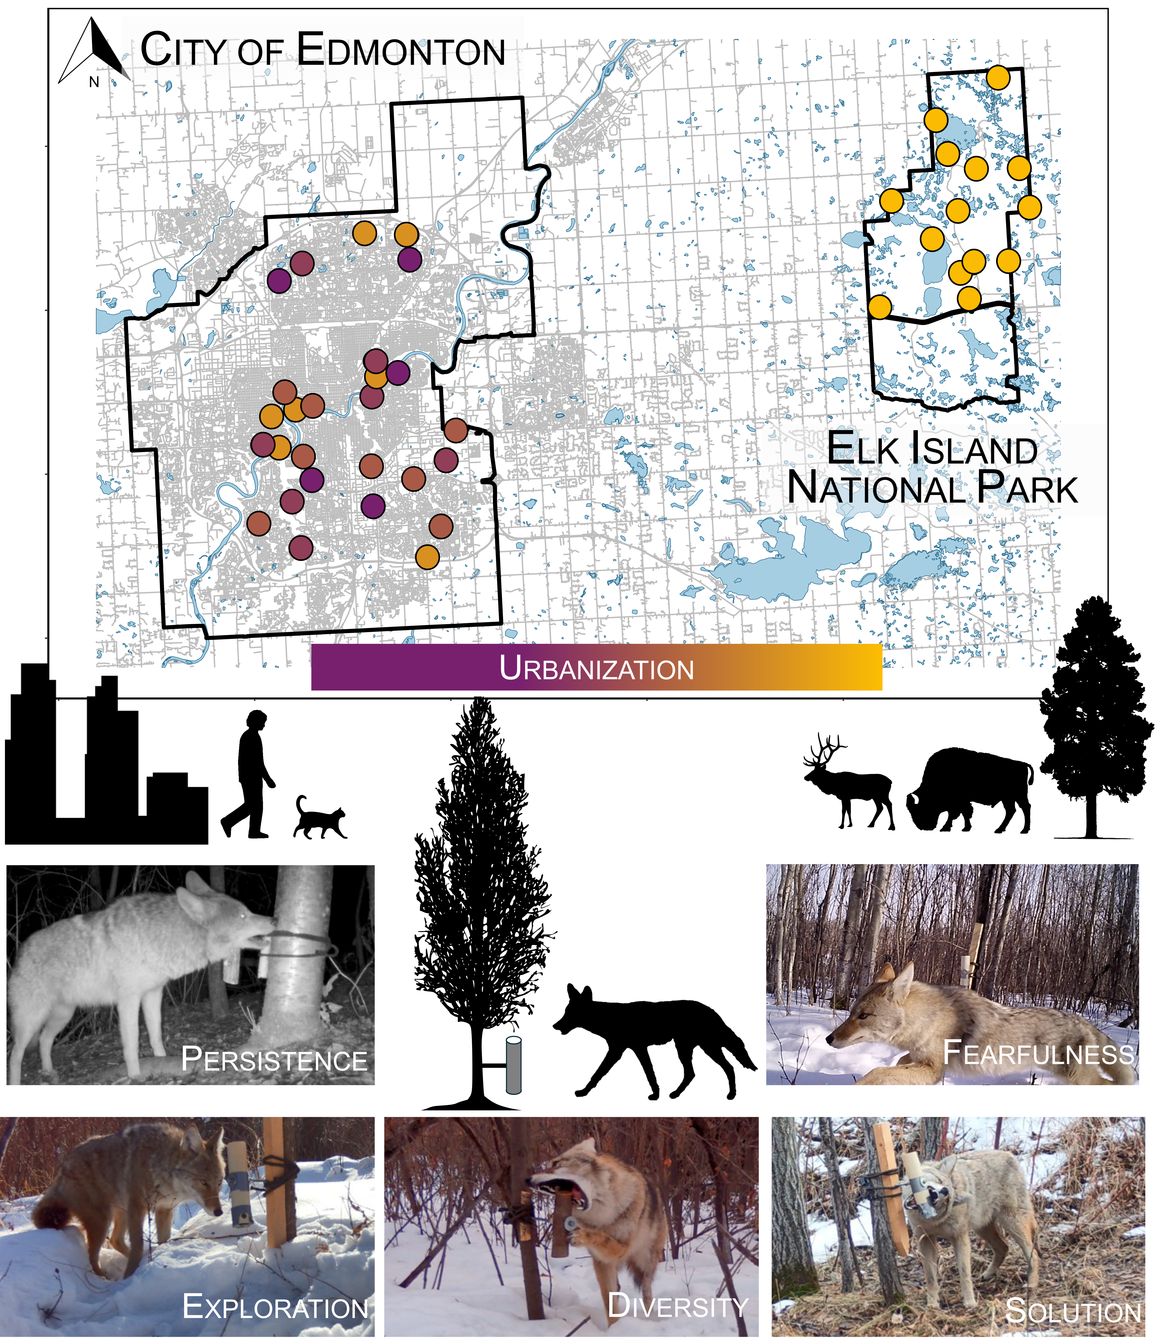

Fig. 1. Innovation and boldness can be assessed by testing the problem-solving abilities of animals. We deployed puzzles along an urbanization gradient in the city of Edmonton and a nearby natural, protected area. We extracted behavioural metrics from resulting videos. Attaining solutions to puzzles depends on innovation, which requires behavioural diversity and persistence, in addition to boldness, which can be approximated as exploration and lack of fearfulness.

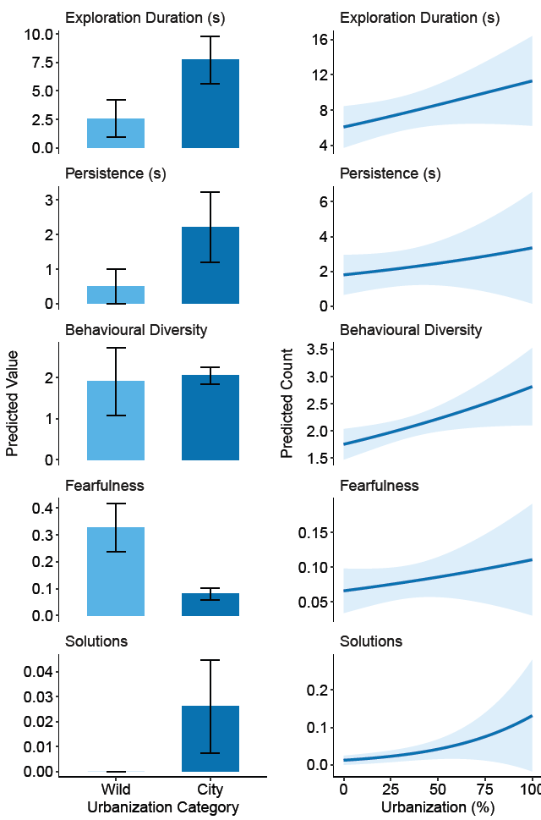

Fig. 2. Urbanization increases problem-solving and related behaviours in wild-living coyotes. Predicted counts for a suite of behaviours related to problem solving in wild-living coyotes at different levels of urbanization, 2024 - 2025. Panels on the left show the predicted counts for wild sites and city sites, and panels on the right show predictions for sites within the city along an urbanization gradient.

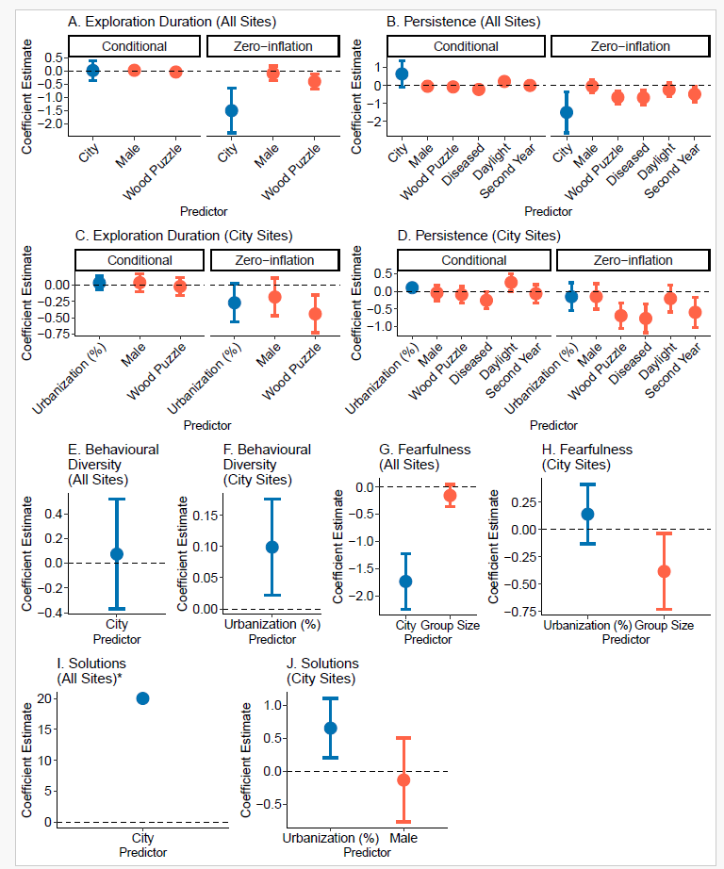
Fig. 3. Urbanization metrics had the strongest influence on problem-solving and related behaviours, even when other environmental and intrinsic factors were considered. Standardized coefficient estimates for top models explaining variation in problem solving and constituent behaviours during events in wild-living coyotes, 2024-2025. Coefficients related to urbanization are in blue, and those related to intrinsic and environmental event characteristics are in red. The zero inflation components indicate the chances of a structural zero (no record of the behavior) occurring. *Because all solutions occurred in the city site, the confidence intervals for this model were very large. So that the value of the beta coefficient was discernible, we removed confidence intervals for this plot.

