Title: Greater Boldness and Innovation in Urban Coyotes Facilitates Increased Problem Solving Relative to Wild Conspecifics
Authors: Sage Raymond¹*, Sarah Benson-Amram², Colleen Cassady St. Clair¹
Affiliations:
¹University of Alberta, Edmonton, Canada.
²Univeristy of British Columbia, Vancouver, Canada.
*Corresponding author. Email: rraymon1@ualberta.ca

Abstract: As global urbanization increases, understanding how wildlife adapt to human-dominated landscapes is increasingly important. The Cognitive Buffer Hypothesis posits that large brains and greater intelligence buffer individuals against environmental challenges via adoption of novel behavioural responses. We tested this hypothesis in wild coyotes (Canis latrans) across an urban-to-wild gradient using puzzle-solving assays. Coyotes in more urbanized areas exhibited greater behavioural diversity and problem solving, indicating greater innovation. They were also more exploratory and persistent, and less fearful, suggesting greater boldness. Urbanization remained explanatory, even when considering intrinsic and environmental factors that can influence innovation, boldness, and problem solving. These cognitive traits may be crucial for adaptation to novel urban environments, but they may also facilitate increasing human-wildlife conflict

Main Text:
Given ongoing and accelerating urbanization and landscape change, studying the effects of anthropogenic disturbance on wildlife is critical. While some species cope remarkably well (1), others do not respond successfully to these new pressures (2, 3). Many studies investigate how species respond to environmental pressures presented by rapid anthropogenic change, but few consider cognitive mechanisms that underlie successful adaptive responses (4). Cognition may have particularly strong effects on fitness of wildlife in cities, arguably the most extreme and novel environment confronted by contemporary wildlife populations (5). Innovation (the production of a novel behavioral response (6)), and behavioral flexibility (the ability of an individual to change its behavior when exposed to new conditions (7)) are two cognitive traits that may be critical for survival in a rapidly changing world (2). Behavioral flexibility allows individuals to express a greater variety of behaviors and strategies, increasing the likelihood that they will discover previously unused resources (e.g. new food sources, shelters, etc.), while innovation increases the likelihood that animals will be able to access these new resources.
The Cognitive Buffer Hypothesis (CBH) is a leading hypothesis to explain the evolution of intelligence; it posits that the primary adaptive function of an enlarged brain is to buffer individuals against environmental challenges through the construction of novel behavioural responses (8). Specifically, the Cognitive Buffer Hypothesis predicts that species with larger brains will have greater domain-general cognition; exhibit more innovation and behavioural flexibility; and have a higher probability of surviving in novel and complex environments, such as cities (Figure 1). The Cognitive Buffer Hypothesis also predicts that within a species, individuals in urban environments will exhibit higher rates of innovation than individuals in natural environments. Empirical evidence for the Cognitive Buffer Hypothesis is lacking, however, due to challenges associated with assessing cognition in wild animals and with standardizing assessments of cognition both across species and environments. Historically, studies of animal cognition have been conducted in controlled laboratory settings on a limited number of species (9). Scientists have also used historical records of behavioural innovations from the published literature, or data on invasion success in introduced species, to test the CBH (10–13). Neither of these approaches permits an in-depth examination of the cognitive abilities of species that successfully live in human-disturbed environments, nor is it possible to evaluate how individuals from these species use their cognitive abilities to solve problems within these environments. Additionally, although there is evidence of high rates of innovation in some successful urban species (2–4, 8, 9); but see (10), there is little empirical data demonstrating a difference in innovation between individuals within a species across an urban-rural gradient.
Innovation can be assessed empirically by testing the problem-solving abilities of animals (13, 14). Animals are presented with a novel problem, often in the form of a puzzle box, and innovative animals are those that successfully solve the problem. Solving puzzles typically requires persistence, where animals that continue in their effort despite failure to complete a task are eventually more successful (15), and behavioural diversity, where animals exhibiting a higher range of exploratory behaviors directed at the novel task are more successful at solving the problem. Puzzles also require interaction with a novel human object, invoking boldness, which is defined as exploration of unfamiliar situations and objects (16, 17). Greater boldness in urban animals relative to wild-dwelling conspecifics has been observed in canids (17, 18), birds (19, 20), small mammals (21, 22), and reptiles (23–25), and boldness is linked to innovative problem-solving success. Boldness and innovation, while being advantageous for accessing resources in an urban environment, can also bring animals into conflict with people (26). For example, bolder animals are more likely to approach people, and more innovative animals are more likely to open trash cans or unlock chicken coops, thus leading to higher human-wildlife conflict rates (26). Human-wildlife conflict includes property damage, zoonotic disease transmission, and injury or death to humans, wildlife, or pets and is one of the greatest threats to survival for species living in human-dominated landscapes (27). Carnivores are more likely to be killed following human-wildlife conflict (28), and the loss of predators negatively impacts ecosystem function, balance, resilience, and health (29). However, cognitive studies are lacking for medium and large urban-adapted carnivores, for whom behavioural responses to novelty may play a critical role in shaping outcomes of human–wildlife coexistence (2, 26).
We tested the Cognitive Buffer Hypothesis by experimentally assessing innovation and boldness in wild-living coyotes (Canis latrans) at varying levels of urbanization. Coyotes are a ubiquitous and highly successful urban-adapted mesocarnivore that is increasingly prevalent and prone to conflict with people in cities across North America (30–32). We deployed two sets of puzzles, one made of more natural materials (i.e., locally-harvested wood) and the other made of artificial material with strong anthropogenic cues (i.e., plastic), to wild-living coyotes in both urban and natural areas. We extracted behavioural metrics for persistence, exploration, boldness, and behavioural diversity from resulting videos. We related these behaviours and frequency of solutions to urbanization and a suite of environmental and intrinsic characteristics. We completed these analyses at two scales of urban development by comparing behaviours (1) between an urban environment and a nearby protected, natural area and (2) along a continuous gradient of urbanization within the city (Figure 1). If the Cognitive Buffer Hypothesis is correct, then we predict that coyotes at more urban sites will exhibit higher innovation, demonstrated by greater behavioural diversity and more frequent solutions to the puzzles than coyotes living at less urban sites. Additionally, if urban coyotes encounter more anthropogenic resources that reward boldness in urban areas, we predict greater exploration and persistence and less fearfulness compared to wild conspecifics.
Results
Between January and April in 2024 and 2025, we recorded a total of 1761 events of coyotes at puzzle assays, most of which occurred in the city (n = 1499, 85.1%; Movies 1-5). In 1156 events, the animal was oriented to the puzzle so the event was retained for subsequent behavioural analysis. Coyotes explored puzzles in 486 events (42.0%), 458 of which occurred in the city (94.2%), and explorations lasted for 0.25 to 248.03 seconds. Coyotes contacted puzzles in 231 events (20.0%), 220 of which occurred in the city (95.2%) and persistence ranged from 0.07 to 144.57 seconds. Among events in which contact occurred, the number of behaviours exhibited ranged from 1 to 5 (x = 2.06, SD = 1.19). Coyotes exhibited fearfulness by fleeing with an escape gait 146 times (12.6% of events; 33.1% of events in wild). In total, coyotes solved puzzles in 48 events (4.2%), all of which occurred in the city. Sex was apparent in 1028 events (88.9%), and animals were visibly diseased in 376 events (32.5%). Most events occurred in darkness (n = 793, 68.6%). Events with a single focal animal were most common (n = 922, 79.8%), but group size ranged between 1 and 4. Mean daily temperature was -4.7°C (SD = 8.5) and ranged between -26.8°C and 9.9°C. Events involved wooden puzzles (n = 592; 51.2%) and plastic puzzles (n = 564; 48.8%) at similar rates.
Urbanization strongly influenced problem-solving and related behaviours (Fig. 2). Univariate models revealed that, relative to events occurring at wild sites, events in the city were characterised by four times greater odds of both exploration and contact, a 9.4% longer exploration duration, and persisted for 25% longer (table S1). City coyotes used 7.6% more behaviours and were 82% less likely to demonstrate an escape gait indicative of fearfulness. Models containing the behavioural metrics of exploration, persistence, fearfulness, and solutions, but not behavioural diversity, improved model performance relative to a null model. R² values revealed that, for all models, much of the explanatory power could be attributed to urbanization rather than site ID.
Similar patterns occurred within the city along a continuous urbanization gradient; for a 10% increase in urbanization, odds of exploration and contact increased by 11.7% and 3.1% respectively, and exploration and persistence increased by 1% and 4% respectively. A 10% increase in urbanization increased behavioural diversity by 4%. Unlike the categorical comparison between city and wild sites, odds of an escape gait indicative of fearfulness increased by 6% per 10% increase in urbanization. Finally, a 10% increase in urbanization was associated with 25% greater odds of a solution. Among these, only models for behavioural diversity and solutions improved model performance relative to a null model. Model explanatory power was low for exploration, persistence, and behavioural diversity. For fearfulness and solutions, much of the explanatory power could be attributed to site ID (table S1). We observed the same pattern at the site scale (table S2; figure S1).
Intrinsic variables of sex and health and environmental event attributes of group size, temperature, puzzle type, daylight, year, and event sequence frequently failed to explain variation in outcome variables related to problem solving, though some patterns emerged (table S3-S4; figure S2). Odds of exploration increased when the puzzle was wooden (51%) and when the focal animal was male (9.4%), but predictors of duration had confidence intervals that considerably overlapped 0. Contact occurred more frequently when animals were diseased (99%), during the second year of study (68%), at wood puzzles (95%), and during the day (32%); persistence was 25% longer during the day. For behavioural diversity, no predictors improved model performance sufficiently for retention. Odds of an escape gait indicating fearfulness decreased by 22% for each additional animal in the group. Odds of a solution increased by 12% when the focal coyote was female, though confidence intervals extensively overlapped zero. For these models of intrinsic and environmental variables, only the persistence model improved performance relative to a null model. For fearfulness and solution models, site ID explained much of the variation (table S4).
When we included both urbanization metrics and the top predictors related to intrinsic and environmental event characteristics in a set of candidate models, urbanization occurred in the top model for all outcome variables (table S5-S6; Fig. 3). The inclusion of interaction terms and dispersion formulas failed to improve model performance for any variable. When we included individual ID as a second random effect in all models, we attained results that were categorically the same, but with weaker statistical power and some convergence problems given added model complexity (Tables S7 – S9).
Discussion
Accelerating urbanization is rapidly transforming landscapes, creating novel and complex ecosystems to which some wildlife species successfully adapt while others do not (33, 34). Species can show rapid evolutionary change to urbanization (35) or can adjust to the environmental changes through changes in behaviour (26). Such behavioural adaptation requires problem solving, which is supported by both innovation and boldness. Together, these cognitive capacities enable animals to navigate novel challenges like human presence (36), vehicle traffic (37), and limited refugia (38), while taking advantage of opportunities like reduced predation pressure (32) and access to rich anthropogenic food sources (39, 40). We tested the Cognitive Buffer Hypothesis by determining innovation and boldness in coyotes both between a city and a nearby protected, natural area and along an urbanization gradient within a city. As predicted, among innovation metrics, ability to solve a novel problem was higher at more urbanized sites, while behavioural diversity increased with increasing urbanization within the city, though it was similar between the urban and natural settings. Consistent with expectations, pronounced differences in exploration, persistence, and fearfulness indicated greater boldness among urban animals. Our results support the idea that behavioural adjustments are central to the success of urban-adapting wildlife.
Greater innovation at urbanized sites was indicated by higher frequency of problem solving with increasing urbanization, including the finding that all 48 puzzle solutions occurred at city sites. The relationship between urbanization and innovation was also demonstrated by greater behavioural diversity at more urban sites, though the difference in behavioural diversity between urban and wild sites was not statistically significant. Despite clear evidence that innovation improves problem solving success (13, 14), presumably facilitating adaptation to urban environments (3, 5), the role of urbanization in shaping innovation remains unclear, with previous studies showing mixed results; greater innovation has been detected in urban mice (41), but in rural hyaenas (42), and studies of red foxes (18) and sparrows (43) showed no difference in innovation along an urbanization gradient. Innovation in wild-living coyotes had not been assessed prior to this study, in part because previous studies with captive coyotes have documented limited evidence of problem-solving, apparently due to their strong neophobia (15, 44–47). Even among successful, urban-adapted mesocarnivores, there is considerable diversity in innovation; raccoons are notably innovative (48, 49), whereas urban red foxes are not more innovative than rural conspecifics (18), and opossums are less innovative than raccoons (50).
That urbanization better predicted increased behavioural diversity among city sites (rather than strictly between city and wild sites) underscores the importance of heterogeneity within urban environments and their complex impacts on animal behaviour (51). Combined with the predictive power of Site ID in within-city models of problem solving, this result suggests that innovation and problem-solving may be geographically stable, with some variation coming from sources other than those that we tested. Coyote home ranges are stable over time (52), and coyotes demonstrate both vertical (53) and horizontal (15) learning, suggesting that local social or ‘cultural’ context could strongly influence response to novel problems or situations (54). Such transmission of innovation and similar cognitive behaviours via learning or other mechanisms could contribute to creating local hotspots of conflict that persist over time and among generations (26).
Greater exploration, longer persistence, and less fearfulness at more urbanized sites indicated greater boldness among animals residing at more urban sites. The relationship between greater boldness and urbanization has been documented in various taxa, including coyotes (17), red foxes (18), birds (19, 20), small mammals (21, 22), and reptiles (23–25). One exception to the observed correlation between increasing urbanization and boldness was an increase in the use of escape gaits at the highest levels of urbanization. Some of these videos apparently contained play behaviour, which often includes escape gaits. Alternately, boldness may be most adaptive in moderately urbanized areas, such as suburbs (31), predicting the greatest boldness at moderately urbanized sites. The explanatory power of urbanization on metrics of boldness was higher between urban and natural sites compared to sites within the city, suggesting that differences in boldness between urban and wild settings were more predictable than those within a city. This pattern may result from our choice of urbanization metric (i.e., percent anthropogenic cover), which is structural and may have failed to capture the most ecologically relevant predictors of boldness (55). For example, access to anthropogenic food and consequent food conditioning (56) presumably increase boldness towards unknown anthropogenic objects, such as puzzles. Such factors are highly localized and difficult to measure consistently across sites (57). Because increased boldness is a frequent correlate of problem solving (16, 58–60), and both boldness and resulting habituation to novel stimuli can persist across animal lives (61) and generations (53, 62), this cognitive trait appears crucial to adaptation to urban environments, though it also seemingly contributes to human-wildlife conflict (26).
Environmental and intrinsic event characteristics had some limited influence on behavioural outcomes, but effect sizes were small and frequently statistically non-significant. Wooden puzzles were more likely to be explored and contacted, perhaps because they lacked strong anthropogenic cues and were perceived as less threatening by neophobic animals (45–47). Diseased individuals were more likely to contact puzzles, which could reflect the increased risk-taking that occurs in physiologically stressed individuals (63), or the known relationship among disease, anthropogenic food consumption, and boldness in coyotes (64). Odds of contact also increased during daylight hours, perhaps because bolder individuals are more diurnal (37). Contact rates increased in the second year of the study, perhaps due to learned familiarity with puzzles. Fearfulness was less likely with increasing group size, which could reveal increased comfort from greater vigilance for predators (65). Though many studies have not found an effect of sex on problem solving (60), we found that males were somewhat more likely to explore puzzles, consistent with literature suggesting greater boldness in males (66), but females were marginally more likely to solve puzzles.
Urban wildlife is an increasing component of the novel and complex urban ecosystems that humans are creating (5). Our study clearly demonstrated with multiple behavioural metrics that innovation, boldness, and concomitant resource acquisition were greater in coyotes occupying more urbanized sites, at two scales of urbanization. Though some adaptation to cities may be genetic or epigenetic (24), much of this variation can likely be attributed to the behavioural flexibility for which coyotes are renowned (32, 37, 40), which supports the ability of individuals to explore and adapt to novel resources in cities (3, 5, 26). These behavioural traits may be enhanced by access to anthropogenic food, favouring further increases in expensive brain tissues (6, 67), which in turn favour more cognitive buffer (8) and greater capacity to adapt to changing urban environments. Such a positive feedback loop may contribute to the increasing prevalence of coyotes in urban areas throughout North America (32) and their recent expansion into South America (68). In a world that is changing rapidly courtesy of expanding urbanization and climate change, evidence of rapid adaptation to novel challenges underscores the capacity of some species to flexibly navigate, persist, and thrive within human-altered landscapes

References and Notes
1. S. R. Palumbi, D. J. Barshis, N. Traylor-Knowles, R. A. Bay, Mechanisms of reef coral resistance to future climate change. Science 344, 895–898 (2014).
2. J. W. Gibbons, D. E. Scott, T. J. Ryan, K. A. Buhlmann, T. D. Tuberville, B. S. Metts, J. L. Greene, T. Mills, Y. Leiden, S. Poppy, The Global Decline of Reptiles, Déjà Vu Amphibians: Reptile species are declining on a global scale. Six significant threats to reptile populations are habitat loss and degradation, introduced invasive species, environmental pollution, disease, unsustainable use, and global climate change. BioScience 50, 653–666 (2000).
3. A. Sih, M. C. Ferrari, D. J. Harris, Evolution and behavioural responses to human‐induced rapid environmental change. Evolutionary applications 4, 367–387 (2011).
4. A. L. Greggor, N. S. Clayton, B. Phalan, A. Thornton, Comparative cognition for conservationists. Trends in Ecology & Evolution 29, 489–495 (2014).
5. D. Sol, O. Lapiedra, C. González-Lagos, Behavioural adjustments for a life in the city. Animal behaviour 85, 1101–1112 (2013).
6. S. Benson-Amram, B. Dantzer, G. Stricker, E. M. Swanson, K. E. Holekamp, Brain size predicts problem-solving ability in mammalian carnivores. Proceedings of the National Academy of Sciences of the United States of America 113, 2532–2537 (2016).
7. S. E. Daniels, R. E. Fanelli, A. Gilbert, S. Benson-Amram, Behavioral flexibility of a generalist carnivore. Animal Cognition 22, 387–396 (2019).
8. C. DARWIN, 7 The Cognitive-Buffer Hypothesis for the Evolution of Large Brains. Cognitive Ecology II, 111 (2009).
9. D. J. Pritchard, T. A. Hurly, M. C. Tello‐Ramos, S. D. Healy, Why study cognition in the wild (and how to test it)? Journal of the Experimental Analysis of Behavior 105, 41–55 (2016).
10. L. Lefebvre, S. M. Reader, D. Sol, Brains, innovations and evolution in birds and primates. Brain Behavior and Evolution 63, 233–246 (2004).
11. S. M. Reader, K. MacDonald, Environmental variability and primate behavioural flexibility. (2003).
12. D. Sol, R. P. Duncan, T. M. Blackburn, P. Cassey, L. Lefebvre, Big brains, enhanced cognition, and response of birds to novel environments. Proceedings of the National Academy of Sciences 102, 5460–5465 (2005).
13. D. Sol, S. Timmermans, L. Lefebvre, Behavioural flexibility and invasion success in birds. Animal behaviour 63, 495–502 (2002).
14. J.-N. Audet, L. Lefebvre, What’s flexible in behavioral flexibility? Behavioral Ecology 28, 943–947 (2017).
15. J. K. Young, L. Touzot, S. P. Brummer, Persistence and conspecific observations improve problem-solving abilities of coyotes. Plos One 14, e0218778 (2019).
16. S. Benson-Amram, M. L. Weldele, K. E. Holekamp, A comparison of innovative problem-solving abilities between wild and captive spotted hyaenas, Crocuta crocuta. Animal Behaviour 85, 349–356 (2013).
17. S. W. Breck, S. A. Poessel, P. Mahoney, J. K. Young, The intrepid urban coyote: a comparison of bold and exploratory behavior in coyotes from urban and rural environments. Sci Rep 9, 2104 (2019).
18. F. B. Morton, M. Gartner, E.-M. Norrie, Y. Haddou, C. D. Soulsbury, K. A. Adaway, Urban foxes are bolder but not more innovative than their rural conspecifics. Animal Behaviour 203, 101–113 (2023).
19. J. W. Atwell, G. C. Cardoso, D. J. Whittaker, S. Campbell-Nelson, K. W. Robertson, E. D. Ketterson, Boldness behavior and stress physiology in a novel urban environment suggest rapid correlated evolutionary adaptation. Behavioral Ecology 23, 960–969 (2012).
20. J. Evans, K. Boudreau, J. Hyman, Behavioural syndromes in urban and rural populations of song sparrows. Ethology 116, 588–595 (2010).
21. V. Mazza, M. Dammhahn, E. Lösche, J. A. Eccard, Small mammals in the big city: Behavioural adjustments of non-commensal rodents to urban environments. Global Change Biology 26, 6326–6337 (2020).
22. M. Dammhahn, V. Mazza, A. Schirmer, C. Göttsche, J. A. Eccard, Of city and village mice: behavioural adjustments of striped field mice to urban environments. Scientific Reports 10, 13056 (2020).
23. O. Lapiedra, Z. Chejanovski, J. J. Kolbe, Urbanization and biological invasion shape animal personalities. Global Change Biology 23, 592–603 (2017).
24. J. Baxter-Gilbert, J. L. Riley, M. J. Whiting, Bold New World: urbanization promotes an innate behavioral trait in a lizard. Behavioral Ecology and Sociobiology 73, 105 (2019).
25. S. Blanchett, A. Turcotte, G. Blouin-Demers, The impact of urbanization on painted turtle (Chrysemys picta) behaviour. Ethology 130, e13467 (2024).
26. L. P. Barrett, L. A. Stanton, S. Benson-Amram, The cognition of “nuisance” species. Animal Behaviour 147, 167–177 (2019).
27. IUCN, What is human-wildlife conflict? Briefing Paper by the IUCN SSC Human-Wildlife Conflict Task Force. IUCN SSC HWCTF (2020).
28. A. Treves, K. U. Karanth, Human-carnivore conflict and perspectives on carnivore management worldwide. Conserv. Biol. 17, 1491–1499 (2003).
29. W. J. Ripple, J. A. Estes, R. L. Beschta, C. C. Wilmers, E. G. Ritchie, M. Hebblewhite, J. Berger, B. Elmhagen, M. Letnic, M. P. Nelson, Status and ecological effects of the world’s largest carnivores. Science 343, 1241484 (2014).
30. R. B. Blair, Land use and avian species diversity along an urban gradient. ECOLOGICAL APPLICATIONS 6, 506–519 (1996).
31. S. D. Gehrt, J. L. Brown, C. Anchor, Is the urban coyote a misanthropic synanthrope? The case from Chicago. Cities and the Environment (CATE) 4, 3 (2011).
32. M. E. Gompper, Top carnivores in the suburbs? Ecological and conservation issues raised by colonization of north-eastern North America by coyotes. Bioscience 52, 185–190 (2002).
33. H. Lowry, A. Lill, B. B. M. Wong, Behavioural responses of wildlife to urban environments. Biological Reviews 88, 537–549 (2013).
34. S. Kark, A. Iwaniuk, A. Schalimtzek, E. Banker, Living in the city: can anyone become an “urban exploiter”? Journal of Biogeography 34, 638–651 (2007).
35. J. Munshi-South, Urban landscape genetics: canopy cover predicts gene flow between white-footed mouse (Peromyscus leucopus) populations in New York City. MOLECULAR ECOLOGY 21, 1360–1378 (2012).
36. K. M. Gaynor, C. E. Hojnowski, N. H. Carter, J. S. Brashares, The influence of human disturbance on wildlife nocturnality. Science 360, 1232-+ (2018).
37. Murray, C. C. St. Clair, Individual flexibility in nocturnal activity reduces risk of road mortality for an urban carnivore. Behav. Ecol. 26, 1520–1527 (2015).
38. S. Raymond, C. C. St Clair, Urban coyotes select cryptic den sites near human development where conflict rates increase. JOURNAL OF WILDLIFE MANAGEMENT 87 (2023).
39. S. Raymond, D. K. Steckler, M. A. Seguin, C. C. St. Clair, Coyote scat in cities increases risk of human exposure to an emerging zoonotic disease in North America. FRONTIERS IN CONSERVATION SCIENCE 4, 1294693 (2024).
40. S. Sugden, M. Murray, M. A. Edwards, C. C. St. Clair, Inter-population differences in coyote diet and niche width along an urban–suburban–rural gradient. Journal of Urban Ecology 7, 1–12 (2021).
41. V. Mazza, A. Guenther, City mice and country mice: innovative problem solving in rural and urban noncommensal rodents. Animal Behaviour 172, 197–210 (2021).
42. L. Johnson-Ulrich, G. Yirga, R. L. Strong, K. E. Holekamp, The effect of urbanization on innovation in spotted hyenas. Animal Cognition 24, 1027–1038 (2021).
43. S. Papp, E. Vincze, B. Preiszner, A. Liker, V. Bókony, A comparison of problem-solving success between urban and rural house sparrows. Behavioral ecology and sociobiology 69, 471–480 (2015).
44. A. C. Garcia, M. A. Parsons, J. K. Young, Effects of early-life experience on innovation and problem-solving in captive coyotes. Behavioral Ecology and Sociobiology 76, 141 (2022).
45. L. A. Stanton, E. S. Bridge, J. Huizinga, S. R. Johnson, J. K. Young, S. Benson-Amram, Variation in reversal learning by three generalist mesocarnivores. Animal Cognition 24, 555–568 (2021).
46. A. E. Mettler, J. A. Shivik, Dominance and neophobia in coyote (Canis latrans) breeding pairs. Applied Animal Behaviour Science 102, 85–94 (2007).
47. P. A. Darrow, J. A. Shivik, Bold, shy, and persistent: variable coyote response to light and sound stimuli. Applied Animal Behaviour Science 116, 82–87 (2009).
48. L. Stanton, E. Davis, S. Johnson, A. Gilbert, S. Benson-Amram, Adaptation of the Aesop’s Fable paradigm for use with raccoons (Procyon lotor): considerations for future application in non-avian and non-primate species. Animal Cognition 20, 1147–1152 (2017).
49. L. A. Stanton, E. S. Bridge, J. Huizinga, S. Benson-Amram, Environmental, individual and social traits of free-ranging raccoons influence performance in cognitive testing. Journal of Experimental Biology 225, jeb243726 (2022).
50. K. A. Adaway, M. H. Snider, C. Vinciguerra, C. A. Kupferman, J. C. Beasley, F. B. Morton, Wild racoons are more innovative but not bolder than another generalist, the Virginia opossum, on a pull-string task. Animal Behaviour 227, 123279 (2025).
51. T. Caspi, M. G. Serrano, S. L. Vanderzwan, J. Kessler, C. J. Schell, B. N. Sacks, Impervious surface cover and number of restaurants shape diet variation in an urban carnivore. Ecosphere 16, e70152 (2025).
52. A. M. Kitchen, E. M. Gese, E. R. Schauster, Long-term spatial stability of coyote (Canis latrans) home ranges in southeastern Colorado. Canadian Journal of Zoology 78, 458–464 (2000).
53. C. J. Schell, J. K. Young, E. V. Lonsdorf, R. M. Santymire, J. M. Mateo, Parental habituation to human disturbance over time reduces fear of humans in coyote offspring. Ecol. Evol. 8, 12965–12980 (2018).
54. A. Whiten, J. Goodall, W. C. McGrew, T. Nishida, V. Reynolds, Y. Sugiyama, C. E. Tutin, R. W. Wrangham, C. Boesch, Cultures in chimpanzees. Nature 399, 682–685 (1999).
55. R. J. Moll, J. D. Cepek, P. D. Lorch, P. M. Dennis, E. Tans, T. Robison, J. J. Millspaugh, R. A. Montgomery, What does urbanization actually mean? A framework for urban metrics in wildlife research. Journal of Applied Ecology 56, 1289–1300 (2019).
56. J. B. Hopkins, S. Herrero, R. T. Shideler, K. A. Gunther, C. C. Schwartz, S. T. Kalinowski, A proposed lexicon of terms and concepts for human-bear management in North America. Ursus 21, 154–168 (2010).
57. S. Raymond, C. C. St Clair, Coyotes access diverse anthropogenic attractants at the ecotone between natural and residential urban areas. URBAN ECOSYSTEMS 26, 1589–1605 (2023).
58. A. S. Griffin, D. Guez, Innovation and problem solving: a review of common mechanisms. Behavioural Processes 109, 121–134 (2014).
59. L. Johnson-Ulrich, Z. Johnson-Ulrich, K. Holekamp, Proactive behavior, but not inhibitory control, predicts repeated innovation by spotted hyenas tested with a multi-access box. Animal Cognition 21, 379–392 (2018).
60. S. Benson-Amram, K. E. Holekamp, Innovative problem solving by wild spotted hyenas. Proceedings of the Royal Society B: Biological Sciences 279, 4087–4095 (2012).
61. K. K. Y. Wat, P. B. Banks, C. McArthur, Linking animal personality to problem-solving performance in urban common brushtail possums. Animal Behaviour 162, 35–45 (2020).
62. A. T. Morehouse, T. A. Graves, N. Mikle, M. S. Boyce, Nature vs. Nurture: Evidence for Social Learning of Conflict Behaviour in Grizzly Bears. Plos One 11, e0165425 (2016).
63. J. S. Gutiérrez, T. Catry, M. Espinosa-Colín, J. A. Masero, J. P. Granadeiro, Heat stress increases risk taking in foraging shorebirds. Functional Ecology 37, 1005–1019 (2023).
64. M. Murray, A. Cembrowski, A. D. M. Latham, V. M. Lukasik, S. Pruss, C. C. St. Clair, Greater consumption of protein-poor anthropogenic food by urban relative to rural coyotes increases diet breadth and potential for human-wildlife conflict. Ecography 38, 1235–1242 (2015).
65. A. S. Griffin, D. Guez, Innovative problem solving in nonhuman animals: the effects of group size revisited. Behavioral Ecology 26, 722–734 (2015).
66. B. R. Smith, D. T. Blumstein, Fitness consequences of personality: a meta-analysis. Behavioral Ecology 19, 448–455 (2008).
67. K. Isler, C. P. van Schaik, The expensive brain: a framework for explaining evolutionary changes in brain size. Journal of human evolution 57, 392–400 (2009).
68. O. Monroy-Vilchis, J. F. Gonzalez-Maya, A. Balbuena-Serrano, F. Elvir, M. M. Zarco-Gonzalez, C. Rodriguez-Soto, Coyote (Canis latrans) in South America: potential routes of colonization. INTEGRATIVE ZOOLOGY 15, 471–481 (2020).

Acknowledgments: We thank Darcy Visscher for sharing equipment used for this study, Erick Lundgren for input on our statistical approach and execution, and Sam Kaviar for assistance designing assays. We thank Elk Island National Park staff for supporting this work. This work was approved by the University of Alberta Animal Care Committee (AUP00003950) and Parks Canada (EINP-2023-45676).
Funding:
Alberta Conservation Association Biodiversity Grant (SR)
Faculty of Science Research Fellowship, University of Alberta (CCSC)
Natural Sciences and Engineering Research Council of Canada Discovery Grant 2023-04892 (CCSC)
Natural Sciences and Engineering Research Council of Canada—Canada Graduate Scholarship-Doctoral. (SR)
President’s Doctoral Prize of Distinction, University of Alberta (SR)
Author contributions:
Conceptualization: SR, SBA, CCSC
Methodology: SR, SBA, CCSC
Investigation: SR
Visualization: SR
Funding acquisition: SR, CCSC
Project administration: SR, SBA, CCSC
Supervision: SBA, CCSC
Writing – original draft: SR
Writing – review & editing: SR, SBA, CCSC
Competing interests: Authors declare that they have no competing interests.
Data and materials availability: All data, code, and materials used in the analysis must be available in some form to any researcher for purposes of reproducing or extending the analysis. Include a note explaining any restrictions on materials, such as materials transfer agreements (MTAs). Note accession numbers to any data relating to the paper and deposited in a public database; include a brief description of the data set or model with the number. If all data are in the paper and supplementary materials, include the sentence “All data are available in the main text or the supplementary materials.”

Supplementary Materials
Materials and Methods
Figs. S1 to S2
Tables S1 to S9
References (##–##)
Movies S1 to S5
DATA

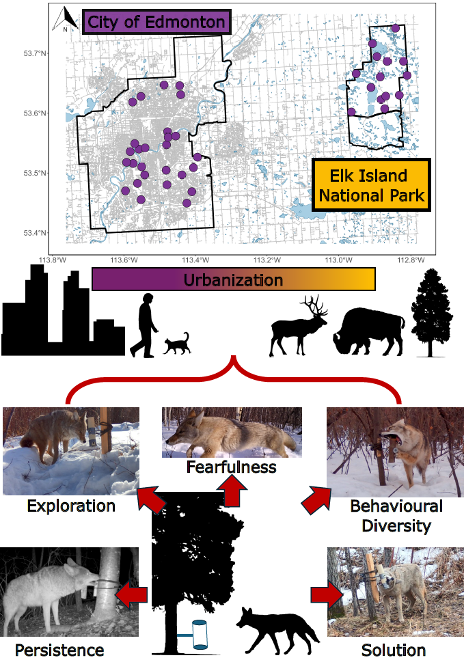

Fig. 1. Innovation can be assessed by testing the problem-solving abilities of animals. We deployed puzzles along an urbanization gradient in the city of Edmonton and a nearby natural, protected area. We extracted behavioural metrics from resulting videos. Attaining solutions to puzzles depends on innovation, which requires behavioural diversity and persistence, in addition to boldness, which can be approximated as exploration and lack of fearfulness.

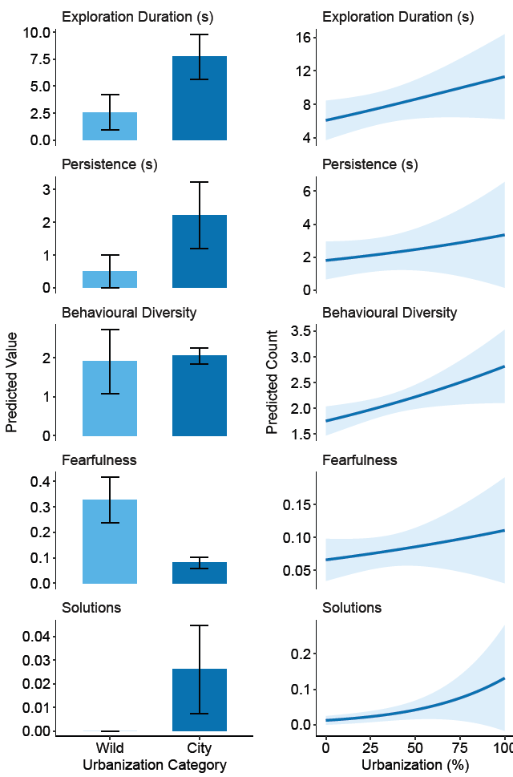

Fig. 2. Urbanization increases problem-solving and related behaviours in wild-living coyotes. Predicted counts for a suite of behaviours related to problem solving in wild-living coyotes at different levels of urbanization, 2024 - 2025. Panels on the left show the predicted counts for wild sites and city sites, and panels on the right show predictions for sites within the city along an urbanization gradient.

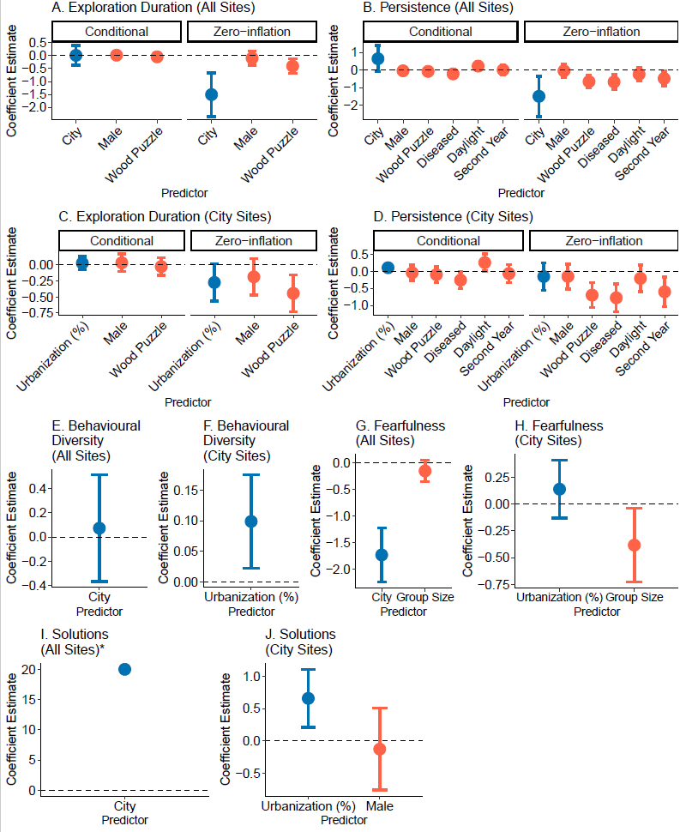
Fig. 3. Urbanization metrics had the strongest influence on problem-solving and related behaviours, even when other environmental and intrinsic factors were considered. Standardized coefficient estimates for top models explaining variation in problem solving and constituent behaviours during events in wild-living coyotes, 2024-2025. Coefficients related to urbanization are in blue, and those related to intrinsic and environmental event characteristics are in red. The zero inflation components indicate the chances of a structural zero (no record of the behavior) occurring.

