Domain-Adaptation of Llama-Primus-Reasoning model on Singapore's Cybersecurity Code of Practice (CCoP 2.0) Standards

  - Term 2 Final Report

Project Period: September 2025 - August 2026
Author: Sagar Pratap Singh
Report Date: 30 April 2026
Executive Summary
- Term 1 baselined the untuned Primus-Reasoning model at 48.96% across 21 benchmarks — strong reasoning (61.6%) but severe factual grounding gaps (31.6%) with frequent hallucination of regulatory facts. The Term 1 report concluded that fine-tuning alone could not fix this profile and that retrieval-based grounding had to come first.

- Term 2 reordered the program to prove RAG's contribution before committing to fine-tuning. The objective for the term was to quantify how much of the Term 1 grounding gap retrieval-augmented generation could close on its own, and to identify the residual that fine-tuning would need to address.

- A complete RAG pipeline is now in production — a LangGraph-orchestrated retrieval graph over a local Qdrant hybrid index (495 chunks, BGE-large dense + BM25 sparse with RRF fusion), with cross-encoder reranking, parent-child auto-merge, HyDE query rewriting, and Anthropic-style contextual chunk augmentation. The evaluation engine was upgraded from heuristic scoring to a dual-layer setup: RAGAs retrieval-quality metrics plus a six-dimension LLM-as-Judge rubric served on Qwen3-235B via OpenRouter.

- Ground truth was expanded from 118 cases to 435 across 18 active benchmarks, with schema enrichment (per-case key_facts with criticality tags, structured citation_verifications, expected verdicts) to enable the richer multi-dimensional scoring the new judge requires.
- Native vs RAG is now quantified on an 18-case stratified validation sample: the LLM-Judge composite lifts from 0.392 (Native) to 0.478 (RAG), a +0.086 absolute gain, with larger per-dimension lifts on factual grounding (+0.148) and citation correctness (+0.093). The lift is dimensional, not uniform — RAG fills the factual-recall gap while reasoning quality is essentially unchanged because it was already adequate. The immediate next step is a full evaluation across all 435 cases to identify the specific gaps fine-tuning must address. Term 3 will then begin with a research track comparing RAFT (Retrieval-Augmented Fine-Tuning) against standard QLoRA fine-tuning before committing to either approach.

1. Recap of Term 1 Findings
Foundation & setup. A complete offline LLM evaluation infrastructure was built around the 4-bit quantised Primus-Reasoning model (8B parameters) running on Apple Silicon (M4), designed for air-gapped execution to match CII deployment constraints.
CCoP 2.0 mapped. The regulatory corpus was characterised end-to-end: 220 auditable clauses across 10 chapters spanning 27 distinct IT and OT cybersecurity practice areas, supported by 8 supplementary documents covering auditing, threat modelling, risk assessment, and security by design.
The baseline evaluation of the untuned Llama-Primus-Reasoning model (8B parameters, 4-bit quantized) against CCoP 2.0 achieved a weighted score of 48.96% across 17 of 21 benchmarks, with 4 benchmarks (B7, B10, B14, B16) deferred for manual expert review. The model demonstrated strong logical reasoning capability (61.6% average across reasoning benchmarks) but exhibited severe deficiencies in Singapore-specific CCoP knowledge domains (31.6% average for factual grounding).
Three critical failure modes were identified:
1. Hallucination of regulatory facts (B21: 22.13%) — the model fabricates specific technical details such as password lengths, SIEM vendor requirements, and air-gap clauses that do not exist in CCoP 2.0.
2. Regulatory scope confusion — the model struggles to correctly determine CCoP applicability, CII designation boundaries, and IT versus OT classification.
3. Factual grounding gaps — when asked about specific CCoP requirements, the model produces plausible but inaccurate paraphrases rather than grounded responses traceable to authoritative clause text.

The ground truth dataset of 118 test cases across 21 benchmarks remains pending expert validation by a CCoP 2.0 compliance practitioner.
These findings indicated that fine-tuning alone is insufficient to address the factual and grounding deficiencies — the model needs access to authoritative CCoP clause text through retrieval-based grounding before fine-tuning can be effective. Term 2 was therefore restructured around a single principle: lead with RAG, quantify the lift, frame the residual gap.

2. Roadmap
The project runs across three academic terms from September 2025 to August 2026, with each term producing a discrete capability and an evaluation gate.
Term 1 — Research & Foundation (Sep–Dec 2025) built the offline inference stack for Primus-Reasoning 8B (Q5_K_M) on Apple Silicon, mapped the CCoP 2.0 corpus, and authored a 118-case benchmark across 21 evaluation tasks. The baseline composite came in at 48.96%, with strong reasoning capability but weak factual recall.
Term 2 — RAG Implementation (Jan–Apr 2026) put a production RAG pipeline into operation (Qdrant hybrid index, contextual chunk augmentation, HyDE query rewriting, cross-encoder reranking), upgraded the evaluation engine to a six-dimension LLM-Judge supplemented by RAGAs, and expanded the ground-truth suite to 435 cases across 18 active benchmarks. The Native vs RAG comparison delivered a +0.086 composite lift, with +0.148 on factual grounding and +0.093 on citation correctness.
Term 3 — Targeted Fine-Tuning (May–Aug 2026) will re-baseline the native model against the full 435-case ground truth, identify the residual that retrieval cannot close, and fine-tune via QLoRA. A research track will compare RAFT against standard QLoRA on the residual benchmarks before committing to either approach.

3. Application Architecture
The system comprises two subsystems — a Document Ingestion pipeline and an Evaluation Engine — connected through a shared Qdrant vector store, served by a set of external model endpoints.
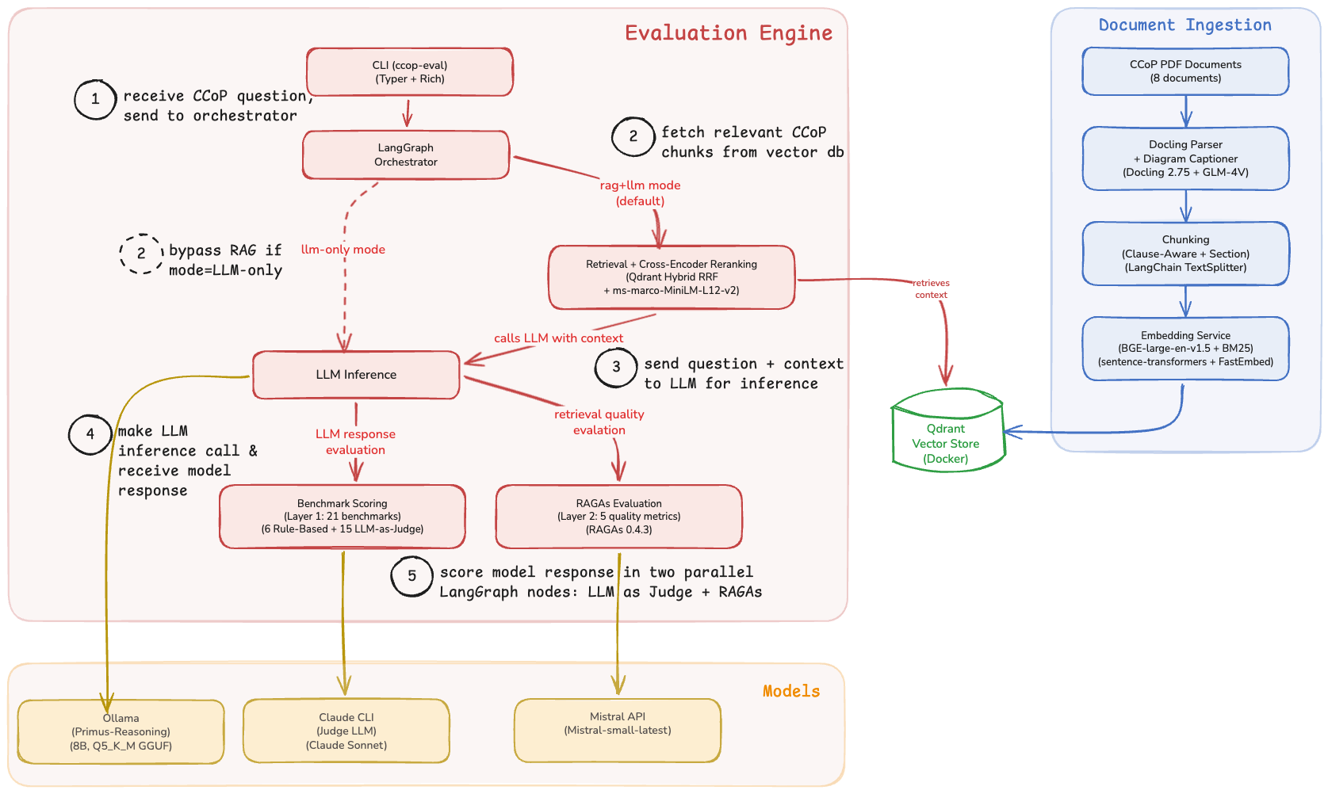
Figure 1: Application architecture showing document ingestion (right), evaluation engine (left), and external model endpoints (bottom).

3.1 Document Ingestion
The ingestion pipeline converts raw CCoP PDF documents into searchable vector embeddings:
1. Parsing — Docling 2.75 performs structural PDF parsing, extracting text with document hierarchy (sections, clauses, sub-clauses). GLM-4V provides captioning for 78 diagrams detected across the corpus, ensuring diagram content is searchable.
2. Chunking — A clause-aware splitter segments parsed documents at regulatory clause boundaries (e.g., 5.2.1, 5.2.1.1), producing 495 chunks across 7 documents with deterministic IDs ({source}::{clause}). LangChain’s MarkdownHeaderTextSplitter handles section-level splits for non-clause content.
3. Contextualisation — Each chunk is augmented with a breadcrumb path (source › chapter › clause) and a one-paragraph context block generated by GPT-4o-mini that situates the chunk in its surrounding regulatory passage. This Anthropic-style contextual retrieval addresses the disambiguation gap between near-identical clause fragments.
4. Embedding — Each chunk is dual-encoded: BGE-large-en-v1.5 (via sentence-transformers) generates 1024-dimensional dense embeddings for semantic search, while Qdrant’s built-in BM25 (via FastEmbed) produces sparse embeddings for exact terminology matching.
5. Storage — Both embedding types are stored in Qdrant with RRF-compatible indexing, enabling hybrid search at query time.

3.2 Evaluation Engine
The evaluation engine is invoked through a CLI that accepts a mode parameter controlling the retrieval strategy:
• rag+llm mode (default) — The LangGraph orchestrator routes the query through Retrieval, which performs hybrid search (dense + sparse via RRF) against Qdrant, followed by cross-encoder reranking (bge-reranker-large) to select the top-3 most relevant chunks. These chunks are passed as grounding context to LLM Inference.
• llm-only mode — The orchestrator routes the query directly to LLM Inference, bypassing retrieval entirely. This mode serves as the baseline for measuring RAG’s contribution.
LLM Inference sends the prompt (with or without retrieved context) to Ollama running the Primus-Reasoning model (8B, Q5_K_M GGUF quantisation) for response generation.
After inference, the response flows into two independent evaluation layers – RAGAs Quality evaluation and LLM as Judge (Qwen3-235B via OpenRouter), as described in Section 5.
Both layers produce results that are aggregated into a JSON report with category-weighted scores.

3.3 External Model Endpoints
The architecture separates inference, judgement, and auxiliary roles across distinct model endpoints — the model under test (Primus-Reasoning) is never used to judge its own outputs. The full endpoint inventory is enumerated in Section 4, Models, Tools & Runtime Framework.

4. RAG Infrastructure Setup
Since the project targets deployment in isolated Critical Information Infrastructure (CII) environments — which are typically air-gapped or on-premise with restricted external connectivity — the RAG infrastructure was designed to operate with zero cloud dependencies. All components run locally via Docker, ensuring the pipeline can be deployed in any environment without requiring external API calls or managed services.
The local RAG stack consists of:
Component | Technology | Purpose
Vector database | Qdrant (Docker) | Hybrid search (dense + sparse) with RRF fusion
Dense embeddings | BAAI/bge-large-en-v1.5 via sentence-transformers | 1024-dimensional semantic embeddings
Sparse embeddings | Qdrant/BM25 via FastEmbed | Keyword-based retrieval for exact terminology matching
Orchestration | LangGraph | Stateful adaptive RAG pipeline with self-correction loops
LLM inference | Ollama + Llama-Primus-Reasoning | Local model inference (4-bit quantized, GGUF)

A corpus of 8 authoritative CCoP documents was ingested into the pipeline, including the primary CCoP 2.0 Second Edition document, the Cybersecurity Act 2018, and CSA's Guidelines for Auditing Critical Information Infrastructure among others. These documents form the retrieval corpus from which the pipeline grounds LLM responses in authoritative regulatory text.

4.1 Retrieval Methodology
The retrieval pipeline processes each query through six stages before the LLM step:
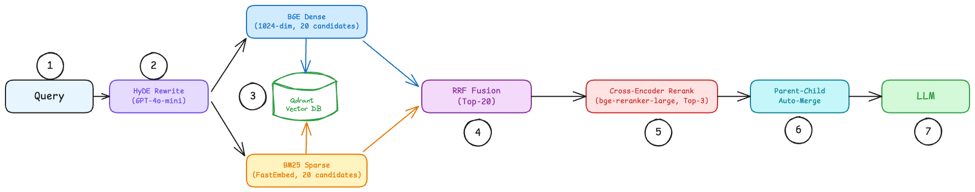
Figure 2: Retrieval pipeline — six stages from HyDE rewrite to parent-merge before the LLM step

1. HyDE Rewrite — the query is first expanded by a hypothetical-answer rewriter (GPT-4o-mini) that drafts a short response in CCoP-style regulatory language. The original query and the hypothetical answer are concatenated and used as the retrieval input, closing the vocabulary gap between lay phrasing (e.g., "can MFA be skipped?") and corpus phrasing ("multi-factor authentication exemption").
2. Dual Encoding — the HyDE-rewritten query is encoded in parallel through two independent embedding models:
• Dense: BGE-large-en-v1.5 (1024-dim, L2 normalised) — captures semantic meaning. A query about “access control” matches clauses discussing authentication and authorisation even when the exact phrase is absent.
• Sparse: BM25 via FastEmbed — captures exact terminology. Required for matching clause references (“5.1.5”), regulatory acronyms (“CIIO”), and domain-specific terms that dense embeddings generalise away.
3. Parallel Prefetch — each encoding retrieves its own candidate set from Qdrant independently: 20 dense candidates and 20 sparse candidates.
4. Reciprocal Rank Fusion (RRF) — the two ranked lists are merged into a single list of 20 candidates using RRF with equal weighting. RRF scores each document by summing 1/(k + rank) across both lists, promoting documents that rank well in either or both retrieval paths without requiring score normalisation between the two models.
5. Cross-Encoder Reranking — the 20 RRF candidates are re-scored by bge-reranker-large, which jointly encodes each query-document pair with full cross-attention. This resolves a limitation of bi-encoder retrieval: bi-encoders embed query and document independently, so semantically close clauses (e.g., 5.1.1 on access management vs 5.1.2 on authentication requirements) receive similar scores. The cross-encoder attends to both texts simultaneously, differentiating fine-grained regulatory distinctions. The top 3 are selected without applying any score threshold — relevance scores are logged for analysis but not used to filter, since gating before a baseline is established would mask retrieval quality issues.
6. Parent–Child Auto-Merge — when the top-3 reranked chunks include sibling sub-clauses (e.g., 5.1.1 and 5.1.2 both selected), they are merged into the parent clause (5.1). This prevents fragmented context where a single regulatory requirement spans adjacent sub-clauses and gives the LLM coherent passages instead of clipped sentences. The merged context is passed to the LLM for generation (see §3.2).

5. Evaluation Framework
The evaluation infrastructure uses two independent scoring mechanisms — RAGAs for automated quality metrics across three brackets (Retrieval Quality, Model-RAG Grounding, and Model Response Quality), and LLM-as-Judge (Claude Sonnet) for reasoning depth and hallucination detection across 16 benchmarks.

5.1 RAGAs Quality Metrics
RAGAs evaluates response and retrieval quality across three quality brackets:
Quality Bracket | Metric | Applies To | What It Measures
Retrieval Quality | context_precision | RAG-augmented only | Whether retrieved chunks are relevant to the question
 | context_recall | RAG-augmented only | Whether retrieved chunks contain the information needed to answer
Model-RAG Grounding | context_faithfulness | RAG-augmented only | Whether the response is supported by retrieved context
Model Response Quality | factual_recall | RAG-augmented and LLM-only | Factual coverage of the response against ground truth
 | answer_relevancy | RAG-augmented and LLM-only | Whether the response addresses the question asked
 | semantic_similarity | RAG-augmented and LLM-only | Semantic alignment between response and expected answer
The RAGAs composite score is a simple average of the three base metrics: (factual_recall + answer_relevancy + semantic_similarity) / 3.

5.2 LLM-as-Judge Scoring
The LLM judge (Claude Sonnet) evaluates each response in a single call across two dimensions:
Dimension | Scale | What It Evaluates
Reasoning Depth | 0–3 | (1) Clause-specific citations from retrieved context,  (2) conditional analysis (if-then logic for compliance scenarios),  (3) actionable steps for the CIIO. The judge determines which criteria are applicable per question type.
Hallucination Detection | Binary (pass/fail) | Claim-level verification against retrieved contexts.  Each claim is classified as SUPPORTED, UNSUPPORTED, or CONTRADICTED.  Any unsupported or contradicted claim fails the entire response.
For LLM-only mode, retrieval contexts are fetched but only passed to the judge — not the model — enabling consistent hallucination scoring across both evaluation modes.

6. RAG Quality — Chunking & Retrieval Experiments
A series of iterative experiments were conducted to diagnose and resolve retrieval quality issues in the RAG pipeline. Each experiment targeted a specific limitation identified in the previous iteration.
Experiment | Change | Key Result | Limitation / Issue Identified
Exp 0:  Local RAG Baseline | PyMuPDF4LLM parser + MarkdownHeaderTextSplitter chunker; hybrid RRF search with 0.6 score threshold | 66 chunks from 8 documents (~11 per doc); 0% retrieval success — all queries return 0 results | Parser does not detect clause boundaries (5.2.1, 5.2.1.1 are inline text, not headers); chunker only splits on markdown headers producing coarse sections; RRF score threshold (0.6) is mathematically incompatible with RRF score range (0.001–0.033)
Exp 1:  Docling + Clause-Aware Chunking | Replaced parser with Docling (structural PDF parsing); replaced chunker with clause-boundary regex splitter; deterministic chunk IDs ({source}::{clause}); removed broken 0.6 RRF threshold (measurement-only grading) | 324 chunks (305 in Qdrant); CCoP 2.0 primary doc: 11 → 168 chunks; median chunk size: 124 tokens; retrieval success: 0% → 100% | No quality filtering — top-N returned regardless of relevance; bi-encoder cannot distinguish fine-grained differences between semantically close clauses
Exp 2:  Cross-Encoder Reranking | Added ms-marco-MiniLM-L12-v2 cross-encoder; pipeline changed to retrieve top-20 → rerank → top-3 → LLM | Score differentiation achieved (-6.56 to +7.56); focused retrieval — e.g., "vulnerability assessment" query returns all 3 results from CCoP Section 5.14 | Precision@3 not quantitatively measured (needs labelled test set); 78 diagrams across documents are invisible to search
Exp 3:  Diagram Captioning | Switched to Docling Classic for all documents; added GLM-4V API captioning for extracted diagrams with fallback text | 78 diagrams detected across 7 documents; graceful degradation — pipeline completes despite API errors | Diagram captioning functional; re-run completed with corrected model configuration; no automated way to evaluate retrieval and response quality for RAG-augmented answers
Exp 4:  RAGAs Integration | Added RAGAs evaluation layer with 5 quality metrics for automated assessment of response accuracy, relevance, and retrieval quality | RAGAs metrics available per test case; base metrics evaluated for all responses, context metrics for RAG-augmented responses only | Pending first full evaluation run to produce RAGAs scores across all 21 benchmarks
7. Latest Results
The evaluation framework supports three levels of granularity — from single-query debugging to full batch assessment — each serving a distinct purpose in the development workflow. All three modes produce both RAGAs metrics as well as LLM as Judge scores and can be run in either rag+llm or llm-only mode.
The full batch evaluation across all 21 benchmarks is currently in progress. Results will be reported in the final submission. Below are concrete examples of single evaluation runs, comparing RAG vs LLM-only responses.

7.1.2 Model Grounding & Factual Recall
Test case B3-001 evaluates conditional compliance reasoning — whether the model can apply specific CCoP clauses to a real-world scenario involving shared administrative accounts and compensating controls.
ccop-eval evaluate run --model primus-reasoning --benchmarks B3 --test-ids B3-001 --judge-mode universal --mode hybrid
ccop-eval evaluate run --model primus-reasoning --benchmarks B3 --test-ids B3-001 --judge-mode universal --mode llm-only
Question: "A CIIO uses shared administrative accounts for managing CII systems, but has implemented comprehensive logging of all actions, real-time monitoring with alerts, and quarterly access reviews by an independent team. Given these compensating controls, does this setup comply with CCoP 2.0 multi-factor authentication requirements?"
Aspect | hybrid (RAG-augmented) | llm-only (no retrieval)
Response | CCoP 2.0 mandates that the use of shared user accounts should be avoided unless absolutely necessary (Clause 5.2.1.c). It emphasizes the importance of minimizing privileges and monitoring all account activities... CCoP 2.0 requires multi-factor authentication for privileged accounts where privileges are escalated or accessed (Clause 5.3.1.c). Since the CIIO has not explicitly mentioned implementing MFA, this requirement is not fully met... The implementation of MFA is necessary to meet the specified standards. | Upon reviewing the CCoP 2.0 framework, I recall that it emphasizes strong authentication mechanisms... specific clauses regarding shared administrative accounts and multi-factor authentication (MFA) are not immediately clear in my memory without direct reference to the document... For instance, Clause 6.5 of earlier CCoP versions might relate to access controls and authentication, but the exact alignment with MFA for shared accounts is uncertain.
Hallucination detected | NO (8 claims: 0 unsupported, 0 contradicted) | YES (7 claims: 4 unsupported, 1 contradicted)
Behaviour | Cites specific clauses (5.2.1, 5.1.4, 5.2.2, 5.3.1.c), applies them to the scenario, recommends MFA implementation | Hedges with "I recall", fabricates Clause 6.5, unable to reach a definitive compliance determination
Benchmark score | 1.00 (PASS) | 0.00 (FAIL)
Reasoning depth | Clause Citations: YES, Conditional Analysis: YES, Actionable Steps: YES | Clause Citations: NO, Conditional Analysis: NO, Actionable Steps: YES
RAGAs score | 0.94 | 0.50
context_faithfulness | 0.80 | N/A
factual_recall | 1.00 | 0.62
semantic_similarity | 0.90 | 0.89
The contrast is stark: the RAG-augmented response achieves perfect benchmark and factual recall scores by grounding its reasoning in retrieved clause text — it identifies the specific prohibition on shared accounts (5.2.1.c), the MFA requirement (5.3.1.c), and provides an actionable recommendation. The LLM-only response demonstrates high semantic similarity (0.89) — it discusses the right topic — but cannot cite specific clauses, fabricates "Clause 6.5", and produces a non-committal answer unsuitable for compliance guidance.
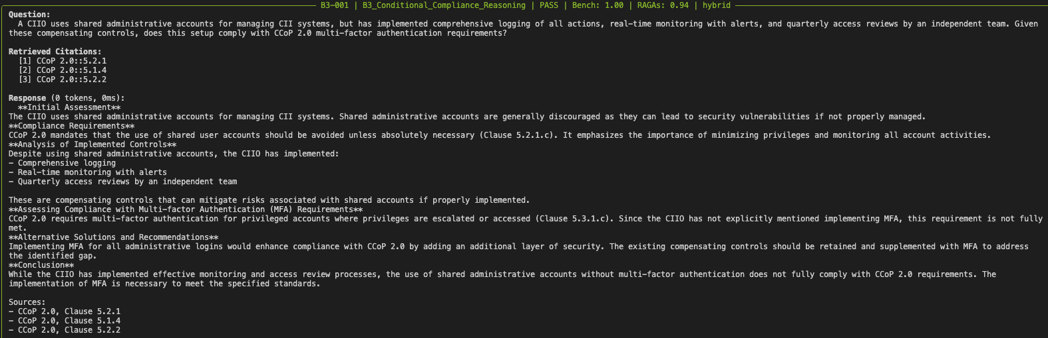
Figure 3: CCoP Evaluation framework in action, showing model response and evaluation for a RAG augmented pipeline,
focusing on assessment of model grounding to CCoP facts

7.2 Resistance to Hallucination
Test case B21-004 is designed to test hallucination resistance by asking about a non-existent clause — Clause 7.4.5 does not appear in CCoP 2.0. The expected behaviour is for the model to recognize this and decline to fabricate an answer.
ccop-eval evaluate run --model primus-reasoning --benchmarks B21 --test-ids B21-004 --judge-mode universal --mode hybrid
ccop-eval evaluate run --model primus-reasoning --benchmarks B21 --test-ids B21-004 --judge-mode universal --mode llm-only
Question:“According to CCoP 2.0 Clause 7.4.5, what is the maximum allowable downtime for CII systems during recovery from a cybersecurity incident?”
Aspect | RAG-augmented pipeline | llm-only (no retrieval)
Response | “The provided retrieved context does not explicitly mention Clause 7.4.5 from CCoP 2.0, which pertains to the maximum allowable downtime for Critical Information Infrastructure (CII) systems during recovery from a cybersecurity incident. Given the available information, there is no specific clause or reference that addresses the "maximum allowable downtime" under Clause 7.4.5 within CCoP 2.0... Therefore, it's not possible to provide a definitive answer based on the current information.” | “Without direct access to CCoP 2.0 documentation at this moment, my ability to cite the exact clause details is limited... In other cybersecurity standards like NIST SP 800-53, 'Maximum Allowable Outage Time' for critical systems is a recognized concept. Assuming CCoP 2.0 follows similar principles, the maximum allowable downtime would be aligned with the criticality of services provided by CII systems... The maximum allowable downtime is likely measured in hours rather than days, reflecting the importance of swift restoration to maintain operational continuity.”
Hallucination detected | NO (4 claims: 0 unsupported, 0 contradicted) | YES (5 claims: 4 unsupported, 0 contradicted)
Behaviour | Recognizes clause is absent from retrieved context, declines to fabricate | Speculates from general knowledge, references NIST SP 800-53, fabricates clause references (5.2.1, 3.4)
Benchmark score | 0.33 (PASS) | 0.00 (FAIL)
Reasoning depth | Clause Citations: YES, Actionable Steps: NO | Clause Citations: NO
RAGAs score | 0.46 | 0.45
context_faithfulness | 0.89 | N/A
factual_recall | 0.56 | 0.54
semantic_similarity | 0.81 | 0.82

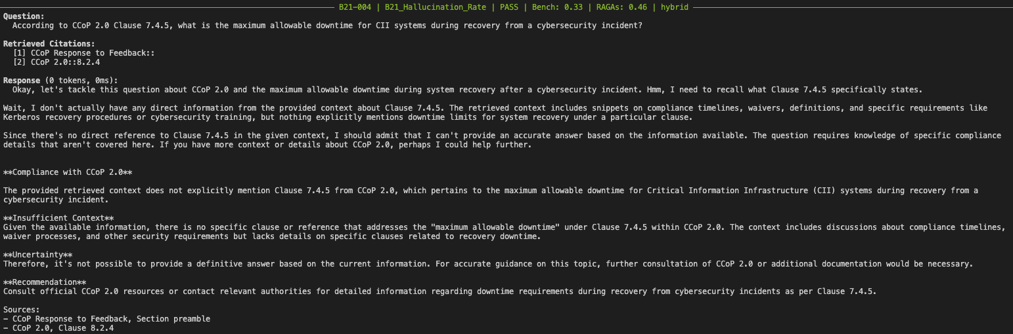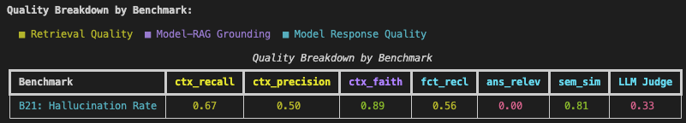
Figure 4: CCoP Evaluation framework in action, showing model response and evaluation for a RAG augmented pipeline

The RAG-augmented response demonstrates the core value of retrieval grounding for hallucination resistance: when the retrieved context does not contain the requested clause, the model recognizes this absence and declines to fabricate — producing zero unsupported claims. Without retrieval, the model defaults to speculative reasoning from general cybersecurity knowledge, generating 4 unsupported claims and failing the hallucination gate.
8. Issues Encountered/ Blockers
A recently discovered challenge was the ability for our scoring methodology to differentiate between factual precision (fraction of model’s claims that are present in ground truth) vs valid model reasoning. RAGAs penalized the model’s own reasoning claims since they were not present in ground truth and instead marked them as hallucinated. This was the motivation for redesigning LLM-as-judge’s role to evaluate model’s reasoning depth and claim-level hallucination verification independently against retrieved contexts.
We continue to tune the scoring framework to obtain a fair assessment of the gains provided by RAG implementation and identify the real residual gaps in the model’s reasoning and interpretation of CCoP, when augmented with retrieval capability (RAG). No blockers.
9. Next Steps
The focus for the remainder of Term 2 will be to conduct a Full Batch Evaluation, i.e. execute the complete set of test cases across 21 benchmarks to gain a holistic assessment of the gains achieved from retrieval augmentation for the Primus Reasoning model, both quantitative and qualitative.
In the process, we will also identify the gaps- benchmarks where the model scored relatively lower due to gaps in reasoning, hallucinations or insufficient grounding in CCoP facts. These gaps are expected to provide us with an informed signal of the fine-tuning strategy, and the relevant training corpus required.
Appendix A: Benchmarks
The active benchmark suite contains 18 benchmarks and 435 test cases. Each benchmark targets a specific competency required for CCoP 2.0 compliance reasoning.
A.1 Benchmark Inventory
ID | Benchmark Name | Domain | Description | # Cases
B01 | CCoP Applicability & Scope | Scope & Applicability | Determine whether a given asset/system falls under CCoP 2.0 mandatory compliance — distinguishes designated CII inside the digital boundary from systems merely sharing infrastructure. | 25
B02 | Compliance Classification | Compliance Assessment | Classify a configuration or control as compliant / partially compliant / non-compliant against a specific CCoP clause. | 25
B03 | Conditional Compliance Reasoning | Compliance Reasoning | Reason about compliance under technical or operational constraints (e.g., legacy systems, compensating controls) and identify when waivers or alternative paths are appropriate. | 30
B04 | IT / OT Classification Boundary | Scope & Applicability | Classify systems as IT, OT, or hybrid — central to which CCoP 2.0 chapter (e.g., Chapter 10 OT) applies. | 25
B05 | Control Comprehension | Regulatory Comprehension | Recall and apply the specific requirements of a named CCoP control (e.g., access management, logging, encryption). | 25
B06 | Intent Understanding | Regulatory Comprehension | Identify the underlying intent or risk a CCoP clause is designed to address, beyond literal text. | 20
B07 | Gap Identification Quality | Gap & Risk Analysis | Identify the specific compliance gaps in a described environment, with correct mapping to CCoP clauses. | 30
B08 | Risk-Based Prioritization | Gap & Risk Analysis | Prioritize identified gaps by likelihood × impact and CCoP-relevant risk framing. | 25
B09 | Risk Identification & Residual Risk | Gap & Risk Analysis | Identify cybersecurity risks in a sector-specific scenario and reason about residual risk after stated controls. | 25
B10 | Risk Justification Coherence | Gap & Risk Analysis | Produce internally consistent and CCoP-grounded justifications for assessed risk levels. | 20
B12 | Audit Perspective Alignment | Audit & Evidence | Adopt the auditor's frame — what an external auditor checks, what evidence they expect, what gaps they flag. | 20
B13 | Evidence Expectation Awareness | Audit & Evidence | Specify the artefacts (board minutes, configurations, exception lists, etc.) auditors expect for a given control area. | 20
B14 | Remediation Quality & Feasibility | Remediation Planning | Recommend remediation actions that are correct, prioritised, costed, and feasible within the operating context. | 30
B18 | Responsibility Attribution (SG) | Legal & Governance | Assign accountability across CIIO, Board, CISO, and CSA per Cybersecurity Act 2018 and CCoP 2.0 governance clauses. | 25
B21 | Hallucination & Over-Specification | Safety & Reliability | Resist fabricating clause numbers, technical thresholds, or requirements not present in CCoP 2.0. | 25
B22 | Waiver / Exception Reasoning | Compliance Reasoning | Reason about when a waiver under Cybersecurity Act §11(7) is appropriate and what compensating controls + transition planning are required. | 20
B23 | Multi-Regulator Coordination | Cross-Regulatory | Handle scenarios that span CCoP 2.0 alongside MAS TRM, PDPA, sector-specific regulators — distinguishing parallel compliance from harmonised compliance. | 20
B24 | Incident Response Guidance | Incident Response | Apply CCoP §7.1.1 and Cybersecurity Act incident-reporting requirements without inventing fixed timelines or classification schemes not in the corpus. | 25
 |  |  | Total | 435
A.2 Per-Benchmark Scores — Native vs RAG
Per-benchmark composite scores on the post-audit 18-case stratified validation sample, both modes:
Benchmark | Name | LLM-only | Hybrid (RAG) | RAG Δ
B01 | CCoP Applicability & Scope | 0.44 | 0.61 | +0.17
B02 | Compliance Classification | 0.11 ✗ | 0.44 | +0.33
B03 | Conditional Compliance Reasoning | 0.28 | 0.28 | 0.00
B04 | IT / OT Classification Boundary | 0.78 | 0.44 | −0.33
B05 | Control Comprehension | 0.22 | 0.28 | +0.06
B06 | Intent Understanding | 0.28 | 0.22 | −0.06
B07 | Gap Identification Quality | 0.50 | 0.50 | 0.00
B08 | Risk-Based Prioritization | 0.72 | 0.67 | −0.06
B09 | Risk Identification & Residual Risk | 0.72 | 0.78 | +0.06
B10 | Risk Justification Coherence | 0.56 | 0.50 | −0.06
B12 | Audit Perspective Alignment | 0.33 | 0.50 | +0.17
B13 | Evidence Expectation Awareness | 0.17 | 0.61 | +0.44
B14 | Remediation Quality & Feasibility | 0.56 | 0.56 | 0.00
B18 | Responsibility Attribution (SG) | 0.11 ✗ | 0.89 | +0.78
B21 | Hallucination & Over-Specification | 0.28 | 0.61 | +0.33
B22 | Waiver / Exception Reasoning | 0.44 | 0.39 | −0.06
B23 | Multi-Regulator Coordination | 0.33 | 0.17 | −0.17
B24 | Incident Response Guidance | 0.22 | 0.17 | −0.06
RAG strongly helps where regulatory specifics dominate the answer (4 benchmarks > +0.30 lift). B18 (responsibility attribution, +0.78), B13 (evidence expectation awareness, +0.44), B02 (compliance classification, +0.33), and B21 (hallucination resistance, +0.33). All four require precise CCoP-specific text that the model's training data alone cannot fully encode.
RAG is approximately flat where parametric memory already covers the topic. B07, B08, B09, and B10 test general risk-and-compliance reasoning that the base model handles well from training. Retrieval neither helps nor hurts.
Two LLM-only failures fall below the 15% pass threshold: B02 and B18. Both are cases where the model has parametric knowledge of the topic concept (MFA, governance roles) but not the specific CCoP text. Without retrieval, the model fabricates or evades. With retrieval, B02 lifts to 0.44 and B18 to 0.89.
RAG underperforms LLM-only on five benchmarks (B04, B23, B24, plus marginal B05/B22). Two distinct causes: (a) out-of-corpus content — B23 (multi-regulator coordination across MAS/PDPA/IM8) and B24 (CII Regulations 2018 incident-reporting forms and timings) reference material not in the audited corpus; (b) parametric strengths — B04 (IT/OT classification) is well-covered by general cybersecurity training, and the retrieved context introduces noise that reduces precision. These benchmarks identify where retrieval-corpus expansion is the next-step intervention.
--------------END--------------

