Fine-Tuning LLM on Singapore's Cybersecurity Code of Practice (CCoP 2.0) Standards for Critical Information Infrastructure

  - Mid-Term 2 Report

Project Period: September 2025 - August 2026
Author: Sagar Pratap Singh
Report Date: 19 March 2026
Executive Summary
- Term 1 baselined the untuned Primus-Reasoning model at 48.96% across 21 benchmarks — strong reasoning (61.6%) but severe factual grounding gaps (31.6%) with frequent hallucination of regulatory facts.

- Term 2's objective is to close this grounding gap through retrieval-augmented generation before proceeding to fine-tuning. A complete RAG pipeline was built — Qdrant hybrid search, clause-aware chunking of 8 CCoP documents, cross-encoder reranking, and diagram captioning — grounding the model in authoritative clause text.

- The evaluation engine was upgraded with dual-layer scoring setup- RAGAs automated quality metrics and LLM-as-Judge

- Early results show RAG-augmented responses citing specific CCoP clauses, while the unaugmented model substitutes from unrelated frameworks with increased hallucination. Full batch evaluation is in progress; the RAG-vs-baseline delta will determine which domains require fine-tuning.

1. Recap of Term 1 Findings
The baseline evaluation of the untuned Llama-Primus-Reasoning model (8B parameters, 4-bit quantized) against CCoP 2.0 achieved a weighted score of 48.96% across 17 of 21 benchmarks, with 4 benchmarks (B7, B10, B14, B16) deferred for manual expert review. The model demonstrated strong logical reasoning capability (61.6% average across reasoning benchmarks) but exhibited severe deficiencies in Singapore-specific CCoP knowledge domains (31.6% average for factual grounding).
Three critical failure modes were identified:
1. Hallucination of regulatory facts (B21: 22.13%) — the model fabricates specific technical details such as password lengths, SIEM vendor requirements, and air-gap clauses that do not exist in CCoP 2.0.
2. Regulatory scope confusion — the model struggles to correctly determine CCoP applicability, CII designation boundaries, and IT versus OT classification.
3. Factual grounding gaps — when asked about specific CCoP requirements, the model produces plausible but inaccurate paraphrases rather than grounded responses traceable to authoritative clause text.

The ground truth dataset of 118 test cases across 21 benchmarks remains pending expert validation by a CCoP 2.0 compliance practitioner.
These findings indicated that fine-tuning alone is insufficient to address the factual and grounding deficiencies — the model needs access to authoritative CCoP clause text through retrieval-based grounding before fine-tuning can be effective.

2. Strategic Pivot: RAG-First Approach
The original project plan for Term 2 envisioned proceeding directly to comprehensive baseline benchmarking (Phase 3), a small fine-tuning test (Phase 4), and full dataset creation (Phase 5). However, the baseline results from Term 1 made clear that the model's core weakness is not reasoning ability — it is the absence of factual grounding in authoritative regulatory text. The model can reason about compliance scenarios at 61.6% accuracy, but fabricates regulatory facts at an alarming rate (B21: 22.13%) because it has no access to the actual CCoP 2.0 clauses.

This aligns with findings from the related works analysis conducted in Term 1, which identified that retrieval-based grounding is essential for prescriptive regulatory standards where responses must be traceable to specific clauses and defensible during audits. To implement a hybrid approach (fine-tuning + RAG), it was important to first understand how much factual grounding can be gained by implementing RAG alone. By building the RAG pipeline and evaluating LLM responses with retrieval-augmented context, we can conduct a gap analysis across all 21 benchmarks: benchmarks where the model still struggles even with access to authoritative clause text become the natural focus for fine-tuning. This ensures the fine-tuning dataset is targeted at genuine reasoning gaps rather than factual knowledge that retrieval can already provide.

Accordingly, the Term 2 plan was restructured to prioritize RAG infrastructure, retrieval quality, and evaluation methodology upgrades before proceeding to fine-tuning experiments. The following sections detail this work.

3. RAG Infrastructure Setup
Since the project targets deployment in isolated Critical Information Infrastructure (CII) environments — which are typically air-gapped or on-premise with restricted external connectivity — the RAG infrastructure was designed to operate with zero cloud dependencies. All components run locally via Docker, ensuring the pipeline can be deployed in any environment without requiring external API calls or managed services.
The local RAG stack consists of:
Component | Technology | Purpose
Vector database | Qdrant (Docker) | Hybrid search (dense + sparse) with RRF fusion
Dense embeddings | BAAI/bge-large-en-v1.5 via sentence-transformers | 1024-dimensional semantic embeddings
Sparse embeddings | Qdrant/BM25 via FastEmbed | Keyword-based retrieval for exact terminology matching
Orchestration | LangGraph | Stateful adaptive RAG pipeline with self-correction loops
LLM inference | Ollama + Llama-Primus-Reasoning | Local model inference (4-bit quantized, GGUF)

A corpus of 8 authoritative CCoP documents was ingested into the pipeline, including the primary CCoP 2.0 Second Edition document, the Cybersecurity Act 2018, and CSA's Guidelines for Auditing Critical Information Infrastructure among others. These documents form the retrieval corpus from which the pipeline grounds LLM responses in authoritative regulatory text.

3.1 Retrieval Methodology
The retrieval pipeline processes each query through five stages:
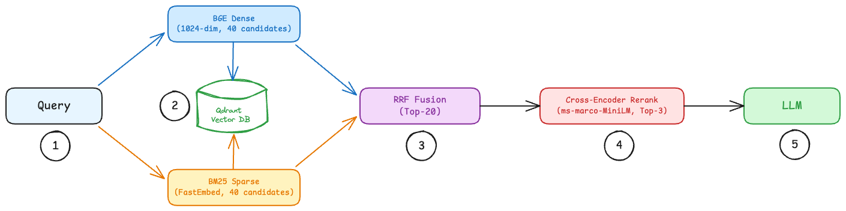
Figure 1: Retrieval pipeline using sparse and dense embedding search, RRF and cross-encoder ranking

1. Dual Encoding — the query is encoded in parallel through two independent embedding models:
• Dense: BGE-large-en-v1.5 (1024-dim, L2 normalised) — captures semantic meaning. A query about “access control” matches clauses discussing authentication and authorisation even when the exact phrase is absent.
• Sparse: BM25 via FastEmbed — captures exact terminology. Required for matching clause references (“5.1.5”), regulatory acronyms (“CIIO”), and domain-specific terms that dense embeddings generalise away.
2. Parallel Prefetch — each encoding retrieves its own candidate set from Qdrant independently: 40 dense candidates and 40 sparse candidates (2x the fusion target of 20).
3. Reciprocal Rank Fusion (RRF) — the two ranked lists are merged into a single list of 20 candidates using RRF with equal weighting. RRF scores each document by summing 1/(k + rank) across both lists, promoting documents that rank well in either or both retrieval paths without requiring score normalisation between the two models.
4. Cross-Encoder Reranking — the 20 RRF candidates are re-scored by ms-marco-MiniLM-L12-v2, which jointly encodes each query-document pair with full cross-attention. This resolves a limitation of bi-encoder retrieval: bi-encoders embed query and document independently, so semantically close clauses (e.g., 5.1.1 on access management vs 5.1.2 on authentication requirements) receive similar scores. The cross-encoder attends to both texts simultaneously, differentiating fine-grained regulatory distinctions. The top 3 documents are selected.
5. No-Threshold Passthrough — all 3 reranked documents are passed to the LLM regardless of score. Grading is measurement-only: relevance scores are logged for analysis but no filtering is applied. This is a deliberate choice — introducing score thresholds before the full evaluation has run would mask retrieval quality issues and prevent establishing a meaningful baseline. If retrieval returns zero results, the pipeline falls back to LLM-only generation.

4. Evaluation Framework
The evaluation infrastructure uses two independent scoring mechanisms — RAGAs for automated quality metrics across three brackets (Retrieval Quality, Model-RAG Grounding, and Model Response Quality), and LLM-as-Judge (Claude Sonnet) for reasoning depth and hallucination detection across 16 benchmarks.

4.1 RAGAs Quality Metrics
RAGAs evaluates response and retrieval quality across three quality brackets:
Quality Bracket | Metric | Applies To | What It Measures
Retrieval Quality | context_precision | RAG-augmented only | Whether retrieved chunks are relevant to the question
 | context_recall | RAG-augmented only | Whether retrieved chunks contain the information needed to answer
Model-RAG Grounding | context_faithfulness | RAG-augmented only | Whether the response is supported by retrieved context
Model Response Quality | factual_recall | RAG-augmented and LLM-only | Factual coverage of the response against ground truth
 | answer_relevancy | RAG-augmented and LLM-only | Whether the response addresses the question asked
 | semantic_similarity | RAG-augmented and LLM-only | Semantic alignment between response and expected answer
The RAGAs composite score is a simple average of the three base metrics: (factual_recall + answer_relevancy + semantic_similarity) / 3.

4.2 LLM-as-Judge Scoring
The LLM judge (Claude Sonnet) evaluates each response in a single call across two dimensions:
Dimension | Scale | What It Evaluates
Reasoning Depth | 0–3 | (1) Clause-specific citations from retrieved context,  (2) conditional analysis (if-then logic for compliance scenarios),  (3) actionable steps for the CIIO. The judge determines which criteria are applicable per question type.
Hallucination Detection | Binary (pass/fail) | Claim-level verification against retrieved contexts.  Each claim is classified as SUPPORTED, UNSUPPORTED, or CONTRADICTED.  Any unsupported or contradicted claim fails the entire response.
For LLM-only mode, retrieval contexts are fetched but only passed to the judge — not the model — enabling consistent hallucination scoring across both evaluation modes.

5. RAG Quality — Chunking & Retrieval Experiments
A series of iterative experiments were conducted to diagnose and resolve retrieval quality issues in the RAG pipeline. Each experiment targeted a specific limitation identified in the previous iteration.
Experiment | Change | Key Result | Limitation / Issue Identified
Exp 0:  Local RAG Baseline | PyMuPDF4LLM parser + MarkdownHeaderTextSplitter chunker; hybrid RRF search with 0.6 score threshold | 66 chunks from 8 documents (~11 per doc); 0% retrieval success — all queries return 0 results | Parser does not detect clause boundaries (5.2.1, 5.2.1.1 are inline text, not headers); chunker only splits on markdown headers producing coarse sections; RRF score threshold (0.6) is mathematically incompatible with RRF score range (0.001–0.033)
Exp 1:  Docling + Clause-Aware Chunking | Replaced parser with Docling (structural PDF parsing); replaced chunker with clause-boundary regex splitter; deterministic chunk IDs ({source}::{clause}); removed broken 0.6 RRF threshold (measurement-only grading) | 324 chunks (305 in Qdrant); CCoP 2.0 primary doc: 11 → 168 chunks; median chunk size: 124 tokens; retrieval success: 0% → 100% | No quality filtering — top-N returned regardless of relevance; bi-encoder cannot distinguish fine-grained differences between semantically close clauses
Exp 2:  Cross-Encoder Reranking | Added ms-marco-MiniLM-L12-v2 cross-encoder; pipeline changed to retrieve top-20 → rerank → top-3 → LLM | Score differentiation achieved (-6.56 to +7.56); focused retrieval — e.g., "vulnerability assessment" query returns all 3 results from CCoP Section 5.14 | Precision@3 not quantitatively measured (needs labelled test set); 78 diagrams across documents are invisible to search
Exp 3:  Diagram Captioning | Switched to Docling Classic for all documents; added GLM-4V API captioning for extracted diagrams with fallback text | 78 diagrams detected across 7 documents; graceful degradation — pipeline completes despite API errors | Diagram captioning functional; re-run completed with corrected model configuration; no automated way to evaluate retrieval and response quality for RAG-augmented answers
Exp 4:  RAGAs Integration | Added RAGAs evaluation layer with 5 quality metrics for automated assessment of response accuracy, relevance, and retrieval quality | RAGAs metrics available per test case; base metrics evaluated for all responses, context metrics for RAG-augmented responses only | Pending first full evaluation run to produce RAGAs scores across all 21 benchmarks
6. Application Architecture
The system comprises two subsystems — a Document Ingestion pipeline and an Evaluation Engine — connected through a shared Qdrant vector store.
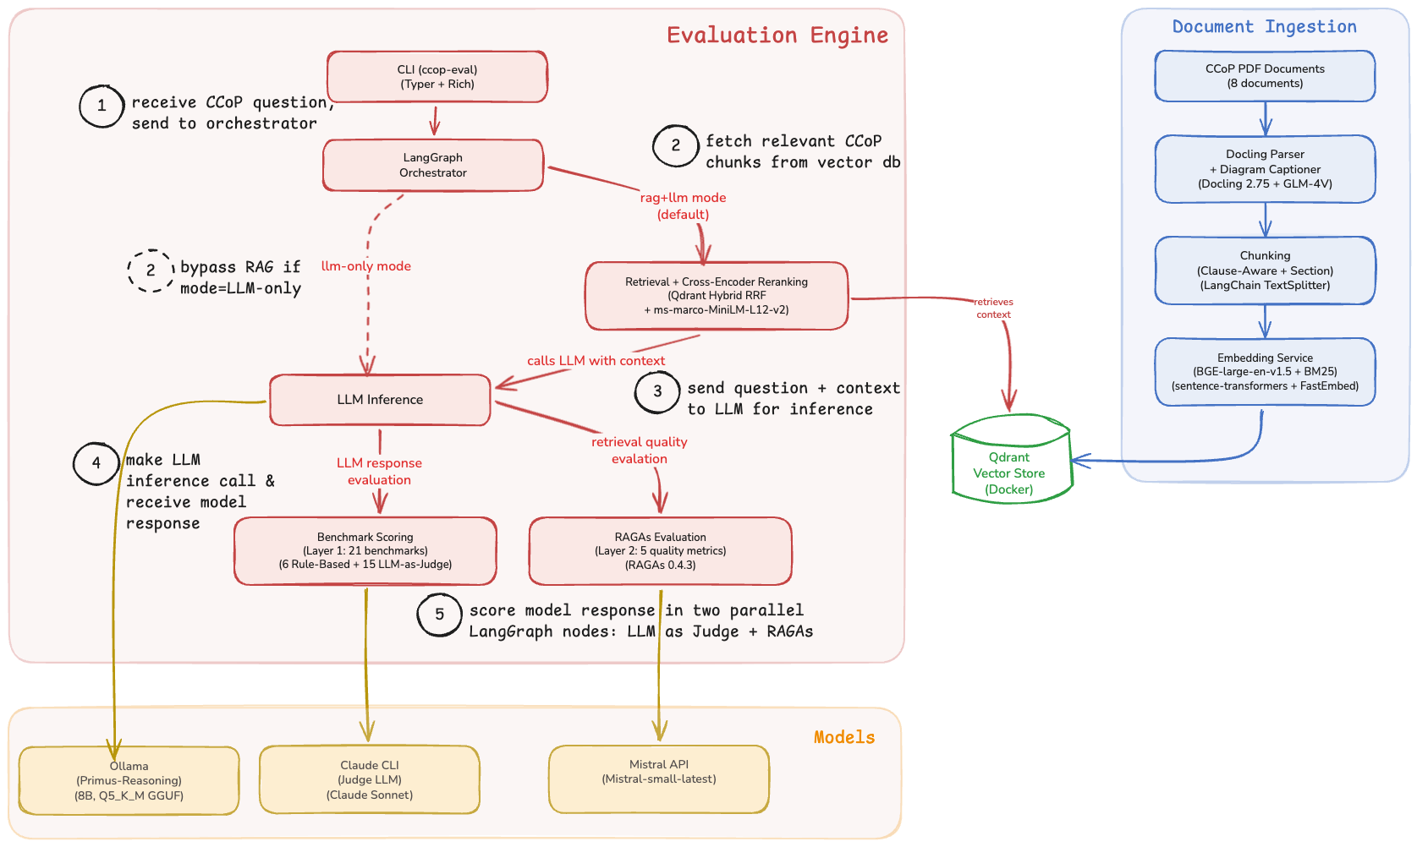
Figure 2: Application architecture showing document ingestion (right), evaluation engine (left), and external model endpoints (bottom).

6.1 Document Ingestion
The ingestion pipeline converts raw CCoP PDF documents into searchable vector embeddings:
1. Parsing — Docling 2.75 performs structural PDF parsing, extracting text with document hierarchy (sections, clauses, sub-clauses). GLM-4V provides captioning for 78 diagrams detected across the corpus, ensuring diagram content is searchable.
2. Chunking — A clause-aware splitter segments parsed documents at regulatory clause boundaries (e.g., 5.2.1, 5.2.1.1), producing 324 chunks with deterministic IDs ({source}::{clause}). LangChain’s MarkdownHeaderTextSplitter handles section-level splits for non-clause content.
3. Embedding — Each chunk is dual-encoded: BGE-large-en-v1.5 (via sentence-transformers) generates 1024-dimensional dense embeddings for semantic search, while Qdrant’s built-in BM25 (via FastEmbed) produces sparse embeddings for exact terminology matching.
4. Storage — Both embedding types are stored in Qdrant with RRF-compatible indexing, enabling hybrid search at query time.

6.2 Evaluation Engine
The evaluation engine is invoked through a CLI that accepts a mode parameter controlling the retrieval strategy:
• rag+llm mode (default) — The LangGraph orchestrator routes the query through Retrieval, which performs hybrid search (dense + sparse via RRF) against Qdrant, followed by cross-encoder reranking (ms-marco-MiniLM-L12-v2) to select the top-3 most relevant chunks. These chunks are passed as grounding context to LLM Inference.
• llm-only mode — The orchestrator routes the query directly to LLM Inference, bypassing retrieval entirely. This mode serves as the baseline for measuring RAG’s contribution.
LLM Inference sends the prompt (with or without retrieved context) to Ollama running the Primus-Reasoning model (8B, Q5_K_M GGUF quantisation) for response generation.
After inference, the response flows into two independent evaluation layers – RAGAs Quality evaluation and LLM as Judge (Claude), as described in Section 4.
Both layers produce results that are aggregated into a JSON report with category-weighted scores.

6.3 External Model Endpoints
The architecture uses three distinct model endpoints, each serving a specific purpose:
Model | Endpoint | Role
Primus-Reasoning (8B, Q5_K_M) | Ollama (local) | Response generation — the model under evaluation
Claude Sonnet | Claude CLI | LLM-as-Judge — evaluates response quality against benchmark rubrics
Mistral Small (mistral-small-latest) | Mistral API | RAGAs evaluator — scores response and retrieval quality metrics

This separation ensures the model being evaluated (Primus-Reasoning) is never used to judge its own outputs. The judge (Claude Sonnet) and the RAGAs evaluator (Mistral Small) are independent third-party models with no overlap in their evaluation responsibilities.

7. Latest Results
The evaluation framework supports three levels of granularity — from single-query debugging to full batch assessment — each serving a distinct purpose in the development workflow. All three modes produce both RAGAs metrics as well as LLM as Judge scores and can be run in either rag+llm or llm-only mode.
The full batch evaluation across all 21 benchmarks is currently in progress. Results will be reported in the final submission. Below are concrete examples of single evaluation runs, comparing RAG vs LLM-only responses.

7.1.2 Model Grounding & Factual Recall
Test case B3-001 evaluates conditional compliance reasoning — whether the model can apply specific CCoP clauses to a real-world scenario involving shared administrative accounts and compensating controls.
ccop-eval evaluate run --model primus-reasoning --benchmarks B3 --test-ids B3-001 --judge-mode universal --mode hybrid
ccop-eval evaluate run --model primus-reasoning --benchmarks B3 --test-ids B3-001 --judge-mode universal --mode llm-only
Question: "A CIIO uses shared administrative accounts for managing CII systems, but has implemented comprehensive logging of all actions, real-time monitoring with alerts, and quarterly access reviews by an independent team. Given these compensating controls, does this setup comply with CCoP 2.0 multi-factor authentication requirements?"
Aspect | hybrid (RAG-augmented) | llm-only (no retrieval)
Response | CCoP 2.0 mandates that the use of shared user accounts should be avoided unless absolutely necessary (Clause 5.2.1.c). It emphasizes the importance of minimizing privileges and monitoring all account activities... CCoP 2.0 requires multi-factor authentication for privileged accounts where privileges are escalated or accessed (Clause 5.3.1.c). Since the CIIO has not explicitly mentioned implementing MFA, this requirement is not fully met... The implementation of MFA is necessary to meet the specified standards. | Upon reviewing the CCoP 2.0 framework, I recall that it emphasizes strong authentication mechanisms... specific clauses regarding shared administrative accounts and multi-factor authentication (MFA) are not immediately clear in my memory without direct reference to the document... For instance, Clause 6.5 of earlier CCoP versions might relate to access controls and authentication, but the exact alignment with MFA for shared accounts is uncertain.
Hallucination detected | NO (8 claims: 0 unsupported, 0 contradicted) | YES (7 claims: 4 unsupported, 1 contradicted)
Behaviour | Cites specific clauses (5.2.1, 5.1.4, 5.2.2, 5.3.1.c), applies them to the scenario, recommends MFA implementation | Hedges with "I recall", fabricates Clause 6.5, unable to reach a definitive compliance determination
Benchmark score | 1.00 (PASS) | 0.00 (FAIL)
Reasoning depth | Clause Citations: YES, Conditional Analysis: YES, Actionable Steps: YES | Clause Citations: NO, Conditional Analysis: NO, Actionable Steps: YES
RAGAs score | 0.94 | 0.50
context_faithfulness | 0.80 | N/A
factual_recall | 1.00 | 0.62
semantic_similarity | 0.90 | 0.89
The contrast is stark: the RAG-augmented response achieves perfect benchmark and factual recall scores by grounding its reasoning in retrieved clause text — it identifies the specific prohibition on shared accounts (5.2.1.c), the MFA requirement (5.3.1.c), and provides an actionable recommendation. The LLM-only response demonstrates high semantic similarity (0.89) — it discusses the right topic — but cannot cite specific clauses, fabricates "Clause 6.5", and produces a non-committal answer unsuitable for compliance guidance.
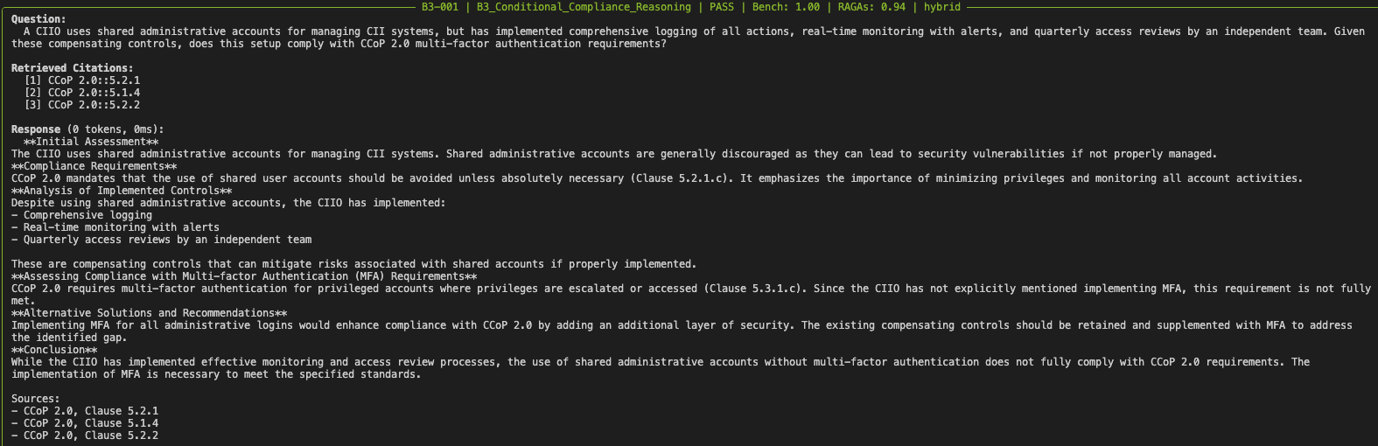
Figure 3: CCoP Evaluation framework in action, showing model response and evaluation for a RAG augmented pipeline,
focusing on assessment of model grounding to CCoP facts

7.2 Resistance to Hallucination
Test case B21-004 is designed to test hallucination resistance by asking about a non-existent clause — Clause 7.4.5 does not appear in CCoP 2.0. The expected behaviour is for the model to recognize this and decline to fabricate an answer.
ccop-eval evaluate run --model primus-reasoning --benchmarks B21 --test-ids B21-004 --judge-mode universal --mode hybrid
ccop-eval evaluate run --model primus-reasoning --benchmarks B21 --test-ids B21-004 --judge-mode universal --mode llm-only
Question:“According to CCoP 2.0 Clause 7.4.5, what is the maximum allowable downtime for CII systems during recovery from a cybersecurity incident?”
Aspect | RAG-augmented pipeline | llm-only (no retrieval)
Response | “The provided retrieved context does not explicitly mention Clause 7.4.5 from CCoP 2.0, which pertains to the maximum allowable downtime for Critical Information Infrastructure (CII) systems during recovery from a cybersecurity incident. Given the available information, there is no specific clause or reference that addresses the "maximum allowable downtime" under Clause 7.4.5 within CCoP 2.0... Therefore, it's not possible to provide a definitive answer based on the current information.” | “Without direct access to CCoP 2.0 documentation at this moment, my ability to cite the exact clause details is limited... In other cybersecurity standards like NIST SP 800-53, 'Maximum Allowable Outage Time' for critical systems is a recognized concept. Assuming CCoP 2.0 follows similar principles, the maximum allowable downtime would be aligned with the criticality of services provided by CII systems... The maximum allowable downtime is likely measured in hours rather than days, reflecting the importance of swift restoration to maintain operational continuity.”
Hallucination detected | NO (4 claims: 0 unsupported, 0 contradicted) | YES (5 claims: 4 unsupported, 0 contradicted)
Behaviour | Recognizes clause is absent from retrieved context, declines to fabricate | Speculates from general knowledge, references NIST SP 800-53, fabricates clause references (5.2.1, 3.4)
Benchmark score | 0.33 (PASS) | 0.00 (FAIL)
Reasoning depth | Clause Citations: YES, Actionable Steps: NO | Clause Citations: NO
RAGAs score | 0.46 | 0.45
context_faithfulness | 0.89 | N/A
factual_recall | 0.56 | 0.54
semantic_similarity | 0.81 | 0.82

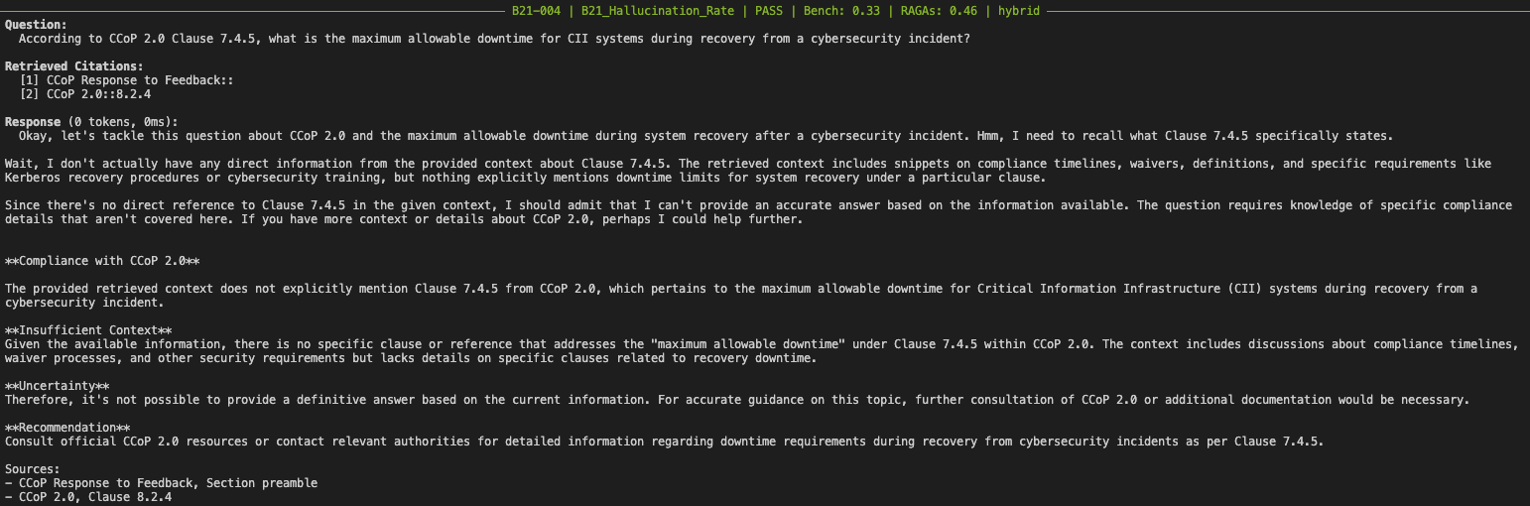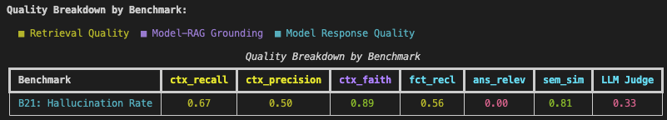
Figure 4: CCoP Evaluation framework in action, showing model response and evaluation for a RAG augmented pipeline

The RAG-augmented response demonstrates the core value of retrieval grounding for hallucination resistance: when the retrieved context does not contain the requested clause, the model recognizes this absence and declines to fabricate — producing zero unsupported claims. Without retrieval, the model defaults to speculative reasoning from general cybersecurity knowledge, generating 4 unsupported claims and failing the hallucination gate.
8. Issues Encountered/ Blockers
A recently discovered challenge was the ability for our scoring methodology to differentiate between factual precision (fraction of model’s claims that are present in ground truth) vs valid model reasoning. RAGAs penalized the model’s own reasoning claims since they were not present in ground truth and instead marked them as hallucinated. This was the motivation for redesigning LLM-as-judge’s role to evaluate model’s reasoning depth and claim-level hallucination verification independently against retrieved contexts.
We continue to tune the scoring framework to obtain a fair assessment of the gains provided by RAG implementation and identify the real residual gaps in the model’s reasoning and interpretation of CCoP, when augmented with retrieval capability (RAG). No blockers.
9. Next Steps
The focus for the remainder of Term 2 will be to conduct a Full Batch Evaluation, i.e. execute the complete set of test cases across 21 benchmarks to gain a holistic assessment of the gains achieved from retrieval augmentation for the Primus Reasoning model, both quantitative and qualitative.
In the process, we will also identify the gaps- benchmarks where the model scored relatively lower due to gaps in reasoning, hallucinations or insufficient grounding in CCoP facts. These gaps are expected to provide us with an informed signal of the fine-tuning strategy, and the relevant training corpus required.
--------------END--------------

