Fine-Tuning LLM on Singapore's Cybersecurity Code of Practice (CCoP 2.0) Standards for Critical Information Infrastructure

  - Mid-Term 2 Report

Project Period: September 2025 - August 2026
Author: Sagar Pratap Singh
Report Date: 19 March 2026
Executive Summary
- Term 1 baselined the untuned Primus-Reasoning model at 48.96% across 21 benchmarks — strong reasoning (61.6%) but severe factual grounding gaps (31.6%) with frequent hallucination of regulatory facts.

- Term 2's objective is to close this grounding gap through retrieval-augmented generation before proceeding to fine-tuning. A complete RAG pipeline was built — Qdrant hybrid search, clause-aware chunking of 8 CCoP documents, cross-encoder reranking, and diagram captioning — grounding the model in authoritative clause text.

- The evaluation engine was upgraded with dual-layer scoring setup- LLM-as-Judge and RAGAs metrics

- Early results show RAG-augmented responses citing specific CCoP clauses, while the unaugmented model substitutes from unrelated frameworks. Full batch evaluation is in progress; the RAG-vs-baseline delta will determine which domains require fine-tuning.

1. Recap of Term 1 Findings
The baseline evaluation of the untuned Llama-Primus-Reasoning model (8B parameters, 4-bit quantized) against CCoP 2.0 achieved a weighted score of 48.96% across 17 of 21 benchmarks, with 4 benchmarks (B7, B10, B14, B16) deferred for manual expert review. The model demonstrated strong logical reasoning capability (61.6% average across reasoning benchmarks) but exhibited severe deficiencies in Singapore-specific CCoP knowledge domains (31.6% average for factual grounding).
Three critical failure modes were identified:
1. Hallucination of regulatory facts (B21: 22.13%) — the model fabricates specific technical details such as password lengths, SIEM vendor requirements, and air-gap clauses that do not exist in CCoP 2.0.
2. Regulatory scope confusion — the model struggles to correctly determine CCoP applicability, CII designation boundaries, and IT versus OT classification.
3. Factual grounding gaps — when asked about specific CCoP requirements, the model produces plausible but inaccurate paraphrases rather than grounded responses traceable to authoritative clause text.

The ground truth dataset of 118 test cases across 21 benchmarks remains pending expert validation by a CCoP 2.0 compliance practitioner.
These findings indicated that fine-tuning alone is insufficient to address the factual and grounding deficiencies — the model needs access to authoritative CCoP clause text through retrieval-based grounding before fine-tuning can be effective.

2. Strategic Pivot: RAG-First Approach
The original project plan for Term 2 envisioned proceeding directly to comprehensive baseline benchmarking (Phase 3), a small fine-tuning test (Phase 4), and full dataset creation (Phase 5). However, the baseline results from Term 1 made clear that the model's core weakness is not reasoning ability — it is the absence of factual grounding in authoritative regulatory text. The model can reason about compliance scenarios at 61.6% accuracy, but fabricates regulatory facts at an alarming rate (B21: 22.13%) because it has no access to the actual CCoP 2.0 clauses.

This aligns with findings from the related works analysis conducted in Term 1, which identified that retrieval-based grounding is essential for prescriptive regulatory standards where responses must be traceable to specific clauses and defensible during audits. To implement a hybrid approach (fine-tuning + RAG), it was important to first understand how much factual grounding can be gained by implementing RAG alone. By building the RAG pipeline and evaluating LLM responses with retrieval-augmented context, we can conduct a gap analysis across all 21 benchmarks: benchmarks where the model still struggles even with access to authoritative clause text become the natural focus for fine-tuning. This ensures the fine-tuning dataset is targeted at genuine reasoning gaps rather than factual knowledge that retrieval can already provide.

Accordingly, the Term 2 plan was restructured to prioritize RAG infrastructure, retrieval quality, and evaluation methodology upgrades before proceeding to fine-tuning experiments. The following sections detail this work.

3. RAG Infrastructure Setup
Since the project targets deployment in isolated Critical Information Infrastructure (CII) environments — which are typically air-gapped or on-premise with restricted external connectivity — the RAG infrastructure was designed to operate with zero cloud dependencies. All components run locally via Docker, ensuring the pipeline can be deployed in any environment without requiring external API calls or managed services.
The local RAG stack consists of:
Component | Technology | Purpose
Vector database | Qdrant (Docker) | Hybrid search (dense + sparse) with RRF fusion
Dense embeddings | BAAI/bge-large-en-v1.5 via sentence-transformers | 1024-dimensional semantic embeddings
Sparse embeddings | Qdrant/BM25 via FastEmbed | Keyword-based retrieval for exact terminology matching
Orchestration | LangGraph | Stateful adaptive RAG pipeline with self-correction loops
LLM inference | Ollama + Llama-Primus-Reasoning | Local model inference (4-bit quantized, GGUF)

A corpus of 8 authoritative CCoP documents was ingested into the pipeline, including the primary CCoP 2.0 Second Edition document, the Cybersecurity Act 2018, and CSA's Guidelines for Auditing Critical Information Infrastructure among others. These documents form the retrieval corpus from which the pipeline grounds LLM responses in authoritative regulatory text.

3.1 Retrieval Methodology
The retrieval pipeline processes each query through five stages:
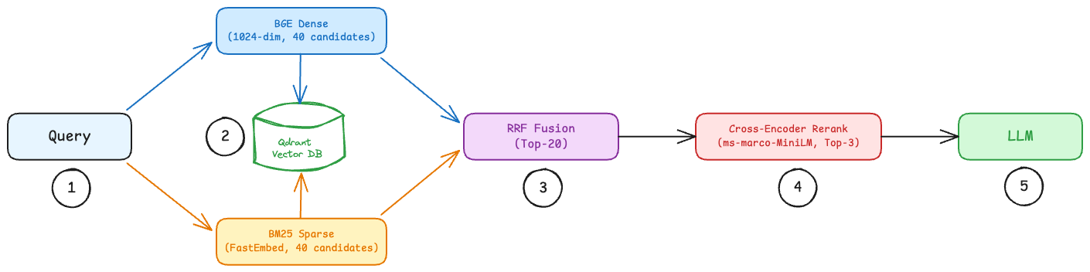
Figure 1: Retrieval pipeline using sparse and dense embedding search, RRF and cross-encoder ranking

1. Dual Encoding — the query is encoded in parallel through two independent embedding models:
• Dense: BGE-large-en-v1.5 (1024-dim, L2 normalised) — captures semantic meaning. A query about “access control” matches clauses discussing authentication and authorisation even when the exact phrase is absent.
• Sparse: BM25 via FastEmbed — captures exact terminology. Required for matching clause references (“5.1.5”), regulatory acronyms (“CIIO”), and domain-specific terms that dense embeddings generalise away.
2. Parallel Prefetch — each encoding retrieves its own candidate set from Qdrant independently: 40 dense candidates and 40 sparse candidates (2x the fusion target of 20).
3. Reciprocal Rank Fusion (RRF) — the two ranked lists are merged into a single list of 20 candidates using RRF with equal weighting. RRF scores each document by summing 1/(k + rank) across both lists, promoting documents that rank well in either or both retrieval paths without requiring score normalisation between the two models.
4. Cross-Encoder Reranking — the 20 RRF candidates are re-scored by ms-marco-MiniLM-L12-v2, which jointly encodes each query-document pair with full cross-attention. This resolves a limitation of bi-encoder retrieval: bi-encoders embed query and document independently, so semantically close clauses (e.g., 5.1.1 on access management vs 5.1.2 on authentication requirements) receive similar scores. The cross-encoder attends to both texts simultaneously, differentiating fine-grained regulatory distinctions. The top 3 documents are selected.
5. No-Threshold Passthrough — all 3 reranked documents are passed to the LLM regardless of score. Grading is measurement-only: relevance scores are logged for analysis but no filtering is applied. This is a deliberate choice — introducing score thresholds before the full evaluation has run would mask retrieval quality issues and prevent establishing a meaningful baseline. If retrieval returns zero results, the pipeline falls back to LLM-only generation.

4. Evaluation Infrastructure & Benchmark Framework
During Term 2 implementation, several limitations of the existing evaluation methodology were identified. The Term 1 evaluation relied on semantic similarity as a proxy metric for Tier 2 benchmarks (B8, B9, B11, B15, B17–B19) — comparing model responses against expected answers using embedding-based cosine similarity. While this approach was computationally efficient, it proved inadequate for compliance reasoning benchmarks: two responses can be semantically similar (discussing the same topic) while being substantively different in audit quality (one correctly prioritises risks, the other does not). Additionally, 4 benchmarks (B7, B10, B14, B16) had no scoring implementation at all.
To address these limitations, the evaluation infrastructure was redesigned as a dual-layer architecture:
Layer | Purpose | Scope | Method
Layer 1: Benchmark Scoring | Domain-specific compliance quality | 21 benchmarks  (B1–B21) | 6 rule-based (B1, B2, B4, B5, B6, B21) + 15 LLM-as-Judge (B3, B7–B20)
Layer 2:  RAGAs Metrics | Generic response and retrieval quality | All responses  (base + RAG-augmented) | 5 automated metrics via RAGAs framework

Layer 1 determines pass/fail and the overall weighted score. Layer 2 operates independently as a diagnostic layer — it assesses response and retrieval quality without influencing benchmark pass/fail determination. This separation enables richer analysis: a response can score high on RAGAs (well-grounded in retrieved context) but low on benchmarks (poor compliance reasoning), or vice versa.
4.1 Layer 1: LLM-as-Judge Benchmark Scoring
Each of the 15 LLM-judged benchmarks has a dedicated rubric template with benchmark-specific evaluation dimensions. Each anchor includes CCoP-specific examples to reduce judge subjectivity. For instance, the B8 (Gap Prioritisation) rubric evaluates the model's ability to prioritise compliance gaps using risk-based criteria. Given the following test question:
"A CIIO's audit identified three control gaps: (1) MFA not implemented for remote access to CII (Clause 5.1.5), (2) Security logs only retained for 6 months instead of 1 year (Clause 6.1.3), (3) Cybersecurity awareness training completed by 85% of personnel, 15% overdue (Clause 9.1.2). Which gap should be addressed first and why?"
The judge evaluates the model's response against the following anchored 0–3 scale:
Score | Anchor | B8 Example
0 | Incorrect — fundamentally wrong or missing | Lists gaps alphabetically; prioritises cosmetic issue over critical MFA gap
1 | Partial — attempted but incomplete or inconsistent | "Fix MFA first because it's important" without risk-based reasoning
2 | Complete — meets the requirement with clear reasoning | "Priority 1: MFA (critical — remote access is primary attack vector, direct essential service impact). Priority 2: Segmentation (high — limits blast radius)"
3 | Exceeds — goes beyond with additional practical insight | Risk-based prioritisation plus implementation sequencing: "Quick win: MFA can be deployed in 2 weeks with existing IAM. Strategic: segmentation requires network redesign — start architecture review now"

The judge LLM (Claude Sonnet) receives the question, model response, expected response, and key facts alongside the rubric, then produces dimension scores with justification. If the judge fails to produce a valid response, the benchmark is flagged with a skip-and-flag error rather than assigned a fallback score — missing data is preferred over wrong data.
The SemanticSimilarityService was removed entirely from the codebase as all its responsibilities are now handled by the LLMJudgeService.
4.2 Layer 2: RAGAs Quality Metrics
The RAGAs layer evaluates response and retrieval quality using 5 automated metrics:
Metric | Applies To | What It Measures
answer_correctness | All responses | Factual accuracy of the response against ground truth
answer_relevancy | All responses | Whether the response addresses the question asked
faithfulness | RAG responses only | Whether the response is supported by the retrieved context (no hallucinated claims beyond what was retrieved)
context_precision | RAG responses only | Whether the retrieved chunks are relevant to the question
context_recall | RAG responses only | Whether the retrieved chunks contain the information needed to answer correctly

For non-RAG (model-only) responses, only the two base metrics (answer_correctness, answer_relevancy) are evaluated. For RAG-augmented responses, all 5 metrics are evaluated. This distinction allows direct comparison of model-only versus RAG-augmented response quality across the same test cases.
Benchmark Scoring Methods (Updated)
Benchmark | Scoring Method | Change from Term 1
B1, B2, B4, B5, B6 | Rule-based (label matching) | Unchanged
B21 | Rule-based (hallucination detection) | Unchanged
B3 | LLM-as-Judge | Was: hallucination misuse scoring
B7, B10, B14, B16 | LLM-as-Judge | Was: not implemented
B8, B9, B11, B15, B17, B18, B19 | LLM-as-Judge | Was: semantic similarity
B12, B13, B20 | LLM-as-Judge | Was: LLM-as-Judge (upgraded with rubrics)

Evaluation Category Weights (unchanged from Term 1)
Category | Weight | Benchmarks
Regulatory Applicability & Interpretation | 25% | B1–B5
Compliance & Risk Reasoning | 25% | B6–B12
Remediation & Audit Reasoning | 20% | B13–B16
Governance & Consistency (SG Context) | 10% | B17–B19
Safety & Regulatory Grounding | 20% | B20–B21

5. RAG Quality — Chunking & Retrieval Experiments
A series of iterative experiments were conducted to diagnose and resolve retrieval quality issues in the RAG pipeline. Each experiment targeted a specific limitation identified in the previous iteration.
Experiment | Change | Key Result | Limitation / Issue Identified
Exp 0:  Local RAG Baseline | PyMuPDF4LLM parser + MarkdownHeaderTextSplitter chunker; hybrid RRF search with 0.6 score threshold | 66 chunks from 8 documents (~11 per doc); 0% retrieval success — all queries return 0 results | Parser does not detect clause boundaries (5.2.1, 5.2.1.1 are inline text, not headers); chunker only splits on markdown headers producing coarse sections; RRF score threshold (0.6) is mathematically incompatible with RRF score range (0.001–0.033)
Exp 1:  Docling + Clause-Aware Chunking | Replaced parser with Docling (structural PDF parsing); replaced chunker with clause-boundary regex splitter; deterministic chunk IDs ({source}::{clause}); removed broken 0.6 RRF threshold (measurement-only grading) | 324 chunks (305 in Qdrant); CCoP 2.0 primary doc: 11 → 168 chunks; median chunk size: 124 tokens; retrieval success: 0% → 100% | No quality filtering — top-N returned regardless of relevance; bi-encoder cannot distinguish fine-grained differences between semantically close clauses
Exp 2:  Cross-Encoder Reranking | Added ms-marco-MiniLM-L12-v2 cross-encoder; pipeline changed to retrieve top-20 → rerank → top-3 → LLM | Score differentiation achieved (-6.56 to +7.56); focused retrieval — e.g., "vulnerability assessment" query returns all 3 results from CCoP Section 5.14 | Precision@3 not quantitatively measured (needs labelled test set); 78 diagrams across documents are invisible to search
Exp 3:  Diagram Captioning | Switched to Docling Classic for all documents; added GLM-4V API captioning for extracted diagrams with fallback text | 78 diagrams detected across 7 documents; graceful degradation — pipeline completes despite API errors | Diagram captioning functional; re-run completed with corrected model configuration; no automated way to evaluate retrieval and response quality for RAG-augmented answers
Exp 4:  RAGAs Integration | Added RAGAs evaluation layer with 5 quality metrics for automated assessment of response accuracy, relevance, and retrieval quality | RAGAs metrics available per test case; base metrics evaluated for all responses, context metrics for RAG-augmented responses only | Pending first full evaluation run to produce RAGAs scores across all 21 benchmarks

6. Application Architecture
The system comprises two subsystems — a Document Ingestion pipeline and an Evaluation Engine — connected through a shared Qdrant vector store.
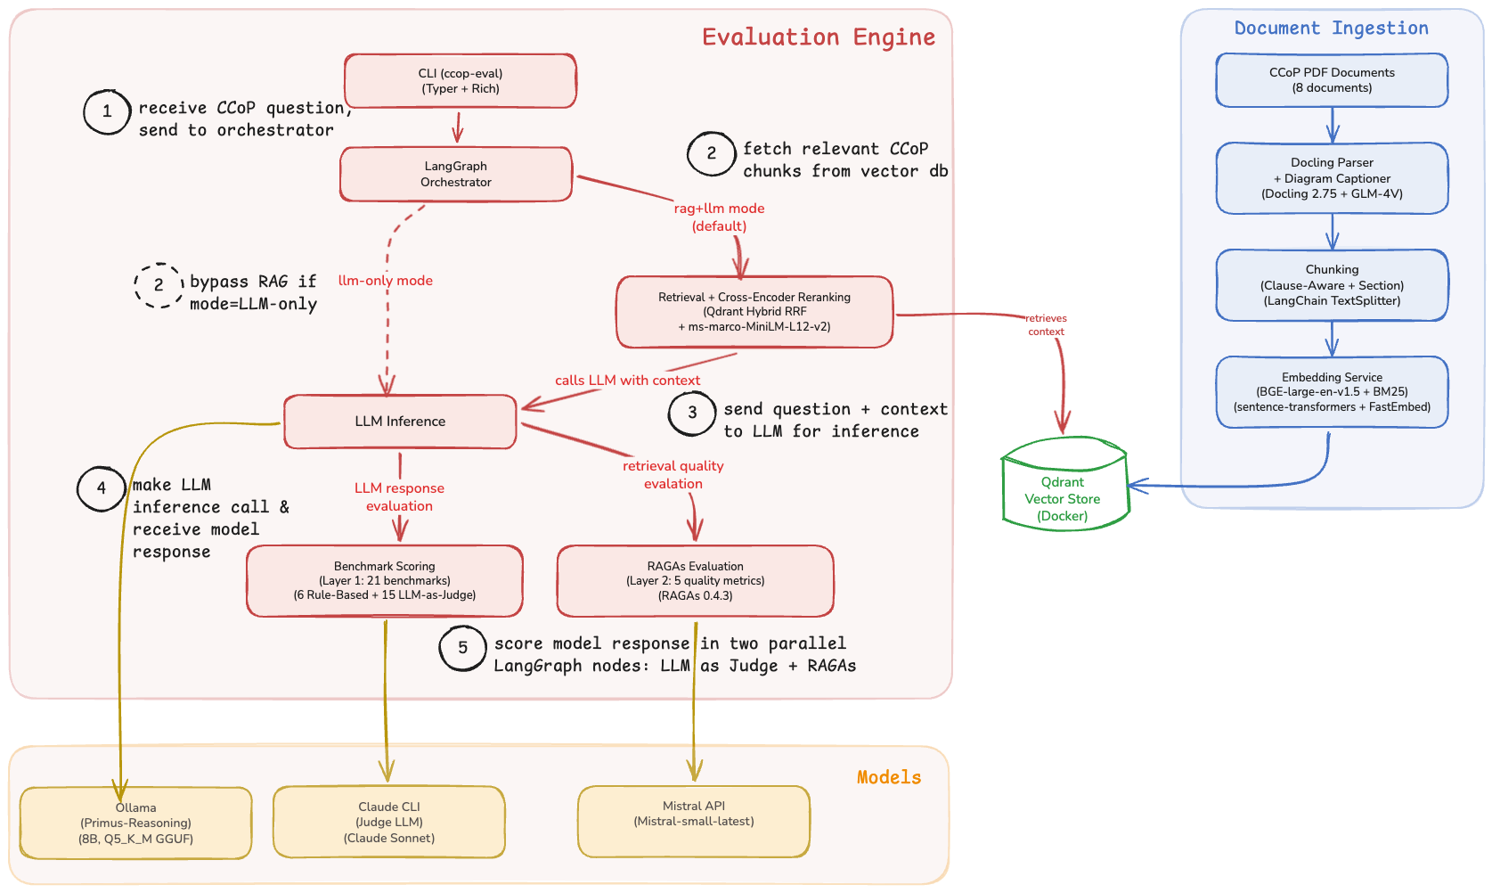
Figure 2: Application architecture showing document ingestion (right), evaluation engine (left), and external model endpoints (bottom).

6.1 Document Ingestion
The ingestion pipeline converts raw CCoP PDF documents into searchable vector embeddings:
1. Parsing — Docling 2.75 performs structural PDF parsing, extracting text with document hierarchy (sections, clauses, sub-clauses). GLM-4V provides captioning for 78 diagrams detected across the corpus, ensuring diagram content is searchable.
2. Chunking — A clause-aware splitter segments parsed documents at regulatory clause boundaries (e.g., 5.2.1, 5.2.1.1), producing 324 chunks with deterministic IDs ({source}::{clause}). LangChain’s MarkdownHeaderTextSplitter handles section-level splits for non-clause content.
3. Embedding — Each chunk is dual-encoded: BGE-large-en-v1.5 (via sentence-transformers) generates 1024-dimensional dense embeddings for semantic search, while Qdrant’s built-in BM25 (via FastEmbed) produces sparse embeddings for exact terminology matching.
4. Storage — Both embedding types are stored in Qdrant with RRF-compatible indexing, enabling hybrid search at query time.

6.2 Evaluation Engine
The evaluation engine is invoked through a CLI that accepts a mode parameter controlling the retrieval strategy:
• rag+llm mode (default) — The LangGraph orchestrator routes the query through Retrieval, which performs hybrid search (dense + sparse via RRF) against Qdrant, followed by cross-encoder reranking (ms-marco-MiniLM-L12-v2) to select the top-3 most relevant chunks. These chunks are passed as grounding context to LLM Inference.
• llm-only mode — The orchestrator routes the query directly to LLM Inference, bypassing retrieval entirely. This mode serves as the baseline for measuring RAG’s contribution.
LLM Inference sends the prompt (with or without retrieved context) to Ollama running the Primus-Reasoning model (8B, Q5_K_M GGUF quantisation) for response generation.
After inference, the response flows into two independent evaluation layers:
• Benchmark Scoring (Layer 1) evaluates the response against 21 domain-specific benchmarks — 6 rule-based and 15 LLM-as-Judge. The judge LLM (Claude Sonnet) is invoked via Claude CLI for each LLM-judged benchmark, applying the rubric templates described in Section 4.1.
• RAGAs Evaluation (Layer 2) assesses response and retrieval quality using 5 automated metrics. RAGAs receives the LLM response from inference and, in rag+llm mode, the retrieved contexts from the retrieval step. The evaluator LLM (Mistral Small, mistral-small-latest via Mistral API) scores each metric independently.
Both layers produce results that are aggregated into a JSON report with category-weighted scores.

6.3 External Model Endpoints
The architecture uses three distinct model endpoints, each serving a specific purpose:
Model | Endpoint | Role
Primus-Reasoning (8B, Q5_K_M) | Ollama (local) | Response generation — the model under evaluation
Claude Sonnet | Claude CLI | LLM-as-Judge — evaluates response quality against benchmark rubrics
Mistral Small (mistral-small-latest) | Mistral API | RAGAs evaluator — scores response and retrieval quality metrics

This separation ensures the model being evaluated (Primus-Reasoning) is never used to judge its own outputs. The judge (Claude Sonnet) and the RAGAs evaluator (Mistral Small) are independent third-party models with no overlap in their evaluation responsibilities.

7. Latest Results
The evaluation framework supports three levels of granularity — from single-query debugging to full batch assessment — each serving a distinct purpose in the development workflow. All three modes produce both Layer 1 (benchmark scoring) and Layer 2 (RAGAs metrics) results, and can be run in either rag+llm or llm-only mode.
The full batch evaluation across all 21 benchmarks is currently in progress. Results will be reported in the final submission.

7.1 Query Evaluation
Query evaluation accepts a free-form compliance question and runs it through the pipeline in the specified mode, producing the model’s response along with retrieval metadata. This mode is used during development to qualitatively verify that retrieval grounding is working — comparing how the same question is answered with and without access to authoritative CCoP clause text.
ccop-eval query ask "What are the access control requirements for CII under CCoP 2.0?" --mode hybrid --verbose
ccop-eval query ask "What are the access control requirements for CII under CCoP 2.0?" --mode llm-only --verbose
The following table compares the two responses to the same access control question:
Aspect | RAG-augmented pipeline | llm-only (no retrieval)
Response | “The access control requirements for CII under CCoP 2.0 include implementing mechanisms to safeguard assets from unauthorized access. Key points: (1) Access Management — ensure only authorized parties can access protected systems, information, and applications. (2) Identification, Authentication, Authorization — these steps form the foundation of access control, verifying user identities before granting access. (3) Inventory Updates — the CIIO must update their inventory whenever there is a change to any CII asset. (4) Network Access Control Rules — establish and implement rules for network access, reviewing periodically based on the CII’s risk profile.” | “Understanding the Question — The user is asking about the access control requirements for CII as per CCoP 2.0... Exploring Relevant Sections of the Framework — Assuming CCoP 2.0 covers best practices... Potential Interpretation Challenges — Without direct access to the official documentation of CCoP 2.0, there’s a possibility that specific details might be misinterpreted... Considering Alternative Solutions — An alternative approach is to consider general principles from other recognized cybersecurity frameworks such as NIST SP 800-53, ISO/IEC 27001...”
Response structure | Structured — 4 numbered requirements with specific CCoP references | Unstructured chain-of-thought — reasoning tokens leaked into output, no clear answer structure
CCoP clause references | Cites Clauses 4.1.2, 5.1, 5.6.1 with correct access control context | None — references NIST SP 800-53 and ISO/IEC 27001 instead of CCoP
Regulatory grounding | Grounded in retrieved clause text: access management, identification/authentication/authorisation, inventory updates, network access control rules | Model explicitly states "Without direct access to the official documentation of CCoP 2.0" — acknowledges it lacks source material
Citations | 2 clause-level citations with traceability | 0
Avg relevance score | 4.71 / 5.0 | N/A

The hybrid response demonstrates that retrieval grounding resolves the core factual deficiency identified in Term 1: the model can now cite specific CCoP clauses rather than fabricating or substituting from other frameworks. The llm-only response confirms the baseline model’s tendency to hallucinate regulatory knowledge — it references unrelated frameworks (NIST, ISO) when it cannot locate CCoP-specific text.

7.2 Single Benchmark Evaluation

7.3 Full Batch Evaluation

8. Known Issues & Blockers
9. Next Steps

