Lab 9 Formal Verification Report
Singapore HDB House Price Monotonicity
Team: Charles Foo, Sagar Pratap Singh | Course: Trustworthy AI | Date: 2026-07-18

Property Statement
For the purposes of this lab, we chose the property Monotonicity (Type C). Monotonicity is a good choice because it matches a real domain assumption in Singapore’s HDB house pricing models where there is an expected correlation between an input feature (floor area) and price movement, specifically, larger floor area should not lower predicted price.
Monotonicity fits this problem statement because it uses one clear feature change in one direction, so the property is easy to state and encode formally. It also yields a clean UNSAT / SAT / UNKNOWN result that is straightforward to interpret.

- Dataset
We used the Singapore HDB resale flats dataset from data.gov.sg, which contains 235,808 transactions. It includes realistic housing features like floor area, lease commence date, remaining lease, storey range and transaction month. These were chosen because they are easy to encode, verifier-friendly, and sufficient for a small ReLU house-price model.
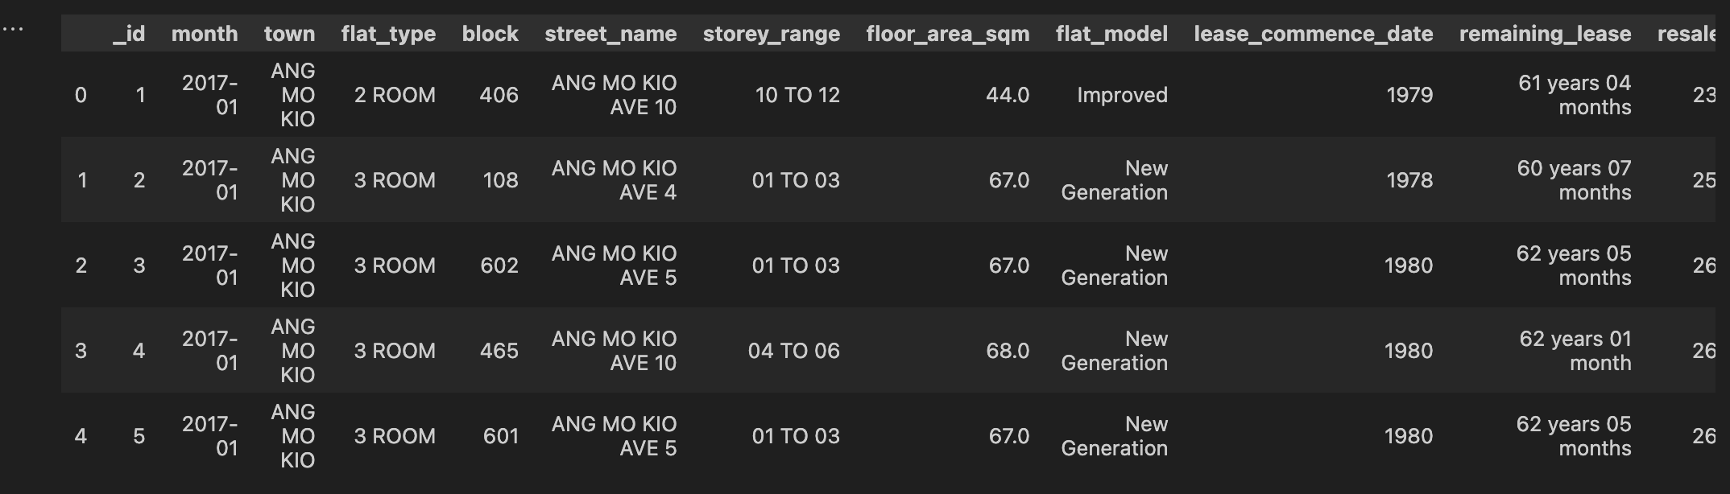
We explored the data by plotting the resale price distribution, the floor area–price relationship, and a correlation heatmap, then checked town and flat-type frequency distributions to see how the dataset is spread across Singapore.
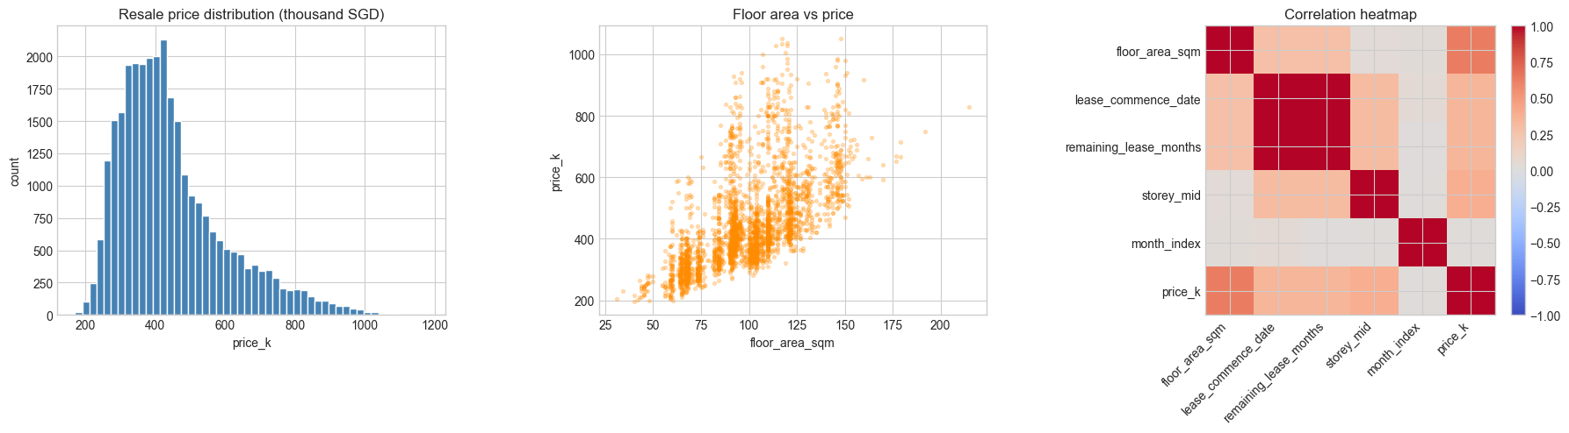
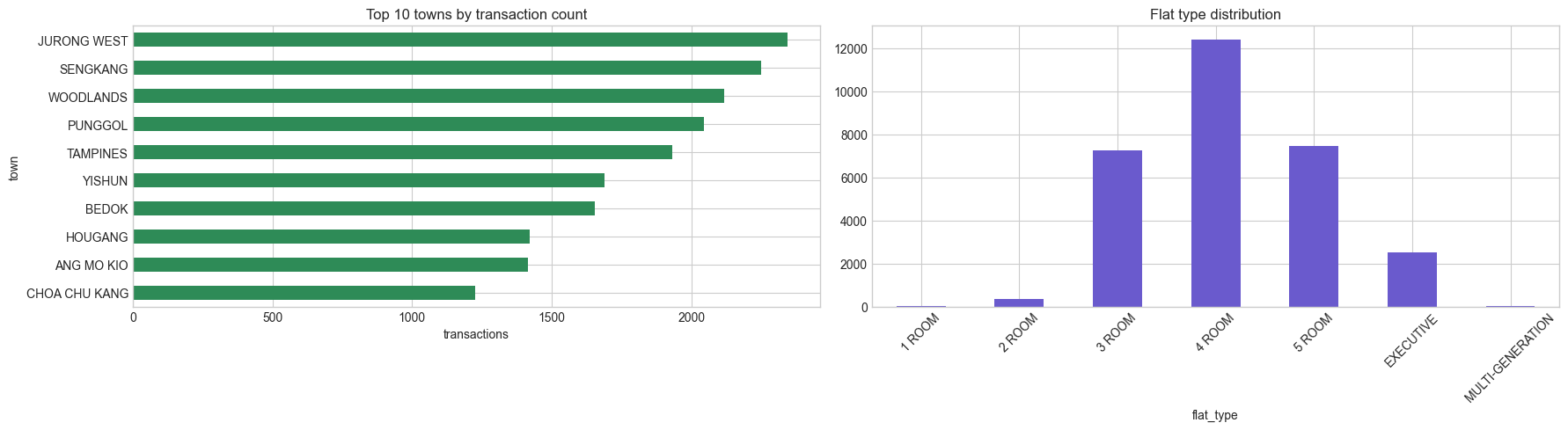
- Model, Tools and Training
We split the data into train and test sets before scaling the features and training the model. We trained a small ReLU MLP on the Singapore HDB resale dataset. The model architecture is 5 input features -> 32 ReLU -> 32 ReLU -> 1 output.
Because this is a regression model, there is no classification-style accuracy. Instead, we use RMSE, MAE, and R² to measure how close the predicted prices are to the true resale prices and how much of the variance the model explains.
Training results and accuracy plots
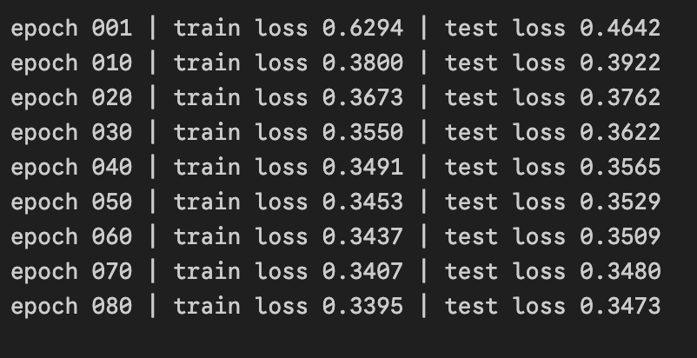 | 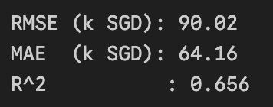

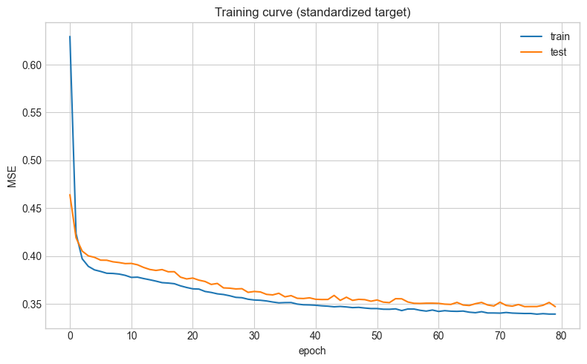 | 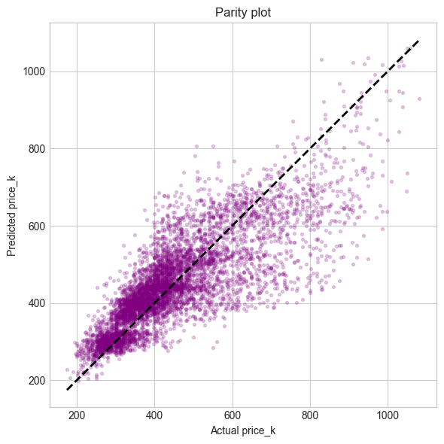
The plots above show the training and test loss dropping over epochs, which tells us the model is learning and lets us spot overfitting. We also compared predicted vs actual prices, points closer to the diagonal mean better predictions.
The model was subsequently exported to ONNX format for formal verification.

- Formal Verification
We verified a local monotonicity property: increasing floor area by a small amount should not decrease the predicted HDB resale price, while all other features stay fixed. The bounded region is defined as-
- all features except floor area were fixed for the selected house
- floor area was allowed to vary by 0 to 0.1 sqm
Mathematically:
For each selected house h, and for all δ in [0, 0.1] sqm, f(h with floor_area_sqm + δ) - f(h) >= 0. We verified the negation y0 <= -0.0001 with Marabou; UNSAT certifies the property on that bounded region.
We encoded the monotonicity check on the exported ONNX model, fixed the other house features, and searched for a counterexample to the property using Marabou 2.0.0 (built locally from source, CPU-only). The verifier was run with a 1800-second timeout, but the representative queries below completed in under 0.1 seconds each.

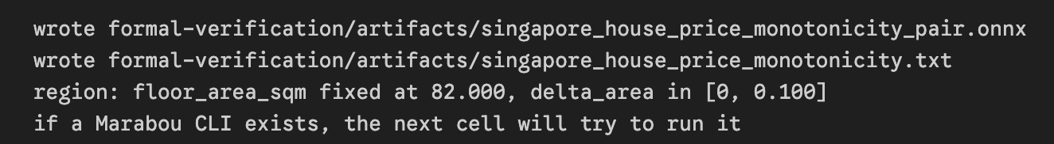
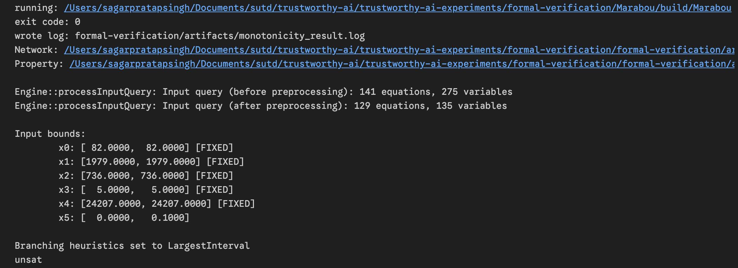

- Result
Town | Flat type | Floor area (sqm) | Query result | Verification  time (s)
ANG MO KIO | 3 ROOM | 68.0 | UNSAT | 0.083
PUNGGOL | 5 ROOM | 111.0 | UNSAT | 0.042
TAMPINES | 3 ROOM | 74.0 | UNSAT | 0.045
WOODLANDS | 4 ROOM | 98.0 | UNSAT | 0.045
All four representative houses returned UNSAT for the negated monotonicity query: ANG MO KIO 3 ROOM, PUNGGOL 5 ROOM, TAMPINES 3 ROOM, and WOODLANDS 4 ROOM.
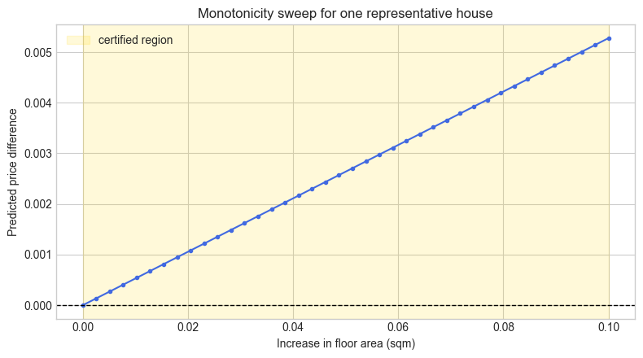
The above chart shows how the predicted price changes as floor area increases from 0 to 0.1 sqm for one fixed HDB house. The yellow band is the certified region, and the blue curve staying at or above zero means the model is monotone there.

- Interpretation
These UNSAT results for the selected houses means Marabau could not find a counterexample within the bounded region for each of the selected houses. In other words, within a 0.1 sqm increase in floor area and with all other features fixed, the model does not reduce its predicted price for these four representative HDB transactions.This is stronger than an empirical spot-check because Marabau exhaustively covers and reasons over the bounded region, not just sampled inputs.
We should also caveat that this formal verification guarantee is pointwise and not global, since it is based on selected house sales from the dataset, not all 23k transactions. The result is still useful because it shows that the model obeys the intended monotonic relationship on multiple Singapore housing examples across different towns and flat types.

- Reflections/Limitations
We did not attempt global certification over the entire dataset because exhaustive verification and coverage would be too expensive. The model was intentionally kept small and ReLU-based to make formal verification feasible. The checked property is also narrow, covering only a tiny positive change in floor area while keeping other features fixed. For the purposes of this lab this demonstrates the local safety guarantee but will require more rigorous and sophisticated verification methods to hold in the actual Singapore HDB market.
We did not attempt global certification over the whole dataset because exhaustive verification would be too expensive. The model was intentionally kept small and ReLU-based to make formal verification feasible. The checked property is also narrow: it covers only tiny positive changes in floor area, with all other features fixed, so it should be read as a local safety-style guarantee rather than a broad market law.

