Using ecological niche modelling for population mapping, and census sizes estimations of a rare plant
Abstract
Aim) Species distribution models (SDMs) are rarely field-verified at landscape scales, and it remains unclear whether their predictions — especially at fine spatial resolutions — can reliably guide the detection of new populations and sub-populations of rare plants, or support estimates of population census size. We tested whether SDMs built at different resolutions, combined with distance-based sampling and density modelling, can achieve both. Location) South-central Rocky Mountains, Colorado, U.S.A. Methods) We compiled occurrence records for Eriogonum coloradense, a rare narrow endemic, from iNaturalist and regional herbaria, and built random forest SDMs at three spatial resolutions (3, 1, and 1/3 arc-second). Before evaluating any model, we first ground-truthed the raw occurrence dataset itself — revisiting existing, previously reported localities to confirm what was actually present — rather than relying on model predictions to guide us to already-known populations. We then tested model predictions using a spatially balanced, adaptive occupancy-based sampling design, classifying newly discovered sites as extensions of known populations, new sub-populations, or new populations based on their Euclidean and least-cost distance from existing occurrences. Plant density was modelled using five machine-learning approaches (XGBoost, light gradient boosting) under spatial and non-spatial cross-validation, and combined with modelled population boundaries to estimate census size. Results) Main Conclusions)

1 | Introduction
https://onlinelibrary.wiley.com/doi/10.1111/ele.12189 https://onlinelibrary.wiley.com/doi/full/10.1111/ddi.13795 # maybe https://www.cell.com/trends/ecology-evolution/fulltext/S0169-5347(18)30304-5 https://www.nature.com/articles/s41559-026-03125-y # maybe
The effects of anthropogenic stressors have led to a global extinction crisis, with estimates suggesting that 20-45% of plant species are facing extinction (Bachman et al. 2024; Brummitt et al. 2015; Pimm and Joppa 2015; Lughadha et al. 2020). Determining which plant species to focus our conservation efforts (e.g., active restoration, preserve creation, ex situ collections) on requires an array of natural history data seldom available to decision-makers (Heywood 2017). The environmental niche of a species, its occupied geographic extent, the occupancy of sites within the range, and the census size of populations are all essential attributes for evaluating the species against anthropogenic stressors (Commission 2001; Faber-Langendoen et al. 2012; USFWS 2016). Although these attributes are relatively simple to characterise on paper, implementation is time-consuming, requiring extensive fieldwork - therefore requiring proxies for use in conservation assessments (Juffe-Bignoli et al. 2016; Bland et al. 2015; Pelletier et al. 2018). Environmental niche models (ENMs or Species Distribution Models, SDMs) have made enormous contributions to two of these attributes, describing the realised environmental niche of a species, and the species’ geographic extent within it (Syfert et al. 2014; R. P. Anderson 2023; Kass et al. 2021). Further, this progress - paired with a growing volume of occurrence data from citizen science platforms and the digitisation of natural history museum records - offers promise for modelling the remaining two attributes, occupancy and census size (Markham et al. 2023; Feldman et al. 2021).
However, despite this progress, the utility of models is seldom field verified, especially at landscape scales (Chiffard et al. 2020; A. Lee-Yaw et al. 2022). ENMs generally suffer from having few, often spatially biased, occurrence records as dependent variables, which often fail to characterise the ecological breadth of the species (Stolar and Nielsen 2015; Feeley and Silman 2011; Pili et al. 2025). Accordingly, while many ENMs achieve high performance on hold-out test subsets, biases in the training data may be carried into predictions (A. Lee-Yaw et al. 2022). To generate more presence and absence records for training, adaptive-niche-based sampling (ANBS) is increasingly used. … preferentially visiting cells with high predicted occurrence probability or high prediction uncertainty (Guisan et al. 2006); because such cells are, almost by definition, close to already-known occurrences, this tests a model’s easiest predictions rather than confirming whether the occurrence records it was trained on remain accurate on the ground. Refitting a model with this newly acquired data not only expands the presence/absence pool, but also verifies coordinate placement, confirms that historic points are still extant, reduces model uncertainty, and yields additional data such as census estimates and life stage demographics (Stockwell and Peterson 2002; Wisz et al. 2008; Jansen et al. 2022; Mondain-Monval et al. 2024). Ground-truthing results are, in any case, seldom shared or reported for plant species, and even less effort has apparently been made to first verify the baseline reliability of existing records for rare species specifically (Johnson et al. 2023; Borokini et al. 2023; Zimmer et al. 2023).
The spatial grain of environmental variables has often been too coarse to model the micro-environments that govern many rare plants’ distributions, especially in heterogeneous environments (Guisan et al. 2013). Accordingly, most early ENM work targeted resolutions useful for conservation policy decisions, while resolutions fine enough for natural resource professionals’ individual management decisions remain nascent. Recent advances in remote sensing, statistics, and software have narrowed this resolution mismatch (Zellweger et al. 2019). Recent papers have had mixed results regarding the effects of imprecisely mapped occurrence data on ENM predictions, with indications that models generated in more heterogeneous environments, and at finer resolutions (e.g. ca. 3 arc-second to 10 arc-minutes (~14.5km at 38$​^{∘}$)) suffer minor decreases in model performance (Graham et al. 2008; Smith et al. 2023) with real species, while increasing error in mapping has drastic effects on model predictions with virtually simulated species (Gábor et al. 2022).
An ENM predicts a single variable: the probability of suitable habitat for the taxon (taddeo2026diversitydistributions). However, in most conservation applications, the insight desired from an ENM is the species’ realised distribution (cite). Significant progress has been made integrating SDM predictions with models of dispersal, recognising that the bridge between an ENM and a plant population’s presence is propagule dispersal and establishment, not the distribution of the fundamental niche alone (Guisan and Thuiller 2005; Franklin 2010; Engler and Guisan 2009). Previous innovations have largely focused on connecting currently suitable habitat to habitat predicted to be suitable under climate change (Engler and Guisan 2009; Bocedi et al. 2014), rather than on detecting populations that already exist but remain undiscovered. To assist practitioners in detecting new populations or extending the range of known populations, we propose modelling plant occupancy as a random variable that depends on distance from known occupied sites. ‘Distance’ may be defined as Euclidean (or Haversine), or as a least-cost distance reflecting a generalised surface which conveys the difficulty for seeds to travel between the nearest occupied sites and the site of interest (Etherington 2016). By combining habitat suitability with both Euclidean and least-cost distance, we distinguish candidate sites as extensions of known populations, new sub-populations, or new populations, rather than relying on suitability alone to prioritise field verification.
Obtaining reliable estimates of plant population census sizes requires two pieces of information: 1) measurements of plant density and 2) population extent. Observers often estimate population sizes rather than directly measuring boundaries or density, and these estimates can be unreliable (Reisch et al. 2018). Several field methods for acquiring density measurements have been developed (Rominger and Meyer 2019; Krening et al. 2021; Ermakova et al. 2021; Alfaro-Saiz et al. 2019; Schorr 2013) to estimate population census size (N), as well as genomic methods to estimate effective population sizes (N_{e}) (e.g. linkage disequilibrium) (Waples 2024). However, these methods are focused on descriptive rather than predictive processes, estimating uncertainty in measurements within a population rather than across the species’ range. We propose generating density estimates with spatial statistical models that predict both estimates and uncertainty across gridded surfaces (Oliver et al. 2012; Doser et al. 2024; A. Lee-Yaw et al. 2022). The second requirement, mapping a population’s boundaries, is similarly time-consuming but no less essential for a realistic census size estimate. Population boundaries are currently delineated implicitly: practitioners walk outward until gene flow between individuals should be minimal (e.g., 1km), searching for additional individuals, or rely on aerial imagery (Elzinga et al. 1998). Many rare plant species are small and inconspicuous, and many taxa grow in small, clustered groups in specific habitats, making detection via either method difficult (G. Chen et al. 2013; Condit et al. 2000).
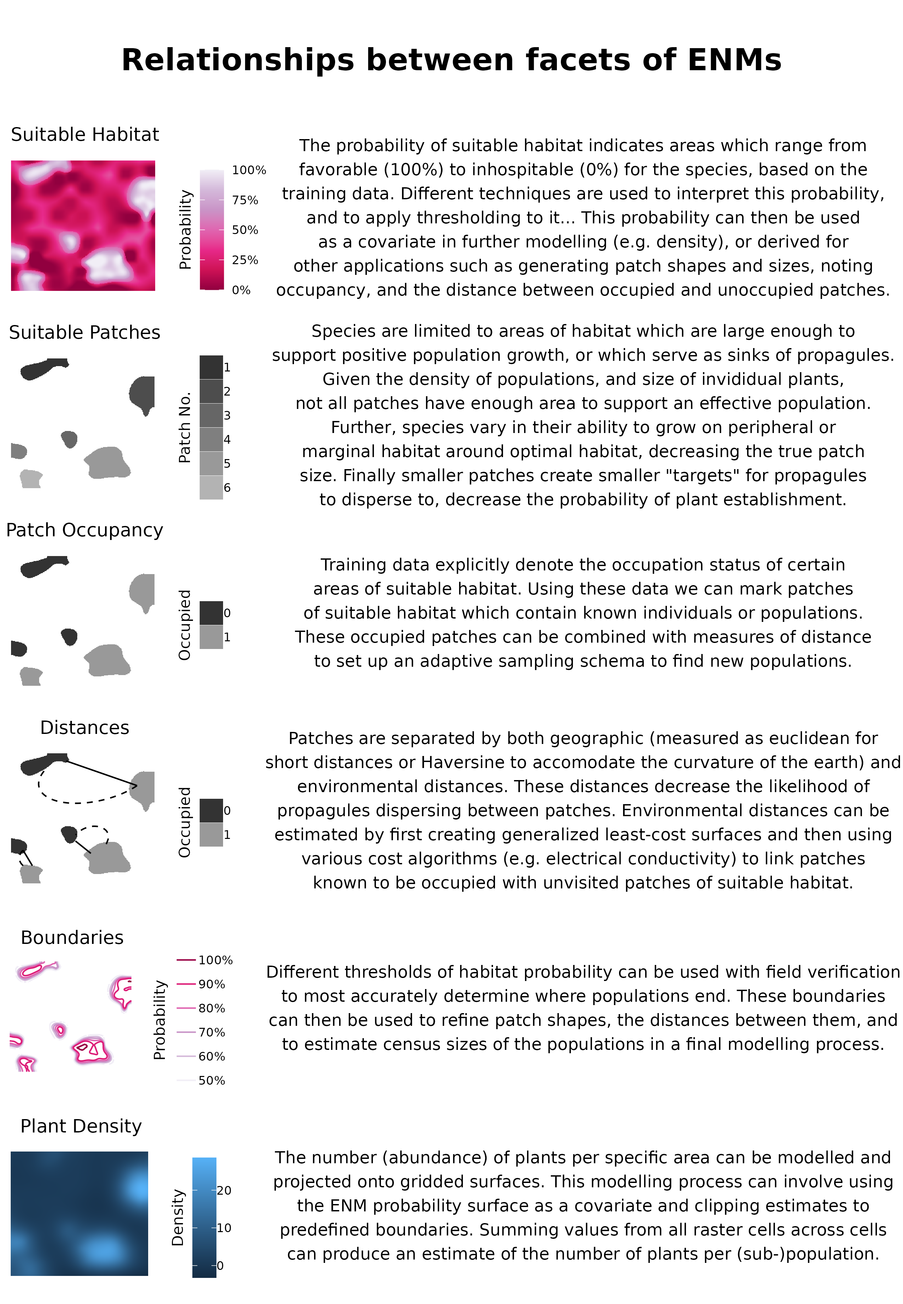
figgy stardust
Here we: 1) evaluate the results of the best-performing model with groundtruthing (within 450m of existing occurrences). 2) Compare the results of models from different resolutions to the best model, as based on hold-out test data. 3) Determine whether model predictions are useful to find new sub-populations (450m - 1km from existing occurrences), or populations (> 1km from existing occurrences). 4) Estimate population census size using 4a) estimates of plant density, and 4b) modelling of population boundaries.

2 | Methods

2.1 | Study Species & System
Eriogonum coloradense Small (Polygonaceae) is a synoecious, mat-forming perennial herb endemic to the south-central Rocky Mountains of Colorado, U.S.A. Its known range spans five counties and encompasses 22 documented populations, occurring across a broad range of elevation (2700-3900 asl), slope, aspects, soil types, and habitats - from high-elevation sagebrush steppe, subalpine grasslands, and alpine slopes. It is ranked S3/G3 by NatureServe and listed as a Tier 2 species in Colorado Parks and Wildlife’s State Wildlife Action Plan (D. G. Anderson 2004).

2.2 | Data Acquisition
Occurrence records were downloaded from iNaturalist (80 records) and the Consortium of Southern Rockies herbaria (131 records) (iNaturalist 2024; Southern Rocky Mountain Herbaria Portal, n.d.). These data were manually reviewed and 16 herbarium records removed due to low geolocation quality or a georeferenced locality inconsistent with the specimen label.
Digital elevation models (DEMs) at 3 arc (type) and 1 arc (type) resolution, and digital elevation products (DEPs) at 1/3 arc resolution, were acquired from the United States Geological Survey and clipped to the analytical domain — a rectangle buffered 16 km (10 mi) beyond any known population [CITE]. These elevation products were used to derive most geomorphology datasets with whiteboxTools (Wu and Brown 2022), plus heat load and diurnal anisotropic heat indices calculated with spatialEco (Evans and Murphy 2025). Vegetation cover data were generated by combining raster layers into three continuous cover classes: Forested, Shrub, and Herbaceous (Tuanmu and Jetz 2014).
ClimateNA was used to create a dataset at 3 arc-second resolution, which was then bilinearly interpolated to generate products at the 1 and 1/3 arc resolutions (Wang et al. 2016). Gray-Level Co-occurrence Matrices (GLCM) were produced with the glcm R package from 2023 NAIP aerial imagery, bilinearly resampled to the original resolution, using default settings with a window size of 5 in both directions (Zvoleff 2020).
Collectively these resulted in 50 indepedent variables for ENM modelling.

2.3 | Ground Verification (H1)
The first round of ground verification was carried out from June to September 2024. All pre-existing occurrence points were considered candidates for revisits, and 25 trails leading to them were marked as sample areas. Each trail was manually mapped and buffered by 45m in each direction; 551 random points were drawn, thinned to distances > 90m, leaving 309 random plots for assessment. 13 trails were visited, allowing for the assessment of 171 random points, of which 20 had new occurrence records. When conducting fieldwork presences of E. coloradense were opportunistically noted to better describe the spread of the population, quadrats were quasi-randomly placed - accounting for local abundance - ca. 30-50m from the previous plot until traversing out of the population (n = 246). Subjectively placed absences were also collected in areas that seemed favourable or were in proximity to E. coloradense individuals; this occurred both in the field (n = 129). Absences in areas known to be outside the range of the populations were also added later via aerial imagery (n = 66). At each occurrence site, individuals were counted by three maturity stages (mature, juvenile, and seedling) in 3x3m quadrats.

2.4 | Comparison of Different Spatial Resolutions (H2)
Environmental niche models were generated at three spatial resolutions: 3 arc-second (~72m), 1 arc-second (~24m), and 1/3 arc-second (~8m). The modelling details followed the same process across spatial resolutions.
Records were thinned to the distance of a hypotenuse of a cell to avoid pseudo-replicates (Aiello-Lammens et al. 2015). 1.1 times as many background absence records as presence records were generated using the environmental distance from the sdm package (Naimi and Araujo 2016). These records were then manually reviewed, and six records in areas with possible presences were removed. After this, the records were randomly sampled to reduce the dataset to XX records. After the first modelling iteration, all additional presences and absences were thinned similarly and combined with the original absence records. ‘Presences’ with greater coordinate uncertainty than the modelling resolution were removed.
Prior to fitting, uninformative predictor variables were removed for each model using Boruta feature selection, retaining both confirmed and tentative important variables (Kursa and Rudnicki 2010). All random forest models were fit using the ranger package; 95% confidence intervals were generated using the infinitesimal jackknife (Wager et al. 2014; Wright and Ziegler 2017).

2.5 | Occupancy Based Field Sampling (H3)
360 candidate ground-truthing sites and 180 oversamples were selected using a spatially-balanced Generalized Random Tessellation Stratified (GRTS) design (Dumelle et al. 2023), stratified by named site regions and allocated proportional to each region’s candidate-pixel count. Within each region, pixels were prioritised using a weighted combination of: 1) predicted suitability, favoring the ~50% probability band; 2) Euclidean distance from known occurrences, favouring the underrepresented far tail; and 3) a cost-distance anomaly. The cost-distance anomaly utilises within-region residuals of least-cost distance (Etten 2017) regressed on Euclidean distance, which flags cells where terrain-based travel difficulty diverges most from straight-line expectations.

2.6 | Plant Density (H4a)
Plant density was modelled using five approaches, with a focus on comparing spatial and non-spatial cross-validation. Because one population (Cochetopa Dome) consistently has far higher plant counts than the other (Comanche Basin), a naive train-test split risked confounding genuine model generalisation with a simple between-population split; training and test sets were instead partitioned using data twinning on rescaled coordinates and count values, which selects a test set whose joint distribution mirrors the training set’s (Vakayil and Joseph 2026). Five density models were fit: four using XGBoost across two distributions (Poisson, Tweedie), and one using light gradient boosting (T. Chen and Guestrin 2016; Ke et al. 2017). For each of the XGBoost model-distribution combinations, both traditional and spatial cross-validation were compared (Milà et al. 2022). Two null models served as baselines for comparison: the arithmetic mean plant count by population, and ordinary kriging interpolation across the study area (E. J. Pebesma 2004).

2.7 | Population Boundaries (H4b)
Population boundaries were delineated by thresholding the continuous habitat suitability surface from the best-performing model using two different threshold-selection rules 1) sensitivity, and 2) equal sensitivity and specificity. — the threshold maximising the sum of sensitivity and specificity (‘spec_sens’), and the threshold at which sensitivity alone is maximised (‘sensitivity’) — producing two independent candidate delineations of suitable habitat, and polygonized each into discrete patches within ground-truthable areas, retaining only patches ≥ 2 pixels of the source raster’s resolution (Hijmans et al. 2024). Because the sensitivity-rule polygons were nested entirely within the spec_sens-rule polygons rather than crossing them, we used the smaller (sensitivity-rule) polygon’s outer edge as the baseline for transect placement, treating the band between the two polygons as the zone where the two threshold rules disagree - and therefore the ground most worth testing to determine which rule better predicts the population’s actual extent. For each patch, we identified the smaller polygon’s outer edge using native raster boundary detection (4-connected neighbours), generating candidate transects along the four cardinal directions from each edge cell. Transects began 50m inside this edge, extended outward across the disagreement band until clearing the larger (spec_sens-rule) polygon’s boundary by a further 15m, and were capped at 150m total length, so that each transect crosses both threshold boundaries and directly tests which rule better matches the field-observed edge of the population. Patches containing a known occurrence within 100m received a size-proportional transect budget (area^0.5, floor of 3, ceiling of 12 per patch); patches without a nearby known occurrence were flagged as exploratory and given only a fixed floor of transects, kept as a separate sampling stage. A per-site cap of 15 transects (trimming exploratory transects first) and a no-crossing constraint were applied before finalising the field sheet, which records each transect’s start coordinates, true and magnetic compass bearing, and a series of stations at 10m intervals along its length.

2.8 | Final Results
Using occurrence, density, and boundary-transect data from both rounds of ground-truthing combined with the original records, we refit final models of habitat suitability, occupancy, and census size, evaluating each solely against a held-out subset of the ground-truthed data not used in any prior training or tuning step.
Data processing was largely performed in R (R Core Team 2026), using sf (E. Pebesma 2018) and terra (Hijmans et al. 2026) for spatial data, and modelling via the tidymodels framework (Kuhn and Wickham 2020).

3 | Results

3.1 | Ground Verification (H1)
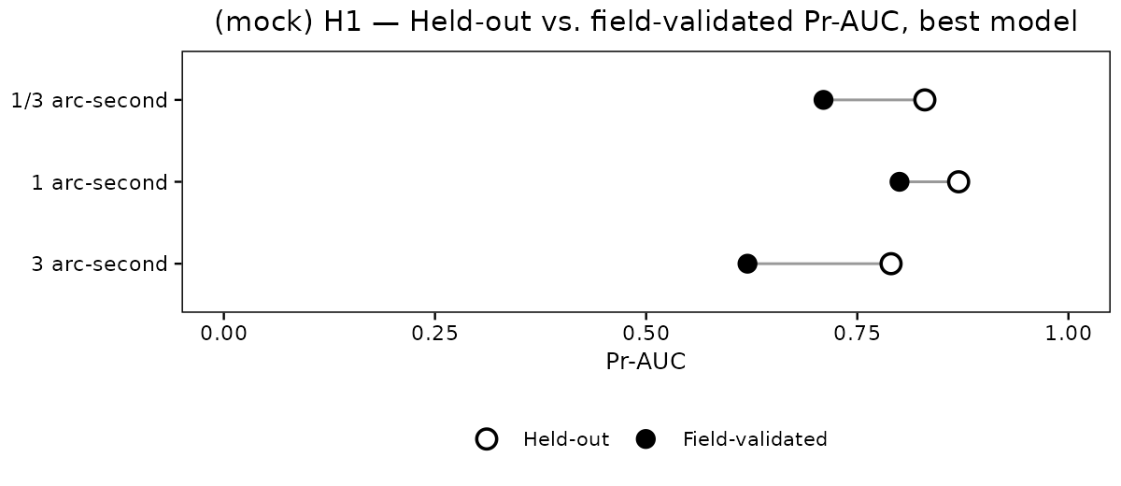

3.2 | Comparison of Different Spatial Resolutions (H2)
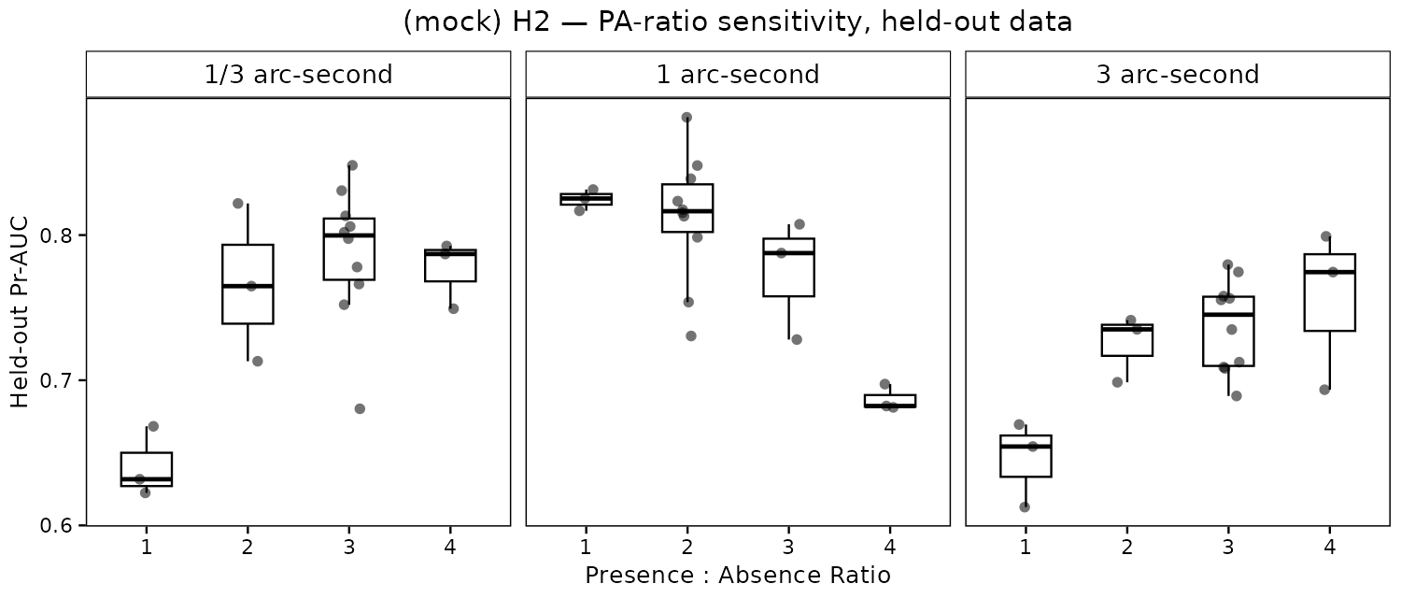
The area under the precision-recall curve (AUC-PR), the True Skill Statistic, and Sensitivity and Specificity (Sofaer et al. 2019; Allouche et al. 2006).

3.3 | Occupancy Based Field Sampling (H3)

3.4 | Plant Density (H4a)
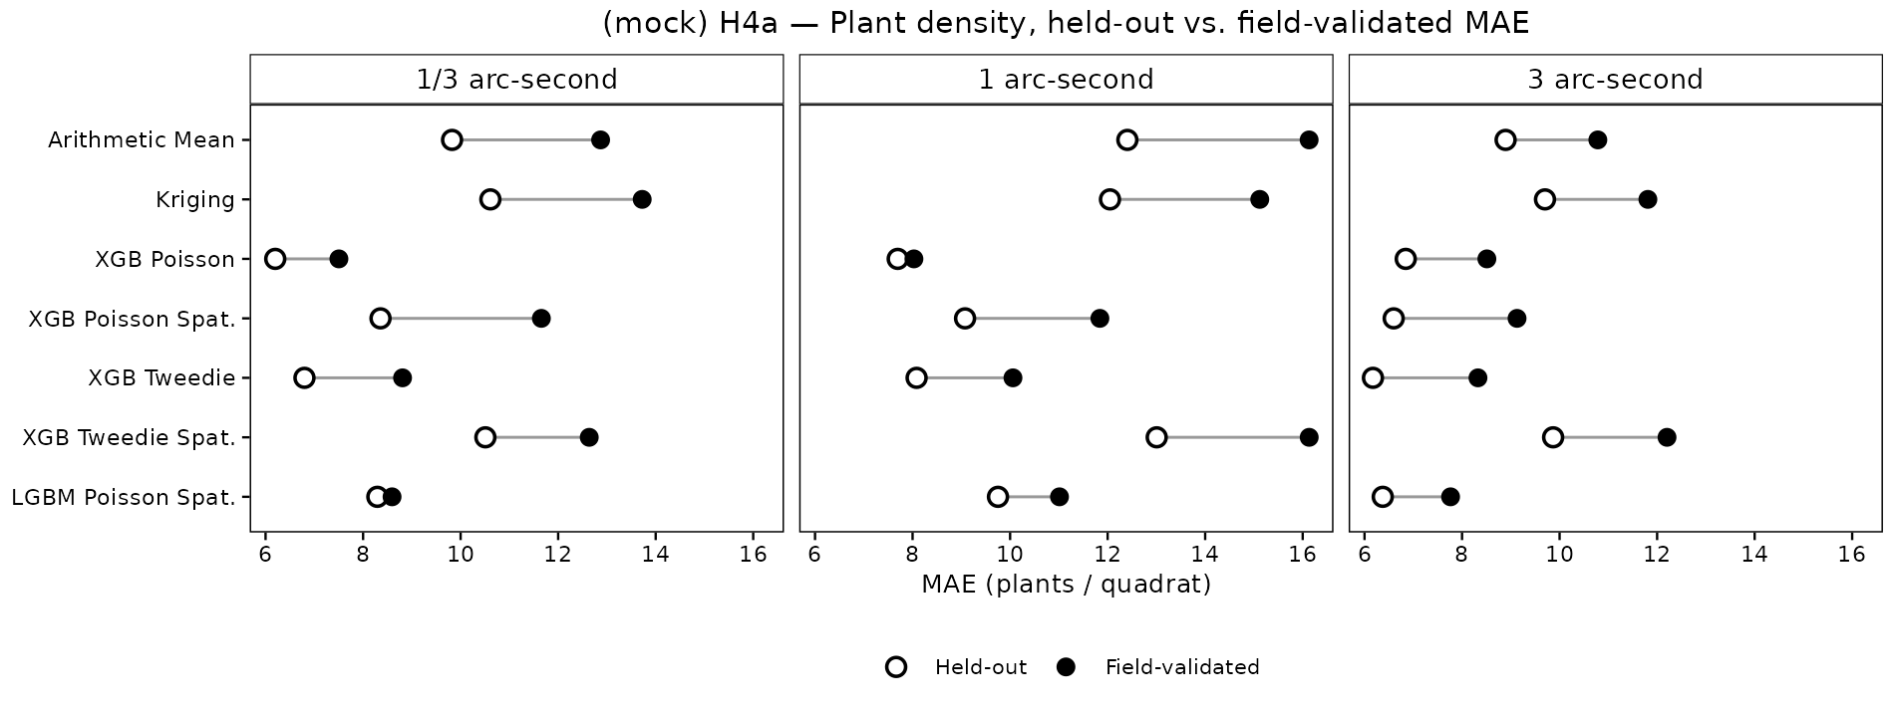

3.5 | Population Boundaries (H4b)

3.6 | Final Results
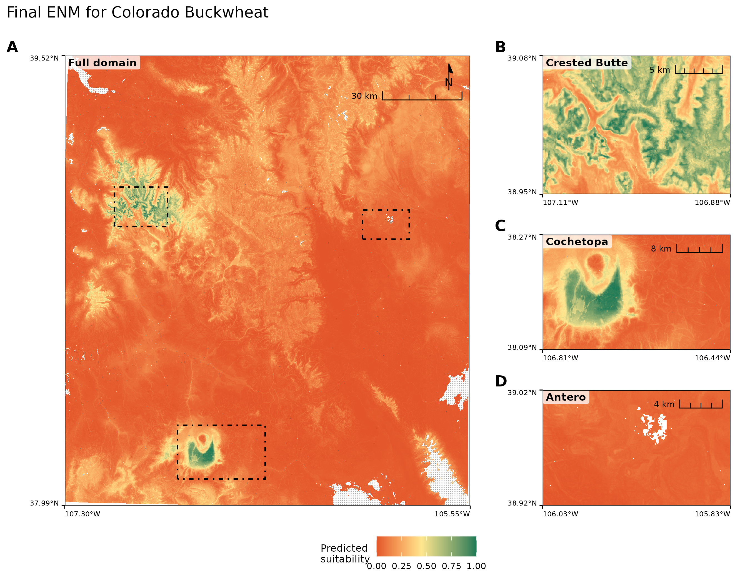
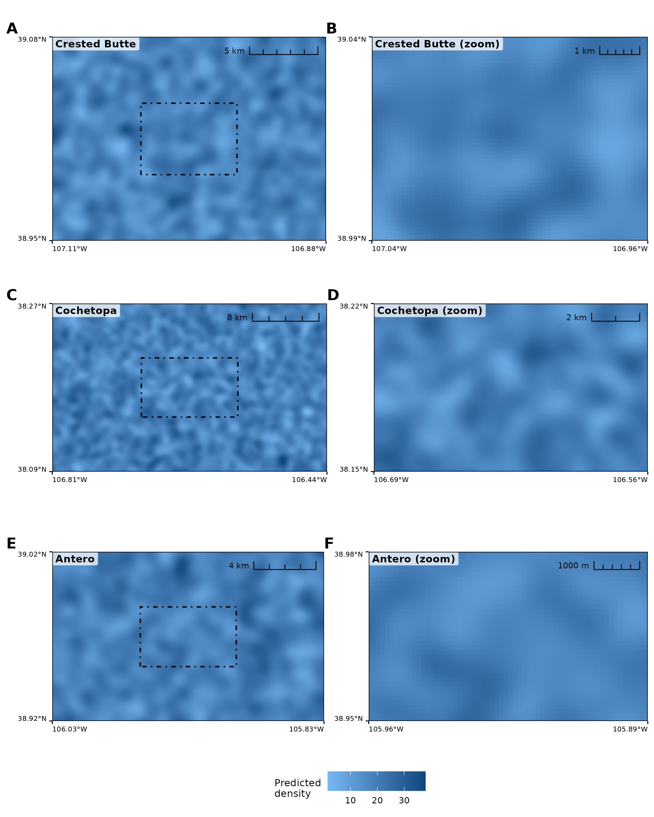

4 | Discussion

5 | Conclusions

6 | Author Contributions
R.C.B.: Conceptualization, Data curation, Formal analysis, Investigation, Methodology, Software, Visualization, Writing. S.T. and J.B.F.: Writing. All authors read, revised and approved the manuscript.

Acknowledgments
The following individuals are thanked for uploading multiple iNaturalist observations that were used in modelling: Rick Williams, Rosemary Smith, John Powers.

Funding
The authors have nothing to report.

Conflicts of Interest
The authors declare no conflicts of interest.

Data Availability Statement
Occurrence data supporting the findings of this study are archived on Zenodo [DOI]. All analysis code is available on GitHub at [REPO URL].

References
A. Lee-Yaw, Julie, Jenny L. McCune, Samuel Pironon, and Seema N. Sheth. 2022. “Species Distribution Models Rarely Predict the Biology of Real Populations.” Ecography 2022 (6): e05877.
Aiello-Lammens, Matthew E., Robert A. Boria, Aleksandar Radosavljevic, and Bruno Vilela. 2015. “spThin: An R Package for Spatial Thinning of Species Occurrence Records for Use in Ecological Niche Models.” Ecography 38 (5): 541–45. https://onlinelibrary.wiley.com/doi/10.1111/ecog.01132.
Alfaro-Saiz, Estrella, Vìctor Granda, Alberto Rodrìguez, Raquel Alonso-Redondo, and Marta Eva Garcìa-González. 2019. “Optimal Census Method to Estimate Population Sizes of Species Growing on Rock Walls: The Case of Mature Primula Pedemontana.” Global Ecology and Conservation 17: e00563.
Allouche, Omri, Asaf Tsoar, and Ronen Kadmon. 2006. “Assessing the Accuracy of Species Distribution Models: Prevalence, Kappa and the True Skill Statistic (TSS).” Journal of Applied Ecology 43 (6): 1223–32.
Anderson, D. G. 2004. Eriogonum Coloradense Small (Colorado Buckwheat): A Technical Conservation Assessment. Technical Conservation Assessment. USDA Forest Service, Rocky Mountain Region. http://fs.fed.us.
Anderson, Robert P. 2023. “Integrating Habitat-Masked Range Maps with Quantifications of Prevalence to Estimate Area of Occupancy in IUCN Assessments.” Conservation Biology 37 (1): e14019.
Bachman, Steven P., Matilda J. M. Brown, Tarciso C. C. Leão, Eimear Nic Lughadha, and Barnaby E. Walker. 2024. “Extinction Risk Predictions for the World’s Flowering Plants to Support Their Conservation.” New Phytologist 242 (2): 797–808. https://doi.org/https://doi.org/10.1111/nph.19592.
Bland, Lucie M., C. David L. Orme, Jon Bielby, Ben Collen, Emily Nicholson, and Michael A. McCarthy. 2015. “Cost-Effective Assessment of Extinction Risk with Limited Information.” Journal of Applied Ecology 52 (4): 861–70.
Bocedi, Greta, Stephen CF Palmer, Guy Pe’er, et al. 2014. “Range s Hifter: A Platform for Modelling Spatial Eco-Evolutionary Dynamics and Species’ Responses to Environmental Changes.” Methods in Ecology and Evolution 5 (4): 388–96.
Borokini, Israel T., Kenneth Nussear, Blaise Petitpierre, Thomas E. Dilts, and Peter J. Weisberg. 2023. “Iterative Species Distribution Modeling Results in the Discovery of Novel Populations of a Rare Cold Desert Perennial.” Endangered Species Research 50: 47–62.
Brummitt, Neil A., Steven P. Bachman, Janine Griffiths-Lee, et al. 2015. “Green Plants in the Red: A Baseline Global Assessment for the IUCN Sampled Red List Index for Plants.” PloS One 10 (8): e0135152.
Chen, Guoke, Marc Kéry, Matthias Plattner, Keping Ma, and Beth Gardner. 2013. “Imperfect Detection Is the Rule Rather Than the Exception in Plant Distribution Studies.” Journal of Ecology 101 (1): 183–91.
Chen, Tianqi, and Carlos Guestrin. 2016. “Xgboost: A Scalable Tree Boosting System.” Proceedings of the 22nd Acm Sigkdd International Conference on Knowledge Discovery and Data Mining, 785–94.
Chiffard, Jules, Coline Marciau, Nigel Gilles Yoccoz, et al. 2020. “Adaptive Niche-Based Sampling to Improve Ability to Find Rare and Elusive Species: Simulations and Field Tests.” Methods in Ecology and Evolution 11 (8): 899–909. https://doi.org/https://doi.org/10.1111/2041-210X.13399.
Commission, Natural Resources. Species Survival. 2001. IUCN Red List Categories and Criteria. IUCN.
Condit, Richard, Peter S. Ashton, Patrick Baker, et al. 2000. “Spatial Patterns in the Distribution of Tropical Tree Species.” Science 288 (5470): 1414–18.
Doser, Jeffrey W., Andrew O. Finley, Marc Kéry, and Elise F. Zipkin. 2024. “spAbundance: An r Package for Single-Species and Multi-Species Spatially Explicit Abundance Models.” Methods in Ecology and Evolution 15 (6): 1024–33. https://doi.org/https://doi.org/10.1111/2041-210X.14332.
Dumelle, Michael, Tom Kincaid, Anthony R. Olsen, and Marc Weber. 2023. “spsurvey: Spatial Sampling Design and Analysis in R.” Journal of Statistical Software 105 (3): 1–29. https://doi.org/10.18637/jss.v105.i03.
Elzinga, Caryl L., Daniel W. Salzer, and John W. Willoughby. 1998. Measuring & Monitoring Plant Populations. BLM Technical Reference ; 1730-1. U.S. Dept. of the Interior, Bureau of Land Management.
Engler, Robin, and Antoine Guisan. 2009. “MigClim: Predicting Plant Distribution and Dispersal in a Changing Climate.” Diversity and Distributions 15 (4): 590–601.
Ermakova, Anna, Keeper Trout, Martin K. Terry, Carolyn V. Whiting, Colin Clubbe, and Norma Fowler. 2021. “Densities, Plant Sizes, and Spatial Distributions of Six Wild Populations of Lophophora Williamsii (Cactaceae) in Texas, USA.” Journal of the Botanical Research Institute of Texas 15 (1): 149–60.
Etherington, Thomas R. 2016. “Least-Cost Modelling and Landscape Ecology: Concepts, Applications, and Opportunities.” Current Landscape Ecology Reports 1: 40–53.
Etten, Jacob van. 2017. “R Package Gdistance: Distances and Routes on Geographical Grids.” Journal of Statistical Software 76 (13): 1–21. https://doi.org/10.18637/jss.v076.i13.
Evans, Jeffrey S., and Melanie A. Murphy. 2025. spatialEco. https://github.com/jeffreyevans/spatialEco.
Faber-Langendoen, Don, Jennifer Nichols, Larry Master, et al. 2012. “NatureServe Conservation Status Assessments: Methodology for Assigning Ranks.” NatureServe, Arlington, VA.
Feeley, Kenneth J., and Miles R. Silman. 2011. “Keep Collecting: Accurate Species Distribution Modelling Requires More Collections Than Previously Thought.” Diversity and Distributions 17 (6): 1132–40.
Feldman, Mariano J., Louis Imbeau, Philippe Marchand, Marc J. Mazerolle, Marcel Darveau, and Nicole J. Fenton. 2021. “Trends and Gaps in the Use of Citizen Science Derived Data as Input for Species Distribution Models: A Quantitative Review.” PloS One 16 (3): e0234587.
Franklin, Janet. 2010. “Moving Beyond Static Species Distribution Models in Support of Conservation Biogeography.” Diversity and Distributions 16 (3): 321–30.
Gábor, Lukáš, Walter Jetz, Muyang Lu, et al. 2022. “Positional Errors in Species Distribution Modelling Are Not Overcome by the Coarser Grains of Analysis.” Methods in Ecology and Evolution 13 (10): 2289–302.
Graham, Catherine H., Jane Elith, Robert J. Hijmans, et al. 2008. “The Influence of Spatial Errors in Species Occurrence Data Used in Distribution Models.” Journal of Applied Ecology 45 (1): 239–47.
Guisan, Antoine, Olivier Broennimann, Robin Engler, et al. 2006. “Using Niche-Based Models to Improve the Sampling of Rare Species.” Conservation Biology 20 (2): 501–11.
Guisan, Antoine, and Wilfried Thuiller. 2005. “Predicting Species Distribution: Offering More Than Simple Habitat Models.” Ecology Letters 8 (9): 993–1009.
Guisan, Antoine, Reid Tingley, John B. Baumgartner, et al. 2013. “Predicting Species Distributions for Conservation Decisions.” Ecology Letters 16 (12): 1424–35.
Heywood, Vernon H. 2017. “Plant Conservation in the Anthropocene–Challenges and Future Prospects.” Plant Diversity 39 (6): 314–30.
Hijmans, Robert J., Andrew Brown, and Márcia Barbosa. 2026. Terra: Spatial Data Analysis. https://doi.org/10.32614/CRAN.package.terra.
Hijmans, Robert J., Steven Phillips, John Leathwick, and Jane Elith. 2024. Dismo: Species Distribution Modeling. https://doi.org/10.32614/CRAN.package.dismo.
iNaturalist. 2024. Observations of Eriogonum coloradense from Colorado, USA, Observed Before 16 June 2024. Https://www.inaturalist.org.
Jansen, Jan, Skipton NC Woolley, Piers K. Dunstan, et al. 2022. “Stop Ignoring Map Uncertainty in Biodiversity Science and Conservation Policy.” Nature Ecology & Evolution 6 (7): 828–29.
Johnson, Sara, Brenda Molano-Flores, and David Zaya. 2023. “Field Validation as a Tool for Mitigating Uncertainty in Species Distribution Modeling for Conservation Planning.” Conservation Science and Practice 5 (8): e12978.
Juffe-Bignoli, Diego, Thomas M. Brooks, Stuart HM Butchart, et al. 2016. “Assessing the Cost of Global Biodiversity and Conservation Knowledge.” PLoS One 11 (8): e0160640.
Kass, Jamie M., Sarah I. Meenan, Nicolás Tinoco, Santiago F. Burneo, and Robert P. Anderson. 2021. “Improving Area of Occupancy Estimates for Parapatric Species Using Distribution Models and Support Vector Machines.” Ecological Applications 31 (1): e02228.
Ke, Guolin, Qi Meng, Thomas Finley, et al. 2017. “Lightgbm: A Highly Efficient Gradient Boosting Decision Tree.” Advances in Neural Information Processing Systems 30.
Krening, Phil P., Carol A. Dawson, Kenneth W. Holsinger, and John W. Willoughby. 2021. “A Sampling-Based Approach to Estimating the Minimum Population Size of the Federally Threatened Colorado Hookless Cactus (Sclerocactus Glaucus).” Natural Areas Journal 41 (1): 4–10.
Kuhn, Max, and Hadley Wickham. 2020. Tidymodels: A Collection of Packages for Modeling and Machine Learning Using Tidyverse Principles. https://www.tidymodels.org.
Kursa, Miron B., and Witold R. Rudnicki. 2010. “Feature Selection with the Boruta Package.” Journal of Statistical Software 36 (11): 1–13. https://doi.org/10.18637/jss.v036.i11.
Lughadha, Eimear Nic, Steven P. Bachman, Tarciso CC Leão, et al. 2020. “Extinction Risk and Threats to Plants and Fungi.” Plants, People, Planet 2 (5): 389–408.
Markham, Katherine, Amy E. Frazier, Kunwar K. Singh, and Marguerite Madden. 2023. “A Review of Methods for Scaling Remotely Sensed Data for Spatial Pattern Analysis.” Landscape Ecology 38 (3): 619–35.
Milà, Carles, Jorge Mateu, Edzer Pebesma, and Hanna Meyer. 2022. “Nearest Neighbour Distance Matching Leave-One-Out Cross-Validation for Map Validation.” Methods in Ecology and Evolution 13 (6): 1304–16.
Mondain-Monval, Thomas, Michael Pocock, Simon Rolph, Tom August, Emma Wright, and Susan Jarvis. 2024. “Adaptive Sampling by Citizen Scientists Improves Species Distribution Model Performance: A Simulation Study.” Methods in Ecology and Evolution.
Naimi, Babak, and Miguel B. Araujo. 2016. “sdm: A Reproducible and Extensible R Platform for Species Distribution Modelling.” Ecography 39: 368–75. https://doi.org/10.1111/ecog.01881.
Oliver, Tom H., Simon Gillings, Marco Girardello, et al. 2012. “Population Density but Not Stability Can Be Predicted from Species Distribution Models.” Journal of Applied Ecology 49 (3): 581–90.
Pebesma, Edzer. 2018. “Simple Features for R: Standardized Support for Spatial Vector Data.” The R Journal 10 (1): 439–46. https://doi.org/10.32614/RJ-2018-009.
Pebesma, Edzer J. 2004. “Multivariable Geostatistics in S: The Gstat Package.” Computers & Geosciences 30: 683–91. https://doi.org/10.1016/j.cageo.2004.03.012.
Pelletier, Tara A., Bryan C. Carstens, David C. Tank, Jack Sullivan, and Anahı́ Espı́ndola. 2018. “Predicting Plant Conservation Priorities on a Global Scale.” Proceedings of the National Academy of Sciences 115 (51): 13027–32.
Pili, Arman, Boris Leroy, and Damaris Zurell. 2025. “Correcting Environmental Sampling Bias Improves Transferability of Species Distribution Models.” Ecography 2025 (10): e08002.
Pimm, Stuart L., and Lucas N. Joppa. 2015. “How Many Plant Species Are There, Where Are They, and at What Rate Are They Going Extinct?” Annals of the Missouri Botanical Garden 100 (3): 170–76.
R Core Team. 2026. R: A Language and Environment for Statistical Computing. R Foundation for Statistical Computing. https://doi.org/10.32614/R.manuals.
Reisch, Christoph, Christoph Schmid, and Florian Hartig. 2018. “A Comparison of Methods for Estimating Plant Population Size.” Biodiversity and Conservation (Dordrecht) 27 (8): 2021–28.
Rominger, Kody, and Susan E. Meyer. 2019. “Application of UAV-Based Methodology for Census of an Endangered Plant Species in a Fragile Habitat.” Remote Sensing 11 (6): 719.
Schorr, Robert A. 2013. “Using Distance Sampling to Estimate Density and Abundance of Saussurea Weberi Hultén (Weber’s Saw-Wort).” The Southwestern Naturalist 58 (3): 378–83.
Smith, Adam B., Stephen J. Murphy, David Henderson, and Kelley D. Erickson. 2023. “Including Imprecisely Georeferenced Specimens Improves Accuracy of Species Distribution Models and Estimates of Niche Breadth.” Global Ecology and Biogeography 32 (3): 342–55.
Sofaer, Helen R., Jennifer A. Hoeting, and Catherine S. Jarnevich. 2019. “The Area Under the Precision-Recall Curve as a Performance Metric for Rare Binary Events.” Methods in Ecology and Evolution 10 (4): 565–77.
Southern Rocky Mountain Herbaria Portal. n.d. Https://www.soroherbaria.org/portal.
Stockwell, David RB, and A. Townsend Peterson. 2002. “Effects of Sample Size on Accuracy of Species Distribution Models.” Ecological Modelling 148 (1): 1–13.
Stolar, Jessica, and Scott E. Nielsen. 2015. “Accounting for Spatially Biased Sampling Effort in Presence-Only Species Distribution Modelling.” Diversity and Distributions 21 (5): 595–608.
Syfert, Mindy M., Lucas Joppa, Matthew J. Smith, David A. Coomes, Steven P. Bachman, and Neil A. Brummitt. 2014. “Using Species Distribution Models to Inform IUCN Red List Assessments.” Biological Conservation 177: 174–84.
Tuanmu, Mao-Ning, and Walter Jetz. 2014. “A Global 1-Km Consensus Land-Cover Product for Biodiversity and Ecosystem Modelling.” Global Ecology and Biogeography 23 (9): 1031–45.
USFWS. 2016. USFWS Species Status Assessment Framework: an integrated analytical framework for conservation 3.4. U.S. Fish; Wildlife Service.
Vakayil, Akhil, and Roshan Joseph. 2026. Twinning: Data Twinning. https://doi.org/10.32614/CRAN.package.twinning.
Wager, Stefan, Trevor Hastie, and Bradley Efron. 2014. “Confidence Intervals for Random Forests: The Jackknife and the Infinitesimal Jackknife.” The Journal of Machine Learning Research 15 (1): 1625–51.
Wang, Tongli, Andreas Hamann, Dave Spittlehouse, and Carlos Carroll. 2016. “Locally Downscaled and Spatially Customizable Climate Data for Historical and Future Periods for North America.” PloS One 11 (6): e0156720.
Waples, Robin S. 2024. “Practical Application of the Linkage Disequilibrium Method for Estimating Contemporary Effective Population Size: A Review.” Molecular Ecology Resources 24 (1): e13879.
Wisz, Mary Suzanne, RJ Hijmans, Jin Li, et al. 2008. “Effects of Sample Size on the Performance of Species Distribution Models.” Diversity and Distributions 14 (5): 763–73.
Wright, Marvin N., and Andreas Ziegler. 2017. “ranger: A Fast Implementation of Random Forests for High Dimensional Data in C++ and R.” Journal of Statistical Software 77 (1): 1–17. https://doi.org/10.18637/jss.v077.i01.
Wu, Qiusheng, and Andrew Brown. 2022. ’Whitebox’: ’WhiteboxTools’ r Frontend. https://CRAN.R-project.org/package=whitebox.
Zellweger, Florian, Pieter De Frenne, Jonathan Lenoir, Duccio Rocchini, and David Coomes. 2019. “Advances in Microclimate Ecology Arising from Remote Sensing.” Trends in Ecology & Evolution 34 (4): 327–41.
Zimmer, Scott N., Kenneth W. Holsinger, and Carol A. Dawson. 2023. “A Field-Validated Ensemble Species Distribution Model of Eriogonum Pelinophilum, an Endangered Subshrub in Colorado, USA.” Ecology and Evolution 13 (12): e10816.
Zvoleff, Alex. 2020. glcm: Calculate Textures from Grey-Level Co-Occurrence Matrices (GLCMs). https://CRAN.R-project.org/package=glcm.

