Empirical seed transfer zones require conventions for data sharing to increase their utilization by practitioners

Abstract

Empirical seed transfers zones (eSTZs) are being developed more often to help guide both the agricultural development of native plant materials, and the selection of these materials for restoration projects. Despite the now widespread utilization of eSTZs, standards for distributing these data are lacking, leading to inconsistent data products. In order to maximize the utilization of eSTZs we propose standards to guide their distribution in the United States, thereby increasing the focus of seed collection efforts and fostering the utilization and accessibility of the most appropriate commercially available seed sources. Further we propose that sharing metrics of model uncertainty for these data, which can help practitioners identify best alternatives for a seed transfer zone, should become common practice. Finally, we briefly introduce an R package eSTZwritR (‘easy rider’) which implements our core suggestions for data dissemination.

## IMPLICATIONS FOR PRACTICE:

* Developing a restoration plan in a short time period, as required after a natural disturbance, can be a difficult process. To decrease the chances of simple mistakes being introduced into plans, we develop standards to increase the consistency between eSTZ data products making their usage in GIS software more consistent.
* We implement these suggestions in an R package ‘[eSTZwritR](https://sagesteppe.github.io/eSTZwritR/)’ which should facilitate adherence to the guidelines for scientists developing eSTZ products, allowing for a rapid uptake of these conventions.
* We also suggest incorporating estimates of uncertainty for spatial eSTZ data products so practitioners have sufficient support for selecting material from non-target seed zones as is often required.

# INTRODUCTION

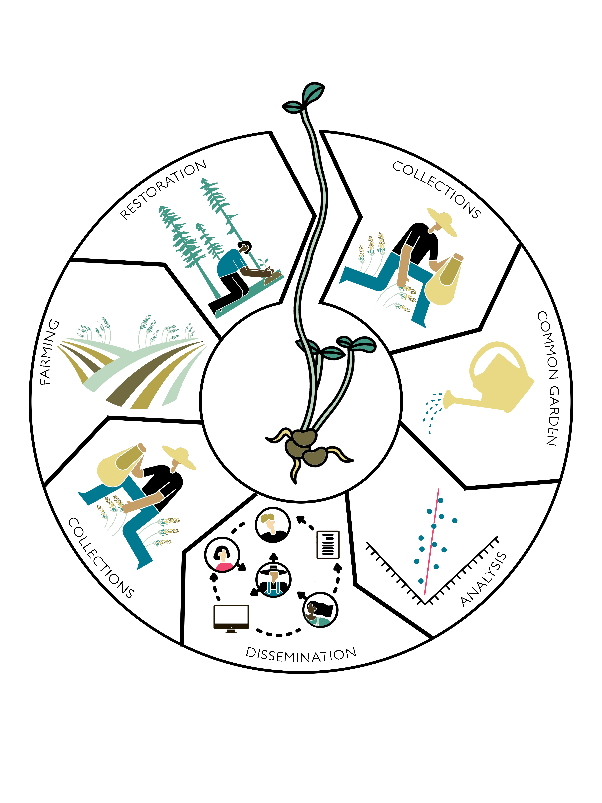

Dissemination. The first three panels (‘collections’, ‘common garden’, ‘analysis’) indicate the process of developing an eSTZ, while the ‘dissemination’ panel showcases the need to share results so they can inform operational seed collections, agricultural increase, and selection of materials for a restoration. Note that ‘common garden’ represents the act of eSTZ development, but could be replaced with molecular work to develop a genetic product, or modelling for a climate matched product. By Emily Woodworth

Empirical seed transfer zones (eSTZs) are gaining popularity amongst restoration practitioners as a tool to help identify the most appropriate seed source for a species at a restoration site (McKay et al. 2005). eSTZs are becoming more widely used for two primary reasons 1) they are based on empirical data - e.g. the phenotypes in a common garden, population genetics, or the correlation between occurrences of the species and environmental variables and 2) generally their are fewer zones than provisional seed transfer zones thereby reducing the number of lineages requiring cultivation in agricultural settings. While popular, the development of eSTZs for a species is a costly and time consuming process, most often involving common garden or genetic studies, with many populations from across the species range incorporated as samples (Kramer et al. 2015).

In western North America, the majority of eSTZs have been developed by just a couple of lab groups, whilst the remainder have been developed by other assorted groups. While practices for developing eSTZs are becoming more defined, to our knowledge no standards exist for *sharing* the results of eSTZs (Supplemental 1). Despite eSTZs being produced by a relatively small pool of lab groups and individuals, inconsistencies vary across the spatial data products used to report eSTZs.

The success of a restoration project relies on the timely application of techniques which are suitable for the site at hand. Implementation of relevant techniques requires not only intrapersonal communication between a practitioner with themselves in time, e.g. avid note taking, but also interpersonal communication between practitioners. Hence the dissemination of ideas during and after a restoration project is our best opportunity to improve the outcomes of restorations (Figure 1). However, ideas have varying levels of complexity which may hinder their transmittal. For example seeding rates may be verbally communicated, while seed mixes are likely to require written documentation, whereas spatial data require both written and geographic data (e.g. coordinates and relations between them) in the form of spatial data products (e.g. rasters, shapefiles) to accurately convey their meaning. Given the relative complexity of communicating precise spatial information standards should exist to ensure not only its accuracy and precision, but also the ease by which it can be interpreted and used.

Using 23 sets of eSTZs produced for 22 taxa, we show that most of the spatial data developed and disseminated, to share the results of an eSTZ, are inconsistent (Supplemental 1). We have already observed significant hindrances to the uptake of these data at the level of practitioners, and search for consensus within these data. Subsequently, using any consensus (wisdom of the masses) from these data, combined with standard conventions of data sharing, we present a set of guiding standards for researchers in the United States to employ in making results more consistent.

# Current Condition

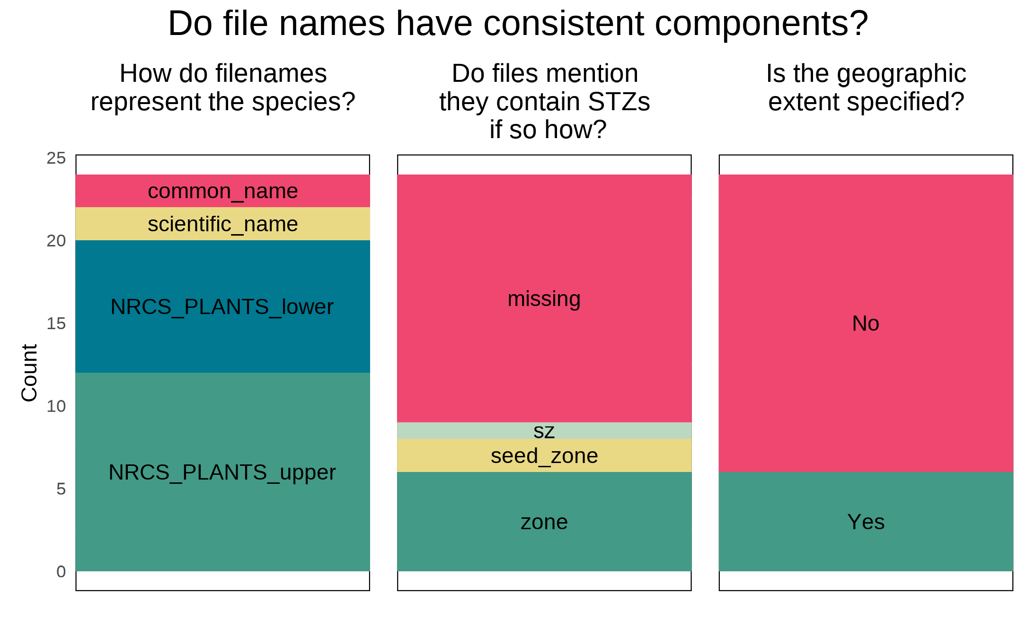

File Naming. Three inconsistencies in file names discussed here, with the advised format for data sharing in green, and the least desirable condition in grey.

We conducted a review of all eSTZs on the Western Wildland Environmental Threat Assessment Center (WWETAC) website as of May 1, 2024 (<https://research.fs.usda.gov/pnw/products/dataandtools/datasets/seed-zone-gis-data>). Each data products: file name structure, field naming conventions, and directory structure, were manually scored, and all analyses were carried out in R version 4.2.1.

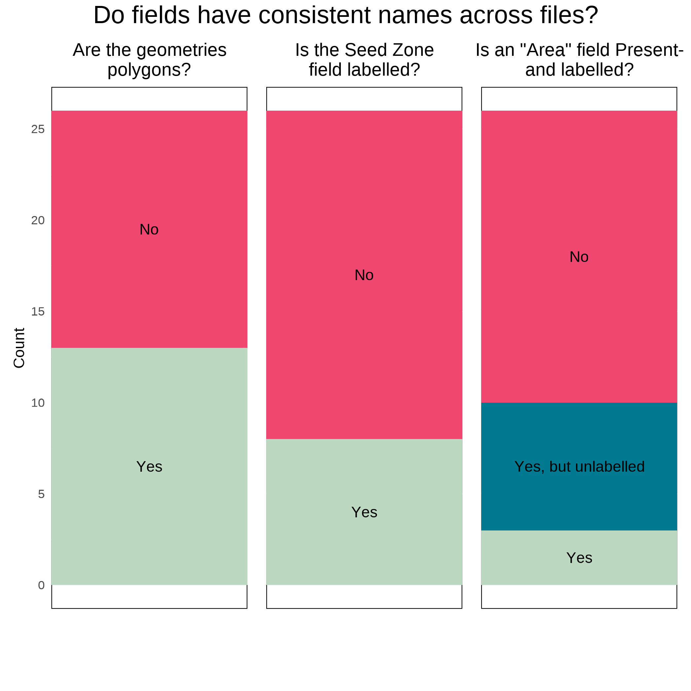

Field Names Shapefile. The three attributes of field names discussed here, with the most desirable condition in green, and the least desirable condition in grey.

In Figures 2 through 4, we present inconsistencies which we believe, or have observed to be, the most likely to interfere with practitioners’ workflows. We encountered considerable inconsistency within file names (Figure 2), in directory structure and naming (Figure 3), and cartographic elements of the 20 maps available (Figure 4). While some consensus existed around the use of USDA NRCS-Plants codes for denoting the taxon contained in the file (Figure 2), the lack of file names mentioning what attribute about the taxon they contained (e.g. ‘zones’, ‘seed_zone’, ‘sz’), and the lack of specified geographic extents can make determining the specifics of the file difficult unless it is explicitly opened in a Geographic Information System (GIS) software.

The naming of the fields (columns) within shapefiles likely presented the most problematic of all results (Figure 3), while many inconsistencies exist, here we focus on three. Different usages of polygon geometry were implemented for representing the individual seed transfer zones, i.e. sometimes all portions of a seed transfer zone - when at least some components are disconnected - where stored within the same object or row (a multipolygon). Other times, each discontinuous portion of the range would be stored as its own polygon. For most infrequent Geographic Information System (GIS) users, we have observed that multipolygons can be confusing and require them to use several moderately advanced spatial techniques to interact with. Surprisingly, within each shapefile the field denoting the seed zones was often ambiguously labelled, or entirely lacking any indication (Figure 3). In a number of instances it took us several minutes to determine which field was the seed zone by toggling through and visualizing many fields, despite us already having interfaced with all of these products multiple times.

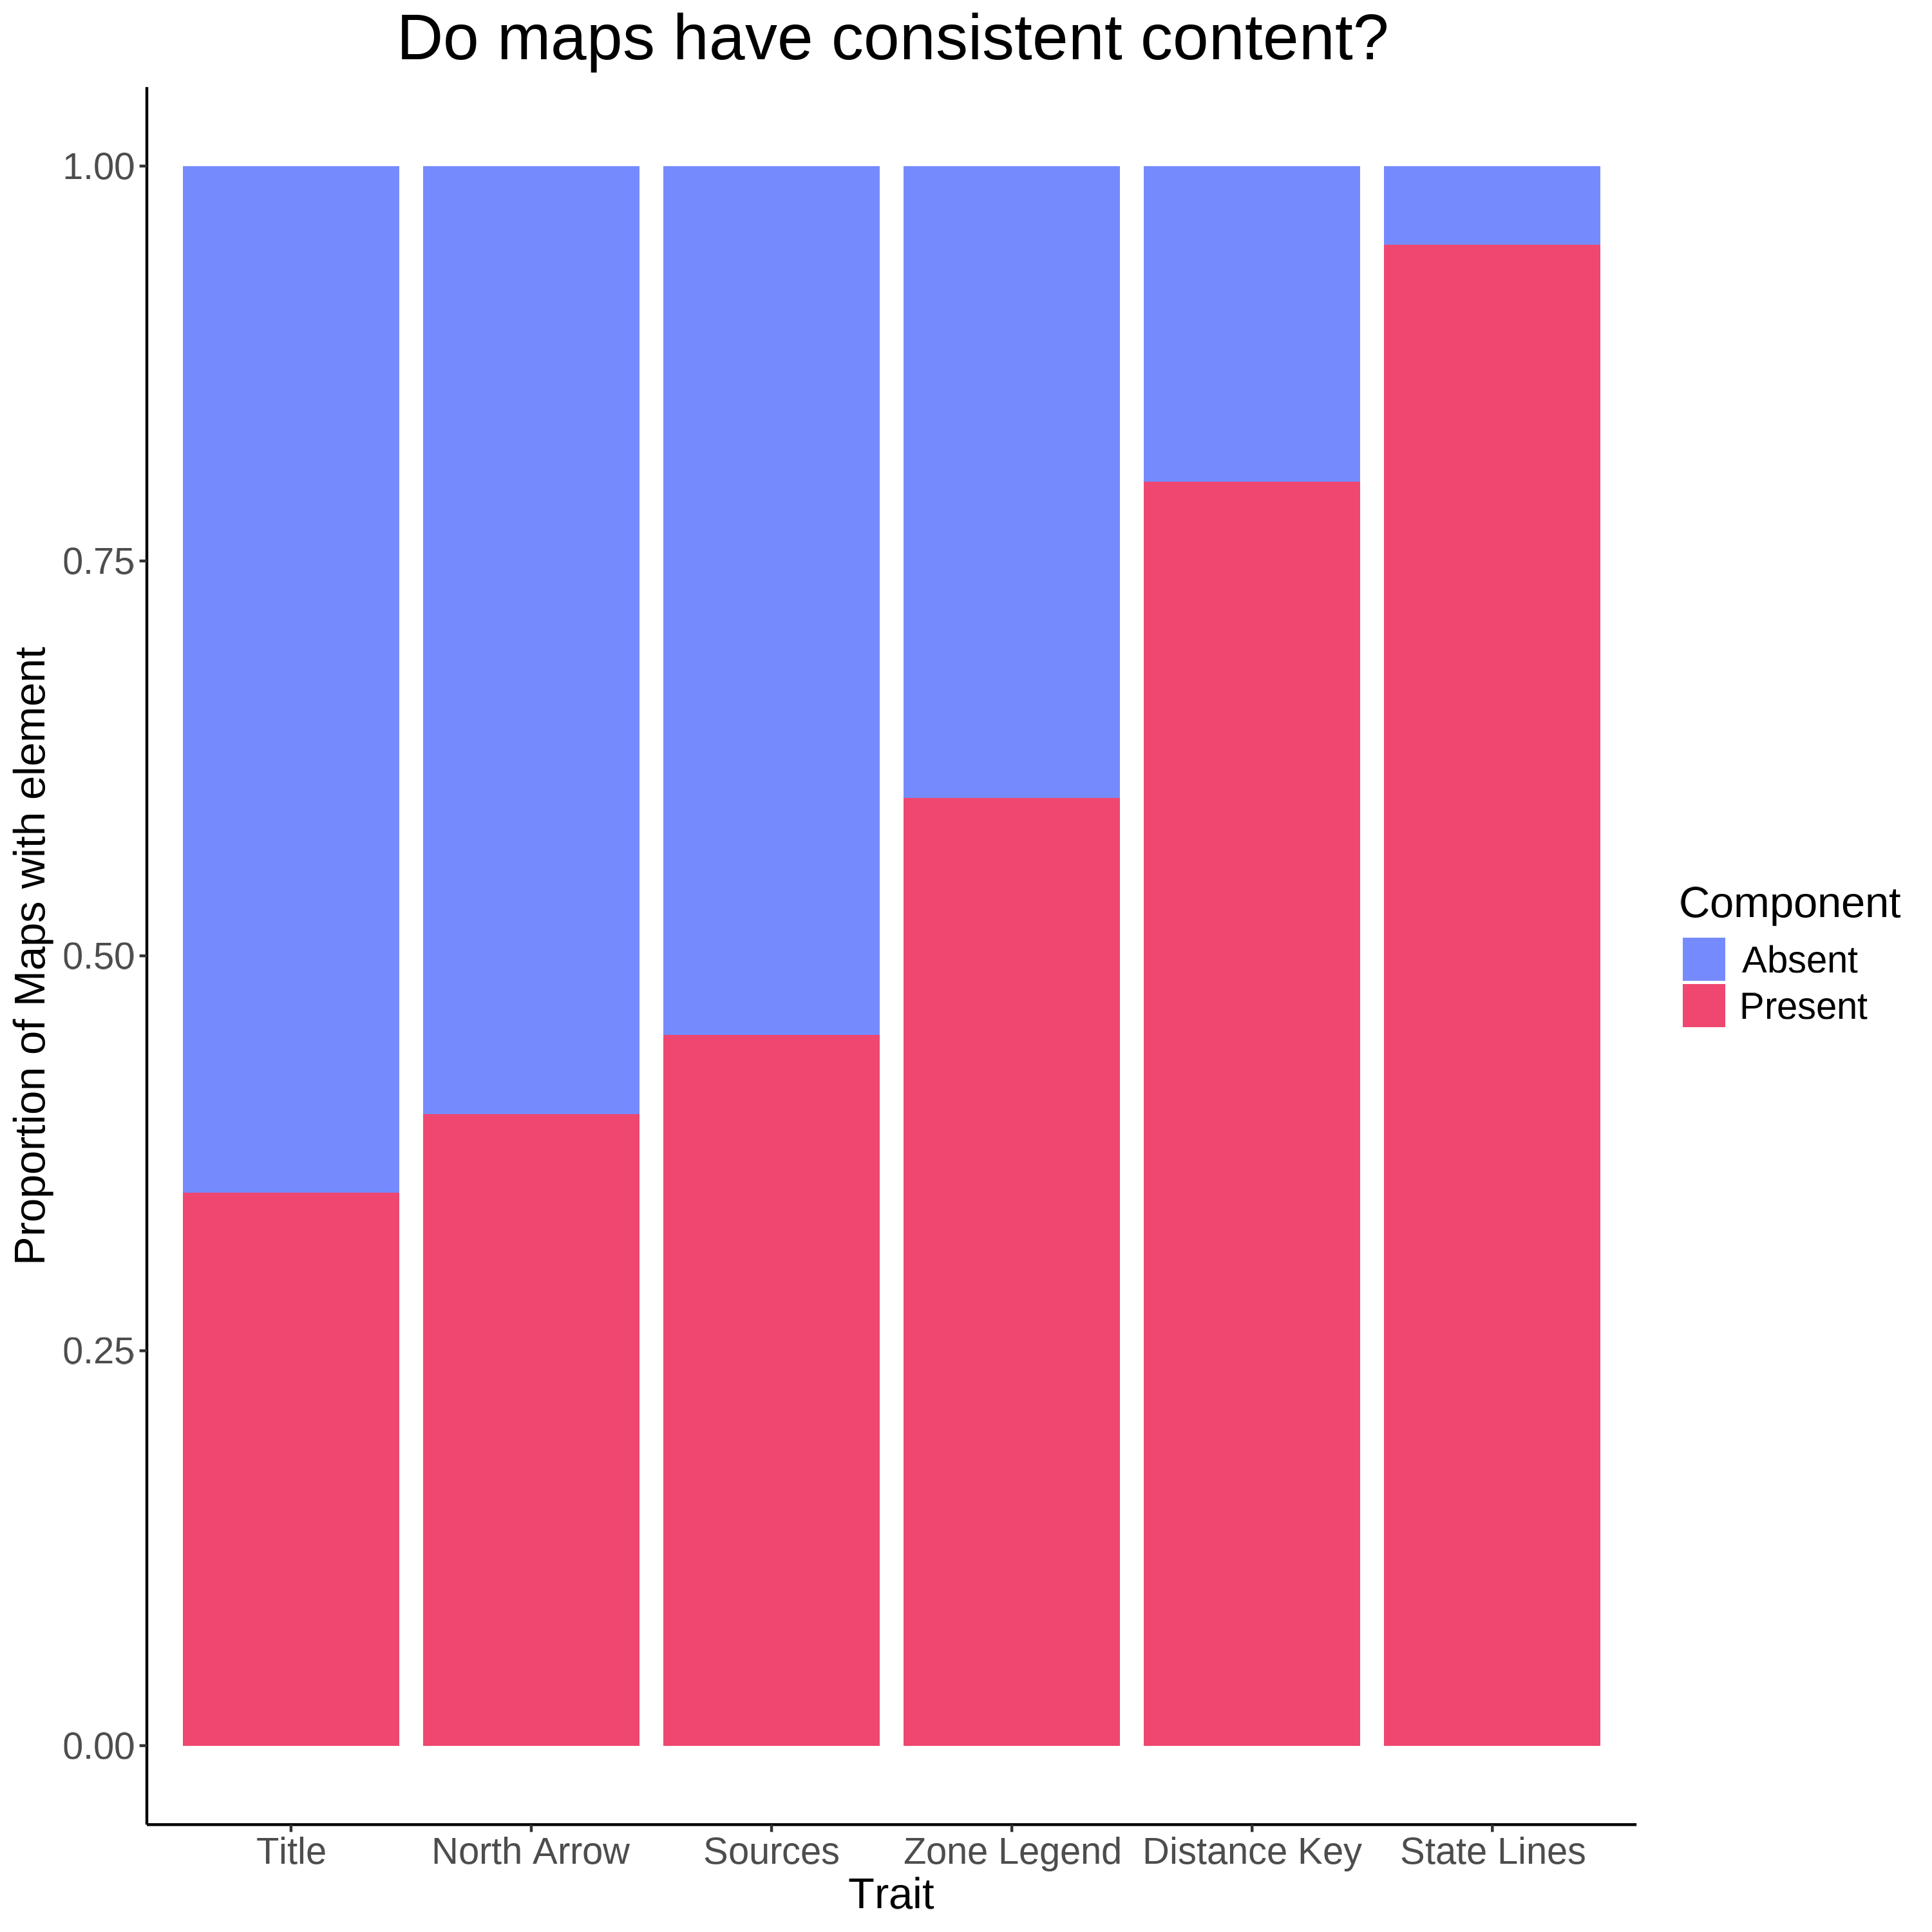

Map Components (n = 20). Several essential cartographic elements - most notably a Title, a statement on data sources, and a legend for the seed zones, where missing from at least - or nearly half of the products inspected.

# Recommendations

Some consensus exists among the developers of eSTZs for a range of attributes related to distribution of data products. Combining those opinions with best practices for data sharing, and experience as users of each of the existing empirical products, results in the following recommendations.

### Directory Structure

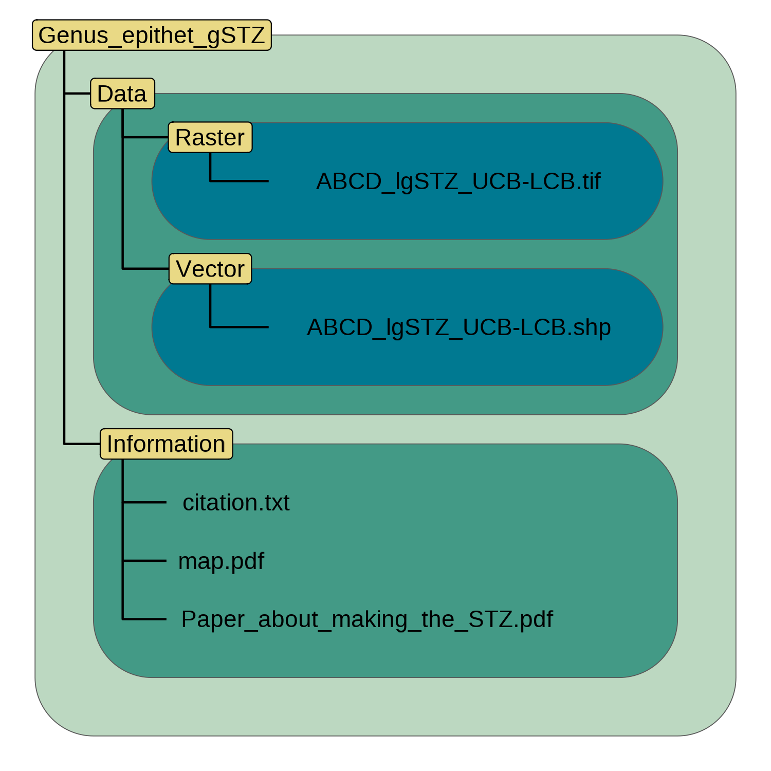

Directory Structure. Each directory is named in yellow, and spans the extent of variously coloured polygons. Individual files (or a set of files in the case of a shapefile) are depicted in black text within these directories.

eSTZs should be distributed using a predictable directory structure allowing users to be immediately familiar with where to find content (Figure 5). We recommend that all directories (folders) have two main subdirectories (Figure 5), one containing the essential data products, preferably in both raster and vector data formats (*see ‘Data Formats’*). The second directory contains information relating to the product, including a formatted citation for data use, a map for quick reference, and any materials describing the development of the product both as a paper, and a text file of quick metadata attributes.

### File Naming

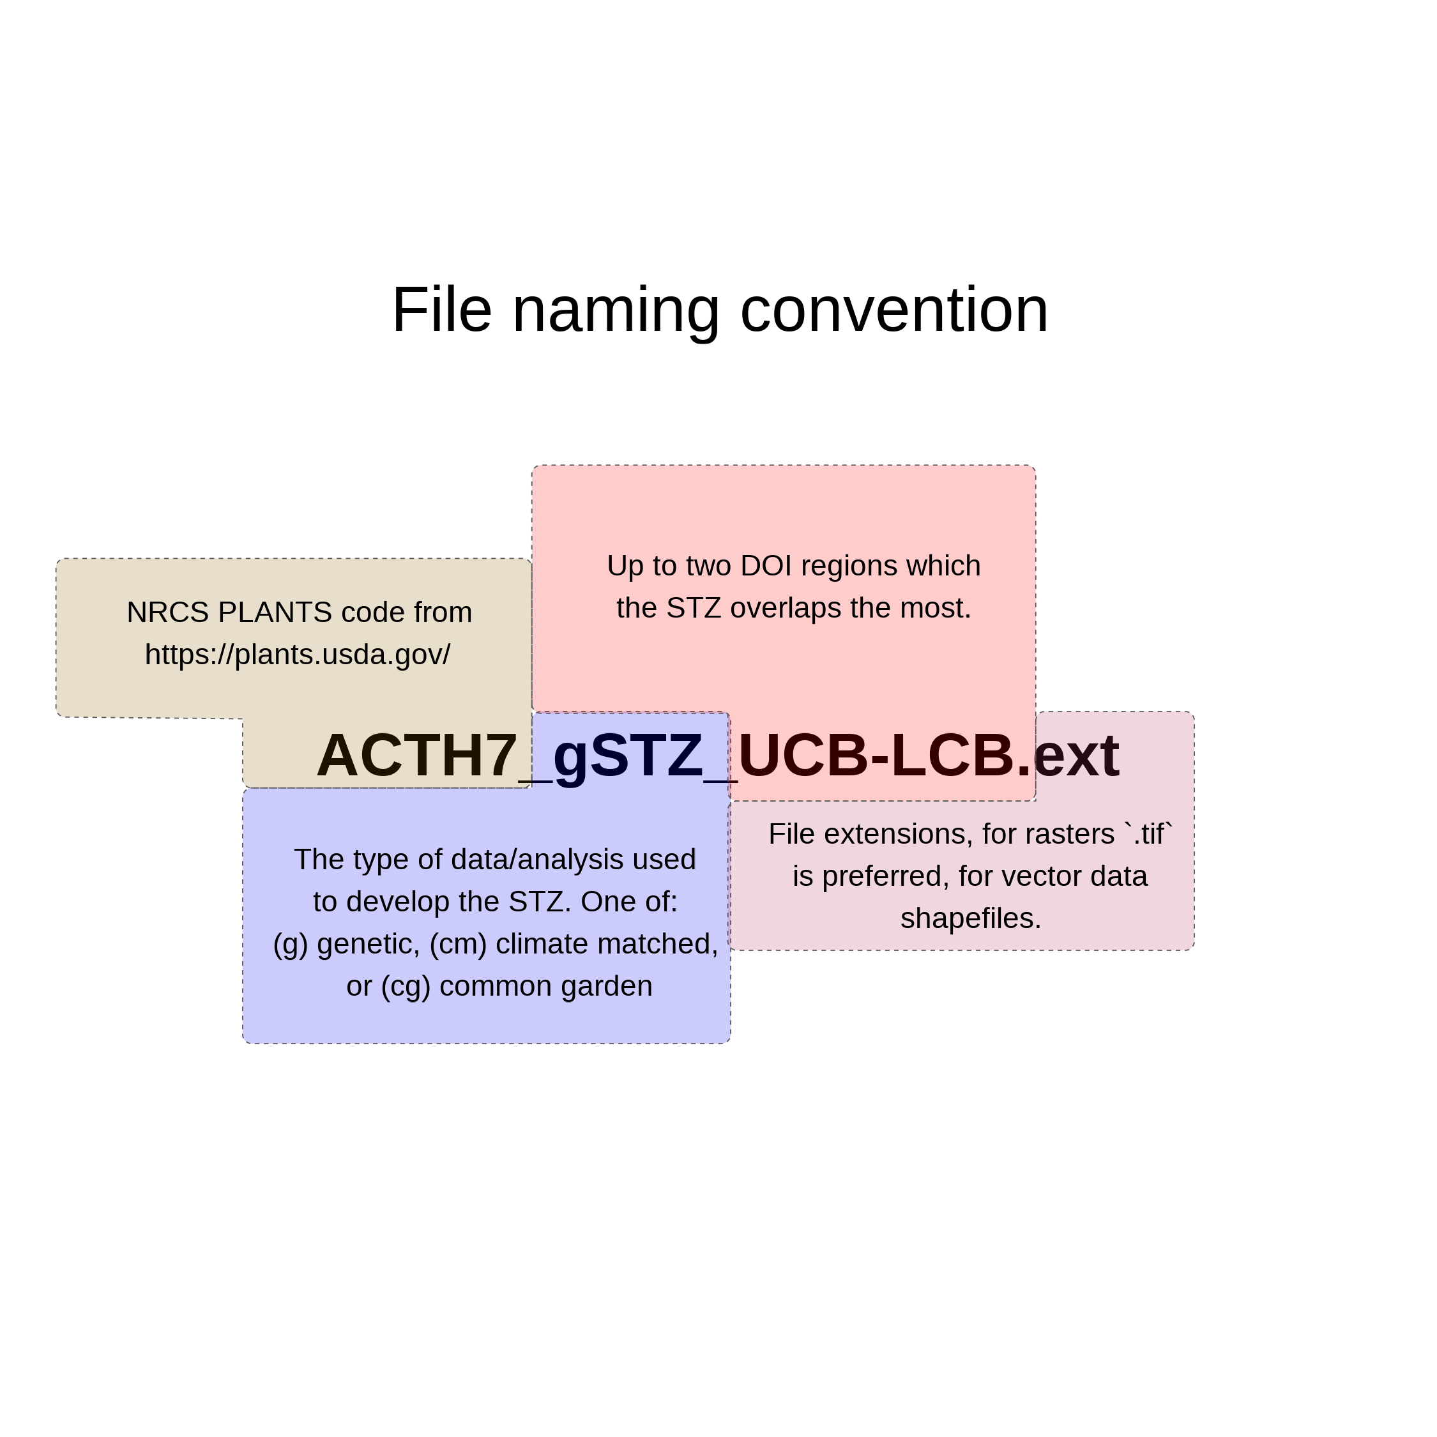

File Naming. The four proposed components of a filename are highlighted in different colours, and with appropriate cases.

The files within the directory should follow a naming convention which is easy for users to interpret and import to various software’s, while also describing essential attributes of the data product. We recommend (Figure 6) that each file name has three main components, in addition to the file extension. The first component is the USDA PLANTS code, and the second is the method used to develop the STZ - currently one of ‘g’, ‘cg’, ‘cm’ (for genetic, common garden, and climate matched, respectively), and the final is up to the two main regions which the product overlaps. In the United States we recommend the use of the 12 Department of Interior regions as they cover contiguous geographic expanses, are few enough they can easily be remembered, and balance L2 Omernik ecoregions and easier to remember state lines. However, we recognize that in other nations the use of ecoregions may be more desirable.

## Maps

Maps of the data product should be included within the ‘Information’ directory. Many questions about eSTZs can be answered quickly and simply from a practitioner consulting a map saved as a PDF with the essential cartographic components; fortunately most developers already supply these. We recommend that each map contains the following elements: north arrow, scale bar, state borders, geographically relevant cities, coordinate reference system information, sensible categorical color schemes for the seed zones (e.g. from ColorBrewer <https://colorbrewer2.org>), a legend, the taxons name as a title, and the maps theme (‘Seed Transfer Zones’) as a subtitle.

## Data Formats

We recommend that the spatial data associated with an eSTZ be distributed using both of the popular spatial data models, vector and raster. For vector data we advocate for the continued usage of the shapefile format, while for raster data we propose the usage of geoTIFFs (‘tifs’, the .tif extension). In our experience tifs seem to be the most widely used of the raster data models in ecology, for non-time series data, and are supported by virtually all GIS software.

## Vector Data Field Attributes

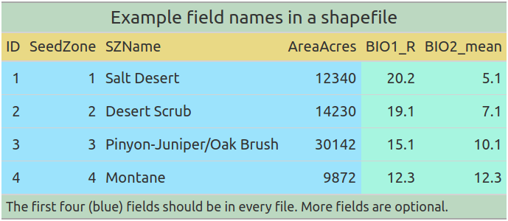

Vector Data Field Attributes. The proposed field names for distributing vector data.

The order of the fields (or columns) of the vector data should follow a predictable pattern (Figure 7), allowing humans interacting with the data in a graphical user interface (GUI) to quickly detect their field of interest, and while it’s bad practice – allow users code to subset columns by position rather than field name.

We recommend that each shapefile has at least four fields in the following order and of the following data types. 1) ID (numeric - integer) a unique number associated with each individual polygon in the file. 2) Seed Zone (numeric - integer) a unique identifier for each of the eSTZs delineated by the product developers, these allow for quick filtering of the data based on a simple numeric value which is hard to misspecify. 3) SZName (character) a human developed name for the zone which may refer to an axis of a principal component analysis, e.g. ‘LOW MEDIUM LOW’, or be defined by the product developers. We propose that semi-informative names should be developed before data distribution to help practitioners more easily convey important attributes without having to rely on numeric values which may be more difficult to remember due to their nondescript nature. 4) AreaAcres (numeric - integer) of each polygon.

In addition to these standard field naming and placement conventions, we further recommend a series of standards for the contents within these essential fields, and how to format any additional fields relevant to the project (see package website).

## Adapting our Proposals to other Regions

We believe that our core set of our proposals are readily adaptable in a variety of regions globally.  
However, some modifications are required to ensure seamless implementation. Notably our suggestions for file names contains three parts, two of which are specific to data sources limited in scope to the United States. The first of these is the use of a set of abbreviated codes which reliably identify a plant taxon (‘NRCS PLANTS code’). The second is the use of administrative (‘DOI’) regions for denoting a general geographic area which the specific product covers. An alternative solution, which we considered for the US, is the use of ecoregions. However, this was rejected due to the number of ecoregions (e.g. 10 conterminous US DOI regions to 20 level 2 Omernik ecoregions), and most importantly because many ecoregions are not contiguous which may lead to confusion. Possible alternatives should be evaluated in light of the points above before they are selected for use.

Additionally, we believe that many other countries may be able to immediately start distributing their vector data as OGC GeoPackage (‘.gpkg’) files, rather than shapefiles. The GeoPackage format is a geodatabase (SQLite Database file) and open source standard which entails all data being stored in a single file (relative to the several files a shapefile requires), contains projection data, and is spatially indexed data. In fact, the data associated with ‘eSTZwritR’ are all shared as GeoPackage files, and anecdotal evidence suggests it’s utilization in US Government agencies is increasing.

While for the US we suggest that seed zones have numeric representations following a generally decreasing pattern in aridity, this is because the success of restorations oftentimes follows this gradient (Shriver et al. 2018). However, in other regions other climate conditions may be more important drivers of restoration outcomes, and they should be used instead of this variable.

# Estimating Uncertainty

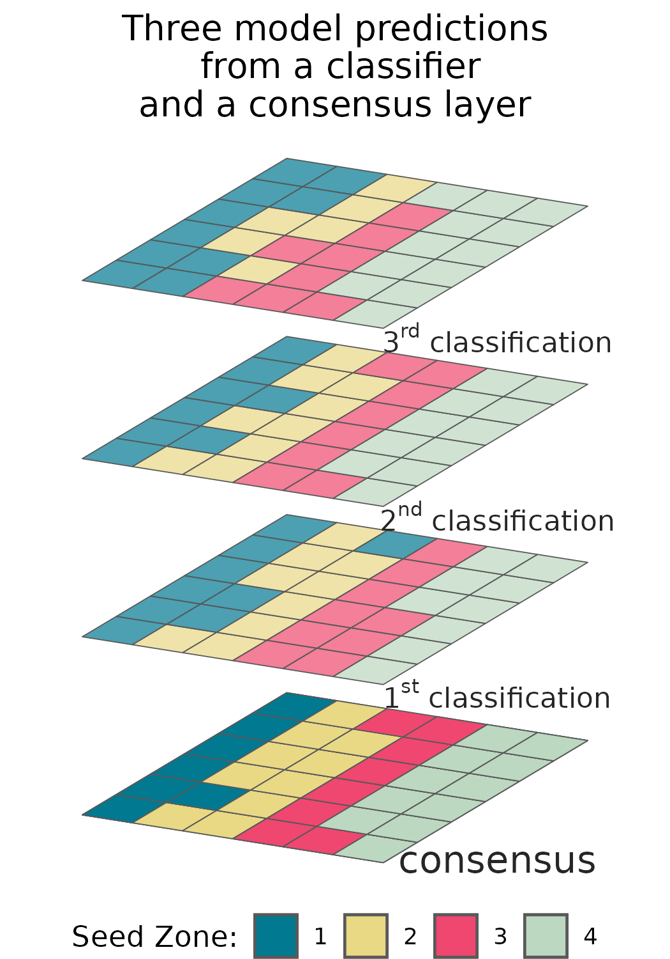

Many common classification algorithms can output probabilities for each class in the model. Reporting a subset of these allows users to interact with prediction probabilities directly.

We have witnessed confusion from seed collection crews, curators, and restoration practitioners alike, over the appropriate classification for a new seed source, and the selection of a seed source for a restoration. Generally, these hesitations relate to a source which is on the border of multiple seed zones. We predict that with the increasing availability of fine resolution spatial data which more accurately reflect local ecological heterogeneity - seed zones will become more fine, increasing the perimeter to surface area ratio and the prevalence of this already common confusion (Gibson et al. 2019).

Currently eSTZs are distributed exclusively as polygon vector data (e.g. shapefiles). Vector data convey a sense of separation between the entities they represent, i.e. they are composed of mutually exclusive categories with discrete borders between them. Common examples of polygon vector data usage include: administrative units (e.g. zip codes, states, and countries), watersheds, and the geographic range of a species. Whereas raster data, or gridded surfaces, are used for representing continuous phenomena, i.e. gradients. Common examples of raster data usages include climate variables, land cover classes, and predictions of a species modelled habitat suitability.

While we agree with the consensus that vector data are generally the best method of distributing data, given the number of times we have observed classification confusion we believe the inclusion of raster data is also warranted. Raster data have an additional benefit that they can intuitively incorporate multiple layers (a ‘raster stack’) for each of their pixels (although this functionality is easily achievable with GeoPackages). Thus allowing for a first layer of consensus predictions (the data conveyed in a vector data set), and other levels of raw predictions. For a simple example, a raster with four layers would have three layers of raw model output while the final layer is a consensus of these products. In the case of regression type analyses two layers could represent predictions at the lower and upper confidence intervals and the final layer a model prediction, while in the case of a classification algorithm the three classes with the highest predicted probabilities and a consensus class would be present.

We believe that conveying these uncertainties will allow users to better understand and explore the caveats with model predictions. This practice is further grounded in best scientific practice as the spatial data used to develop the initial zones are imperfect representations of the modelled phenomenon itself, the study itself introduced a variety of errors, and the classification (modelling) process itself is a generalization (Ascough et al. 2008; Li et al. 2018; Lechner et al. 2012).

A meta-analysis of genetic data sets, collected over large spatial domains in Western North America, found that the probability of mixing populations of more distantly related evolutionary lineages (i.e. different clusters, or *K*, identified by STRUCTURE analyses) increases as a function of distance between the prospective populations (Massatti et al. 2020). These analyses suggest that to avoid the possibility of outbreeding depression at a restoration site the most appropriate seed source will likely be the most proximate source, relative to a more distal source from within the same pSTZ. This work provides a precedent which supports restoration ecologists in leaning towards using closer, rather than further away seed sources even if they are located within the same seed zone; combining the above findings with metrics of uncertainty from eSTZ classifications will further bolster decision making.

The use of raster surfaces are already implemented in the Seedlot Selection Tool and Climate-Smart Restoration Tool, which blend attributes of pSTZs and eSTZs, or can be used to select the most appropriate eSTZ based seed source factoring in observed and forecast (e.g. RCP pathways) climatic values and custom functions (St. Clair et al. 2022). These tools offer both an alternative format for guiding native germplasm development (e.g. spatially where should germplasm be developed from?) via gap analysis, and especially for choosing a priority seed source for a restoration when multiple are available. However, one drawback of the existing implementation of these tools is that they calculate climate similarity from a single focal cell, e.g. a restoration site, to the entire surface. In many instances seed lots need to be developed *before* a restoration site is known, for example in the case of reseeding severe disturbances (e.g. wildfires). Combining the development of seed sources within zones, which allows for decision making to develop seed availability, with the Climate-Smart Restoration Tool to select potential seed source options after a natural disaster may lead to the most pragmatic decisions.

# IMPLEMENTATION

## Software

To make these suggestions easy to implement we have created an R package, eSTZwritR (pronounced ‘easy rider’), which can implement all of them, lessen the statistical processing, with minimal user inputs. The package is installable from GitHub <https://github.com/sagesteppe/eSTZwritR>, and has a GitHub pages website (<https://sagesteppe.github.io/eSTZwritR/>) for users interested in better understanding it’s functionality and which includes supplemental figures and details not discussed here.

### FOR DEVELOPERS

The package requires only 5 functions to produce a directory with the contents discussed above, with minimal data entry. Most importantly the entries are well outlined and easily entered without requiring close attention to detail, an omnipresent scenario when processing standards by hand.

### FOR PRACTITIONERS

These results should allow for simple utilization of existing empirical seed transfer zone resources. We have re-processed all eSTZ data products we are aware of to follow these standards, with the exception of creating the uncertainty raster layers. We have provided some sample code which showcases loading these data into a non-GUI GIS at the website above.

# CONCLUSIONS

Seed based active restoration will always be a relatively expensive, yet necessary, option for terrestrial restoration. Here we present simple standards for the scientists developing eSTZs to use in order to standardize the data products they are developing to assist in their uptake. While these conventions should be easy to implement for a sufficiently motivated individual, we also present an R package which can quickly achieve these results.

# ACKNOWLEDGEMENTS

Two anonymous reviewers are thanked for their constructive comments on this manuscript.

# DATA AVAILABILITY STATEMENT

The scored data for the analysis, and post processed eSTZ data sets are openly available on Dryad at … (doi)… reference number …

## Term box

Seed transfer zones are intended to improve restoration outcomes by decreasing the chances of using maladpted seed at a restoration site (Kramer & Havens 2009). They seek to characterize (empirically), or estimate (provisionally), local adaption and aim to minimize the variation between prospective seed sources and restoration sites (Leimu & Fischer 2008; Kramer & Havens 2009). Provisional seed transfer zones (pSTZs) can be utilized across all vascular plants and are based on the similarity between several climate variables known to be broadly relevant to plant life in a region (e.g. in the U.S. Winter Minimum Temperature, and Annual Heat:Moisture index) (Bower et al. 2014). eSTZs have the same goal as pSTZs, but are tailored for individual species, allowing for more accurate determination of zones which seed can be transferred within under existing climate regimes.

The development of seed transfer zones in the US can be traced back to the 1960’s when forestry companies, which had to replant timber stands after logging, developed guidance to ensure the success of their re-plantings (Johnson et al. 2004). However, it was not until the early 21st century that researchers began developing STZs for other groups of plants in the US (McKay et al. 2005), in part due to the increasing size of large wildfires and demand for locally adapted seed (National Academies of Sciences et al. 2023) Tandem to the development of STZs for non-tree species in the US has been the development of STZs in both Europe (Johnson et al. 2004).

# LITERATURE CITED

Ascough JI, Maier H, Ravalico J, Strudley M (2008) Future research challenges for incorporation of uncertainty in environmental and ecological decision-making. Ecological modelling 219:383–399

Bower AD, Clair JBS, Erickson V (2014) Generalized provisional seed zones for native plants. Ecological Applications 24:913–919

Gibson A, Nelson CR, Rinehart S, Archer V, Eramian A (2019) Importance of considering soils in seed transfer zone development: Evidence from a study of the native *Bromus marginatus*. Ecological Applications 29:e01835

Johnson G, Sorensen FC, St Clair JB, Cronn RC (2004) Pacific northwest forest tree seed zones: A template for native plants? Native Plants Journal 5:131–140

Kramer AT, Havens K (2009) Plant conservation genetics in a changing world. Trends in plant science 14:599–607

Kramer AT, Larkin DJ, Fant JB (2015) Assessing potential seed transfer zones for five forb species from the Great Basin Floristic Region, USA. Natural Areas Journal 35:174–188

Lechner AM, Langford WT, Bekessy SA, Jones SD (2012) Are landscape ecologists addressing uncertainty in their remote sensing data? Landscape ecology 27:1249–1261

Leimu R, Fischer M (2008) A meta-analysis of local adaptation in plants. PloS one 3:e4010

Li L, Ban H, Wechsler SP, Xu B (2018) 1.22-spatial data uncertainty. Comprehensive geographic information systems 313–340

Massatti R, Shriver RK, Winkler DE, Richardson BA, Bradford JB (2020) Assessment of population genetics and climatic variability can refine climate-informed seed transfer guidelines. Restoration Ecology 28:485–493

McKay JK, Christian CE, Harrison S, Rice KJ (2005) ‘How local is local?’—a review of practical and conceptual issues in the genetics of restoration. Restoration Ecology 13:432–440

National Academies of Sciences Engineering, Medicine, others (2023) An assessment of native seed needs and the capacity for their supply.

Shriver RK, Andrews CM, Pilliod DS, Arkle RS, Welty JL, Germino MJ, Duniway MC, Pyke DA, Bradford JB (2018) Adapting management to a changing world: Warm temperatures, dry soil, and interannual variability limit restoration success of a dominant woody shrub in temperate drylands. Global Change Biology 24:4972–4982

St. Clair JB, Richardson BA, Stevenson-Molnar N, Howe GT, Bower AD, Erickson VJ, Ward B, Bachelet D, Kilkenny FF, Wang T (2022) Seedlot selection tool and climate-smart restoration tool: Web-based tools for sourcing seed adapted to future climates. Ecosphere 13:e4089