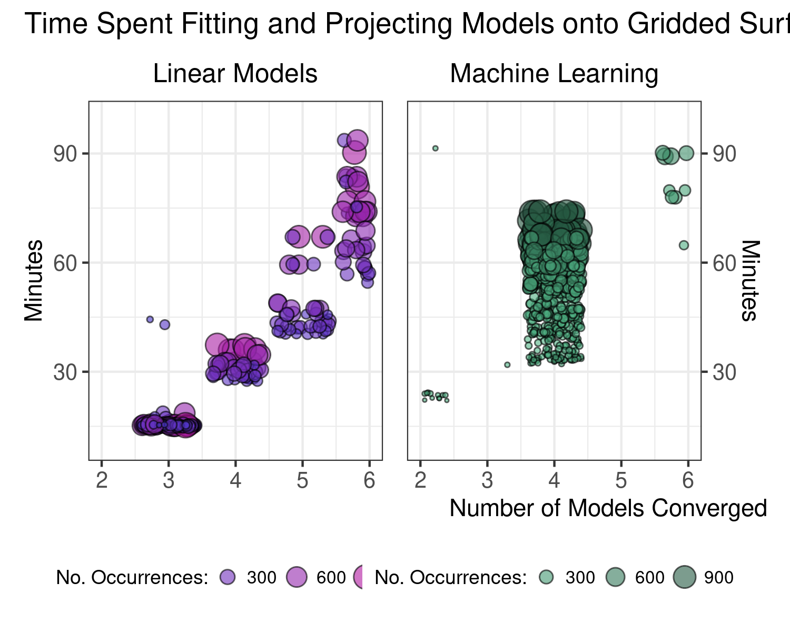

wor

ds

to

the

people

### Relationship between number of records and individual model run diagnostics

