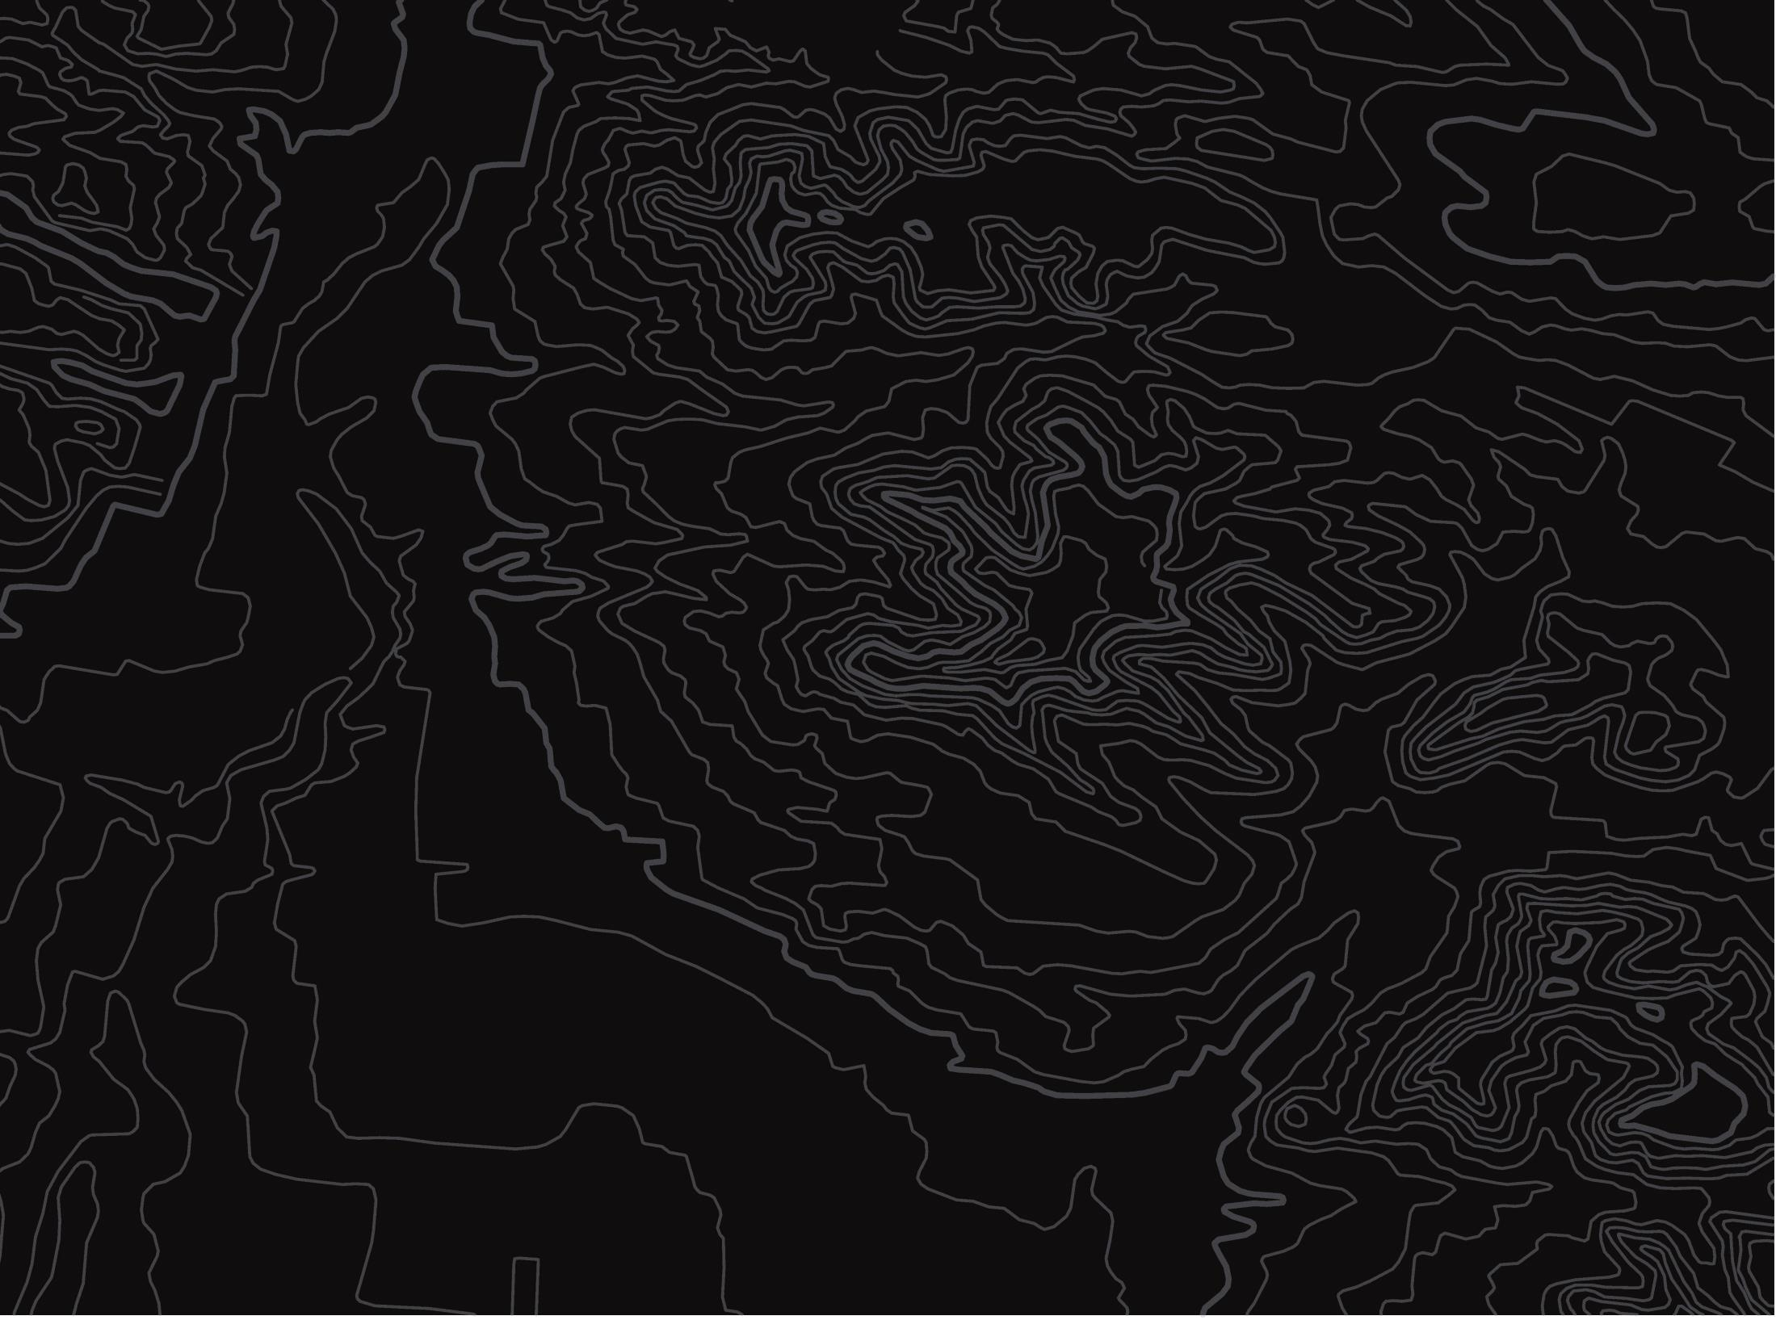
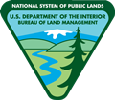
BUREAU OF LAND MANAGEMENT

Assessment of Current Upland Vegetation Conditions in the Uncompahgre Field Office, Gunnison Gorge, and
Dominguez-Escalante National Conservation Areas

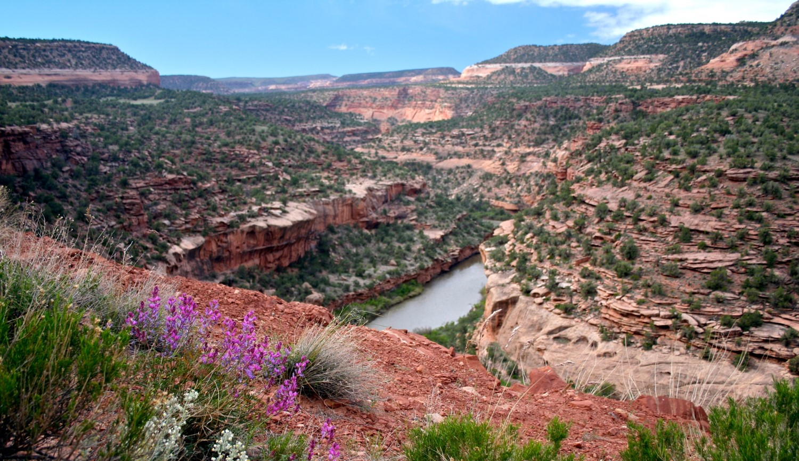

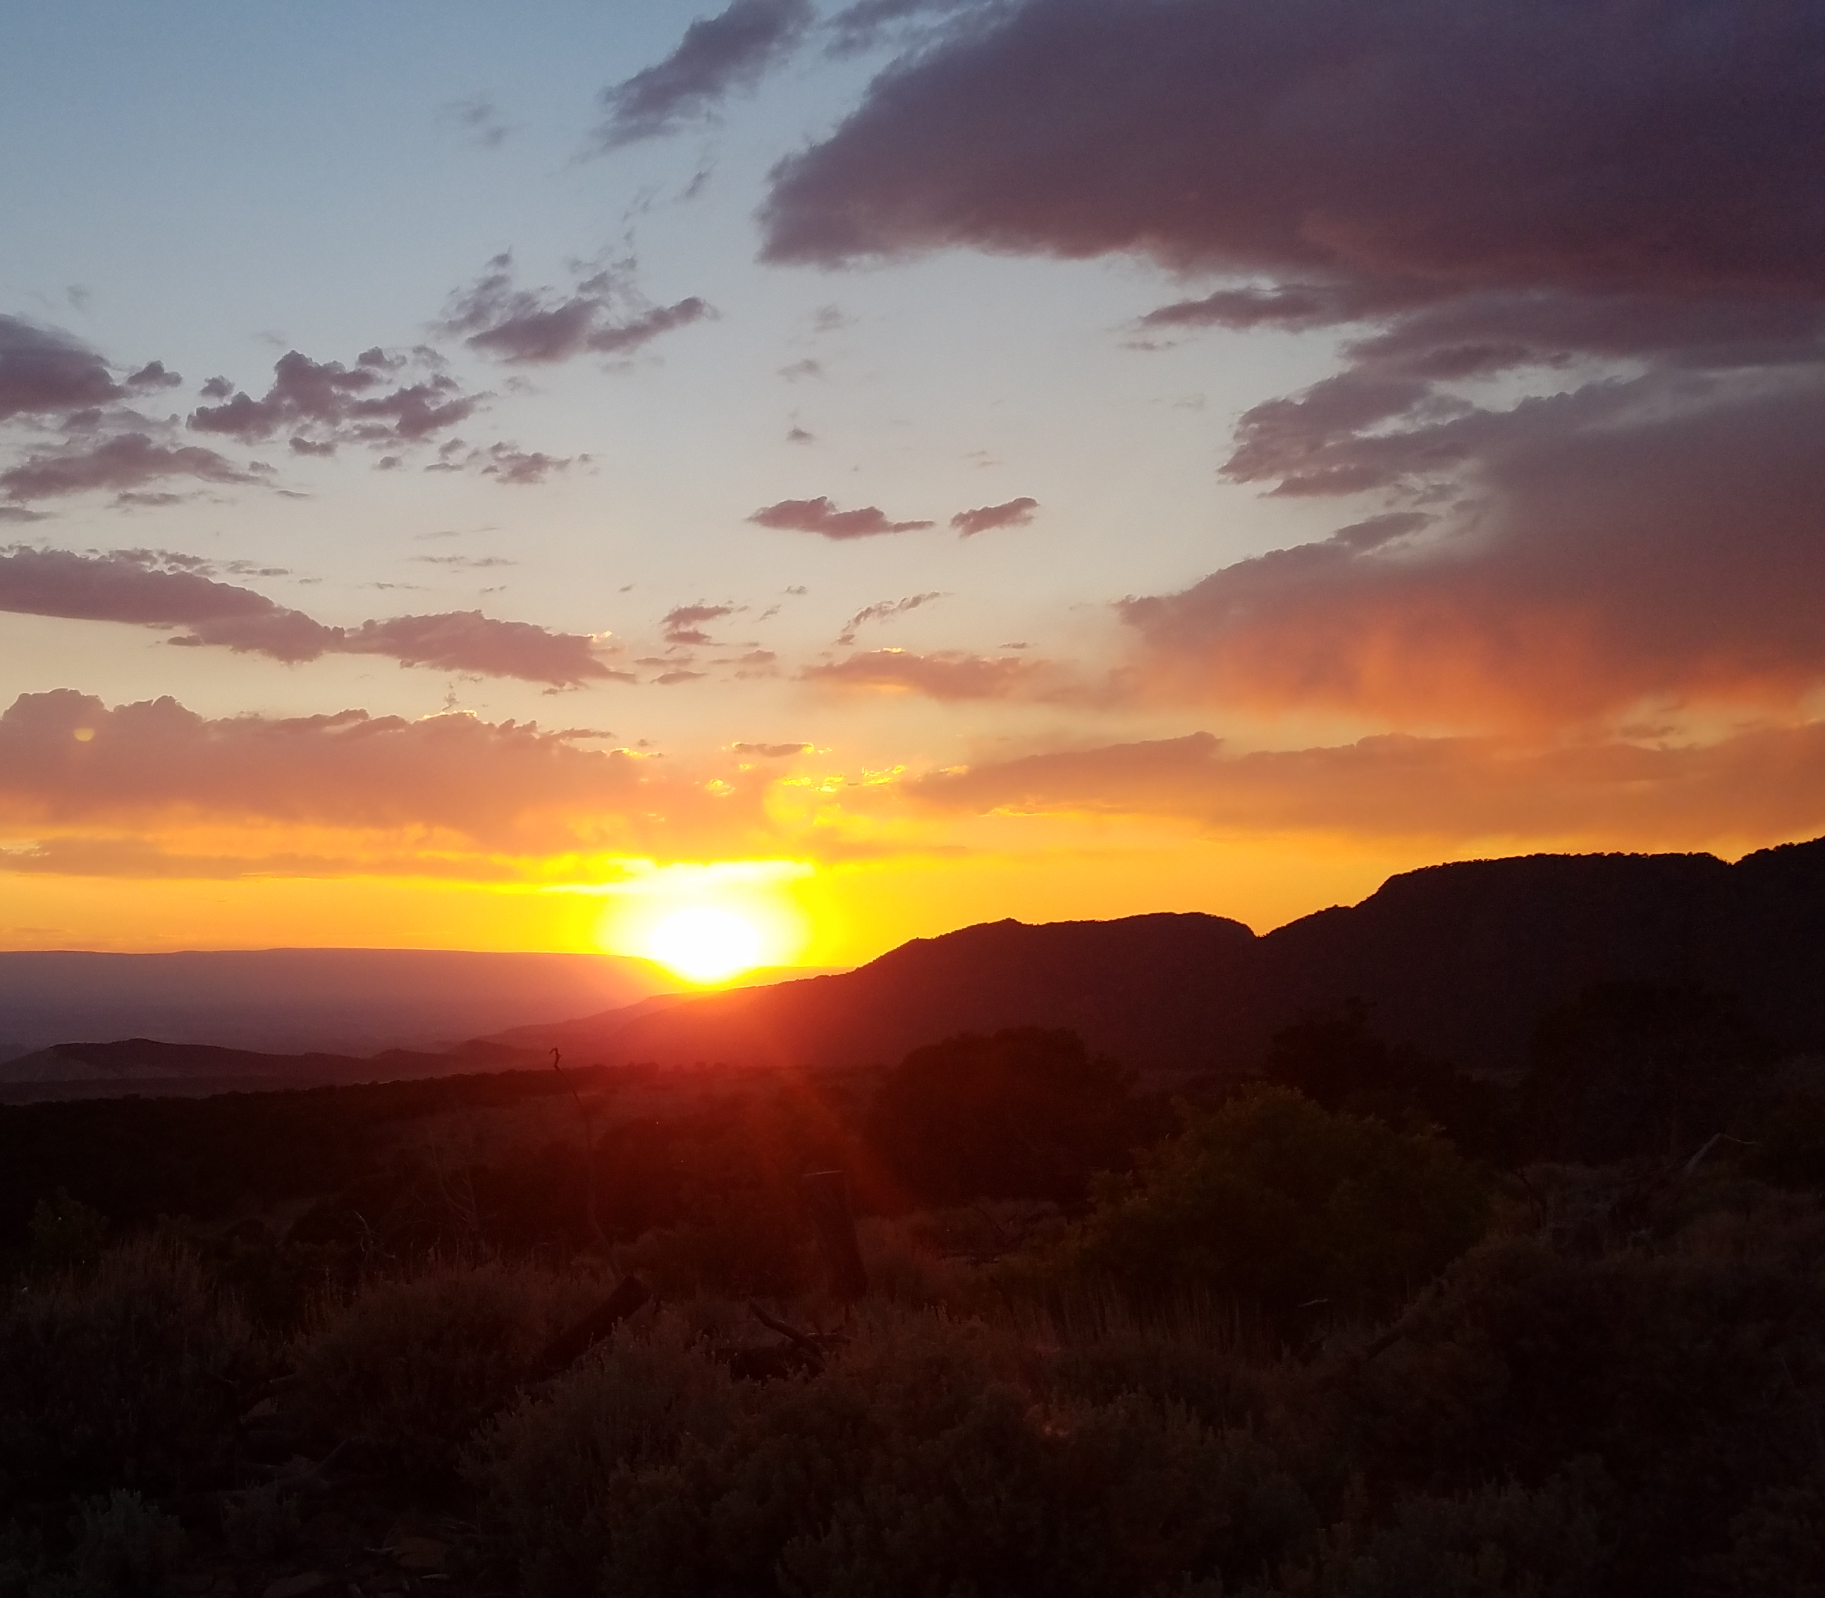
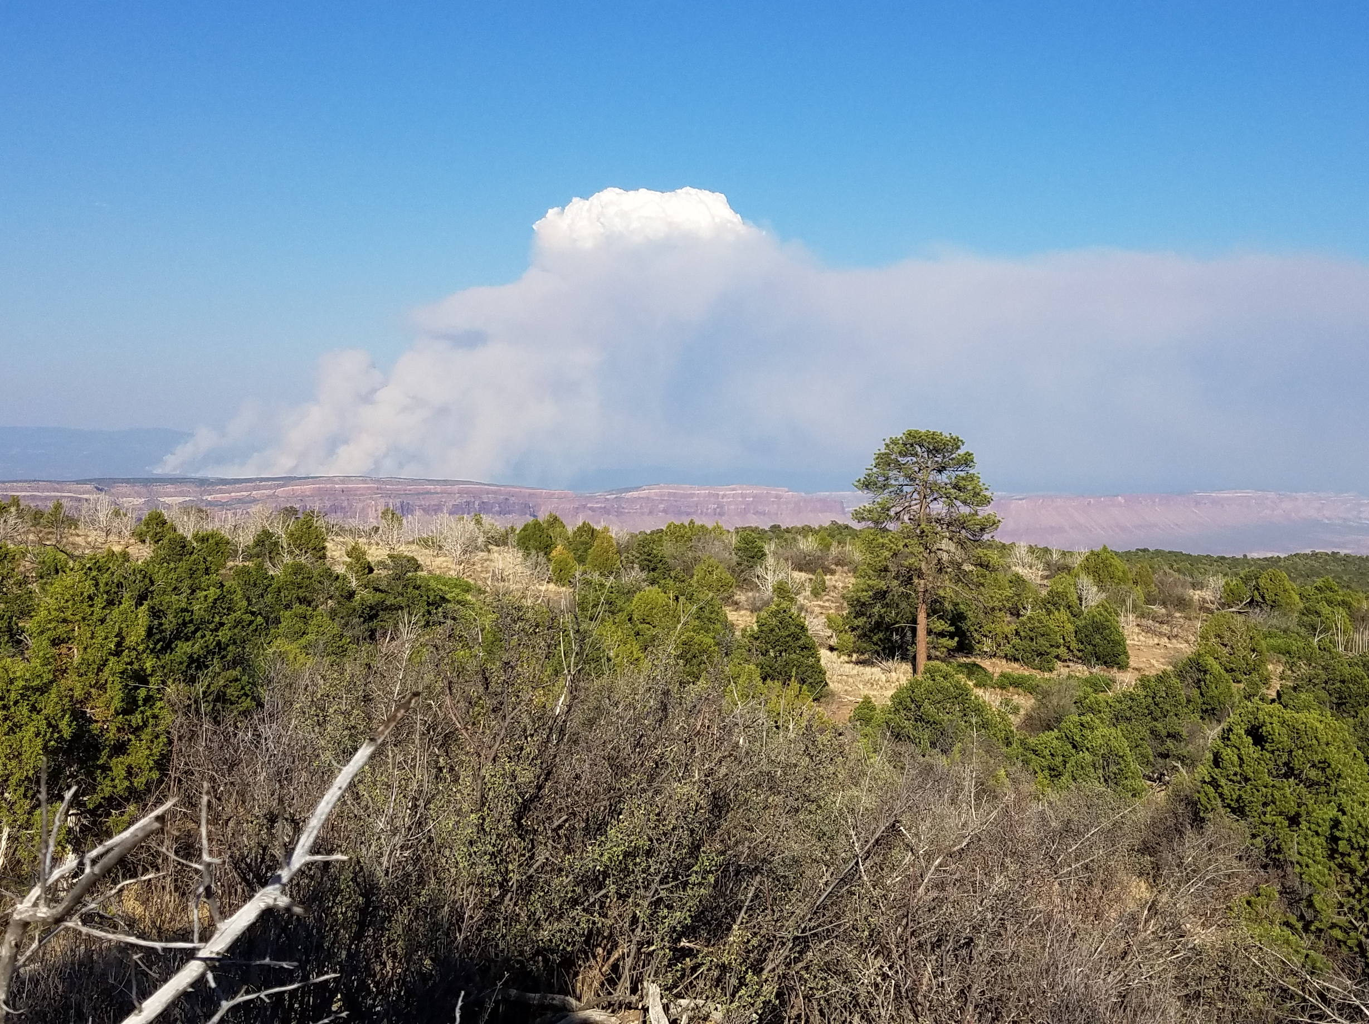
June 2023

