Floristic Quality Index

Floristic Quality Assessments (FQA) utilize the presence of vascular plant species in an area as indicators of the quality of the habitat. The fundamental assumption guiding the use of plants as indicators of habitat quality is that different species respond differently to the types and frequencies of disturbance. At one end of this spectrum are species which are able to persist, or may introduced to an area, after certain types of disturbance - e.g. compaction of soil via heavy vehicles. On the other end of the spectrum are taxa which may only grow in areas which receive episodic disturbances characteristic of their ecosystem - e.g. a 100 year flood in a wetland. The subjectively estimated likelihood of a species either persisting, or being removed from a site due to disturbance is expressed as a Conservatism Value (C-Value). C-Values range from 1 to 10 for plants native to North America, and 0 for plants introduced to the continent by since colonization by European Settlers, with highly disturbance tolerant plants being at the upper end of the spectrum.

The use of FQI are uncommon in the Bureau of Land Management, perhaps in part due to the FQI originating in the Midwest in, and the assignment of C-values being a task which requires considerable amounts of human resources (Spyreas (2019)). A further requirement which hampers the utilization of these metrics are that each individual plant species, often times including subspecies, is assigned a separate C-value, the number of land management professionals which are capable of distinguishing taxa at these resolutions are limited (Kramer & Havens (2015), Ahrends et al. (2011), Morrison (2016)). Other possible limiting factors are that the FQI indices have been traditionally associated with the portions of Natural Resources focused on designation of parcels for conservation and preservation, rather than land management.

While C-values exist for virtually all states East of the Continental Divide, Colorado is one of only two states with significant surface lands administered by the BLM which has existing C-values for every documented member of it’s flora (Spyreas (2019)); additionally BLM Colorado staff, including the lead state botanist, assisted in developing these scores (Smith et al. (2020)). Here we utilize C-values, to supplement our formal AIM analysis, and to attempt to develop a map of the habitat quality of the UFO field office.

The Floristic Quality (FQ) Assessments are comprised of two core indices Mean Coefficient of Conservatism (Mean C) and Floristic Quality Index (FQI) (see Appendix A for equations). While many novel permutations of these calculations exist, they seem to offer little insight in addition to the pair of main indices and appear only useful for niche applications (Spyreas (2019)). As the general goal of the FQA is the assessment of parcels of land, the location of study areas across different habitat types is accepted, and as we used a weighted stratified sample design our points meet the assumptions implicit in the FQA sample design (CITE, Spyreas (2019)). FQ Assessments have yet to converge on a standardized size for conducting the species inventory, and while Mean-C is affected by plot size FQI is relatively robust against small plot size, however the size of the AIM plot has been shown to be adequate for noting enough species to conduct the analyses (Spyreas (2016)). In several applications C-values have been shown to be stable across sampling time, in part perhaps due to a propensity for many species at a site to share the same C-values (Spyreas (2016), Matthews et al. (2015), Bried et al. (2013)). C-values have also been shown capable of distinguishing habitat variability more effectively than the traditional diversity metrics (Taft et al. (2006)). Practicioners of varying degrees of skill are likely to have minimal effects on the estimates of the FQA indices due to the species encoding some degrees of redundant information (Bried et al. (2018), Spyreas (2019)).

## Utility and Limitations of FQA

FQA scores are tied to the regional list of C-values, accordingly they cannot be compared across these regions, in other words the FQA scores of sites in the mixed grass prairies of Kansas and Colorado are incomparable. Scores have the potential to be misleading if compared across major habitats, (e.g. comparing sagebrush steppe to Salt desert). The score is relatively boundless, e.g. we could visit plots which we designate high quality and use them as benchmark for FQI values, but we cannot incorporate metrics e.g. land > 4 is ‘good’, until we consider these locally relevant measurements.

*‘… tolerance of anthropogenic disturbance and exclusivity to remnant habitats are the only validated criteria for deﬁning FQA.’* — Spyreas 2019

*“…FQA conveys two things about high conservative species: (1) All else being equal, they have greater conservation value, and (2) they reﬂect a site’s history of minimal disturbance and degradation.”* — Spyreas 2019

# Methods

Cleaned AIM species richness data were imported from TerrAdat and joined to the CNHP c-values using the lookup keys developed for the Functional Diversity section. All species from the plot based species richness which were not unamibgiously identified to terminal taxon were droppped from analysis. The Mean Coefficient of Conservatism and Floristic Quality Index were calculated via the formulation in the appendix. To determine whether their were bias in the MCoC values between the strata, a linear model with a single set categorical predictors and a single continuous response (an ‘ANOVA’; Analysis of Variance) was used, with a Kruskall-Wallis Post-hoc test with 95% Confidence Intervals. The strata used for detecting differences were those developed in SECTION XXX.

Estimates of the total portion of each parcel of BLM land’s condition at certain Mean COC values were calculated using the ‘cont_analysis’ function from spsurvey. This function was used due to BLM not having metrics of benchmarks, nor what constitutes land meeting them for FQA.

The floristic quality index data are independent of the ecological sites. Accordingly, we can create a statistical using the plots which were sampled, and predict the values of floristic quality across the field office. Based on the map above, and our field experience collecting these data, we suspected that the variables which are most related to the FQI scores, and which we could readily acquire or create were: 1) distance to nearrest road, 2) patch size of federal public lands, 3) the human population density within ~ 10 km (~6 miles), 4) elevation. These analyses occurred across the extent of the mapped area in Figure 1), at a resolution of 90meters. To calculate the distance of each 90m pixel of BLM land from the nearest road, the U.S. Census Bureau’s ‘roads’ data set was acquired through ‘tigris’ and simplified using st_simplify, the distance function of ‘terra’ was then used to calculate the distances to nearest roads. The tigris dataset contains nearly all of ‘major’ dirt and gravel roads across the field office, included many used for historic mining activities. To calculate the patch size of federal lands, i.e. all area, across BLM Forest Service and National Park Service managements, were queried from the PAD-US database and then these areas were erased using the tigris road dataset, the areas of each parcel were then calculated using st_area from sf, and then converted from meters squared to hectares, the patches were then converted into a raster using ‘rasterize’ from terra. To create estimates of population density within a distance of each pixel of BLM Land, population density data at 30m resolution were downloaded from HDX (cite). Elevation data were acquired from EarthEnv, and were prepared by JETZ ET AL. All data sets were cropped and re-sampled to a template to ensure optimal matching of cells.

In order to detect variables which were collinear, and hence would violate assumptions, of independence variance inflation factors calculated used from the ‘function’ vifstep in the package usdm with a theta cut off 10 using 5000 random pixels regularly dispersed across the extent of the sample area (Naimi et al. (2014)). No combination of variables were suggested to be removed from the analysis, but collinearity existed between the elevation and x coordinates, this likely due to the increase in elevation from the Colorado Plateau into the Rocky Mountains. In order to create a model which could capture the variation in our data and generalize them, a maximal model of the term *glm(mcoc_r ~ road_dist * pop_density * patch_size * elevation * xcoord * ycoord)* was created. This model was then fed into the ‘dredge’ function from the package MuMIn, which creates all smaller models, and evaluates them in an information theoretic framework (Bartoń (2022)). All tops models, those with AIC < 2.0, were each selected for further analyses. Each model was checked for the effect of spatial autocorrelation in the residuals by creating identifying neighboring points using ‘graph2nb’ from and converting them into three neighbor lists using ‘nb2listw’ (both functions from ‘spdep’), the Moran’s Index for each model was very low, despite the Moran’s Index for the predictor variables being very high and showing significant clustering (Bivand (2022)). Subsequent to the interpretation of the maps produced by the stacked model outputs, and considering that the model including the coordinates, did not suffer from autocorrelation, and that the X coordinate was often selected as a predictor in top models, we believe that collinearity between the X coordinate and the strongest predictor Elevation indicated that it was redundant. Accordingly both coordinate terms were removed and a new a full model in the form *glm(mcoc_r ~ road_dist * pop_density * patch_size * elevation)* was passed to MuMIn. The results of the tops models, those with AIC <= 2.13 were checked for spatial autocorrelation, using the same methods as the models above. The general rule of thumb for only utilizing models with AIC < 2, was bent in order to accommodate two more models which incorporated terms we have observed to be ecologically relevant, and are well supported in the primary literature. After evaluation of the stacked prediction map from these top models, it was used for the final analysis, in part because removal of the x-coordinates made it more easy to interpret, and it was able to utilize the other predictors which are known to affect species compositions, both universally and strongly.

All six of these candidate AIC models were predicted into space, and the weighted means, based on each models weight in a final combination model, were used to generate a consensus prediction layer (Bartoń (2022), Dormann et al. (2018)). The consensus prediction was then clipped to the extent of UFO BLM administered lands. Most spatial analyses were performed using terra Hijmans (2022), and sf Pebesma (2018).

# Discussion

The mean C-Values varied by stratum (Analysis of Variance (ANOVA)), follow-up tests (Kruskall-Wallis) indicated that Salt-Desert and Sage-Brush sites did not differ from each other, nor Mixed Mountain Shrub and Pinon-Juniper from each other. Results indicate that all members of these two groups differed across them, e.g. Sage-brush differed from both Mixed Mountain Shrub and Pinon-Juniper and *vice versa*. The two lower elevation strata, Salt Desert and Sage Brush, are generally more accessible to humans and have higher recreational land uses, and had the lowest C-Vals. While the values did vary, the extent of the variation was minor, with the range of variation from the median values 4.18 - 4.86 and a mean range of 4.21 - 4.76, given that the these values occur over a range of 0-10, we considered this to be a negligible difference, not indicative of major biases in the C-values ascribed to plants themselves, but rather indicative of actual land conditions.

The generalized linear models were used to predict the floristic quality of un-sampled areas of BLM Land. Based on AIC model selection a total of 6 top models were retained, and these were then combined into a single model, of which the weights used to make an ensembled prediction of the Mean Coefficient of Conservatism. The results from these top models indicate that all predictors, elevation, human population density, Federal lands patch size, and distance to nearest road, affect the FQI, but that by far the strongest predictor is elevation. Elevation was such a useful predictor, that under certain statistical paradigms our models may be simplified to include it as the only predictor, and still give very good results. The other predictors had the expected effect on FQI as expected, FQI slowly increases as nearby human population density decreases, and FQI slowly increases as the size of the patch of natural lands and the distance from the nearest road increase.

From the predicted FQI values we can infer that habitat quality varies across the field office. In general, the lowest elevation sites display the lowest values of FQI and Mean CoC. This is especially apparent as one would be travelling to Montrose from Grand Junction on Highway 50, before reaching Delta. In particular, these and several other areas of Salt Desert along Highway 50, and near Crawford are areas of concern. However, not all Salt Desert is inherently in this condition as can be seen from the values for a moderately sized parcel of BLM managed land immediately Southeast of Montrose; indicating that human uses of theses areas may be causal factors in these low values. These areas represent targets for eventual restoration action. The highest elevation portions of BLM managed land are in the best habitat condition, and very good conditions range into Pinon-Juniper, including most of the disturbed areas around historic mining in the West End. By these metrics considerable portions of BLM Sagebrush areas, such as ‘Crawford Country’ are also in good condition, given the high priority nature of these areas for Gunnison Sage Grouse conservation this is promising.

Subjective interpretation suggests these results seem very similar to those generated by the much more time intensive comparison of Ecological Sites to Benchmarks. This relationships considers serious consideration in the use of FQA as a proxy of site condition.

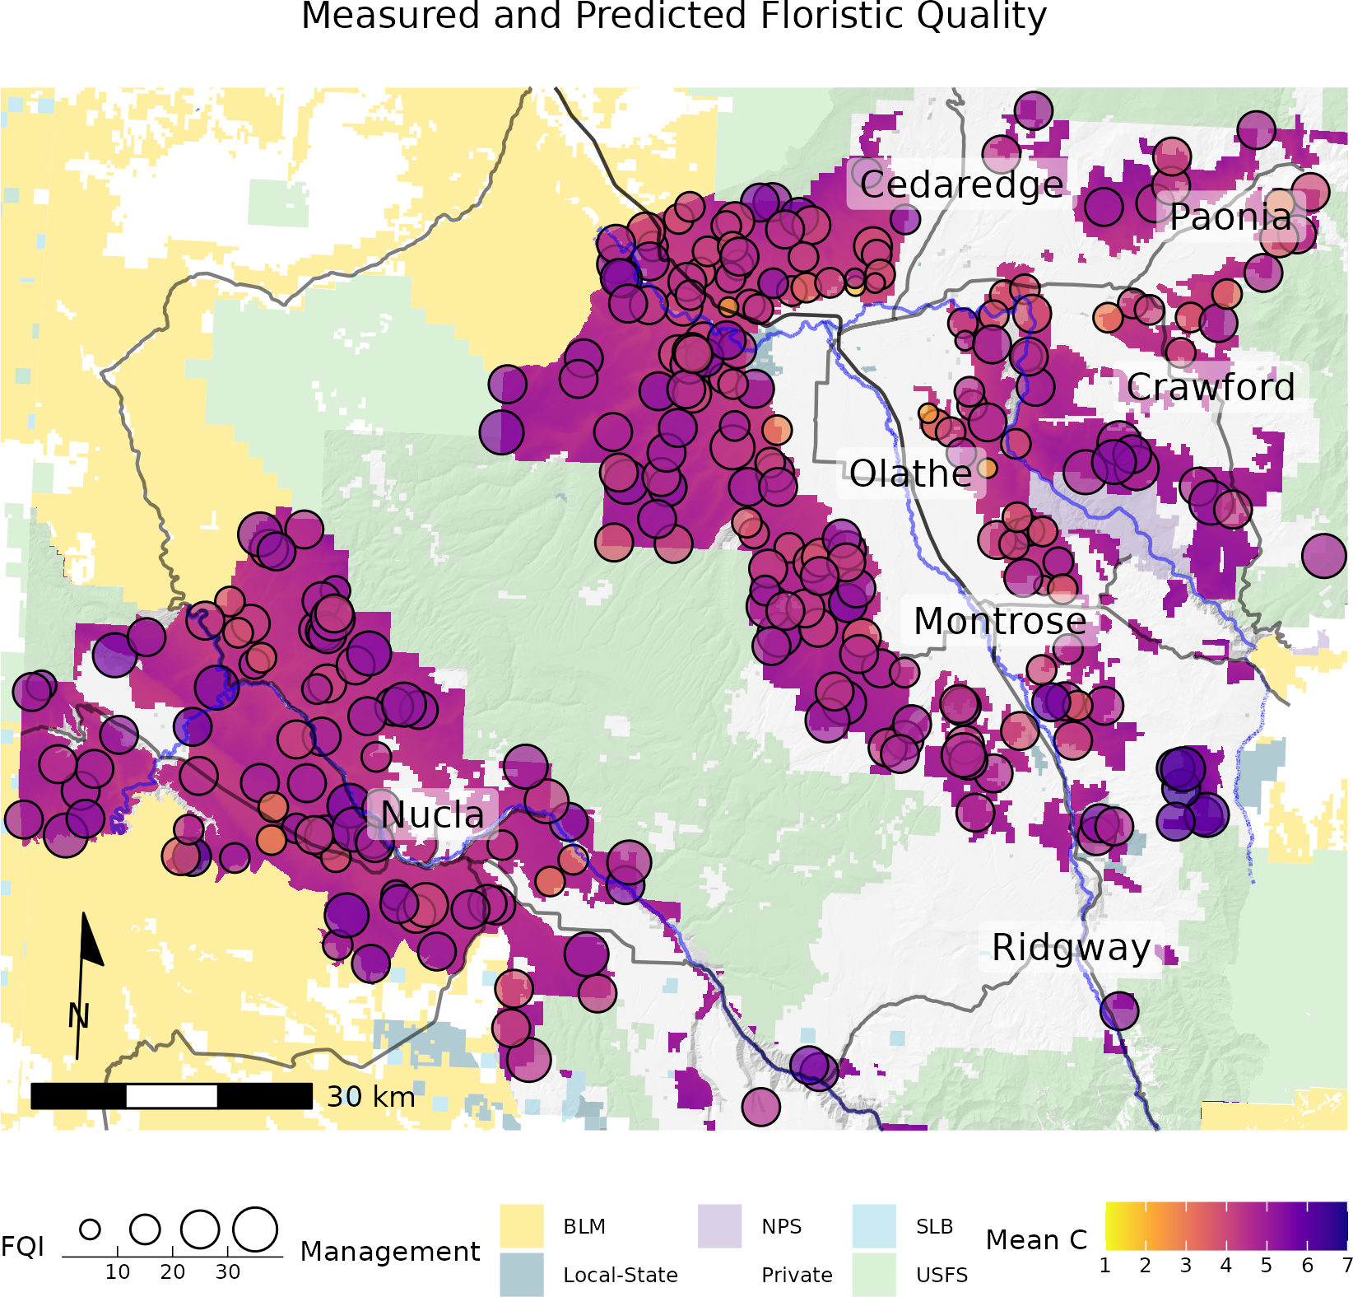

Consensus predictions of FQI Values across the UFO Field Office (excluding lands East of Paonia along the North Fork of the Gunnison)

## Appendix A - Indices

**Mean Coefficient of Conservatism**

Where:

**Floristic Quality Index**

Where:

Equations from Swink et al. (1994), and modified for simpler formulations.

# References

Ahrends, A., Rahbek, C., Bulling, M. T., Burgess, N. D., Platts, P. J., Lovett, J. C., Kindemba, V. W., Owen, N., Sallu, A. N., Marshall, A. R., et al. (2011). Conservation and the botanist effect. *Biological Conservation*, *144*(1), 131–140.

Bartoń, K. (2022). *MuMIn: Multi-model inference*. <https://CRAN.R-project.org/package=MuMIn>

Bivand, R. (2022). R packages for analyzing spatial data: A comparative case study with areal data. *Geographical Analysis*, *54*(3), 488–518. <https://doi.org/10.1111/gean.12319>

Bried, J. T., Allen, B. E., Azeria, E. T., Crisfield, V. E., & Wilson, M. J. (2018). Experts and models can agree on species sensitivity values for conservation assessments. *Biological Conservation*, *225*, 222–228.

Bried, J. T., Jog, S. K., & Matthews, J. W. (2013). Floristic quality assessment signals human disturbance over natural variability in a wetland system. *Ecological Indicators*, *34*, 260–267.

Dormann, C. F., Calabrese, J. M., Guillera-Arroita, G., Matechou, E., Bahn, V., Bartoń, K., Beale, C. M., Ciuti, S., Elith, J., Gerstner, K., et al. (2018). Model averaging in ecology: A review of bayesian, information-theoretic, and tactical approaches for predictive inference. *Ecological Monographs*, *88*(4), 485–504.

Hijmans, R. J. (2022). *Terra: Spatial data analysis*. <https://CRAN.R-project.org/package=terra>

Kramer, A. T., & Havens, K. (2015). Report in brief: Assessing botanical capacity to address grand challenges in the united states. *Natural Areas Journal*, *35*(1), 83–89.

Matthews, J. W., Spyreas, G., & Long, C. M. (2015). A null model test of floristic quality assessment: Are plant species’ coefficients of conservatism valid? *Ecological Indicators*, *52*, 1–7.

Morrison, L. W. (2016). Observer error in vegetation surveys: A review. *Journal of Plant Ecology*, *9*(4), 367–379.

Naimi, B., Hamm, N. a.s., Groen, T. A., Skidmore, A. K., & Toxopeus, A. G. (2014). Where is positional uncertainty a problem for species distribution modelling. *Ecography*, *37*, 191–203. <https://doi.org/10.1111/j.1600-0587.2013.00205.x>

Pebesma, E. (2018). Simple Features for R: Standardized Support for Spatial Vector Data. *The R Journal*, *10*(1), 439–446. <https://doi.org/10.32614/RJ-2018-009>

Smith, P., Doyle, Georgia, & Lemly, J. (2020). *Revision of colorado’s floristic quality assessment indices*. Colorado Natural Heritage Program. <https://cnhp.colostate.edu/download/documents/2020/CO_FQA_2020_Final_Report.pdf>

Spyreas, G. (2016). Scale and sampling effects on floristic quality. *PloS One*, *11*(8), e0160693.

Spyreas, G. (2019). Floristic quality assessment: A critique, a defense, and a primer. *Ecosphere*, *10*(8), e02825.

Swink, F., Wilhelm, G., et al. (1994). *Plants of the chicago region*. Indiana Academy of Science.

Taft, J. B., Hauser, C., & Robertson, K. R. (2006). Estimating floristic integrity in tallgrass prairie. *Biological Conservation*, *131*(1), 42–51.