Functional Diversity and Benchmarks

While each plant functions differently in an ecosystem context, the degrees of dissimilarity which exist between all species are unequal allowing them to clump together into groups. This observation has given rise to the notion of *Plant Functional Types*, shared attributes which unite similar species, and which bind how they affect ecosystems. Oftentimes, form follows function, and functions are hence referred to as forms. For example, Trees provide large amounts of shade, which in combination with their transpiration lower the temperature of areas. Plant functional types are quite often the easiest form of vegetation data to measure, and accordingly great amounts of work have been conducted on how they affect ecosystem function.

In Western Colorado, five major forms of plant functional types are often used to evaluate range conditions. These forms are: Trees, Shrubs, Grasses, and Forbs (or herbs), and each has been linked to affecting rangelands in multiple ways; theoretically their distributions and abundances are driven by variations in soil moisture throughout horizons (O. Sala et al. (1997)). Accordingly, in nearly all instances a mix of each of these groups, less trees, is best to maintain ecosystem services on BLM Land. In our area which features massive extents of Pinon-Juniper Woodland, trees when present, are included in this mix on ecological sites which they are more capable of surviving on over long periods relative to shrubs.

Semi-arid lands which are utilized as rangelands across the world are experiencing several common issues relating to shifts in the composition of their plant functional types (Archer & Predick (2014), Eldridge et al. (2016), Maestre et al. (2016), Diaz et al. (2007), Dalgleish et al. (2010)). Namely, decreases in grasses whilst increases in woody species are occurring. In certain areas, the increases - or encroachment of - woody species may be split into encroachment of trees, and the transition to a shrub state in ecological sites which do not support trees. In nearly all lands utilized as rangelands around the world the cover of and species richness of perennial forbs decreases, while the cover of annual forbs increases (Diaz et al. (2007), West & Yorks (2006)).

The current increases in shrub cover relative to the cover of the herbaceous strata, grasses and forbs, are problematic for a variety of reasons. The increase in Trees at mixed grass-shrublands sites may decrease water available to grasses and shrubs but not non-native annual grasses (McIver et al. (2022)), as cattle depend on grasses and wildlife shrubs these decrease the ability of our lands to support either. Increases in shrubs at the expense of perennial grasses and forbs may increase the severity of site level drought (Wilson et al. (2018)), further shrubs and trees may foster higher severity fires (CITE). Increases in shrubs decrease soil stability, allowing increased erosion, increasing DUST ON SNOW, and is an irritant to human breathing (Munson et al. (2011)). Decreases in perennial grass may reduce competing non-native annuals from overtaking sites Sheley & James (2010), Corbin & D’Antonio (2004), although a diversity of species may be best (Belnap & Sherrod (2008)). A decreases in forbs adversely affect wildlife feeding both directly and indirectly, and by decreasing the quality of habitats, the lack of perennial forbs are widely evident for species such as the Gunnison Sage-Grouse (Pennington et al. (2016)). These issues we are currently facing may be compounded in the future by problems which are only begin to become apparent.

While the major functional groups are capable of capturing considerable variation which predicts rangeland responses, they often maintain large amounts of variation with them (Lavorel et al. (2007), Funk et al. (2017)). And we believe that additional functional groups warrant attention in our area. As mentioned above C3 and C4 grasses have different responses to many environmental cues. Sprouting and non-sprouting shrubs differ widely in their responses to wildfire, and sites require different post fire management strategies. Annual and perennial forbs (life cycles), differ in their responsiveness to precipitation, with annuals declining rapidly in times of low precipitation.

# Methods

Due to certain inconsistencies in the assignment of plant species to functional groups in historic AIM analyses by the National Operations Center, these vegetation indicators were re-run locally using the cleaned field data.

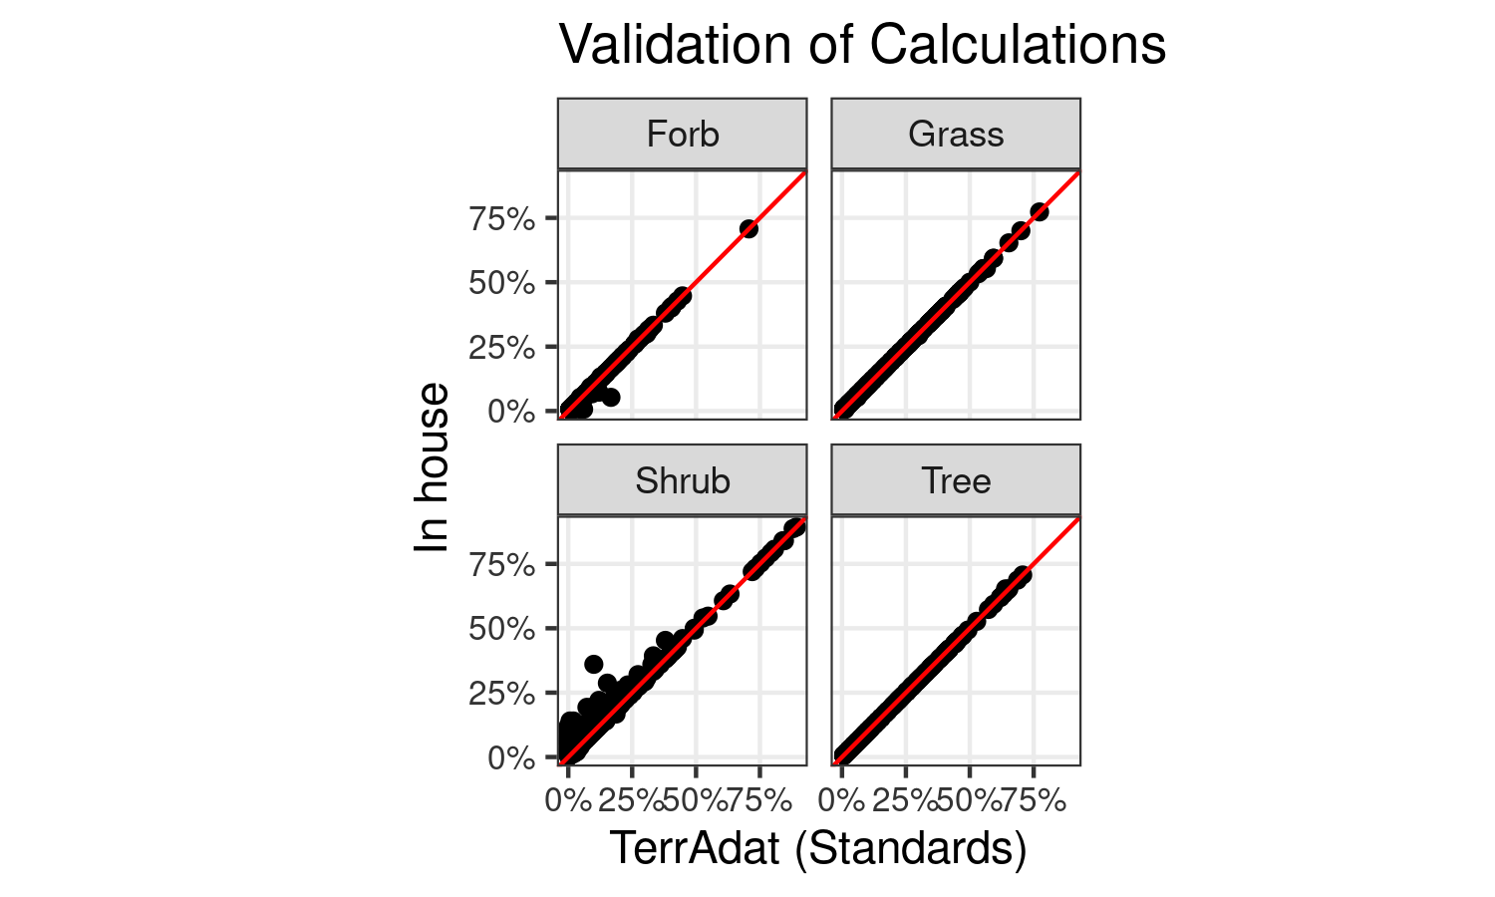

As can be seen in figure 1, very good accord existed between both in-house and the official calculations. This plot was fashioned and consulted in an iterative fashion, with manual investigation of the functional classification of plants at Ecological Sites; in other words points falling off the red line were investigated for the species contributing to the mismatch. We than reassigned the desired NOC group functional classification to these species. The discord between the Forb and Shrub functional groups are due to variability within the reference calculations in how at least two species were treated, either as a ford or shrub, over the time period. We did not attempt to emulate this, as these taxa are consistently scored within the ESD references. A total of 1466 site functional group pairs were utilized for this process. By the end of the process 1250 of these pairs had identical values when rounded to 1 decimal point (a tenth of a percent), of the remaining 216 records, 79 had less than a one percent difference in cover, and 116 were less than a 1.5% difference. By the end of the process the Pearson correlation coefficient for trees (n = 233, *r* = 0.99999) and grass (n = 333, *r* = 0.99998) indicated the values were essentially identical, and most likely diverged merely according to rounding during internal computations.

For the functional groups which diverged more notably, Forbs and Shrubs, these appear to be the result of a discrepancy regarding a single abundant species, *Gutierrezia sarothrae*. Based on a limited re-review of ESD’s, most authors considered this a sub-dominant shrub, a group which is combined into their estimates for Shrub Cover. Accordingly, we will utilize this assessment of *Gutierrezia sarothrae* and include it as a shrub in calculations. Largely due to this treatment we have slightly larger discrepancy between our and the Standard estimate of shrub cover (n = 364, *r* = 0.98489). This also leads to a discrepancy associated with estimates of forb covers (n = 320, *r* = 0.99612). However, a greater number of values diverge between the TerrAdat references and the in house calculated values, of the 216 records which diverge by > 0.1% cover, 176 of them are associated with Shrubs, and the correlation here is much lower at *r* = 0.96655. The 28 records have a correlation of *r* = 0.96798.

Further based on the same limited review of ESD’s succulents, notably *Opuntia* were also included in Shrub calculations. Given the functional nature of the above ground portions of *Opuntia*, and where it thrives, we include it in our calculations of Shrub cover.

# Results

Benchmark forb cover is generally low across all Ecological Sites in the study area, with a maximum expected cover at any site of 15% and the median mean value across all sites being 5.5%. In general these estimates focus on perennial species, as after they germinate nearly all of these species will retain some above ground biomass across each active growing season of their lives, whereas annual forbs may not germinate in drier years and hence have more across year variation in their abundance. As these values are intended to capture the variation of these Ecological Sites, and these estimates were presumably created within the last 20 years (see SECTION XX on ESD development), we would expect that the covers observed on AIM plots were close to the lower estimates of variability.

While nearly all plants produce less above-ground biomass during drought, additional complications with natural and climate induced mortality and the subsequent lack of recruitment of perennial forbs from the soil seed bank may contribute to sites not meeting benchmarks (Eziz et al. (2017), Casper (1996) Munson et al. (2022) ???). The establishment of both long and short lived forbs seems hampered during drought periods, and it may take several years after the cessation of a drought for the cover of perennial forbs to return to pre-drought conditions (Anderson & Inouye (2001)).

In particular it is probable that short lived perennial forbs, which generally only live a total of 2-4 years past their germination (Dalgleish et al. (2010)) have widely decreased in areas during the drought (Torang et al. (2010), Anderson & Inouye (2001)). While their appear to be few scientifically conducted observations on perennial forb longevity, many perennial forbs seem to generally persist for one to two decades (but up to four are noted), and once established (i.e. they reach reproductive maturity) are able to survive a couple types of disturbances, such as drought (Treshow & Harper (1974), Lauenroth & Adler (2008), Morris et al. (2008)). However, given the duration of the current drought, and the merely episodic periods of normal moisture balances (SECTION XX), required to recruit new individuals, it is possible many of the long lived perennials have suffered non-drought induced mortality, and have not recruited individuals from the seed bank. Recovery of the above ground cover of both forms of perennial forbs may require periods of from 2-5 years in more mesic sage-steppe areas (Anderson & Inouye (2001)).

Particular areas across the field office which may be the most affected by forb declines may be those inherently lower water storing capacity; such as those with skeletal soils and short depths to bedrock, e.g. Salt Desert and considerable portions of Pinyon-Juniper Woodland. It has been observed that the soil depth of sites can be a highly, or the most, influential factor on survival of perennial forbs during times of drought (Davison et al. (2010), Nicole et al. (2011)). Accordingly, sites supporting Wyoming Big-Sage, some of which constitute our Gunnison Sage-Grouse habitat should be less affected.

The cover of woody plants, both shrubs and trees, is expected to be at the upper end and beyond the reference benchmark values at nearly all Ecological Sites (Figure XX).The cover of woody plants being elevated relative to the reference conditions is a common occurrence in nearly all arid and semi-arid lands utilized as rangelands globally (Bestelmeyer et al. (2018), Archer et al. (2017)). While some disagreement over the exact mechanistic causes of increases in woody plant cover exist in the literature the major opinions largely reflect the opinions of land managers, whom feel that this trend may mostly be attributed to: 1) An altered fire-cycle 2) increasing atmosphere CO2 3) improper grazing by livestock (Bestelmeyer et al. (2018)). All of these initial drivers may lead to feedback loops enforced by changes to soil fertility which cause the shrub-encroached status of these sites to perpetuate (Bestelmeyer et al. (2018)).

Unfortunately in most scenarios, we do not expect that drought is going to have significant effects on reducing shrub and tree cover, and where mortality has occurred it threatens to create conditions which allow for potential of server wildfire. The species of shrubs and trees which grow in semi-arid lands are considered less responsive to droughts due to depths which many of their roots are able to reach to draw soil moisture (Winkler et al. (2019), CITE). The longevity of shrubs and trees is considerably greater than either forbs and grasses, and while it is expected the recruitment of these species are limited during dry periods, the effects of background mortality on them should have marginal effects at the time scales over which the current drought is occurring. However, a lack of self thinning processes and the competition between densely colonizing trees for limited water at their soils depths is likely to result in considerable mortality in areas with very dense stands of similarly aged trees. These areas are often times the result of an historic vegetation treatments, or other severe disturbances which led to a very large cohort of shrub and trees species germinating and attempting to develop synchronously. Given the high density of these individuals and the long time which it takes for them to decompose, if a source of ignition occurs these areas are likely to allow fires to spread rapidly and burn hot.

We expect that except for Salt Desert areas, nearly all plots across all Ecological Sites will have shrub covers exceeding the reference benchmarks. Further the extent of Ecological Sites which have elevated shrub cover is expected to be greater than for trees for multiple reasons. Chief among them are that in the study area shrubs have faster growth rates than trees, and a greater number of shrub species than trees species allow them to grow in more numerous habitat types. Further we expect that a great number of re-sprouting shrubs compose considerable amounts of this cover, in lieu of non-resprouting shrubs such as most of our species of sagebrush.

Reductions in shrubby plant cover, while maintaining and enhancing other functional groups, is difficult to implement at a landscape scale, and varies considerably by ecological site (CITE). Accordingly, we expect that many areas of the field office which had been treated before the advent of the current Ecological Sites have already had shrub cover return…

Whereas shrubs are expected to be greatly reduced in the Salt Desert, especially areas which have historically been composed primarily of shadscale (saltbush) (*Atriplex* spp.). Cover of most palatable species of shrubs, especially winterfat (*Krascheninnikovia*) & sages (*Artemisia*), in these areas was greatly reduced by improper livestock utilization upwards of a century ago (CITE). While passive efforts have been made to facilitate the establishment of shrubs at these sites, the very slow re-generative process, combined with climate and seasonal effects on usage, have not always shown the desired results (@, @, @).

As a component of woody cover, the same general trends, expectations, and reasoning behind an increase in tree cover is shared as discussed in the shrub section. Mortality of portions of trees is expected less on trees than shrubs.

Many historical vegetation treatments, especially for Pinyon-Juniper forests, were conducted throughout the study area (Pilliod et al. (2017)). However, akin to a great proportion of other such treatments globally, most of these were marginally effective (Ding & Eldridge (2022)). This is likely due to the potential of those ecological sites not including a mixed grass and shrub land more desirable for livestock use.

Currently three trajectories for Pinyon-Juniper cover exists in the study area. The **first** is the regrowth of Pinyon-Juniper on sites which were historically treated, and cannot support mixed grass-shrublands, and which are being allowed to naturally re-vegetate. The **second** is that a lack of certain disturbances, e.g. fire, at certain Ecological Sites is resulting in increases in Pinyon-Juniper as natural process of *succession*, i.e. these are parts of the landscape where the final vegetation community is PJ, but which via certain disturbances may be kept in a grass-shrub condition. The **third** trajectory is that Pinon-Juniper are encroaching upon lands which been largely devoid of naturally occurring processes, and are starting to promote their own expansions via feedback loops (CITE). In areas such as this multiple functionalities of the land are reduced, and are sites where vegetation treatments are highly desirable from a variety of ecosystem services perspectives (@), and which are capable of regaining ground for livestock usage (Anadon et al. (2014), Archer et al. (2017), Morford et al. (2022)).

The higher cover of trees than expected throughout the study area identifies ecological sites which vegetation treatments which involve tree removal can be implemented. Due to the effects of woody encroachment on the production of species which are used as forage by livestock, removals of low percentages

Prioritization of sites where treatments will offer the most ecosystem services, such as the most productive sites in terms of forage production, and areas with species of wildlife which are susceptible to higher predation via tree encroachment.

It is difficult to determine the extent to which grasses of the Colorado Plateau will reduce their above ground growth in response to drought. Various studies have found that grass production decreases during drought, and during periods of highly variable precipitation, however the extent of reductions are variable (Gherardi & Sala (2015), Staver et al. (2019), Munson et al. (2022)). While other studies show that the amount of biomass produced by grasses is quite resilient to drought (Byrne et al. (2017)), and that moisture limitation reductions in grass growth are largely buffered by legacy effects (in this case, a single normal year of precipitation, e.g. 2018, can offset the next few years of dryness and *vice versa*; SECTION XX) (O. E. Sala et al. (2012), Reichmann et al. (2013)). More recent studies limited to the Colorado Plateau have shown reduced growth of C4 grasses, partially due to variability in Monsoons, and C3 grasses via reduced cool season precipitation (Munson et al. (2022), Hoover et al. (2021)). However, given the distinctive growth forms of grasses (i.e. generally columnar), it is unlikely that their cover would be found to be much lower via the methods employed by AIM, unless high levels of mortality occurred.

Compared to perennial forb duration perennial grasses in general appear to live for considerable longer, many from 4-7 decades (Lauenroth & Adler (2008), Treshow & Harper (1974)) but purportedly many of the local grasses only persist 1-1.5 decades (WHERE WAS THIS?!?!?! - USGS local). Many clonal grass species, such as some species of *Bouteloua* appear much less likely to undergo mortality of the whole plant or many clones (De Witte & Stocklin (2010)) relative to bunch-grasses (but see Winkler et al. (2019)). Mortality due to drought is expected to reduce cover measurements of grasses more than reductions in above ground biomass. While grasses tend to have deeper roots than forbs, soil textures and depths (Chamrad & Box (1965), Griffin & Hoffmann (2012)) still mediate drought effects. A manipulative experiment which sought to determine the effect of drought on five grass species in the Colorado Plateau observed mortality of roughly 25% of all individuals under the ambient treatment (similar conditions to what the UFO experienced), largely attributed to Indian Rice Grass (*Achnatherum hymenoides*), tracked in ambient conditions over the time period 2011-2018 (Winkler et al. (2019)). Similar to forbs, we expect little to none recruitment of new grass individuals from the soil seed bank. However suspect it is unlikely that has considerably high a proportion of the members of this functional group would have died off over this period, independent of drought induced mortality (Morris et al. (2008), Winkler et al. (2019)) as perennial forbs, and given their average rooting depths relative to forbs should be more drought tolerant (O. Sala et al. (1997)). Accordingly we expect estimates of grass cover to be at the lowest end of the benchmarks.

### Metrics Combined

The condition of many Ecological Sites varied, and which benchmarks were being achieved, and at how many plots differed. Certain benchmarks were achieved more often than others (Figure 5)… Clearly the cover of tree was meet at many sites, given the aforementioned inability of them to grow in many habitats.

The feature engineered cover of forb is used across all plots. for sites in salt desert they alone are likely to not have enough SHRUB cover, sites in ASPEN/MMC stratum are automatically PASS for any cover of TREE.

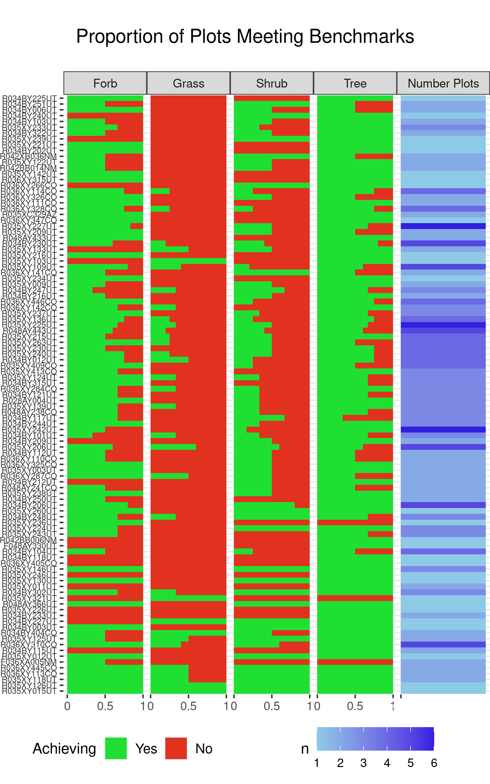

The Proportion of Plots in Each ESD which are meeting Reference Benchmarks

We can combine the number of plots, and their weight acres, within each stratum which had all four major functional groups within reference to develop a sense of how well the RMP objectives are being meet (Figure 6).

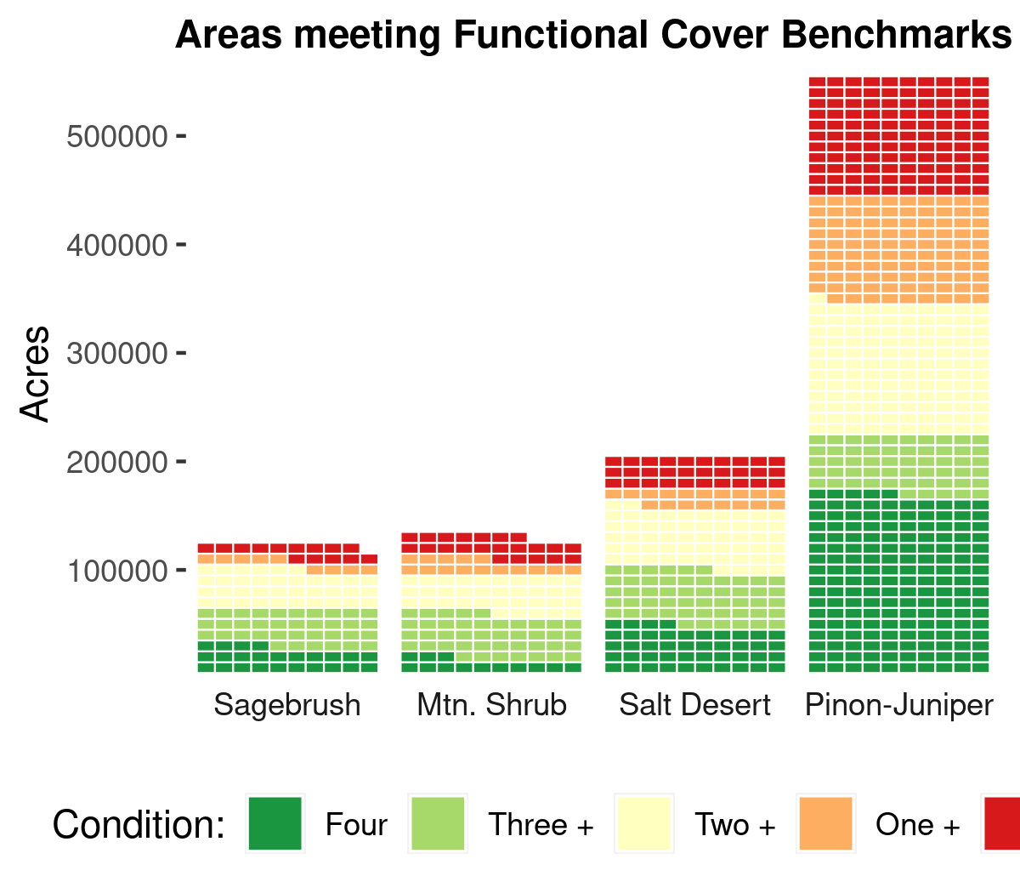

Total area of each stratum and the overall status of benchmarks

### Geographic Trends in Conditions

Certain areas throughout the Field Office differ in regards to meeting their benchmarks. Areas which…

# References

Anadon, J. D., Sala, O. E., Turner, B., & Bennett, E. M. (2014). Effect of woody-plant encroachment on livestock production in north and south america. *Proceedings of the National Academy of Sciences*, *111*(35), 12948–12953.

Anderson, J. E., & Inouye, R. S. (2001). Landscape-scale changes in plant species abundance and biodiversity of a sagebrush steppe over 45 years. *Ecological Monographs*, *71*(4), 531–556.

Archer, S. R., Andersen, E. M., Predick, K. I., Schwinning, S., Steidl, R. J., & Woods, S. R. (2017). Woody plant encroachment: Causes and consequences. In D. D. Briske (Ed.), *Rangeland systems: Processes, management and challenges* (pp. 25–84). Springer International Publishing. <https://doi.org/10.1007/978-3-319-46709-2_2>

Archer, S. R., & Predick, K. I. (2014). An ecosystem services perspective on brush management: Research priorities for competing land-use objectives. *Journal of Ecology*, *102*(6), 1394–1407.

Belnap, J., & Sherrod, S. K. (2008). Soil amendment effects on the exotic annual grass bromus tectorum l. And facilitation of its growth by the native perennial grass hilaria jamesii (torr.) benth. In *Herbaceous plant ecology* (pp. 345–357). Springer.

Bestelmeyer, B. T., Peters, D. P., Archer, S. R., Browning, D. M., Okin, G. S., Schooley, R. L., & Webb, N. P. (2018). The grassland–shrubland regime shift in the southwestern united states: Misconceptions and their implications for management. *BioScience*, *68*(9), 678–690.

Byrne, K. M., Adler, P. B., & Lauenroth, W. K. (2017). Contrasting effects of precipitation manipulations in two great plains plant communities. *Journal of Vegetation Science*, *28*(2), 238–249.

Casper, B. B. (1996). Demographic consequences of drought in the herbaceous perennial cryptantha flava: Effects of density, associations with shrubs, and plant size. *Oecologia*, *106*(2), 144–152.

Chamrad, A. D., & Box, T. W. (1965). Drought-associated mortality of range grasses in south texas. *Ecology*, *46*(6), 780–785.

Corbin, J. D., & D’Antonio, C. M. (2004). Competition between native perennial and exotic annual grasses: Implications for an historical invasion. *Ecology*, *85*(5), 1273–1283.

Dalgleish, H. J., Koons, D. N., & Adler, P. B. (2010). Can life-history traits predict the response of forb populations to changes in climate variability? *Journal of Ecology*, *98*(1), 209–217.

Davison, R., Jacquemyn, H., Adriaens, D., Honnay, O., De Kroon, H., & Tuljapurkar, S. (2010). Demographic effects of extreme weather events on a short-lived calcareous grassland species: Stochastic life table response experiments. *Journal of Ecology*, *98*(2), 255–267.

De Witte, L. C., & Stocklin, J. (2010). Longevity of clonal plants: Why it matters and how to measure it. *Annals of Botany*, *106*(6), 859–870.

Diaz, S., Lavorel, S., McIntyre, S., Falczuk, V., Casanoves, F., Milchunas, D. G., Skarpe, C., Rusch, G., Sternberg, M., Noy-Meir, I., et al. (2007). Plant trait responses to grazing–a global synthesis. *Global Change Biology*, *13*(2), 313–341.

Ding, J., & Eldridge, D. (2022). The success of woody plant removal depends on encroachment stage and plant traits. *Nature Plants*, 1–10.

Eldridge, D. J., Poore, A. G., Ruiz-Colmenero, M., Letnic, M., & Soliveres, S. (2016). Ecosystem structure, function, and composition in rangelands are negatively affected by livestock grazing. *Ecological Applications*, *26*(4), 1273–1283.

Eziz, A., Yan, Z., Tian, D., Han, W., Tang, Z., & Fang, J. (2017). Drought effect on plant biomass allocation: A meta-analysis. *Ecology and Evolution*, *7*(24), 11002–11010.

Funk, J. L., Larson, J. E., Ames, G. M., Butterfield, B. J., Cavender-Bares, J., Firn, J., Laughlin, D. C., Sutton-Grier, A. E., Williams, L., & Wright, J. (2017). Revisiting the h oly g rail: Using plant functional traits to understand ecological processes. *Biological Reviews*, *92*(2), 1156–1173.

Gherardi, L. A., & Sala, O. E. (2015). Enhanced precipitation variability decreases grass-and increases shrub-productivity. *Proceedings of the National Academy of Sciences*, *112*(41), 12735–12740.

Griffin, P. C., & Hoffmann, A. A. (2012). Mortality of australian alpine grasses (poa spp.) After drought: Species differences and ecological patterns. *Journal of Plant Ecology*, *5*(2), 121–133.

Hoover, D. L., Pfennigwerth, A. A., & Duniway, M. C. (2021). Drought resistance and resilience: The role of soil moisture–plant interactions and legacies in a dryland ecosystem. *Journal of Ecology*, *109*(9), 3280–3294.

Lauenroth, W. K., & Adler, P. B. (2008). Demography of perennial grassland plants: Survival, life expectancy and life span. *Journal of Ecology*, *96*(5), 1023–1032.

Lavorel, S., Diaz, S., Cornelissen, J. H. C., Garnier, E., Harrison, S. P., McIntyre, S., Pausas, J. G., Perez-Harguindeguy, N., Roumet, C., & Urcelay, C. (2007). Plant functional types: Are we getting any closer to the holy grail? In *Terrestrial ecosystems in a changing world* (pp. 149–164). Springer.

Maestre, F. T., Eldridge, D. J., Soliveres, S., Kefi, S., Delgado-Baquerizo, M., Bowker, M. A., Garcia-Palacios, P., Gaitan, J., Gallardo, A., Lazaro, R., et al. (2016). Structure and functioning of dryland ecosystems in a changing world. *Annual Review of Ecology, Evolution, and Systematics*, *47*, 215.

McIver, J., Grace, J. B., & Roundy, B. (2022). Pion and juniper tree removal increases available soil water, driving understory response in a sage-steppe ecosystem. *Ecosphere*, *13*(11), e4279.

Morford, S. L., Allred, B. W., Twidwell, D., Jones, M. O., Maestas, J. D., Roberts, C. P., & Naugle, D. E. (2022). Herbaceous production lost to tree encroachment in united states rangelands. *Journal of Applied Ecology*, *59*(12), 2971–2982.

Morris, W. F., Pfister, C. A., Tuljapurkar, S., Haridas, C. V., Boggs, C. L., Boyce, M. S., Bruna, E. M., Church, D. R., Coulson, T., Doak, D. F., et al. (2008). Longevity can buffer plant and animal populations against changing climatic variability. *Ecology*, *89*(1), 19–25.

Munson, S. M., Belnap, J., & Okin, G. S. (2011). Responses of wind erosion to climate-induced vegetation changes on the colorado plateau. *Proceedings of the National Academy of Sciences*, *108*(10), 3854–3859.

Munson, S. M., Bradford, J. B., Butterfield, B. J., & Gremer, J. R. (2022). Primary production responses to extreme changes in north american monsoon precipitation vary by elevation and plant functional composition through time. *Journal of Ecology*, *110*(9), 2232–2245.

Nicole, F., Dahlgren, J. P., Vivat, A., Till-Bottraud, I., & Ehrlen, J. (2011). Interdependent effects of habitat quality and climate on population growth of an endangered plant. *Journal of Ecology*, *99*(5), 1211–1218.

Pennington, V. E., Schlaepfer, D. R., Beck, J. L., Bradford, J. B., Palmquist, K. A., & Lauenroth, W. K. (2016). Sagebrush, greater sage-grouse, and the occurrence and importance of forbs. *Western North American Naturalist*, *76*(3), 298–312.

Pilliod, D. S., Welty, J. L., & Toevs, G. R. (2017). Seventy-five years of vegetation treatments on public rangelands in the great basin of north america. *Rangelands*, *39*(1), 1–9.

Reichmann, L. G., Sala, O. E., & Peters, D. P. (2013). Precipitation legacies in desert grassland primary production occur through previous-year tiller density. *Ecology*, *94*(2), 435–443.

Sala, O. E., Gherardi, L. A., Reichmann, L., Jobbagy, E., & Peters, D. (2012). Legacies of precipitation fluctuations on primary production: Theory and data synthesis. *Philosophical Transactions of the Royal Society B: Biological Sciences*, *367*(1606), 3135–3144.

Sala, O., Lauenroth, W., & Golluscio, R. (1997). 11 plant functional types in temperate semi-arid regions. *Plant Functional Types: Their Relevance to Ecosystem Properties and Global Change*, *1*, 217.

Sheley, R. L., & James, J. (2010). Resistance of native plant functional groups to invasion by medusahead (taeniatherum caput-medusae). *Invasive Plant Science and Management*, *3*(3), 294–300.

Staver, A. C., Wigley-Coetsee, C., & Botha, J. (2019). Grazer movements exacerbate grass declines during drought in an african savanna. *Journal of Ecology*, *107*(3), 1482–1491.

Torang, P., Ehrlen, J., & Aagren, J. (2010). Linking environmental and demographic data to predict future population viability of a perennial herb. *Oecologia*, *163*(1), 99–109.

Treshow, M., & Harper, K. (1974). Longevity of perennial forbs and grasses. *Oikos*, 93–96.

West, N. E., & Yorks, T. P. (2006). Long-term interactions of climate, productivity, species richness, and growth form in relictual sagebrush steppe plant communities. *Western North American Naturalist*, *66*(4), 502–526.

Wilson, S. D., Schlaepfer, D., Bradford, J., Lauenroth, W., Duniway, M., Hall, S., Jamiyansharav, K., Jia, G., Lkhagva, A., Munson, S., et al. (2018). Functional group, biomass, and climate change effects on ecological drought in semiarid grasslands. *Journal of Geophysical Research: Biogeosciences*, *123*(3), 1072–1085.

Winkler, D. E., Belnap, J., Hoover, D., Reed, S. C., & Duniway, M. C. (2019). Shrub persistence and increased grass mortality in response to drought in dryland systems. *Global Change Biology*, *25*(9), 3121–3135.