Calculating SPEI to contextualize our sampling times within drought

steppe

## Background

The AIM sample design is split into five panels, one for each year, with the intention that temporal analyses can be conducted across the panels (*see X.X for more info*). Ideally, these panels will reflect consistent natural climatic variation. In others words, some years will be drier while other years will be wetter, and the differences they have on the attributes measured by AIM can be considered. However, we felt, and our constant monitoring of the University of Nebraska-Lincolns Drought Monitor over this period, supported the notion that we sampled during a period of immense drought. In fact, the sampling was concluded during a period of drought shown to be the most severe since the year 800 A.D. (Williams et al. (2022)). Here we contextualize our sampling period within the known climatic variation in the field office, and discuss why we dismiss calculating AIM metrics separately for each year.

Contrary to the concept of Agricultural drought, the exploration and understanding of Ecological drought is nascent and not as well defined (Crausbay et al. (2017), Slette et al. (2019)). In fact, numerous recent papers published in *peer-reviewed journals* have sought to both define this term, and formulate it in a way which it may be applied to the management of natural resources. A recent example of the term is:

“***ecological drought*** *… an episodic deficit in water availability that drives ecosystems beyond thresholds of vulnerability, impacts ecosystem services, and triggers feedbacks in natural and/or human systems*”

— Crausbay et al. 2017

Guidance regarding how to move from defining the term ‘ecological drought’ to using it this term is also recent, and limited.

“*We suggest that future drought publications provide at least one of the following:* ***(a)*** *the climatic context of the drought period based on long‐term records;* ***(b)*** *standardized climatic index values;* ***(c)*** *published metrics from drought‐monitoring organizations;* ***(d)*** *a quantitative definition of what the authors consider to be drought conditions for their system*”

— Slette et al. 2019

In this section of the report, we perform both operations **a, b**, and calculate our own drought metrics using the exact same equations, and software implementations to calculate **c**, as these organizations. We opt to calculate **c** ourselves due to the topographic complexity (rugged mountainous) of the study area making the coarse scale models generated by other organizations of limited utility in understanding the Uncompahgre Field Office. Finally, for the purposes of this document we do define **d** for our field office, using the expertise of several Natural Resource Specialists in Western Colorado. Hence, in this section we will meet not only the suggested one metric above, but all of them.

## Methods:

Calculations of metrics which measure drought essentially reflect the relationship of 1) the amount of moisture entering an area, 2) and the amount of moisture leaving that area, and how 3) these values are balanced. When more moisture enters an area than leaves it, the moisture balance will be positive, when the moisture balance is negative for an extended period of time the area will in drought. Hence all equations for measuring drought may be conceptually simplified to

When than is negative and drier conditions prevail. In calculating drought the amount of moisture entering an area (1), is simply equivalent to the volume or precipitation, in any form (e.g. rain or snow). The amount of moisture leaving the area (2) via the process of evaporation is driven by many processes, such as the amount and intensity of sunshine, wind, temperature. The amounts of potential evaporation (the evaporation which would occur is sufficient amounts of water were present to allow) is commonly modelled using one of three models, which since their original developments have been slightly modified in numerous ways (Xiang et al. (2020)). In order of increasing complexity these are the Thornwaite, Hargreaves, and the Penman-Montieth equations (Thornthwaite (1948) Penman (1948), Hargreaves et al. (1985)). We chose to utilize the Penman-Montieth equation to estimate the Potential Evaporation in our study area, because both the Thornwaite and Hargreaves equations have been shown to under-estimate drought conditions in arid regions (Begueria et al. (2014)).

The most common and widely employed metric of measuring drought is the Palmer Drought Severity Index (PDSI). This metric is used by the USDA, and is highly effective for conveying information regarding drought in agricultural settings (Palmer (1965)). However, a metric preferred for calculating general drought outside of irrigated agricultural areas is the Standardized Precipitation Index (SPI) (McKee et al. (1993), Hayes et al. (2011)). One drawback of the SPI is that it does not account well for long linear trends, namely climate change. Using SPI would underestimate the values of drought in the study area, as drought is contingent upon air temperature and it’s effect upon evaporation. To overcome this shortcoming the Standardized Precipitation Evapotranspiration Index (SPEI) was developed (Vicente-Serrano et al. (2010), Begueria et al. (2014)). We will employ the SPEI for visualizing drought.

Metrics of sunshine were calculated using r.sun (total beam irradiance) and r.sunhours (daily sunhours) in Grass GIS (GRASS Development Team (2017)), on Linux Ubuntu 20.04.5 LTS. The function r.sunhours requires a year for which to calculate these values for, the year 2000 was selected as it represents a rounded midpoint of the temporal range of the climate variables (1979-2021), the linke value for r.sun was set at 2.35 (in lieu of the default value of 3.0), which is the mean of the annual linke value for mountains (2.75), and rural areas (1.9). Subsequent to these calculations, which were performed for each day of the year, the values were recalculated as monthly means. Subsequent to the calculations the total sun hours were subtracted from the mean monthly percent cloud cover dataset.

All climate variables, aside from cloud cover, were downloaded from gridMet using ‘Get_Gridmet’ (Abatzoglou (2013), Lovell & Benkendorf 2022). These variables were chosen in lieu of one of the two datasets from which they are derived, PRISM, due to that dataset lacking Wind Speed and Relative Humidity data (Abatzoglou (2013)). As gridMET data are at a daily resolution, the means for each month of each year from 1979 to 2021 were calculated using R. The temperature values were converted to Celsius from Kelvin .

Cloud Cover data were downloaded from EarthENV, from the study of Wilson (2016), and were transformed back into percentages by multiplying , raster data are often transmitted with alterations of decimal points to reduce the file size.

The digital elevation model (DEM), which was utilized in the calculation of sunshine metrics and in the Penman equation, was downloaded from EarthENV, and re-sampled from it’s 90m resolution to align with the grain of the other datasets - 4km (Robinson et al. (2014)).

**Variables to calculate Potential Evaporation via the Penman-Montieth equation**

| Variable | Source |
| --- | --- |
| precipitation sum (mm) | GridMET (pr) |
| mean max temp (ºC) | GridMET (tmmx) |
| mean min temp (ºC) | GridMET (tmmn) |
| mean rel. humidity |  |
| mean wind speed (km h-1) | GridMET (vs) |
| mean sun hours (hours) | r.sunhours (sunhour) |
| mean solar radiation (MJ-m-d) | r.sun (beam_rad) |
| mean cloud cover (percent) | Wilson, EarthEnv |
| elevation in meters | EarthEnv 90m |

Note all of these values are over a month

SPEI was calculated for all 42 years between 1979-2021. Cells in rasters which contained missing (NA) values, these resulting from missing a value required for either the penman or SPEI calculations, were filled using the ‘focal’ function from the r package ‘Terra’. This function calculated the mean of the 9 nearest pixels to the missing value. SPEI was calculated using moisture balances of the: 6, 12, 24 months preceding the current month of analysis. For example, the SPEI value for the Month of January 1981, under a scenario with a 6 month window, would go back as far as June 1980, while for a longer window such as 24 months, would go back to January 1979. Because our SPEI calculations included these windows, each data set could not-natively start at the same date. For example our dataset with the longest SPEI window, 24 months, exceeded the shortest windows by 18. Accordingly, we removed any months of values preceding the origin date for the start of the longest SPEI calculation intervals, and for ease of analysis and reporting began our background climate dataset in 1981.

We subset the drought data so that the beginning period for all temporal extents has the same start date, January 1981. It is recommended to have 30 years of climate data to compare local conditions to. We will span the years from 1981-2015 as our 34 year background data. This will also allow a slight degree of buffering between our data sets, so that the starting times between our two datasets, the occurrence of drought during the AIM sampling, and the historic climate variables are not temporally replicated.

SPI Values Interpretation

| Value | Interpretation |
| --- | --- |
| > -0.5 | near normal |
| -0.5 to -0.7 | Abnormally Dry |
| -0.8 to -1.2 | Moderate Drought |
| -1.3 to -1.5 | Severe Drought |
| -1.6 to -1.9 | Extreme Drought |
| < -2.0 | Exceptional Drought |

From a presentation by Brian Fuchs of the National Drought Mitigation Center and University of Nebraska-Lincoln

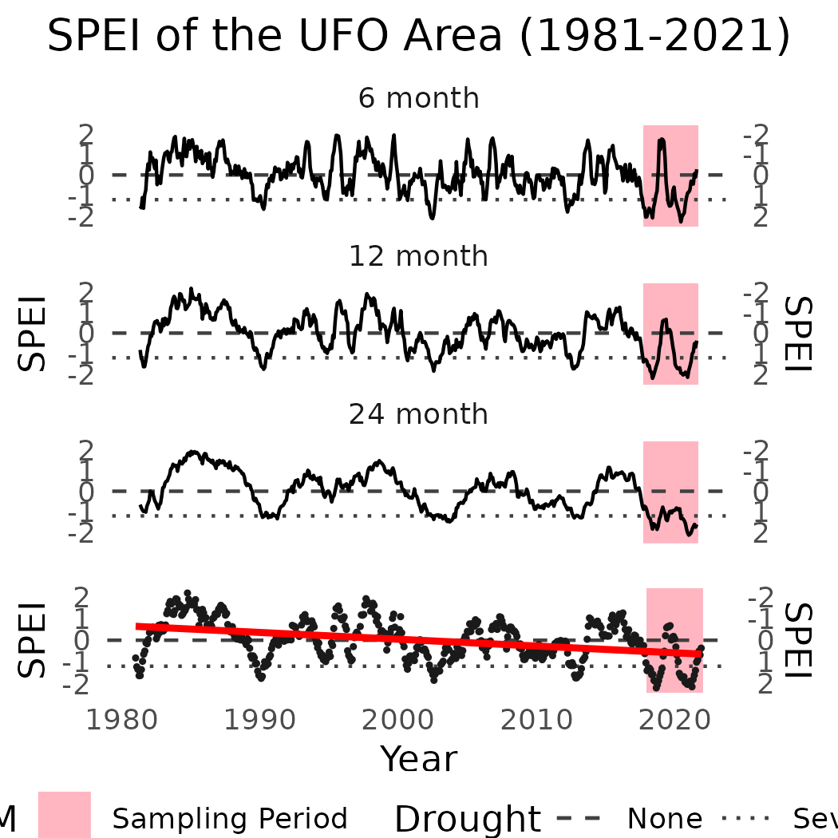

Mean Drought Status of the UFO area over time

We can see that the UFO has oscillated between drought status and excessive

# References

Abatzoglou, J. T. (2013). Development of gridded surface meteorological data for ecological applications and modelling. *International Journal of Climatology*, *33*(1), 121–131.

Begueria, S., Vicente-Serrano, S. M., Reig, F., & Latorre, B. (2014). Standardized precipitation evapotranspiration index (SPEI) revisited: Parameter fitting, evapotranspiration models, tools, datasets and drought monitoring. *International Journal of Climatology*, *34*(10), 3001–3023.

Crausbay, S. D., Ramirez, A. R., Carter, S. L., Cross, M. S., Hall, K. R., Bathke, D. J., Betancourt, J. L., Colt, S., Cravens, A. E., Dalton, M. S., et al. (2017). Defining ecological drought for the twenty-first century. *Bulletin of the American Meteorological Society*, *98*(12), 2543–2550.

GRASS Development Team. (2017). *Geographic resources analysis support system (GRASS GIS) software, version 7.2*. Open Source Geospatial Foundation. <http://grass.osgeo.org>

Hargreaves, G. L., Hargreaves, G. H., & Riley, J. P. (1985). Irrigation water requirements for senegal river basin. *Journal of Irrigation and Drainage Engineering*, *111*(3), 265–275.

Hayes, M., Svoboda, M., Wall, N., & Widhalm, M. (2011). The lincoln declaration on drought indices: Universal meteorological drought index recommended. *Bulletin of the American Meteorological Society*, *92*(4), 485–488.

McKee, T. B., Doesken, N. J., Kleist, J., et al. (1993). The relationship of drought frequency and duration to time scales. *Proceedings of the 8th Conference on Applied Climatology*, *17*, 179–183.

Palmer, W. C. (1965). *Meteorological drought* (Vol. 30). US Department of Commerce, Weather Bureau.

Penman, H. L. (1948). Natural evaporation from open water, bare soil and grass. *Proceedings of the Royal Society of London. Series A. Mathematical and Physical Sciences*, *193*(1032), 120–145.

Robinson, N., Regetz, J., & Guralnick, R. P. (2014). EarthEnv-DEM90: A nearly-global, void-free, multi-scale smoothed, 90m digital elevation model from fused ASTER and SRTM data. *ISPRS Journal of Photogrammetry and Remote Sensing*, *87*, 57–67.

Slette, I. J., Post, A. K., Awad, M., Even, T., Punzalan, A., Williams, S., Smith, M. D., & Knapp, A. K. (2019). How ecologists define drought, and why we should do better. *Global Change Biology*, *25*(10), 3193–3200.

Thornthwaite, C. W. (1948). An approach toward a rational classification of climate. *Geographical Review*, *38*(1), 55–94.

Vicente-Serrano, S. M., Begueria, S., & Lopez-Moreno, J. I. (2010). A multiscalar drought index sensitive to global warming: The standardized precipitation evapotranspiration index. *Journal of Climate*, *23*(7), 1696–1718.

Williams, A. P., Cook, B. I., & Smerdon, J. E. (2022). Rapid intensification of the emerging southwestern north american megadrought in 2020–2021. *Nature Climate Change*, *12*(3), 232–234.

Xiang, K., Li, Y., Horton, R., & Feng, H. (2020). Similarity and difference of potential evapotranspiration and reference crop evapotranspiration–a review. *Agricultural Water Management*, *232*, 106043.