Vegetation_Classification

steppe

2022-10-03

The initial AIM sample design for each office was based upon small stratified areas - (Primary Sampling Units) PSU’s which up to 3 plots per each of are to make inference of. The primary sampling units were based on older vegetation classification projects which do not perform as high as other mechanisms.

We have used the in field AIM data to reclassify a number of plots in unusual strata such as: ‘Other’, ‘Mixed Conifer’, and ‘Riparian’. We will use all of this reclassified AIM data to determine whether the PSU on the whole is classified as the same vegetation type as the points which were sampled within it.

To do this a very simple vegetation classification will be performed using a handful of spatial products. The central product will be the National Aerial Imagery Programs flight data. Supplemental data includes a 10m DEM which was previously re-processed using WhiteBoxTools, a 10m resolution slope dataset, and a 10m landform classification dataset.

# Methods

NAIP Imagery for Colorado 2019 was downloaded from the official repository at Box in Fall 2022. While decoding from MrSID to tif file formats, their resolution was reduced by a factor of two using the ‘mrsiddecode’ program (Vers. 9.5.1.4427) from LizardTech. These raster tiles were united via mosaic, cropped to the extent of the Field Office Buffer, and masked to BLM administered surface areas. and they were aligned with previously generated raster datasets derived from a 10m DEM.

A Gray Level Co-occurrence Matrix (GLCM) was created using the glcm package to create a texture raster layer to aid in classification. Texture bands are, among other properties, capable of indicating the amounts of heterogeneity of habitat types across the landscape.

NAIP data were processed to create an NDVI band.

$$NDVI=\left(NearIR−Red\right)/\left(NearIR+Red\right)$$

 NDVI is well suited for identifying sparsely vegetated areas, it may be useful in distinguishing salt desert from all other strata, and help in distinguishing between MMS and PJ.

To create a more equally balanced training data set, all classified AIM points were exported to Google Earth. 150 random points were generated across the focal BLM district and classified in Google Earth via the vegetation ecologist which lead the AIM sampling in 2022. Additional records for each stratum, less Aspen forest, without enough points for balanced sampling were found by the vegetation ecologist and marked via Google Earth.

To create a more equally balanced training data set, all 469 AIM and LMF points were exported to Google Earth and 440 were classified. 400 random points were generated across the focal BLM district and 377 classified in Google Earth via the vegetation ecologist which lead the AIM sampling in 2022. An additional 885 regularly placed plots were drawn across the extent of the field office and 854 were classified. Unclassified computer generated points were generally those that fell upon a wide road, or were outside BLM Ownership. Unclassified AIM/LMF points were LMF points which must have represented the revisitation of a single plot.

Classified plots were randomly sampled to ensure an equal number of points per stratum, less Aspen and Mixed Conifer.

The dataset of 1657 classified points were partioned into a 0.3 test and training set 0.7 using caret, the dataset was not balanced, see table XX for sample sizes.

The number of mtry in the random forest model were tuned using the function tuneRF with the number of trys set to 1000, a step factor of 1.5 and a relative minimum improvement in Out of Bag (OOB) error rate set at 0.01. The random forest model was than trained using 4 mtry and 1000 trees, all using the RandomForest package.

The Random Forest classification model was predicted onto a raster surface using the package Terra. This raster was then smooth using focal statistics, with a window of 5 cells, using the mode as the value to return.

# Comparision of New and Old vegetation classification models.

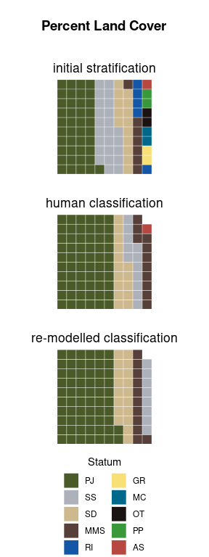

Changes in Estimated Land Cover between the initial stratification and post-stratification

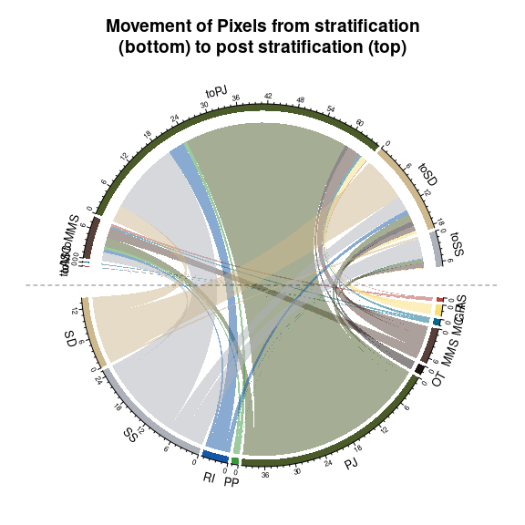

This diagram shows how raster cells in the UFO are redistributed from the original sample design, to the the reclassified spatial product for the sample design

The initial AIM sample design was based upon a stratification which included r communities. This design was based on a manual reclassification of the GAP/LANDFIRE National Terrestrial Ecosystems 2011 data set.

# Citations

[[1]]  
Hijmans R (2022). _terra: Spatial Data Analysis_. R package version  
1.6-17, <https://CRAN.R-project.org/package=terra>.  
  
[[2]]  
Zvoleff A (2020). _glcm: Calculate Textures from Grey-Level  
Co-Occurrence Matrices (GLCMs)_. R package version 1.6.5,  
<https://CRAN.R-project.org/package=glcm>.  
  
[[3]]  
Leutner B, Horning N, Schwalb-Willmann J (2022). _RStoolbox: Tools for  
Remote Sensing Data Analysis_. R package version 0.3.0,  
<https://CRAN.R-project.org/package=RStoolbox>.  
  
[[4]]  
Liaw A, Wiener M (2002). "Classification and Regression by  
randomForest." _R News_, *2*(3), 18-22.  
<https://CRAN.R-project.org/doc/Rnews/>.  
  
[[5]]  
Kuhn M (2022). _caret: Classification and Regression Training_. R  
package version 6.0-93, <https://CRAN.R-project.org/package=caret>.  
  
[[6]]  
R Core Team (2022). _R: A Language and Environment for Statistical  
Computing_. R Foundation for Statistical Computing, Vienna, Austria.  
<https://www.R-project.org/>.  
  
[[7]]  
Corporation M, Weston S (2022). _doParallel: Foreach Parallel Adaptor  
for the 'parallel' Package_. R package version 1.0.17,  
<https://CRAN.R-project.org/package=doParallel>.