Action 3.1, Geomorphology, Supplemental

The effects of climate and extreme weather on plant survival and growth are mediated directly and indirectly by landforms, and indirectly by soil across a range of spatial scales (Giaccone et al. 2019; Moeslund et al. 2013; Swanson et al. 1988). Landforms directly influence climate to produce micro-climates such as cold pools and micro-rain shadows, resulting in variations in evapotranspiration and soil moisture availability gradients, even in relatively flat landscapes (Pastore et al. 2022; Minder et al. 2008). Topographic slope and aspect control the amount of incipient solar radiation generating local gradients in both soil temperature and soil moisture (Dearborn and Danby 2017). Landform features and positions have also been shown to influence the amount of soil moisture, at various depths and across time, by altering the amount of overland, and subsurface, water flow leading to areas with either elevated or reduced soil moisture (McAuliffe 1994; Wondzell, Cunningham, and Bachelet 1996; Qiu et al. 2001). Soil moisture has naturally also been shown to be influenced by the number of soil properties such as coarse fragments throughout the horizons [Katra, Lavee, and Sarah (2008), as well as physical texture (English et al. 2005; Fernandez-Illescas et al. 2001; Singh, Milchunas, and Lauenroth 1998), and chemical properties (e.g., carbonates and soil organic carbon) (Duniway, Herrick, and Monger 2010; Rawls et al. 2003). Collectively, these factors can lead to a decoupling between the resolution of climate variables generated by climatological spatial modelling and the responses of plant populations to evapotranspirative demands (Ackerly et al. 2020; Potter, Arthur Woods, and Pincebourde 2013; Lenoir, Hattab, and Pierre 2017).

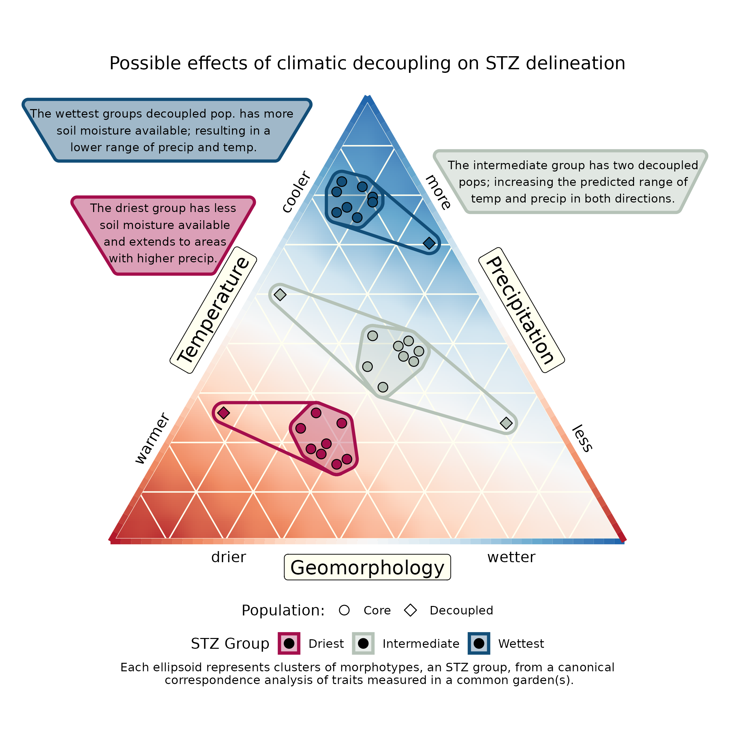

Conceptual figure illustrating the effects of climatic decoupling on seed transfer zone development from common garden studies.

Effectively, the decoupling between climate and soil moisture may result in idiosyncratic results in common garden studies, where source populations may be adapted to drier (e.g., coarse soils, south-facing aspects, ridgelines) or wetter conditions (e.g., fine soils, northern aspects, footslopes) than climate alone would indicate (Figure 1). This may affect both fitting regression models to the canonical correlation analysis (CCA) axes of traits (such as phenology dates and productivity) measured in common gardens -which form the basis for seed transfer zone groups- and the prediction of these models into environmental and geographic space, and hence the subsequent partitioning of areas into seed transfer zones. A similar cost could be associated with seed transfer zone models based on correlative ecological niche models and climate matching (for example, (Crow et al. 2018; Shryock et al. 2017)), except that the original models would fit directly to a binary (or somatic growth) response without the possibility of a common garden to mitigate any effects; however, given the potential for larger samples, this effect may be ameliorated.

The direct effects of topography on climate are a well-known phenomenon, and various approaches for downscaling gridded climate data from moderate (e.g. ~4km, ~1km, ~800m) to finer resolutions (e.g. 30m) have been developed and shown to better capture local climatology (Potter, Arthur Woods, and Pincebourde 2013; Wang et al. 2016). The use of these downscaled data sets (e.g. ClimateNA) has already been implemented by the majority of researchers (for example, Bradley St. Clair et al. (2013). Although these tools are more effective for modelling localized climates, they do not address the effects of geomorphology on precipitation that has reached the soil surface. However, recent advances in LiDAR have made the inclusion of moderate to high resolution landform attributes, such as topographic position, topographic wetness indices, aspect, slope, and terrain-derived derivatives, achievable with data products such as Geormopho90m (Amatulli et al. 2018, 2020) or can be readily calculated using a variety of geographic information systems (e.g., WhiteBoxTools). As covariates landform attributes may help explain responses between populations; for example, many populations from more arid regions may actually be located in refugial areas (e.g., northern facing toes of slope) where they are buffered from the realized microclimate.

Moderate resolution soil data are available for a variety of physical and chemical components (for example SoilGrids), as well as soil moisture; however, in our experience, these data are less accurate than the aforementioned topographic data sets because of the disparity in the abilities of remote sensing approaches (Hengl et al. 2017; Vergopolan et al. 2021). Gibson et al. 2019 used soil covariates from the SSURGO database and found variables which moderate soil moisture, such as soil organic carbon and percent clay, and were able to decrease variance in models relating common garden results to source populations. However, within their region of analysis, the climate-only models suggested three zones, and the climate + soil models generated eight zones, four of which collectively constituted less than 5%, relative to a similar number of pSTZ for treating the same area (Bower, Clair, and Erickson 2014). Hence, while utilization of geomorphological covariates may increase predictive abilities, they may also create more seed zones than are practical, especially small isolated patches within larger zones ((Gibson et al. 2019); Shyrock, unpublished data) and their incorporation may require post-processing steps where STZs with very small total geographic coverage are removed from downstream applications, for example, by reassignment to their nearest neighbors; or if retained a raster of multi class classifications can help land managers determine if development of materials for these zones are warranted (see Benkendorf & Wieferich *in revision*).

Note that, aside from ‘extreme’ or harsh soils such as (for example mine tailings, serpentine, gypsum, limestones, marine clays, and tuffs) evidence for adaption of plant populations to individual soil types appears to seldom be documented in the literature (Macel et al. 2007; Ellis and Ågren 2024; O’Dell and Rajakaruna 2011), indicating that most populations for most species appear suitable for restoration sites of appropriate aridity levels. Notably, several experiments show that the abiotic soil environment alone does not show cases differences in fitness between ecotypes, in the absence of another stressor such as herbivory or drought (Dittmar and Schemske 2023; Dorey et al. 2024). And that for ‘common’ soil types the effect of micro-organisms have been shown to be more strong than abiotic effects ((Sherrard and Maherali 2012), *see Section 3.2*). In restoration contexts, of five commonly used restoration species of Central European grasslands only one showed a weak adaption to acidic soils (relative to calcareous) (Rupprecht, Hölzel, and Bucharova 2021), and in an evaluation of eSTZs in the Great Basin USA no evidence of adaption to local soil types, or differing survival on different common garden soils were observed (Davidson and Germino 2020). Hence our recommendation for focusing on continuous landform and soil variables which affect soil moisture, rather than using soil classes, for research.

## Restoration Action

Restoration practitioners, when presented with multiple seed source options for a restoration and which have similar climate similarity to the site, have expressed interest in matching seed sources to site using additional criteria. Under certain scenarios, the use of ecological site descriptions (ESD’s) will articulate the relationship between climate, geomorphology, and the response of vegetation to sites (Moseley et al. 2010). The use of ESDs will not only lead to a match between climate and geomorphology, but also foster the selection of seed lots where the focal species has been in a similar vegetation context to it’s desired outcome (*Section 3.4*), i.e. the population will have been exposed to other species likely to recruit at the site, or to be seeded. However, the development of ESDs across Western North America has been a long process, and the status of their mapping is variable, and to date no gridded surfaces for them exist (Brown 2010). A possible solution has been the development of Ecological Site Groups (ESGs), which combine local expertise with geospatial modelling approaches, and have been developed for at least one large geographic domain (the Colorado Plateau) (Nauman et al. 2022). While ESGs do not offer the same thematic resolution as ESDs, they still reflect the interactions between climate and geomorphology, and may be used in the interim to express these relationships within seed transfer zones; further as they are developed computationally they can developed in a cost-effective manner (Nauman et al. 2022). For immediate use, practitioners may be able to combine data sets which classify landform positions, with continuous soil textural and physical properties (discussed above) to help inform the similarity between prospective seed sources and a restoration site; however these approach is more time intensive and will require extensive domain knowledge. Finally, combining multiple data sets, e.g. climate similarity and geomorphology, may result in more rather than less confusion when selecting plant materials without a clearly defined workflow for decision making.

## Works Cited

Ackerly, David D, Matthew M Kling, Matthew L Clark, Prahlad Papper, Meagan F Oldfather, Alan L Flint, and Lorraine E Flint. 2020. “Topoclimates, Refugia, and Biotic Responses to Climate Change.” *Frontiers in Ecology and the Environment* 18 (5): 288–97.

Amatulli, Giuseppe, Sami Domisch, Mao-Ning Tuanmu, Benoit Parmentier, Ajay Ranipeta, Jeremy Malczyk, and Walter Jetz. 2018. “A Suite of Global, Cross-Scale Topographic Variables for Environmental and Biodiversity Modeling.” *Scientific Data* 5 (1): 1–15.

Amatulli, Giuseppe, Daniel McInerney, Tushar Sethi, Peter Strobl, and Sami Domisch. 2020. “Geomorpho90m, Empirical Evaluation and Accuracy Assessment of Global High-Resolution Geomorphometric Layers.” *Scientific Data* 7 (1): 162.

Bower, Andrew D, J Bradley St Clair, and Vicky Erickson. 2014. “Generalized Provisional Seed Zones for Native Plants.” *Ecological Applications* 24 (5): 913–19.

Bradley St. Clair, John, Francis F Kilkenny, Richard C Johnson, Nancy L Shaw, and George Weaver. 2013. “Genetic Variation in Adaptive Traits and Seed Transfer Zones for p Seudoroegneria Spicata (Bluebunch Wheatgrass) in the Northwestern United States.” *Evolutionary Applications* 6 (6): 933–48.

Brown, Joel R. 2010. “Ecological Sites: Their History, Status, and Future.” *Rangelands* 32 (6): 5–8.

Crow, Taylor M, Shannon E Albeke, C Alex Buerkle, and Kristina M Hufford. 2018. “Provisional Methods to Guide Species-Specific Seed Transfer in Ecological Restoration.” *Ecosphere* 9 (1): e02059.

Davidson, Bill E, and Matthew J Germino. 2020. “Spatial Grain of Adaptation Is Much Finer Than Ecoregional-Scale Common Gardens Reveal.” *Ecology and Evolution* 10 (18): 9920–31.

Dearborn, Katherine D, and Ryan K Danby. 2017. “Aspect and Slope Influence Plant Community Composition More Than Elevation Across Forest–Tundra Ecotones in Subarctic Canada.” *Journal of Vegetation Science* 28 (3): 595–604.

Dittmar, Emily L, and Douglas W Schemske. 2023. “Temporal Variation in Selection Influences Microgeographic Local Adaptation.” *The American Naturalist* 202 (4): 471–85.

Dorey, Thomas, Léa Frachon, Loren H Rieseberg, Julia M Kreiner, and Florian P Schiestl. 2024. “Biotic Interactions Promote Local Adaptation to Soil in Plants.” *Nature Communications* 15 (1): 5186.

Duniway, Michael Cohrs, Jeffrey E Herrick, and H Curtis Monger. 2010. “Spatial and Temporal Variability of Plant-Available Water in Calcium Carbonate-Cemented Soils and Consequences for Arid Ecosystem Resilience.” *Oecologia* 163: 215–26.

Ellis, Thomas James, and Jon Ågren. 2024. “Adaptation to Soil Type Contributes Little to Local Adaptation in an Italian and a Swedish Ecotype of Arabidopsis Thaliana on Contrasting Soils.” *Biology Letters* 20 (9): 20240236.

English, NB, JF Weltzin, A Fravolini, L Thomas, and DG Williams. 2005. “The Influence of Soil Texture and Vegetation on Soil Moisture Under Rainout Shelters in a Semi-Desert Grassland.” *Journal of Arid Environments* 63 (1): 324–43.

Fernandez-Illescas, Coral Pilar, Amilcare Porporato, Franscesco Laio, and Ignacio Rodriguez-Iturbe. 2001. “The Ecohydrological Role of Soil Texture in a Water-Limited Ecosystem.” *Water Resources Research* 37 (12): 2863–72.

Giaccone, Elisa, Miska Luoto, Pascal Vittoz, Antoine Guisan, Grégoire Mariéthoz, and Christophe Lambiel. 2019. “Influence of Microclimate and Geomorphological Factors on Alpine Vegetation in the Western Swiss Alps.” *Earth Surface Processes and Landforms* 44 (15): 3093–3107.

Gibson, Alexis, Cara R Nelson, Susan Rinehart, Vince Archer, and Aram Eramian. 2019. “Importance of Considering Soils in Seed Transfer Zone Development: Evidence from a Study of the Native Bromus Marginatus.” *Ecological Applications* 29 (2): e01835.

Hengl, Tomislav, Jorge Mendes de Jesus, Gerard BM Heuvelink, Maria Ruiperez Gonzalez, Milan Kilibarda, Aleksandar Blagotić, Wei Shangguan, et al. 2017. “SoilGrids250m: Global Gridded Soil Information Based on Machine Learning.” *PLoS One* 12 (2): e0169748.

Johnson, RC, EA Leger, and Ken Vance-Borland. 2017. “Genecology of Thurber’s Needlegrass (Achnatherum Thurberianum [Piper] Barkworth) in the Western United States.” *Rangeland Ecology & Management* 70 (4): 509–17.

Katra, Itzhak, Hanoch Lavee, and Pariente Sarah. 2008. “The Effect of Rock Fragment Size and Position on Topsoil Moisture on Arid and Semi-Arid Hillslopes.” *Catena* 72 (1): 49–55.

Lenoir, Jonathan, Tarek Hattab, and Guillaume Pierre. 2017. “Climatic Microrefugia Under Anthropogenic Climate Change: Implications for Species Redistribution.” *Ecography* 40 (2): 253–66.

Macel, Mirka, Clare S Lawson, Simon R Mortimer, Marie Šmilauerova, Armin Bischoff, Lisèle Crémieux, Jiřı́ Doležal, et al. 2007. “Climate Vs. Soil Factors in Local Adaptation of Two Common Plant Species.” *Ecology* 88 (2): 424–33.

McAuliffe, Joseph R. 1994. “Landscape Evolution, Soil Formation, and Ecological Patterns and Processes in Sonoran Desert Bajadas.” *Ecological Monographs* 64 (2): 111–48.

Minder, Justin R, Dale R Durran, Gerard H Roe, and Alison M Anders. 2008. “The Climatology of Small-Scale Orographic Precipitation over the Olympic Mountains: Patterns and Processes.” *Quarterly Journal of the Royal Meteorological Society: A Journal of the Atmospheric Sciences, Applied Meteorology and Physical Oceanography* 134 (633): 817–39.

Moeslund, Jesper Erenskjold, Lars Arge, Peder Klith Bøcher, Tommy Dalgaard, and Jens-Christian Svenning. 2013. “Topography as a Driver of Local Terrestrial Vascular Plant Diversity Patterns.” *Nordic Journal of Botany* 31 (2): 129–44.

Moseley, Kendra, Pat L Shaver, Homer Sanchez, and Brandon T Bestelmeyer. 2010. “Ecological Site Development: A Gentle Introduction.” *Rangelands* 32 (6): 16–22.

Nauman, Travis W, Samuel S Burch, Joel T Humphries, Anna C Knight, and Michael C Duniway. 2022. “A Quantitative Soil-Geomorphic Framework for Developing and Mapping Ecological Site Groups.” *Rangeland Ecology & Management* 81: 9–33.

O’Dell, Ryan E, and Nishanta Rajakaruna. 2011. “Intraspecific Variation, Adaptation, and Evolution.” *Serpentine: Evolution and Ecology in a Model System* 97: 137.

Pastore, Melissa A, Aimée T Classen, Anthony W D’Amato, Jane R Foster, and E Carol Adair. 2022. “Cold-Air Pools as Microrefugia for Ecosystem Functions in the Face of Climate Change.” *Ecology* 103 (8): e3717.

Potter, Kristen A, H Arthur Woods, and Sylvain Pincebourde. 2013. “Microclimatic Challenges in Global Change Biology.” *Global Change Biology* 19 (10): 2932–39.

Qiu, Yang, Bojie Fu, Jun Wang, and Liding Chen. 2001. “Soil Moisture Variation in Relation to Topography and Land Use in a Hillslope Catchment of the Loess Plateau, China.” *Journal of Hydrology* 240 (3-4): 243–63.

Rawls, WJ, Ya A Pachepsky, JC Ritchie, TM Sobecki, and H Bloodworth. 2003. “Effect of Soil Organic Carbon on Soil Water Retention.” *Geoderma* 116 (1-2): 61–76.

Rupprecht, Denise, Norbert Hölzel, and Anna Bucharova. 2021. “Is There Local Adaptation in Plant Species to Soil Reaction? A Lesson from a Multispecies Experiment.” *Restoration Ecology* 29 (5): e13393.

Sherrard, Mark E, and Hafiz Maherali. 2012. “Local Adaptation Across a Fertility Gradient Is Influenced by Soil Biota in the Invasive Grass, Bromus Inermis.” *Evolutionary Ecology* 26: 529–44.

Shryock, Daniel F, Caroline A Havrilla, Lesley A DeFalco, Todd C Esque, Nathan A Custer, and Troy E Wood. 2017. “Landscape Genetic Approaches to Guide Native Plant Restoration in the Mojave Desert.” *Ecological Applications* 27 (2): 429–45.

Singh, J. S., Milchunas D. G., and W. K. ( Lauenroth. 1998. “Soil Water Dynamics and Vegetation Patterns in a Semiarid Grassland.” *Plant Ecology* 134: 77–89.

Swanson, FJ, TK Kratz, N Caine, and RG Woodmansee. 1988. “Landform Effects on Ecosystem Patterns and Processes.” *BioScience* 38 (2): 92–98.

Vergopolan, Noemi, Nathaniel W Chaney, Ming Pan, Justin Sheffield, Hylke E Beck, Craig R Ferguson, Laura Torres-Rojas, Sara Sadri, and Eric F Wood. 2021. “SMAP-HydroBlocks, a 30-m Satellite-Based Soil Moisture Dataset for the Conterminous US.” *Scientific Data* 8 (1): 264.

Wang, Tongli, Andreas Hamann, Dave Spittlehouse, and Carlos Carroll. 2016. “Locally Downscaled and Spatially Customizable Climate Data for Historical and Future Periods for North America.” *PloS One* 11 (6): e0156720.

Wondzell, Steven M, Gary L Cunningham, and Dominique Bachelet. 1996. “Relationships Between Landforms, Geomorphic Processes, and Plant Communities on a Watershed in the Northern Chihuahuan Desert.” *Landscape Ecology* 11: 351–62.