Power Flow Equation for xxxx Subsystems

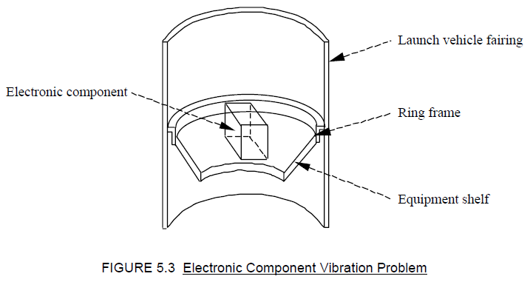

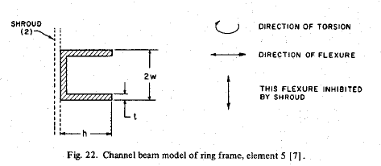

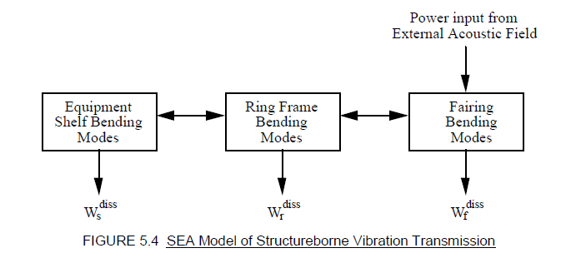

Π a,d

Π in

Acoustic Cavity

Equipment Shelf

Fairing

Ring Frame

Π f,d

Π r,d

Π s,d

420 x 269

External Acoustic Field Power Π in

Π a

Bending modes only for simplicity



|  |  |  |  |  |  |  |  |  |  |  |  |  |  |  |  |  |  |  |  |
| --- | --- | --- | --- | --- | --- | --- | --- | --- | --- | --- | --- | --- | --- | --- | --- | --- | --- | --- | --- |
|  | |  |  | | --- | --- | | Π in, i | Power input to subsystem i | | Π diss, i | Power dissipated from subsystem i | | Π i, j | Power transferred from subsystem i to j | |  | Spatial average energy in subsystem i | |  | Dissipation loss factor in subsystem i | |  | Coupling loss factor from subsystem i to j | | ω | Center Frequency (rad/sec) | | M i | Mass of subsystem i | |  | Spatial average mean square velocity in subsystem i | |

Power Flow Equation for the Fairing, Ring Frame, Shelf Example



The energy and velocity equation is: 

Subscripts: f = faring, r = ring frame, a = acoustic cavity, s = shelf

|  |  |  |  |  |
| --- | --- | --- | --- | --- |
| Π in, i | Power input to subsystem i |  | ω | Center Frequency (rad/sec) |
|  | Spatial average energy in subsystem i |  | M i | Mass of subsystem i |
|  | Dissipation loss factor in subsystem i |  |  | Spatial average mean square velocity in subsystem i |
|  | Coupling loss factor from subsystem i to j |

Reference

J. Wijker, Random Vibrations in Spacecraft Structure Design, Springer, New York, 2009. Equations (4.103) to (4.105)

sfdfd

sadfds

Dfsadfsdfds

|  |  |  |  |  |
| --- | --- | --- | --- | --- |
|  | ddd |  |  |  |
|  |  |  |  |  |
|  |  |  |  |  |
|  | gfddf |  |  |  |
|  |  |  |  |  |
|  |  |  |  |  |

asdfsadf

h

a

Fairing Wall

L-Shape Ring 1

h

a

b

Fairing Wall

Rectangular Ring

Fairing Wall

a

Channel Ring

h

a

Fairing Wall

b

b

h

L-Shape Ring 2

Fairing Wall

Fairing Wall

Power Flow Equation for the Cylindrical Shell & Shelf Example



The energy and velocity equation is: 

Subscripts: c= cylindrical shell, a = acoustic cavity, s = shelf

|  |  |  |  |  |
| --- | --- | --- | --- | --- |
| Π in, i | Power input to subsystem i |  | ω | Center Frequency (rad/sec) |
|  | Spatial average energy in subsystem i |  | M i | Mass of subsystem i |
|  | Dissipation loss factor in subsystem i |  |  | Spatial average mean square velocity in subsystem i |
|  | Coupling loss factor from subsystem i to j |

Reference

J. Wijker, Random Vibrations in Spacecraft Structure Design, Springer, New York, 2009. Equations (4.103) to (4.105)

A = imread('fairing_ring_shelf_eq.jpg');

A = imread('cylindrical_shelf_eq.jpg');

figure(999)

imshow(A,'border','tight','InitialMagnification',100)

Equipment Shelf

Π a,d

Acoustic Cavity

Π in

Π s,d

Π f,d

Fairing

Direct Mechanical Path