Sage 300 Web Screens SDK
Declarative Setup Reports Interface

August 2022
The MIT License (MIT)
Copyright © 2022 The Sage Group plc or its licensors. All rights reserved.
Permission is hereby granted, free of charge, to any person obtaining a copy of this software and associated documentation files (the “Software”), to deal in the Software without restriction, including without limitation the rights to use, copy, modify, merge, publish, distribute, sublicense, and/or sell copies of the Software, and to permit persons to whom the Software is furnished to do so, subject to the following conditions:
The above copyright notice and this permission notice shall be included in all copies or substantial portions of the Software.
THE SOFTWARE IS PROVIDED “AS IS”, WITHOUT WARRANTY OF ANY KIND, EXPRESS OR IMPLIED, INCLUDING BUT NOT LIMITED TO THE WARRANTIES OF MERCHANTABILITY, FITNESS FOR A PARTICULAR PURPOSE AND NONINFRINGEMENT. IN NO EVENT SHALL THE AUTHORS OR COPYRIGHT HOLDERS BE LIABLE FOR ANY CLAIM, DAMAGES OR OTHER LIABILITY, WHETHER IN AN ACTION OF CONTRACT, TORT OR OTHERWISE, ARISING FROM, OUT OF OR IN CONNECTION WITH THE SOFTWARE OR THE USE OR OTHER DEALINGS IN THE SOFTWARE.
Contents
1. Introduction 4
2. How to add a report 5
2.1 File Path 5
2.2 JSON Configuration 5
2.3 Menu Screen URL 6
3. Examples 7
3.1 Simple report with no parameters 7
3.2 Report with multilanguage support 8
3.3 Report with custom layout 10
3.4 Report with option type controls 12
3.5 Report with Section control 14
3.6 AP Account Set Report 16
4. JSON Configuration 18
4.1 Root Properties 18
4.2 Parameters 19
4.3 ControlType 20
4.4 Range 20
4.5 DataSource 21
4.6 HtmlAttrs 21
4.7 Textbox 21
4.8 Finder 21
4.9 Numeric 22
4.10 Datepicker 22
4.11 Checkbox 22
4.12 RadioButtonGroup 22
4.13 Dropdown 23
4.14 Section 23
4.15 RenderDirection 23

- Introduction
This document is intended to provide information on the declarative setup report interface, introduced in Sage 300 2023, which allows developers to create a report web screen via a JSON configuration as opposed to regular web screen development consisting of managed code, Razor views and JavaScript files.

- How to add a report
The assumption is that the Crystal Report and supporting Accpac View already exist.
  - File Path

The path to the JSON configuration is configurable in the web.config file:
<add key="DeclarativeReportLocation" value="~/App_Data/Reports" />
The default is "~/App_Data/Reports" and both absolute and relative paths are supported.

Ensure the above setting in the web.config file exists, and the file path specified exists as this is where the JSON configuration file will reside.
  - JSON Configuration

A JSON configuration contains one report and can be found in the above noted file path in a module Id subfolder:

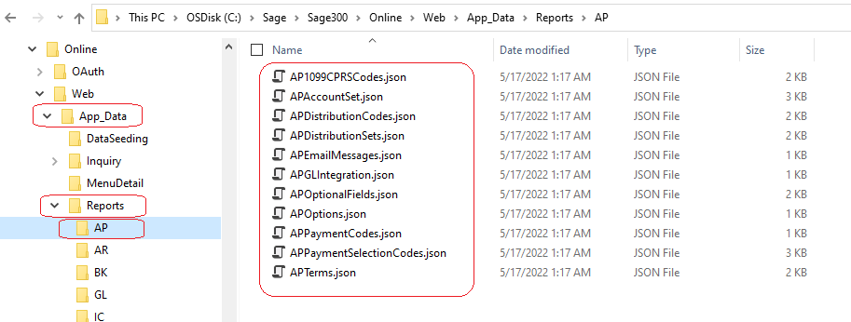

The folder hierarchy is for segregation of reports and to accommodate 3rd party reports

Refer to the examples in this document for creating the JSON configuration.

  - Menu Screen URL

The URL for a declarative report is specified in the module’s XML menu file:
<ScreenURL>Core/DeclarativeReport/Load?module=AP&amp;report=APAccountSet</ScreenURL>
The module parameter is optional and refers to the folder under the above noted file path. Multiple subfolders may be defined in the module parameter (i.e., ValuedPartner1/AP).
The report parameter is required and refers to the name of the JSON configuration file without extensions.

An example of the AP Account Sets declarative setup report’s menu item:

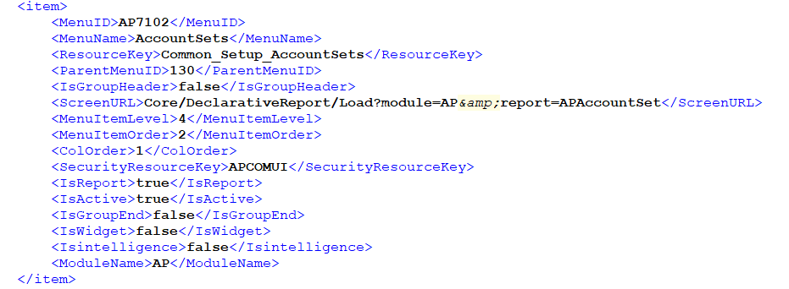

The modules XML menu file will require a new entry specifying the report to be menu linked

- Examples
Declarative Setup Report configurations for ~97 declarative setup reports for Sage 300 can be found in your Sage 300 web screen installation folder, in the path defined by the DeclarativeReportLocation setting in web.config file. These are also great examples to be leveraged when creating declarative setup reports.

The examples listed in this document cover most configurations of Sage 300 declarative setup reports to-date.
  - Simple report with no parameters

This example report has no parameters. It is a very simple report that has no user input required for the report.

    - Configuration
{
"ReportNames": [ "APACCT01" ], // Comma separated list of multiple reports
"ReportName": "APACCT01", // Default report
"EntityName": "AP0006", // ACCPAC entity for the report
"ScreenNameText": "Simple report", // Report title (not localized)
"Module": "AP", // Report’s module
"SecurityResource": "APCOMUI", // User permission required for the report
}

    - Screen Example

  - Report with multilanguage support

This example report has multilanguage support. It is a very simple report that has a couple of user inputs and supports localization.

    - Configuration
{
"ReportNames": [ "APACCT01"],
"ReportName": "APACCT01",
"EntityName": "AP0006",
"ScreenNameResource": "Sage.CA.SBS.ERP.Sage300.Common.Resources.DeclarativeReportResx.AP_AccountSetsTitle", // Report title (localized)
"Module": "AP",
"SecurityResource": "APCOMUI",
"ResourceAssembly": "Sage.CA.SBS.ERP.Sage300.Common.Resources.dll", // Resource assembly for resource strings for report
"ResourceAssemblyPath": "~\\bin\\", // Location of the resource assembly
"Parameters": [
{
"Name": "FROMCODE",
"Length": "6",
"ControlType": "Finder",
"FinderDefinition": "sg.viewFinderProperties.AP.AccountSet",
"LabelResource": "Sage.CA.SBS.ERP.Sage300.Common.Resources.DeclarativeReportResx.AccountSetFrom", // Resource string for the textbox label
"ID": "txtFromAcct",
"ButtonID": "btnFromAcct",
"HtmlAttrs": [
{
"Key": "formattextbox",
"Value": "alphaNumeric"
}
]
},
{
"Name": "TOCODE",
"Length": "6",
"ControlType": "Finder",
"FinderDefinition": "sg.viewFinderProperties.AP.AccountSet",
"LabelResource": "Sage.CA.SBS.ERP.Sage300.Common.Resources.DeclarativeReportResx.AccountSetTo", // Resource string for the textbox label
"ID": "txtToAcct",
"ButtonID": "btnToAcct",
"DefaultValue": "ZZZZZZ",
"HtmlAttrs": [
{
"Key": "formattextbox",
"Value": "alphaNumeric"
}
]
}
]
}

    - Screen Example
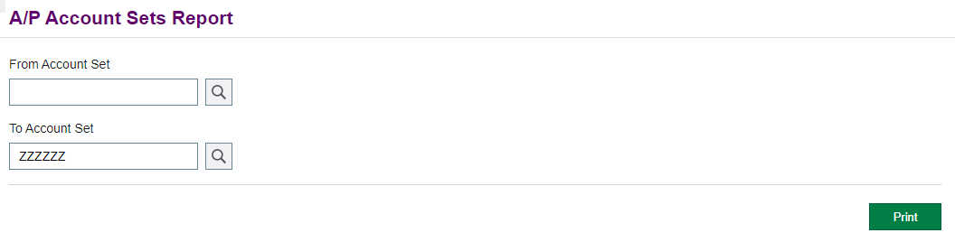

  - Report with custom layout

This example report has custom layout support. It is a simple report that has a couple of user inputs, supports localization, and a custom layout.

    - Configuration
{
"ReportNames": [ "APACCT01" ],
"ReportName": "APACCT01",
"EntityName": "AP0006",
"ScreenNameResource": "Sage.CA.SBS.ERP.Sage300.Common.Resources.DeclarativeReportResx.AP_AccountSetsTitle",
"Module": "AP",
"SecurityResource": "APCOMUI",
"ResourceAssembly": "Sage.CA.SBS.ERP.Sage300.Common.Resources.dll",
"ResourceAssemblyPath": "~\\bin\\",
"HtmlTemplate": "<div>{resx:Sage.CA.SBS.ERP.Sage300.Common.Resources.DeclarativeReportResx.AccountSet}<div>{txtFromAcct}</div>
<div>{txtToAcct}</div></div>", // Custom layout with a resource string and 2 parameters specified by ID
"Parameters": [
{
"Name": "FROMCODE",
"Length": "6",
"ControlType": "Finder",
"FinderDefinition": "sg.viewFinderProperties.AP.AccountSet",
"LabelResource": "Sage.CA.SBS.ERP.Sage300.Common.Resources.DeclarativeReportResx.AccountSetFrom",
"ID": "txtFromAcct", // ID of the textbox
"ButtonID": "btnFromAcct",
"HtmlAttrs": [
{
"Key": "formattextbox",
"Value": "alphaNumeric"
}
]
},
{
"Name": "TOCODE",
"Length": "6",
"ControlType": "Finder",
"FinderDefinition": "sg.viewFinderProperties.AP.AccountSet",
"LabelResource": "Sage.CA.SBS.ERP.Sage300.Common.Resources.DeclarativeReportResx.AccountSetTo",
"ID": "txtToAcct", // ID of the textbox
"ButtonID": "btnToAcct",
"DefaultValue": "ZZZZZZ",
"HtmlAttrs": [
{
"Key": "formattextbox",
"Value": "alphaNumeric"
}
]
}
]
}

    - Screen Example
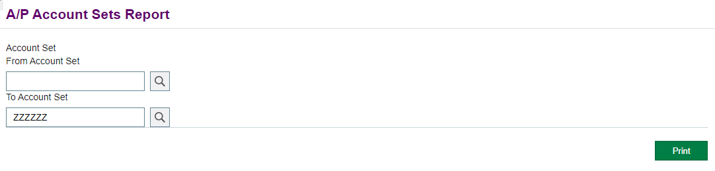

  - Report with option type controls

This example report has controls presenting various options. It is a simple report that has user inputs with options.
    - Configuration
{
"ReportNames": [ "APACCT01" ],
"ReportName": "APACCT01",
"EntityName": "AP0006",
"ScreenNameResource": "Sage.CA.SBS.ERP.Sage300.Common.Resources.DeclarativeReportResx.AP_AccountSetsTitle",
"Module": "AP",
"SecurityResource": "APCOMUI",
"ResourceAssembly": "Sage.CA.SBS.ERP.Sage300.Common.Resources.dll",
"ResourceAssemblyPath": "~\\bin\\",
"Parameters": [
{
"Name": "SortBy",
"ControlType": "Dropdown", // Dropdown control
"LabelResource": "Sage.CA.SBS.ERP.Sage300.Common.Resources.CommonResx.SortBy",
"ID": "ddlSortBy",
"DefaultValue": "ITEMNO", // Initial selection
"Size": "medium",
"DataSource": [ // Data source for dropdown
{
"Value": "ITEMNO", // Option value
"LabelResource": "Sage.CA.SBS.ERP.Sage300.Common.Resources.DeclarativeReportResx.ItemNumber" // Option text
},
{
"Value": "CATEGORY",
"LabelResource": "Sage.CA.SBS.ERP.Sage300.Common.Resources.DeclarativeReportResx.Category"
},
{
"Value": "SEGMENT",
"LabelResource": "Sage.CA.SBS.ERP.Sage300.Common.Resources.DeclarativeReportResx.ItemSegment"
}
]
},
{
"Name": "SWINCLCOMPBOMS",
"ControlType": "Checkbox", // Checkbox control
"LabelResource": "Sage.CA.SBS.ERP.Sage300.Common.Resources.DeclarativeReportResx.IncludeComponentBOMs",
"ID": "chkIncludeCompBoms",
"DefaultValue": "0", // Initial selection
"DataSource": [ // Data source for checkbox
{
"Value": "0" // First option is the false value
},
{
"Value": "1" // Second option is the true value
}
]
}
]
}

    - Screen Example
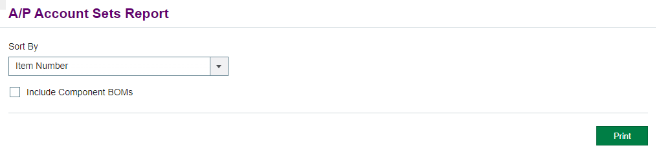

  - Report with Section control

This example report has controls contained in a section. It is a simple report that has user inputs for a range.
    - Configuration
{
"ReportNames": [ "APACCT01" ],
"ReportName": "APACCT01",
"EntityName": "AP0006",
"ScreenNameResource": "Sage.CA.SBS.ERP.Sage300.Common.Resources.DeclarativeReportResx.AP_AccountSetsTitle",
"Module": "AP",
"SecurityResource": "APCOMUI",
"ResourceAssembly": "Sage.CA.SBS.ERP.Sage300.Common.Resources.dll",
"ResourceAssemblyPath": "~\\bin\\",
"Parameters": [
{
"Name": "Panel", // Name of section
"Active": false, // Do not pass this parameter to the Crystal Report
"ID": "panel",
"ControlType": "Section", // Section control used to contain other controls
"DisplayBorders": false, // Do not show top and bottom borders of the panel
"RenderingDirection": "Horizontal" // Controls inside are displayed horizontally
},
{
"Name": "FROMCODE",
"Length": "6",
"ControlType": "Finder",
"ParentContainer": "Panel", // Name of section
"FinderDefinition": "sg.viewFinderProperties.AP.AccountSet",
"LabelResource": "Sage.CA.SBS.ERP.Sage300.Common.Resources.DeclarativeReportResx.AccountSetFrom",
"ID": "txtFromAcct",
"ButtonID": "btnFromAcct",
"HtmlAttrs": [
{
"Key": "formattextbox",
"Value": "alphaNumeric"
}
]
},
{
"Name": "TOCODE",
"Length": "6",
"ControlType": "Finder",
"ParentContainer": "Panel", // Name of section
"FinderDefinition": "sg.viewFinderProperties.AP.AccountSet",
"LabelResource": "Sage.CA.SBS.ERP.Sage300.Common.Resources.DeclarativeReportResx.AccountSetTo",
"ID": "txtToAcct",
"ButtonID": "btnToAcct",
"DefaultValue": "ZZZZZZ",
"HtmlAttrs": [
{
"Key": "formattextbox",
"Value": "alphaNumeric"
}
]
}
]
}

    - Screen Example
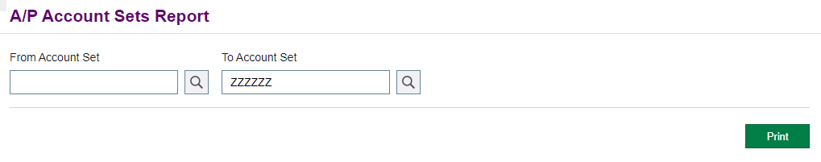

  - AP Account Set Report

This example report is the AP Account Set report for Sage 300. It is a simple report that has numerous features such as multiple Crystal report formats, localization, custom JavaScript, range validation, multi-currency checks, etc.

    - Configuration
{
"ReportNames": [ "APACCT01", "APACCT1Z" ], // Allowed reports via this web screen
"ReportName": "APACCT01", // Default report
"EntityName": "AP0006", // ACCPAC entity
"ScreenNameResource": "Sage.CA.SBS.ERP.Sage300.Common.Resources.DeclarativeReportResx.AP_AccountSetsTitle", // Resource string for the report title
"Module": "AP", // Report’s Module
"SecurityResource": "APCOMUI", // User permission required
"ResourceAssembly": "Sage.CA.SBS.ERP.Sage300.Common.Resources.dll", // Resource assembly to load for resource strings
"ResourceAssemblyPath": "~\\bin\\", // Location of the resource assembly
"CustomScripts": [ // Javascript files to include
"~/Areas/Core/Scripts/DeclarativeReport/Shared/Sage.CA.SBS.ERP.Sage300.Common.DeclarativeReport.SetMultiCurrencyYN.js", // This Javascript file contains a function to set the MULTCURN? parameter to “Y” if AP multicurrency option is true
"~/Areas/Core/Scripts/DeclarativeReport/Shared/Sage.CA.SBS.ERP.Sage300.Common.DeclarativeReport.SetFunctionalCurrency.js", // This Javascript file contains a function to set the FUNCCURN parameter to the functional currency code in company options
"~/Areas/AP/Scripts/Reports/AccountSet/Sage.CA.SBS.ERP.Sage300.AP.AccountSetBehaviour.js" // This javascript file contains a function to set the ReportName if GL module is active
],
"Ranges": [ // Paired parameters in this list will be rendered side by side. When print is clicked, an error message will appear if the value of the From parameter is greater than the value of the To parameter
{
"LabelResource": "Sage.CA.SBS.ERP.Sage300.Common.Resources.DeclarativeReportResx.AccountSet", // Used in the error message
"From": "FROMCODE", // Parameter name of the From range
"To": "TOCODE" // Parameter name of the To range
}
],
"Parameters": [ // Controls that will be rendered on the page
{
"Name": "FROMCODE", // Parameter name in the Crystal report
"Length": "6", // Maximum length of the textbox value
"ControlType": "Finder", // A finder will be rendered
"FinderDefinition": "sg.viewFinderProperties.AP.AccountSet", // The Javascript object containing the finder definition
"LabelResource": "Sage.CA.SBS.ERP.Sage300.Common.Resources.DeclarativeReportResx.AccountSetFrom", // Resource string for the textbox label
"ID": "txtFromAcct", // ID of the textbox
"ButtonID": "btnFromAcct", // ID of the finder button
"HtmlAttrs": [ // Html attributes of the textbox
{
"Key": "formattextbox",
"Value": "alphaNumeric" // Textbox only accepts alphanumeric characters
}
]
},
{
"Name": "TOCODE",
"Length": "6",
"ControlType": "Finder",
"FinderDefinition": "sg.viewFinderProperties.AP.AccountSet",
"LabelResource": "Sage.CA.SBS.ERP.Sage300.Common.Resources.DeclarativeReportResx.AccountSetTo",
"ID": "txtToAcct",
"ButtonID": "btnToAcct",
"DefaultValue": "ZZZZZZ", // Initial value of the textbox when the page is loaded
"HtmlAttrs": [
{
"Key": "formattextbox",
"Value": "alphaNumeric"
}
]
},
{
"Name": "MULTCURN?",
"ControlType": "Hidden", // A hidden input will be rendered
"ID": "hdnMulticurrency",
"DefaultValue": "N",
"IsMultiCurrency": true, // This parameter should be validated on the server side for multicurrency
"ValidationErrorValue": "N" // If multicurrency validation fails, this value is passed instead to print
},
{
"Name": "FUNCCURN",
"ControlType": "Hidden",
"ID": "hdnFunctionalCurrency"
}
]
}

    - Screen Example
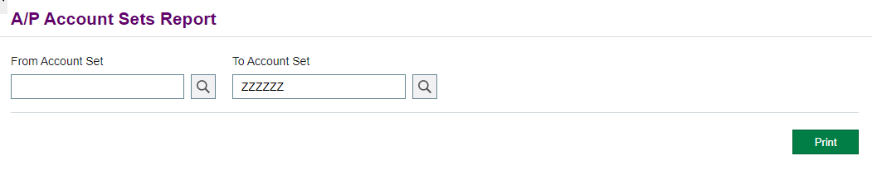
- JSON Configuration

The following section will describe the format of the JSON configuration file.
  - Root Properties
The root section of a report JSON file.
Property | Type | Required | Description
ReportName | string |  | Crystal report file name to print, excluding extension
ReportNames | string[] |  | List of valid Crystal reports the web screen can print. This must contain the ReportName
EntityName | string |  | Business entity name (Accpac View)
Module | string |  | Module ID
ScreenNameText | string |  | Web screen title specified if no localization is required
ScreenNameFunction | string |  | Javascript function that returns the web screen title. If set, overrides ScreenNameText and ScreenNameResource
ScreenNameResource | string |  | Resource string that returns the web screen title. If set, overrides ScreenNameText
ResourceAssembly | string |  | Assembly to load resource strings for supporting localization
ResourceAssemblyPath | string |  | Resource assembly path
HtmlTemplate | string |  | Html layout for parameters. Used if a different layout other than the generated one is desired. Controls can be injected into the template marked by {Parameter.ID}. Resource strings can be injected into the template marked by {resx:resourceBaseName.resourceName}
SecurityResource | string |  | Security string to check if user has access to the report. This should match the value of the SecurityResourceKey in the web screen menu’s XML file
Parameters | List<Parameter> |  | List of parameters for the report
Ranges | List<Range> |  | List of ranges in Parameters. Parameter pairs defined will be rendered horizontally, and the values will be checked when print is clicked. If the From parameter value is greater than the To parameter value, an error will display
CustomScripts | List<string> |  | List of Javascript files to be included in the page. The path and file must exist and be available to the web application. Only .js files are accepted. This can be used to add additional logic to the web screen
RazorViews | List<string> |  | List of Razor files to be included in the page. The path and file must exist and be available to the web application. Only .cshtml files are accepted.

  - Parameters
An array of parameters containing generated controls for the page which are usually mapped to a parameter in the Crystal Report.
Property | Type | Required | Description
ID | string |  | Html id attribute of the control
Name | string |  | Crystal Report parameter name
ControlType | ControlType |  | Type of UI control (Textbox, Finder, Dropdown, Checkbox, Hidden, Numeric, Datepicker, RadioButtonGroup, Currency, Section)
Value | string |  | Value sent to the Crystal Report
Length | int |  | Maximum length for Textbox, Finder, Numeric, and Currency ControlType parameters
Hidden | bool |  | True to hide the parameter. Default false
ParentContainer | string |  | Name of a Section ControlType parameter that contains this parameter
HasCustomBinding | bool |  | True to add Knockout attributes. Default false
DataAttrs | List<KeyValue> |  | Data attributes for the control, used by Knockout binding
HtmlAttrs | List<KeyValue> |  | Html attributes for the control
DefaultValue | string |  | Initial value when the page is loaded
Datasource | List<DataSource> |  | Static data source for Dropdown, Checkbox, and RadioButtonGroup ControlType parameters. Dynamic data sources can be initialized using Javascript defined from CustomScripts
IncludeLabel | bool |  | True to render a label with the control. Default true
LabelText | string |  | Label text
LabelFunction | string |  | Javascript function that returns the label text. If set, overrides LabelText and LabelResource
LabelResource | string |  | Resource string that returns the label text. If set, overrides LabelText
LabelDataAttrs | List<KeyValue> |  | Data attributes for the label, used by Knockout binding
LabelHtmlAttrs | List<KeyValue> |  | Html attributes for the label
Active | bool |  | True to send the parameter to the Crystal Report. Default true. Parameters used for formatting and helpers should be set to false
SecurityResource | string |  | Security string to check if user has access to the parameter. If not, the parameter is not rendered
ValidationErrorValue | string |  | Used for server validation. If IsOptionalFields or IsMultiCurrency is true, or LicensesToValidate is not empty, these options and licenses are checked on print. If the result is false, ValidationErrorValue is sent to the Crystal Report instead of the Value passed by the client
IsOptionalFields | bool |  | True if the parameter requires optional fields license. If there is no license, the parameter will be hidden. Default false. On print, if there is no license, ValidationErrorValue is sent to the Crystal Report instead of the client’s supplied Value
IsMultiCurrency | bool |  | True if the parameter should validate on print the module’s multicurrency option. Default false. If multicurrency is false, ValidationErrorValue is sent to the Crystal Report instead of the client’s supplied Value
LicensesToValidate | string[] |  | List of licenses to validate on print. If any of the licenses are not active, ValidationErrorValue is sent to the Crystal Report instead of the client’s supplied Value
IncludeValidation | bool |  | True to include html attributes for client-side validation. Default true
ValidationText | string |  | The text message for client-side validation
  - ControlType
Enum of supported control types for a parameter. Refer to Sage300SDK_HtmlHelpers.docx for details
Name | Enum | Description
Textbox | 0 | A textbox
Finder | 1 | A finder
Dropdown | 2 | A dropdown
Checkbox | 3 | A checkbox
Hidden | 4 | A hidden input
Numeric | 5 | A numeric textbox
Datepicker | 6 | A datepicker
RadioButtonGroup | 7 | A group of radio buttons
Currency | 8 | A currency textbox
Section | 9 | A container for other Control Types
  - Range
Parameter pairs defined will be rendered horizontally, and the values will be checked when print button is clicked. If the From parameter value is greater than the To parameter value, an error message will display, with the LabelText referring to the type of the value in the message.
Property | Type | Required | Description
From | string |  | From parameter Name
To | string |  | To parameter Name
LabelText | string |  | Label text
LabelFunction | string |  | Javascript function that returns the label text. If set, overrides LabelText and LabelResource
LabelResource | string |  | Resource string that returns the label text. If set, overrides LabelText

  - DataSource
Static data source for Dropdown, Checkbox, and RadioButtonGroup ControlType parameters. Dynamic data sources can be initialized using Javascript defined from CustomScripts. LabelText is the display text of the option.
Property | Type | Required | Description
Value | string |  | Data source value
LabelText | string |  | Label text
LabelFunction | string |  | Javascript function that returns the label text. If set, overrides LabelText and LabelResource
LabelResource | string |  | Resource string that returns the label text. If set, overrides LabelText
  - HtmlAttrs
Dictionary for Html attributes.
Property | Type | Required | Description
Key | string |  | Key
Value | object |  | Value
  - Textbox
Inherits Parameter (see 4.2). These are additional properties for the control type.
Property | Type | Required | Description
Size | string |  | The CSS class for the size of the textbox. Default ‘default’ (default, small, smaller, xsmall, large, larger, xlarge, medium, mediumlarge)
  - Finder
Inherits Parameter (see 4.2). These are additional properties for the control type.
Property | Type | Required | Description
ButtonID | string |  | Html id attribute of the button
FinderDefinition | string |  | Finder properties. Refer to Sage300SDK_FinderArchitecture.docx for details
Size | string |  | The CSS class for the size of the textbox. Default ‘default’ (default, small, smaller, xsmall, large, larger, xlarge, medium, mediumlarge)
IsNumeric | bool |  | True if the values of the type of finder are numeric. Default false
GoButtonID | string |  | Html id attribute of the Go button
LabelWithHamburger | bool |  | True to include a hamburger next to the label. Default false
HamburgerUrl | string |  | Url of the hamburger control
HamburgerValue | string |  | Value of the hamburger control
ButtonDataAttrs | List<KeyValue> |  | Data attributes for the button, used by Knockout binding
IncludeNavigationButtons | bool |  | True to include navigation buttons (to navigate to First, Previous, Next, or Last record). Default false
IncludeAddButton | bool |  | True to include the add button (to create new record). Default false
NavGroupIndex | int |  | Navigation group index
IncludeGoButton | bool |  | True to include the Go button. Default false
IncludeFinderButton | bool |  | True to include the button to open the finder popup. Default true
  - Numeric
Inherits Parameter (see 4.2). These are additional properties for the control type.
Property | Type | Required | Description
DecimalPlaces | int |  | Number of decimal places
ShowSpinners | bool |  | True to display a spinner. Default false
StepIncrement | int |  | Step increment
MaxDigits | int |  | The maximum number of digits to display
MinValue | int |  | The minimum allowable value
MaxValue | int |  | The maximum allowable value
FormatString | string |  | The formatting string template
Size | string |  | The CSS class for the size of the textbox. Default ‘default’ (default, small, smaller, xsmall, large, larger, xlarge, medium, mediumlarge)
  - Datepicker
Inherits Parameter (see 4.2). These are additional properties for the control type
Property | Type | Required | Description
Size | string |  | The CSS class for the size of the textbox. Default ‘small’ (default, small, smaller, xsmall, large, larger, xlarge, medium, mediumlarge)
  - Checkbox
Inherits Parameter (see 4.2). These are additional properties for the control type
Property | Type | Required | Description
LabelFirst | bool |  | True to display the label on the left of the checkbox. False to display the label on the right of the checkbox. Default false
  - RadioButtonGroup
Inherits Parameter (see 4.2). These are additional properties for the control type
Property | Type | Required | Description
LabelFirst | bool |  | True to display the label on the left of the radio button. False to display the label on the right of the radio button. Default false

  - Dropdown
Inherits Parameter (see 4.2). These are additional properties for the control type
Property | Type | Required | Description
OptionLabel | string |  | The option label for the dropdown
Size | string |  | The CSS class for the size of the textbox. Default ‘default’ (default, small, smaller, xsmall, large, larger, xlarge, medium, mediumlarge)
  - Section
Inherits Parameter(see 4.2). These are additional properties for the control type.
Nested Sections are not supported.
Property | Type | Required | Description
RenderingDirection | RenderDirection |  | Direction to lay out the controls in the panel. Default ‘Vertical’
DisplayBorders | bool |  | True to show a top and bottom border around the panel. Default true
  - RenderDirection
Enum of supported layouts for a Section ControlType parameter.
Name | Enum | Description
Vertical | 0 | Controls are laid out vertically
Horizontal | 1 | Controls are laid out horizontally

- Notes
  - Parameter Security Resource and Custom HTML

In order to properly hide controls with security resources, some additional custom html is required. The typical control looks something like:

<div class='ctrl-group'>{chkHideFromNonManagers}</div>

This control needs to be hidden if the user doesn’t have (for example) ICMGR access:
“ID”: “chkHideFromNonManagers”,
….
“SecurityResource”: “ICMGR”,

In order to do this and not interfere with any system ID’s, wrap this in a span, and an element ID as indicated, using single quotes:
<span id='SecurityResource_chkShowSinNumbers'>
<div class='ctrl-group'>{chkShowSinNumbers}</div></span>

