Sage 300 Web Screens SDK
Web Subclassing Prep Utility

May 2024
The MIT License (MIT)
Copyright © 2024 The Sage Group plc or its licensors. All rights reserved.
Permission is hereby granted, free of charge, to any person obtaining a copy of this software and associated documentation files (the “Software”), to deal in the Software without restriction, including without limitation the rights to use, copy, modify, merge, publish, distribute, sublicense, and/or sell copies of the Software, and to permit persons to whom the Software is furnished to do so, subject to the following conditions:
The above copyright notice and this permission notice shall be included in all copies or substantial portions of the Software.
THE SOFTWARE IS PROVIDED “AS IS”, WITHOUT WARRANTY OF ANY KIND, EXPRESS OR IMPLIED, INCLUDING BUT NOT LIMITED TO THE WARRANTIES OF MERCHANTABILITY, FITNESS FOR A PARTICULAR PURPOSE AND NONINFRINGEMENT. IN NO EVENT SHALL THE AUTHORS OR COPYRIGHT HOLDERS BE LIABLE FOR ANY CLAIM, DAMAGES OR OTHER LIABILITY, WHETHER IN AN ACTION OF CONTRACT, TORT OR OTHERWISE, ARISING FROM, OUT OF OR IN CONNECTION WITH THE SOFTWARE OR THE USE OR OTHER DEALINGS IN THE SOFTWARE.
Contents
1. Overview 4
2. Running the Utility 5

- Overview
This document is intended to serve as a guide for illustrating how to use the Web Subclassing Prep Utility which is an executable.

This utility is an internal utility and is only for use by Sage developers.

The following files will be generated for the partner facing wizards:
- JSON
  - A ModelsSource.json file will be created and later used in the Web Subclassing Configurations Wizard
  - This JSON file contains all of the models in the Sage web modules categorized by module. This will allow the configurations wizard to use this already populated list of modules and models instead of having to discover them.
- ZIP
  - Module zip files will contain the Visual Studio Models project for each module
  - These zip files will be used by the Web Subclassing Compiler and Deployment Wizard to use these projects for adding extended properties and later compilation and deployment.

- Running the Utility
The Sage.CA.SBS.ERP.Sage300.SubclassPrep.exe is in the SDK’s bin/utilities folder.

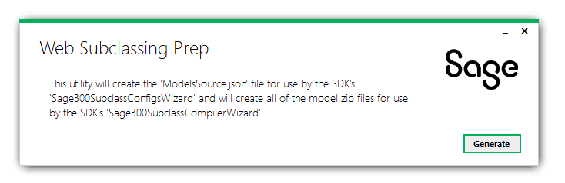
Select ‘Generate’ to execute the utility to generate the JSON and ZIP files.

Ensure that the web screen source is updated prior to using this utility to guarantee the latest available source will be used for the generate files.

