Sagewood Physical Therapy North, LLC
Jennifer Anderson MS, PT
3180 Harlan Street, Wheat Ridge, CO 80214
Office: 720-635-9868 Fax: 303-235-2706

Physical Therapy Intake Document

Patient Name: _____________________________________________Date:_____________________
Home Address:
City: State: Zip:
Home Phone: Cell: Work: _____
E-mail address:
Emergency Contact Name: __ Relationship: __ Phone: ________________
Patient’s Birthdate: Social Security #:
Referring Doctor: Phone:
Diagnosis: Date of Onset:
Please use the diagram below to indicate where you feel symptoms at this time. Please circle the area
of pain.

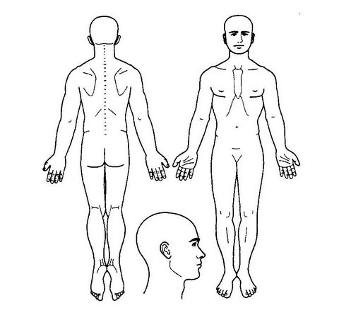
Please score the circled painful areas from
1 (minimal) to 10 (worst pain imaginable)

*We will verify your insurance benefits. However, it is the patient’s responsibility to know their physical therapy benefits within their insurance coverage. Insurance Carrier:
If injury is related to work, please provide the following:
Employer Name: Employer Phone:
Employer Address:

MEDICAL HISTORY:

Please list any medications you are currently taking:

How did you hear about us?

Sagewood Physical Therapy North, LLC
Jennifer Anderson MS, PT
3180 Harlan Street
Wheat Ridge, CO 80214
(720) 635-9868

PATIENT AGREEMENT & DISCLOSURE INFORMATION

The following is the financial policy and disclosure information of Sagewood Physical Therapy North, LLC which we require that you read and sign prior to treatment.

Payment of fees is due at the time of service, this includes co-payments or co-insurance. Acceptable forms of payment are cash, personal check, or money order. Payment not made at the time of service is considered past due when the Patient leaves the facility.

The patient recognizes that he/she is responsible for paying the full amount for all services unless the Practice has an agreement with the Patient’s Insurance carrier for alternative payments. As a courtesy to all Patients, our office will file insurance claims with all standard Insurance carriers. The Patient is responsible to make available to the Practice complete Insurance information for accurate filing of claims. Insurance information includes: any necessary referrals for primary and secondary insurance coverage and all identification and benefit cards and documents.

There is a $20.00 charge for missed appointments unless you call the office 24 hours prior to the appointment. Exceptions can be made at the Provider’s discretion. Insurance carriers will not pay for missed appointments.

By this agreement, the Patient also authorizes the exchange of information relating to care and claims with the Patient’s Insurance company(s,) and authorize insurance payments be made directly to the Practice for services provided under the Patient’s Insurance agreement and otherwise payable to the Patient.

The Patient understands that delinquent accounts are subject to a finance charge of 5% per month, rebilling charges, collection fees, and/or administration fees and that special arrangements can only be made with an addendum to this document.

If the services are due to an injury and are in litigation, please provide the following information:

Name of Law Firm:___________________________________________________________________

Name of Attorney:____________________________________________________________________

Phone number:_______________________________ Fax number:_____________________________

You also need to know that I have contracted my Insurance and Patient billing with Western Professional Services and it will be necessary to provide this billing service with certain information in order to file claims. Western Professional Services and Sagewood Physical Therapy North, LLC are HIPPAA complaint and will adhere to the Client Confidentiality as outlined in the Notice of Privacy Practices.

PATIENT AGREEMENT: I have read and understand the Financial Policy and disclosures information and agree to the terms stated. In signing this, I also authorize consent to Physical Therapy Treatment.

_______________________________________ _______________________________________
Patient or Legal Guardian’s Signature Patient’s Printed Name

_______________________________________ _______________________________________
Date Patient’s Date of Birth

Sagewood Physical Therapy North, LLC
Jennifer Anderson, M.S., PT

