**A fast 3D gravity forward algorithm based on cyclic convolution**

Code By: Xianzhe Yin, Changli Yao, Yuanman Zheng, Guangxi Chen, Wenqiang Xu

School of Geophysics and Information Technology, China University of Geosciences, Beijing, China: 100083

E-mail: [yinxz@cugb.edu.cn](mailto:yinxz@cugb.edu.cn)

[clyao@cugb.edu.cn](mailto:clyao@cugb.edu.cn)

The code is written in Matlab R2022a. The NED (North-East-Downward) coordinate system as positive x, y, and z directions is picked. Pseudo-code for novel spatial domain convolution fast forward modeling algorithm is shown following.

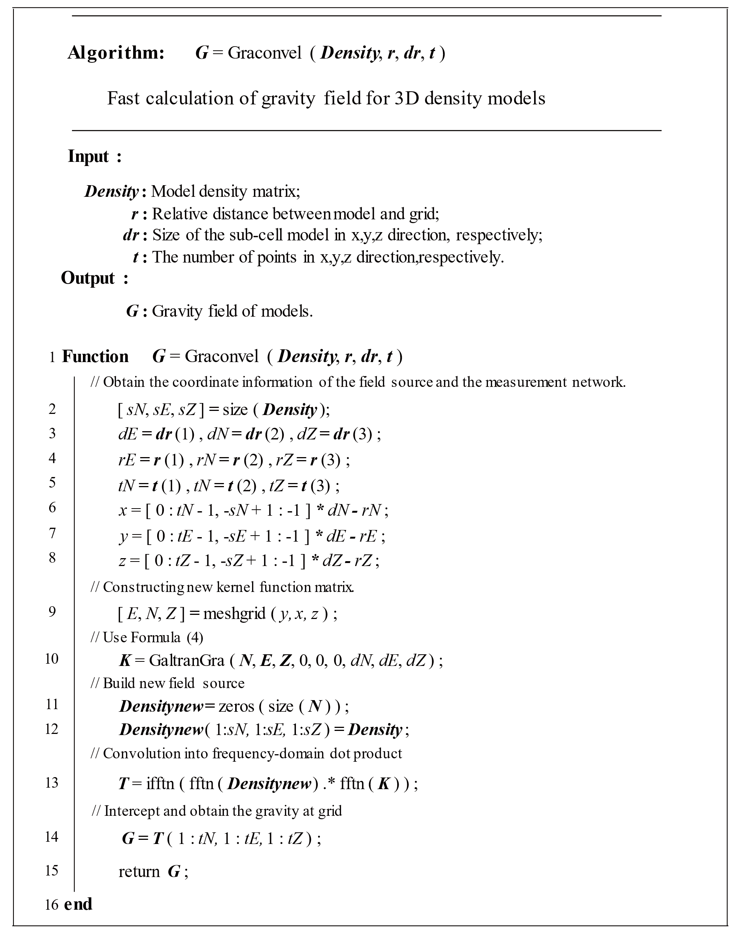

**Code Description**

1. **Our methond**

Fast computation of gravity field based on circular convolution.

**Main function:**

*Cal_ModelGravityinFourie.m*

**Calling sub-functions:**

* *Cal_tranGraf.m :* *Analytic formula method for calculating the gravity of a cube*
* *GraconvelP.m : Construct the circular kernel matrix and calculate the gravity field using FFT algorithm*

**2、In space domain**

**Main function:**

*Cal_ModelGravityinFourie.m*

**Calling sub-functions:**

* *Cal_tranGraf.m :* *Analytic formula method for calculating the gravity of a cube*
* ***Note: See code comments for detailed parameters.***