Monitoring project POC:
- Create a docker-compose.yml file:
version: '3'
services:
elasticsearch:
image: docker.elastic.co/elasticsearch/elasticsearch:6.2.4
container_name: elasticsearch
environment:
cluster.name: "docker-cluster"
bootstrap.memory_lock: "true"
ES_JAVA_OPTS: "-Xms512m -Xmx512m"
TAKE_FILE_OWNERSHIP: "true"
ulimits:
memlock:
soft: -1
hard: -1
volumes:
- ./data/esdata1:/usr/share/elasticsearch/data
ports:
- 9200:9200
- 9300:9300
grafana:
image: grafana/grafana:5.1.0
container_name: grafana
volumes:
- ./data/grafana:/var/lib/grafana
ports:
- 3000:3000
user: "0”

- run command: docker-compose up
- then launch Elasticsearch and Grafana
Grafana URL: http://localhost:3000
Elasticsearch URL: http://localhost:9200/
- Create ES Index through Postman:
Mapping:
{
"mappings": {
"data": {
"properties": {
"timestamp": {
"type": "date"
}
}
}
}
}

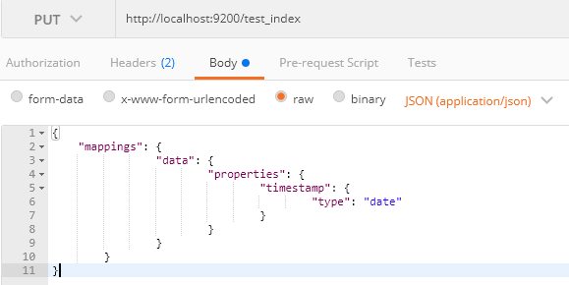
- Post data into ES index
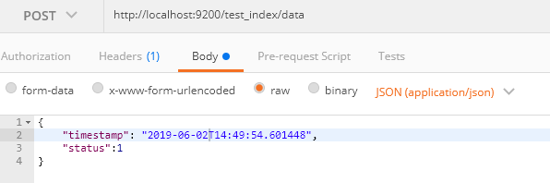

- Configure Data source for ES:

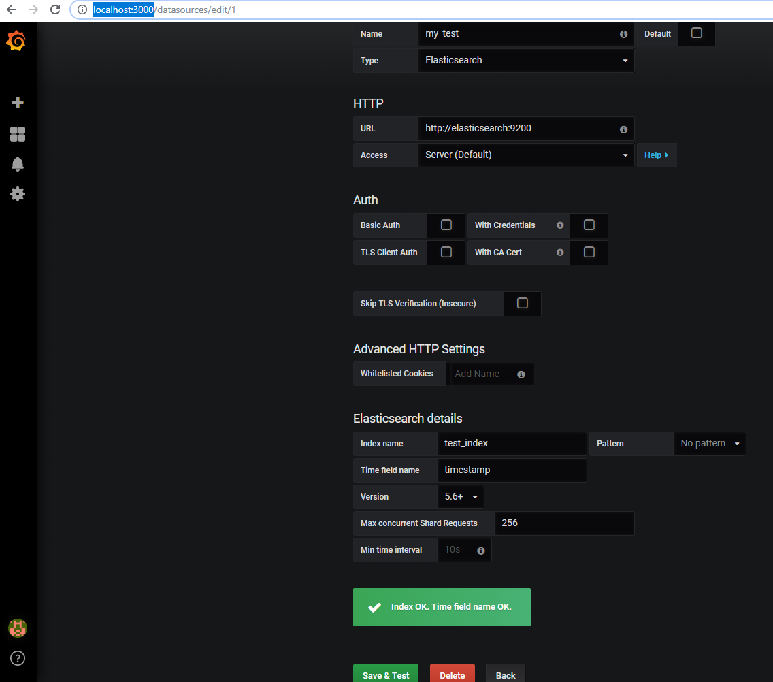

Example:
