One Approach to Assessment the Quality of Communication Services
Ramin R. Rzayev and Aydin I. Goyushov
Institute of Cybernetics of National Academy of Science

Correspondence concerning this article should be addressed to Ramin R. Rzayev, Department of Signal Prosessing and Information Technology, Cybernetics Institute of National Academy of Science, 9 Baxtiyar Vahabzadeh str., Baku, Azerbaijan, AZ1141. Email: raminrza@yahoo.com
Abstract
Fuzzy inference method based approach to the forming of modular intellectual system of assessment the quality of communication services is proposed. Developed under this approach the basic fuzzy estimation model takes into account the recommendations of the International Telecommunication Union in respect of the operation of packet switching networks based on IP-protocol.
Keywords: quality of telecommunication services, IP-telephony, fuzzy set, fuzzy implication
1. Introduction
At the present stage of development of telecommunications and wireless communications technologies improving the quality of telecom services is most nagging problem, which is permanently being improved by increasing the speed of data transmission and mobility of users, diversification of services, improving the efficiency of radio frequency spectrum and the intelligent degree of networking equipment and subscriber gadgets. At the same time improving the telecommunications occurs at the junction of contradictions between the ever-growing consumer demand for subscriber services and the limited number of frequencies that is completely objective. In turn, this causes a significant expansion of the range of provisioning provided by the telecoms operator, increment of consumer demands for their quality and, as a result, improvement of existing controls technologies.
The fact of the matter is that during operation the objective technical characteristics of communication networks are inherited by systems of telecommunication services, thereby transforming into the characteristics of the provided services. But also communication services have their characteristic features, among which quality is the dominant. Moreover, if at the initial operation and advance communication networks the service quality characterized by a set of objective technical characteristics, then at the stage of operation it is already occur the transformation of these characteristics, as under competitive market for telecommunications services the quality of networks becomes the subject of discussion and subjective assessments of their users. As a result, the category of quality of telecommunication services is increasingly shifting towards nonmetrizable characteristics reflecting a common measure of subjective satisfaction of consumers.
As any consumer product telecommunication service complies with the market laws. Therefore, increasing the customer base providing competitive position and, consequently, profit markup turning into the main prerogative of telecommunications companies. The requirements of communication subscribers, which evaluate communication service through their subjective judgments, such as "the presence (or absence) of communication interruptions", "it is not enough (or enough) good audibility", "acceptable (or unacceptable) speech intelligibility" etc., become the dominant factors for the management of telecommunications companies. Actually, subscriber choice for benefit of one or another telecommunication service is realized by the set of listed subjective requirements to communication quality.

2. Problem formulation
It is obvious that subjective estimations of users to a communication quality are derivative of objective (technical) characteristics of the telecommunications network and result of their interaction with characteristics of traffic load. In a highly competitive market place this nonmetrizable subjective estimations of users are becoming objective functions through which management of the company can estimate subjective satisfaction of the client. Subject to a multiservice of modern telecommunications networks it is necessary to solve this problem for all range of communication services within the creation of uniform system of assessment of the quality processing both objective (structured) and subjective (semi-structured or unstructured) quality indicators.
3. Communication services quality control system under fuzzy environment
Today one of effective methods of managerial technologies is elements of artificial intelligence including fuzzy logic and fuzzy processors, which well proved in telecommunication administration (Zadeh, 2001). In particular, application of methods of fuzzy logic in the cognitive networks management allows to consider easily a set of parameters for decision-making and doesn't demand difficult mathematical calculations (Zadeh, 1974). Moreover, the mathematical apparatus of the fuzzy sets theory allows to operate equally easily both metrizable and nonmetrizable data (Zadeh, 1976).
Consider a standard functional diagram of the communication services quality control system (Sokolov, 2009) on the base of fuzzy inferences mechanism allowing quickly to obtain a multi-objective estimation of provided telecommunication service under fuzzy information (see Fig. 1).
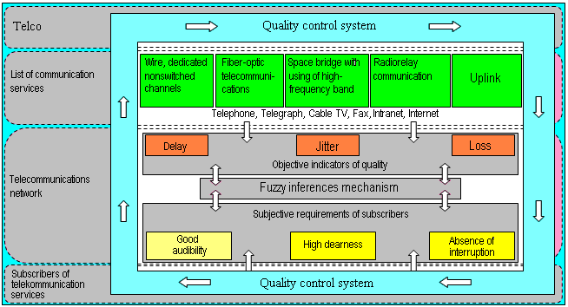
Figure 1. Functional diagram of the communication services quality control system
As objective quality indicators we will choose those that can control at determination the quality levels of communication services. Moreover, these indicators should be well-known, uniquely interpreted and, most importantly, reflected the quality of services adequately. In a number of recommendations of the International Telecommunication Union (ITU) for prevalent packet networks on the base protocols IPv4 and IPv6 it is proposed to control the specific objective quality indicators to determine the level of services (ITU-T Y.1541, 2012). In particular, the recommendation ITU Y.1541 provides network service classes (Network QoS Classes) formed by objective criteria (quality) of user communication services and applications. As such indicators in given recommendations are numerical values of network performance parameters, which are presented in Table 1.
As an example, consider the telephone communications by IP-protocol (IP-telephony), which is an application of a more general technology VoIP (Voice over IP) to transmit voice. Choosing this service is justified by the fact that IP-telephony is very sensitive to jitter.
According to the recommendation Y.1541 IP-telephony can function under performance parameters corresponding to classes 0 and/or 1 (ITU-T Y.1541, 2012). Herewith providing services in Class 0 guarantees high quality and hence satisfaction of network users. At the same time the quality of IP-telephony services in class 1 will be a little worse and it would have to be offset by the implementation of additional options to continue to expand its customer base. In other cases, the communication quality will be too low.
Table 1. Classification of service by network performance parameters
Network performance parameter | Nature of network performance objective | QoS Classes
Network performance parameter | Nature of network performance objective | Class 0 | Class 1 | Class 2 | Class 3 | Class 4 | Class 5 Unspecified
IPTD: IP-packet Transfer Delay | Upper bound on the mean IPTD | 100 ms | 400 ms | 100 ms | 400 ms | 1 s | U
IPDV (Jitter): IP-packet Delay Variation | Upper bound on the 1 – 10^{–3}  quantile of IPTD minus the minimum IPTD | 50 ms | 50 ms | U | U | U | U
IPLR: IP-packet Loss Ratio | Upper bound on the packet loss probability | 1×10⁻³ | 1×10⁻³ | 1×10⁻³ | 1×10⁻³ | 1×10⁻³ | U
IPER: IP-packet Error Ratio | Upper bound | 1×10⁻⁴ |  |  |  |  | U
In (Sokolov, 2009) proposed a very interesting approach for generating fuzzy quality evaluation system of communication services. By means of generated consistent linguistic rules author analysis the quality of services on the basis of available information about the network performance parameters (see Table 1), i.e. judges their quality on the basis of objective characteristics interpreted by adequate fuzzy sets. However, in the presented approach is not quite clearly showed: how these objective qualities of network services are transformed into subjective judgments of consumers, in their subjective criteria of estimation. In other words, forming the cause-effect relations between these characteristics could be classified qualities of provided services by the network user satisfaction, actually, what we are going to do.

4. Classification of satisfaction degrees of communication service users (by example of IP-telephony)
Obviously, the evaluation of the communication services quality is a multi-objective procedure meaning application of compositional rule of aggregation of estimation for each concrete case. To evaluate the quality of IP-telephony service we choose five estimated concepts for network performance parameters: u₁ – “too low”; u₂ – “low”; u₃ – “low enough”; u₄ – “significant”; u₅ – “high”. Simpler words, in the capacity of С=(u₁,u₂,u₃,u₄,u₅) we will mean a set of characters classifying the communication services quality. Then, assuming that the technical characteristics of the network (assessment criterions of quality) are the fuzzy sets, assessment of provided IP-telephony services one can realize with using sufficient set of fuzzy implicative rules of the form “If…, then…”, and on their basis we will determine the appropriate scale of satisfaction gradation of client base.
So, we formulate our opinions as follows:
e₁: “If on transmission of IP-packet transfer delays are not observed and delay variation is low, then the quality of the network is satisfactory”;
e₂: “If in addition to the above requirements there are no losses of IP-packet, then the quality of the network is more than satisfactory”;
e₃: If in addition to the conditions specified in the e₂ errors on transmission of IP-packet are not occur, then the quality of the network is perfect”;
e₄: “If on transmission of IP-packet delay variation is low and there are no losses and errors, then the quality of the network is very satisfactory”;
e₅: “If on transmission of IP-packet there are no transfer delays and losses, though errors are observed, then the quality of the network is just the same satisfactory”;
e₆: “If on transmission of IP-packet there are losses and errors, then the quality of the network is unsatisfactory”
In these statements, which are essentially cause-effect relations, the following features are input characteristics:
- X₁ – availability of IP-packet Transfer Delay;
- X₂ – availability of IP-packet Delay Variation;
- X₃ – IP-packet Loss Ratio;
- X₄ – IP-packet Error Ratio,
and as the output characteristic Y actually we will be assume the quality assessment of communication services – the level of consumer satisfaction. Then, defining appropriate values (terms) of the linguistic variables X_{i} (i=1÷4) and Y, on the basis of the above statements let’s construct the following implicative rules:
e₁: “If X₁=not observed and X₂=low, then Y=satisfactory”;
e₂: “If X₁=not observed and X₂=low and X₃=not observed, then Y=more than satisfactory”;
e₃: “If X₁=not observed and X₂=low and X₃=not observed and X₄=not observed, then Y=perfect”;
e₄: “If X₂=low and X₃=not observed and X₄=not observed, то Y=very satisfactory”;
e₅: “If X₁=not observed and X₃=not observed and X₄=observed, then Y=satisfactory”;
e₆: “If X₃=observed and X₄=observed, then Y=unsatisfactory”.
Linguistic variable Y is defined on a discrete set J={0;0.1;0.2;…;1}. Then its terms used in implicative rules one can describe by fuzzy sets with appropriate membership functions (Rzayev, 2013):
- =satisfactory, 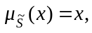 x∈J;
- =more than satisfactory, 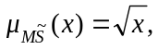 x∈J;
- =perfect, 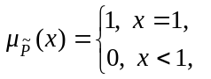 x∈J;
- 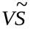=very satisfactory, 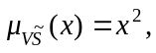 x∈J;
- =unsatisfactory, 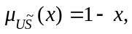 x∈J.
Fuzzification of terms in the left-hand sides of the accepted rules one can exercise by using of Gaussian membership functions 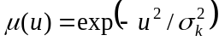 (k=1÷4), restoring the fuzzy sets on the support vector (u₁, u₂, u₃, u₄, u₅), where 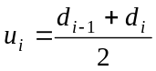 (i=1÷5) (see Fig. 2). The values for σ_{k} are selected on the basis of the degree of importance of features that classify the quality of communication services.
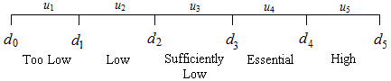
Figure 2. Uniform gradation of network performance parameters according to their levels¹
In Fig. 2 the gradation of network performance levels is presented in a general form. However, it is obvious that interval [d₀, d₅] can be easily reduce to the unit interval [0,1] by the simple transformation x=d₀+t(d₅-d₀), where t∈[0,1]. Therefore, evaluating the quality of telecommunication service in terms of its technical characteristics graded on the scale of unit interval (see Fig. 3), where d_{i}=0.2⋅i (i=0÷5), let’s describe the terms from the left-hand sides of implicative rules as follows:
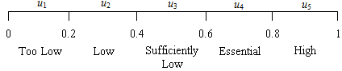
Figure 3. The levels of network performance parameters on the scale of the unit interval
- not observed (IP-packet Transfer Delay):
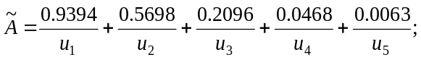
- low (IP-packet Delay Variation):
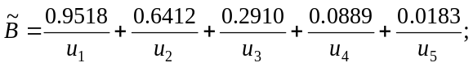
- not observed (IP-packet Losses):
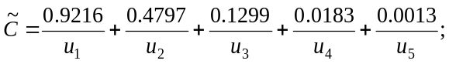
- not observed (IP-packet Errors):
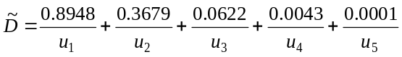.
Then, subject to these formalisms the fuzzy rules are formulated as:
e₁: “If X₁= and X₂=, then Y=”;
e₂: “If X₁= and X₂= and X₃=, then Y=”;
e₃: “If X₁= and X₂= and X₃= and X₄=, then Y=”;
e₄: “If X₂= and X₃= and X₄=, then Y=”;
e₅: “If X₁= and X₃= and X₄=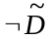, then Y=”;
e₆: “If X₃=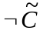 and X₄=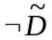, then Y=”.
Further, for the left-hand sides of these rules let’s compute the membership function 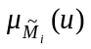 (i=1÷6). In particular, we have:
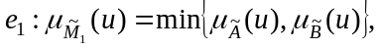
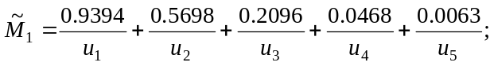
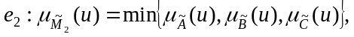
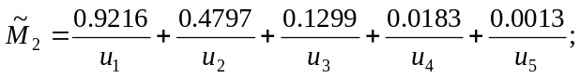
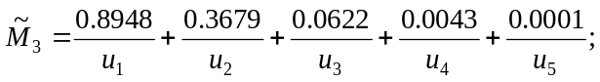
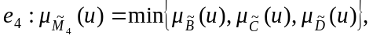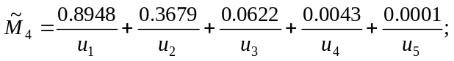
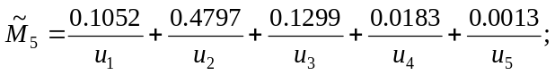
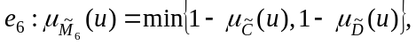
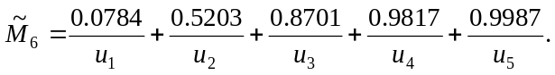
As a result, the rules are interpreted in a more compact form:
e₁: “If X=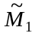, then Y=”;
e₂: “If X=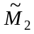, then Y=”;
e₃: “If X=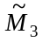, then Y=”;
e₄: “If X=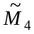, then Y=”;
e₅: “If X=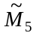, then Y=”;
e₆: “If X=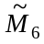, then Y=”.
To convert these implicative rules one can use Lukasiewicz’s implication (Rzayev, 2013):
. (1)
In this case for each pair (u,j)∈U×Y we obtain the following fuzzy relations on U×Y:
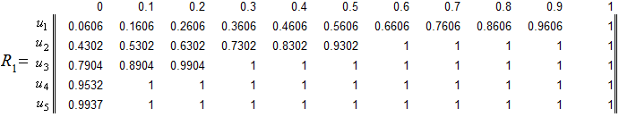
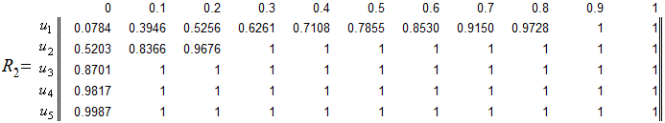
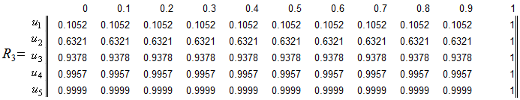
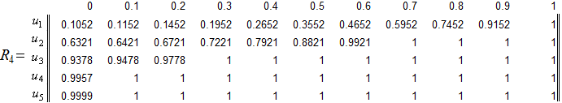
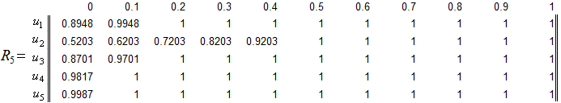
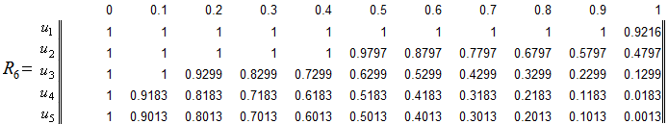
At the intersection of fuzzy relations R₁, R₂,…, R₆ finally we obtain the following general functional solution that reflects a cause-effect relation between the network performance parameters and quality of communication services:
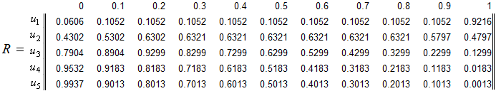
To determine the level of quality of telecommunications services one can apply the composition rule of conclusion under fuzziness:
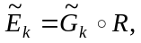 (2)
where 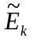 is k-th level quality of communication services, the 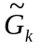 is k-level mapping of network performance parameters in the form of fuzzy subsets. Then, choosing the composition rule as
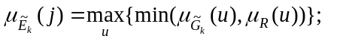 (3)
and assuming that 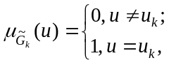 finally we have: 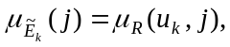 i.e. 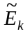 is k-th row of matrix R.
Now for the classification of telecommunication services quality we use defuzzification procedure for fuzzy outputs of applied model. So, for the assessed concept of network performance u₁ fuzzy interpretation of the corresponding level of quality communication services will be a fuzzy set:
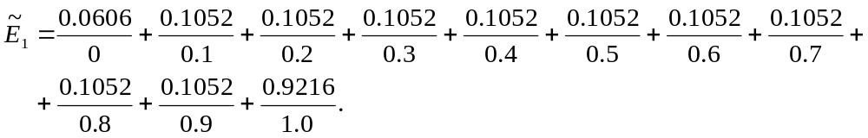
Determining the level sets E_{1α} and calculating their respective cardinal numbers M(E_{1α}) by formula 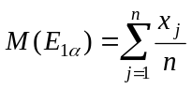, we have:
- for 0<α<0.0606: Δα=0.0606, E_{1α}={0; 0.1; 0.2; 0.3; 0.4; 0.5; 0.6; 0.7; 0.8; 0.9; 1}, M(E_{1α})=0.5;
- for 0.0606<α<0.1052: Δα=0.0446, E_{1α}={0.1; 0.2; 0.3; 0.4; 0.5; 0.6; 0.7; 0.8; 0.9; 1}, M(E_{1α})=0.55;
- for 0.1052<α<0.9216: Δα=0.8164, E_{1α}={1}, M(E_{1α})=1.
To find the point estimates of the fuzzy outputs one can use the equation
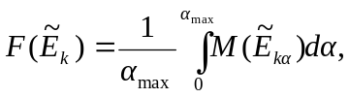 (k=1÷5) (4)
where α_{max} is a maximal value on (Rzayev, 2013). In this case we have:
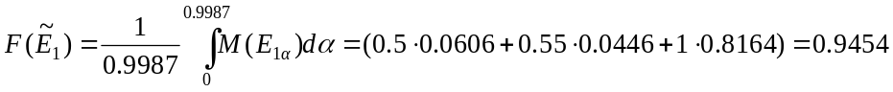.
For assessed concept of network performance u₂
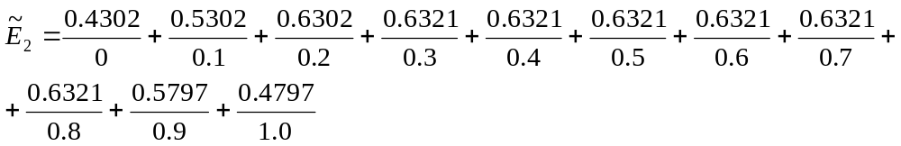
respectively we have:
- for 0<α<0.4302: Δα=0.4302, E_{1α}={0; 0.1; 0.2; 0.3; 0.4; 0.5; 0.6; 0.7; 0.8; 0.9; 1}, M(E_{1α})=0.50;
- for 0.4302<α<0.4797: Δα=0.0494, E_{1α}={0.1; 0.2; 0.3; 0.4; 0.5; 0.6; 0.7; 0.8; 0.9; 1}, M(E_{1α})=0.55;
- for 0.4797<α<0.5302: Δα=0.0506, E_{1α}={0.1; 0.2; 0.3; 0.4; 0.5; 0.6; 0.7; 0.8; 0.9}, M(E_{1α})=0.50;
- for 0.5302<α<0.5797: Δα=0.0494, E_{1α}={0.2; 0.3; 0.4; 0.5; 0.6; 0.7; 0.8; 0.9}, M(E_{1α})=0.55;
- for 0.5797<α<0.6302: Δα=0.0506, E_{1α}={0.2; 0.3; 0.4; 0.5; 0.6; 0.7; 0.8}, M(E_{1α})=0.50;
- for 0.6302<α<0.6321: Δα=0.0019, E_{1α}={0.3; 0.4; 0.5; 0.6; 0.7; 0.8}, M(E_{1α})=0.55.
The point estimate of the fuzzy outputs 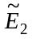 will be:
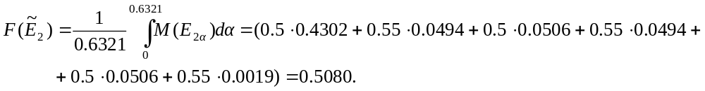
Similarly one can determine point estimates for all other outputs:
- at the level of network performance u₃ – 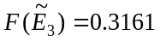;
- at the level of network performance u₄ – 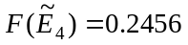;
- at the level of network performance u₅ – 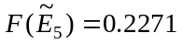.
Thus, in the accepted assumptions the total scale for the estimation of IP-telephony quality can look as it is shown in Fig. 4.
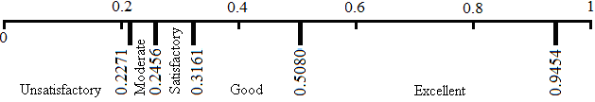
Figure 4. Scale of gradation of quality of IP-telephony services
In essence, the value 0.2271, which is the smallest defazzified output of fuzzy model for the multicriteria assessment of IP-telephony quality, corresponds to the consolidated unsatisfactory assessment of network users as the upper bound. Similarly we mean that from the point of view of consumers of the IP-telephony services the defazzified output:
- 0.2456 is the upper bound of estimation “Moderate”;
- 0.3161 is the upper bound of estimation “Satisfactory”;
- 0.5080 is the upper bound of estimation “Good”;
- 0.9454 is the upper bound of estimation “Excellent”.

5. Communication services quality scoring system and its analysis
Now, after we have established the reasonable scale for the classification of the services quality, let us consider a fuzzy model to evaluate the quality of communication services. For this purpose use the following rather trivial implicative rules:
- “If Transfer Delay is too low and Jitter is too low and Loss Ratio is too low and Error Ratio is too low, then IP-telephony quality is excellent”;
- “If Transfer Delay is low and Jitter is low and Loss Ratio is low and Error Ratio is low, then IP-telephony quality is good”;
- “If Transfer Delay is sufficiently Low and Jitter is sufficiently low and Loss Ratio is sufficiently low and Error Ratio is sufficiently low, then IP-telephony quality is satisfactory”;
- “If Transfer Delay is essential and Jitter is essential and Loss Ratio is essential and Error Ratio is essential, then IP-telephony quality is moderate”;
- “If Transfer Delay is high and Jitter is high and Loss Ratio is high and Error Ratio is high, then IP-telephony quality is unsatisfactory”;
As input characteristics there are used five assessed concepts, which are terms of linguistic variables – network performance parameters. Using ranges of numerical values of the network performance parameters (see Table 1), let us realize given rules in the notation of MATLAB/Fuzzy Sets Toolbox. Linguistic variable "quality of communication services", which assigns 5 fuzzy values (terms), formalized by Gaussian membership functions with vertices at the points: 0.2271, 0.2456, 0.3161, 0.5080 and 0.9454 is the output characteristic.
So, after setting the input and output characteristics of the fuzzy model in the form of Gaussian membership functions and fuzzy implicative rules let us proceed to analyze the work of the scoring system. Realization of rules in the notation of MATLAB/Fuzzy Sets Toolbox demonstrates that the consolidated level of network quality at best hypothetical values of its performance parameters does not exceed 0.837 (see Fig. 5).
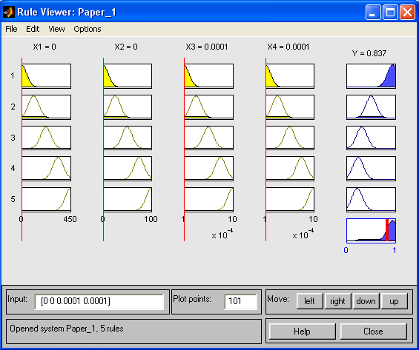
Figure 5. Assessment of quality of IP-telephony services with the best values of the performance parameters
With increasing of IP-packet transfer delay to 376 ms the level of services falls to 0.417 (according to the obtained scale this value corresponds to a good quality of network) and remains invariable for its further growth (see Fig. 6, a). With the loss of IP-packet share to 10⁻³ the quality of network services slumps to value 0.417 (see Fig. 6, b). It is necessary to note that under given scenarios the quality of communication services remains invariable with increasing levels of jitter.
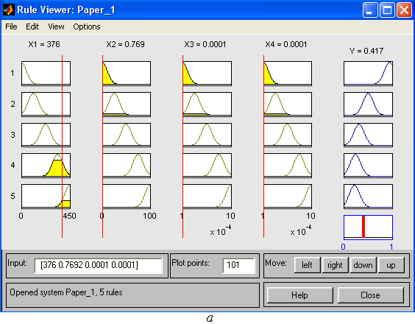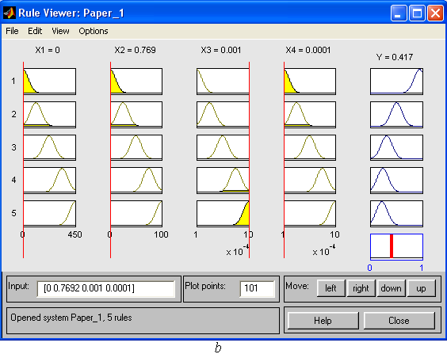
Figure 6. Quality of IP-telephony services at two extreme values of the network parameters
6. Conclusion
As is known fuzzy logic allows modeling uncertainty of human language and allows the involvement in the computational process nonmetrizable subjective categories, which, in particular, used by consumers for evaluating of provided services [5]. Application of fuzzy logic allows to take into account a set of heterogeneous parameters for decision-making and doesn't demand difficult mathematical calculations.
In this work comparatively reasonable scale for gradation of the consolidated estimates of IP-telephony users was obtained by limited set of consistent implicative rules. On this base offered IP-telephony services quality scoring system does not differ by itself parametrical and structural optimization. Possible inaccuracies can be eliminated due to implementation of a self-training element of system on the basis of the historical data (Lin & George Lee, 1994). Nevertheless even in the rough the offered system can be diversified on any other communication services and, thereby, becomes a basis for creation of the modular intellectual scoring system for telecommunication services (see Fig. 7).
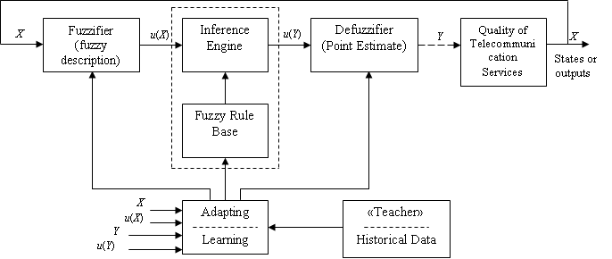
Figure 7. Intellectual scoring system for telecommunication services
Thus, the fuzzy scoring system for ccommunication services is capable to control communication network functioning through the subjective consolidated satisfaction of clients with level of services provided to them. This system is simple with a view to design and can be easily adapted to various conditions.

References
ITU-T Y.1541. (2012). Recommendation ITU. Series Y: Global Information Infrastructure, Internet Protokol Aspects and Next-Generation Networks. Network Performance Objectives for IP-based services. Switzerland, Geneva. http://www.itu.int/rec/recommendation.asptype=series&lang=e&parent=T-REC
Lin, C.T. and George Lee, C.S. (1994). Supervised and Unsupervised Learning with Fuzzy Similarity for Neural Network − Based Fuzzy Logic Control Systems. Fuzzy Sets, Neural Networks, and Soft Computing. Edited by R.R. Yager, L.A. Zadeh. New York: Van Nostrand Reinhold, 85 - 125.
Rzayev, R.R. (2013). Data Mining in Decision-Making Support Systems. Verlag: LAP Lambert Academic Publishing GmbH & Co. KG, 130 p. (in Rus)
Sokolov, D. (2009). Fuzzy System of quality estimation. Нечеткая система оценки качества. Technology and communication facilities, 4, 26-28. (in Rus)
Zadeh, L.A. (1974). Foundations for a new approach to the analysis of complex systems and decision processes. Moscow. (in Rus)
Zadeh, L.A. (1976). Concept of linguistic variable and its application to the adoption of approximate solutions. Moscow. (in Rus)
Zadeh, L.A. (2001). The role of Soft Computing and Fuzzy Logic in understanding, design and development of information/intelligent systems. News of Artificial Intelligence, 2-3. (in Rus)
Footnotes
¹This gradation can be irregular and that does not change the approach

