**Acknowledgements:**

We would like to acknowledge our supervisor Martin Hynes for all the support and GMIT staff for their help throughout the last four years.

**Abstract:**

In this project, we will be building a web application for students which will act as a student portal. We used SpringBoot, ReactJS, MongoDB and Google Firebase as the main frameworks for our web application, user authentication and data storage. We used AWS and DockerHub as our cloud platforms to deploy the Web Application, GitHub for controlling the source code and saving our work. The project will be written mainly in java and the react framework and a few other languages such as Javascript and CSS.

Currently with the times we are in, studying and keeping up with our work is very challenging. We cannot get access to course materials due to several reasons, such as little to no face to face contact with lecturers, and college work is being done all online. A lot of students miss the online lectures due to bad internet and because of this they may fall behind on their work. Other students do not even have an opportunity to visit their institute/university and are not able see any of their peers in person throughout the year. This is what sparked us and made us think that by making a student portal we can enhance and help these students with their college work and allow them to participate with each other.

This project is a research project as it will allow us to get a better understanding of the work that goes into making a high-end web application. It would also allow us to get a better comprehension of the different languages and frameworks that we will be using.

The overall objective of this project is to assist students with their online learning and to make online learning more enjoyable. It will also allow students to reach out to other students through the messaging part of the web application. First year students who have not been to college do not know who is in their class or what they look like. The web app will act as a social media platform which will allow the students to talk to each and get to know each other.

This project supports further expansion and insertion of new code and components such as a user profile page and a timetable to manage classes and modules. The proposed solution will be comprised of a high-end web application that allows the user to log in, talk to their fellow students and save notes in a notepad or as sticky notes. This will be done through CRUD functionalities of the app.

Chapter one:

Introduction:

Initially our first idea for our final year project was to create a web application but we did not know what direction to go in. We thought of different ideas such as a business website for buying and selling products or a blog website. While discussing our ideas together, we realized that due to the global pandemic happening around us, our college life will be affected. We will not be able to see each other and work on this project due to lockdown. We thought that if we are going to have this problem, then there will be other students who will be faced with the same issues. We decided that we would build a web app that will help us with this problem. This web app will allow students to get in contact with other students and share their notes and resources in a global notepad or talk to each other privately and share documents. The intention of this project is solely research based with the purpose of helping students.

Developing our Design:

At the beginning of this project it was challenging to select the language and the framework we wanted to work with. There were a lot of options that we could have gone with such as Python and Django or IonicJS. We decided not to use these languages and frameworks because we had previously used these, and we wanted to challenge ourselves with something new. While researching about different companies in our field, we discovered the most widely used frameworks that a lot of the companies use are SpringBoot and ReactJS. We thought this would be a great opportunity to learn new frameworks and enhance our skills further in Java.

This project uses the ReactJS framework to build the front end of the web app, and it uses the SpringBoot framework for the back end of the application. The ReactJS framework uses Javascript as the main language while the SpringBoot framework uses Java as the main language. We wanted to use MongoDB and Google firebase as the databases for the project because they are the most popular databases in the industry. We also wanted to run this project on the cloud so that it could be accessible from anywhere. We had numerous options when it came to cloud services, such as Google Cloud, Amazon Web Services and Microsoft Azure. We decided to use Amazon Web Services (AWS) and DockerHub for this part as they are industry standards.

The figures below indicate how both of these frameworks work. We will address these frameworks in depth further in the dissertation.

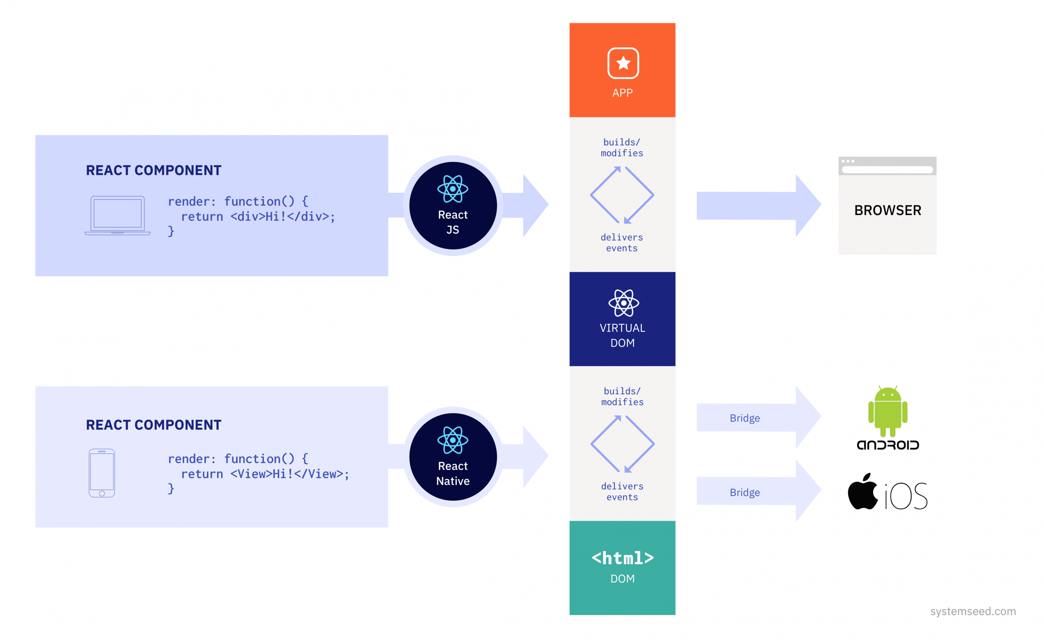

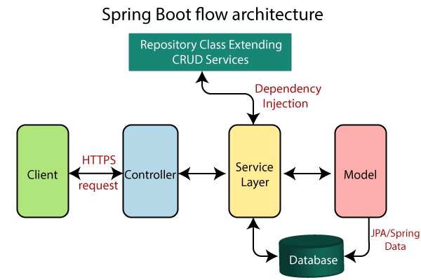

Final Design:

Student Hub, the title of our project, is a web application project that involves SpringBoot, ReactJS, MongoDB, FireBase and AWS cloud technology. The end product of this project will be a web application that will be running on aws and can be accessed anywhere and on any device. The user will have access to several services to help them get through each semester of college and have a pleasant experience throughout. There will be a facility that will authenticate the user and give them access to these services. The users will be saved in MongoDB, running on the cloud. The user will also be able to contact us regarding any queries that they may have through our live contact page. Below is a schematic diagram that we came up with at the start of the project to give us an idea of the end product.

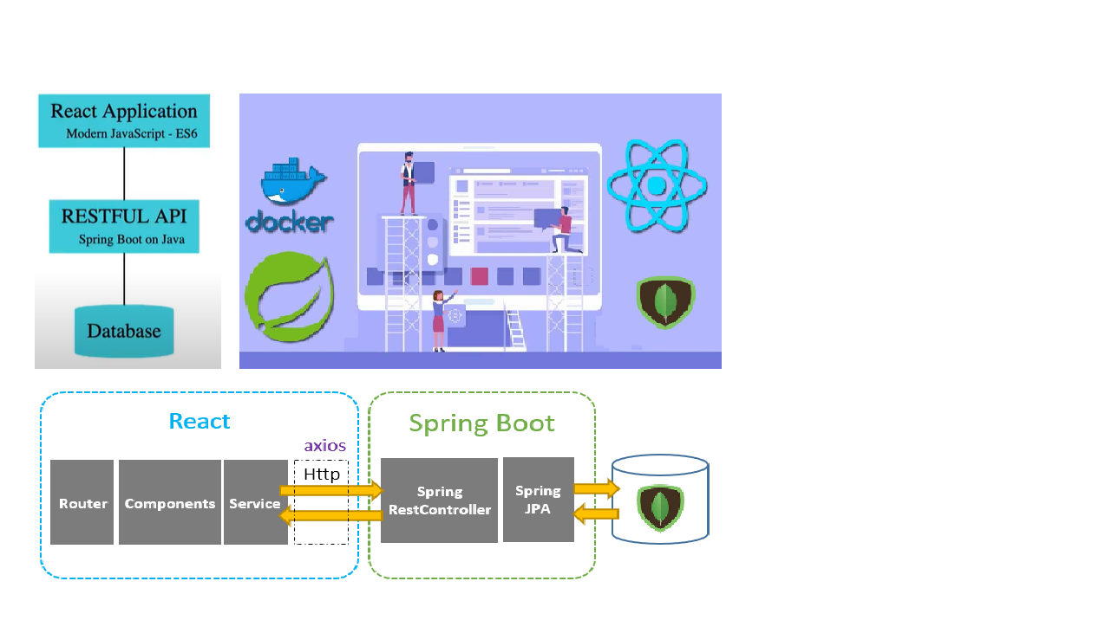

Objectives:

In order to provide a high-end web application that is also high performing, multiple goals need to be accomplished during the course of this project.

* The first objective was to create a SpringBoot and ReactJS application that could talk to each other and save details to the Mongo database. We also wanted to have a basic web application set up i.e. home page, navbar and footer.
* With the initial web app configured, we want to work on the common pages that usually appear on a website such as a contact page and an about us page. In order to achieve this we will be running a node server that will detect when the user wants to contact us and will send us an email.
* Subsequently, we will create pages for the user authentication. Once we have designed the register and login page we will connect them to the back end where the data will be saved in our database. The password will be hashed using the hash algorithm for extra security. We will implement a recaptcha on the login page to provide further security against bots and androids. The mongo database will be setup on the cloud so that it can be accessed from anywhere.
* After the user has successfully logged in they will be able to access a number of features such as sticky notes, notepad, messenger and a student forum page. All these features will be connected to the firebase database to allow for quick access. The messenger chat feature will be using an external API known as chat engine. We will edit this API and add our changes to the chat page.
* Lastly, the next step would be to deploy our project to the cloud. This will be completed through the use of Docker files and Docker-compose. The docker files will then be run on an Instance that we create in AWS.
* If we have extra time, we would also like to include a user profile page where the user can customise their profile and it can be viewed by other students.

Overview:

As this is our final year project, we knew that we would have to challenge ourselves to work on a project that will allow for independent learning. We wanted to make sure that we learned something new through each stage of development. This dissertation will be laid into different chapters, these chapters will explain our thought process and the different aspects of the project. This section contains a small description of each of the chapters that we will be covering.

Methodology:

This chapter of the dissertation will be focusing on the steps that we took throughout the development stage to make sure we have a successful project. We will discuss the reasons for various technologies we used such as, SpringBoot, ReactJS and mention the problems that we encountered during the initial set up and the development stages of the project. We mainly used the agile methodology, and we will further provide diagrams where needed to show off the methodology used in our final project design.

Technology Review

This chapter will be looking at all the different technologies that we have encountered during our research. We will go into further details on how to set up various technologies, for example Docker, Robo3T, Postman, and their key functionalities and advantages.

System Design

This chapter will focus on the different components and how they were implemented. Snippets of our code and images will be provided when explaining components to give a better understanding of the project. Each component will be discussed in great detail and we will explain how each part of the project contributes to the final product.

System Evaluation

This chapter of our project will discuss how our project performs, how scalable it is and its robustness. We will also mention any limitations that we faced such as, latency issues and cloud issues.

Conclusion

This chapter will be going over our goals and challenges that we set ourselves with. It will also cover if we accomplished these challenges and goals. The end result of the project will be discussed alongside all the difficulties that were experienced. These difficulties then will be discussed to show how we overcame our problems.

Project Links:

Link to Repository

* <https://github.com/sagheerahmadGmit/FinalYearProject>

Chapter two:

Methodology

As previously said, this section would focus on the various methodologies used to deter possible disasters. It was important to schedule and monitor the production stage ahead of time, so that any anticipated issues or glitches could be addressed. This enables us to make smarter plans, resulting in a faster planning phase and less lost time. We can also write simpler, more readable code by planning ahead. If this project is not properly prepared, it will result in events such as missed deadlines or the need to cut back on the project, resulting in the goals not being achieved.

Planning Phase

We defined the project's scope during the initial planning process. We concluded that Agile would be the best methodology to use. We investigated other methodologies, such as waterfall, but after comparing them to agile, we opted to stick with agile. We were able to divide the project into multiple stages, thanks to the Agile approach. It allowed us to make incremental improvements to the project at each point. Agile approach allows for greater flexibility in project planning and execution. We could also modify the project's various elements as it progressed. After discussing the different methodologies, we had to decide on the technologies to use. We researched into several technologies and there were a lot of good options to go with, but we concluded that Java, SpringBoot, ReactJS and MongoDB would be the main technology for developing this web application. In addition to the technologies, we had to choose an integrated development environment (IDE). We knew we had to use IntelliJ for the backend, we had previously used it in one of our modules and wanted to expand our skills and knowledge on it. We decided to use Visual Studio Code for the frontend. This way it would be easier to navigate through the code and see where the backend and frontend connect to each other.

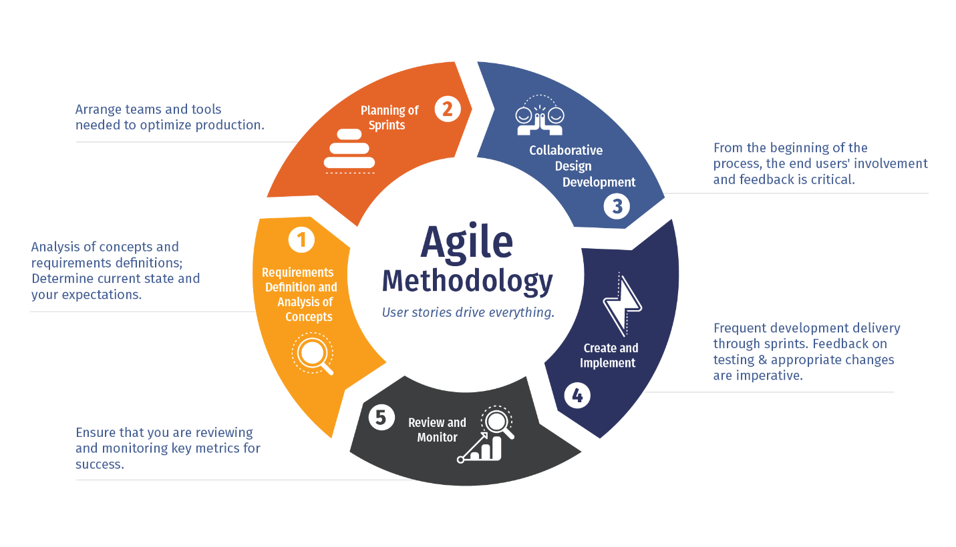

We developed a few diagrams during this process to help us better visualize the work that will be needed. The diagrams looked a lot like the schematic diagram described earlier. Since we couldn't meet in person to collaborate on the idea, we had to think about how we would approach everything. When doing research for this initiative, we came across a programming technique called mob programming. After doing more research, we decided to tackle the project with a mob programming approach. Mob programming is a method of software development in which a group or team of people work on the same project element at the same time. This way, we could both work on the project at the same time and know what was going on with the code. We made the decision to call a few days a week to progress on the application.

Requirements Analysis

One of the most important facets of this project was defining the project's criteria, as it would help us to understand what we need to do and split each phase down into steps. These phases will then assist us in completing various activities based on priority and importance. We had to explore and research what is needed for a viable web app, as well as the components that are required. We needed our web app to be able to meet these standards as efficiently as possible. These requirements are as follows:

* To begin, we must have a functioning web application that operates correctly and enables the user to perform the function for which it was designed.
* Second, provide a completely functioning and stable register and login framework that saves user data in a database. To add to the encryption, the password must be hashed.
* Next, the user should then be able to log in and communicate with other students, as well as save notes and documents to their account. They should also have access to the student forum, where they can post questions and get answers.
* After that, we would like to have the project running on the cloud through docker hub and AWS.
* Finally, if we have enough time, we'd like to convert our web app into a mobile app so that users can access all of their information on the go.

Meetings

Since we were a two-person team, we had to organize and arrange our meetings to collaborate on the project on specific days and times. We had to schedule it around other classes and assignments. We agreed that we will work on the project every other day and make a few commits. Since we had other assignments to complete during the year, this was a little more complicated at times. We had talks with our supervisor as well. Every week, either on Monday or Thursday, we met with our supervisor. This was to provide a report on our development, get input on any prior work, and address potential future proposals. The minutes of the meeting will be emailed to our supervisor, and we hoped to complete the recommended conditions for the next meeting. We used Microsoft Teams as the main tool for communication and meetings.

Development

We divided our work into smaller tasks and kept track of all these tasks on Atlassian Jira. We registered any bugs or concerns on Jira so that if we have these problems in the future, we can report back to this documentation. To ensure that we were on track with the project, we reviewed each feature separately and made regular GitHub commits.

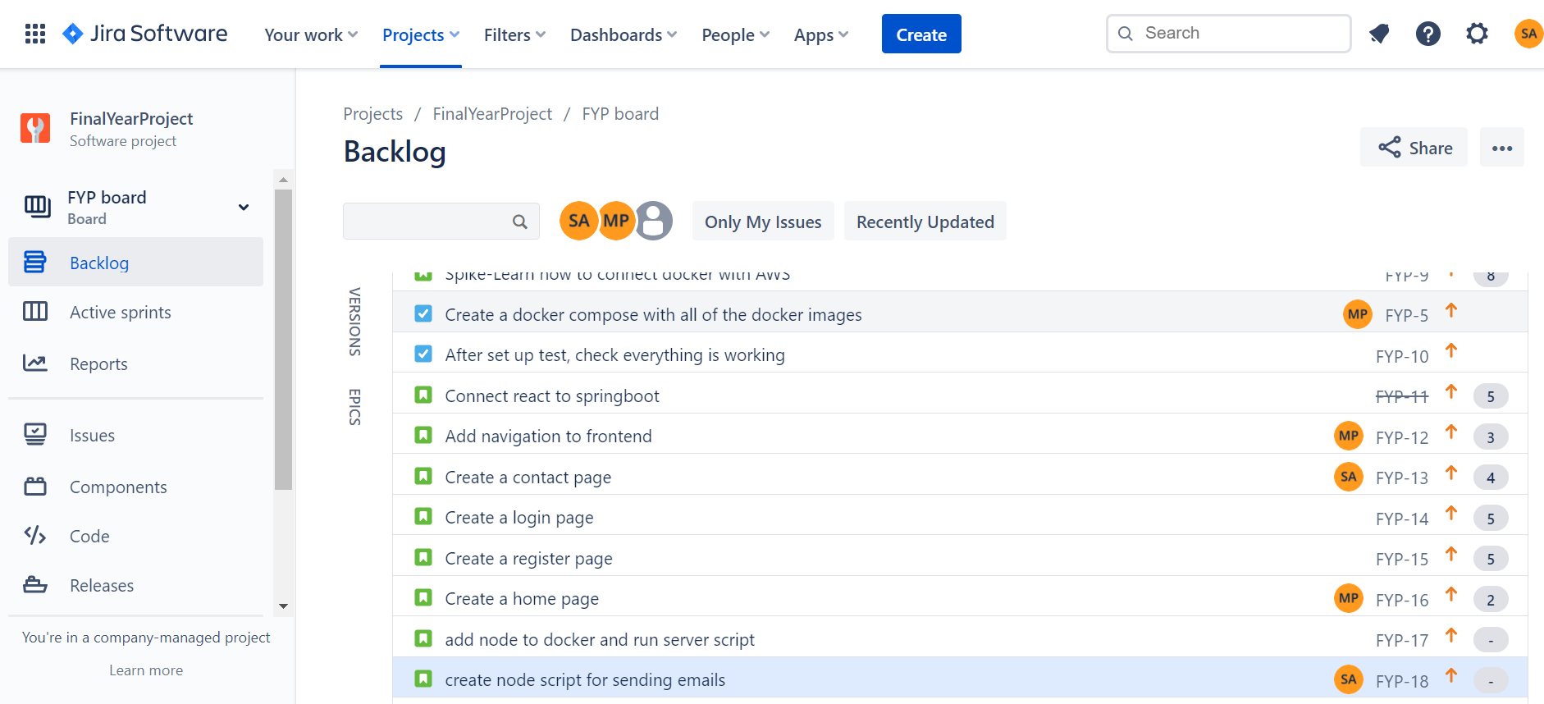

This is an example of how we used Atlassian Jira. We gave each task a story point and that dictated the amount of time that we could devote to that specific task.

Testing and Validation

Testing was a critical component of the project, as well as software in general. Testing can save us a lot of time by preventing any future catastrophes in the code and project. It also reassures us that the software can fit in with other features and elements of the web application. To test the project, we used Robo3T and Postman, among other tools. We carried out black box testing on the project by allowing other students to register and access the website in order to assess the various functionality and components. Black box testing is a form of software testing that focuses solely on the website's front end. It has no understanding of the website's back end or the code that makes it work. This was extremely beneficial because we received direct feedback from students. We asked them if we could strengthen and change things, and we tried to make the necessary improvements.

Allowing a client to log in with incorrect information and watching what happens or attempting to enter a website function without being logged in, are examples of black box testing.

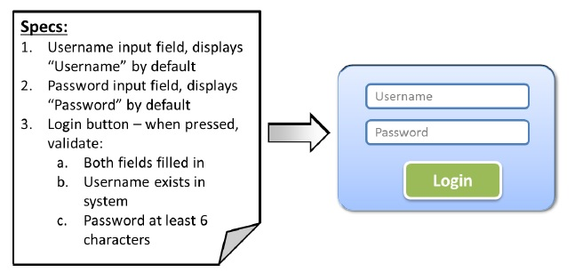

Problems Encountered

We ran into a lot of issues and failures during the early stages of development, including docker not running, the user being unable to save their credentials while registering, and GitHub failing to push our code to the correct branch. We had to look at these mistakes and come up with suitable alternatives. We made a note of the solution after we had resolved these problems. This was so that if the same issue arose again, we would know how to correct the mistakes and issues.

Version Control Manager

We wanted to select a version control manager before we began working on the actual code component of the project. There were a couple of great options, including Bitbucket, an Atlassian version control repository hosting site, and AWS CodeCommit. We concluded that using GitHub, which is more well-known and widely used in the tech industry than any other version control manager, would be more useful to us. We had been using GitHub for our work and projects since our first year of college, so it made the decision easier. GitHub has a lot of features that we could take advantage of, the most important of which is the ability to work on various branches to finish different parts of the project. It also allowed us to keep track of our issues inside the project repository. If we make an error or accidentally insert the incorrect file, GitHub helps us to revert our commits and return to the original code. We knew we wouldn't lose any of our code this way. Since GitHub helps us to see where in the code, we make modifications and how they affect the code, we were able to quickly see where we had glitches and errors. We decided to commit to GitHub on a regular basis to encourage us to work on the project more often. We made small commits rather than huge commits or one final commit at the end. This is because it demonstrates our progress and thought process in the development stage. It further demonstrates the many issues we encountered and how we addressed them. In our view, GitHub was by far the best version control manager.

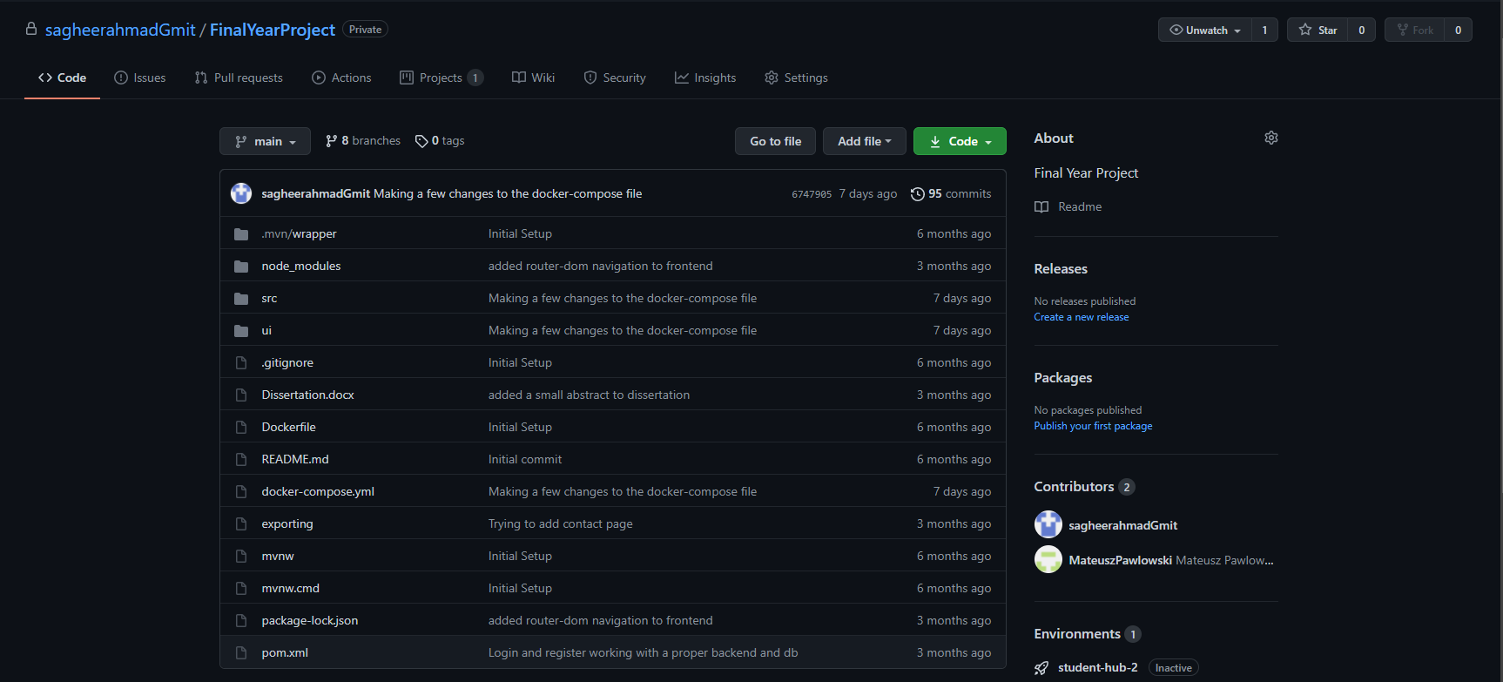

Figure: GitHub

Chapter Three

Technology Review

This segment discusses the various technology that we used to construct our web application. We will use code samples and visual aids to help you visualize how the technologies work. The technologies we will be talking about are:

* MongoDB
* Firebase
* NodeJS
* ReactJS
* Spring Boot
* Postman
* Robo3T
* Atlassian Jira
* GitHub
* GitHub Desktop
* Docker
* Amazon Web Services (AWS)
* Visual Studio Code
* IntelliJ

**Database**

The data tier refers to the processing of data that have been stored in the database. The user will be able to perform CRUD (create, read, update, delete) operations on the application. We have two databases setup for our project. Our account information is kept in MongoDB, while our website data is kept on Firebase.

MongoDB

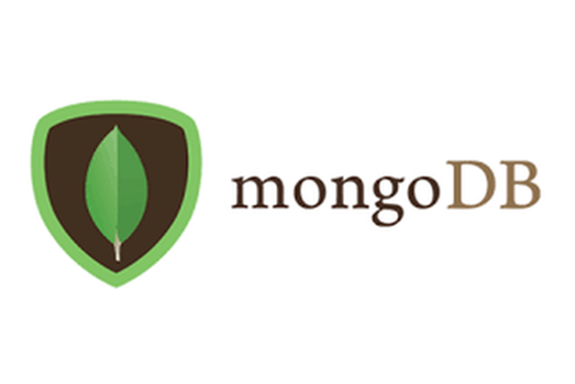

MongoDB is a document database, meaning it contains information in JSON like formats. According to MongoDB, “We believe this is the most natural way to think about data and is much more expressive and powerful than the traditional row/column model”. MongoDB's goal is to store and recover data easily so that developers can switch and program quickly. MongoDB is a NoSQL database, which means it isn't tabular and doesn't store data in the same way as relational tables do. MongoDB has several features, including horizontal scaling (distribution of data across multiple devices allowing for a better distribution system) and load balancing. It can support modular schemas and is readily elastic when dealing with massive volumes of data and heavy user traffic. It allows data to be viewed instantly after being inserted into the database. MongoDB allowed us to change the structure of the database as the project progressed. Ad-hoc queries can be used by developers to obtain real-time metrics. Ad-hoc is a short-term command that is dependent on the value of a variable. With these features MongoDB is a very efficient software that helps us to view and analyse our data.

As previously said, MongoDB stores all of its data in JSON format. JSON uses fewer data in general, lowering costs and reducing storage requirements. As a result, JSON parsing is faster than other formats such as CSV and XML. No matter what programming language you use, JSON is easier to read and map to domain properties. The mongo database was originally set up locally to validate the project, but after the initial implementation stage, we migrated the database to AWS cloud using a docker images.

Robo3T

Robo3T (originally known as Robomongo) helps users to communicate with MongoDB data using visual indications rather than a text-based interface. It has a graphical user interface that is like that of a desktop graphical user interface. It supports cross-platform applications, which means it can incorporate the mongo shell into its user interface for text-based or graphical interaction.

While testing the project, we used Robo3T to keep track of our data. We had to make sure that the users were saved to the database and that the passwords of the users were hashed. We have used Robo3T to retrieve data and build new columns and tables. In the figure below we can see that there are several users saved in the users section of the database

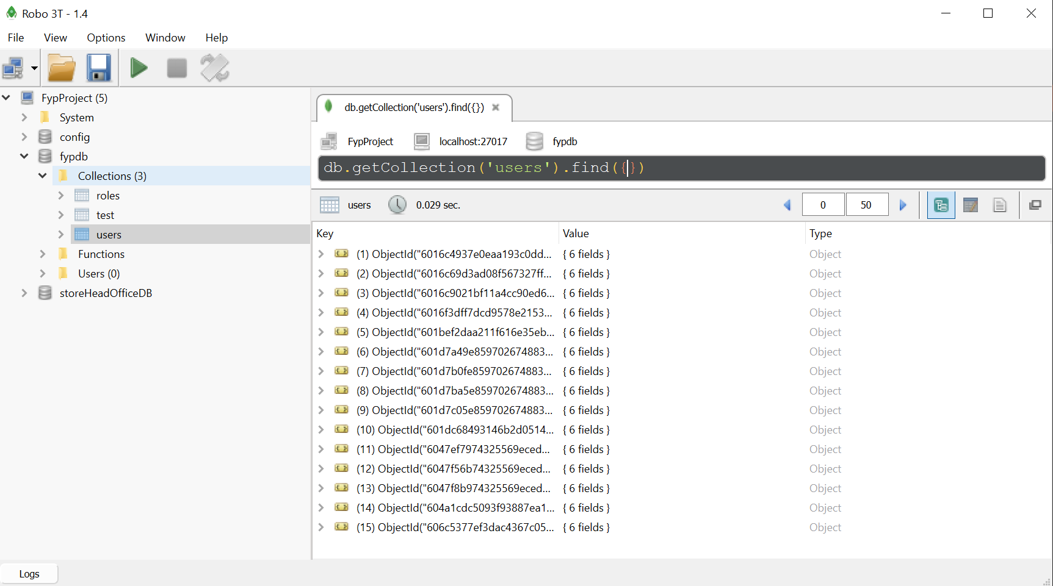

Firebase

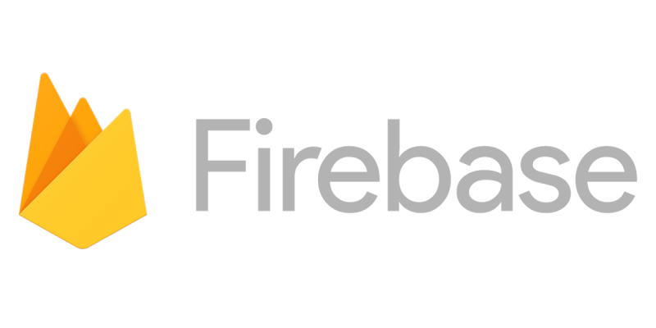

We chose firebase to handle all the data on our web app such as the student forum page or the student notepad element. Firebase is a database provided by Google to enable developers to create high-quality web apps easily. It has a variety of tools and services that aid the developers to grow their user base and create quality apps. Just like MongoDB, Firebase is also a NoSQL database and stores data in JSON format. Firebase has a lot of useful features that make developing more fun. The data is synced in real time and remains available even when the app goes offline. It can provide fast hosting for a web app and makes the whole hosting process much easier.

Software development kits (SDK) are used by Firebase to provide methods for generating and handling data. These SDKs will submit information to Google's cloud database, which can then be shared with other web users. All users share a single database instance and are immediately updated with the most recent information. If the user loses connection, the data will still be transmitted to the database. Below are details of the app that we created in firebase and the SDK to that app.

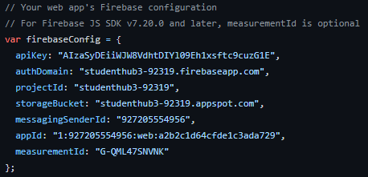

Version Control Manager

GitHub

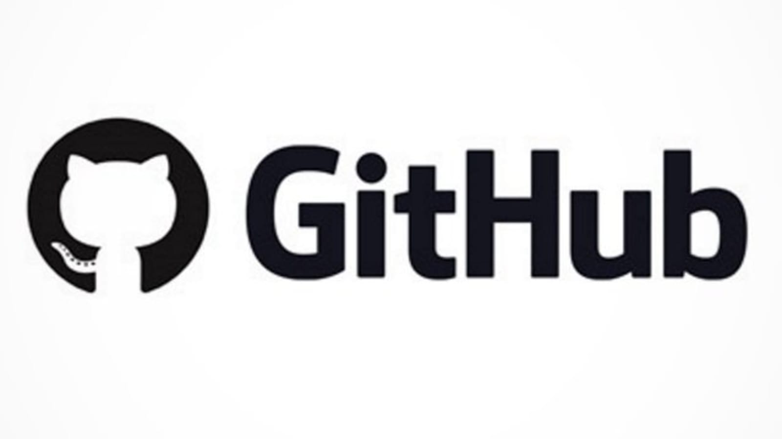

GitHub is a collaborative code hosting site. It allows you and others to collaborate on projects from any place at any time. For Git commands, GitHub provides a graphical user interface (GUI). It is used as a version control manager, as previously mentioned. Java, Docker, Python are a handful of the languages that can be hosted on GitHub. Some of the features available to GitHub include, following other users, forking other people's repositories, subscribing to other’s projects. Since it is widely used in the industry, GitHub is an excellent skill to acquire. Cloning other people's repositories is a fantastic feature of GitHub; it allows you to get another person's code and make improvements to it in your repository.

GitHub Desktop

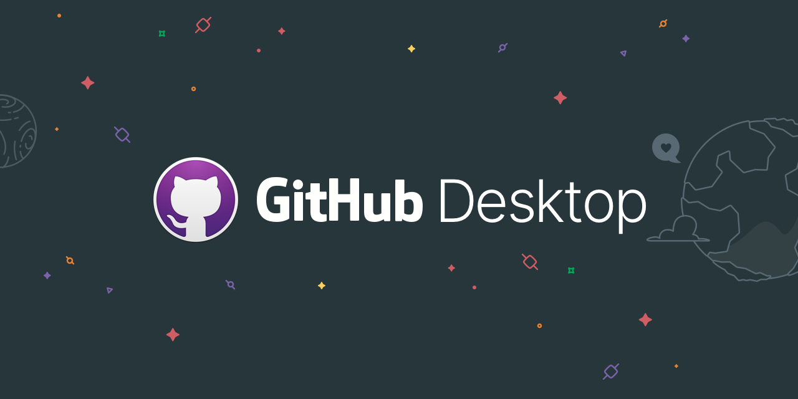

Along with all of this, GitHub has created GitHub Desktop, a software program that works in the same manner as their website. It's available as an interface which gives you easy access to GitHub repositories. We decided to focus on the desktop edition because it's easier to read and doesn't require the use of the command line for any inserting, committing, pushing, or pulling. It also enables users to clone any directory onto their machine and begin working on it right away. We may even inspect all of the modifications we made to the project before committing them using GitHub Desktop. If we feel that these modifications aren't what we want, we can roll back directly from GitHub Desktop, saving us the trouble of getting into the code and removing any changes we created. Many of these features are accessible via GitHub Desktop's user-friendly graphical user interface.

Spring boot Framework

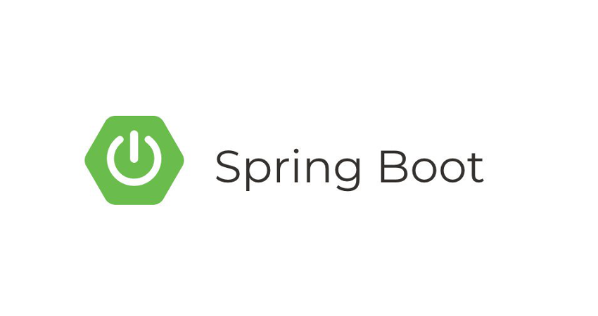

Spring boot is an application framework and inversion of controller

Resources

<https://www.mongodb.com/what-is-mongodb/features>

<https://www.mongodb.com/nosql-explained>

<https://blog.cloud-elements.com/using-json-over-xml#:~:text=JSON%20uses%20less%20data%20overall,language%20you're%20working%20with>.

<https://firebase.google.com/>

<https://www.educative.io/edpresso/what-is-firebase>

<https://firebase.google.com/docs/database>