**Developer Diary**

Sagheer Ahmad – G00357770

# Introduction

This is the Developer Diary that I will be using for the module, Mobile Applications Development 3. This diary will be used to keep track of the progress I make on the game and keep notes of my thought process on how I implement the different parts of the game. This developer diary is my account of development. I hope to do frequent updates on my progress and the development of the game.

# Entry 1. 24/10/20

After reading the design document that I was provided by my designer, I could see that I had to develop an endless runner. The main concept of the game was to control an avatar through an endless map while trying to avoid objects in the way by jumping or moving out of the way. The overall aim of the game is to last as long as possible and get the highest score. I will discuss some of the features with the designer and see if I could add some additional features or change a couple features around to best suit the game. I started creating small ideas on how I wanted to go about developing the game.

# Entry 2. 27/10/20

I have started doing research into the game and how I should go about developing the game. I searched the asset store and other places for sprites or tiles that I could use. I have also created a github repository to get the project started. The project requires me to find a pig character because the main character of the game is a pig. I struggled to find a character online and on the asset store because most assets required me to pay. I finally found a good sprite that I could use. My next step is to start developing the game.

# Entry 3. 29/10/20

I have started developing the game. After the initial struggle of finding the correct assets, I wanted to make the player run and move side to side. After achieving this I decided to create a simple level that I could use to test the movement. I had to do a lot of research on how to implement all of this. I watched a lot of online tutorials. Unity has good amount of documentation that I watched and read on creating levels and terrains. I also sent a picture of the test level to the designer to get their opinion on the design. The designer said that the level looks good and I should keep working on it. I started to work on the player movement. The designer wanted the player to be able to move using the A and D keys. I did this by getting the player position and changing the transformation when the keys are pressed. Now the player is able to move with the A and D keys, but I plan on implementing the jump and touch controls later in the development stage.

# Entry 4. 04/11/20

The character is now able to move along the x axis and run straight. My next step was to get the character jumping. I used the space key to make the character jump. I next wanted to make the terrain for the character to run through. The initial terrain that the developer wants is a terrain with hills. I used a terrain with houses and a couple trees and sent a pic to the developer, who approved of the idea. The character will be initially running on the road. I next had to test that the character was able to run along the terrain and move on the road. I had a few difficulties here because of the character’s x position. The terrain was not reset, and the player kept moving to a different position after the game started. I had to change the terrain to the characters position. My next aim is to add obstacles on the path for the character to avoid.

# Entry 5. 07/11/20

I started to add obstacles to the course. I got some assets from the asset store and used these as the obstacle blocks. After adding the obstacles, I wanted the player to be able to collide into them, so I had to add colliders to the obstacles and a killPlayer script. I had it so that when the player collides with an obstacle, the dying animation plays. I had to use a player animator to do this. I also added a running animation, so the game feels better when playing. My next aim is to add the coins to the game.

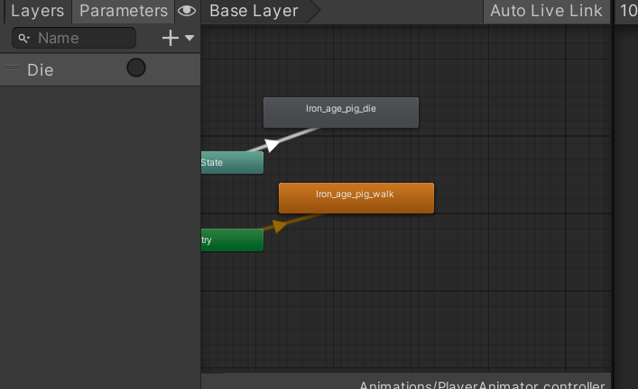

After the player dies the player just lies on the floor. Next, I worked on the jumping part of the game so the player can jump over obstacles and not die.

# Entry 6. 11/11/20

I added more obstacles to the course to make it more challenging for the player. I am now working on the coins and power ups aspect of the game. The game originally had no power ups or coins so I had to message the designer if I could add these into the game. The designer was happy to let me add these into the game. Adding the coins to the game is proving to be a little difficult. I am getting a few errors from unity and have to do research on how to fix these. The problem I kept getting by the coins was that when the coins appeared on the screen the player picked up one coin and that got rid of all the coins and the coin sound played even before and after the coin was picked up.

# Entry 7. 16/11/20

I have been working on the coins and I am still getting errors. I have decided to move on from the coins and work on the level design of the game. I will come back to the coins at a later stage and fix the errors. I now want to make the game endless and make it so the player can play infinitely. I am struggling with the endless part of the game because the roads are not repeating properly, and the game is not endless. I have to do more research into this and try to fix the problem so I can work more on the game. I have spent a lot of time researching the problem and different methods on fixing the issue. I found the issue was very small but caused a lot of problems. The road was repeating but the x and y position was not accurate, and this was due to the terrain in the back, was static, so it was not moving properly. I made it so the terrain was not static. This fixed the level and the level is now endless.

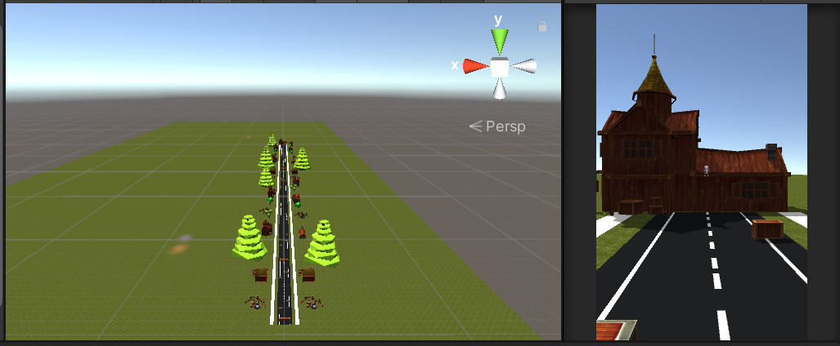

I made the level with two road game objects so when the player moves from the first segment into the second, the first one will be deleted and moved to the front of the next one. This is how the endless part of the game works

# Entry 8. 22/11/20

I next want to add a script that will start the game with one camera and change to a different camera once the player is out of view. I will do this by creating an empty object that will have a box collider. This box collider will be a trigger for the camera change. When the player hits the collider. It will run a script that will set the active status of the main camera to false and make the camera following the player to true. While trying to do this there were a few issues that I had to deal with. The player had a script that triggered the road repeating script everyone the player collided with a collider. In order to fix this problem, I had to remove this part from the script and create a new script and apply that to the spawnTrigger gameObject. I messaged the designer and sent him a video explaining the game so far. The video demonstrates the endless part of the game along with the obstacles and the terrain. I am still waiting on a reply from the designer regarding the video.

# Entry 9. 24/11/20

I want to work on a camera switch mechanic in this entry. I want the game to start off with the camera in front of the player. When the player is out of the camera angle, it will switch to a different camera that will follow the player. This will be done through another collider. When the player hits a collider that will deactivate the main camera and activate the follow camera. I wrote a script that will take two camera objects and activate and deactivate them. I had a few issues with this because the main camera was glitching out and it would not work. I had to turn the main camera off and insert a new camera module. After doing this, the camera switching was working.

# Entry 10. 26/11/20

I have started working on the main menu and the pause menu. I created a canvas with a panel and put buttons inside the panel. The panel contains 3 buttons, for sound, help and quit. When the user presses these buttons, separate actions will be taken. The sound button will allow the player to turn on and off the sound. The help button plays an animation that brings up a small panel with information about the game. The quit button allows the user to exit the game. The pause menu is very similar to the main menu, where it contains 3 buttons. These are the resume, restart and quit button. I have sent pictures to the designer to confirm if the menu system is okay.

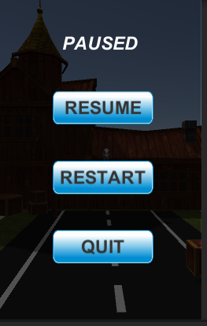

# Entry 11. 28/11/20

# References

**Moving the Player:**

<https://www.youtube.com/watch?v=rA_JDSGgZlw&list=PL0WgRP7BtOez8O7UAQiW0qAp-XfKZXA9W&index=2&ab_channel=Developer3.5Pro>

**Camera Following Player:**

<https://www.youtube.com/watch?v=8JHrM7yS0Xw&ab_channel=N3KEN>

**Making the Level Endless:**

<https://www.youtube.com/watch?v=RYouWeqZbPc&ab_channel=Quick%27nDirty>

**How to Switch the Camera:**

<https://answers.unity.com/questions/265759/camera-switching-by-trigger.html>