Fixing problem: filament stuck on nozzle.

1/4/2024

3d printer : Alfawise U20

While assemble the robot we ran into problem, the printer finished to printing but stop extruding filament in the middle of the printing, what results us an finished part that we couldn’t use.

after trying different result methods to fix the problem and some searches in the internet we came into the conclusion that the filament is stuck in the nozzle head or somewhere in the tube, what gave us the complete joy to dismantle fix and reassemble the Alfawise U20 printer in order to keep our project on the air.

We used this introductions to fix it : <https://www.youtube.com/watch?v=THckvut7I7w>

Lets start! ☺

1. Rise up the extruder for easy disassembly.
2. Hit the extruder to 210 degrees.

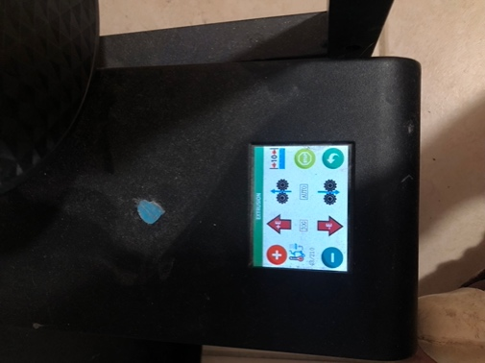

1. Use player and a screw key to screw of the nozzle.  
   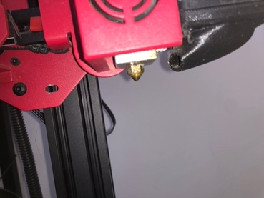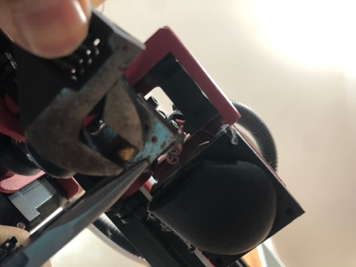
2. 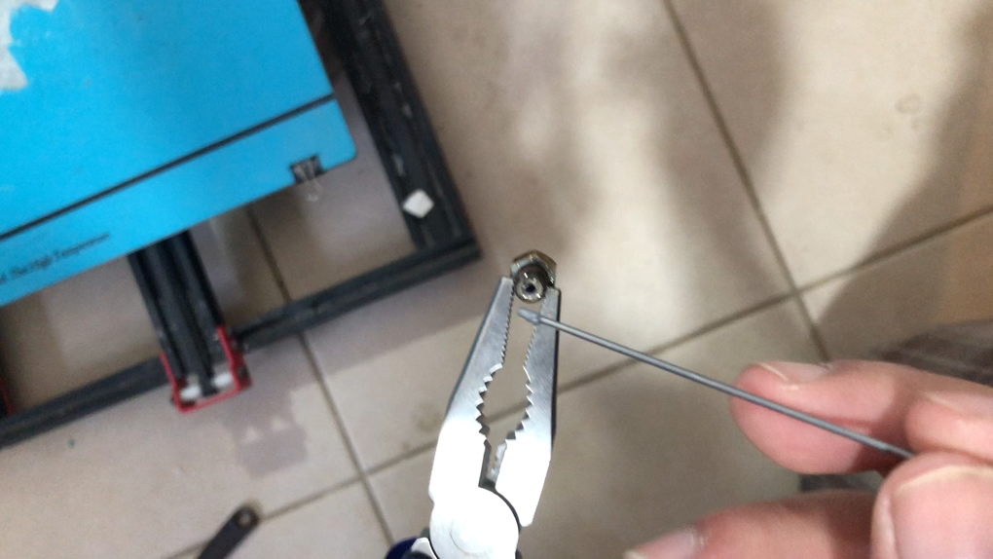Clean and open up the nozzle head using a thin needle(you should be able to look trough this gap).  
   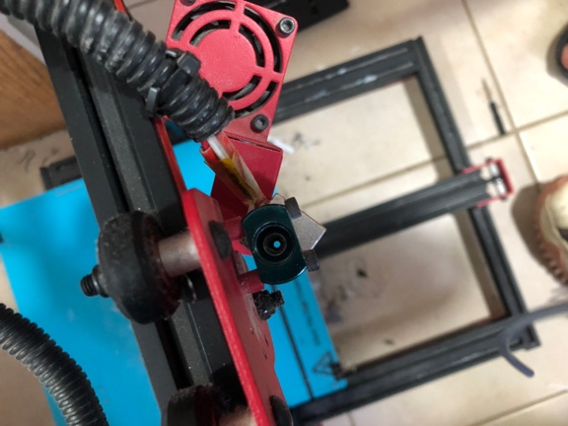

1. Push the ring above the printing head while pulling the filament tube gently (you might want to remove this screws easy care).  
   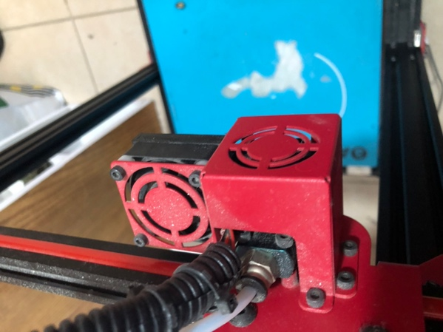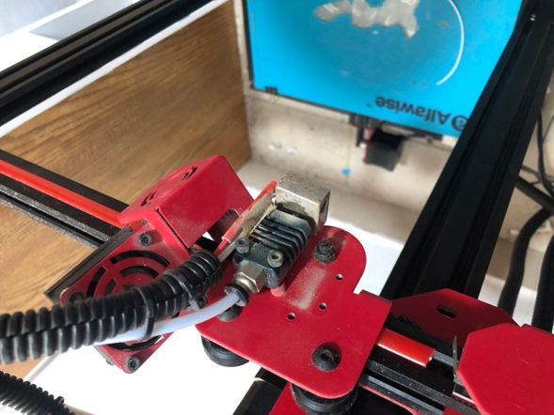
2. Push the ring near the extruder while puling the filament tube gently.
3. Clean or replace the tube.

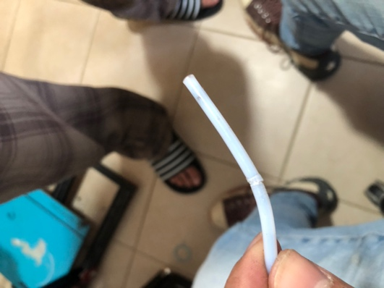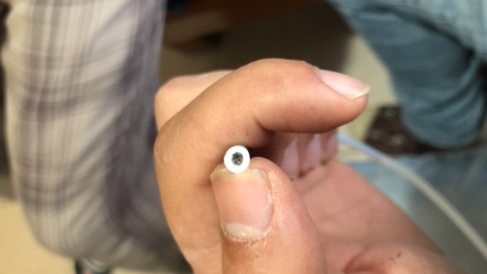

1. From heare folow back on the instucations on this order.