EviewsR Package created by Sagiru Mati

# 1 About EviewsR

EviewsR is an R package that can run Eviews program from R Markdown.

# 2 Installation

EviewsR can be installed using the following commands in R.

install.packages("EviewsR")  
  
 OR  
   
devtools::install_github('sagirumati/EviewsR')

# 3 Setup

To run the package successfully, you need to allow Eviews program to run on Eviews startup. This can be set by clicking on options, General Options, window behaviour and ticking run program on Eviews startup as shown below:

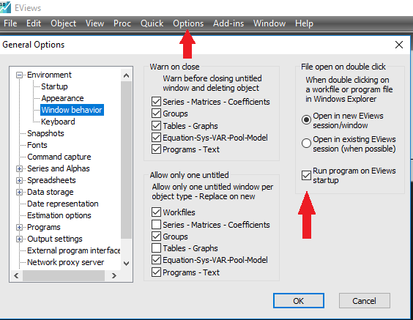

# 4 Usage

Please load the EviewsR package as follows:

```{r EviewsR} .  
library(EviewsR)  
```

Then create a chunk for Eviews as shown below:

```{eviews EviewsR1,eval=T,echo=T,comment=NULL,results='hide'} .  
 'This program is created in R Markdown with the help of EviewsR package  
 %path=@runpath  
 cd %path  
 wfcreate(page=EviewsR) EviewsR m 1999 2020  
 for %y Created By Sagiru Mati Northwest University Kano Nigeria  
 pagecreate(page={%y}) EviewsR m 1999 2020  
 wfsave EviewsR  
 next  
 pageselect Sagiru  
 genr y=rnd  
 genr x=rnd  
 equation ols.ls y c x  
 freeze(EviewsR_OLS,mode=overwrite) ols  
 EviewsR_OLS.save(t=csv, r=r7c1:r10c5) EviewsROLS  
 EviewsR_OLS.save(t=csv) EviewsRtable  
 freeze(EviewsR_Plot,mode=overwrite) y.line  
 EviewsR_Plot.save(t=png) EviewsR_Plot_color  
 EviewsR_Plot.save(t=png,-c) EviewsR_Plot_nocolor  
 exit  
```

The above chunk creates an Eviews program with the chunk’s content, then automatically open Eviews and run the program, which will create an Eviews workfile with pages containing monthly sample from 1999 to 2020. The program will also save an Eviews workfile named EviewsR in the current directory.

We can *dynamically and reproducibly* fetch the Eviews graph object we created with the Eviews chunk using the following R chunk:

For the color graph object:

knitr::include_graphics("tools/EviewsR_Plot_color.png")

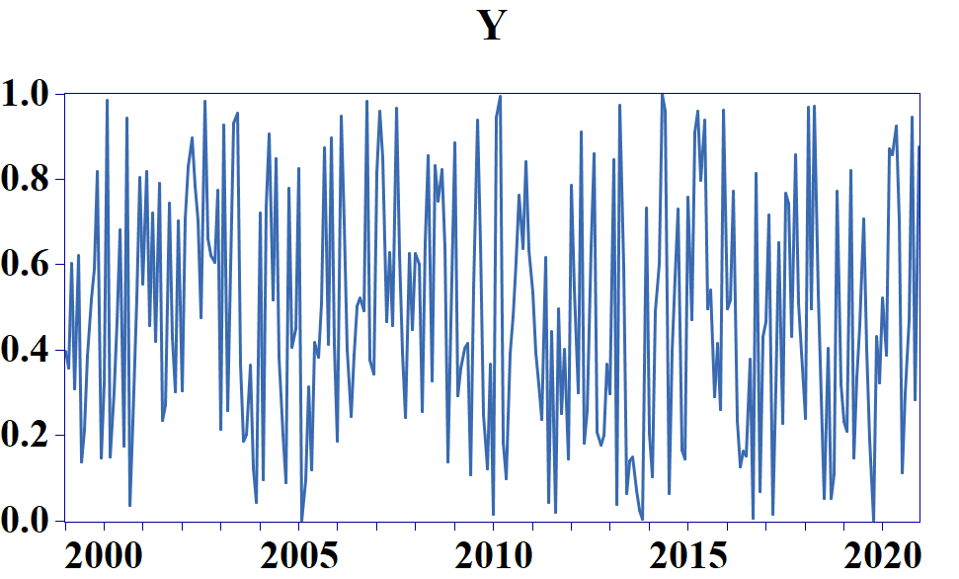

Figure 4.1: Eviews graph object with colour

or the black and white graph object:

knitr::include_graphics("tools/EviewsR_Plot_nocolor.png")

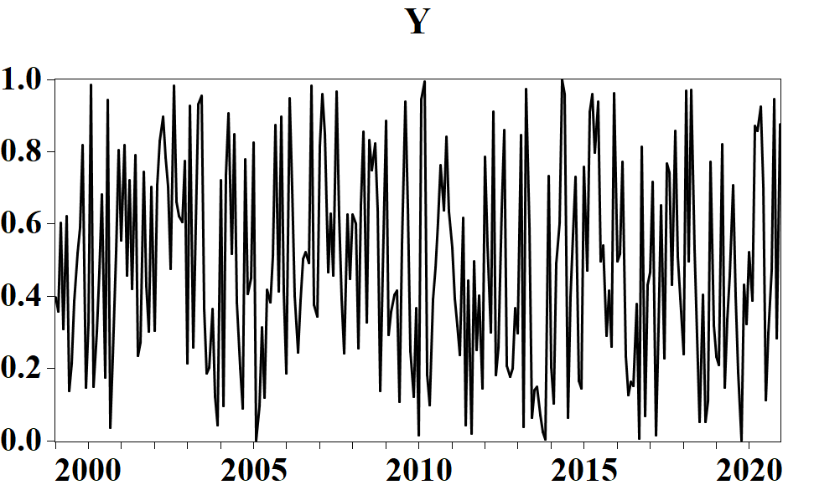

Figure 4.2: Eviews graph object without colour

we can also include the results of the OLS generated by the Eviews chunk using the following R chunk;

For the OLS result only:

olsResult=read.csv("tools/EviewsROLS.csv")  
knitr::kable(olsResult)

Variable

Coefficient

Std..Error

t.Statistic

Prob.

NA

NA

NA

NA

C

0.480025

0.033905

14.157800

0.0000

X

0.009925

0.060301

0.164585

0.8694

or the entire OLS output:

olsTable=read.csv("tools/EviewsRtable.csv")  
knitr::kable(olsTable,format = "html")

Dependent.Variable..Y

X

X.1

X.2

X.3

Method: Least Squares

Date: 11/01/21 Time: 20:52

Sample: 1999M01 2020M12

Included observations: 264

Variable

Coefficient

Std. Error

t-Statistic

Prob.

C

0.480025

0.033905

14.15780

0.0000

X

0.009925

0.060301

0.164585

0.8694

R-squared

0.000103

Mean dependent var

0.484811

Adjusted R-squared

-0.003713

S.D. dependent var

0.282646

S.E. of regression

0.283170

Akaike info criterion

0.322007

Sum squared resid

21.00851

Schwarz criterion

0.349098

Log likelihood

-40.50495

Hannan-Quinn criter.

0.332893

F-statistic

0.027088

Durbin-Watson stat

1.817012

Prob(F-statistic)

0.869398

Please visit my [Github](https://github.com/sagirumati/EviewsR/tree/master/example) for a better explanation and example files.

Table 4.1

EviewsR::eviews_rwalk("Eviewsr",series = "x y z")

eviews_commands("wfcreate m 1990 +90")

import_table("eviewsr1",table_name = "SAGIRU",caption = "Some Nice Caption",digits = 2)

Table 4.1: Some Nice Caption

| header 1 | $α_{t}$ | B | C | D |
| --- | --- | --- | --- | --- |
| R-squared | 0.00 | Mean dependent var | NA | 0.50 |
| Adjusted R-squared | 0.00 | S.D. dependent var | NA | 0.30 |
| S.E. of regression | 0.30 | Akaike info criterion | NA | 0.45 |
| Sum squared resid | 23.91 | Schwarz criterion | NA | 0.48 |
| Log likelihood | -57.58 | Hannan-Quinn criter. | NA | 0.46 |

chunkKable=kable_styling(chunkKable,latex_options = c("basic","hold_positon","scale_down")) %>%  
footnote(general="insert footnote here", general_title = "",footnote_as_chunk=T,threeparttable=T,escape=F) %>%  
row_spec(0,bold=T)  
chunkKable

chunkKable  
y="insert footnote here"  
kable(y,format=ifelse(knitr::opts_knit$get("rmarkdown.pandoc.to")=="docx","pandoc","latex"),booktabs=T,escape=F,col.names = NULL,linesep="")

unlink("C:/Users/SMATI/Google Drive/GITHUB/Repos/sagirumati/EviewsR/inst/examples/sagiru.csv",recursive = T,force = T)