Untitled

2022-06-11

## 0.1 R Markdown

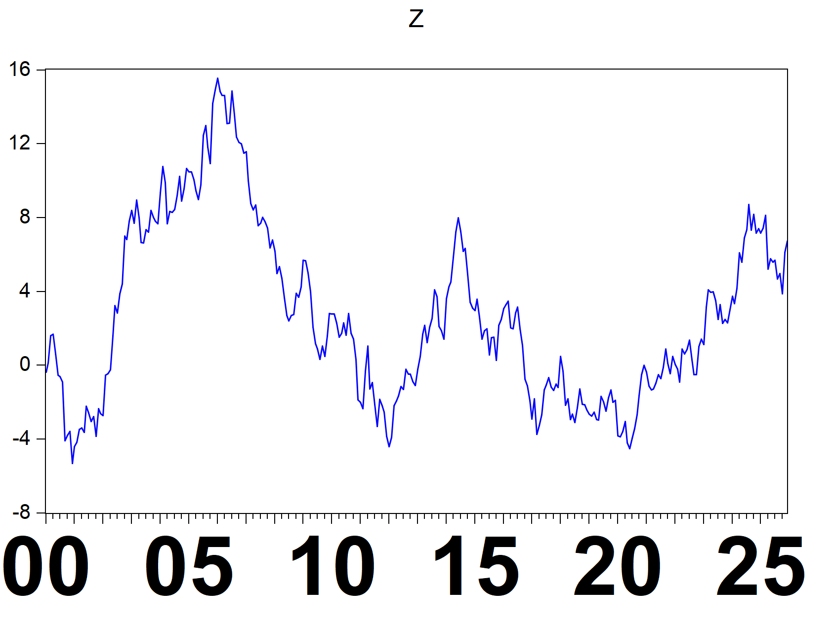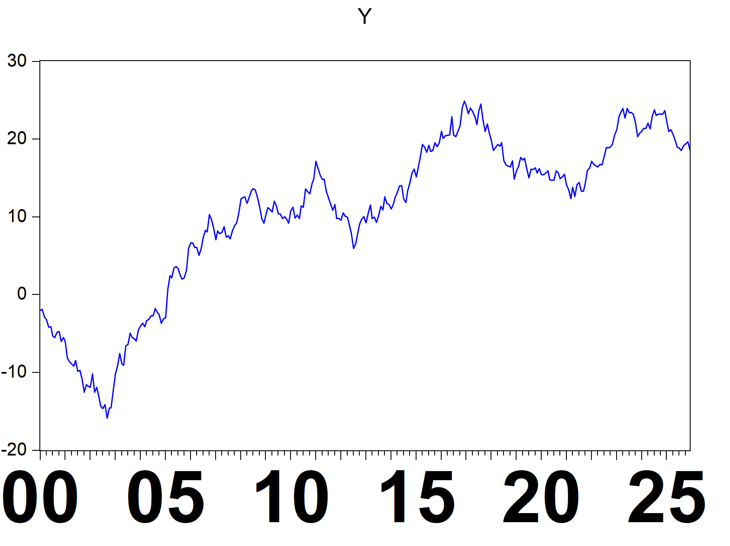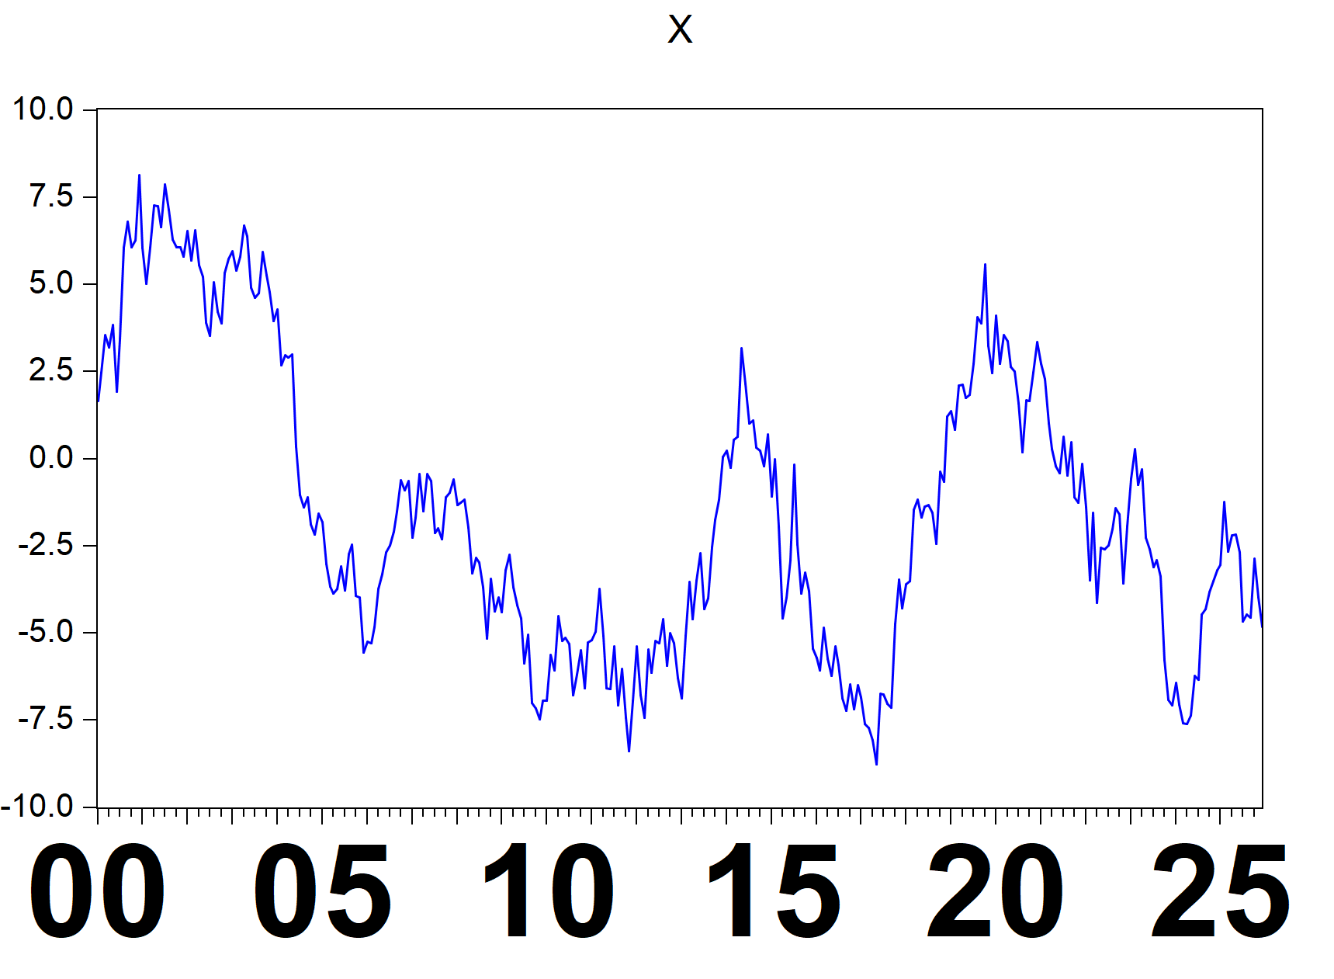hold1

## aic df coefs dw f fprob hq logl meandep  
## 1 6.964478 310 7.955609 0.062658 221.7466 3.32e-38 6.974067 -1084.459 10.41799  
## 2 NA NA -1.610669 NA NA NA NA NA NA  
## ncoef pval r2 rbar2 regobs schwarz sddep se ssr  
## 1 2 2.01e-45 0.417016 0.415135 312 6.988471 10.26041 7.846797 19087.39  
## 2 NA 3.32e-38 NA NA NA NA NA NA NA  
## stderrs tstats  
## 1 0.474015 16.78345  
## 2 0.108163 -14.89116

# 1 R plots

## NULL

## [1] "asis"

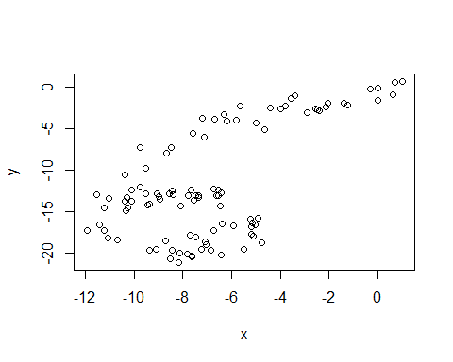

Figure 1.1: another fig

