DBMS – PAYMENT MANAGEMENT
Project Title: Nykaa E-Commerce Management System – Payment Management
Skill Task: DBMS
Week: 5
1. Database Design
1.1 Payment Table
Attribute | Data Type | Constraint
Payment_ID | NUMBER(5) | Primary Key
Order_ID | NUMBER(5) | Foreign Key
Payment_Mode | VARCHAR2(20) | NOT NULL
Payment_Date | DATE | NOT NULL
Payment_Amount | NUMBER(10,2) | NOT NULL
Payment_Status | VARCHAR2(20) | NOT NULL

2. Table Relationships
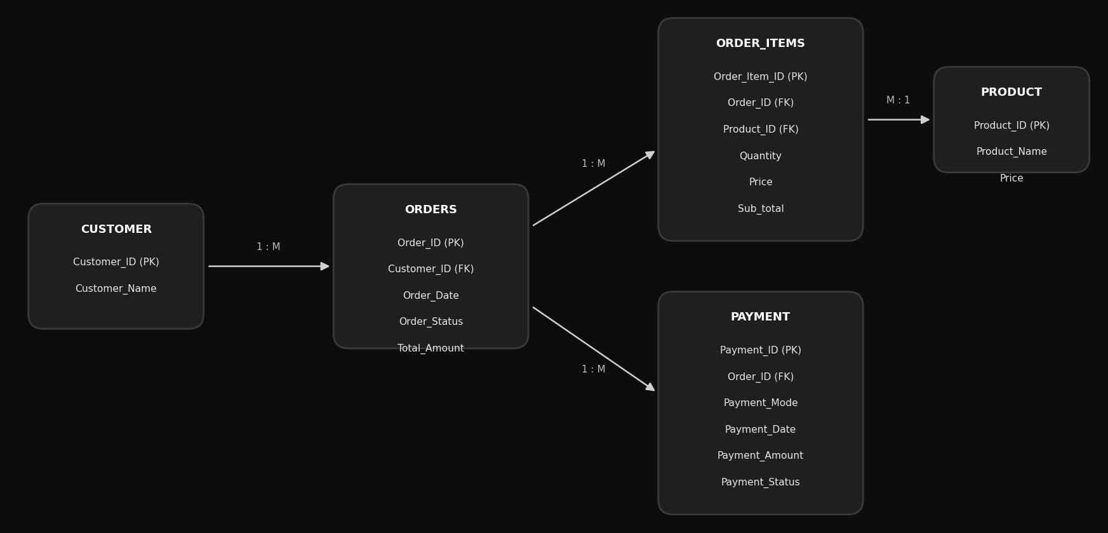

3. Table Creation
3.1 Create Payment Table
SQL> CREATE TABLE Payment (
2 Payment_ID NUMBER(5) PRIMARY KEY,
3 Order_ID NUMBER(5),
4 Payment_Mode VARCHAR2(20) NOT NULL,
5 Payment_Date DATE NOT NULL,
6 Payment_Amount NUMBER(10,2) NOT NULL,
7 Payment_Status VARCHAR2(20) NOT NULL,
8 CONSTRAINT fk_payment_order
9 FOREIGN KEY (Order_ID)
10 REFERENCES Orders(Order_ID)
11 );

Table created.

4. Payment Data Insertion
SQL> INSERT INTO Payment
2 (Payment_ID, Order_ID, Payment_Mode, Payment_Date, Payment_Amount, Payment_Status)
3 VALUES
4 (501, 3001, 'UPI', SYSDATE, 1299.00, 'Successful');

1 row created.

SQL> INSERT INTO Payment
2 (Payment_ID, Order_ID, Payment_Mode, Payment_Date, Payment_Amount, Payment_Status)
3 VALUES
4 (502, 3002, 'Card', SYSDATE, 2450.00, 'Successful');

1 row created.

SQL> INSERT INTO Payment
2 (Payment_ID, Order_ID, Payment_Mode, Payment_Date, Payment_Amount, Payment_Status)
3 VALUES
4 (503, 3003, 'Net Banking', SYSDATE, 899.00, 'Failed');

1 row created.

SQL> INSERT INTO Payment
2 (Payment_ID, Order_ID, Payment_Mode, Payment_Date, Payment_Amount, Payment_Status)
3 VALUES
4 (504, 3004, 'UPI', SYSDATE, 1750.00, 'Successful');

1 row created.

5. Manage Payment Transactions
5.1 Display Successful Payments
SQL> SELECT *
2 FROM Payment
3 WHERE Payment_Status = 'Successful';

PAYMENT_ID ORDER_ID PAYMENT_MODE PAYMENT_D PAYMENT_AMOUNT
---------- ---------- -------------------- --------- --------------
PAYMENT_STATUS
--------------------
501 3001 UPI 28-SEP-26 1299
Successful

502 3002 Card 28-SEP-26 2450
Successful

504 3004 UPI 28-SEP-26 1750
Successful

5.2 Display Failed Payments
SQL> SELECT *
2 FROM Payment
3 WHERE Payment_Status = 'Failed';

PAYMENT_ID ORDER_ID PAYMENT_MODE PAYMENT_D PAYMENT_AMOUNT
---------- ---------- -------------------- --------- --------------
PAYMENT_STATUS
--------------------
503 3003 Net Banking 28-SEP-26 899
Failed

6. Modify Payment Status
SQL> UPDATE Payment
2 SET Payment_Status = 'Successful'
3 WHERE Payment_ID = 503;

1 row updated.

SQL> SELECT *
2 FROM Payment
3 WHERE Payment_ID = 503;

PAYMENT_ID ORDER_ID PAYMENT_MODE PAYMENT_D PAYMENT_AMOUNT
---------- ---------- -------------------- --------- --------------
PAYMENT_STATUS
--------------------
503 3003 Net Banking 28-SEP-26 899
Successful

7. Analyze Payment Methods
Count the transactions made through each payment mode
SQL> SELECT
2 Payment_Mode,
3 COUNT(*) AS Total_Transactions
4 FROM Payment
5 GROUP BY Payment_Mode;

PAYMENT_MODE TOTAL_TRANSACTIONS
-------------------- ------------------
Net Banking 1
Card 1
UPI 2

Calculate amount collected by payment mode
SQL> SELECT
2 Payment_Mode,
3 SUM(Payment_Amount) AS Total_Amount
4 FROM Payment
5 WHERE Payment_Status = 'Successful'
6 GROUP BY Payment_Mode;

PAYMENT_MODE TOTAL_AMOUNT
-------------------- ------------
Net Banking 899
Card 2450
UPI 3049

8. Payment Transaction Report
SQL> SELECT
2 p.Payment_ID,
3 o.Order_ID,
4 c.Customer_ID,
5 c.Customer_Name,
6 p.Payment_Mode,
7 p.Payment_Date,
8 p.Payment_Amount,
9 p.Payment_Status
10 FROM Payment p
11 JOIN Orders o
12 ON p.Order_ID = o.Order_ID
13 JOIN Customer c
14 ON o.Customer_ID = c.Customer_ID
15 ORDER BY p.Payment_Date DESC;

PAYMENT_ID ORDER_ID CUSTOMER_ID
---------- ---------- -----------
CUSTOMER_NAME
--------------------------------------------------------------------------------
PAYMENT_MODE PAYMENT_D PAYMENT_AMOUNT PAYMENT_STATUS
-------------------- --------- -------------- --------------------

504 3004 304
Kavya Reddy
UPI 28-SEP-26 1750 Successful

503 3003 303
Rohit Verma
Net Banking 28-SEP-26 899 Successful

502 3002 302
Meera Nair
Card 28-SEP-26 2450 Successful

501 3001 301
Ananya Iyer
UPI 28-SEP-26 1299 Successful

4 rows selected.

SQL> COMMIT;

Commit complete.

