DBMS – PRODUCT REVIEW AND RATING MANAGEMENT
Project Title: Nykaa – Beauty & Wellness E-Commerce Management System
Skill Task: DBMS
Week: 6

1. Database Design

1.1 Review Table
Attribute | Data Type | Constraint
Review_ID | NUMBER(10) | Primary Key
Customer_ID | NUMBER(10) | Foreign Key
Product_ID | NUMBER(10) | Foreign Key
Review_Text | VARCHAR2(500) | NOT NULL
Review_Date | DATE | NOT NULL

1.2 Rating Table
Attribute | Data Type | Constraint
Rating_ID | NUMBER(10) | Primary Key
Customer_ID | NUMBER(10) | Foreign Key
Product_ID | NUMBER(10) | Foreign Key
Rating_Value | NUMBER(1) | NOT NULL, CHECK (1 to 5)
Rating_Date | DATE | NOT NULL

2. Table Relationships
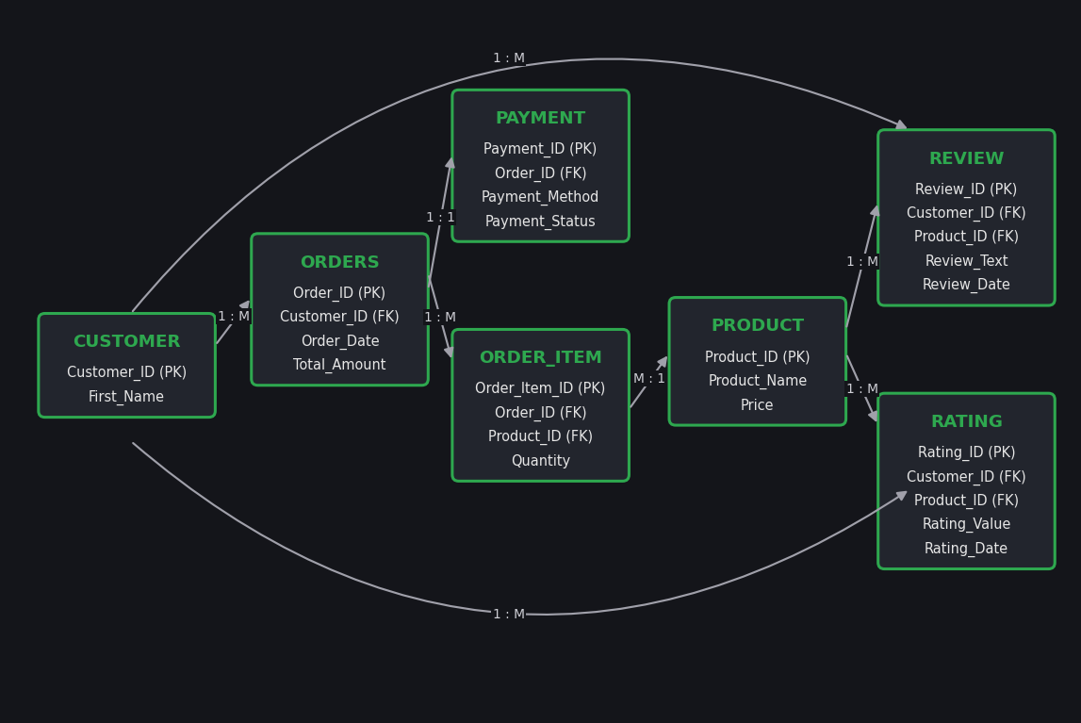
One customer can write many reviews and give many ratings. One product can receive many reviews and many ratings. Review and Rating both reference the Customer and Product tables through foreign keys, as defined in the Entity Analysis of the Nykaa E-Commerce Management System.

3. Table Creation

3.1 Create Review Table
SQL> CREATE TABLE Review (
Review_ID NUMBER(10) PRIMARY KEY,
Customer_ID NUMBER(10) NOT NULL,
Product_ID NUMBER(10) NOT NULL,
Review_Text VARCHAR2(500) NOT NULL,
Review_Date DATE NOT NULL,
CONSTRAINT fk_review_customer FOREIGN KEY (Customer_ID)
REFERENCES Customer(Customer_ID),
CONSTRAINT fk_review_product FOREIGN KEY (Product_ID)
REFERENCES Product(Product_ID)
);

Table created.

3.2 Create Rating Table
SQL> CREATE TABLE Rating (
Rating_ID NUMBER(10) PRIMARY KEY,
Customer_ID NUMBER(10) NOT NULL,
Product_ID NUMBER(10) NOT NULL,
Rating_Value NUMBER(1) NOT NULL CHECK (Rating_Value BETWEEN 1 AND 5),
Rating_Date DATE NOT NULL,
CONSTRAINT fk_rating_customer FOREIGN KEY (Customer_ID)
REFERENCES Customer(Customer_ID),
CONSTRAINT fk_rating_product FOREIGN KEY (Product_ID)
REFERENCES Product(Product_ID)
);

Table created.

4. Review Data Insertion
SQL> INSERT INTO Review (Review_ID, Customer_ID, Product_ID, Review_Text, Review_Date)
VALUES (1, 1, 1001, 'Very good product and suitable for my skin', SYSDATE);

1 row created.

SQL> INSERT INTO Review (Review_ID, Customer_ID, Product_ID, Review_Text, Review_Date)
VALUES (2, 2, 1002, 'The product quality is excellent', SYSDATE);

1 row created.

SQL> INSERT INTO Review (Review_ID, Customer_ID, Product_ID, Review_Text, Review_Date)
VALUES (3, 3, 1003, 'Good product with a pleasant fragrance', SYSDATE);

1 row created.

SQL> INSERT INTO Review (Review_ID, Customer_ID, Product_ID, Review_Text, Review_Date)
VALUES (4, 4, 1004, 'The product is useful and effective', SYSDATE);

1 row created.

SQL> INSERT INTO Review (Review_ID, Customer_ID, Product_ID, Review_Text, Review_Date)
VALUES (5, 5, 1005, 'Nice product and good quality', SYSDATE);

1 row created.

SQL> INSERT INTO Review (Review_ID, Customer_ID, Product_ID, Review_Text, Review_Date)
VALUES (6, 1, 1006, 'Very effective face pack', SYSDATE);

1 row created.

SQL> INSERT INTO Review (Review_ID, Customer_ID, Product_ID, Review_Text, Review_Date)
VALUES (7, 2, 1007, 'Good moisturizer for daily use', SYSDATE);

1 row created.

SQL> INSERT INTO Review (Review_ID, Customer_ID, Product_ID, Review_Text, Review_Date)
VALUES (8, 3, 1008, 'Gentle and refreshing cleanser', SYSDATE);

1 row created.

SQL> COMMIT;

Commit complete.

5. Rating Data Insertion
SQL> INSERT INTO Rating (Rating_ID, Customer_ID, Product_ID, Rating_Value, Rating_Date)
VALUES (1, 1, 1001, 5, SYSDATE);

1 row created.

SQL> INSERT INTO Rating (Rating_ID, Customer_ID, Product_ID, Rating_Value, Rating_Date)
VALUES (2, 2, 1002, 4, SYSDATE);

1 row created.

SQL> INSERT INTO Rating (Rating_ID, Customer_ID, Product_ID, Rating_Value, Rating_Date)
VALUES (3, 3, 1003, 5, SYSDATE);

1 row created.

SQL> INSERT INTO Rating (Rating_ID, Customer_ID, Product_ID, Rating_Value, Rating_Date)
VALUES (4, 4, 1004, 4, SYSDATE);

1 row created.

SQL> INSERT INTO Rating (Rating_ID, Customer_ID, Product_ID, Rating_Value, Rating_Date)
VALUES (5, 5, 1005, 3, SYSDATE);

1 row created.

SQL> INSERT INTO Rating (Rating_ID, Customer_ID, Product_ID, Rating_Value, Rating_Date)
VALUES (6, 1, 1006, 4, SYSDATE);

1 row created.

SQL> INSERT INTO Rating (Rating_ID, Customer_ID, Product_ID, Rating_Value, Rating_Date)
VALUES (7, 2, 1007, 5, SYSDATE);

1 row created.

SQL> INSERT INTO Rating (Rating_ID, Customer_ID, Product_ID, Rating_Value, Rating_Date)
VALUES (8, 3, 1008, 3, SYSDATE);

1 row created.

SQL> INSERT INTO Rating (Rating_ID, Customer_ID, Product_ID, Rating_Value, Rating_Date)
VALUES (9, 4, 1001, 4, SYSDATE);

1 row created.

SQL> INSERT INTO Rating (Rating_ID, Customer_ID, Product_ID, Rating_Value, Rating_Date)
VALUES (10, 5, 1003, 4, SYSDATE);

1 row created.

SQL> COMMIT;

Commit complete.

6. Retrieve Product Review Details
SQL> SET LINESIZE 200
SQL> COLUMN First_Name FORMAT A12
SQL> COLUMN Review_Text FORMAT A42
SQL> SELECT r.Review_ID, c.First_Name, r.Product_ID, r.Review_Text, r.Review_Date
FROM Review r JOIN Customer c ON r.Customer_ID = c.Customer_ID
ORDER BY r.Review_Date DESC, r.Review_ID;

REVIEW_ID FIRST_NAME PRODUCT_ID REVIEW_TEXT REVIEW_DATE
--------- ------------ ---------- ------------------------------------------ -----------
1 Ananya 1001 Very good product and suitable for my skin 07-OCT-26
2 Priya 1002 The product quality is excellent 07-OCT-26
3 Divya 1003 Good product with a pleasant fragrance 07-OCT-26
4 Meena 1004 The product is useful and effective 07-OCT-26
5 Kavya 1005 Nice product and good quality 07-OCT-26
6 Ananya 1006 Very effective face pack 07-OCT-26
7 Priya 1007 Good moisturizer for daily use 07-OCT-26
8 Divya 1008 Gentle and refreshing cleanser 07-OCT-26

8 rows selected.

7. Calculate Average Product Ratings
This uses the AVG() aggregate function with GROUP BY.
SQL> SELECT Product_ID, ROUND(AVG(Rating_Value), 2) AS Average_Rating
FROM Rating GROUP BY Product_ID
ORDER BY Average_Rating DESC, Product_ID;

PRODUCT_ID AVERAGE_RATING
---------- --------------
1007 5
1001 4.5
1003 4.5
1002 4
1004 4
1006 4
1005 3
1008 3

8 rows selected.

8. Identify Highly Rated Products
Products with an average rating of 4 or above can be displayed using HAVING.
SQL> SELECT Product_ID, ROUND(AVG(Rating_Value), 2) AS Average_Rating
FROM Rating GROUP BY Product_ID
HAVING AVG(Rating_Value) >= 4
ORDER BY Average_Rating DESC, Product_ID;

PRODUCT_ID AVERAGE_RATING
---------- --------------
1007 5
1001 4.5
1003 4.5
1002 4
1004 4
1006 4

6 rows selected.

9. Product Rating Report
A combined report can be generated using the Rating and Product tables.
SQL> COLUMN Product_Name FORMAT A22
SQL> SELECT p.Product_ID, p.Product_Name,
COUNT(r.Rating_ID) AS Total_Ratings,
ROUND(AVG(r.Rating_Value), 2) AS Average_Rating,
MAX(r.Rating_Value) AS Highest_Rating,
MIN(r.Rating_Value) AS Lowest_Rating
FROM Rating r JOIN Product p ON r.Product_ID = p.Product_ID
GROUP BY p.Product_ID, p.Product_Name
ORDER BY Average_Rating DESC, p.Product_ID;

PRODUCT_ID PRODUCT_NAME TOTAL_RATINGS AVERAGE_RATING HIGHEST_RATING LOWEST_RATING
---------- ------------ ------------- -------------- -------------- -------------
1007 Cucumber Moisturizer 1 5 5 5
1001 Aloe Vera Face Wash 2 4.5 5 4
1003 Coconut Hair Oil 2 4.5 5 4
1002 Rose Face Cream 1 4 4 4
1004 Herbal Body Wash 1 4 4 4
1006 Neem Face Pack 1 4 4 4
1005 Natural Lip Balm 1 3 3 3
1008 Natural Face Cleanser 1 3 3 3

8 rows selected.

10. Conclusion
The Product Review and Rating Management System stores customer feedback and ratings for Nykaa products in a structured way. Foreign keys and the CHECK constraint maintain data integrity, while JOIN, AVG(), COUNT(), MAX(), MIN(), GROUP BY and HAVING make it possible to retrieve reviews, calculate average ratings and identify highly rated products.

